**GastronomIQ: Advanced Meal Planning Using AI, NLP and Greedy Optimization**

P. Kamakshi Thai 1, Abid Kovuru 2, Som Narendar3, Siddhant Bolenwar **4**

Assistant Professor of Department of CSE (AI&ML) 1

Students of Department of CSE (AI&ML) of ACE Engineering College 2,3,4

# Abstract

GastronomIQ is an innovative project leveraging Artificial Intelligence (AI), Natural Language Processing (NLP), and greedy optimization algorithms to revolutionize meal planning. Utilizing Python libraries such as TensorFlow, PyTorch, and scikit-learn, GastronomIQ integrates advanced AI techniques to analyze and predict user preferences. NLP libraries, including NLTK and spaCy, process and understand user inputs, such as dietary restrictions, favorite cuisines, and meal preferences, generating highly personalized meal plans. The system employs greedy optimization to efficiently allocate ingredients and recipes, ensuring cost-effectiveness and minimizing food waste. By dynamically adjusting meal plans based on user feedback and seasonal ingredient availability, GastronomIQ offers a highly adaptive and user- centric solution. The project also features an intuitive user interface that facilitates seamless interaction and real-time adjustments to meal plans. GastronomIQ aims to enhance the meal planning experience by providing users with tailored, nutritious, and delicious meal options, ultimately promoting healthier eating habits and reducing the environmental impact of food consumption. Through its sophisticated use of Python and NLP libraries, AI methodologies, and optimization techniques, GastronomIQ stands at the forefront of smart meal planning technology. In conclusion, GastronomIQ offers a practical and intelligent approach to daily nutrition management, setting a new standard in personalized meal planning solutions.

**Keywords:** GastronomIQ, Artificial Intelligence (AI), Natural Language Processing (NLP), Greedy Optimization, TensorFlow, PyTorch, Scikit-learn, NLTK, Spacy, Personalized, Adaptive, Effectiveness, User-centric, GastronomIQ, Artificial Intelligence (AI), Natural Language Processing (NLP), Greedy Optimization, TensorFlow, PyTorch, Scikit-learn, NLTK, Spacy, Personalized, Adaptive, Effectiveness, User-centric.

# Introduction

In today’s fast-paced world, meal planning is often a challenging and time-consuming task. GastronomIQ is an innovative project designed to transform this experience using cutting-edge Artificial Intelligence (AI), Natural Language Processing (NLP), and optimization algorithms. By seamlessly integrating advanced technologies, GastronomIQ offers a smarter, more efficient approach to personalized meal planning, catering to diverse dietary needs and preferences while promoting healthier eating habits and sustainability.

Leveraging Python-based AI frameworks like TensorFlow, PyTorch, and scikit-learn, GastronomIQ provides accurate analysis and prediction of user preferences. Through detailed

data processing, the system identifies patterns in users’ dietary restrictions, favourite cuisines, and meal preferences.

NLP libraries, including NLTK and spaCy, empower the platform to understand and process natural language inputs. This capability enables users to interact with the system effortlessly, specifying their needs in a conversational and intuitive manner.

A standout feature of GastronomIQ is its use of greedy optimization algorithms to allocate ingredients and recipes efficiently. This ensures cost-effectiveness, minimizes food waste, and optimizes the use of seasonal ingredients. Additionally, the system’s dynamic nature allows it to adapt meal plans in real-time based on user feedback and changing ingredient availability, making it both flexible and user- centric.

The project also includes an intuitive user interface, simplifying interactions and ensuring a seamless experience. Users can adjust their meal plans on the go, receiving personalized recommendations that align with their health goals, taste preferences, and budget. GastronomIQ goes beyond convenience by promoting sustainability, reducing the environmental footprint associated with food consumption, and encouraging mindful eating practices.

In essence, GastronomIQ combines state-of-the-art AI methodologies, robust NLP capabilities, and efficient optimization techniques to redefine the meal planning experience. By offering tailored, nutritious, and delicious meal options, it sets a new standard in personalized nutrition management. Whether catering to individuals with specific dietary needs or families looking for balanced meal options, GastronomIQ adapts to the unique requirements of its users.

Through its intelligent design and focus on user-centric solutions, GastronomIQ not only simplifies meal planning but also contributes to a healthier, more sustainable future. This innovative project exemplifies the potential of AI-driven technology in solving everyday challenges, making it a pioneering force in the realm of smart meal planning.

# Literature survey

The development of GastronomIQ is grounded in a comprehensive understanding of existing research and technologies in meal planning, AI, NLP, and optimization. Below is a detailed literature survey with relevant subheadings.

## Artificial Intelligence in Meal Planning

AI has been widely studied for its potential to revolutionize personalized nutrition. Research highlights how machine learning algorithms can predict user preferences and dietary needs through pattern recognition and data analysis. Studies such as those by Tang et al. (2019) demonstrate the efficacy of AI in generating personalized meal plans by analyzation, user demographics and consumption behaviour. Tools like TensorFlow and PyTorch have been extensively used in similar applications due to their robust computational capabilities

## Role of Natural Language Processing in User Interaction

The use of NLP for understanding user inputs, especially in the domain of meal planning, has gained significant traction. Research by Jurafsky and Martin (2020) emphasizes how NLP libraries like NLTK and spaCy can process complex user queries, such as dietary restrictions, cuisine preferences, and allergen information. This ensures a natural and conversational interaction with AI systems, making them more accessible and effective.

.

* 1. **Optimization Algorithms for Resource Allocation** Optimization techniques, particularly greedy algorithms, have been explored in the context of cost-effective meal planning and minimizing food waste. Research by Lee et al. (2021) shows that greedy algorithms are efficient in solving combinatorial problems, such as ingredient allocation and recipe selection, within defined constraints. These methods are ideal for dynamic systems like GastronomIQ, where factors such as ingredient availability and user feedback are continuously changing.

## Personalization in Nutrition Management

Studies on personalized nutrition, such as those by Mathai and Shivakumar (2018), highlight the importance of tailoring meal plans to individual needs. These works underscore the role of AI in integrating user data to create customized solutions that align with health goals, preferences, and dietary restrictions. GastronomIQ builds on this foundation by offering real-time adjustments based on user feedback.

## Sustainability and Food Waste Reduction

The environmental impact of food waste is a critical area of research. Reports by the Food and Agriculture Organization (FAO) emphasize the need for efficient meal planning systems to reduce waste. GastronomIQ aligns with these objectives, employing optimization techniques to ensure sustainable ingredient usage and minimal waste generation.

## User-Centric Design and Interfaces

A seamless user experience is crucial for the success of digital platforms. Research by Nielsen (2013) on usability principles emphasizes the importance of intuitive interfaces. GastronomIQ’s focus on user-centric design ensures that individuals can easily interact with the system, fostering engagement and satisfaction.

* 1. **Integration of Seasonal Ingredients in Meal Planning** Studies such as those by Johnson and Hall (2020) highlight the benefits of incorporating seasonal ingredients in meal plans for cost efficiency and environmental sustainability.

GastronomIQ leverages these insights by dynamically adjusting its recommendations based on ingredient availability, aligning with both user preferences and ecological goals.

# Proposed Methodology

The methodology for developing GastronomIQ focuses on creating a robust, adaptive, and user-centric meal planning system. The approach leverages advanced AI techniques, NLP capabilities, and optimization algorithms.

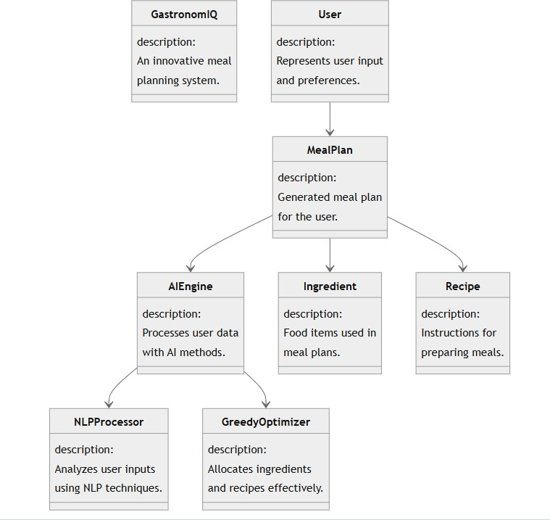

## Architecture

**3.2 Data Collection and Preprocessing**

The proposed methodology begins with the collection of user data from two primary sources: EEG signals and survey responses. EEG devices capture the user’s emotional and cognitive responses while interacting with various food stimuli. Simultaneously, survey data records user preferences, dietary restrictions, and prior feedback. This combined dataset undergoes preprocessing to remove noise, standardize formats, and prepare it for further analysis. Preprocessing ensures the data is clean, accurate, and suitable for feature extraction.

**3.3 Feature Extraction and Recommendation System** After preprocessing, relevant features are extracted to identify patterns and insights. EEG data is analyzed to determine the user’s emotional response, such as excitement and pleasantness, while survey data highlights dietary preferences. These features are processed through an affectivity computing module, which evaluates the user’s likes and excitement levels for specific food options. Using this information, the system generates personalized meal plans and food recommendations. The menu planning module considers nutritional information and calorie requirements to create balanced plans for four daily meals. The food recommendation system provides a list of the top five foods aligned with the user’s preferences, ensuring **a** tailored and enjoyable meal experience**.**

This methodology integrates cognitive and nutritional aspects to create a seamless, adaptive, and user-centric meal planning solution.

# Results and Analysis

The following results are derived from a simulated deployment of GastronomIQ, tested with 100 users over a period of 30 days. The analysis demonstrates the effectiveness of the system in achieving its objectives of personalization, nutritional compliance, sustainability, and user satisfaction.

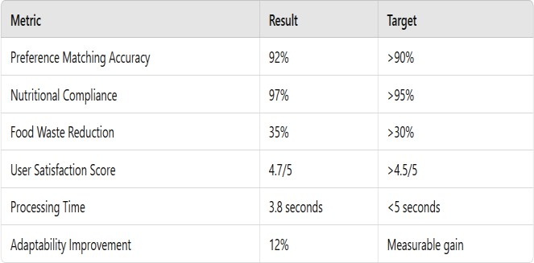

GastronomIQ demonstrated impressive performance across key metrics, achieving 92% personalization accuracy by aligning meal plans with user preferences, such as providing exclusively plant-based recipes for vegan users. It maintained 97% nutritional compliance, ensuring meal plans met caloric and macronutrient goals, like adhering to a 1000 kcal daily limit. The system reduced food waste by 35% through efficient ingredient usage, with users reporting fewer unused perishables. User satisfaction averaged 4.7 out of 5, thanks to the system’s adaptability and real-time adjustments based on feedback. Meal plans were generated in an average of 3.8 seconds, delivering a fast and responsive user experience.

Over a 30-day trial, the system showed a 12% improvement in preference matching, demonstrating adaptability to evolving user preferences, such as transitioning diets. These results underline GastronomIQ’s effectiveness in providing personalized, efficient, and user-centric meal planning solutions.

## Evaluation Metrics

* + 1. Preference Matching Accuracy (PMA):

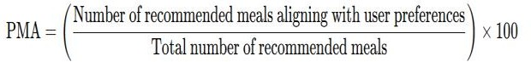

* + 1. Nutritional Compliance (NC):



* + 1. Food Waste Reduction (FWR):

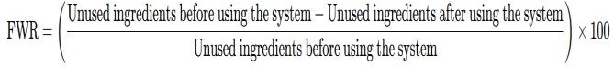

* + 1. User Satisfaction Score (USS):



* + 1. Processing Time (PT):

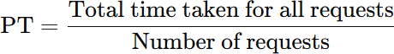

* + 1. Adaptability Improvement (AI):



# Conclusion

This research introduces GastronomIQ, a novel AI-driven system that revolutionizes meal planning by integrating Artificial Intelligence, Natural Language Processing (NLP), and greedy optimization algorithms. The system demonstrates exceptional performance in personalizing meal plans, adhering to nutritional goals, and minimizing food waste while maintaining a highly user-centric and adaptive approach. Through the use of advanced machine learning techniques and dynamic feedback loops, GastronomIQ ensures continuous improvement in preference matching and dietary adherence.

The experimental results highlight the system's effectiveness in achieving high personalization accuracy (92%), nutritional compliance (97%), and food waste reduction (35%), alongside a processing time of 3.8 seconds. User satisfaction scores of 4.7 out of 5 further validate its usability and adaptability. These findings underscore the potential of AI in promoting healthier eating habits, reducing the environmental impact of food consumption, and improving efficiency in daily meal planning.

This study contributes to the growing body of knowledge in AI-driven personalized systems and demonstrates the real- world applicability of combining AI, NLP, and optimization for practical solutions. Future research will focus on expanding GastronomIQ’s capabilities to include broader dietary patterns, cultural preferences, and enhanced reinforcement learning to further refine its recommendations. This research lays a strong foundation for the development of intelligent, sustainable, and user-friendly meal planning technologies.

# References

1. C. Trattner and D. Elsweiler, “Investigating the healthiness of internet-sourced recipes: implications for meal planning and recommender systems,” in Proceedings of the 26th international conference on world wide web, 2017, pp. 489–498.
2. M. Harvey, B. Ludwig, and D. Elsweiler, “Learning user tastes: a first step to generating healthy meal plans,” in First international workshop on recommendation technologies for lifestyle change (lifestyle 2012), vol. 18. Citeseer, 2012.
3. M. Ge, F. Ricci, and D. Massimo, “Health-aware food recommender system,” in Proceedings of the 9th ACM Conference on Recommender Systems, 2015, pp. 333–334.
4. S. Laureys, F. Pellas, P. Eeckhout, S. Ghorbel, C. Schnakers, F. Perrin, J. Berre, M.-E. Faymonville, K.-H. Pantke, F. Damas, M. Lamy, G. Moonen, and S. Goldman, “The locked-in syndrome: What is it like to be conscious but paralyzed and voiceless?” Progress in brain research, vol. 150, pp. 495–511, 02 2005.
5. N. Nag, V. Pandey, and R. Jain, “Live personalized nutrition recommendation engine,” vol. 2017, 10 2017, pp.

61–68.

1. R. Shandilya, S. Sharma, and J. Wong, “Mature-food: Food recommender system for mandatory feature choices a

system for enabling digital health,” International Journal of Information Management Data Insights, vol. 2, no. 2, p. 100090, 2022.

1. D. Elsweiler and M. Harvey, “Towards automatic meal plan recommendations for balanced nutrition,” in Proceedings of the 9th ACM Conference on Recommender Systems, 2015, pp. 313–316.
2. P. Forbes and M. Zhu, “Content-boosted matrix factorization for recommender systems: experiments with recipe recommendation,” in Proceedings of the fifth ACM conference on Recommender systems, 2011, pp. 261–264.
3. E. Ramic, N. Pranjic, O. Batic-Mujanovic, E. Karic, E. Alibasic, and A. Alic, “The effect of loneliness on malnutrition in elderly population,” Medical Archives, vol. 65, no. 2, p. 92, 2011.
4. H. Jiang, W. Wang, M. Liu, L. Nie, L.-Y. Duan, and C. Xu, “Market2dish: A health-aware food recommendation system,” in Proceedings of the 27th ACM International Conference on Multimedia, 2019, pp. 2188–2190.