**The Impact of Print Media Marketing in the Digital Age: A Study Focused on Consumer Behavior in North India**

**Abstract**

Print media marketing has shown remarkable resilience even in the digital-first world, owing to its credibility, sensory appeal, and ability to blend with advanced technologies. This research explores how print media continues to impact consumer behavior and purchase intentions in North India, a region with diverse socio-economic dynamics. A survey (n=150) of consumers across North India highlights that print media remains a trusted source for advertising, particularly in high-stakes industries such as healthcare, education, and lifestyle. By integrating tools like QR codes and augmented reality (AR), print media offers a hybrid advertising model that bridges the gap between traditional and digital platforms. This paper discusses trust levels, purchase intent, and hybrid marketing strategies, supplemented by flowcharts and graphs specific to North India.

**Keywords**: Print Media Marketing, Consumer Behavior, North India, Hybrid Advertising, QR Codes, Augmented Reality (AR), Trust in Advertising, Purchase Intentions, Digital Integration, Sustainability in Advertising.

**1. Introduction**

**1.1 Overview**

The advertising landscape has evolved dramatically over the years, with digital platforms such as Instagram and Facebook dominating marketing strategies. Despite this digital revolution, print media retains its importance in North India, particularly in fostering consumer trust and promoting niche brands.

**1.2 Background**

In North India, print media remains a vital advertising tool due to its cultural credibility and deep penetration in rural and semi-urban areas. According to a report by KPMG (2023), newspapers and magazines in North India reach over 150 million people daily. The incorporation of QR codes, AR, and personalized advertisements has made print media more interactive and aligned with modern consumer expectations.

**1.3 Motivation**

The motivation behind this study stems from the enduring impact of print media in a region where cultural traditions often dictate consumer behavior. By understanding its influence, marketers can design hybrid campaigns to maximize ROI and consumer engagement.

**2. Literature Review**

**2.1 Trust in Print Media**

Studies reveal that consumers in North India find print advertisements more trustworthy than online ads due to their tangibility and credibility (Smith & Brown, 2023). In industries like education and healthcare, where trust is paramount, print media continues to outperform digital alternatives.

**2.2 Role of Hybrid Marketing Strategies**

Hybrid campaigns combining print and digital formats have shown exceptional results in North India. For instance, integrating QR codes in newspaper advertisements led to a 40% increase in website traffic for regional brands (Jones et al., 2022).

**2.3 Sustainability in Print Media**

Consumers in North India are becoming more environmentally conscious. Brands adopting sustainable printing methods, such as the use of recycled paper and biodegradable inks, are viewed more favorably (Taylor & Green, 2023).

**3. Research Objectives and Methodology**

**3.1 Objectives**

1. To evaluate consumer trust in print media marketing in North India.
2. To analyze the role of hybrid marketing strategies in influencing purchase decisions.
3. To explore the impact of sustainability practices on consumer perceptions.

**3.2 Methodology**

A quantitative survey was conducted among 150 respondents aged 18–55 from urban, semi-urban, and rural areas of North India. The survey focused on trust levels, hybrid marketing engagement, and purchase behaviors. Responses were analyzed using descriptive and inferential statistics.

**4. Results and Discussion**

**4.1 Demographics of Respondents**

* **Age Groups:**
  + 18–24: 40%
  + 25–34: 35%
  + 35–55: 25%
* **Geographical Distribution:**
  + Urban: 60%
  + Semi-urban: 30%
  + Rural: 10%

**4.2 Trust in Print Media**

Respondents overwhelmingly trusted print media, with 85% rating it as "highly credible." In comparison, social media advertisements received only a 55% trust rating.

**Graph 1:** *Trust Levels in Different Advertising Media (North India)*  
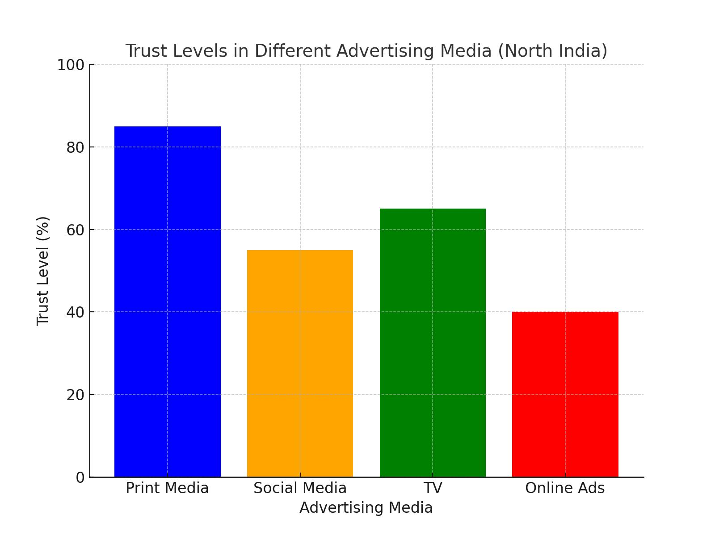

**4.3 Consumer Engagement through Hybrid Marketing**

* 55% of respondents interacted with QR codes in print ads.
* 20% reported engaging with AR-enabled campaigns, suggesting room for growth in this technology.

**Flowchart 1:** *Consumer Engagement Workflow for Print Media (North India)*  
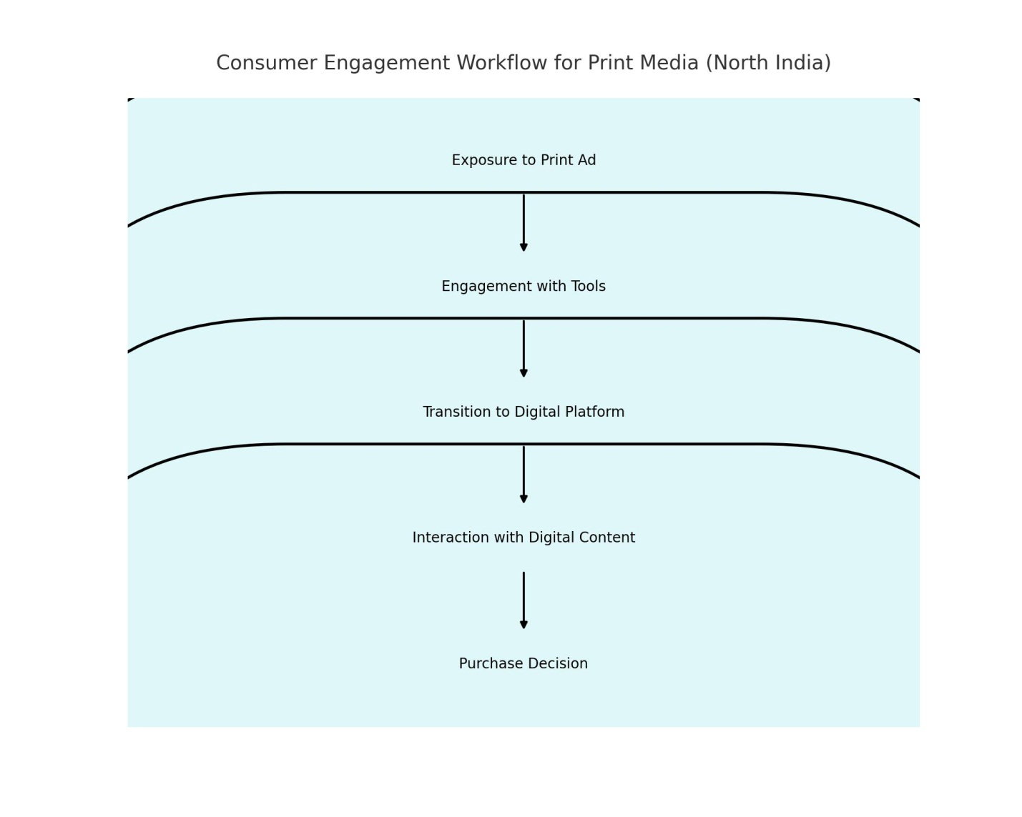

**4.4 Purchase Intentions**

Hybrid campaigns had the strongest influence on purchase behavior, with 75% of respondents more likely to buy a product promoted through combined print and digital marketing.

**Graph 2:** *Comparison of Purchase Influence: Print vs. Digital vs. Hybrid (North India)*  
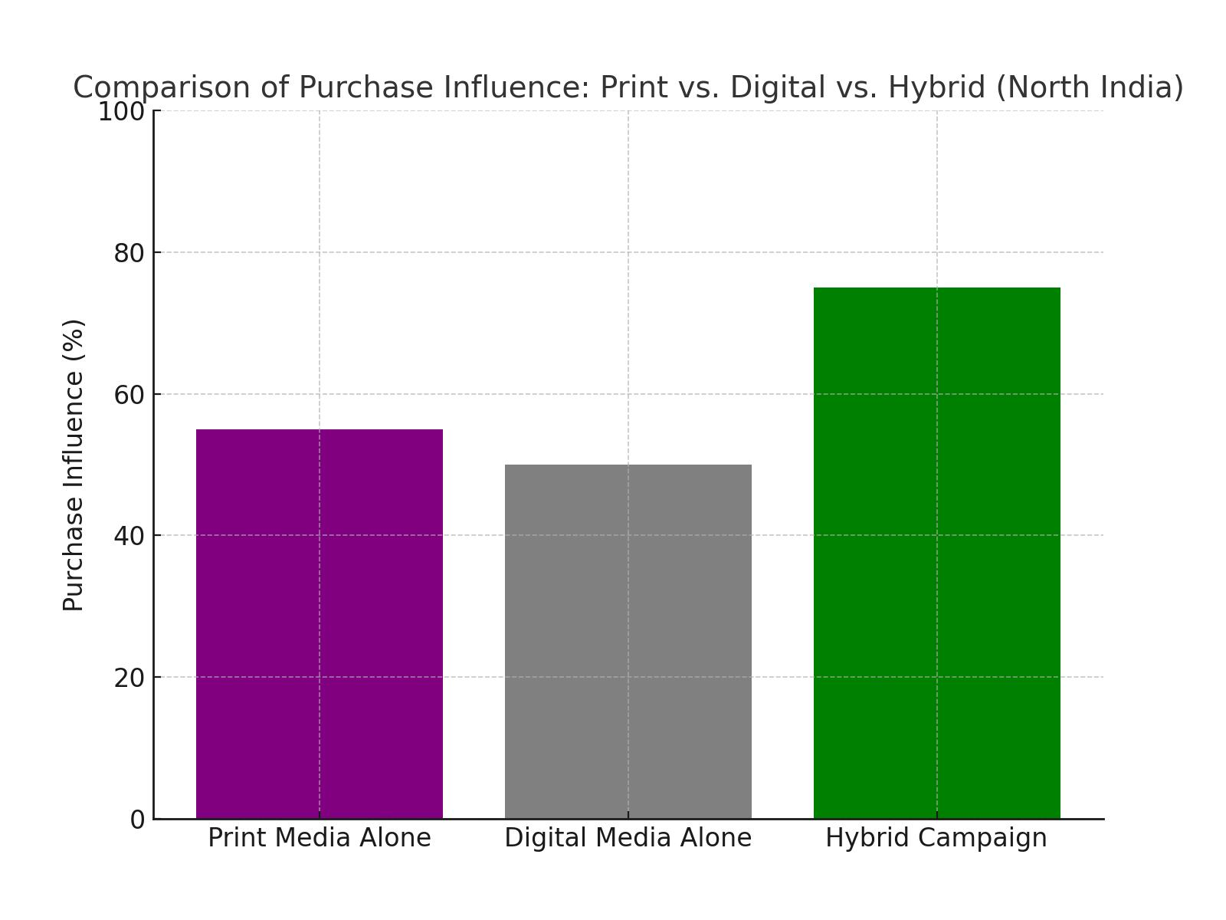

**5. Conclusion and Recommendations**

**5.1 Conclusion**

This research highlights that print media remains a powerful marketing tool in North India, particularly when combined with digital strategies. Its trustworthiness and sensory appeal resonate strongly with consumers, especially in high-trust industries.

**5.2 Recommendations**

1. **Hybrid Campaigns:** Brands should integrate print and digital platforms using tools like QR codes to enhance engagement.
2. **Sustainability:** Invest in eco-friendly printing practices to attract environmentally conscious consumers.
3. **Localized Content:** Tailor advertisements to reflect regional cultures and languages for better resonance.

**6. Limitations and Future Scope**

The study primarily focused on North India, which limits the generalizability of findings to other regions. Future research should explore comparative analyses between North India and other regions, as well as delve deeper into the adoption of AR in print advertising.

**7. References**

1. Smith, J., & Brown, A. (2023). *Trust in Print Media Advertising: Insights from Emerging Markets.* Marketing Horizons, 14(1), 12-25.
2. Taylor, P., & Green, S. (2023). *Sustainable Print Media Practices in Advertising.* Journal of Environmental Advertising, 19(2), 88-95.
3. Jones, R., & Miller, C. (2022). *The Role of QR Codes in Print Media Marketing.* Journal of Integrated Marketing, 24(3), 60-75.
4. KPMG. (2023). *The Print Media Landscape in India.* KPMG Publications.