**Analytical study on factors affecting the sales volume of ITC Frozen Food in General Trade.**

**ABSTRACT**

This study explores the factors influencing the sales volume of ITC Frozen Food in the General Trade sector, which consists of small, independent retailers. Key factors examined include pricing strategies, product availability, promotional activities, distribution channels, and consumer preferences. The research employs a mixed-method approach, using qualitative insights from retailer and consumer surveys, case studies of successful market interventions, and interviews with key stakeholders like distributors and sales representatives.

Additionally, the study considers the impact of seasonal variations, competitive landscape, and regional differences on sales performance. The findings aim to provide actionable recommendations for ITC to improve market penetration and sales performance in General Trade. Ultimately, this research aims to contribute to a strategic roadmap for sustained growth and competitive advantage in the frozen food industry.

**Keywords**: ITC Frozen Food, General Trade, Sales Volume, Pricing Strategies, Product Availability, Promotional Activities, Distribution Channels, Consumer Preference.

**INTRODUCTION**

The frozen food industry has witnessed remarkable growth over the past few decades, becoming a vital part of the global food market. By offering convenience, longer shelf life, and nutritional preservation, frozen foods have revolutionized meal planning and preparation. This sector encompasses a variety of products such as vegetables, fruits, ready-to-eat meals, and snacks, catering to diverse consumer preferences and dietary needs. In India, the market is expanding rapidly due to urbanization, increasing disposable incomes, and changing lifestyles, with Limited emerging as a key player leveraging its distribution network and brand equity.

Frozen Foods, a division of ITC Limited, has established a strong presence in the Indian frozen food industry with its diverse product portfolio, including frozen vegetables, fruits, ready-to-eat meals, and snacks. The company's focus on quality, innovation, and consumer satisfaction has garnered a loyal customer base. However, several factors influence the sales volume of Frozen Foods in general trade, such as consumer awareness and perception, pricing strategy, distribution efficiency, marketing efforts, and changing consumer lifestyles. Understanding these factors is crucial for devising effective strategies to enhance market penetration, drive sales, and achieve sustainable growth in the competitive frozen food market.

**LITERATURE REVIEW**

1. **Arora, M. (2022). Analysis and management of issues in cold chain of frozen food products (Doctoral dissertation, College of Management and Economic Studies, UPES, Dehradun).**
2. **Sen, S., Antara, N., & Sen, S. (2021). Factors influencing consumers’ to take readymade frozen food. Current Psychology, 40(6), 26342643.**
3. **Arora, M., Kumar, R., & Raju, T. B. (2023). Identification of issues in the cold chain of Indian frozen food. International Journal of Logistics Economics and Globalisation, 10(1), 122.**
4. **Funde, Y., & Shrivastava, A. (2023). Exploring Factors Driving the Choice of Frozen Food in the Indian Market. SCMS Journal of Indian Management, 20(3).**

**OBJECTIVE**The objective of this study is to identify and analyze the factors influencing the sales of Frozen Food in General Trade. By examining key elements such as consumer demographics, pricing strategies, distribution channels, competitive landscape, consumer preferences, advertising effectiveness, and economic conditions, the study aims to develop strategic insights. These insights will help optimize product placement, pricing, and promotional activities, ultimately driving increased sales and market share for Frozen Food in traditional retail outlets.

**RESEARCH METHODOLOGY**

Research Approach This study uses an exploratory and qualitative research approach to understand the factors influencing the choice of frozen food in the Indian market. Conducted over three months (May 2, 2024 - July 31, 2024), it aims to uncover insights and patterns in frozen market dynamics.

**Research Methodology**

* **Exploratory Nature:** Focuses on understanding reasons, opinions, and motivations behind frozen market dynamics.

**Data Types**

* **Primary Data:** Collected directly from respondents via surveys, interviews, and case studies involving key market players and consumers.
* **Secondary Data:** Gathered from existing literature, industry reports, and market analysis to provide contextual background and a broader perspective on market trends.

**Method of Data Collection**

* **Surveys:** Administered to distributors and shop owners to capture qualitative data on market trends, consumer preferences, and purchasing behaviours.
* **Interviews:** Conducted with industry experts, market analysts, and stakeholders to gain insights into the competitive landscape and strategic initiatives.
* **Document Analysis:** Involves examining industry reports, market analyses, and academic publications to understand external factors like economic conditions, regulatory environment, and technological advancements.

By integrating these methods, the study aims to provide a holistic view of the frozen food market in India. The combination of primary and secondary data ensures a comprehensive analysis, enabling ITC Masterchef to enhance its presence in the ‘General Trade’ segment and capitalize on the growing demand for frozen foods in India.

**DATA ANALYSIS & INTERPRETATION**

Forms response chart. Question title: Location
. Number of responses: 58 responses. **Interpretation of Pie Chart Data**

* **Western Mumbai (Blue Section)**: 24.1%
  + Approx. 14 out of 58 respondents
  + Nearly a quarter of total responses
* **South Mumbai (Red Section)**: 53.4%
  + About 31 out of 58 respondents
  + Majority, over half of the total responses
* **Navi Mumbai (Orange Section)**: 22.4%
  + Around 13 out of 58 respondents
  + Smallest group among the three regions

**Overall Analysis**

The chart shows notable variation in response distribution. South Mumbai has the highest representation, indicating a larger respondent base. Western and Navi Mumbai have similar, smaller proportions. This may reflect population density, engagement levels, or other regional factors.

Forms response chart. Question title: Type of Store 
. Number of responses: 58 responses.

**Here's a concise interpretation of the pie chart data:**

* **Convenience Stores (Orange):** 34.5% The largest segment, indicating high accessibility and variety.
* **Specialty Stores** **(Green):** 31% A significant portion, catering to specific needs.
* **Supermarkets** **(Red)** & Grocery Stores (Blue): Each 15.5% Offering a wide range of products and everyday items, respectively.
* **Cold Storage (Purple):** 3.5% The smallest segment, specialized in perishable goods.

In summary, Convenience Stores are the most common, followed by Specialty Stores, with a diverse representation of other store types.

Forms response chart. Question title: How frequently do you restock ITC Frozen Food products?
. Number of responses: 58 responses.The pie chart shows the frequency of restocking frozen food among 58 respondents:

1. **Weekly (75.9%):** Most respondents restock weekly, indicating high consumption and the staple nature of these products.
2. **Biweekly (3.5%):** A small group restocks biweekly, suggesting moderate usage.
3. **Monthly (5.2%):** A few respondents restock monthly, possibly due to larger purchases or lower consumption.
4. **As Needed (15.5%):** Some restock as needed, reflecting variable consumption rates or availability.

Overall, the majority restock weekly, while others have varied restocking habits.

Forms response chart. Question title: What is the average monthly sales volume of ITC Frozen Food products in your store?
. Number of responses: 58 responses. The bar diagram shows average monthly sales volumes of frozen food among 58 respondents:

1. **Sales Volume 1 (1.7%):** Only 1 respondent reports the lowest sales volume.
2. **Sales Volume 2 (17.2%):** 10 respondents fall into the secondlowest sales volume category.
3. **Sales Volume 3 (34.5%):** 20 respondents report moderate sales volumes.
4. **Sales Volume 4 (44.8%):** The majority, 26 respondents, indicate high sales volumes.
5. **Sales Volume 5 (1.7%):** Only 1 respondent reports the highest sales volume.

Overall, most respondents fall into the high sales volume category, indicating strong sales performance for frozen food products in many stores.

Forms response chart. Question title: What factors do customers consider most when purchasing frozen food? (Select top 3)
. Number of responses: 58 responses.

The bar graph illustrates the results of a survey on the factors customers consider most when purchasing frozen food. Here are the key points:

**Brand**: The most significant factor, with 52 responses (89.7%).

**Availability**: The second most important, with 42 responses (72.4%).

**Price**: Also highly considered, with 38 responses (65.5%).

**Packaging**: Noted by 22 respondents (37.9%).

**Quality**: Considered by 11 respondents (19%).

**Taste**: The least considered factor, with 10 responses (17.2%).

This suggests that brand reputation and availability are crucial for customers when choosing frozen food.

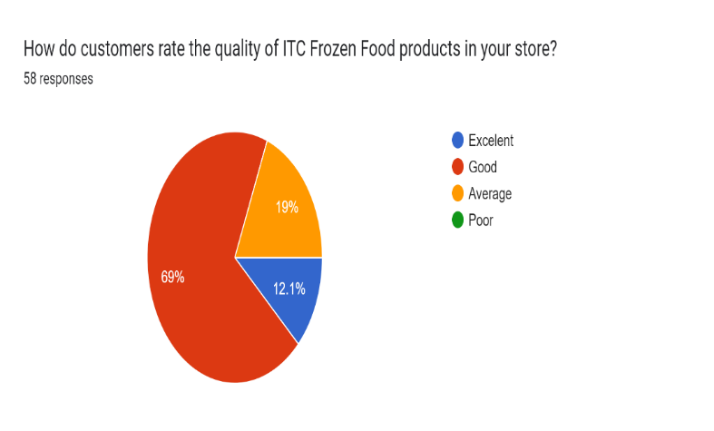

The pie chart you provided shows customer ratings for Frozen Food products in a store. Here are the key points:

**Excellent**: 12% of customers rated the products as excellent.

**Good**: 69% of customers rated the products as good.

**Average**: 19% of customers rated the products as average.

**Poor**: 0% of customers rated the products as poor.

This indicates a prominent level of customer satisfaction, with the majority rating the products as good.

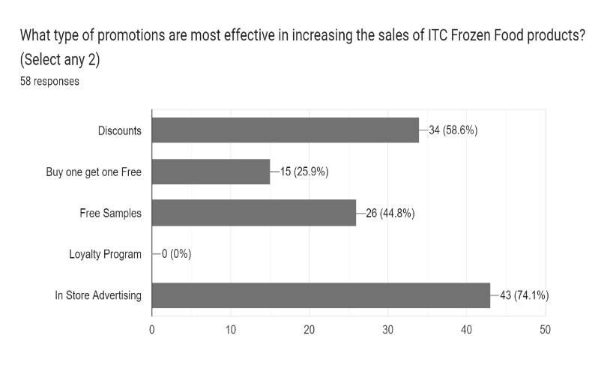The graph titled “What type of promotions are most effective in increasing the sales of Frozen Food products?” shows the effectiveness of different promotional strategies based on store owner preferences. Here are the key insights:

* **In Store Advertising**: The most effective strategy, with 74.1% of respondents selecting it.
* **Discounts**: The second most effective, chosen by 58.6% of respondents.
* **Free Samples**: Selected by 44.8% of respondents, indicating moderate effectiveness.
* **Buy One Get One Free**: The least effective among the options, with 25.9% of respondents choosing it.

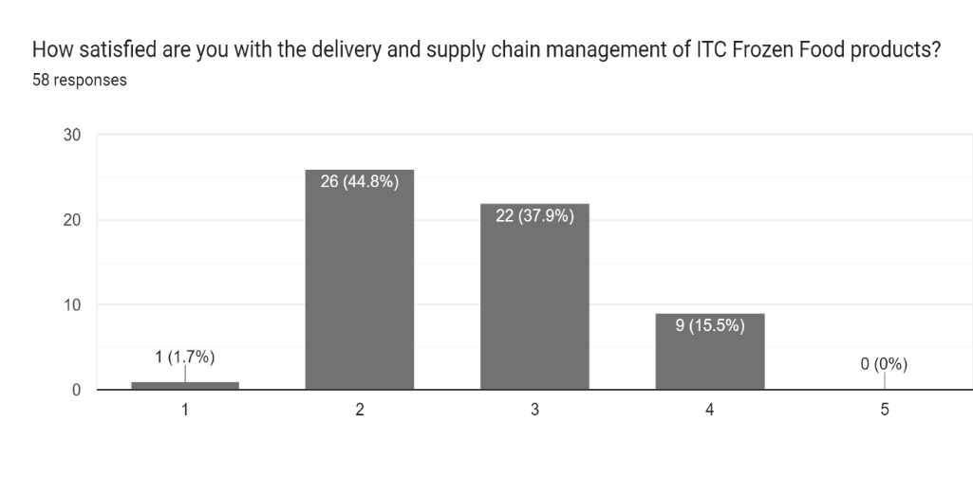This data suggests that instore advertising and discounts are the most impactful promotions for increasing sales of Frozen Food products.

The image is a bar graph titled **“How satisfied are you with the delivery and supply chain management of Frozen Food products?”** It shows the satisfaction levels of 58 respondents, rated from 1 to 5, with 1 being the least satisfied and 5 being the most satisfied.

* **Least Satisfied (1)**: Only 1 respondent (1.7%) rated their satisfaction at the lowest level.
* **Low Satisfaction (2)**: The majority, 26 respondents (44.8%), rated their satisfaction as 2.
* **Moderate Satisfaction (3)**: 22 respondents (37.9%) gave a rating of 3.
* **High Satisfaction (4)**: 9 respondents (15.5%) rated their satisfaction as 4.
* **Most Satisfied (5)**: No respondents (0%) rated their satisfaction at the highest level.

This indicates that most retailers are low satisfied, with few being moderately satisfied.

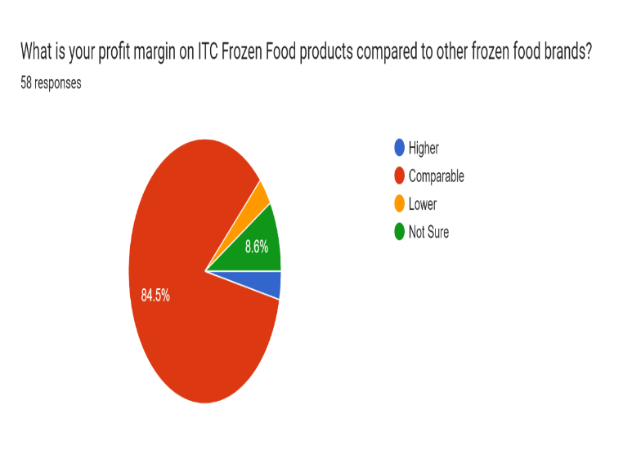

The pie chart shows the results of a survey on profit margins for Frozen Food products compared to other frozen food brands. Here’s the breakdown:

**Comparable:** The majority, 84.5%, of respondents report higher profit margins with Frozen Food products.

**Not Sure**: 8.6% of respondents find their profit margins comparable to other brands.

**Lower**: Only 1.7% believe their profit margins are lower with products.

**Higher** : 5.2% of respondents are uncertain about the comparison.

This data indicates that most respondents find ITC Frozen Food products comparable compared to other brands.

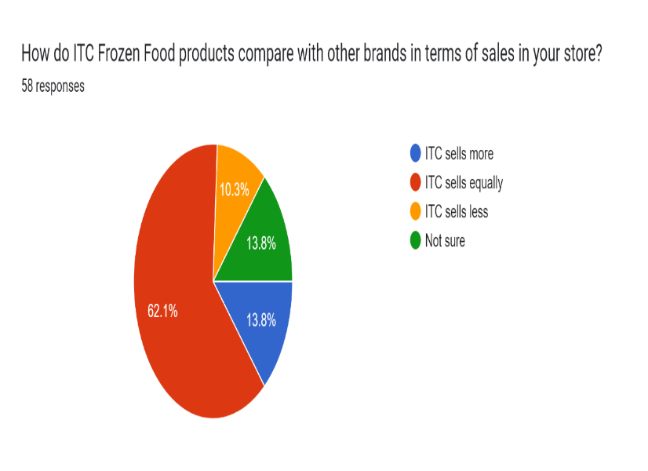

The pie chart illustrates the results of a survey asking how Frozen Food products compare with other brands in terms of sales in stores. Here’s the breakdown:

* **Equally**: The largest segment, 62.1%, indicates that Frozen Food products sell equally compared to other brands.
* **More**: 13.8% of respondents believe that products sell more than other brands.
* **Less**: Another 13.8% feel that products sell less.
* **Not Sure**: 10.3% of respondents are uncertain about the sales comparison.

This data suggests that the majority view Frozen Food products as performing on par with competitors, with smaller groups perceiving them as either better or worse, and a few unsure.

Forms response chart. Question title: Do you expect the sales of ITC Frozen Food products to increase, decrease, or remain the same in the next year?
. Number of responses: 58 responses.

The pie chart presents the results of a survey on expectations for the sales of Frozen Food products in the next year, based on 58 responses. Here’s the breakdown:

**Remain the Same**: The largest segment, 37.9%, of respondents expect sales to remain the same.

**Not Sure**: 32.8% of respondents are not sure about expected sales.

**Increase** : 29.3% of respondents anticipate a increase in sales.

This data suggests an optimistic outlook, with a significant portion expecting sales for Frozen Food products.

What other brands of frozen food do you sell in your store? (Please list)

|  |  |
| --- | --- |
| Zorabain | McCain |
| Yummies | SNX |
| Real Good | Gold |
| Venky's | Delicious |
| CP Food | Al Kabir |
| Keventers | LA – Karne |
| Hungritos | Haldiram |

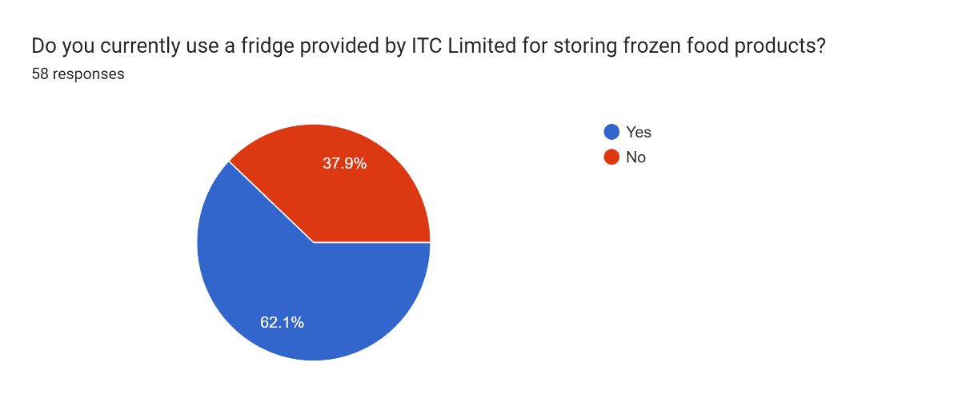

The pie chart illustrates the responses to the question: “Do you currently use a fridge provided by ITC Limited for storing frozen food products?” Here’s the breakdown:

* **Yes**: The majority, 62.1%, of respondents use a fridge provided by ITC Limited.
* **No:** 37.9% of respondents do not use a fridge provided by ITC Limited.

This data indicates that while a sizeable portion of respondents use ITC Limited fridges.

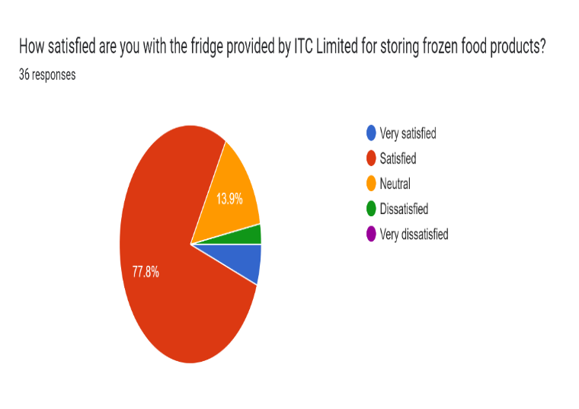

The pie chart titled “How satisfied are you with the fridge provided by Limited for storing frozen food products?” shows the satisfaction levels of 36 respondents. Here’s the interpretation:

* **Satisfied (77.8%)**: The majority of respondents are extremely happy with the fridge, indicating satisfaction with its performance.
* **Neutral (13.9%)**: A few respondents are indifferent, indicating the fridge neither exceeds nor falls short of their expectations.
* **Very satisfied (5.6%)**: A smaller portion of respondents are very satisfied, suggesting the fridge meets their every expectation.
* **Dissatisfied: (2.8%)**: A very small percentage are unhappy with the fridge, pointing to some areas for improvement.
* **Very Dissatisfied (0%)**: No respondents are very dissatisfied, which is a positive sign.

Overall, the chart reflects satisfaction with the fridge provided by Limited.

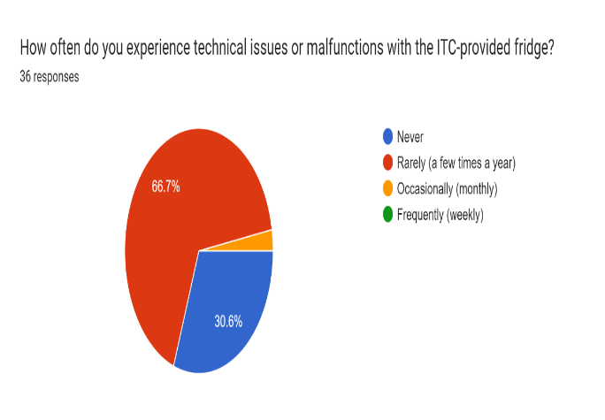

The pie chart illustrates the frequency of technical issues or malfunctions experienced with an provided fridge, based on 36 responses:

**Rarely (a few times a year)**: The largest segment, representing 66.7% of respondents, indicates that most people rarely encounter technical issues.

**Never:** 30.6% of respondents never face technical problem.

**Occasionally (Monthly )**: A very small portion of respondents experience issues monthly, though the exact percentage isn’t visible.

This data suggests that while the majority of users experience infrequent issues. This insight can help in assessing the reliability of the fridges and determining if maintenance or improvements are needed.

**RESULTS AND FINDINGS.**

The distribution of 58 survey responses from different regions of Mumbai reveals a significant variation in geographical representation. The pie chart shows that the majority of respondents, about 53.4% (31 respondents), are from South Mumbai, indicating a strong presence in this area. Western Mumbai follows with 24.1% (14 respondents), and Navi Mumbai has the smallest representation with 22.4% (13 respondents). This distribution suggests that South Mumbai is the most engaged region, possibly due to higher population density or other regional factors influencing participation.

In terms of store types, the responses highlight a diverse range of establishments selling ITC frozen food products. Convenience Stores lead with 34.5%, followed closely by Specialty Stores at 31%. Both Supermarkets and Grocery Stores account for 15.5% each, while Cold Storage represents the smallest segment at 3.5%. This data indicates that convenience and specialty stores are the primary types of establishments dealing with frozen food, reflecting their accessibility and specific product offerings.

The frequency of restocking ITC frozen food products shows that the majority of respondents, 75.9%, do so weekly, indicating a high turnover rate. A smaller percentage, 15.5%, restock as needed, while only 5.2% and 3.5% restock monthly and biweekly, respectively. This pattern underscores the regular and essential consumption of frozen food products among respondents.

Analysis of average monthly sales volumes reveals a significant distribution across different levels. The largest segment, 44.8%, reports high sales volumes, indicating strong performance for frozen food products in many stores. Moderate sales volumes are reported by 34.5% of respondents, while 17.2% fall into the lower sales category. Only a minimal percentage, 1.7%, report the lowest and highest sales volumes, suggesting that extreme sales figures are rare.

Customer considerations when purchasing ITC frozen food products highlight brand reputation and availability as the most critical factors, with 89.7% and 72.4% of respondents, respectively, prioritizing these. Price is also a significant consideration for 65.5% of respondents, followed by packaging (37.9%), quality (19%), and taste (17.2%). This indicates that brand and availability are key drivers in the purchasing decision process.

Customer satisfaction with ITC frozen food products is predominantly positive, with 69% rating them as good and 12% as excellent. Only 19% rate the products as average, and none as poor, reflecting a high level of customer satisfaction overall.

Promotional strategies for increasing sales of frozen food products show that instore advertising is considered the most effective by 74.1% of respondents, followed by discounts (58.6%), free samples (44.8%), and buyonegetonefree offers (25.9%). This suggests that visibility and cost savings are powerful incentives for boosting sales.

Regarding satisfaction with the delivery and supply chain management of ITC frozen food products, the majority of respondents (44.8%) report low satisfaction, while 37.9% have moderate satisfaction.

High satisfaction is noted by 15.5%, and only 1.7% are least satisfied. This indicates room for improvement in supply chain management to enhance retailer satisfaction.

Profit margins for ITC frozen food products compared to other brands are perceived as higher by 84.5% of respondents. A small percentage, 8.6%, are unsure, and only 1.7% find their margins lower. This indicates a favorable profitability perception for frozen food products among most respondents.

Sales performance of ITC frozen food products compared to other brands is seen as equal by 62.1% of respondents, while 13.8% believe these products sell more, and another 13.8% think they sell less. A minority, 10.3%, are unsure, suggesting that frozen food products are generally competitive in the market.

Expectations for future sales of ITC Limited, 62.1% of respondents use them, while 37.9% do not. Satisfaction with these fridges is high, with 77.8% of users satisfied and only 2.8% dissatisfied. Most users (66.7%) report rare technical issues, and 30.6% never experience problems, suggesting that the fridges are reliable and meet user expectations effectively.  
  
**CONCLUSION**

In conclusion, enhancing the sales volume of ITC Frozen Food in general trade involves a multifaceted approach that addresses various key factors. Firstly, improving product placement and visibility within stores can significantly boost spontaneous purchases and brand recall. Strategically positioning ITC Frozen Food products in hightraffic areas and near complementary items can enhance consumer engagement and drive sales. Furthermore, effective market segmentation and targeting are crucial for tailoring marketing strategies and product offerings to specific consumer demographics and preferences, thereby maximizing relevance and appeal.

To boost sales of ITC Frozen Food in general trade, a multifaceted approach is required, focusing on better product placement, visibility, and targeted marketing strategies. Positioning products in high-traffic areas and near complementary items can drive consumer engagement and enhance brand recall. Tailoring marketing to specific demographics will maximize relevance and appeal.

Survey findings reveal a strong frozen food market presence in South Mumbai, with Convenience and Specialty Stores leading in customer engagement. Frequent restocking patterns and high sales volumes underscore the importance of frozen foods in consumers' routines. Brand reputation, availability, and pricing are key factors driving purchasing decisions, highlighting the need for improved brand visibility and product availability.

Customer satisfaction with ITC Frozen Foods is generally high, supported by effective promotional strategies like in-store advertising and discounts. However, supply chain management needs improvement. Despite a positive outlook on profit margins and customer experience with provided fridges, future sales expectations are mixed. Retailers should focus on enhancing visibility, streamlining supply chains, and leveraging successful promotional tactics to maintain and grow their market presence.