A REVIEW ARTICLE OF IMPLANTABLE DRUG DELIVERY SYSTEM

**ABSRTACT**

Conventional drug delivery methods often struggle to maintain consistent therapeutic drug levels and control release rates. To address these issues, Novel Drug Delivery Systems (NDDS) were developed, offering safer, more effective alternatives. Implantable Drug Delivery Systems (IDDS) are a key part of NDDS, providing targeted drug distribution, controlled release, and reduced side effects. These systems allow for less frequent dosing, such as weekly or yearly, compared to daily medications. While IDDS is used in fields like dentistry, ophthalmology, contraception, and oncology, its high cost and the need for further scientific testing limit widespread adoption.Advancements in implant technologies, across areas like brain, breast, cochlear, dental, retinal, and prosthetic devices, have significantly improved patient care. Brain implants, such as those from Neuralink, enhance brain-computer interfaces for treating neurological disorders. Breast implants are generally safe but can have complications like BIA-ALCL. Cochlear and dental implants improve hearing and oral health, respectively, with high success rates, while retinal implants are still under development. Prosthetic devices are advancing in terms of function and comfort, including for upper and lower limbs, and knee replacements provide effective joint pain relief, though revision surgeries may be needed. These innovations aim to enhance patients' quality of life with more personalized treatments.

**KEY WORDS**

Implantable dryg delivery ,implants, noveldrug delivery system ,brain implants , knee implants authroplasty

# INTRODUCTION

Despite of progression and innovations in novel administration of drugs, regulation of constant uniform plasma therapeutic index of drugs is still a big concern. The potential harm of using periodic oral or IV drug administration comprises of elevated concentration of medication (peaks) which contribute to adverse effects or inadequate concentration of medication (troughs) which can lead to failure of therapy. The old way to overcome the issue of the variable concentrations of medication includes constant intravenous infusion rate dependent on medication pharmacokinetic profile. In order to minimise these unwanted outcomes, there is a need of modern approach in achieving optimised rate of drug discharge. [1] Implantable drug delivery systems have potential superiority in regional administration with better pharmacologic outcomes at minimum doses. Due to which, they lower possible toxicities thereby improving likelihood for medication adherence. This kind of administration enables convenient delivering of medications that are ordinarily incompatible to be taken by oral way, escapes presystemic elimination as well as enzymatic destruction in abdomen, thus, remarkably enhancing bioavailability. [2] Implantable devices have ability to minimise the need of frequent drug intake as well as authorize medication needs with approachable way. At present, these devices are commonly employed in many therapeutic areas such as contraception, chemotherapy, dentistry etc. The expanding production and market

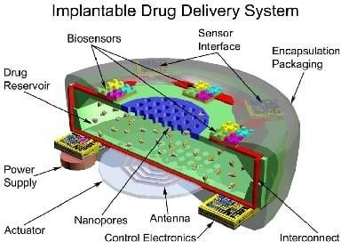availableness of implants are evident of immense growth in this sector .[3]

##### Figure 1:

**Illustration of an implantable drug device** Implantables are commonly selected for their property of extended use with constant release of medicament which will eventually promote the patient compliance.[4]

# IDEAL REQUIREMENTS

The ideal requirements of an implantable device are- Exhibit zero order or modulated drug release kinetics for constant delivery rate to minimise adverse effects. The dosing frequency shall be minimised for enhancing patient adherence and must fully discharge the medication during duration of therapy. Safe, stable and effective with good mechanical strength

Comfortable to extract by medical practitioner to suspend treatment in case of need

Easily sterilizable.

Free from any complicated process of insertion and hence adaptable. No possible serious complications.

Relatively inexpensive.

Non-toxic and non-carcinogenic.[5]

#### ADVANTAGES

* Targeted action.
* Helpful in delivery of drugs exhibiting short in vivo halflives.
* Improved Patient compliance.
* Reduced wastage of the drug.
* Improved efficiency.
* Minimum dose is required.
* Reduced side effects.
* Convenient therapy.
* Provide continuous sustained drug discharge over extended duration.

#### BENEFITS

* Convenience
* Improved drug delivery
* Compliance
* Potential for controlled release
* Flexibility

#### . DISADVANTAGES

* Interactions between host and implant.
* Insertion of big size implants requires surgical interventions which can be unpleasant.
* Treatment cannot be abruptly stopped.
* Possibility of inadequate release of drug.
* Predicted danger of device failure.
* Chances of adverse reactions due to the local high concentration of drug at site of implantation

#### LIMITATIONS

* Chances of toxicity.
* Painful.
* Dose tapering is not easy in case of need.
* Need for surgery to insert the device.[7]

# CLASSIFICATION OF IMPLANTABLE POLYMERIC DRUG DELIVERY DEVICE SYSTEMS

Polymers are the key elements in implantable systems as they provide extended and optimised drug release. They act as rate-limiting membrane in implant system and the choice of which must be done in keeping view of host biocompatibility and ease of sterilization. [8]

### Polymeric implants are classified into two main categori

###### Passive Polymeric Implants:

**Non-Biodegradable Systems:** These include matrix-controlled and reservoir-type devices. Common polymers used are polyurethanes, polyacrylates, silicones, and polyethylene vinyl acetate (PEVA).

**Matrix-Controlled:** The drug is uniformly distributed in the polymeric base, releasing it gradually. The release rate varies based on the amount of drug in the matrix.

**Reservoir Systems:** The drug is enclosed in a non-biodegradable, porous membrane. The membrane's properties influence the drug release rate. These implants are durable but need replacement after drug depletion to avoid complications.

**Example:** Norplant, used in contraception

**Biodegradable Systems:** These are preferred due to their ability to break down within the body, eliminating the need for removal surgery. Common polymers include polycaprolactone (PCL), polylactic acid (PLA), and polylactic-co-glycolic acid (PLGA). The drug release depends on the polymer's degradation, which can be influenced by body pH and temperature. Types: **Reservoir Systems**: Similar to non-biodegradable ones, but with an outer layer that degrades at a controlled rate, leaving the drug inside.

**Monolithic Systems**: The drug is uniformly dispersed in the polymer, which gradually erodes, providing a steady release.

Overall, biodegradable implants are more patient-friendly due to their ability to break down in the body, whereas non-biodegradable implants require replacement after the drug is used up.[9]

1. **Active or dynamic polymeric implants:** This kind of Implantables use definite propulsion in regulating discharge of medicine across the aid. Thus it offer advanced standard in drug discharging. They use some sorts of energy dependent methods for positive impulse to regulate discharge. The power origin can range different from osmotic pressure gradient to electromechanical forces.[12]

# IMPLANT PUMPS

Various drugs need exterior source to control amount and expulsion which is not achieved by biodegradable or non biodegradable systems except in magnetically modulated devices. The presence of sophisticated microsystems have made easy in designing pumps as little adequate that it can be implanted hypodermally to deliver drugs. Pumps discharge medications via pressure difference which is obtained by pressing the reserve either osmotically or mechanically resulting in flow of drug at optimised way. The pumps should possess desirable properties like non inflammatory, non-thrombogenic, non antigenic, non carcinogenic, convenience, long reserve and battery life, easily organisable, and can be inserted using local anaesthesia. It should also be simple to check the condition and working of the system. Hence, pump systems deliver drugs with ideal precision. Presently five groups of implant pumps are present. These pumps are infusion, osmotic, peristaltic, positive displacement and modulated discharge Microsystems.[1]

### Types of implant pumps:

***Infusion pumps***

Infusion pumps distribute the stored medicament inside the body with the help of a fluorinated hydrocarbon as energy source. They were earlier used in delivering insulin to diabetic people who need more than one dose in a day. This results in plasma peaks and troughs of insulin which may lead to diabetes induced complications. The pump contains disc-like container constructed

by lightweight bio composite titanium that comprises of foldaway that divides the container interiorly in two isolated compartments. The former compartment comprises of the energy source while the latter stores insulin. A gas forces the stored drug to expel via sift and course controller which gives optimised drug delivery at a mentioned temperature. It does not require external source of energy to drive the pump. A load of stored dose is released across a silicone rubber membrane that itself seals then moved across a Teflon layer when pump stock is refilled. The device is recharged by the force of the delivery drive that pressurises the device. Apart from application in insulin delivery, it is found useful in field of anticoagulation and chemotherapy. [3]

##### Osmotic pumps

Osmotic pumps are extensively prevalent of all implant types. These devices involve medication confined in a selectively permeable membrane that permits an inward movement of aqueous fluids in the device by simple osmosis. The built hydrostatic pressure forces invariable expulsion of medication through an orifice in membrane of system and whose swiftness in discharge can be altered by modifying the structure of semi-permeable membrane. However, the pace of discharge remains persistent or zero order till stored load is been exhausted .

##### Peristaltic pumps

Peristaltic pumps work by external source of power mainly by batteries and consist of cylindrically rotating apparatus. An exterior source modulates the flow of drug from it. This class of pumps are made of a rubber membrane of silicone and their duration of use is dependent on the battery as energy source used. These systems are quite expensive to be used in standard practice in market.[6]

#### MECHANISM OF DRUG DISCHARGE FROM IMPLANT DEVICES

There are primarily four ways of medication discharge through the implant devices – polymer disintegration, optimised expansion, osmosis and simple diffusion. Implants acting by optimised expansion, water absorption in device controls drug discharge which is generally inadequate over normal dispersion and thus contributes to a steady proportion of release. The disintegration of expanded matrix allows diffusion of drug mainly and improving the disintegrating capacity of

the matrix significantly enhances the efficiency of the implant. Osmosis mediated release and free diffusion techniques of drug release are appropriate for delivering drugs linearly where the quantity of liberated drug relies proportionally to square root of discharge duration. Osmosis is simple passage of aqueous molecules from an area of low concentration to a greater concentration via a semi permeable membrane which creates a pressure gradient. Diffusion worksby process in which solute moves voluntary in all areas to saturate chemical composition. The mobile substances are called diffusants and a membrane through which diffusants travels is known as diffusional barrier. The concentration gradient is the impulsion for the release of medicament from system. However the discharge profile of drugs depends upon contents of delivery system which in turn relies on factors like inhibition, osmotic pressure, and passive diffusion, and molecules stability, diffusion coefficient in polymer, drug content, and disintegration rate of polymer in vivo.[10]

#### MANUFACTURING METHODS OF IMPLANTS

##### Hot melt extrusion:

The drug is made to dissolve in an appropriate solvent to make a solution mixture. Then polymer is slowly incorporated and allowed to soak for 15-20 minutes. The swollen product is mixed thoroughly till it forms like dough and moved into ejection cylinder and elongated rod-like structure is obtained with use of showerhead. The product is made to dry overnight at ambient temperature and trimmed into required dimensions. Finally, it is dehydrated at 41 to obtain finished product. Extrusion can be carried out simultaneously which allows efficient output . Polymeric substances are required to be thermoplastic like poly amide aliphatic polyesters like PLA, PGA, and PLGA. It requires non solvents. However, this may result in degeneration of heat sensitive medications.[14]

##### Compaction:

The drug with polymer are diffused to make a suspension and subjected to lyophilization to produce a cake. It is further exposed to compaction to derive an implant by Carver hydraulic machine with a force of a metric ton. It offers advantage of no usage of heating and solvents thus ideally compatible for designing implants that embody thermo labile matter notably proteinaceous content. These implantables show a quick release profile

which necessitates optimisation by layering them. Additionally, implants produced have asymmetrical appearance having numerous cavities that can further contribute in unsteady discharge. [15]

##### Moulding:

The polymeric material is subjected to heating then incorporated in form of a mould followed by solidification. A decrease occurs in relative molecular mass of the polymers due to high heat applied. Molecular mass as well as dispers ability may be lowered using different ways and is furthermore amplified by this method. Due to which, these types of implantables disintegrated earlier as compared to factory-made mistreatment injections moulding

##### 3D Printing:

It is an inexpensive, consistent and versatile procedure and can be useful in future especially in quick manufacture of standard units for investigatory purposes. However, it is not used in mass production but its suitability progressed in 2015 when FDA approved one such material. This technique is mainly applied in creating prostheses and implants used in dentistry and orthopaedics.[13,14]

**EVALUATION PARAMETERS OF IMPLANTS** : Various parameters are implemented in the evaluation of implants after manufacture by any appropriate method. These are as follows

**A. Shape and size**: The size of an implant is verified using Vernier Callipers under light

##### B. Uniform Thickness:

The individual thickness of separate implants as well as the variations among them is determined by using Vernier Callipers. At least three specimens must be determined and average value is found out.

##### C. Uniform Weight:

The aim of this test is to calculate the uniform weight of each implant. The test is performed by random selection of twenty implants and weighing them separately. Mean weight is obtained. From the results, two implants must not weigh more than the mean weight and none of them must have twofold value of mean.36 D. Swelling Index: A specimen is placed in swelling

solution of phosphate buffer pH 7 for an hour and the weight is estimated. The remaining solution is cautiously removed by gently cleaning with dry sheet. The magnitude of swelling for every unit at any instant is determined by given formula:

###### swelling index = w2-w1/w1 x 100

Where, W2 and W1 represent the specimen’s mass at specified instant and in dried form, correspondingly. E. In-vitro dissolution profile: In-vitro dissolution profile of the implantt is crucial in estimation of release and the stability of drug. Dissolution medium is taken in a container while optimal conditions and RPM are fixed. The implant is placed in the vessel and the paddle is rotated. The samples are taken out after specific time intervals. The samples are thereafter examined by UV visible spectrophotometry at a particular wavelength. The procedure is repeated for at least three observations and the average value is noted. Stability testing: This test is done to detect disparities in standard of drug accompanied by time and storage characteristics like temperature, moisture, light, shelf life, etc.

##### G. Interaction analysis between polymer and drug :

Implant containing drug is analyzed using FTIR for finding suitability of drug with other formulation components and possibility of such interactions.[11,15]

#### THERAPEUTIC APPLICATIONS OF IDDS

##### Contraception:

Implants are widely used in contraceptive purposes. Norplant is a type of implant placed sub-dermally intended for sustained discharge of levonorgestrel (used in contraception). It comprises of 6 silicon membrane units, every one having microgram of drug. The capsule release 70 mcg daily in initial three months and further reduction in release to 30 mcg daily for around 800 days and offer constant release rate for five years. Another example includes Progestasert which is an intrauterine implant made of ethylene vinyl acetate copolymer. This device is used for 3-6 months and can be removed for a week in a month at time of menstrual period.[9]

##### Ocular use:

Membrane controlled devices, silicone devices, infusion devices and different implantable devices are popularly used to deliver drugs for prolonged ocular use. Ocusert is a classic example of membrane controlled device containing a pilocarpin with alginate inside medication reserve enclosed with ethylene vinyl acetate membrane. This device provides outburst of drug initially then follows zero order release profile of drug at 20-40 milligrams hourly for weekly period. It extends good management of intraocular pressure (IOP) with insignificant adverse outcomes and is well cacepted in adults whereas poorly tolerated in elderly people.[5]

##### Cancer

Silicone rod implants are useful in administration of ethinyl estradiol and testosterone propionic acid in treatment of prostate adenocarcinoma. Lupron depot offers release of leuprolide acetate for a month, which is structurally similar to gonadotropin-releasing hormone (GnRH). Zoladex depot unleashes go serelin acetate from a biodegradable rod for one month and is used to treat prostate adenocarcinoma.

##### Narcotic antagonism:

Long term narcotic antagonism is provided by implantable device of naltrexone hydrochloride. It liberates its base from hydrochloride or palmitic acid salt and is available in different polymers and formulations.

##### Other uses:

Insulin preparations are widely administered via biofeedback operated implantable devices in which drug is released based on pharmacological requirements of body at a specified instance.[12] [15]

#### EXAMPLES

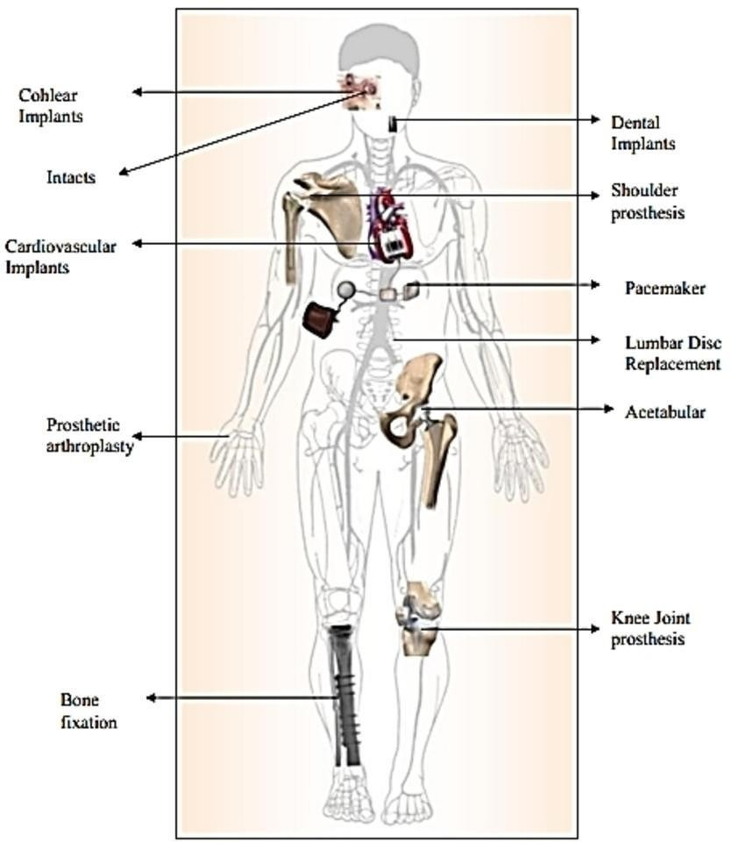

Fig 2: Implants of all over body

BRAIN IMPLANT

Recent advances in brain implants are rapidly transforming the treatment landscape for neurological and psychiatric conditions. In 2023, significant progress was made with Neuralink launching its first clinical trial for paralyzed patients and Precision Neuroscience receiving FDA breakthrough designation for accelerated trials. These developments are opening new possibilities for restoring lost abilities and addressing psychiatric disorders.[16]

##### Restoring Abilities

Brain implants are currently used to manage epilepsy, Parkinson’s disease, and obsessive- compulsive disorder (OCD). The next frontier includes restoring movement, speech, and vision. Researchers like Bradley Greger are optimistic about the potential for these devices to achieve such restorations, highlighting advancements in electrode technology and engineering that promise enhanced functionality and durability.

Startups such as Neuralink and Precision Neuroscience, alongside established players like Blackrock Neurotech, are pioneering new methods. Precision Neuroscience's non-penetrating brain-computer interface (BCI) uses thin film electrodes to record and stimulate the brain at a fine scale, minimizing inflammation and potentially offering broader coverage of the cortex. [17]

##### Advances in Deep Brain Stimulation (DBS)

Deep brain stimulation continues to be a powerful tool for various conditions. NeuroPace’s device now provides real-time brain activity data, improving our understanding of conditions like depression. Helen Mayberg's research into DBS for treatment-resistant depression has shown promising results, including potential structural changes in brain circuits.

New approaches to DBS, such as closed-loop stimulation for OCD, are enhancing treatment by responding directly to brain activity. Casey Halpern’s preclinical trials have demonstrated how targeted stimulation can alleviate symptoms linked to compulsive behaviors and other disorders, with potential applications extending to eating disorders and addiction.

##### Leveraging Data for Broader Insights

Brain implants not only offer direct patient benefits but also generate valuable data for neuroscience. This data could lead to new markers for health indicators and improve our understanding of brain function in different states. Researchers hope these advancements will alleviate concerns about brain implants and underscore their potential to offer life-changing benefits.

Overall, the rapid evolution of brain implants promises significant strides in treating neurological and psychiatric conditions, with the potential to profoundly impact patient care and scientific understanding.[16,17]

**BREAST IMPLANT**

A **Breast implant** is a [prosthesis](https://en.wikipedia.org/wiki/Prosthesis) used to change the size, shape, and contour of a person's [breast.](https://en.wikipedia.org/wiki/Breast) In reconstructive [plastic surgery,](https://en.wikipedia.org/wiki/Plastic_surgery) breast implants can be placed to restore a natural looking breast following a [mastectomy,](https://en.wikipedia.org/wiki/Mastectomy) to correct [congenital defects](https://en.wikipedia.org/wiki/Congenital_defect) and [deformities](https://en.wikipedia.org/wiki/Congenital_abnormality) of the chest wall or, cosmetically, to enlarge the appearance of the breast through [breast augmentation](https://en.wikipedia.org/wiki/Breast_augmentation) [surgery.](https://en.wikipedia.org/wiki/Breast_augmentation) Complications of implants may include [breast pain,](https://en.wikipedia.org/wiki/Breast_pain) rashes, skin changes, infection, rupture, cosmetic changes to the breasts such as asymmetry and hardness, and a fluid collection around the breast. A rare complication associated with textured surfaced implants and polyurethane foam-covered implants is a type of lymphoma (cancer of the immune system) known as breast implant-associated anaplastic large-cell lymphoma (BIA-ALCL). [18]There are four general types of breast implants, defined by their filler material: saline solution, silicone gel, structured and composite filler. The saline implant has an [elastomer](https://en.wikipedia.org/wiki/Elastomer) [silicone](https://en.wikipedia.org/wiki/Elastomer) shell filled with sterile [saline](https://en.wikipedia.org/wiki/Saline_(medicine)) [solution](https://en.wikipedia.org/wiki/Saline_(medicine)) during surgery; the silicone implant has an elastomer silicone shell pre- filled with viscous [silicone](https://en.wikipedia.org/wiki/Silicone) gel; structured implants use nested elastomer silicone shells and two saline-filled lumen; and the alternative composition implants featured miscellaneous fillers, such as hydrogel, [soy oil](https://en.wikipedia.org/wiki/Soy) or [polypropylene string.](https://en.wikipedia.org/wiki/String_breast_implant)[citation needed]In surgical practice, for the reconstruction of a breast, the [tissue expander](https://en.wikipedia.org/wiki/Tissue_expansion) device is a temporary breast prosthesis used to form and establish an implant pocket for the future permanent breast implant. For the correction

of male breast defects and deformities, the pectoral implant is the breast prosthesis used for the reconstruction and the aesthetic repair of a man's chest wall (see: [gynecomastia](https://en.wikipedia.org/wiki/Gynecomastia) and [mastopexy](https://en.wikipedia.org/wiki/Mastopexy))[19]

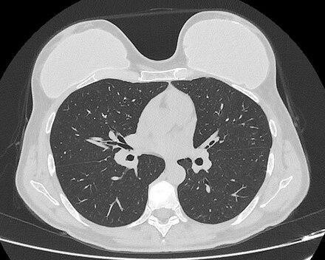

Fig 3: Breast implant

#### USES

[Computed tomography](https://en.wikipedia.org/wiki/Computed_tomography) of a woman with breast implants

A [mammoplasty](https://en.wikipedia.org/wiki/Mammoplasty) procedure for the placement of breast implant devices has three purposes:

primary reconstruction: the replacement of breast tissues damaged by trauma ([blunt](https://en.wikipedia.org/wiki/Blunt_trauma), [penetrating,](https://en.wikipedia.org/wiki/Penetrating_trauma) [blast](https://en.wikipedia.org/wiki/Blast_injury)), disease ([breast cancer](https://en.wikipedia.org/wiki/Breast_cancer)), and failed anatomic development ([tuberous](https://en.wikipedia.org/wiki/Tuberous_breast_deformity) [breast deformity](https://en.wikipedia.org/wiki/Tuberous_breast_deformity)).revision and reconstruction: to revise (correct) the outcome of a previous breast reconstruction surgery.

primary augmentation: to aesthetically [augment](https://en.wikipedia.org/wiki/Breast_augmentation) the size, form, and feel of the breasts.

The [operating room](https://en.wikipedia.org/wiki/Operating_room) time of post–[mastectomy](https://en.wikipedia.org/wiki/Mastectomy) [breast reconstruction,](https://en.wikipedia.org/wiki/Mastectomy) and of [breast](https://en.wikipedia.org/wiki/Breast_augmentation) [augmentation](https://en.wikipedia.org/wiki/Breast_augmentation) surgery is determined by the procedure employed, the type of incisions, the breast implant (type and materials), and the pectoral locale of the implant pocket.

Recent research has indicated that mammograms should not be done with any greater frequency than that used in normal procedure in patients undergoing breast surgery, including breast implant, augmentation, mastopexy, and breast reduction. [16,17]

## COCHLEAR IMPLANT (CI)

A **Cochlear implant** (**CI**) is a surgically implanted [neuro prosthesis](https://en.wikipedia.org/wiki/Neuroprosthetics) that provides a person who has moderate-to-profound [sensorineural hearing loss](https://en.wikipedia.org/wiki/Sensorineural_hearing_loss) with sound perception. With the help of therapy, cochlear implants may allow for improved speech understanding in both quiet and noisy environments. A CI bypasses acoustic hearing by direct electrical stimulation of the auditory nerve. Through everyday listening and auditory training, cochlear implants allow both children and adults to learn to interpret those signals as speech and sound.[ 20]

The implant has two main components. The outside component is generally worn behind the ear, but could also be attached to clothing, for example, in young children. This component, the sound processor, contains microphones, electronics that include [digital signal processor](https://en.wikipedia.org/wiki/Digital_signal_processor) (DSP) chips, battery, and a coil that transmits a signal to the implant across the skin. The inside component, the actual implant, has a coil to receive signals, electronics, and an array of [electrodes](https://en.wikipedia.org/wiki/Electrode) which is placed into the [cochlea,](https://en.wikipedia.org/wiki/Cochlea) which stimulate the [cochlear nerve.](https://en.wikipedia.org/wiki/Cochlear_nerve)[21] The surgical procedure is performed under [general anesthesia.](https://en.wikipedia.org/wiki/General_anesthesia) Surgical risks are minimal and most individuals will undergo [outpatient surgery](https://en.wikipedia.org/wiki/Outpatient_surgery) and go home the same day. However, some individuals will experience [dizziness,](https://en.wikipedia.org/wiki/Dizziness) and on rare occasions, [tinnitus](https://en.wikipedia.org/wiki/Tinnitus) or facial nerve bruising.[20]

From the early days of implants in the 1970s and the 1980s, speech perception via an implant has steadily increased. More than 200,000 people in the [United States](https://en.wikipedia.org/wiki/United_States) had received a CI through 2019. Many users of modern implants gain reasonable to good hearing and speech perception skills post-implantation, especially when combined with lip reading. One of the challenges that remain with these implants is that hearing and speech understanding skills after implantation show a wide range of variation across individual implant users. Factors such as age of implantation, parental involvement and education level, duration and cause of hearing loss, how the implant is situated in the cochlea, the overall health of the cochlear nerve, and individual capabilities of re-learning are considered to contribute to this variation. [20,21]

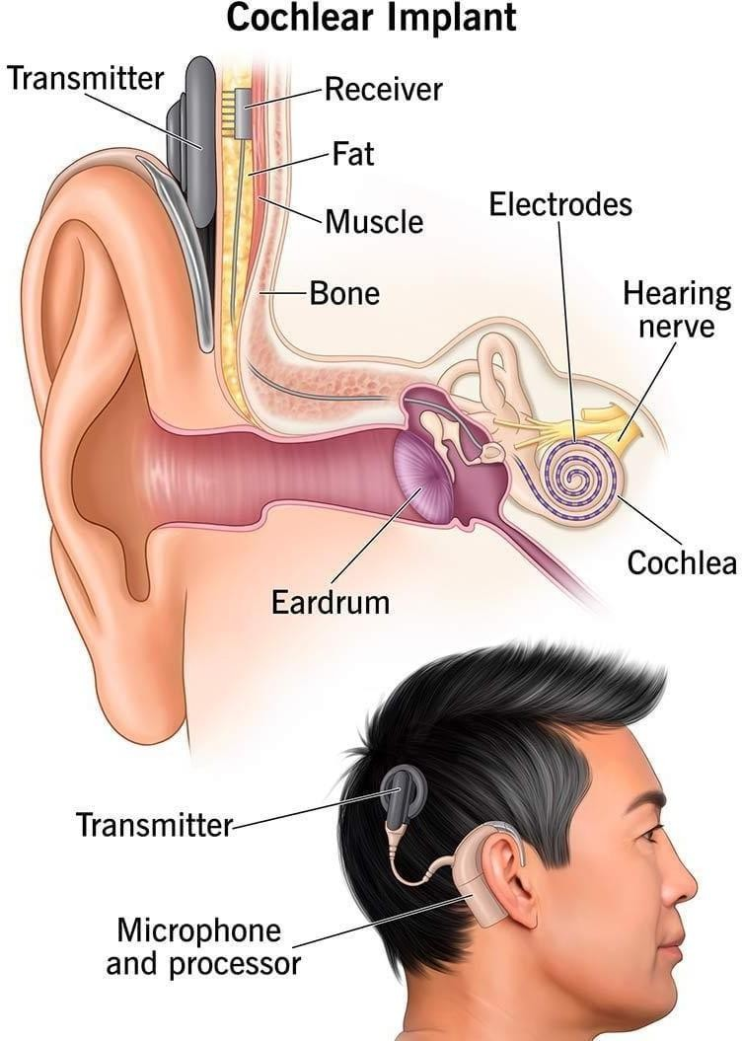

Fig 4 : Cochlear implant

##### DENTAL IMPLANT

A dental implant (also known as an endosseous implant or fixture) is a prosthesis that interfaces with the bone of the jaw or skull to support a dental prosthesis such as a crown, bridge, denture, or facial prosthesis or to act as an orthodontic anchor. The basis for modern dental implants is a biological process called osseointegration, in which materials such as titanium or zirconia form an intimate bond to the bone. The implant fixture is first placed so that it is likely to osseointegrate, then a dental prosthetic is added. A variable amount of healing time is required for osseointegration before either the dental prosthetic (a tooth, bridge, or denture) is attached to the implant or an abutment is placed which will hold a dental prosthetic or crown. [23]

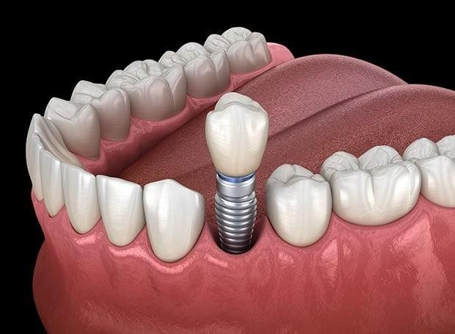

Figure 5: Dental implant 3d illlusion

Success or failure of implants depends primarily on the thickness and health of the bone and gingival tissues that surround the implant, but also on the health of the person receiving the treatment and drugs which affect the chances of osseointegration. The amount of stress that will be put on the implant and fixture during normal function is also evaluated. Planning the position and number of implants is key to the long-term health of the prosthetic since biomechanical forces created during chewing can be significant.[22] The position of implants is determined by the position and angle of adjacent teeth, by lab simulations or by using computed tomography with CAD/CAM simulations and surgical guides called stents. The prerequisites for long-term success of osseointegrated dental implants are healthy bone and gingiva. Since both can atrophy after tooth extraction, pre-prosthetic procedures such as sinus lifts or gingival grafts are sometimes required to recreate ideal bone and gingiva. The final prosthetic can be either fixed, where a person cannot remove the denture or teeth from their mouth, or removable, where they can remove the prosthetic. [22,23] In each case an abutment is attached to the implant fixture. Where the prosthetic is fixed, the crown, bridge or denture is fixed to the abutment either with lag screws or with dental cement. Where the prosthetic is removable, a corresponding adapter is

placed in the prosthetic so that the two pieces can be secured together. The risks and complications related to implant therapy divide into those that occur during surgery (such as excessive bleeding or nerve injury, inadequate primary stability), those that occur in the first six months (such as infection and failure to osseointegrate) and those that occur long-term (such as peri-implantitis and mechanical failures).[23] In the presence of healthy tissues, a well-integrated implant with appropriate biomechanical loads can have 5-year plus survival rates from 93 to 98 percentage and 10- to-15-year lifespans for the prosthetic teeth. Long-term studies show a 16- to 20- year success (implants surviving without complications or revisions) between 52% and 76%, with complications occurring up to 48% of the time. Artificial intelligence is relevant as the basis for clinical decision support systems at the present time. Intelligent systems are used as an aid in determining the success rate of implants. [22,23]

#### RETINAL IMPLANT

A retinal implant is a visual prosthesis for restoration of sight to patients blinded by retinal degeneration. The system is meant to partially restore useful vision to those who have lost their photoreceptors due to retinal diseases such as retinitis pigmentosa (RP) or age-related macular degeneration (AMD). Retinal implants are being developed by a number of private companies and research institutions, and three types are in clinical trials: epiretinal (on the retina), subretinal (behind the retina), and suprachoroidal (between the choroid and the sclera). The implants introduce visual information into the retina by electrically stimulating the surviving retinal neurons. So far, elicited percepts had rather low resolution, and may be suitable for light perception and recognition of simple objects. [24]

**Recent Developments**:

* Ongoing improvements in electrode technology and resolution.
* Research into gene therapies and stem cell-based approaches to complement retinal implant for more effective long-term outcomes.

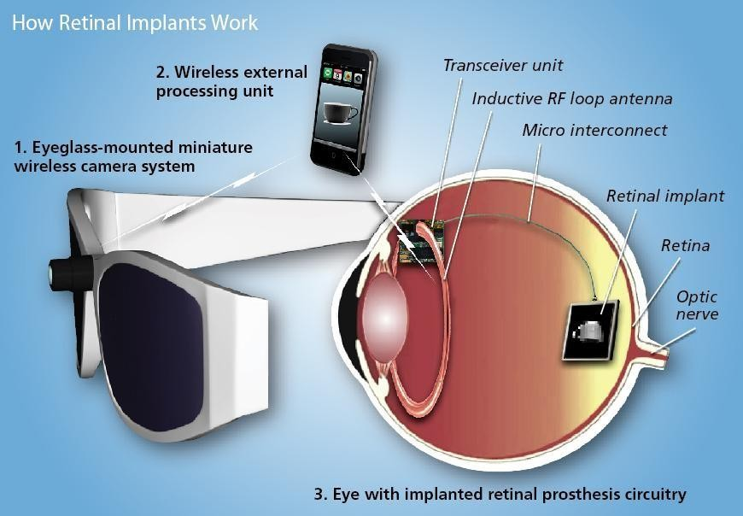

Fig 6: Retinal implant

##### Types of Retinal Implants

1. **Epiretinal Implants**

Placement: Positioned on the internal surface of the retina.

* + Function: Directly stimulate ganglion cells, bypassing other retinal layers.

##### Subretinal Implants

* + Placement: Located between the outer retinal layer and the retinal pigment epithelium.

##### Design Principles of Epiretinal Implants

1. **Stimulation Method**
   * The array of electrodes is placed above the nerve fiber layer.
   * Directly stimulates ganglion cells for visual signal transmission.

##### Stabilization

* + Utilizes micro tacks to secure the electrode array to the retina.
  + Tacks penetrate into the sclera to maintain position.

##### External Hardware

* + Typically involves an external video camera to capture visual information for processing.[25]

##### Types eyeglasses

acquires images and transmits processed video information to the stimulating electrodes via wireless telemetry. An external transmitter is also required to provide power to the implant via radio-frequency induction coils or infrared lasers. The real-time image processing involves reducing the resolution, enhancing contrast, detecting the edges in the image and converting it into a spatio-temporal pattern of stimulation delivered to the electrode array on the retina.The majority of electronics can be incorporated into the associated external components, allowing for a smaller implant and simpler upgrades without additional surgery. [24] The external electronics provides full control over the image processing for each patient. Advantages Epiretinal implants directly stimulate the retinal ganglion cells, thereby bypassing all other retinal layers. Therefore, in principle, epiretinal implants could provide visual perception to individuals even if all other retinal layers have been damaged. Disadvantages Since the nerve fiber layer has similar stimulation threshold to that of the retinal ganglion cells, axons passing under the epiretinal electrodes are stimulated, creating arcuate percepts, and thereby distorting the retinotopic map. So far, none of the epiretinal implants had light-sensitive pixels, and hence they rely on external camera for capturing the visual information. Therefore, unlike natural vision, eye movements do not shift the transmitted image on the retina, which creates a perception of the moving object when person with such an implant changes the direction of gaze. Therefore, patients with such implants are asked to not move their eyes, but rather scan the visual field with their head. Additionally, encoding visual information at the ganglion cell layer requires very sophisticated image processing techniques in order to account for various types of the retinal ganglion cells encoding different features of the image.[24 ,25]

#### PROSTHESIS

In medicine, a prosthesis (pl.: prostheses; from Ancient Greek: πρόσθεσις, romanized: prósthesis,lit. 'addition, application, attachment')[26] or a prosthetic implant, is an artificial device that replaces a missing body part, which may be lost through physical trauma, disease, or a condition present at birth (congenital disorder). Prostheses are intended to restore the normal functions of the missing body part. Amputee rehabilitation is primarily coordinated by a physiatrist as part of an inter-disciplinary team consisting of physiatrists, prosthetists, nurses, physical therapists, and occupational therapists. Prostheses can be created by hand or with computer-aided design (CAD),a software interface that helps creators design and analyze the creation with computer-generated 2-D and 3-D graphics as well as analysis and optimization

Tools A man with a lower-extremity[27] T**ypes of prostheses**

##### Upper Limb Prostheses

* + Transradial Prosthesis: Designed for individuals with limb loss below the elbow.

##### Types:

* + - **Aesthetic Functional Device:** Focuses on appearance with limited function.
    - **Myoelectric Device**: Controlled by electrical signals from the user's muscles.
    - **Body-Powered Device:** Operated through mechanical linkage with body movement.
    - **Activity-Specific Device:** Tailored for specific activities or sports.

##### 2.Craniofacial Prostheses

* + **Intra-oral Prostheses:** Used within the mouth.

##### Types:

* + - **Dentures:** Replace missing teeth.
    - **Obturators**: Close a defect in the palate.
    - **Dental Implants:** Surgically placed for tooth replacement.
    - **Extra-oral Prostheses:** Used outside the mouth.
    - **Hemifacial Prostheses:** Replace parts of the face.
    - **Auricular Prostheses:** Replacement for the ear.
    - **Nasal Prostheses:** Replacement for the nose.
    - **Orbital Prostheses:** Replacement for the eye socket.
    - **Ocular Prostheses: A**rtificial eye replacement.

##### 3.Neck Prostheses

* + **Larynx Substitutes:** Used for individuals who have lost their voice box.
  + **Trachea Replacements:** Substitute for the windpipe.

**4.Somato Prostheses**

* + **Torso Prostheses:**
  + **Breast Prostheses:**
  + **Single or Bilateral:** For one or both breasts.
  + **Full Breast Devices:** Replace entire breast volume.
  + **Nipple Prostheses:** Specifically designed to replace the nipple.

##### 5.Penile Prostheses

* + **Indications:**
    - Treatment of erectile dysfunction.
    - Correction of penile deformity.
    - Phalloplasty in cisgender men.
    - Construction of a new penis in female-to-male gender reassignment surgeries.[26,27]

**Limb prostheses**

Limb prostheses include both upper- and lower-extremity prostheses. Upper-extremity prostheses are used at varying levels of amputation: forequarter, shoulder disarticulation, trans humeral prosthesis, elbow disarticulation, transradial prosthesis, wrist disarticulation, full hand, partial hand, finger, partial finger. A transradial prosthesis is an artificial limb that replaces an arm missing below the elbow .Upper limb prostheses can be categorized in three main categories: Passive devices, Body Powered devices, and Externally Powered (myoelectric) devices,[29] Passive devices can either be passive hands, mainly used for cosmetic purposes, or passive tools, mainly used for specific activities An extensive overview and classification of passive devices can be found in aliterature review by Maat et.al. A passive device can be static, meaning the device has no movable parts, or it can be adjustable, meaning its configuration can be adjusted (e.g. adjustable hand opening). Despite the absence of active grasping, passive devices are very useful in bimanual tasks that require fixation or support of an object, or for gesticulation in social interaction. According to scientific data a third of the upper limb amputees worldwide use a passive prosthetic hand. Body Powered or cable-operated limbs work by attaching a harness and cable aroundthe opposite shoulder of the damaged arm. A recent body-powered approach has explored the utilization of theuser's breathing to power and control the prosthetic hand to help eliminate actuation cable andharness. The third category of available prosthetic devices comprises myoelectric arms.[28] This particular class of devices distinguishes itself from the previous ones due to the inclusion of a battery system. This battery serves the dual purpose of providing energy for both actuation and sensing components. While actuation predominantly relies on motor or pneumatic systems, a variety of solutions have been explored for capturing

muscle activity, including techniques such as Electromyography, Sonomyography, Myokinetic, and others. These methods function by detecting the minute electrical currents generated by contracted muscles during upper arm movement, typically employing electrodes or other suitable tools. Subsequently, these acquired signals are converted into gripping patterns or postures that the artificial hand will then execute. In the prosthetics industry, a trans-radial prosthetic arm is often referred to as a "BE" or below elbow prosthesis. Lower- extremity prostheses provide replacements at varying levels of amputation. These include hip disarticulation, transfemoral prosthesis, knee disarticulation, transtibial prosthesis, Syme's amputation, foot, partial foot, and toe. The two main subcategories of lower extremity prosthetic devices are trans-tibial (any amputation transecting the tibia bone or a congenital anomaly resulting in a tibial deficiency) and trans- femoral (any amputation transecting the femur bone or a congenital anomaly resulting in a femoral deficiency).A transfemoral prosthesis is an artificial limb that replaces a leg missing above the knee. Transfemoral amputees can have a very difficult time regaining normal movement. In general, a transfemoral amputee must use approximately 80% more energy to walk than a person with two whole legs.] This is due to the complexities in movement associated with the knee. In newer and more improved designs, hydraulics, carbon fiber, mechanical linkages, motors, computer microprocessors, and innovative combinations of these technologies are employed to give more control to the user. In the prosthetics industry, a trans-femoral prosthetic leg is often referred to as an "AK" or above the knee prosthesis.A transtibial prosthesis is an artificial limb that replaces a leg missing below the knee. [30]A transtibial amputee is usually able to regain normal movement more readily than someone with a transfemoral amputation, due in large part to retaining the knee, which allows for easier movement. Lower extremity prosthetics describe artificially replaced limbs located at the hip level or lower. In the prosthetics industry, a trans-tibial prosthetic leg is often referred to as a "BK" or belowthe knee prosthesis .Prostheses are manufactured and fit by clinical prosthetists. Prosthetists are healthcare professionals responsible for making, fitting, and adjusting prostheses and for lower limb prostheses will assess both gait and prosthetic alignment. Once a prosthesis has been fit and adjusted by a prosthetist, a rehabilitation physiotherapist (called physical therapist in America) will help teach a new prosthetic user to walk with a leg prosthesis. To do so, the physical therapist may provide verbal instructions and may also help guide the person using touch or tactile cues. This maybe done in a clinic or home. There is some research suggesting that such training in the home maybe more successful if the treatment includes the use of a treadmill. Using a treadmill, along with the physical therapy treatment, helps the person to experience many of the challenges of walking with a prosthesis. In the United Kingdom, 75% of lower limb amputations are performed due to inadequate circulation(dysvascularity). This condition is often associated with many other medical conditions (com orbidities) including diabetes and heart disease that may make it a challenge to recover and use a prosthetic limb to regain mobility and independence. For people who have inadequate circulation and have lost a lower limb, there is insufficient evidence due to a

lack of research, to inform them regarding their choice of prosthetic rehabitatin enhances.[28

,29,30].

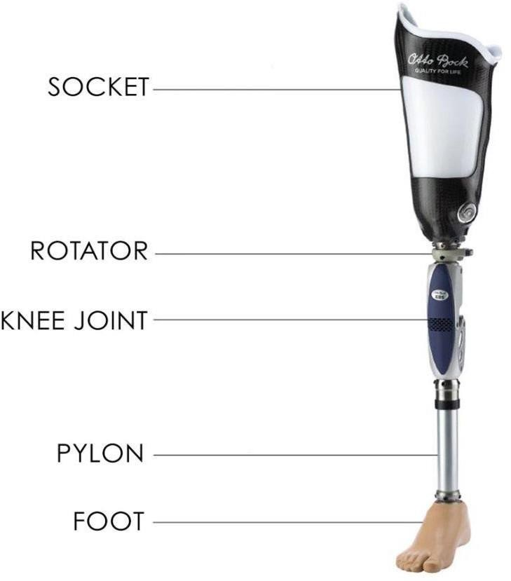

Fig7:Limb prosthesis

Lower extremity prostheses are often categorized by the level of amputation or after the name of a surgeon

Transfemoral (Above-knee) Transtibial (Below-knee)

Ankle disarticulation (more commonly known as Syme's amputation Knee disarticulation (also see knee replacement)

Hip disarticulation, (also see hip replacement) Hemi-pelvictomy

Partial foot amputations (Pirogoff, Talo-Navicular and Calcaneo-cuboid (Chopart), Tarso metatarsal (Lisfranc), Trans-metatarsal, Metatarsal-phalangeal, Ray amputations, toeamputations).

Van Nes rotationplasty

##### Prosthetic raw materials

Prosthetic are made lightweight for better convenience for the amputee. Some of these materials include:

##### Plastics:

Polyethylene Polypropylene Acrylics FrPolyurethane

##### Wood (early prosthetics)

**Rubber (early prosthetics) Lightweight metals:**

Titanium Aluminum

##### Composites:

Carbon fiber reinforced polymers

Wheeled prostheses have also been used extensively in the rehabilitation of injured domestic animals, including dogs, cats, pigs, rabbits, and turtles. [30,31]

## Current technology and manufacturing

Over the years, there have been advancements in artificial limbs. New plastics and other materials,such as carbon fiber, have allowed artificial limbs to be stronger and lighter, limiting the amount of extra energy necessary to operate the limb. This is especially important for trans- femoral amputees. Additional materials have allowed artificial limbs to look much more realistic, which is important totrans-radial and transhumeral amputees because they are more likely to have the artificial limb exposed.[31]

##### The four main types of knee replacement surgery are:

total knee replacement.

unicompartmental (partial) knee replacement. kneecap replacement (patellofemoral arthroplasty) complex or revision knee replacemen [32]

##### Total knee replacement

Knee replacement, also known as knee arthroplasty, is a surgical procedure to replace theweight- bearing surfaces of the knee joint to relieve pain and disability, most commonly offered when joint pain is not diminished by conservative sources.[32] It may also be performed for other knee diseases, such as rheumatoid arthritis. In patients with severe deformity from advanced rheumatoid arthritis, trauma, or long-standing osteoarthritis, the surgery may be more complicated and carry higher risk. Osteoporosis does not typically cause knee pain, deformity, or inflammation, and is not a reason to perform knee replacement. Knee replacement surgery can be performed as a partial or a total knee replacement. In general, the surgery consists of replacing the diseased or damaged joint surfaces of the knee with metal and plastic components shaped to allow continued motion of the knee. [33]

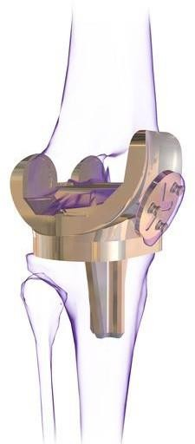

Fig 8 : Total knee replacement

Other names :Knee arthroplasty ICD-10-PCS :0SRD0JZ

ICD-9-CM :81.54 MeSH :D019645

MedlinePlus :002974

eMedicine :1250275

The operation typically involves substantial postoperative pain and includes vigorous physical rehabilitation. The recovery period may be 12 weeks or longer and may involve the use of mobility aids (e.g. walking frames, canes, crutches) to enable the patient's return to preoperative mobility. It is estimated that approximately 82% of total knee replacements will last 25 years. [ 33 ]

## Unicompartmental knee arthroplasty

Unicompartmental knee arthroplasty (UKA) is a surgical procedure used to relieve arthritis in one ofthe knee compartments in which the damaged parts of the knee are replaced. UKA surgery may reduce post-operative pain and have a shorter recovery period than a total kneereplacement procedure, particularly in people over 75 years of age. Moreover, UKAs may require a smaller incision, less tissue damage, and faster recovery times.[34]

In the United States, the procedure constitutes approximately 8% of knee arthroplasties. In comparisons with a more extensive surgical procedure called high tibial osteotomy, UKA has equal or better outcomes.[35]

### Advantages and Disadvantages of Partial Knee Replacement

Multiple studies show that most patients who are appropriate candidates for unicompartmental knee replacement have good results with this procedure.

* The advantages of partial knee replacement over total knee replacement include:
* Quicker recovery
* Less pain after surgery
* Less blood loss
* Lower risk of infection and blood clots

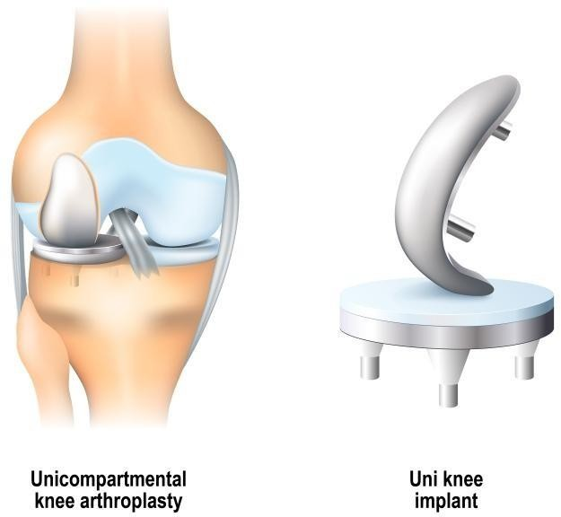

Fig 9:Unicompartmental knee arthroplasty

## Patellofemoral Arthroplasty

Patellofemoral arthroplasty (PFA) is a surgical procedure that replaces damaged cartilage in the knee with an artificial implant to treat pain and improve function.[36] It's used to treat isolated patellofemoral osteoarthritis (PFOA) in patients who don't have patellar malalignment or tibiofemoral chondromalacia. It Reduce pain, improve function, preserve bone and ligaments, and maintain or improve knee kinematics and Pain relief, improved mobility, reduced risk of injury .Improved short-term and midterm outcomes due to advancements in surgical technique, implant design, and patient selection.[36]

Your knee is divided into three major compartments:

* Medial compartment — the inside part of the knee
* Lateral compartment — the outside part of the knee
* Patellofemoral compartment — the front of the knee between the patella and femur

### Advantages of Patellofemoral Replacement

Potential advantages of patellofemoral replacement over total knee

replacement include:

* Less blood loss
* Smaller surgical incision/less surgical trauma
* Less pain and swelling
* Quicker recovery
* Decreased complications
* Increased knee function and activity

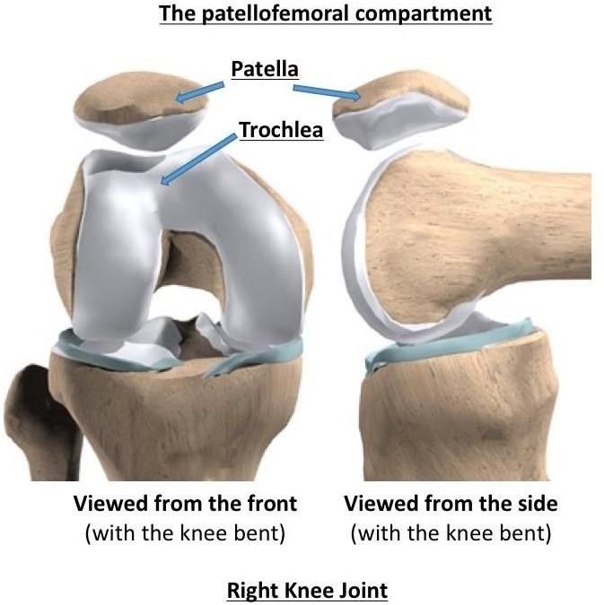

Fig 10 : Patellofemoral arthroplasty

## Revision Total Knee Replacement

Total knee replacement is one of the most successful procedures in all of medicine. In the vast majority of cases, it enables people to live richer, more active lives free of chronic knee pain. Over time, however, a knee replacement may fail for a variety of reasons. When this occurs, your knee can become painful and swollen. It may also feel stiff or unstable, making it difficult to perform your everyday activities. If your knee replacement fails, your doctor may recommend that you have a second surgery — revision total knee replacement. In this procedure, your doctor removes some or all of the parts of the original prosthesis and replaces them with new ones.

Although both procedures have the same goal — to relieve pain and improve function — revision surgery is different than primary total knee replacement. It is a longer, more complex procedure that requires extensive planning, and specialized implants and tools to achieve a good result.[36]

CONCLUSION

Implantable drug delivery systems offer a promising alternative to traditional drug administration by providing controlled, sustained release at therapeutic concentrations. These systems are advancing rapidly, with a focus on improving the biocompatibility and biodegradability of materials, reducing toxicity, and optimizing drug release profiles. They offer several benefits, including reduced dosing frequency, better patient compliance, and improved drug efficacy, making them a cost-effective and patient-friendly option, especially for newer protein-based drugs unsuitable for oral delivery.Similarly, advancements in implant and prosthetic technologies have revolutionized medical care, offering innovative solutions across various fields such as brain implants, dental prostheses, and limb replacements. These technologies, using materials like carbon fiber and titanium, and enhanced by myoelectric control systems, have significantly improved functionality, comfort, and aesthetics. Knee replacements, one of the most successful procedures, continue to evolve with specialized options like unicompartmental and patellofemoral arthroplasty. These innovations not only restore lost function but also advance our understanding of human biology, promising even greater improvements in patient outcomes in the future.

#### REFERENCES

1.Danckwerts M, Fassihi A, Implantable Controlled Release Drug Delivery Systems: A Review, Drug Development and Industrial Pharmacy,1991; 17(11): 1465-1502. https://doi.org/10.3109/03639049109026629.

2.Ms. Aishwarya Sandip Ankaram, Ms Shubhangi Raosaheb Mali, Implantable Polymeric Drug Delivery Devices: Classification, Manufacture and Clinical Applications, International Journal of Research Publication and Reviews, 2022; 3(6): 3200-3205. https://ijrpr.com/uploads/V3ISSUE6/IJRPR5158.pdf.

3.Saettone MF, Salminen L, Ocular inserts for topical delivery,Advanced Drug Delivery Reviews, 1995; 16(1): 95-106.

https://doi.org/10.1016/0169-409X(95)00014-X.

4.PVA, PEVARajgor N, Patel M, bhaskar VH, implantable drug delivery systems: An overview, systemic reviews in pharmacy, 2011;2[2] 91-96.

https://faculty.ksu.edu.sa/sites/default/files/implantable_drug_delivery_systems_an_over

view.pdf. https://doi.org/10.1016/0169-409X(95)00014-X

5.Chien, Y. W., Lin, S, Optimization of treatment by applying programmable rate- controlled drug delivery technology, Clinical Pharmacokinetics, 2002; 41(15): 1267–1299.

https://doi.org/10.2165/00003088-200241150-00003.

6.Bhowmik, D., Pusupoleti, K. R. Duraivel, S. Kumar, K. S., Recent approaches in transdermal drug delivery system, The Pharma Innovation,2013; 2(3): 99-108. https:/[/www.thepharmajournal.com/vol](http://www.thepharmajournal.com/vol2Issue3/Issue_may_2013/3.pdf)2[Issue3/Issue_may_2013/3.pdf](http://www.thepharmajournal.com/vol2Issue3/Issue_may_2013/3.pdf) https://doi.org/10.2165/00003088-200241150-00003

7.Mohammad Zaki AJ., Satish K. Patil, Dheeraj T. Baviskar1,Dinesh K. Jain, Implantable Drug Delivery System: A Review; International Journal of PharmTech Research, 2012; 4(1): 280-292. https://sphinxsai.com/2012/pharm/PHARM/PT=40(280- 292)JM12.pdf

8.da Silva, G.R. Fialho, S.L. Siqueira, R.C. Jorge, R. Cunha, A.D, Implants as drug delivery devices for the treatment of eye diseases, Brazilian Journal of Pharmaceutical Sciences, 2010; 46(3):585-595.

https://doi.org/10.1590/S1984-82502010000300024

9.Dr. Aijaz A. Sheikh, Dr. Subhash V. Deshmane, Dr. Md. Rageeb,Md. Usman, Dr. Kailash R. Blyani. A Textbook of Novel Drug Delivery System. 2019 edition. Jalandhar: Pee Vee publication; 2019. P.77.

https://doi.org/10.2165/00003088-200241150-00003

10.Iaes L., Ignatius A, Development of new biodegradable implants, Der Chirurg, 2002; 73:990-996.

https://doi.org/10.1007/s00104-002-0543-0

11.Tian W., Mahmoudi M., Lhermusier T., Kiranmijyan S., Chen F., Torguson R., Suddath W.O., Satler L.F., Pichard A.D., Waksman R., The influence of advancing age on implantation of drug eluting stents, Catheterization and Cardiovascular Interventions, 2015; 88 :516-521

https://doi.org/10.1002/ccd.26333.

12.Preparation of implants ; “ pharma tips” available at:

[http://www.pharmatips.in/Articles/Pharmaceutics/Preparation-Of-Implants.aspx.](http://www.pharmatips.in/Articles/Pharmaceutics/Preparation-Of-Implants.aspx) Accessed July 4, 2011.

13.Kumar A., Pillai J. Nanostructures for the Engineering of Cells,Tissues and Organs. Elsevier. Implantable drug delivery systems, 2018: P. 473–511. https://doi.org/10.1002/ccd.26333

14.Bourges, J. L., Bloquel, C., Thomas, A.; Froussart, F., Bochot, A.,Azan, F., Gurny, R.; BenEzra, D., Behar-Cohen, Intraocular Implants for Extended Drug Delivery: Therapeutic Applications, Advanced Drug Delivery Reviews, 2006; 58: 1182–1202. https://doi.org/10.1016/j.addr.2006.07.026

15.Wang X, Chen T, Yang Z, Wang W, Study on structural optimum design of implantable drug delivery micro-system, SimulationModelling Practice andTheory,2007; 15:47-56.

https://doi.org/10.1016/j.simpat.2006.09.017

16 . Krucoff, Max O.; Rahimpour, Shervin; Slutzky, Marc W.; Edgerton, V. Reggie; Turner, Dennis A. (2016-01-01). "Enhancing Nervous System Recovery through Neurobiologics, Neural Interface Training, and Neurorehabilitation". Frontiers in Neuroscience. 10: 584. doi:10.3389/fnins.2016.00584. ISSN 1662-4548. PMC 5186786.PMID 28082858.

17."Implantable Device that Blocks Brain Signals Shows Promise in Obesity". Medscape. Archived from the original on 2013-05-17. Retrieved 2013-08-25.

18.Loch-Wilkinson, Anna; Beath, Kenneth J; Magnusson, Mark R; Cooter, Rodney; Shaw, Karen; French, James; Vickery, Karen; Prince, H Miles; Deva, Anand K (2020-07- 13). "Breast Implant-Associated Anaplastic Large Cell Lymphoma in Australia: A Longitudinal Study of Implant and Other Related Risk Factors". Aesthetic Surgery Journal. 40 (8): 838–846. doi:10.1093/asj/sjz333. ISSN 1090-820X.

19.American Society of Plastic Surgeons (24 April 2014), "Five Things Physicians and Patients Should Question", Choosing Wisely: an initiative of the ABIM Foundation, American Society of Plastic Surgeons, archived from the original on 19 July 2014, retrieved 25 July 2014

20.Sweetow R, Palmer CV (July 2005). "Efficacy of individual auditory training in adults: a systematic review of the evidence". Journal of the American Academy of Audiology. 16 (7): 494–504. doi:10.3766/jaaa.16.7.9. PMID 16295236. NCBI NBK71453.

21.Naples JG, Ruckenstein MJ (February 2020). "Cochlear Implant". Otolaryngologic Clinics of North America. 53 (1): 87–102. doi:10.1016/j.otc.2019.09.004. PMID31677740. S2CID 207890377

22.Dental Materials | AMERICAN ELEMENTS ®". American Elements: The Materials Science Company. Retrieved 2024-02-14.

23.Papaspyridakos P, Mokti M, Chen CJ, Benic GI, Gallucci GO, Chronopoulos V (October 2014). "Implant and prosthodontic survival rates with implant fixed complete dental prostheses in the edentulous mandible after at least 5 years: a systematic review". Clinical Implant Dentistry and Related Research. 16 (5): 705–17. doi:10.1111/cid.12036. PMID 23311617

24.O. Foerster (1929). "Beitrage zur Pathophysiologie der Sehbahn und der Sehsphare". Journal für Psychologie und Neurologie. 39: 463–85.

25.G. Brindley; W. Lewin (1968). "The sensation produced by electrical stimulation of the visual cortex". Journal of Physiology. 196 (2): 479–93.

doi:10.1113/jphysiol.1968.sp008519. PMC 1351724. PMID 4871047.

26.Bowker, John H.; Michael, John W. (2002). Atlas of limb prosthetics: surgical, prosthetic, and rehabilitation principles. American Academy of Orthopaedic Surgeons (2nd ed.). St. Louis: Mosby Year Book. pp. 389, 413, 429, 479, 501, 535, 885. ISBN 978-0892032754.OCLC 54693136 (https://search.worldcat.org/oclc/54693136)

27.Söderberg, Bengt (2001). Partial foot amputations (2nd ed.). Sweden: Centre for Partial Foot Amputees.p.21.ISBN978-9163107566.OCLC152577368

(https://search.worldcat.org/oclc/1 52577368)

28.Maat, Bartjan; Smit, Gerwin; Plettenburg, Dick; Breedveld, Paul (1 March 2017). "Passive

prosthetic hands and tools: A literature review". Prosthetics and Orthotics International. 42 (1): 66–74. doi:10.1177/0309364617691622. PMC 5810914. PMID 28190380

29.Nagaraja, Vikranth H.; da Ponte Lopes, Jhonatan; Bergmann, Jeroen H. M. (September 2022).

"Reimagining Prosthetic Control: A Novel Body-Powered Prosthetic System for Simultaneous Control and Actuation". Prosthesis. 4 (3): 394–413. doi:10.3390/prosthesis4030032.

30.Nagaraja, Vikranth H.; Moulic, Soikat Ghosh; D’souza, Jennifer V.; Limesh, M.; Walters, Peter; Bergmann, Jeroen H. M. (December 2022). "A Novel Respiratory Control and Actuation System for Upper-Limb Prosthesis Users: Clinical Evaluation Study". IEEE Access. 10: 128764–128778.

31.M. Hutson, “This new surgical procedure could lead to lifelike prosthetic limbs,” Science, May 2017, doi: 10.1126/science.aan6912

32.Zhang WC, Xiao D (November 2020). "Efficacy of proprioceptive training on the recovery of total joint arthroplasty patients: a meta-analysis". Journal of Orthopaedic Surgery and Research. 15

(1): 505. doi:10.1186/s13018-020-01970-6. PMC 7640714. PMID 33143719.

33.Palmer SH (27 June 2012). "Total Knee Arthroplasty". Medscape Reference.

34.Ollivier M, Parratte S, Lunebourg A, Viehweger E, Argenson JN. The John Insall award: no functional benefit after unicompartmental knee arthroplasty performed with patient-specific instrumentation: a randomized trial. Clin Orthop Relat Res 2016;474:60–68. [DOI] [PMC free article] [PubMed] [Google Scholar]

35.Ng CTJ, Newman S, Harris S, Clarke S, Cobb J. Patient-specific instrumentation improves alignment of lateral unicompartmental knee replacements by novice surgeons. Int Orthop 2017;41:1379–1385. [DOI] [PubMed] [Google Scholar

36.American academy of aurthopedic https://orthoinfo.aaos.org/en/treatment/revision-total-knee-replacement/