# Autonomous Vehicle Control, Part XI: Unmanned Air Vehicle (UAV) Velocity Control Using I-First Order, Feedback Pd And First-Order Compensators Compared With A Pi Controller

**Galal Ali Hassaan**

Emeritus Professor, Department of Mechanical Design and Production, Faculty of Engineering, Cairo University, Cairo, Egypt

**ABSTRACT**

This is the 11th part in a series of research papers investigating autonomous vehicle control. The paper proposes three compensators from the second generation of control compensators handled by the author since 2014 to control an UAV velocity: I-first order, feedback PD and feedback first order. The compensators are tuned for the control of the UAV velocity using a combination of three tuning techniques. The effectiveness of using the proposed compensators is evaluated through comparison with the use of a conventional PI controller from the first generation of PID controllers and the best compensator/controller for the purpose of UAV velocity control is assigned.

**Keywords:** UAV velocity control, I-first order compensator, Feedback PD compensator, Feedback first order compensator, PI controller, compensator tuning

1. **INTRODUCTION**

UAV is the latest technology application in military and civil applications and subjected to intensive research regarding its design and control. The whole world now is struggling to keep the best styles with most sophisticated control. This paper presents three compensators from the second generation of control compensators introduced by the author in 2014 and onwards to control one of the variables of an UAV, the forward velocity. First of all I present a short survey for the efforts paid by researchers to control this important engineering application, the UAV.

Ren and Beard (2004) investigated the dynamic problem of constrained nonlinear trajectory tracking control for UAV’s with account for heading rate and velocity input constraints. They proposed a control Lyapunov function approach applied to simulation scenario where the UAV was assigned to transition several targets with multiple dynamic threats present [1]. Simpson, Jacob and Smith (2006) studied the testing of inflatable wings for UAV’s covering design and bench tunnel testing. They investigated the mechanical manipulators of the wing shape on a test vehicle as effective means of roll control [2].

Zhang, Zhu and Zhou (2010) proposed a reference model based state predictive algorithm to solve the transport delay problem. They designed a pitch angle control loop employing the proposed algorithm. They claimed that simulation results indicated the effectiveness of their algorithm in decreasing the effect of time delay [3]. Colunga, Guerrero, Escarere and Lozaro (2012) considered the development of a simplified model of an UAV formed by a minimum number of states and inputs and used it in the study of control schemes for roll, pitch and yaw angles. They used first order models for servo and variable pitch propeller, first order + integrator for the roll angle dynamics, 0/2 second order model for the pitch angle and first order + integrator for the yaw angle of the UAV [4].

Gau, Wang and Hou (2015) designed an algorithm for a UAV velocity controller based on improved PID. They could remove deviation and achieve fast time response and small maximum overshoot [5]. Pan et al. (2018) proposed a dynamic speed control algorithm for UAV’s to maximize the data collection efficiency. They analysed and modelled the connection establishment process between sensors and drones. They obtained optimal speed under different sensor device densities and presented simulation results verifying models accuracy and data collection efficiency and low collision probability [6].

Mazlan et al. (2021) developed an automatic flight control system for a fixed-wing UAV using software in loop method implementing a PID controller with LabVIEW software and the UAV flight dynamics were simulated through X-Plane flight simulator. They used the pole placement technique to tune the PID controller and validated the proposed controller using altitude and velocity simulations. They used a 0/1 transfer function model for the UAV velocity and a PI controller [7]. Zhao (2023) modelled the nonlinear UAV dynamic system and designed a cascade PID based attitude controller and position controller for the UAV. They simulated the designed control system using MATLAB for straight flight and target position flight with obstacles application to verify the control system effectiveness. Their objectives were to design the controller for 3.5 % maximum overshoot and 15 s settling time [8].

Lohani, Dixit and Agrawal (2024) developed a dynamic model for an Aerosonde UAV for use with an adaptive PID for lateral and longitudinal autopilots. The PID gain parameters were self-tuned based on analytical approach and the robustness was checked in the presence of external wind disturbance. They proved through simulation the effectiveness and robustness of their autopilot control system [9].

1. **THE UAV VELOCITY AS A PROCESS**

Mazlan et al. used a 0/1transfer function for the UAV velocity control using a PI-controller [7]. Their UAV velocity transfer function Gv(s) is given by [7]:

## Gv(s) = 5.6218/(s+0.3395) (1)

The unit step time response of the UAV velocity due to a unit step input is generated using the process model in Eq.1 using the step command of MATLAB [10] and shown in Fig.1.

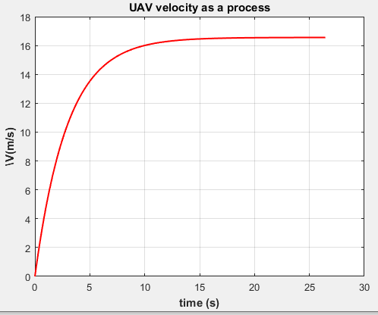

**Figure 1:** Unit step time response of the UAV velocity as a process.

COMMENTS:

* Maximum overshoot: zero
* Settling time: 11.5 s
* Steady state error: -15.557 m/s

- Any proposed successful compensator has to cope with this large steady-state error and improve the settling time of the closed-loop control system.

1. **CONTROLLING THE UAV VELOCITY USING AN I-FIRST ORDER COMPENSATOR**

The I-first order compensator is one of the second generation of control compensators introduced by the author in 2014. It was applied by the author for the first time to control autonomous car longitudinal velocity in September 2024 [11].

The I-first order compensator has a structure composed of two control modes in cascade with the controlled process in a single-loop block diagram. The first control mode is an integral mode of gain Ki and the second control mode is a first-order compensator of a zero z and a pole p. It has a transfer function GI-1st(s) given by:

GI-1st(s) = (Ki/s)(s+z)/(s+p) (2)

The I-first order compensator is tuned as follows:

* Using the process transfer function in Eq.1 and the controller transfer function in Eq.2, the open-loop transfer function of the control system G1(s) is given :

G1(s) = (Ki/s)(s+z)(s+p).(5.0218)/(s+0.3395) (3)

* The zero/pole cancellation technique [12] is used to cancel the zero of the compensator with the pole of the process in Eq.3. This reveals the compensator zero as:

z = 0.3395 (4)

* The transfer function of the closed-loop control system incorporating the I-first order compensator and the UAV velocity process in a unit feedback control loop, M1(s) will be:

M1(s) = 5.0218Ki/(s2+ps+5.0218Ki) (5)

* Eq.5 represents a standard second order transfer function of the form ωn2/(s2+2ζωns+ωn2). The natural frequency ωn and damping ratio ζ are related to the compensator parameters using Eq.5 as:

ωn = √(5.0218Ki) , ζ = p/(2ωn) (6)

* The performance of any control system is measured by its stability, maximum overshoot and settling time. The maximum overshoot of the second order system related to its damping ratio ζ. The minimum damping ratio producing zero maximum overshoot is the critical damping (ζ = 1) [13].
* The settling time Ts of the second-order control system is related to its damping ration and natural frequency for ± 2 % tolerance band through the equation [14]:

Ts ≈ 4/( ζ ωn) (7)

* ِAssigning the desired settling time to be one second and using Eqs.6 and 7 with trial adjustment for the compensator gain gives the compensator integral gain Ki and pole p as:

Ki = 10 , p = 14.17293 (8)

* The time response of the control system is obtained for a unit step input and using Eqs.5 and 8 using the step command of MATLAB [10] and shown in Fig.2.

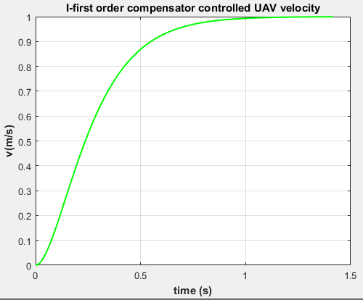

Figure 2: UAV velocity step time response using an I-first order compensator.

COMMENTS:

* Maximum overshoot: zero
* Settling time: 0.8233 s compared with 11.5 s for an uncontrolled UAV velocity.
* Steady state error: zero compared with –15.557 m/s for an uncontrolled UAV velocity.

1. **CONTROLLING THE VESSEL YAW ANGLE USING A FEEDBACK PD COMPENSATOR**

The feedback PD compensator was introduced by the author in 2014 as one of the second generation of control compensators used to control processes having bad dynamics [15]. - -

The feedback PD compensator was set in the feedback path of a single-loop block diagram for the control of the process which is located in the forward path of the control loop. The PD-control mode has the transfer function GPD(s) given by:

GPD(s) = Kpc+Kds (9)

Where Kpc and Kd are the integral and derivative gain parameters of the compensator.

The two gain parameters of the feedback PD compensator are tuned as follows:

* The transfer function of the closed loop control system incorporating the UAV speed process (Eq.1) and the feedback PD compensator (Eq.9) and given by:

M2(s) = 0.6218/[(1+5.6218Kd)s+0.3395+5.6218Kpc] (10)

* It is clear from Eq.10 that this automatic control structure will not generate a zero steady-state error except when a constraint is set on its proportional gain Kpc.
* This constraint is set by equating the numerator of Eq.10 and the free term of the denominator. This reveals Kpc as:

Kpc = 0.93961 (11)

* Now, we use the requirement of the settling time of the closed-loop control system as 0.5 s.
* From Eq.10, the control system is a first-order one where its settling time of its step time response will be 4T where T is its time constant [14]. This reveals the corresponding value of the compensator derivative gain as:

Kd = -0.05287 (12)

* The unit step time response of the control system for the UAV velocity using the proposed feedback PD compensator using its gain parameters in Eqs.11 and 12 is shown in Fig.3.

COMMENTS:

* Maximum overshoot: zero
* Settling time: 0.489 s compared with 11.5 s for an uncontrolled UAV velocity.
* Steady state error: zero compared with –15.557 m/s for an uncontrolled UAV velocity.

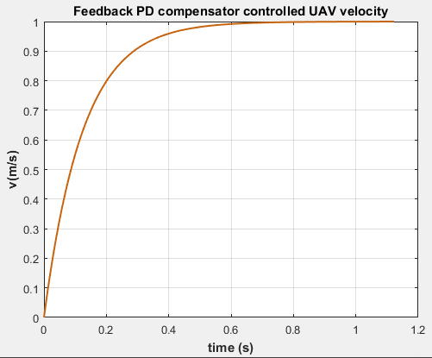

Figure3: UAV velocity step time response using a feedback PD compensator.

1. **CONTROLLING THE SIDESLIP ANGLE USING A FEEDBACK FIRST-ORDER COMPENSATOR**

The feedback first-order compensator was one of the second generation of control compensators introduced by the author in 2014. He applied the feedback first-order compensator to control a highly oscillating second-order process in 2014 [16]. The compensator was set in the feedback path of a single loop block diagram incorporating the controlled process in the feedforward path. The compensator transfer function G1st(s) is given by [16].

G1st (s) = Kc(s+z)/(s+p) (13)

Where Kc is the compensator gain, z its zero and p is its pole.

The feedback first-order compensator is tuned as follows:

* The zero/pole cancellation technique [12] is used. When driving the closed-loop transfer function of the control system incorporating the UAV velocity process and the feedback first-order compensator, the zero of the compensator is set equal tp the pole of the UAV velocity. This reveals the compensator zero as:

z = 0.3395 (14)

* The closed-loop transfer function is derived and a condition was set for zero steady-state error revealing a relation between the compensator pole p and its gain parameter Kc. This relation is:

p = 0.36132 (15)

* We are left know with one compensator parameter to be identified, Kc. An ITAE performance index [16] function of the error between the reference input and the UAV velocity is to be minimized using the MATLAB optimization toolbox [17]. This step reveals the optimal compensator gain and hence the other compensator parameters as:

Kc = 0.938994 ; z = 0.3395 ; p = 0.339277 (16)

* The unit step time response of the control system is drawn using the ‘step’ and ‘plot’ commands of MATLAB [10] using the tuned feedback first-order compensator parameters in Eq.16 and shown in Fig.4.

COMMENTS:

* Maximum overshoot: zero
* Settling time: 0.6915 s compared with 11.5 s for an uncontrolled UAV velocity.
* Steady state error: zero compared with –15.557 m/s for an uncontrolled UAV velocity.

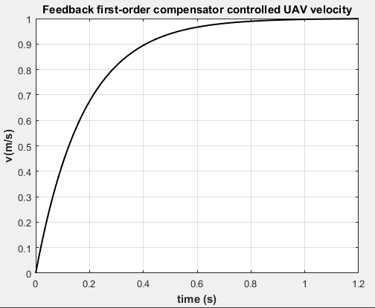

Figure 4: UAV velocity step time response using a feedback first-order compensator.

1. **CONTROLLING THE SIDESLIP ANGLE USING A PI CONTROLLER**

The PI controller is one of the first generation of PID controllers. It is still in use nowadays in controlling some of the industrial processes [18-21]. It has a transfer function GPI(s) given by:

GPI(s) = Kpc+(Ki/s) (17)

Where Kpc and Ki are the integral and derivative gain parameters of the PI controller.

The two gain parameters were tuned by Mazlan et al for the UAV velocity under study in the present research and given by [7]:

Kpc = 0.473 ; Ki = 0.220 (18)

The unit step time response of the control system using the PI controller parameters in Eq.18 and the closed-loop transfer function incorporating the UAV velocity transfer function in Eq.1 is drawn using the ‘step’ and ‘plot’ commands of MATLAB [10] and shown in Fig.5.

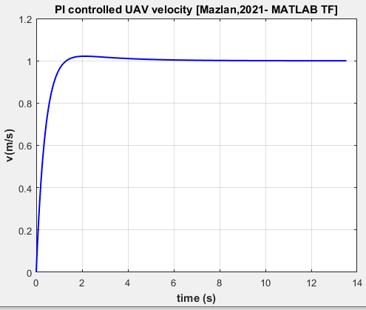

Figure 5: UAV velocity step time response using a PI controller.

COMMENTS:

* Maximum overshoot: 2.15 % compared
* with zero for an uncontrolled UAV velocity.
* Settling time: 2.55 s compared with 11.5 s for an uncontrolled UAV velocity.
* Steady state error: zero compared with –15.557 m/s for an uncontrolled UAV velocity.

1. **COMPARISON OF PROPOSED COMPENSATORS WITH A PI CONTROLLER**

The time-based characteristics of the control systems used to control the UAV velocity are compared as follows:

## Graphical Comparison

The unit step time response of the control systems proposed to control the UAV velocity with graphical comparison with PI controller is shown in Fig.6.

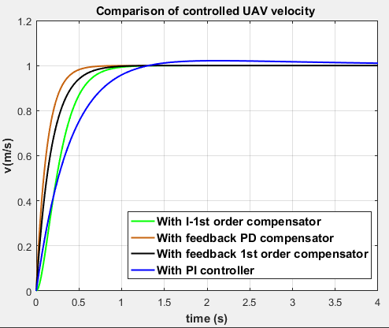

Figure 6: UAV velocity step time response comparison.

## Numerical Comparison

The time-based characteristics of the control systems proposed to control the UAV velocity as extracted from Fig.6 are tabulated in Table 1 compared with those of uncontrolled and PI controlled velocity.

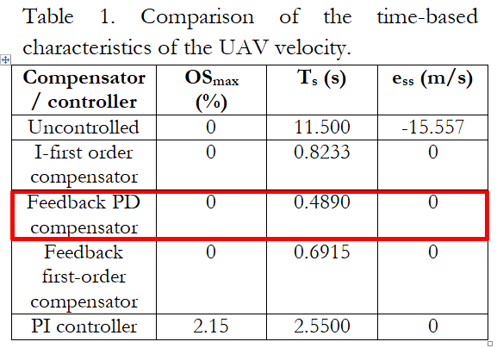

OSmax: maximum overshoot

Ts: Settling time

ess: Steady-state error

1. **CONCLUSION**

* The control of the UAV velocity was investigated in this research paper using three compensators from the second generation of control compensators: I-first order, feedback-PD and feedback first order.
* The use of the three compensators was compared with the use of PI controller from the first generation of PID controllers.
* The compensators were tuned using a combination of two or three techniques: zero/pole cancellation, special requirement for some characteristics of the closed-loop control system and using the MATLAB optimization toolbox.
* The unit step time response of the closed-loop control system was presented and the main time-based characteristics were extracted from the plot.
* The compensators performance in controlling the UAV velocity was compared with the PI controller graphically and quantitatively.
* The I-first order compensator could eliminate completely the maximum overshoot (compared with 2.15 % for the PI controller) and the steady-state error and achieve a settling time of 0.8233 s (compared with 2.55 s for the PI controller).
* The feedback PD compensator could eliminate completely the maximum overshoot (compared with 2.15 % for the PI controller) and the steady-state error and achieve a settling time of 0.489 s (compared with 2.55 s for the PI controller).
* The feedback first order compensator could eliminate completely the maximum overshoot (compared with 2.15 % for the PI controller) and the steady-state error and achieve a settling time of 0.6915 s (compared with 2.55 s for the PI controller).
* The feedback PD compensator was selected as the best controller for the UAV velocity for its perfect performance depicted in Fig.3 and Table 1.

1. **REFERENCES**
2. W. Ren and R. Beard, “Trajectory tracking for unmanned air vehicles with velocity and heading rate constraints”, IEEE Transactions on Control Systems Technology, Volume 12, Issue 5, 2004, pp. 706-716.
3. A. Simpson, J. Jacob and S. Smith, “Flight control of a UAV with inflatable wings with wing warping”, 24th AIAA Applied Aerodynamics Conference, San Francisco, USA, 5-8 June, 2006, 19 pages.
4. J. Zhang, X. Zhu and Z. Zhou, “Design of time delayed control system in UAV using model based predictive algorithm”, 2nd International Asia Conference on Informatics in Control, Automation and Robotics, Wuhan, 2010, pp. 269-272.
5. G. Colunga, A. Guerrero, J. Escarero and R. Lozano, “Modeling and control of of mini UAV”, in: J. Guerreno and R. Lozano (Editors), “Flight formation control”, Wiley, 2012, pp. 99-134.
6. J. Gao, P. Wang and Z. Hou , “UAV velocity control based on improved PID algorithm”, Volume 43, 2015, pp. 1-5, DOI: 10.13245/j.hust.15S1001.
7. Q. Pan et al., “Dynamic speed control of unmanned aerial vehicles for data collection under internet of things”, Sensors, Volume 18, Issue 3951, 2018, 18 pages.
8. N. Mazlan et al., “The design of an automatic flight control system and dynamic simulation for fixed wing unmanned aerial vehicle (UAV) using X-plane and LabVIEW”, Progress in Aerospace and Aviation Technology, Volume 1, Issue 1, 2021, pp. 56-69.
9. J. Zhao, “Quadrotor’s modeling and control system design based on PID control”, Journal of Physics: Conference Series, Volume 2483, Issue 012034, 2023, 13 pages.
10. T. Lohani, A. Dixit and P. Agrawal, “Adaptive PID control for autopilot design of small fixed wing UAV’s”, MATEC Web of Conferences, Volume 393, Issue 03005, 2024, 14 pages.
11. Mathworks, “Generating a step response in MATLAB”,

<https://ctms.engin.umich.edu/CTMS/index.php?aux=Extras_step>

1. G. A. Hassaan, “Autonomous vehicles control, Part I: Car longitudinal velocity control using P-D, I-first order, 2/2 second order and notch compensators compared with a PID controller”, International Journal of Research Publication and reviews, Volume 5, Issue 9, 2024, pp. 334-344.
2. M. C. Campi, “The problem of pole-zero cancellation in transfer function identification and application to adaptive stabilization”, Automatica, Volume 32, Issue 6, 1996, pp. 849-857.
3. S. Shahruz, G. Langari and M. Tomizuka, “Optimal damping ratio for linear second-order systems”, Journal of Optimization Theory and Applications, Volume 73, 1992, pp. 563-576.
4. A. M. Hussein, “Lecture notes, Chapter 7: Time-domain analysis”, College of Engineering, Shubra University, Egypt, 39 pages, <https://feng.stafpu.bu.edu.eg/Electrical%20Engineering/3106/crs-15061/Files/chapter%207%20Transient%20Response.pdf>
5. G. A. Hassaan, “A novel feedback PD compensator used with underdamped second-order processes”, International Journal of Mechanical Engineering, Volume 4, Issue 2, 2014, pp.1-10.
6. F. G. Martins, “Tuning PID controllers using the ITAE criterion”, International Journal of Engineering Education, Volume 21, Issue 5, 2005, pp. 867-873.
7. C. Lopez, “MATLAB optimization Techniques”, 1st Edition, Apress, 2014.
8. S. Singh, V. Singh, S. Singh and R. Dohere, “Tuning of Optimal P and PI controllers for level control of single tank system”, International Journal of Advanced Technology and Engineering Exploration, Volume 3, Issue 23, 2016, pp. 165-169.
9. J. Zhou, “Adaptive PI control of bottom hole pressure during oil well drilling”, IFAC Paper Online, Volume 51, Issue 4, 2018, pp. 166-171.
10. R. S. Widagdo, “Simulation of speed control on a PMSM using a PI controller”, Jambura Journal of Electrical and Electronics Engineering, Volume 6, Issue 1, 2024, pp. 63-69.
11. A. Platon, S. Oprea, A. Florescu and S. Rosu, “Simplified digital implementation of PI controller used in voltage mode control”, 10th International Conference on Electronics, Computers and Artificial Intelligence, 2018, pp. 1-6.
12. A. R. Lais, “Abbas Ibn Firnas, the first man to fly and live to tell the tale”, <https://aertecsolutions.com/en/2018/05/21/abbas-ibn-firnas-the-first-man-to-fly-and-live-to-tell-the-tale/>, May, 2018.
13. Wikipedia, “Abbas Ibn Firnas”, <https://en.wikipedia.org/wiki/Abbas_ibn_Firnas>, 2024.

**DEDICATION**

***ABBAS IBN FIRNAS* (810-887 AC)**

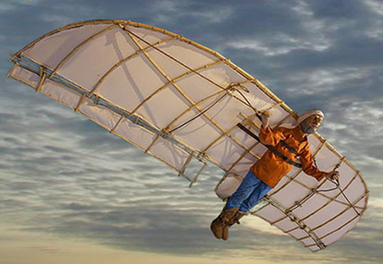

**Image for Ibn Firnas flying in Al-Andalos sky in 887 AC [22]**

* He was an aviation pioneer, the first man to fly on a heavier-than-air machine 1000 year before the Wright brothers [22].
* He was known as the ‘Wiseman of Al-Andalos’ because he was an inventor, poet, philosopher, alchemist, musician and astronomer [22].
* He manufactured colorless glass, glass planispheres, corrective lenses for reading, simulator for some planets and stars motion, tool for crystal cutting, introduced the book of ‘Sindhind’ to Al-Andalos, designed a ‘water clock’ and designed a prototype of a ‘metronome’ (oscillating pendulum) [23].
* Worldwise appreciation for Ibn Firnas: Installing a statue for him in Baghdad International Airport in 1973, naming a crater on the moon by his name in 1976, naming a bridge in Cortoba (Spain) ‘Abbas Ibn Firnas Bridge’ and naming ‘Firnas Airline’ in UK [23].

**BIOGRAPHY**

***GALAL ALI HASSAAN***

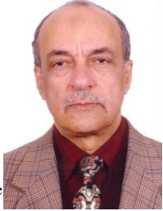

* Emeritus Professor of System Dynamics and Automatic Control.
* Has got his B.Sc. and M.Sc. from Cairo University in 1970 and 1974.
* Has got his Ph.D. in 1979 from Bradford University, UK under the supervision of Late Prof. John Parnaby.
* Now with the Faculty of Engineering, Cairo University, EGYPT.
* Research on Automatic Control, Mechanical Vibrations, Mechanism Synthesis and History of Mechanical Engineering.
* Published more than 340 research papers in international journals and conferences.
* Author of books on Experimental Systems Control, Experimental Vibrations and Evolution of Mechanical Engineering.
* Member of the Editorial Board of some engineering and computer technology international journals.
* Reviewer in some international journals.
* Scholars interested in the authors publications can visit:

[**http://scholar.cu.edu.eg/galal**](http://scholar.cu.edu.eg/galal)