**DEVELOPMENT AND IMPLEMENTATION OF ELECTRONIC WATER LEVEL CONTROLLER**

**Nwogbu Celestine Chidi1, Udeh Ubasinachi Osmond2 , Nwogbu Paul Iloabuchi3**

**1Material and Metallurgy Department Enugu State University of Science and Technology, Enugu**

**2DEPARTMENT OF MECHANICAL /PROD. ENGINEERING, CARITAS UNIVERSITY AMORJI-NIKE-NIGERIA**

**3Chemical Engineering Department Enugu State University of Science and Technology, Enugu**

**Corresponding Author E. Mail: fr.chidi34@gmail.com**

**Abstract**

Electronic water level controller is development to monitor the level of water in a tank. It displays the level of water and when it is at the lowest level, a pump is activated automatically to refill the tank. When the tank is filled to it maximum capacity, the pump is automatically de-energized. Several circuits are put together to ensure proper working of this development, and the block diagram includes the supply unit, the micro-processor unit, the display unit and the pump drives unit. The power unit is responsible for turning on the entire circuit. Some components are used to set up transformer, a bridge rectifier circuit, a smoothening capacitor and a voltage regulator IC. The microprocessor (AT89S50) controls virtually all the actions carried out in this development (AT89S50) is used in the development.

**Keyword**: Automatically de-energized, Step down transformer, Relay, LCD, AT8950.

1. **INTRODUCTION**

Electronic water level control is design to monitor the level of liquid in the tank. The system has an automatic pumping system attached to it so as to refill the tank once the liquid gets to the lower threshold, while offing the pump once the liquid gets to the higher threshold. Sustainability of available water resource in many reason of the word is now a dominant issue. This problem is quietly related to poor water allocation, inefficient use, and lack of adequate and integrated water management. Water is commonly used for agriculture, industry, and domestic consumption. Therefore, efficient use and water monitoring are potential constraint for home or office water management system. Moreover, the common method of level control for home appliance is simply to start the feed pump at a low level and allow it to run until a higher water level is reached in the water tank. This water level control, controls monitor and maintain the water level in the overhead tank and ensures the continuous flow of water round the clock without the stress of going to switch the pump ON or OFF thereby saving time, energy, water, and 13 prevent the pump from overworking Besides this, liquid level control systems are widely used for monitoring of liquid levels in reservoirs, silos.

The goal or objectives of which the designed device is expected to accomplish is to build an automatic water level control with automatic control system. In this project sensors are place at different level of the tank and with the aid of this sensors, the micro-controller monitor the level of the liquid at any particular point in time, some of the objectives are

1. to design an automatic water monitoring system
2. to incorporate an interactive medium between the end user and the machine 3. to prevent over labor of the pumping machine and prevent it from getting bad
3. to avoid wastage of water since the demand of electricity is very high, automatic water level control saves energy .

**II. LITERATURE REVIEW**

This product is designed to automatic control of motor, which ensures constant reserve of water in storage tanks. Automatic water level controller is used to automatically fill the overhead tank as and when it gets empty and monitor the water level initially. Automatic water level controller switches ON the motor when the water level in the overhead tank drops below pre-fixed low level (on point) and puts off the motor when water level rises up to pre-fixed high level (off point) motor also switches off when the sump water is exhausted before filling overhead tank, pump running dry, Mains voltage fluctuations.

**III. COMPONENTS AND METHODS**

COMPONENTS

1. FLUID LEVEL DETECTOR SENSORS

Sensors are devices that convert physician property or a change in the physician property into a more easily manipulated form e.g. voltage, displacement, resistance the major forms of energy that sensors can Fluid level Detection Sensors Sensors Signal AMP I.C Unit LED Display and alarm LED Display and alarm Regulated Power Supply 23 detect can be classified as motion, temperature and light pressure, electrical, magnetic, chemical and nuclear. It is important to know that a wide variety of sensors can measure temperature but are tupe may be more useful to an electronic circuit because it convert temperature to an electrical signal compatible with electronic circuit.

1. STEP-DOWN TRANSFORMER

A transformer is a device consisting of two closely coupled coils called primary and secondary coils. An AC voltages applied to the primary appears across the secondary with a voltage multiplication proportional to the to primary appears across the secondary with a voltage multiplication proportion to the turn ratio of the transformer and a current multiplication inversely proportional to the turn ratio power

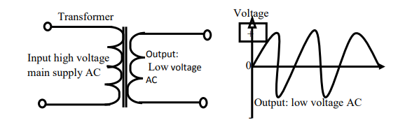

FIGURE 1.0 TRANSFORMER CIRCUIT` REPRESENTATION

1. DIODES

The term diode usually implies a small signal device with current typically in the milliamp range. A semiconductor diode consist of a PN junction and has two (2) terminals, an anode (+) and cathode (-) current flows from anode to cathode within the diode. Diodes are semiconductor device that might be described as passing current in one direction only. The latter part of that statement applies equally vacuum Transformer Output: Low voltage AC Input high voltage main supply AC - Voltage Output: low voltage AC + 0 25 tube diodes. Diodes however are far more extremely versatile in fact. Diode can be used as voltage regulators, turning devices in radio frequency tuned circuit, frequency multiplying device in radio frequency circuit, mixing devices application or can be used to make logic decision in digital circuit. There are also diodes which emit “light” known as light emitting diodes or LED.

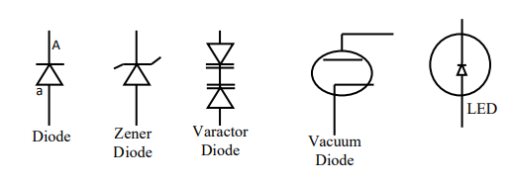

Figure 1.1. Symbols of diode

1. LIGHT EMITTING DIODES OR (LED)

Light emitting diodes commonly called LED they do dozens of different jobs and are found in all kinds of devices. Among other things they form the numbers on digital close, transmit information from remote controls, light up watches and tell you when your appliance are turned on collected together they can form images on a jumbo television screen or illuminate a traffic light. Basically, LED are just ting light bulbs that fit easily into an electrical circuit but unlike ordinary incandescent bulbs, they don’t have a filament that will burn out and they don’t have get hot. They are illuminated by the movement of electron in a 27 semiconductor material. Many circuits use a LED as a usual indicator of some sort even if only as an indicator of power supply being turned on. A sample calculation of the dropping resistor is included below.

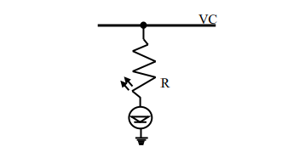

Figure 1.2. LIGHT EMITTING DIODES

1. BRIDGE RECTIFIER

A bridge rectifier can be made using four individual diodes, but it is also available in special packages containing the four diodes required. It is called full-wave rectifier because it uses the entire AC waves (both positive and negative section) 1.4v is used up in the bridge rectifier because each diode uses 0.7v when diodes conducting as shown in the figure below. The maximum current they can pass rates bridge rectifiers and the maximum reverse voltage they can withstand this must be of least three times the supply RMs voltages so the rectifier can withstands the peak voltage.

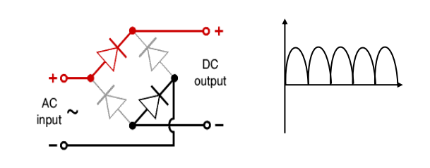

Figure1.3. BRIDGE RECTIFIER CIRCUIT REPRESENTATION

1. Voltage Regulator
2. Resistor
3. Transistor
4. Capacitor
5. Relay
6. Piezo Electric Buzzer
7. Seven segment display

**OPERATIONAL WORKING**

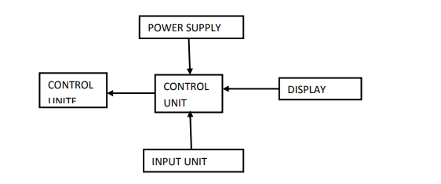

In three phase supply, first R-phase and Y-phase are connected to primary winding of the Scott connection transformer of which R phase is connected through a switch SW. This transformer reduces the 440V AC to 12V AC. We get 12V AC at secondary winding of the transformer. An isolation rectifier circuit is connected to the secondary winding of transformer. This rectifier circuit rectifies the 12V AC to 12V DC. A LED is connected to rectifier circuit in series with resistor to indicate the presences of R and Y phases. This output is connected to the transistor base. Transistor emitter is connected to the ground and collector is connected to the anode of free-wheeling diode. Across the free-wheeling diode operational relay RL is connected. The NO of operational relay RL is connected to Y phase. The pole of operational relay RL is connected to coil of 3 pole contactor 𝑅𝐿1 through the NC terminals of thermal overload relay, the B phase is directly connected to the second terminal of the contactor RL1 coil. For input side of 3 pole contactor 𝑅𝐿1 , three phase supply is connected. And for output side, a thermal overload relay is connected to which the load is connected. The contactor 𝑅𝐿1 acts as switch depending upon the presence of all the three phases. In the first case by using the output of rectified voltage the availability of water level is checked which mentioned as the sump circuit. If the water available the relay coil is operated and then the water tank circuit is operated otherwise the circuit is not operated. All these conditions are check by using sump operation which is based on the availability of water in the sump. In this mode relay is in ON condition and motor is in OFF condition.

1. 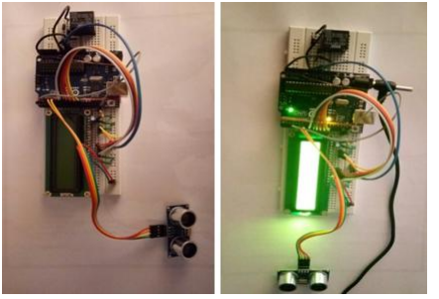**RESULT**

The water pump should turn ON automatically whenever the water level drops below the low point and should automatically turn OFF when the water rises well above the fixed level. And also LED will glow indicating that the tank is filled.

**CONCLUSION**

Going through the planning, flow process, design and software implementation, the system has been a tough one, the chapter one to four has actually tried as much as possible to explain vividly almost all (if not all) what is involved in the construction of this project. After the complete design of the system, the deviation between the expected result and the actual result was very close. The performance and efficiency was beyond expectation and from every ramification the design of automatic water controller was successful.

**REFERENCE**

1. Aye, T. S., &Lwin, Z. M. (2006). Microcontroller Based Electric Expansion Valve Controller for Air Conditioning System, World Academy of Science, Engineering and Technology. Vol. 2864.
2. Belone, S., &Graw, H. W. (2004). Electronic Circuit Discrete & Integration, (23rd Edition).
3. New Delhi, India: S, Chand & Company. Byrne, L., Lau, K. T., & Diamond, D. (2002).
4. Monitoring of Headspace Total Volatile Basic Nitrogen from Selected fish Species using Reflectance Spectroscopic Measurements of pH Sensitive filmsî, The Analyst, vol. 127, Dietz, P.
5. Yerazunis W., & Leigh, D. (2003). Very Low-Cost Sensing Devices. India: Chand & Company.

APPENDICE : ARDUINO LAYOUT

