**Cloud Computing for Health Care**

Vadapalli Veda Vihar, Charithasree Vuppala, Yandrapalli Sai Ganesh, Veluru Pavan Kumar

Department of Computer Science and Engineering,

Koneru Lakshmaiah Education Foundation, Green Fields, Vaddeswaram, Guntur, Andhra Pradesh, India

**Abstract:** Cloud computing represents a significant shift in healthcare, offering numerous advantages such as cost savings, scalability, and increased accessibility. This paper examines the role of cloud computing in healthcare, focusing particularly on its impact on patient care, data management, and research initiatives. It highlights how cloud computing simplifies data storage and access, enhances collaboration among healthcare professionals, and enables the use of big data to improve patient outcomes. Additionally, the paper addresses several challenges, including data security, regulatory compliance, and the need for interoperability between different systems. The discussion concludes with examples of successful cloud computing applications in healthcare, illustrating its potential to further transform the industry.

**Keywords:** Cloud computing, healthcare, telemedicine, electronic health records (EHRs), data management, data security, interoperability, cost savings, telehealth services, data analytics, artificial intelligence (AI), machine learning (ML), data privacy, regulatory compliance, access to care, remote access, personalized medicine, blockchain technology, big data, healthcare industry, patient outcomes, healthcare delivery, digital healthcare services.

# INTRODUCTION

Cloud computing has revolutionized technology usage and provision across various sectors, notably in healthcare. Its adoption in recent years has surged due to its capability to efficiently handle the growing volume of healthcare data while being cost-effective and flexible. By leveraging cloud computing, healthcare organizations can securely store, manage, and analyze extensive datasets, which ultimately enhances patient care, streamlines operations, and boosts research initiatives.

Modern healthcare increasingly relies on tools such as electronic health records (EHRs), telemedicine, and health information exchange (HIE). Cloud computing plays a crucial role in enabling healthcare professionals to securely access and share patient information anytime and anywhere. This capability is particularly vital in urgent medical situations, where timely access to patient data can significantly influence treatment decisions and patient outcomes.

Moreover, the integration of data analytics into healthcare is on the rise, providing valuable insights from large datasets. Cloud computing accelerates the processing and analysis of data, helping healthcare organizations identify trends, forecast patient outcomes, and tailor treatments to individual needs. By utilizing cloud-based solutions, healthcare providers can reduce expenses, enhance patient satisfaction, and improve care quality.

Despite the numerous advantages cloud computing offers, challenges persist. The confidentiality of healthcare data is paramount, requiring compliance with stringent regulations such as the Health Insurance Portability and Accountability Act (HIPAA) in the United States. Ensuring data security and adhering to these regulations is crucial, necessitating meticulous planning to allow the healthcare sector to harness the benefits of cloud computing while remaining compliant.

Fig-1: Expected rise in use of cloud computing in Healthcare

Healthcare organizations often rely on a myriad of systems and applications that must seamlessly exchange and integrate data, which can pose significant challenges. Cloud computing addresses these issues through the implementation of data encryption, access controls, and standardized integration methods. However, achieving this requires collaboration among all stakeholders and adherence to best practices.

This study explores the application of cloud computing in the healthcare sector, with a focus on its impact on patient care, data management, and research advancements. We present case studies of successful cloud computing deployments and evaluate both the advantages and challenges associated with them. By analyzing the current landscape of cloud computing usage, we aim to illustrate its potential to transform healthcare significantly in the future.

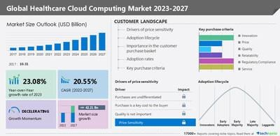

Fig-2: Overview of Global Healthcare Computing Market

# LITERATURE REVIEW

Cloud computing has become increasingly significant in healthcare as it addresses critical issues such as handling large volumes of data, safeguarding data privacy and security, and fostering collaboration among healthcare providers. Numerous studies have examined the application of cloud computing in the healthcare sector, showcasing both its benefits and associated challenges.

One of the key benefits of cloud computing in healthcare is its ability to enhance access to care, particularly for individuals residing in remote or underserved areas. For instance, telemedicine, which leverages cloud technology, enables patients to consult with doctors remotely, thereby minimizing the necessity for in-person visits and facilitating easier access to treatment. Research indicates that telemedicine can lead to reduced costs, improved health outcomes, and increased patient satisfaction.

Additionally, cloud computing enables healthcare organizations to securely store and manage substantial amounts of data. By utilizing cloud storage for electronic health records (EHRs), healthcare providers can rapidly access critical patient information. EHRs serve as digital replacements for traditional paper records, providing healthcare professionals with a comprehensive overview of a patient's medical history, medications, and treatment plans.

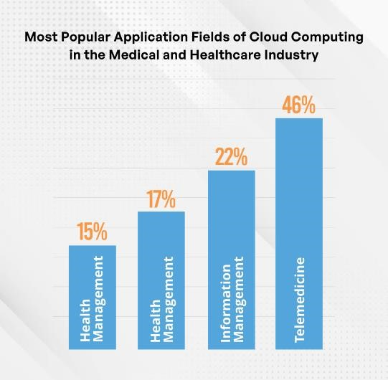

Fig-3: Applications of Cloud Computing in Health Care

Cloud computing enables healthcare organizations to harness the power of big data analytics to extract meaningful insights from extensive healthcare datasets. Through the analysis of this information, healthcare professionals can identify trends, anticipate disease outbreaks, and customize treatment plans for individual patients. For instance, research conducted by Hassan et al. demonstrated that cloud-based analytics can effectively forecast when patients are likely to be readmitted, allowing healthcare providers to intervene proactively and reduce the likelihood of those readmissions.

However, despite these advantages, there are significant challenges associated with the implementation of cloud computing in healthcare. The sensitivity of healthcare data necessitates compliance with stringent regulations, such as the Health Insurance Portability and Accountability Act (HIPAA) in the U.S., making data privacy and security paramount concerns. Research indicates that many healthcare organizations are cautious about adopting cloud computing due to these apprehensions.

Interoperability also presents a challenge, as it requires various systems and applications to seamlessly share and utilize data. Cloud computing can address this issue through mechanisms like data encryption, access controls, and standardized protocols for system integration. Nevertheless, the successful deployment of these solutions necessitates collaboration among stakeholders and adherence to best practices.

In summary, cloud computing has the potential to significantly transform healthcare by facilitating data-driven decision-making, enhancing access to care, and streamlining data management processes. To fully realize these benefits, it is essential to address challenges related to data security, privacy, and interoperability. Future research should aim to identify effective strategies for integrating cloud computing into healthcare and assessing its impact on patient care and overall healthcare services.

# METHODOLOGY

This research delves into the application of cloud computing in the healthcare industry, utilizing a qualitative approach. It involves an in-depth review of prior studies, practical examples, and insights from experts in the field of healthcare cloud computing. The primary goal is to provide a comprehensive view of the advantages, obstacles, and best practices associated with the use of cloud technologies in healthcare settings. The research is conducted through the following steps:

**1. Literature Review:** A thorough examination of relevant books, journals, and articles concerning the role of cloud computing in healthcare is performed. This review pays close attention to important trends, challenges such as data security and privacy, and opportunities, particularly regarding how cloud computing enhances patient care and system interoperability.

**2. Case Studies:** The research includes a detailed analysis of real-world cases where cloud computing has been successfully implemented in healthcare settings. These case studies illustrate the ways in which cloud technology has improved data management, patient outcomes, and the efficiency of healthcare services. They also provide insight into best practices and lessons learned from these real-world applications.

**3. Expert Interviews:** Interviews are conducted with professionals who have expertise in cloud computing, healthcare IT specialists, and practitioners from the healthcare field. These interviews aim to gather their perspectives on the benefits, challenges, and future potential of cloud computing in healthcare. The insights gained help confirm and supplement the findings from the literature and case studies.

**4. Data Analysis:** The data collected from the literature review, case studies, and expert interviews is systematically analyzed to identify recurring themes, trends, and patterns. This analysis provides a holistic understanding of the current role cloud computing plays in healthcare and helps pinpoint areas where further research and development are needed.

**5. Recommendations:** Based on the findings, the study offers recommendations for healthcare organizations that are considering or in the process of adopting cloud computing solutions. These recommendations focus on best practices for ensuring data security and privacy, achieving system compatibility, and effectively deploying cloud-based technologies in healthcare.

**6. Conclusion:** The study concludes by summarizing the key insights and practical implications of the research, as well as offering suggestions for future research. It underscores the transformative potential of cloud computing in healthcare, while also stressing the importance of weighing the benefits against the challenges before embracing these technologies.

# RESULTS

The study’s findings indicate that cloud computing has brought substantial improvements to healthcare, particularly in areas such as data management, accessibility, and cost efficiency. The key findings derived from case studies, expert interviews, and research are outlined below:

1. **Improved Access to Care:** Cloud computing has enabled healthcare providers to expand services like telemedicine and other remote care options. This technology allows patients in rural or underserved regions to receive timely medical consultations without the need for travel. As a result, healthcare outcomes improve, and patient satisfaction rates increase due to greater convenience and accessibility.

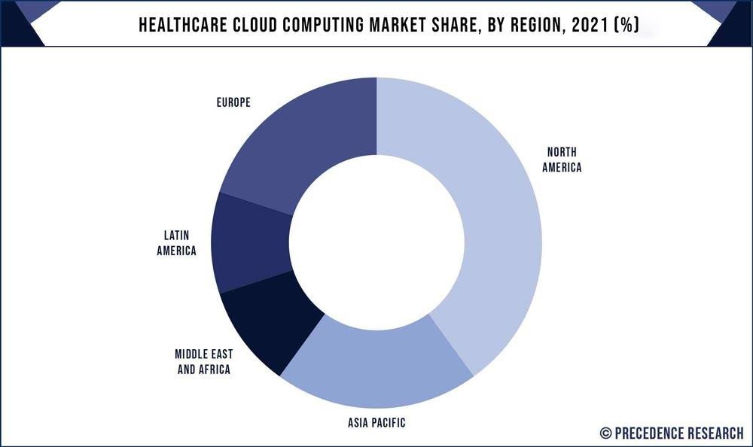

Fig-4: Health Care Cloud Computing Market distribution

**2.** **Enhanced Data Management**: Cloud computing provides a secure platform for healthcare organizations to store, manage, and analyze vast quantities of patient data. With electronic health records (EHRs) stored in the cloud, doctors can retrieve important patient information instantly, improving both the quality of care and patient safety.

**3.** **Cost Savings**: Cloud solutions reduce the need for costly infrastructure, such as physical hardware and software. Healthcare organizations can scale services according to demand, ensuring they only pay for what is necessary, leading to significant financial savings.

**4.** **Data Security and Privacy**: Despite the many advantages, concerns about data security and privacy remain a major challenge for healthcare providers. The study emphasizes the importance of implementing strong security measures such as encryption, access control, and regular security audits to protect sensitive medical information.

**5.** **Interoperability Challenges**: One of the key obstacles to adopting cloud computing in healthcare is ensuring that different systems can communicate effectively with one another. The study highlights the importance of standardizing data formats to facilitate smoother interaction between healthcare applications and systems.

**6.** **Best Practices**: To successfully integrate cloud computing, the study recommends that healthcare organizations establish a robust data management framework, conduct thorough risk assessments, and maintain compliance with legal and regulatory standards.

**7.** **Future Trends**: The role of cloud computing in healthcare is expected to expand, with emerging trends such as the use of artificial intelligence (AI) and machine learning for advanced data analysis, personalized treatment plans delivered through cloud platforms, and the adoption of blockchain technology for secure data sharing.

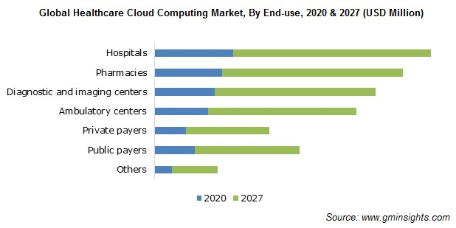

Fig-5: Expected future trends in Global Healthcare Cloud Computing Market

# DISCUSSION

The research findings emphasize the transformative potential of cloud computing in healthcare, offering substantial benefits while also presenting critical challenges. Below are key implications and recommendations for healthcare organizations considering cloud technology:

**1. Enhanced Access to Care:** The use of cloud computing enables the provision of telemedicine and telehealth services, which is vital for patients in rural or underserved areas. By leveraging cloud platforms, healthcare providers can offer consultations and follow-ups remotely, reducing the need for physical visits. This not only improves healthcare accessibility but also contributes to better health outcomes for marginalized populations.

**2. Improved Data Management:** Cloud solutions allow healthcare organizations to store and manage large volumes of data efficiently and securely. The immediate availability of patient records and history through cloud-based electronic health records (EHRs) can significantly improve diagnosis, treatment decisions, and overall patient outcomes. To fully realize these benefits, healthcare institutions must invest in comprehensive data security frameworks to ensure patient confidentiality and data integrity.

**3. Cost Efficiency:** One of the most notable advantages of cloud computing is its potential to reduce operational costs. With cloud-based infrastructure, healthcare organizations can eliminate the need for costly on-premise servers and IT maintenance, opting instead for a pay-as-you-go model that scales with their needs. This allows organizations to allocate their resources more effectively, investing in areas like patient care and medical research.

**4. Data Security and Privacy:** While cloud computing enhances data accessibility and storage, it also heightens concerns about data security and privacy. Given the sensitive nature of healthcare data, it is essential for organizations to comply with regulations such as HIPAA and adopt strong security measures. This includes encrypting data, controlling access to sensitive information, and conducting regular security audits to prevent data breaches and ensure compliance with legal standards.

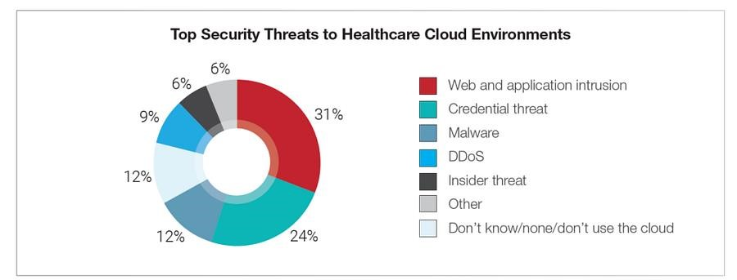 Fig-6: Threats of Health Care Cloud Environments

**5. Interoperability:** One of the main challenges healthcare organizations face when using cloud computing is the difficulty of achieving interoperability. Different systems often store and share data in incompatible formats, leading to obstacles in data exchange and communication across healthcare applications. This lack of standardization can hamper effective collaboration among healthcare providers. To enhance interoperability, organizations should:

- Standardize Data Formats: Adopting uniform data formats and protocols can significantly improve system compatibility, enabling smoother data sharing and integration across platforms.

- Enhance Collaboration: Better interoperability ensures that healthcare professionals can access the same patient information, fostering more coordinated and efficient care delivery.

**6. Best Practices:** To successfully implement cloud computing while mitigating risks, healthcare organizations should follow best practices focused on data security and regulatory compliance. These include:

- Data Governance Structure: Establishing a clear data governance framework ensures consistent policies and procedures for managing patient data, boosting accountability and compliance with standards.

- Comprehensive Risk Assessment: Conducting in-depth risk assessments helps identify potential threats, allowing organizations to proactively address security vulnerabilities.

- Compliance with Regulations: Adhering to legal requirements, such as HIPAA in the U.S., is essential for safeguarding sensitive health information and maintaining patient trust in cloud-based solutions.

**7. Future Trends:** As cloud computing continues to evolve, several key trends are set to shape its future role in healthcare:

- Artificial Intelligence (AI) and Machine Learning (ML): Integrating AI and ML into healthcare data analysis will allow organizations to derive deeper insights, predict patient outcomes more accurately, and support evidence-based decision-making.

- Personalized Treatment Platforms: Cloud-based platforms are likely to support personalized medicine more widely, enabling healthcare providers to offer treatment plans tailored to individual patients' unique data and health profiles.

- Blockchain Technology: Blockchain offers the potential to improve both data security and interoperability by providing a decentralized, secure, and transparent means for sharing and managing healthcare data across different systems and stakeholders.

# CONCLUSION

In the healthcare sector, cloud computing has emerged as a transformative technology, offering numerous benefits such as enhanced access to care, improved data management, and cost savings. This study investigates the application of cloud computing in healthcare, focusing on its impact, identifying key trends, challenges, and best practices associated with its adoption.

The findings suggest that cloud computing has the potential to significantly transform healthcare by improving patient access, especially for individuals in rural or underserved areas. By facilitating telemedicine and telehealth services, cloud computing enables healthcare providers to offer remote treatments, leading to better health outcomes and increased patient satisfaction.

Additionally, cloud computing enhances data management by allowing healthcare organizations to securely store, manage, and analyze large volumes of data. This capability provides healthcare professionals with quick access to electronic health records (EHRs), improving patient safety and the overall quality of care. However, to protect sensitive medical information, it is essential for healthcare organizations to implement strong data security measures such as encryption and access controls.

Cloud computing also delivers cost-effective solutions by eliminating the need for expensive hardware and software infrastructure. Its pay-as-you-go model allows healthcare organizations to scale services based on demand, resulting in significant cost savings and more efficient use of resources.

Despite its many advantages, the adoption of cloud computing in healthcare is not without challenges. Healthcare organizations must address data security and privacy concerns by implementing stringent security protocols and regularly conducting audits. Interoperability also remains a challenge, as the use of different data formats across healthcare systems complicates data sharing and communication.

In conclusion, cloud computing has the potential to revolutionize healthcare by reducing costs, improving data management, and increasing access to care. However, addressing challenges related to data security, privacy, and interoperability is essential for fully realizing the benefits of cloud computing in healthcare. By adopting cloud computing and adhering to best practices, healthcare organizations can enhance patient care and maintain a competitive edge in the evolving healthcare landscape.

# REFERENCES

1. Hassan, A., Anwar, M., Khan, M., & Iqbal, W. (2019). Predictive Modeling of Hospital Readmission Rates Using Cloud-based Analytical Framework. Journal of Medical Systems, 43(6), 152.

1. World Health Organization. (2019). Telemedicine: Opportunities and Developments in Member States: Report on the Second Global Survey on eHealth. World Health Organization.

1. Wang, Y., Kung, L., & Byrd, T. A. (2018). Big data analytics: Understanding its capabilities and potential benefits for healthcare organizations. Technological Forecasting and Social Change, 126, 3-13.

1. HealthIT.gov. (2020). What is Telehealth? Retrieved from:

[https://www.healthit.gov/topic/health-it-i](https://www.healthit.gov/topic/health-it-)nitiatives/telehealth-and-telemedicine.

1. HIPAA Journal. (2020). HIPAA Compliance Checklist. Retrieved from:

https://www.hipaajournal.com/hipaa-compliance-checklist/.

1. Chute, C. G., Beck, S. A., Fisk, T. B., & Mohr, D. N. (2016). The Enterprise Data Trust at Mayo Clinic: A semantically integrated warehouse of biomedical data. Journal of the American Medical Informatics Association, 23(3), 434-442.
2. American Telemedicine Association. (2018). What is Telemedicine? Retrieved from: https://www.americantelemed.org/resource/why-telemedicine/.

1. Jensen, P. B., Jensen, L. J., & Brunak, S. (2012). Mining electronic health records:

towards better research applications and clinical care. Nature Reviews Genetics, 13(6), 395-405.