# Abstract:-

This abstract outlines the development and assessment of herbal tooth powders aimed at offering a natural alternative for oral hygiene. With rising concerns about the potential hazards of synthetic chemicals and additives in commercial toothpaste, there is an increasing demand for herbal and natural oral care solutions. A combination of carefully chosen botanical ingredients known for their efficacy in enhancing oral health was used to create the Herbal Tooth Powder. These formulations leverage the antibacterial, anti-inflammatory, and refreshing qualities of herbs. The powder was designed to ensure user convenience, effective cleaning, and overall oral health improvement. The evaluation of these herbal formulations encompassed various parameters such as physical characteristics, microbial safety, and sensory experience. The physical properties were examined to meet specified quality standards, microbial analysis confirmed the absence of harmful pathogens, and sensory evaluations assessed taste, aroma, and overall user satisfaction.

**Keyword:-** Natural, Oral care products, Botanical substances, Ease of use, Efficient cleaning.

# INTRODUCTION:-

Good health is one of the most valuable assets of every individual. Oral health, as an integral component of general well-being, plays a significant role in maintaining overall quality of life. A healthy dentition is a foundational element in achieving optimal dental health.1 Brushing teeth is a fundamental practice in oral hygiene that helps prevent the accumulation of oral biofilms, which can lead to issues such as tooth decay, gum inflammation, and periodontal diseases.2 If left untreated, infections can progress, potentially spreading and leading to tooth loss. The mouth's natural flora consists of opportunistic bacteria that are usually harmless. However, an imbalance in this microbial ecosystem can result in dental infections and tooth decay. Tooth decay primarily occurs due to *Streptococcus mutans*, an acid-producing bacterium that ferments carbohydrates, contributing to the breakdown of tooth enamel.3 Herbal remedies have been used for centuries and are widely accepted due to their patient-friendly nature and popularity among the general population. Medicinal plants are a sustainable and cost-effective source of healthcare solutions for the growing global population. Their cultivation and processing often employ environmentally sustainable methods. In countries like India, with diverse agro-climatic conditions, cultural practices, and ethnic biodiversity, the abundant availability of medicinal plants ensures a steady supply for the development of herbal products.4Certain herbal ingredients are reported to offer significant benefits for various dental concerns. These include forming a protective layer over teeth, providing a refreshing sensation, exhibiting antibacterial properties, and alleviating dental pain.5Herbalism involves the use of plants and plant-derived products for medicinal purposes. While any part of a plant can be utilized to create herbal remedies, the roots, leaves, flowers, and bark are the most commonly used components.6Interest in herbal-based products is steadily increasing in the field of dentistry. Many herbs have demonstrated antiseptic properties and are commonly used in India for dental hygiene. If proven effective in reducing plaque, these herbal remedies could play a significant role in promoting oral health and providing a safer, more affordable solution for managing periodontal problems.7In early dental care practices, abrasives such as crushed bones, eggshells, and oyster shells were used to clean teeth by removing debris. One of the earliest advancements in oral hygiene was the introduction of tooth powders, which included ingredients like powdered charcoal. These powders, often combined with bark powder and flavoring agents, were applied to the teeth using a basic stick.8Tooth powders are typically free from chemicals, harmful substances, water, and preservatives. They are easy to use, effectively clean the teeth, and support overall dental health.9Because of the negative side effects associated with synthetic treatments, researchers are increasingly turning to herbal remedies. Various plants and plant extracts have demonstrated properties such as anti-inflammatory, anticancer, and immune-boosting effects.10 Creating tooth powders at home is simple and cost-effective. Various natural ingredients are incorporated into herbal tooth powders to help cleanse the mouth. The physiochemical properties of both allopathic and herbal powders can be influenced by the micromeritics of the particles, as these ingredients are composed of fine particles.11As public awareness of the harmful effects of chemicals grows, more people are turning to natural alternatives, a shift that has influenced the development of cosmetics, including oral care products. In the past, natural substances were commonly used for maintaining oral hygiene and freshening breath. Dental health is a strong indicator of overall well-being. In semi-urban and rural regions of India, tooth powder remains the most widely used oral hygiene method, primarily due to cost considerations and the widespread belief that locally made herbal products are beneficial for dental and gum health.5Using herbal products is recommended to maintain good oral hygiene and prevent mouth infections12 Toothpowder and toothpaste contain similar ingredients, but toothpowders lack humectants, water, and binding agents. The formulation was evaluated based on the standards set by the Indian Herbal Pharmacopoeia and the recommendations of the WHO.9 The primary function of toothpowder is to clean the accessible surfaces of the teeth. Developing an effective herbal dental care formulation could provide a valuable alternative to antibiotics in treating oral infections like dental caries, as many of the bacteria responsible for tooth decay show moderate resistance to antibiotics.13The goal of formulating and evaluating herbal tooth powder is to offer a natural and effective alternative to traditional toothpaste, supporting oral health and hygiene while reducing the reliance on synthetic ingredients.

# 1.1 IDEAL PROPERTIES OF HERBAL TOOTH POWDER

* Good abrasive effect • Non irritant and nontoxic
* Impart no stain in tooth.
* Keep the mouth fresh and clean.
* Cheap and easily available.

# 2. MATERIAL & METH0ODS

**2.1 COLLECTION OF HERBAL INGREDIENTS AND EXCIPIENT**

Herbal ingredients and excipient profile were collected from the local market.

## 2.2 SELECTION OF HARBAL INGREDIENTS

The formulation process should involve a thoughtful choice of herbal ingredients that are widely recognized for their therapeutic properties. These may include herbs like Neem ,clove, baking soda ,activated charcoal ,amla ,turmeric ,cinnamon , guava leaf ,harada ,babul.

## 2.3 SELECTION OF EXCIPIENT PROFILE

Choose a suitable base material that offers gentle abrasive action for cleaning teeth without damaging the enamel. Potential options include: Menthol, Himalayan rock salt

## 2.4 PREPARATION OF THE TOOTH POWDER

The herbal ingredients were dried in the shade and then ground into a fine powder using a mixer. Afterward, the powdered herbs were sifted through a sieve with very fine pores to ensure a smooth texture. The resulting powder was then mixed thoroughly and stored in an airtight container for preservation. This process outlines the preparation of the herbal tooth powder formulation.

# 3. FORMULATION OF HERBAL TOOTH POWDER

## 1 NEEM

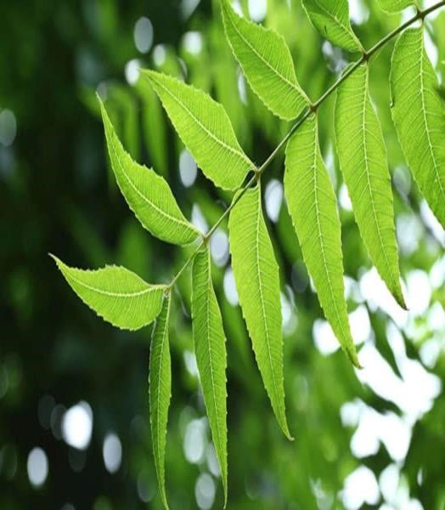Common name: Neem

Family: Meliaceae

Scientific name: Azadirachta indica

Parts used: Leaves, Seeds, Bark, Wood

Role: Anti-inflammatory, Antibacterial

Treatment: plaque, gingivitis, and cavitie

**2 CLOVE** Common name: Clove, Lavang

Family: Myrtaceae

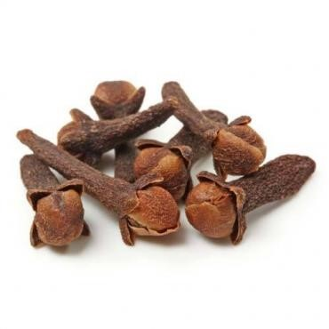Scientific name: Eugenia caryophyllus

Parts used: Dried flower buds

Role: Analgesic, Antioxidant, Anti-inflammatory

Treatment: Caries cavities, Dentrifice

## 3 ACTIVATED CHARCOAL

Common name: activated charcoal

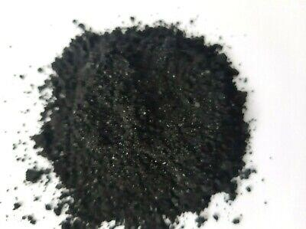 Family: coconut shells ,bamboo

Scientific name: carbon

Role: whitening agents

**4. AMLA :**

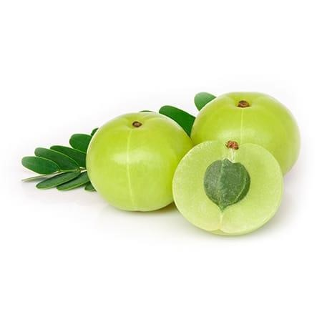 Common name: Amla, Indian gooseberry

Family: Euphorbiacea

Scientific name: Phyllanthus emblica Linn

Parts used: Pericarp of dried matured fruits

Role: Antibacterial

Treatment: Periodontal disease

## 5. CINNAMON

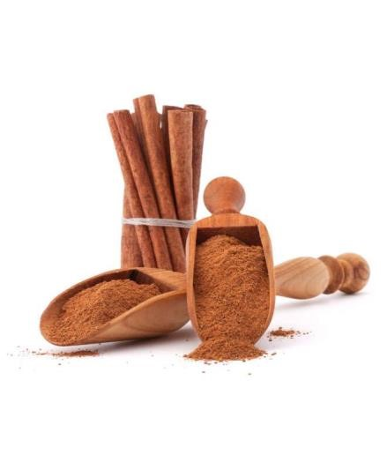

Common name: Cinnamon

Family: Lauraceae

Scientific name: Cinnamon verum

Parts used: Bark

Role: Analgesic,Germicide, Antimicrobial

Treatment: Toothache, Halitosis

6 TURMERIC

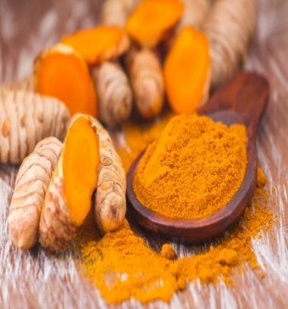Common name : Indian saffron

Family : Zingiberaceae

Scientific name: Curcuma longa

Parts used: underground stem

Role: Reducing inflammation, Controlling plaque, Preventing cavities

## 7. GUAVA LEAF

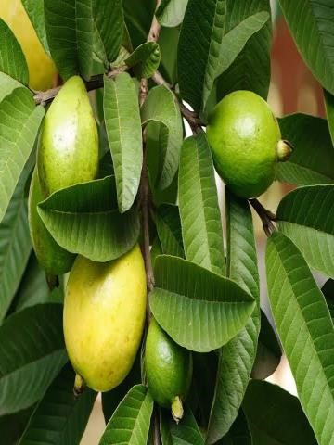Common name: Guava

Family: Myrtaceae

Scientific name: Psidium guajava

Parts used: Leaf

Role: Antibacterial

Treatment: Toothache, Bleeding gums

## 8. HARADA

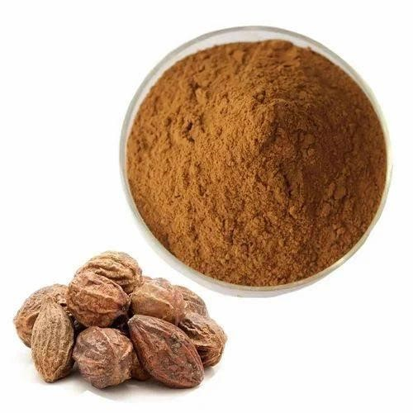Common name: Kadukkai, Harada

Family: Combretacaea

Scientific name: Terminalia chebula

Parts used: Dried immature fruits

Role: Anti-caries

Treatment: Cavities, Tooth decay

## 9 BABUL

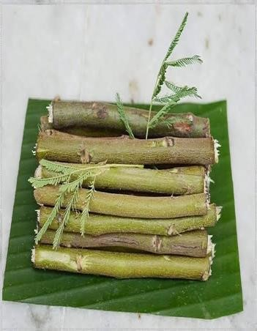Common name: Karuvellampattai, Babul

Family: Fabaceae

Scientific name: Acacia nilotica

Parts used: Bark

Role: Analgesic, Anti-inflammatory

Treatment: Plaque, Gingivities

## 10 MENTHOL

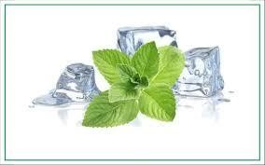Common name: Mint

Family: Lamiaceae

Scientific name: Mentha arvensis

Extract: Mint essential oil

Role: Antimicrobial

Uses: Refreshing, Cooling, Flavouring agents

## 11 HIMALAYAN ROCK SALT

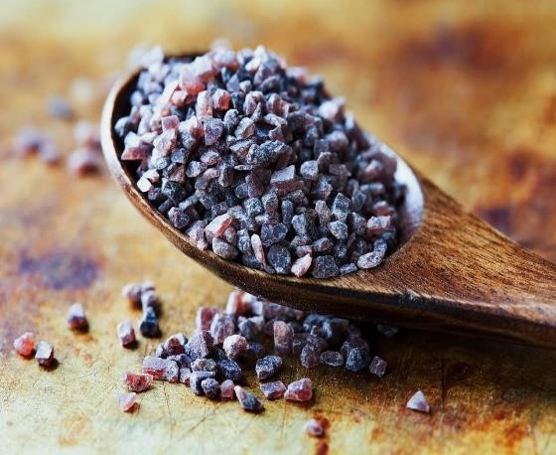Common name: Pink salt, Halite, Sendha namak

Treatment: Prevent the buildup of plaque and tarter

Uses: Flavouring agen

# 4. EVALUATION OF HERBAL TOOTH POWDER

The prepared herbal tooth powder underwent various assessments to determine its characteristics. These evaluations included organoleptic tests, which assess sensory properties such as taste, color, and odor; a patch test to check for potential skin reactions; a Physicochemical analysis to examine properties like texture, pH, and solubility; and an anti-microbial test to evaluate its effectiveness against harmful microorganisms. This version conveys the same message but is structured and worded differently to ensure originality.

## 5. ORGANOLEPTIC EVALUATION

The sensory characteristics, including color, aroma, and taste, were meticulously documented. Independent evaluations were conducted to assess the organoleptic and morphological attributes of the raw materials and their powdered forms, focusing on aspects such as color, fragrance, texture, and overall appearance.

**5.1 Colour:**

The color of the prepared tooth powder was assessed visually through direct observation.

**5.2 Odour:**

The odor of the product was evaluated through sensory examination by smelling.

**5.3 Taste**

The taste of the product was assessed through direct sensory evaluation.

**5.4 Texture**

The texture was assessed to determine its contribution to the overall quality of the product.

**5.5 Appearance**

The appearance was assessed through visual observation.

## 6 THERAPEUTIC EFFECTS AND BENEFIT

**6.1 Antibacterial Properties**: Several studies have highlighted the antimicrobial properties of ingredients like neem, clove, and turmeric, which help in reducing the bacterial load in the mouth and preventing common oral conditions like gingivitis and periodontitis.

**6.2 Plaque and Tartar Control**: Herbal ingredients like neem and baking soda are effective in controlling plaque formation and reducing tartar buildup. found that neem-based formulations were effective in reducing plaque and gingival bleeding, which are precursors to periodontal disease.

**6.3 Whitening and Stain Removal**: Activated charcoal and baking soda are often included for their gentle abrasive nature, helping to remove surface stains from teeth. While the efficacy of activated charcoal remains debated, found that activated charcoal toothpaste formulations could significantly reduce surface stains on teeth.

**6.4 Gum Health**: Turmeric’s anti-inflammatory properties have been found to help soothe gum tissues and prevent bleeding gums, which are often early indicators of gum disease

## 7 Formulation Techniques and Challenges

**7.1 Stability**: Many natural ingredients can degrade over time, losing their potency or flavor. For instance, essential oils can evaporate, and certain plant compounds can oxidize, reducing their effectiveness (Ahmad et al., 2021).

**7.2 Safety**: Some herbal ingredients, such as high concentrations of clove oil or charcoal, can be abrasive or irritating to sensitive gum tissues. Hence, proper formulation to balance effectiveness with safety is essential (Jain et al., 2020).

**7.3 Aesthetic and Palatability**: The taste, texture, and color of herbal tooth powders are important for consumer acceptance. Incorporating pleasant-tasting herbs like mint or fennel helps make the powder more appealing for regular use.

### 7.4 Recent Advances in Research

Nanotechnology in Herbal Tooth Powders: Recent innovations include the incorporation of nanoparticles, such as silver or zinc oxide, in herbal tooth powder formulations to enhance their antibacterial activity. Studies such as those by Sharma et al. (2022) suggest that silver nanoparticles have an enhanced ability to kill oral pathogens compared to traditional herbal ingredients.

Clinical Trials and Comparisons with Commercial Products: Clinical studies have also been conducted comparing the effectiveness of herbal tooth powders to conventional fluoride toothpaste. For example, a study by Sultana et al. (2023) compared the effects of a neembased herbal tooth powder with fluoride toothpaste on plaque control and gum health. The results showed that both products were equally effective in reducing plaque, though the herbal powder was perceived as safer for long-term use due to its natural composition.

## 8. Future Directions

The herbal tooth powder market is experiencing significant growth, driven by a rising consumer preference for natural and eco-friendly products. Research indicates that certain herbal ingredients can be effective in supporting oral health. However, further large-scale clinical studies are required to thoroughly assess the long-term benefits and any possible drawbacks associated with these products.

## 9.Research and Developments

### 9.1 Comparing Herbal Tooth Powders to Conventional Toothpaste :-

Research has yielded varied outcomes when evaluating herbal tooth powders against conventional toothpaste. Some studies indicate that herbal tooth powders can be equally effective in reducing plaque and gum inflammation. However, others suggest that fluoridebased toothpaste is superior in preventing tooth decay.

### 9.2 Safety Concerns :-

The long-term safety of herbal tooth powders raises some concerns, particularly with ingredients like activated charcoal, which may contribute to enamel erosion over time. Further studies are necessary to fully understand their potential side effects.

### 9.3 Regulations

Regulations for herbal tooth powders vary across countries. For example, they are widely used and accepted in countries like India. However, in many Western nations, there is a greater emphasis on establishing stricter standards and conducting comprehensive testing.

### 10. CONCLUSION

Herbal tooth powders are gaining popularity as individuals increasingly prefer natural health products. Ingredients such as neem, miswak, clove, turmeric, and activated charcoal are known for their potential oral health benefits. Despite this, questions remain regarding their efficacy, safety, and regulatory standards.

**11. REFERENCE:**

1. Valkenburg, C., Van der Weijden, F. A., & Slot, D. E. (2019). Plaque control and reduction of gingivitis: The evidence for dentifrices. Periodontology 2000, 79(1), 221-232.
2. Ledder, R. G., Latimer, J., Humphreys, G. J., Sreenivasan, P. K., & McBain, A. J. (2014). Bacteriological effects of dentifrices

with and without active ingredients of natural origin. Applied and environmental microbiology, 80(20), 6490-6498.

1. Shukla, K. V., & Kumari, D. (2019). Formulation Development and Evaluation of Herbal Toothpaste for Treatment of Oral

Disease. Journal of drug delivery and Therapeutics, 9(4-s), 98-104.

1. Prabha, M. S., Aruna, M. S., Gulshan, M. D., Radhika, S., & Ramarao, N. (2014). PREPARATION AND EVALUATION

OF HERBAL TOOTH PASTE COMPOSED OF HERBAL PRODUCTS. INTERNATIONAL

JOURNAL OF INNOVATIVE

PHARMACEUTICAL SCIENCES AND RESEARCH, 2(4), 817-826.

1. Saloni, S., & Shailedra, W. (2016). Preparation & evaluation of herbal toothpaste. Asian Journal of Pharmaceutical Research and Development, 1-05.
2. Arshad, Z., Abrar, A., Nosheen, S., & Mughal, T. (2020). Determining cadmium levels in herbal tooth powders purchased from streetmarkets in Lahore, Pakistan. Kuwait Journal of Science, 47(1).
3. Kadam, A., Prasad, B. S., Bagadia, D., & Hiremath, V. R. (2011). Effect of Ayurvedic herbs on control of plaque and gingivitis:

A randomized controlled trial. Ayu, 32(4), 532.

1. Ganesan, S. (2008). Traditional oral care medicinal plants survey of Tamil Nadu.
2. Devi, N., Parashar, B., & Kaushal, M. (2019). Preparartion, evaluation and comparision study of herbal tooth powder with marketed toothpowder.
3. Ojha, S. (2018). Formulation and evaluation of antibacterial herbal mouthwash against oral disorders. Indo Glob. J. Pharm.

Sci, 8, 37-40.

1. Chidi, P. C., Isima, P. C., Ikpa, C., Udumebraye, R. O., Ekwem, O. S., Obasi, T. O., ... & Agwu, C. O. (2022). Antibacterial

activity of chewing stick, dental powder and toothpastes sold in Umuahia, Abia State, Nigeria. GSC Advanced Research and

Reviews, 13(1), 039-049.

1. Anitha, A., & Praveen, G. (2015). Use of herbs in preventive dental care. Journal of Education and Ethics in Dentistry, 5(2),

55.

1. Bharathi, M., Rajalingam, D., Vinothkumar, S., Artheeswari, R., Kanimozhi, R., & Kousalya, V. (2020). Formulation and

evaluation of herbal tooth powder for oral care. International Journal of Pharmaceutical Research and Life Sciences, 8(1), 1-

5.

1. Dakhurkar, S. P., Mijgar, P. V., Wani, S. D., & Murkute, P. M. (2019).

Preparation and Evaluation of Herbal Tooth

Powder. World Journal of Pharmaceutical Research, 8(10), 944-948.

1. Asnotikar, G., Shetty, A. S., Mithun, C., Nayak, R., & Shilpashree, V. K. (2022). Development, Standardization and

Microbiological appraisal of Herbal Dentifrice prepared from Achyranthes aspera Linn.(Apamarga) leaves. World Journal of

Current Medical and Pharmaceutical Research, 131-138.

© 2023 IJNRD | Volume 8, Issue 8 August 2023 | ISSN: 2456-4184 |

IJNRD.ORG

IJNRD2308433 International Journal of Novel Research and Development

1. Mamatha, A., Swathi Vijaya, P., Vinutha, L., & Hemalatha, S. (2022). FORMULATION AND EVALUATION OF

HERBAL TOOTHPOWDERS USING INDIAN NETTLE, COCONUT SPATHE, TULSI

AND OTHERS. International

Journal of Pharmaceutical Research and Application, 7(1), 416-422.

1. Dudhe, S. B., & Doijad, C. R. Formulation and evaluation of Herbal toothpowder