**Fake News Detection Using Passive Aggressive Classifier**

**Gunashekhar S1, Nishanthi S2, Gayathri P 3, Ramya S4, Dr Jerald Prasath G5**

1Student, CSE, TJIT, Bengaluru, Karnataka, India

2Student, CSE, TJIT, Bengaluru, Karnataka, India

3Student, CSE, TJIT, Bengaluru, Karnataka, India

4Student, CSE, TJIT, Bengaluru, Karnataka, India

5 Associate Professor, CSE, TJIT, Bengaluru, Karnataka, India

**ABSTRACT**

The spread of fake news has become a significant issue in the digital age, affecting societal trust and decision-making. This paper presents a machine learning-based approach to fake news detection using the Passive-Aggressive Classifier. By leveraging natural language processing (NLP) for text preprocessing and feature extraction, the system classifies news articles as real or fake. The model demonstrates high efficiency and scalability, making it suitable for real-time applications such as social media moderation. This study highlights the effectiveness of the Passive-Aggressive Classifier for dynamic environments and provides insights into future enhancements to improve detection accuracy and applicability.

**Keywords:** News Detection, Passive Aggressive Classifier, machine learning.

1. **INTRODUCTION**

The proliferation of misinformation, commonly referred to as fake news, poses a growing threat in the digital era. Fake news is intentionally fabricated information designed to mislead readers and manipulate opinions. The ease of publishing and sharing content on digital platforms has accelerated the spread of such misinformation, impacting politics, public health, and societal cohesion.

Traditional methods of identifying fake news rely on manual fact-checking, which is time-consuming and infeasible at scale. Machine learning offers an automated solution to this problem. This study focuses on utilizing the Passive-Aggressive Classifier, an efficient online learning algorithm, to detect fake news. The classifier is particularly well-suited for this task due to its ability to process streaming data and adapt to new information incrementally.

1. **METHODOLOGY**

**2.1 Data Collection and Preprocessing**

A labeled dataset containing fake and real news articles was used to train and test the model. The text data underwent preprocessing steps such as tokenization, removal of stop words, stemming, and vectorization using Term Frequency-Inverse Document Frequency (TF-IDF). These steps ensured that the input features were optimized for the classifier.

**2.2 Passive-Aggressive Classifier**

The Passive-Aggressive Classifier is a linear model designed for online learning. Its dual behavior enables it to remain passive when predictions are correct and update aggressively in response to errors. The hinge loss function was employed to measure errors, and the model parameters were updated incrementally based on this loss. This approach ensures quick adaptation to new data while maintaining stability.

**2.3 Implementation and Evaluation**

The model was implemented using Python and Scikit-learn. The dataset was divided into training and testing sets, and performance metrics such as accuracy, precision, recall, and F1-score were used to evaluate the model. Cross-validation was employed to ensure robustness and generalizability.

1. **MODELING AND ANALYSIS**

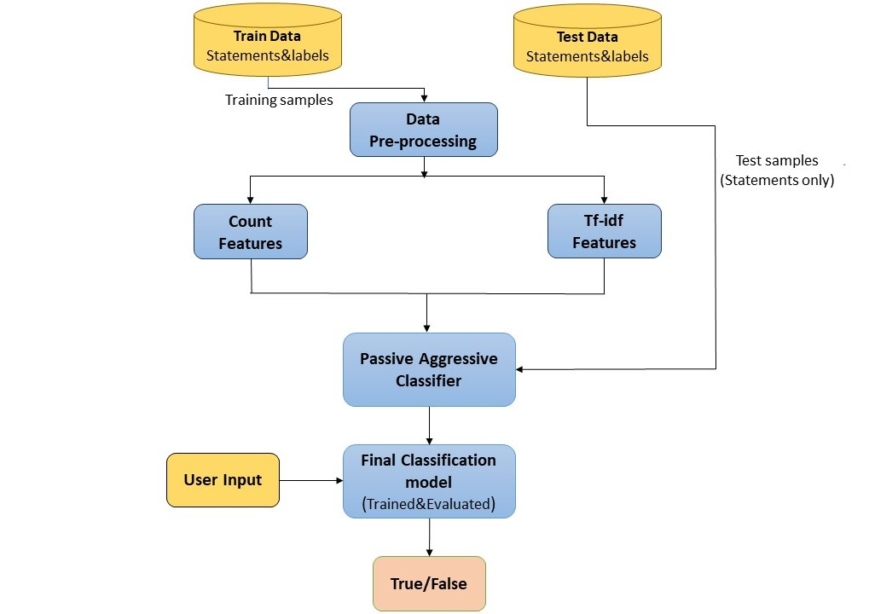

**Figure 1:** Passive Aggressive.

1. **RESULTS AND DISCUSSION**

The Passive-Aggressive Classifier demonstrated excellent performance in classifying fake and real news articles. With a high F1-score, the model proved effective in handling high-dimensional text data. Its ability to process data incrementally made it suitable for real-time applications. However, the study also revealed areas for improvement, such as enhancing the model's ability to handle multilingual data and non-textual content like images and videos.

The approach highlights the importance of feature engineering in improving classification accuracy. TF-IDF vectorization provided a strong representation of textual data, but additional features, such as sentiment analysis or metadata, could further enhance performance.

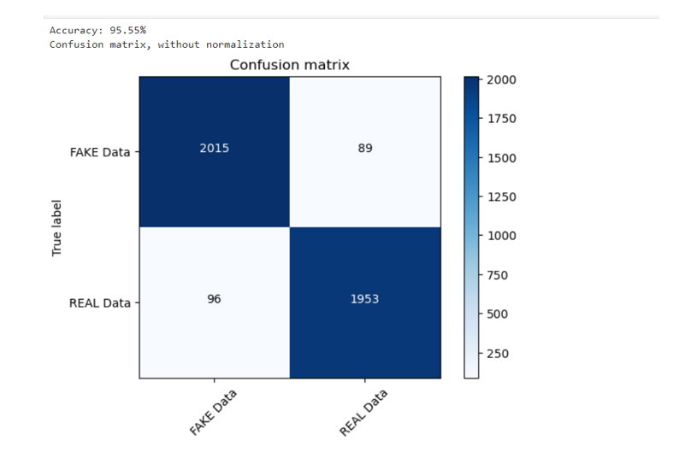

**Figure 1:** Confusion matrix.

1. **CONCLUSION**

This study demonstrates the efficacy of the Passive-Aggressive Classifier in detecting fake news through a machine learning framework. The model's efficiency, adaptability, and scalability make it a powerful tool for combating misinformation in dynamic environments. While the current implementation is focused on English text, future work will explore multi-language support, multimedia content analysis, and integration with real-time systems. These advancements will enable a more comprehensive and effective approach to fake news detection, contributing to a more informed and responsible digital ecosystem.

1. **REFERENCES**
2. Wang, W. Y. (2017). "Liar, liar pants on fire": A new benchmark dataset for fake news detection. Proceedings of the 55th Annual Meeting of the Association for Computational Linguistics.
3. Shu, K., Sliva, A., Wang, S., Tang, J., & Liu, H. (2017). Fake news detection on social media: A data mining perspective. ACM SIGKDD Explorations Newsletter.
4. Zhou, X., & Zafarani, R. (2019). Fake News: Fundamental theories, detection strategies, and challenges. Proceedings of the 12th ACM International Conference on Web Search and Data Mining.
5. Pedregosa, F., Varoquaux, G., Gramfort, A., Michel, V., Thirion, B., Grisel, O., ... & Duchesnay, E. (2011). Scikit-learn: Machine learning in Python. Journal of Machine Learning Research.