Abstract

Rainbow trout is a fish that nurtures itself to survive the wilderness. Sometimes, they use skin colouration for outer protection and to distract others from interfering with their private space. Marine biologists studied and researched the strategic and appropriate safety measures for breeding and controlling fish densities in aquaculture farming activity. Extreme weather and other environmental issues increase the infection rate due to the Epizootic haematopoeitic necrosis virus. It is a waterborne illness that is infested on a Rainbow trout fish to initiate its contagiousness and abruption to the liver, spleen, and kidney. External bleeding and other excessive complications increase the mortality rate among Rainbow trout fish.

Keywords: Aquaculture, Contagiousness, External bleeding, Excessive complications, Mortality rate.

Introduction

There is a tip and tail for codons in sequencing the three nucleotides named a trinucleotide, which empowers the tip and tail of a capping and amino acid by signaling the end of pathways, the stop signs for protein synthesis. DNA is very informative in that the letters of abbreviations are sequential in the form of bases in structural for its back structure. Then, the DNA is in a single strand of RNA left with unpaired bases of sequence to form amino acids according to paired-up trinucleotides. At first, they are individual trinucleotides. Afterward, they are separated to create amino acids for protein synthesis.

Genomes are characteristics or traits of attributes artificially made into binary options, such as infected or not infected. Inherited or not inherited is a spot as a carrier or recessive gene to develop the disease. They are also coated within a capsid, a shield form of protection, and their mobility traveling across the body's host is attached to receptors of cells as the main entrance for the invasion. Each pitstop has its reactivity after being signaled and activated for stimulation and triggering the body's sensational healing responses and embedded in antibody cells.

Rainbow trout are non-native fish that survive in the cold waters. Rainbow trout is rare in India (Devaa et al., 2023). The water temperature is more suited to recreational fish. No fishing activities are allowed. Located near Southern India, aquaculture activities are allowable for the Rainbow trouts due to water cultivation suitability. One of the human settlements in India is fishing activity. They continuously supported the activity until they decided to import Rainbow trout and heal themselves by the river banks of Southern India (Devaa et al., 2023).

Depending on the fattiness of the Rainbow trout, the dam and streamy locations of the rivers of Kerala and Tamil Nadu are the targeted sites for aquaculture activity. Thus, there is a story behind the nutritious meal prepared for Rainbow trout in addition to its captivity in bigger size (Kamalam et al., 2020). The price of food ranges between 40 and 70% of the production cost (Kamalam et al., 2020). Thus, the Rainbow trout farmers have done their budgeting and cutting costs by introducing alternative fish meals to maximise the return on investment.

Thus, nitrogen and protein are the main components of the meal (Kamalam et al., 2020). The vitamin is an added value in keeping up with their immune system. The Epizootic haematopoietic necrosis virus is contagious and has infected in abundance in the cold waters of the Rainbow Trouts. Geographical locations near the Lake of Mokoan and Nilahcootie Dam of catchments in Australia are the locations for the targetted disease (Becker et al., 2019). The location of infection is fatal in the visceral tissue where the fat adipose tissue is, as this can be further inspected with the flesh of the fish (Becker et al., 2019). The virus is double-stranded DNA that has infected the fish's skin, gills, or mouth (Becker et al., 2019). What is most worrying is that it may also infect other sites, such as spleens, kidneys, and liver (Becker et al., 2019).

The gene mapping is to investigate several farmed rainbow trouts for future reference. Despite the alarming series of events, they attempted to do polymerase chain reaction and serology tests for further confirmation of having the disease. Thus, epidemiology, histology, and aetiology of the disease are to understand and identify the causes of the low water flow and poor water quality, the potential factors for the number of losses.

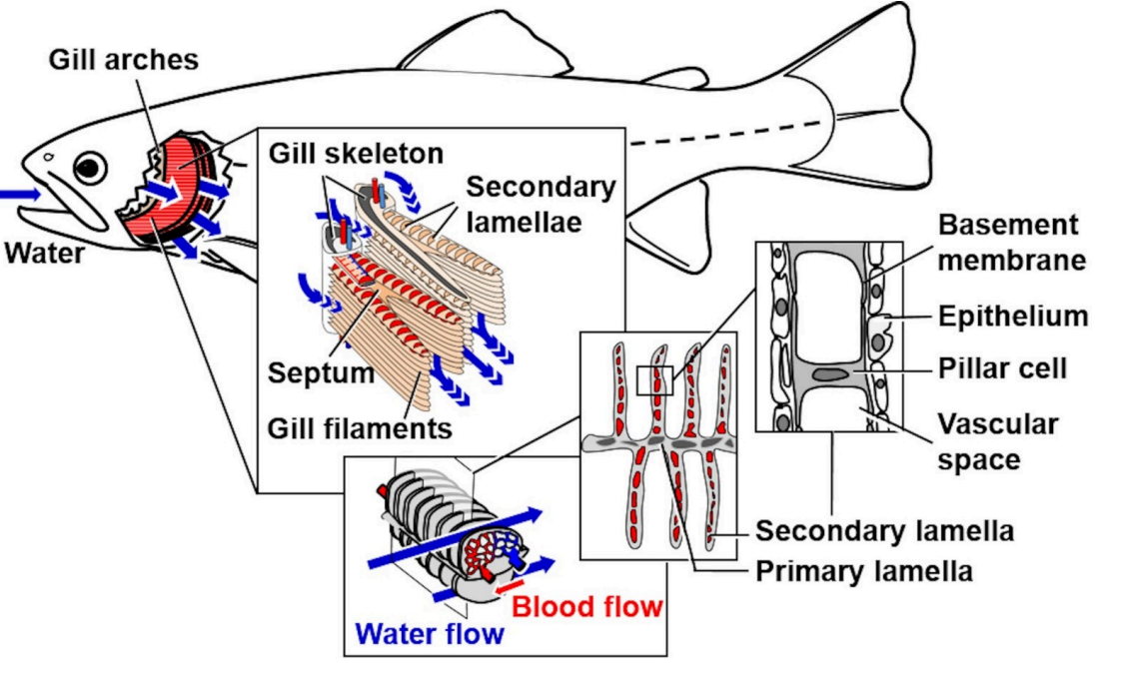

Figure 1: Schematic pictures of morphological and corresponding histological sections. Source: Fiedler et al., 2020)

Literature Review

Rainbow trout are a scarce species. Fish samples have been taken from the riverbed to breed, feed, and adapt to the environment. Rainbow trout are native to freshwater and riverbanks as they are attracted to and find their homes for shelter, such as aquatic freshwater and caskets to give them some space of a micasa. They feed on plankton and other sea crawlers creeping on the sand underneath the sea. They even face against the current to flip all the way through.

Across the Pacific Ocean from America to Russia, there is also a hybrid gene of a trout fish. The hatcheries near the nest and fish lairs as other fighting fish bred there. The interbreeding season is during the fall or autumn season (May to October) and (November to April). Hence, the morphological characteristics of rainbow trout are also of interest in providing a comprehensive overview to highlight the descriptive statistics of the data (Fiedler et al., 2020). It is as if another dimension of planes plotted to get a hold of the picture of the significance computationally to describe their characteristics (Fiedler et al., 2020). The thin bone called lamella intends to give more ion exchange of a breathing mechanism in the gill (Fiedler et al., 2020).

Then, the gill lesions are affected by the environmental cause of oil spills. It damages the gills' health and puts them at a higher risk of living. According to the correct methodology, they used a laser sheet fluorescence microscopic to take on the gill filament samples for further examination. Afterward, the methodological approach involved a fixation that may also risk them called vascular perfusion fixation to examine the liver and kidney (Fiedler et al., 2020). Another method of investigation is to use a dye solution to identify the metals and other substances discovered in the gills of Rainbow trout for interrupting the breathing and feeding mechanisms.

Ecosystem health is interdisciplinary and depends on the fish population since fish breed in freshwater. Other land-based animals must rely on carbon-efficient food, which may not interrupt the food chain system. Therefore, there is a need for governance on the nature preseverence. The organs and cells infected by pathogens, prions, and parasites are identifiable within the human respiratory system. Thus, asthma and allergy were two airborne diseases that infect their breathing systems. In the epizootic animal approach, aquatic animals tend to have the disease due to fungi called oomycete. The fungi itself is affected by morphological measurements, nutrient uptake, and nature's uptake. Therefore, they are interconnected and integrated most environmentally.

The infected gill in Rainbow trout is highly inflammable, with cell infiltrations and ulcerative lesions (Fiedler et al., 2020). Five Rainbow trouts with morphological measurements of 300 to 2000g put on weight to be experimented with for this paper (Fiedler et al., 2020). They used gill parameters for further analyses of the health indicators (Fiedler et al., 2020). The tissue is one cell thick and consists of the first filament of lamellae and the secondary one. The ingrowth of smaller bones or cartilages called archers from the first gill of lamellae. The secondary is the extension of the first gill lamellae.

Trout farming was initiated in California as early as 1870-1873 (Sun et al., 2023). In the 1990s, the pellet was on fish meat, which was more expensive than beef steak (Sun et al., 2023). The genetic code for a trout depends on the habitats and hatcheries of many dry fish. For instance, European dry fish trout were exported to Denmark, becoming the first trout farm in 1885 (Sun et al., 2023). Thus, the field estimates in the descriptive analyses are on different trout species. To gain more knowledge and understanding of the habitual and genetic differences in Rainbow trout among themselves.

Further, a correlational analysis is a suitable method for identifying and determining which factors influenced the productivity of Rainbow trout fish. It can be experimental since the whole process of analysing involves different life stages of Rainbow trout and body composition traits for the pedigree in life development (Vehvilainen et al., 2012). Therefore, there is a need to study the health traits and resistance to different kinds of diseases. One of the crucial points in studying the correlation between growth and survival in nature is to propose life history theory and selective breeding (Vehvilainen et al., 2012). Other external factors entered the vector as the third party to explain genetic associations (Vehvialinen et al., 2012).

They theorised that there is a positive correlation between growth and survival among farm animals (Vehvialinen et al., 2012). The negative correlation occurs when the development of a Rainbow trout also increases the risk of wanting more on feeding and causing the fatness of the fish to construe with the statement (Vehvialinen et al., 2012). Thus, it is not a directive relationship between the two but more of a multitude of mortality factors (Vehvialinen et al., 2012).

The fingerling is the baseline period in which it all started right from the beginning. The change in shape and size faced during the first development stage in Rainbow trout resulted in a positive correlation between weight and survival. Their eyesight depends on the weight that they put on. Yet, the Rainbow trout is in between weight and mortality. As they put more weight, the survivability of the Rainbow trout influences the lives they have had. It all depends on the life stages of Rainbow trout and the risk taken to be a survivor (Vehvilainen et al., 2012).

Thus, a mesocosm method would study their resistance to the tide and adaptability in the ecosystem. To their understanding, in the power of logic, Rainbow trout can swim, and even in a group, they are trying to look out for a hide as their breeding site. Even giant companies are targeting having an organic fish meal for the trouts. As a rough guide, protein-based meals have even been tried to experience the newly acquired taste but still lack support. The formula feed conversion ratio is an added value to health effects among the fish (Tefal et al., 2024). Hermetia and fish meals are among their favourite delicacies (Tefal et al., 2024).

The growth assay measures the necessities in response to nutritional and biometrics. Hence, composition values are used just like nutrient supplementary facts and figures printed on the back of the food packaging. Thus, at a control level, the fish feed consisted highly of fishmeal, soybean meal, wheat, and fish oil (Tefal et al., 2024). Overall, the nutritional composition of the control fish feed is mostly crude protein followed by energy in carbohydrates, protein, and fat (Tefal et al., 2024). To others, the seabass-fishmeal surpasses the whole mixture of fish feed since it is highly nutritious and edible for the fish to feed on (Tefal et al., 2024). In essential amino acids, seabass-fishmeal is the most likely to be selected for enhancing the flavours and health benefits (Tefal et al., 2024). However, they found that seabass-fishmeal is more of a divine supplementary food to others since the non-essential amino acids are produced in the body (Tefal et al., 2024).

Therefore, there is a significant value in having supplementary food to replace the body's function in a regulated way. Too many non-essential amino acids cause the body to process energy conversion and by-product formation at a slower rate.

Methodology

The method used is a rapid review of the morphology and pathological ways for epidemiological and pathogenicity of epizootic haematopoeitic necrosis virus, especially in Rainbow trout fish. The environmental factors of an oceanic composition to treat chlorinated wastes in combating the disease are more impactful to the study. The pathogenicity of the epizootic haematopoeitic necrosis virus may cause a deadly threat to the fish once it gets infected. It is not that much known for its infectivity as the infection rate is still increasing and the confounding factors, such as oceanic settings and temperature have the tendency to indirectly and directly correlated with the disease.

Result and Analysis

Epizootic hematopoietic necrosis virus was first identified in 1984 in Victoria, Australia (Becker et al., 2019). The World Organization for Animal Health has clarified its virulence and virus spread at the speed of light after two decades (Becker et al., 2019). Although Rainbow trout are not in the lead for the prevalence, there are still figures that support the fact that the fish species may also reconsider further health checking. Thus, the sample size is too small for a land down under. Another type of fish to be infected is the red perch, in which the number of catchments and the number of infected is limited. The angling survey needs to be improved further to balance the data for training and testing.

Thus, the epizootic hematopoietic necrosis virus is an unrecognisable iridovirus and anthropoid that is difficult to detect before its virulence becomes uncontrollable. The infections are viral among Rainbow trout, similar to the bluetongue virus (an insect-borne disease) on live ruminants only. Haematopoietic refers to the blood production cell that infects the skin, gills, or mouth on water temperature and humidity. Therefore, there is not much literature explaining the phenomena of the definition and histology of the disease.

The infected dorsal fin held it in the opposite force of the drag. The pathological effect of the virus also turns the bleeding process into a nightmare. The liver, spleen, and kidney involved in the circulation process may also face the same consequences. It is a causative virus that only infects red Perch and Rainbow trout. Necrosis is more like a tissue disease that has already gone out of order due to an infection. It is alarming that the outbreak in Australia has caused many fish's lives to vanquish into thin air without a sign.

Even husbandry practices worldwide are still puzzled about the kind of treatment that would cure the virus totally inside the fish's organs. The virus is automatically highly reactive when a chemical process is inside a cell. Thus, the nucleic acids mutate the genetic sequence in the dysfunctional process of manufacturing proteins. The strategy is to remove the bacteria or anthropods from circulating and attaching themselves to the body's cellular functions. Therefore, the proteins are sheaths that unleash an abundance of antibodies that attach themselves to these anthropods and act as a magnet to remove them from the body.

Their habitat and living spaces in freshwater and the Pacific Ocean are unbearable. They have to compete for a living. They swam across the streams in the same repetitive activity. They are under cover from other predatory fish in the gravel bottoms. Ever since the climatic change, the water temperature has been in a cyclical vortex to regulate the temperature of the fish habitat to avoid any unwanted body changes. Nature itself has debts to pay. The cyclical formation of hurricanes and floods also comes from the biological process in living things. There is a high tendency to increase the number of pathogens during climatic changes (Leiva-Rebollo et al., 2024).

Vaccines are ready for further protection against the epizootic haematopoietic necrosis virus at the innate and adaptive immunity level (Leiva-Rebollo et al., 2024). The iridoviruses are the most common among the Rainbow trout fish (Leiva-Rebollo et al., 2024). Therefore, an orally administered vaccination for the gastrointestinal tract lowers the risk of having pathogenic blood-borne transformation (Leiva-Rebollo et al., 2024). Thus, the pathology for the virus to come in is also halted and avoided for further complications. Vaccine efficacy and fish survival rates relied on dosage intake and water temperature (Leiva-Rebollo et al., 2024).

Further, there was cell culture by smudging the petri dish with a dye solution to place it on a cellulose fin structure of the Red seabream (Min et al., 2024). Then, under a microscope, the icosahedron shaped like a capsid in its presence. There is a mass mortality in the Red seabream fish species, which instantly spread across their habitats (Min et al., 2024). However, the rock bream is not registered for vaccination against the disease (Min et al., 2024). Hence, most of the enlisted factors for the efficacy of inoculation are under study (Min et al., 2024). Then, there is a cyclical vaccination over time for the side effects of medication and the improvement in the functionality of their spleens (Min et al., 2024).

The cyclical event is an epidemic model to predict the outcomes. Within a couple of weeks, the Red seabream will experience some differences in their physical morphology and inner body strength in fighting off the disease. Thus, the vaccinated Red Seabream has a higher likelihood of fewer events in the health outcome. The control ones are facing dismaying consequences as their mortality rate is higher than the vaccinated ones (Min et al., 2024). The neutralising antibodies give more chances and increase the probability of protecting themselves from the infection.

The prolactin gene is the key to all functionality of the Red seabream in adapting itself to the aquatic life (Nam et al., 2019). The prolactin gene is in the osmoregulation process for a fish to breathe beneath the sea. Prolactin and its' permeability property and ionisation metabolism is an unbearable protective figure of a barrier in the immunity system. The known cytokine storms and cell growth and division would be a great start to a wholesome of healthy cells in tingling with the body's functional system. As an expansion to the previous studies, there is an interest in observing and identifying the various factors affecting their genomic characteristics in three different fish farms (Nam et al., 2019).

Total gas concentration and saturation may affect the PH and water temperatures (Lahnsteiner, 2024). Unfortunately, a rainbow trout cannot survive the tremendous gauge and uprising water temperature as it is beyond the regulated temperature and optimisation of ionisation in the gills epithelium through the surface area and horizontal plane (Lahnsteiner, 2024). On the horizontal plane, the bouncy ions and particles collide. To show that the changes in temperate water are not that calm for a fish to swim across. The ionic gaseous exchange is not affected by body heat and blood circulation.

The phylogenetic characteristics of a species are also related to the pathology of a gill disease (Al-Saeedi et al., 2024). Environmental pressure, including the dysregulation of water temperature and the survivability of a fish, also lives on it (Al-Saeedi et al., 2024). In other words, the fish has a respiratory problem in an aquatic environment. They even devised a solution using a dye and veterinary medicament to reduce the fungus in chlorinated water (Al-Saeedi et al., 2024). The smell of a fish from its snout is more like ammonia gas, diluting the water surface as chemically-borne breathing affects the ventilation inside the gills.

In a wild catch, 21% of steelhead trout had a myxobacterial infection on the gills, which troubled them with a good appetite and breathing difficulty (Al-Saeedi et al., 2024). More than 90% of Catfish have experienced different physical changes that affected their marketing value (Al-Saeedi et al., 2024). A gill has a set of arches that put the filaments in place and increase the surface area for a jawline to feed on their meals. In terms of humanity, they attempted to put on medication to reduce the symptoms and improve their breathing mechanism. The first potential solution is to heal the epithelial cells in the bronchial area to remove the mucus, support more oxygenated and deoxygenated circulation of the alveolus, and improve the immune response for a more air-quality-breathable surface area in the lining of the gills.

Marine biologists even simulate and reenact the event by artificially placing the water composition at an even temperature and less fish density, to begin with. The sand limestone dissolves the salt beside the shore with a never-ending water surface that evaporates the whole time. Even the slightest changes in water salinity may affect the water composition, causing a chemical reaction in the body's biochemical process (Bawa-Allah et al., 2021). For instance, niacin is a soluble vitamin that can be a proper meal for a shrimp and a fish. In this case, the rainbow trout didn't face any water toxicity and adjusted to different water salinity in a fixated viability (Bawa-Allah et al., 2021). The enlightened spirit of a fish can reduce the level of stress pressed by the water pollutants that are dysregulated by the glucocorticoid (Bawa-Allah et al., 2021).

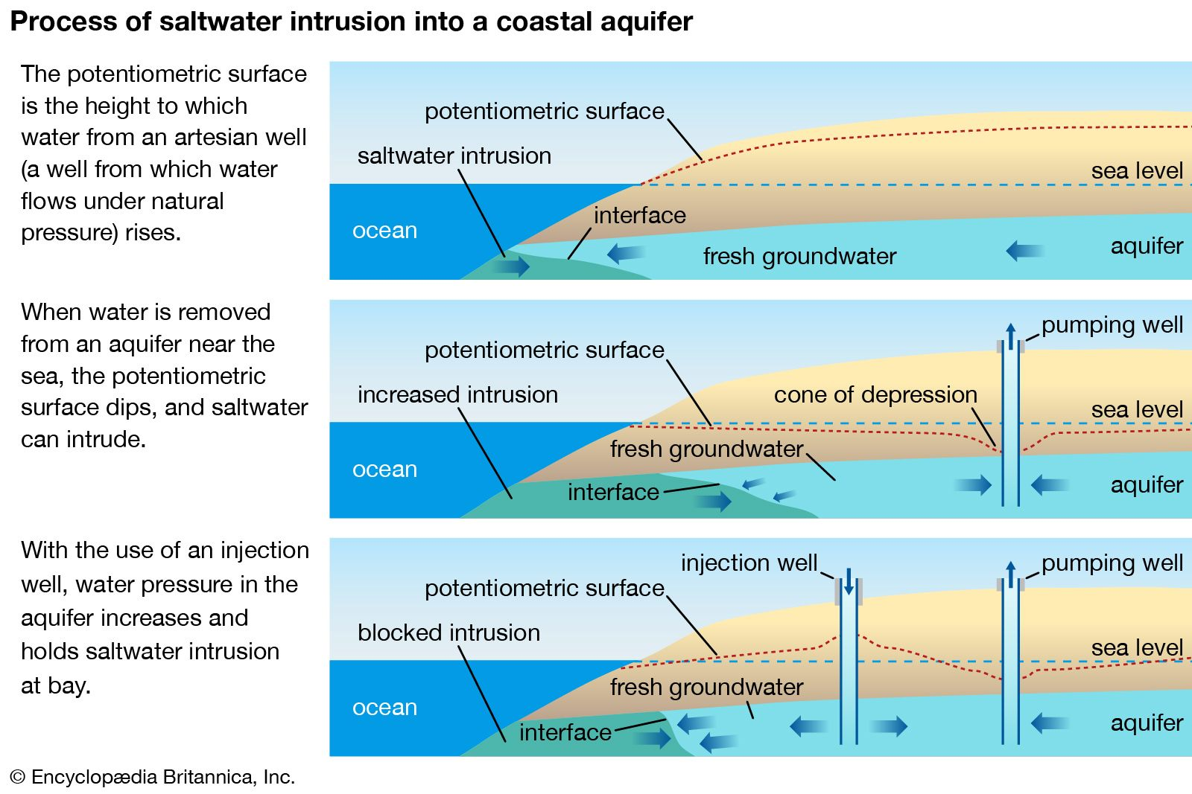Figure 2: The Water Salinity and Composition in Depth of Ocean’s Level. (Source: Britannica, 2019).

Overall, the diagnosis and aetiology causes of pathological pathways and manifestations of fish diseases are still under review for oceanic discovery. For control measures, there is biosecurity to avoid any hazards and risks of the invasion and dissemination of virulent viruses from the danger of infectious disease. The spreading model of the the epizootic haematopoeitic necrosis virus is by translocation in the fish bait (Oidtmann et al., 2017). Premineralisation decay and elevated temperature due to methane gas emitted by the erupted volcanic ocean floor may contribute to the hardness of water.

Through a range of observant and unexpected series of events, marine biologists and activists decided to adopt fish farming or aquaculture for rainbow trout. As mentioned before, the decay of viruses can also be restructured and remodeled in a simulated way (Oidtmann et al., 2017). The infectious pancreatic necrosis virus cointegrates from penetration to the excretion of lysozyme in undertaking the overpressure and overbearing of the metabolic effect of the contagious disease (Pajdak-Czaus et al., 2021).

Discussion

Imbalanced data in a geographical expansion leads to inconclusive statements on scarcity. Iridovirus is a patch of microorganisms enlivened as the water-borne illness remains undetectable. Vaccines were researched and manufactured at ease with the help of cell cultivation. The oceanic approach plays a role in regulating the temperature and fish density.

Simulated and artificial data involved randomisation. In this case, it is with the same species of Rainbow trout fish. Treatment allocation controlled and tested for pre-medication in a clinical trial have a promising aftervalue. Water chemistry and electrolytes are two intertwined wordings used in cytoplasmatic and biochemical reactions. Water turbulence may have a cyclical and uneven data distribution to control for a more environmentally friendly approach.

Technologically driven data on oceanic surface and water beaming during the day and night are for more aerial surveys. Since it is a symptomless disease, early detection and high-tech or sensory devices are required for Mother Nature. A dye solution for eliminating harmful chemicals and dechlorination is not the only solution. The salinity of water that cointegrates with a water-borne transmission is not consistent.

Conclusion

Water-borne illness, the epizootic haematopoietic necrosis virus unanimously is undetectable and remains uncensored for its series of events in improving the survivability of the Rainbow trout fish. It is more environmentally related due to water temperature, water contentment, oceanic atmospheric pressure, fish density, and habitual behaviour affecting the manifestation of the disease. Veterinary medicament is one of the secure ways to treat water and control the spreading of the disease. Based on the spreading model itself, it is still inconclusive about the early detection and symptoms of the disease.

References:

1. A practical guide to unbiased quantitative morphological analyses of the gills of rainbow trout (Oncorhynchus mykiss) in ecotoxicological studies.
2. Sun, L., Engle, C. R., Kumar, G., & van Senten, J. (2023). Supermarket trends for rainbow and steelhead trout products: Evidence from scanner data. *Aquaculture Reports*, *30*, 101579.
3. Vehviläinen, H., Kause, A., Kuukka-Anttila, H., Koskinen, H., & Paananen, T. (2012). Untangling the positive genetic correlation between rainbow trout growth and survival. *Evolutionary applications*, *5*(7), 732–745. <https://doi.org/10.1111/j.1752-4571.2012.00251.x>.
4. Tefal, E., Peñaranda, D. S., Martínez-Llorens, S., Tomás-Vidal, A., Jauralde, I., Lagos, L., Moyano, F.J., & Jover-Cerdá, M. (2024). Feeding of rainbow trout (Oncorhynchus mykiss) with organic ingredients replacing fish meal. *Aquaculture*, 741257.
5. Becker, J., Gilligan, D., Asmus, M., Tweedie, A., & Whittington, R. (2019). Geographic Distribution of Epizootic haematopoietic necrosis virus (EHNV) in Freshwater Fish in South Eastern Australia: Lost Opportunity for a Notifiable Pathogen to Expand Its Geographic Range. *Viruses*, *11*(4), 315. <https://doi.org/10.3390/v11040315>.
6. Epizootic haematopoietic necrosis. (2022). *CABI Compendium*, *CABI Compendium*. <https://doi.org/10.1079/cabicompendium.83967>.
7. Leong, J.-A. (2024). infectious haematopoeitic necrosis [Review of *infectious haematopoeitic necrosis*]. *CABI COMPENDIUM*.
8. Leiva-Rebollo, R., Labella, A. M., Gémez-Mata, J., Castro, D., & Borrego, J. J. (2024). Fish Iridoviridae: infection, vaccination and immune response. *Veterinary Research*, *55*(1), 88.
9. Min, J.-G., Kim, G.-H., Kim, C.-H., Kwon, W.-J., Jeong, H.-D., & Kim, K.-I. (2024). Evaluation of Formalin-Inactivated Vaccine Efficacy against Red Seabream Iridovirus (RSIV) in Laboratory and Field Conditions. *Vaccines*, *12*(6), 680–680. <https://doi.org/10.3390/vaccines12060680>.
10. Nam, B.-H., Yoo, D., Kim, Y.-O., Park, J. Y., Shin, Y., Shin, G., Park, C.-I., Kim, H., & Kwak, W. (2019). Whole genome sequencing reveals the impact of recent artificial selection on red sea bream reared in fish farms. *Scientific Reports*, *9*(1). <https://doi.org/10.1038/s41598-019-42988-z>.
11. Lahnsteiner, F. (2024). Morphometric and Enzymatic Changes in Gills of Rainbow Trout after Exposure to Elevated Temperature—Indications for Gill Remodeling. *Animals*, *14*(6), 919–919. <https://doi.org/10.3390/ani14060919>.
12. Al-Saeedi, N.K., Dakheel, M., & Degaim, Z. D. (2024). Understanding and Managing Gill Infections in Fish. *University of Thi-Qar Journal of agricultural research*, *13*(2), 315-326.
13. Bawa-Allah, K. A., Otitoloju, A., & Hogstrand, C. (2021). Cultured rainbow trout gill epithelium as an in vitro method for marine ecosystem toxicological studies. *Heliyon*, *7*(9).
14. Oidtmann, B., Dixon, P., Way, K., Joiner, C., & Bayley, A. E. (2017). Risk of waterborne virus spread - review of survival of relevant fish and crustacean viruses in the aquatic environment and implications for control measures. *Reviews in Aquaculture*, *10*(3), 641–669. <https://doi.org/10.1111/raq.12192>.
15. Britannica. (2019). Seawater - Salinity distribution. In *Encyclopædia Britannica*. <https://www.britannica.com/science/seawater/Salinity-distribution>.
16. Pajdak-Czaus, J., Schulz, P., Elżbieta Terech-Majewska, Szweda, W., Andrzej Krzysztof Siwicki, & Aleksandra Platt-Samoraj. (2021). Influence of Infectious Pancreatic Necrosis Virus and Yersinia ruckeri Co-Infection on a Non-Specific Immune System in Rainbow Trout (Oncorhynchus mykiss). *Animals*, *11*(7), 1974–1974. <https://doi.org/10.3390/ani11071974>.