Interactive Learning in Cybersecurity: A Study on the Effectiveness of Simulation Games in Educating Users

Ayush Samir Rane
Department of Information Technology
Kishinchand Chellaram College
HSNC University
Mumbai,India
aayushrane39@gmail.com

Dr. Rakhi O. Gupta
Co-ordinator, I.T Department Kishinchand Chellaram College
HSNC University
Mumbai, India
rakhi.gupta@kccollege.edu.in

Nashrah Gowalker
Assistant Professor, I.T. Department
Kishinchand Chellaram College
HSNC University
Mumbai, India
nashrah.gowalkar@kccollege.edu.in

Abstract— In the quickly advancing scene of cybersecurity, conventional preparing strategies regularly drop brief in giving hands-on involvement and viable aptitudes. This inquiries about investigates the viability of utilizing reenactment recreations as an instrument for cybersecurity instruction. We display a cybersecurity recreation diversion outlined to inundate clients in practical cyber danger scenarios, such as phishing assaults, ransomware, and unauthorized get to endeavors. The diversion points bridge the crevice between hypothetical information and real-world application by advertising intuitively and locking in learning encounters. Through a combination of gameplay mechanics and instructive substance, this consider assesses how reenactment recreations can upgrade users' understanding of cybersecurity concepts, move forward their danger discovery and reaction aptitudes, and contribute to more compelling preparing arrangements. The discoveries propose that recreation diversions can give important, viable learning openings and offer experiences into their potential benefits and confinements in the setting of cybersecurity instruction.
Keywords: Cybersecurity Education, Simulation Games, Gamification, Interactive Learning, Threat Detection, Cybersecurity Training, Practical Experience, Real-Time Feedback, Engagement, Skill Development

Introduction

Traditional Methods of Learning Cybersecurity
Traditional methods of cybersecurity education encompass a range of pedagogical approaches including lectures, textbooks, and theoretical coursework. These methods are fundamental for establishing a foundational understanding of cybersecurity principles, such as confidentiality, integrity, and availability (CIA), as well as various security protocols and strategies. Lectures typically deliver broad overviews of security concepts and introduce theoretical frameworks. Textbooks provide in-depth coverage of topics such as network security, cryptographic techniques, and risk management, offering detailed explanations of security measures, attack vectors, and defense mechanisms.
While these approaches are crucial for building a theoretical knowledge base, they often fall short in offering practical, hands-on experiences. Traditional education methods focus on imparting knowledge through static content without the opportunity for learners to actively engage with real-world scenarios. This approach may result in a superficial understanding of complex cybersecurity issues, as learners are not given the chance to apply theoretical knowledge in practical situations.
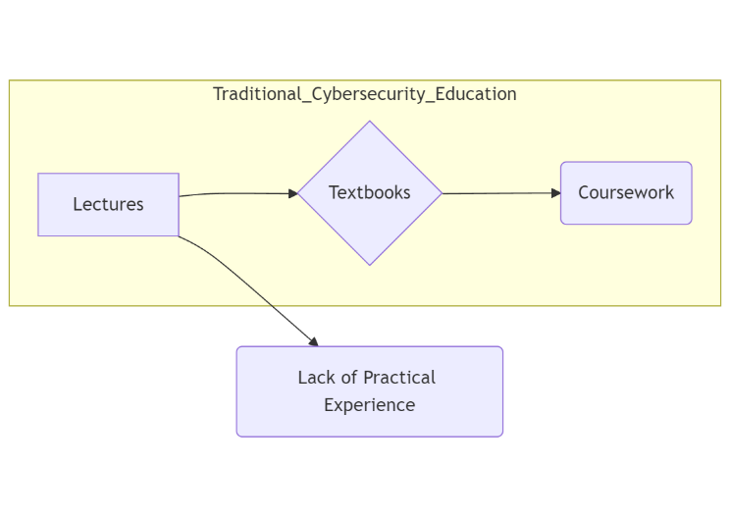
Figure 1: Traditional Cybersecurity Education

Disadvantages of Traditional Cybersecurity Education
Despite their importance, traditional cybersecurity education methods have several notable limitations:
- Lack of Engagement:
Traditional educational approaches often fail to actively engage learners. The reliance on lectures and textbooks can lead to passive learning, where students absorb information without interacting with the material or applying it in practical contexts.
- Limited Practical Application:
One of the significant drawbacks of traditional methods is the limited opportunity for learners to apply their knowledge. Theoretical coursework may not adequately prepare learners to handle real-world cyber threats, as it lacks interactive elements that simulate actual cybersecurity scenarios.
- Inability to Simulate Real-World Threats:
Traditional education methods are generally static and do not adapt to the evolving nature of cyber threats. As cyber threats continuously evolve, traditional approaches struggle to keep pace, leaving learners unprepared for the latest attack vectors.
- Lack of Real-Time Feedback:
Traditional methods do not offer real-time feedback, which is crucial for effective learning. Without immediate feedback on their actions, learners may not fully understand the consequences of their decisions or have the opportunity to correct mistakes in real time.
- Inadequate Adaptability:
Conventional training methods are often rigid and do not adapt to individual learning needs or emerging threats. This lack of adaptability can hinder learners' ability to stay current with the latest cybersecurity challenges.

Introduction of Simulation Games in Cybersecurity Education
In response to the limitations of traditional methods, simulation games have emerged as a promising alternative for enhancing cybersecurity education. These games create immersive, interactive environments where users can engage with realistic cyber threat scenarios. Simulation games offer several advantages:
- Interactive Learning:
Simulation games provide a dynamic learning experience, allowing users to actively participate in scenarios that mimic real-world cyber threats. This interactive approach helps bridge the gap between theoretical knowledge and practical application.
- Gamification:
Many simulation games incorporate gamification elements, such as scoring systems, progress tracking, and rewards, to increase engagement and motivation. These elements encourage learners to actively participate and invest in their learning process.
- Hands-On Experience:
Simulation games offer hands-on experience by allowing users to practice and refine their cybersecurity skills in a controlled setting. This practical approach enables learners to experiment with different strategies and solutions in response to simulated threats.
- Real-Time Feedback:
One of the key benefits of simulation games is the provision of real-time feedback. Learners receive immediate responses to their actions, helping them understand the impact of their decisions and adjust their strategies accordingly.
- Dynamic Content:
Simulation games can dynamically adapt to emerging threats and scenarios, providing up-to-date content that reflects the current cybersecurity landscape. This adaptability ensures that learners are exposed to the latest attack vectors and defense techniques.
By addressing the limitations of traditional methods, simulation games offer a more effective and engaging approach to cybersecurity education, enhancing learners' understanding and practical skills.
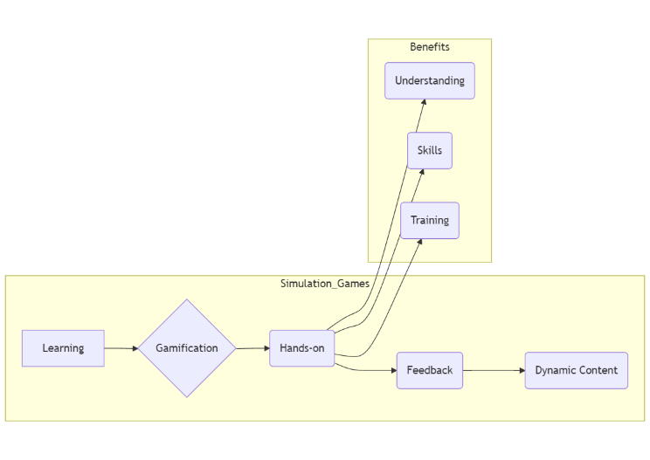Figure 2: Simulation Games for Practical Cybersecurity Learning

Literature Review
The ever-evolving landscape of cyber threats presents a significant challenge for traditional cybersecurity education. While foundational, these methods often struggle to keep pace with the rapid development of new attack vectors and defense mechanisms, leaving learners unprepared for real-world scenarios. This gap between theoretical knowledge and practical application has led researchers and practitioners to explore alternative learning environments, specifically simulation games, as a promising solution.
A. Enhanced Engagement and Motivation:
Research consistently demonstrates that simulation games can effectively increase learner engagement and motivation in cybersecurity education. Wu et al. (2021) found that gamification significantly improves Information Security Awareness (ISA) knowledge acquisition compared to traditional lecture-based approaches. Simulation games often incorporate gamification elements like points, rewards, and leaderboards, contributing to a more enjoyable and motivating learning experience.
B. Development of Practical Skills:
Simulation games provide a valuable opportunity for learners to develop practical cybersecurity skills in a controlled environment. Švábenský et al. (2018) demonstrated that simulations effectively enhance cybersecurity skills, particularly highlighting the role of real-time feedback in promoting adaptive learning and improved decision-making. These games allow learners to practice applying cybersecurity concepts in realistic scenarios, receive immediate feedback on their actions, and learn from their mistakes.
Williams et al. (2024) further support this finding, showing that gamified Capture The Flag (CTF) competitions, which often involve simulating real-world cybersecurity scenarios, effectively enhance student engagement, motivation, and learning outcomes in cybersecurity education.
C. Adaptability to Emerging Threats:
A key advantage of simulation games is their ability to adapt to the ever-changing landscape of cybersecurity threats. Kavak et al. (2021) emphasize that simulation games can be dynamically updated to incorporate emerging threats and technologies. This adaptability ensures that learners are exposed to the latest attack vectors and defensive techniques, equipping them to handle the evolving cybersecurity landscape.
D. Real-Time Feedback and Continuous Improvement:
The provision of real-time feedback is a critical factor in effective learning, and simulation games excel in this area. Scherb et al. (2023) highlight the importance of real-time feedback in cybersecurity simulations, emphasizing that it allows learners to immediately understand the consequences of their actions and adjust their strategies accordingly. This dynamic feedback mechanism fosters a more responsive and adaptive learning experience, promoting continuous improvement.
E. Challenges and Limitations
While simulation games offer promising benefits, they are not without challenges. Simpson and Brantly (2022) advocate for more comprehensive simulations that encompass a wider range of security concepts beyond cybersecurity, such as disaster response and national security.
Accessibility issues also pose a significant challenge. Simulation games may require specific hardware or software, making them less accessible to learners who lack the necessary resources. Furthermore, the lack of standardized evaluation methods hinders widespread adoption and limits understanding of the long-term impact of simulation-based training.
F. Solutions and Future Directions
Addressing these challenges requires ongoing research and development. Future research should focus on:
- Expanding the scope of simulations: Creating simulations that encompass a wider range of security concepts and address real-world scenarios beyond technical aspects.
- Improving accessibility: Exploring low-cost or open-source platforms to make simulation games more accessible to diverse learners.
- Developing standardized evaluation methods: Creating rigorous and reliable methods for evaluating the long-term impact and effectiveness of simulation-based training.
The existing literature strongly suggests that simulation games offer a more engaging, effective, and practical approach to cybersecurity education compared to traditional methods. However, further research is needed to address challenges related to comprehensiveness, accessibility, and evaluation. By focusing on these areas, researchers can continue to improve the effectiveness of simulation games and maximize their potential to prepare learners for the complex and evolving landscape of cybersecurity.

Objective of Study

The primary objective of this study is to explore the effectiveness of simulation games in enhancing cybersecurity education by addressing the limitations of traditional training methods. Specifically, this study aims to:

Identify Limitations of Traditional Cybersecurity Training:
Examine the deficiencies of conventional training approaches, including their lack of practical application, engagement, and adaptability to current cyber threats. This involves analyzing how traditional methods fall short in preparing learners for real-world cybersecurity challenges.

Evaluate the Role of Simulation Games in Cybersecurity Education:
Assess how simulation games can offer a more effective learning experience compared to traditional methods. This includes understanding how simulation games can provide interactive and immersive environments that reflect real-world cybersecurity scenarios.

Analyze the Impact of Simulation Games on Skill Development:
Investigate how simulation games contribute to the development of practical skills necessary for effective cybersecurity. This includes evaluating improvements in threat detection, response strategies, and overall cybersecurity awareness.

Explore Engagement and Motivation Factors:
Determine how simulation games enhance learner engagement and motivation through gamification techniques such as rewards, progress tracking, and interactive challenges. This aims to understand how these factors influence the learning process and retention of cybersecurity concepts.

Assess the Real-Time Feedback Mechanism:
Evaluate the effectiveness of real-time feedback provided by simulation games in enhancing the learning experience. This involves analyzing how immediate feedback helps learners adjust their strategies, learn from mistakes, and improve their practical skills.

Compare Learning Outcomes with Traditional Methods:
Compare the learning outcomes of simulation-based training with traditional cybersecurity education. This includes evaluating whether simulation games offer superior learning experiences and better prepare learners for real-world cybersecurity tasks.

Identify Potential Limitations and Challenges:
Identify and discuss any limitations or challenges associated with using simulation games in cybersecurity education. This includes exploring technical, pedagogical, and logistical issues that may impact the effectiveness of simulation-based training.

From Theory to Practice: A Comparative Look at Cybersecurity Training Methods

Feature | Traditional Cybersecurity Education | Simulation-based Cybersecurity Education
Learning Style | Passive, lecture-based, textbook-driven | Active, interactive, experiential
Engagement | Often low | High, gamified elements, rewards
Practical Application | Limited, mostly theoretical | Hands-on, real-world scenarios
Real-time Feedback | Lacking | Immediate, allows for immediate learning
Adaptability to New Threats | Difficult, requires constant updates | Dynamic, can adapt to evolving threats
Skill Development | Primarily theoretical knowledge | Practical skills, threat detection, incident response
Cost | Typically, lower (textbooks, lectures) | Can be more expensive (game development, software)
Accessibility | Widely available | May require specialized hardware/software

How Simulation Will Overcome the Disadvantages of Traditional Cybersecurity Education
Simulation games offer several key advantages over traditional cybersecurity training methods:
Advantage | Description | Impact on Learning
Practical, Hands-On Experience | Simulations create a safe environment where learners can practice responding to cyber threats without real-world consequences. | Develops essential practical skills in areas like threat detection, malware mitigation, and incident response.
Higher Engagement and Retention | Interactive gameplay and gamification elements, like points, rewards, and progress tracking, keep learners engaged and motivated. | Enhances learner motivation, promotes active learning, and improves long-term knowledge retention.
Up-to-Date Learning Material | Simulations can be continuously updated to reflect the latest cybersecurity threats and technologies. | Ensures learners are exposed to the most relevant and current information, keeping their skills relevant.
Real-Time Feedback | Simulation games provide immediate feedback on learners' actions, allowing them to learn from mistakes and adjust strategies accordingly. | Fosters a dynamic and adaptive learning experience, promoting continuous improvement in critical thinking and decision-making.
.

Conclusion
The advent of simulation games marks a pivotal shift in the field of cybersecurity education, addressing many of the limitations inherent in traditional training methods. This theoretical study has demonstrated that simulation games offer several advantages that enhance the learning experience and better prepare individuals for real-world cybersecurity challenges.
- Bridging the Gap Between Theory and Practice:
Traditional cybersecurity education often emphasizes theoretical knowledge through lectures, textbooks, and coursework. While these methods are essential for laying a foundational understanding, they fall short in providing practical experience. Simulation games address this gap by creating immersive environments where learners can actively engage with realistic cyber threat scenarios. This hands-on approach allows learners to apply theoretical concepts in practical settings, bridging the gap between knowledge acquisition and real-world application.
- Enhancing Engagement and Motivation:
One of the notable advantages of simulation games is their ability to enhance learner engagement and motivation. Traditional methods can sometimes lead to passive learning, where students absorb information without active participation. In contrast, simulation games incorporate gamification elements such as scoring systems, progress tracking, and rewards, which foster a sense of achievement and progress. These interactive elements make the learning process more enjoyable and compelling, encouraging learners to explore various aspects of cybersecurity with increased enthusiasm.
- Improving Skill Development:
Simulation games offer a practical approach to skill development by providing learners with opportunities to practice and refine their cybersecurity skills in controlled environments. The real-time feedback mechanisms inherent in simulation games allow learners to understand the immediate consequences of their actions, helping them to adjust their strategies and improve their decision-making abilities. This iterative learning process contributes to the development of critical problem-solving skills and enhances overall cybersecurity competence.
- Adapting to Evolving Threats:
The dynamic nature of cybersecurity requires continuous adaptation to new and emerging threats. Traditional training methods may struggle to keep pace with these changes due to their static nature. Simulation games, on the other hand, can incorporate up-to-date content and evolving scenarios that reflect current cyber threats. This adaptability ensures that learners are exposed to the latest attack vectors and defensive techniques, keeping their skills relevant and current.
- Real-Time Feedback and Continuous Improvement:
Real-time feedback is a critical component of effective learning, as it helps learners to understand their mistakes and adjust their strategies in the moment. Simulation games excel in this regard by providing immediate feedback on learners' actions, which enhances their ability to learn from their experiences and continuously improve their skills. This feature of simulation games supports a more dynamic and responsive learning process compared to traditional methods.
In conclusion, simulation games offer a promising alternative to traditional cybersecurity education methods by providing interactive, engaging, and practical learning experiences. They address many of the shortcomings of conventional training approaches and offer valuable opportunities for learners to develop and apply their cybersecurity skills in realistic scenarios. As the cybersecurity landscape continues to evolve, simulation games hold the potential to play a crucial role in preparing individuals to tackle the challenges of the digital age.

LIMITATIONS
While simulation games offer promising benefits for cybersecurity education, they face several challenges that must be addressed to ensure their widespread adoption and effectiveness.
A. Comprehensiveness:
Developing simulations that accurately model the complexities of real-world cybersecurity situations requires significant effort and expertise. Simpson and Brantly (2022) highlight the need for simulations to go beyond technical aspects and encompass a broader range of security challenges, such as disaster response and national security.
B. Accessibility:
Accessibility issues can hinder the reach of simulation-based training. The requirement for specific hardware or software can limit access for learners without necessary resources and create disparities in access to quality cybersecurity education.
C. Evaluation and Assessment:
The lack of standardized evaluation methods makes it difficult to measure the long-term impact and effectiveness of simulations. Robust and reliable methods are needed to assess the retention and application of skills acquired through simulation-based training.
D. Further Research:
To address these limitations, future research should focus on:
- Expanding the scope of simulations to encompass a wider range of security concepts and real-world scenarios.
- Improving accessibility by exploring low-cost or open-source platforms.
- Developing standardized evaluation methods to ensure the effectiveness of simulations.
While simulation games hold significant promise for cybersecurity education, ongoing research, development, and collaboration are crucial to address limitations related to comprehensiveness, accessibility, and evaluation. Focusing on these areas will help maximize the potential of simulations to prepare learners for the complex and evolving cybersecurity landscape.

Future Directions
To further advance the use of simulation games in cybersecurity education, future research should focus on evaluating their long-term impact and effectiveness through quantitative studies. While simulations offer immediate benefits, it is crucial to assess how well the skills and knowledge gained from these games are retained over time and applied in real-world situations. Longitudinal studies can provide insights into the lasting benefits of simulation-based training and whether additional reinforcement is needed to maintain skills. Furthermore, integrating simulation games with traditional educational methods, such as theoretical coursework and hands-on labs, could create a more comprehensive learning experience. This hybrid approach would combine foundational knowledge with practical application, potentially enhancing overall training effectiveness.
Another important direction for future research is addressing the technical and pedagogical challenges associated with simulation games. Improving the realism and accuracy of simulated scenarios is essential for ensuring that they reflect current and emerging cyber threats. Additionally, developing best practices for designing educational simulations that align with pedagogical principles can enhance their instructional value. Expanding the range of scenarios and incorporating diverse cyber threats will better prepare learners for complex real-world challenges. Additionally, investigating how different gamification elements affect learner engagement and motivation will help create more compelling and effective training experiences.
BIBLIOGRAPHY:
- Williams, L., Anthi, E., Cherdantseva, Y., & Javed, A. (2024). Leveraging Gamification and Game-based Learning in Cybersecurity Education. Journal of the Colloquium for Information Systems Security Education, 11(1), 8. https://doi.org/10.53735/cisse.v11i1.186
- Alnajim, A. M., Habib, S., Islam, M., AlRawashdeh, H. S., & Wasim, M. (2023). Exploring Cybersecurity Education and Training Techniques: A Comprehensive Review of Traditional, Virtual Reality, and Augmented Reality Approaches. Symmetry, 15(12), 2175. https://doi.org/10.3390/sym15122175
- Batzos, Z., Saoulidis, T., Margounakis, D., Fountoukidis, E., Grigoriou, E., Moukoulis, A., Sarigiannidis, A., Liatifis, A., Karypidis, P., Bibi, S., Filippidis, A., Kazanidis, I., Nifakos, S., Kasig, T., Heydari, M., & Mouratidis, H. (2023). Gamification and Serious Games for Cybersecurity Awareness and First Responders Training: An overview. Journal Not Specified. https://doi.org/10.36227/techrxiv.22650952.v1
- Prümmer, J., Van Steen, T., Van Den Berg, B., & Institute of Security and Global Affairs, Faculty of Governance and Global Affairs, Leiden University, the Netherlands. (2023). A systematic review of current cybersecurity training methods. Computers & Security, 136, 103585. https://www.researchgate.net/publication/375530081
- Scherb, C., Heitz, L. B., Grimberg, F., Grieder, H., & Maurer, M. (2023). A Cyber Attack Simulation for Teaching Cybersecurity. EPiC Series in Computing. https://doi.org/10.29007/dkdw
- Jagtap, P. S., Potey, M., & K J Somaiya College of Engineering, Department of Computer Engineering, Mumbai-77, India. (2022). Application of Gamification for Cyber Security Awareness (pp. 1–2) [Journal-article]. Grenze Scientific Society. https://svu-naac.somaiya.edu/C3/DVV/3.4.5/Confernce+and+Book+Chapter/101.pdf
- Simpson, Joseph and Brantly, Aaron (2022) "Security Simulations in Undergraduate Education: A Review,"
Journal of Cybersecurity Education, Research and Practice: Vol. 2022: No. 1, Article https://doi.org/10.62915/2472-2707.1086
- Kavak, H., Padilla, J. J., Vernon-Bido, D., Diallo, S. Y., Gore, R., & Shetty, S. (2021). Simulation for cybersecurity: state of the art and future directions. Journal of Cybersecurity, 7(1). https://doi.org/10.1093/cybsec/tyab005
- Wu, T., Tien, K., Hsu, W., & Wen, F. (2021). Assessing the Effects of Gamification on Enhancing Information Security Awareness Knowledge. Applied Sciences, 11(19), 9266. https://doi.org/10.3390/app11199266
- Veneruso, S. V., Ferro, L. S., Marrella, A., Mecella, M., & Catarci, T. (2020). A game-based learning experience for improving cybersecurity awareness. https://www.semanticscholar.org/paper/A-game-based-learning-experience-for-improving-Veneruso-Ferro/61febb927abd8a8a9be2cc882e4a5cf5e52f9535
- Švábenský, V., Vykopal, J., Cermak, M., & Laštovička, M. (2018). Enhancing cybersecurity skills by creating serious games. Journal Not Specified. https://doi.org/10.1145/3197091.3197123
- Veksler, V. D., Buchler, N., Hoffman, B. E., Cassenti, D. N., Sample, C., & Sugrim, S. (2018). Simulations in Cyber-Security: A Review of Cognitive Modeling of Network Attackers, Defenders, and Users. Frontiers in Psychology, 9. https://doi.org/10.3389/fpsyg.2018.00691

