Gastro Retentive Drug Delivery System

Author Name- Dr. Hiteshkumar Shantilal Agrawal

Ms. Kurkute Rutika Sunil

Email ID- rutikakurkute8@gmail.com

**Abstract: -**

Gastroretentive drug delivery systems represent an advanced method for achieving sustained and prolonged release of medications, particularly effective for treating local conditions such as ulcers and other gastrointestinal disorders. One significant challenge in oral drug delivery is the limited gastric residence time and variability in gastric emptying rates. To address these issues, several strategies have been developed to enhance the retention of drug formulations in the upper gastrointestinal tract. These strategies include floating drug delivery systems (FDDS), swelling or expanding systems, mucoadhesive systems, magnetic systems, modified-shape systems, high-density systems, and various gastric-emptying devices. Among these, FDDS are the most widely utilized as they allow for the retention of dosage forms in the stomach for extended periods in a controlled manner. The technology behind gastroretentive drug delivery is particularly promising for improving the bioavailability and controlled release of drugs with a narrow absorption window. This overview focuses on the different developmental strategies, characterization techniques, suitable drug candidates, benefits, and applications of gastroretentive systems in modern pharmacotherapy.

**Keywords**: Gastro-retentive drug delivery system, Low density GRDDS, High density GRDDS, Floating system, Magnetic system

**Introduction**

**Definition**: -Gastro retentive drug Delivery is an approach to prolong gastric residence Time, thereby targeting site-specific drug release in the upper gastro intestinal tract for local action.

**Goals to develop gastro retentive formulation**: -

The primary objective of any drug delivery system is to administer an appropriate therapeutic dosage of medication to the target site within the body, achieving and maintaining the desired drug concentration effectively. Traditionally, oral administration has been the most favored and widely used method for delivering drugs.

When drugs are readily absorbed from the gastrointestinal tract (GIT) and possess a short half-life, they tend to be eliminated rapidly from systemic circulation. This necessitates frequent dosing to maintain therapeutic effectiveness. To address this issue, the development of oral sustained-release formulations aims to gradually deliver the drug into the GIT, thereby maintaining effective drug concentrations in systemic circulation for extended periods.

Upon oral administration, these drug delivery systems are designed to remain in the stomach while releasing the drug in a controlled manner. This continuous supply to the absorption sites in the GIT is crucial. However, these systems face two significant challenges:

1) Short gastric retention time (GRT)

2) Unpredictable gastric emptying time (GET)

These challenges can lead to incomplete drug release from the dosage form at the absorption sites (in the stomach or upper small intestine), ultimately reducing the effectiveness of the medication. Consequently, the incomplete release of the drug and the reduced residence time in the upper GIT an essential area for the absorption of numerous medicationsca n result in lower bioavailability.

To counteract these issues, efforts to enhance oral drug bioavailability have progressed alongside advancements in the pharmaceutical industry. As the variety and complexity of drugs have expanded, innovative strategies are necessary for developing effective oral therapeutics. Gastro-retentive dosage forms have been created to extend the residence time of drugs in the stomach, thereby enhancing their bioavailability. These formulations also improve the solubility of drugs that are less soluble in high pH environments, elongate the duration of drug release, minimize drug waste, and extend gastric retention time (GRT). This can be particularly beneficial for localized treatments in the upper part of the small intestine, such as those required for peptic ulcer disease.

**Selection Criteria For Gastro Retentive Drug Delivery**

1.Drugs that work locally in the stomach, such as antacids and misoprostol.

2.Drugs absorbed mainly in the stomach. Examples include calcium supplements, Cinnarazine and chlordiazepoxide.

3.Those drug that is poorly soluble at alkaline pH.

4.Absorption of drug with narrow window. For example, riboflavin and levodopa.

5. If the drugs disturtb normal colonic microorganisms.

6.Such drug which are unstable in the colon or intestinal environment. For example, Ranitidine and metronidazole.

7.Drugs with variable bioavailability. E.g. Sotalol hydrochloride.

**Drugs Those Are Unsuitable For Grdds**:-

1.Drugs that have very limited acid Solubility e.g. Phenytoin etc.

2. that suffers instability in the gastric Environment Eg.Rabeprazole, Esomeprazole etc

3.Drugs intended for selective release in the Colon . e.g. 5-amino salicylic acid and Corticosteroids etc.

**Basic Gastro Intestinal Tract Physiology**

The gastrointestinal (GI) tract has a complex structure and function. Factors such as pH levels, bile composition, and enzyme activity can significantly affect how drugs dissolve, are released, and are absorbed from their forms in the GI tract. The GI tract itself is a tube approximately nine meters long, extending from the mouth to the anus. It encompasses several key areas: the throat (pharynx), esophagus, stomach, small intestine (comprising the duodenum, jejunum, and ileum), and large intestine (including the cecum, appendix, colon, and rectum).

The stomach is divided into three main sections:

Body: This serves as a reservoir for food that is yet to be digested.

Fundus: This is the uppermost part of the stomach, located proximal to the body.

Antrum (Pylorus): This section plays a critical role in mixing food and is responsible for the propulsion of gastric contents into the small intestine.

**Different features of stomach:**

Gastric pH: Fasted healthy subject 1 + o. 15

Fed healthy subject 3.6 + O.4

Volume: Resting volume is about 25-50 ml

Gastric secretion: Acid, pepsin, gastrin, mucus and some enzymes about 60 ml with Approximately 4 mmol Of hydrogen ions per hour.

Effect of food on Gastric secretion: About 3 litres of secretions are added to the food. Gastro Intestinal transit time increase.

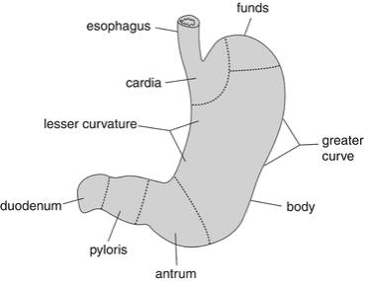

**Fig no. 1:Basic Gastrointestinal Tract anatomy**

The stomach primarily functions in the digestion and movement of food. It acts as a temporary storage facility for larger meals, allowing for quick consumption. The stomach is rich in enzymes that are crucial for the digestion of proteins. Through a process called peristalsis, the stomach mixes and breaks down food with its natural secretions, transforming it into a liquid form. This liquefied mixture is then passed into the small intestine for further digestion.

Anatomically, the stomach is divided into three main sections: the fundus, body, and antrum (also known as the pylorus). The fundus is the upper region, while the body serves as a reservoir for undigested food. The antrum is the primary site for mixing the food and functions as a gastric emptying pump through its propulsive movements.

Gastric emptying is influenced by whether the stomach is in a fasting or fed state, leading to alterations in motility patterns. This process involves a series of electrical events that occur in cycles throughout the stomach and intestines every 2 to 3 hours. A key aspect of this is the interdigestive myoelectric cycle, also referred to as the migrating myoelectric complex (MMC), which consists of four distinct phases:

1. Phase I: This phase lasts 30 to 60 minutes and is characterized by a lack of secretory and contractile activity.

2.Phase I: Known as the pre-burst phase, this stage involves intermittent contractions that occur over 20 to 40 minutes. As this phase progresses, both the intensity and frequency of contractions gradually increase.

3. Phase II: Termed the burst phase, this phase lasts for 4 to 6 minutes and features intense, regular contractions. This wave-like motion helps to push undigested material from the stomach into the small intestine. It is often referred to as the "housekeeper wave."

4.Phase IV: This brief phase lasts between 0 to 5 minutes and serves as a transition between Phase II and Phase I.

After food intake, the pattern of contractions shifts from the fasting to the fed state, resulting in the breakdown of food particles to less than 1 mm in size, which are then propelled toward the pylorus in suspension.

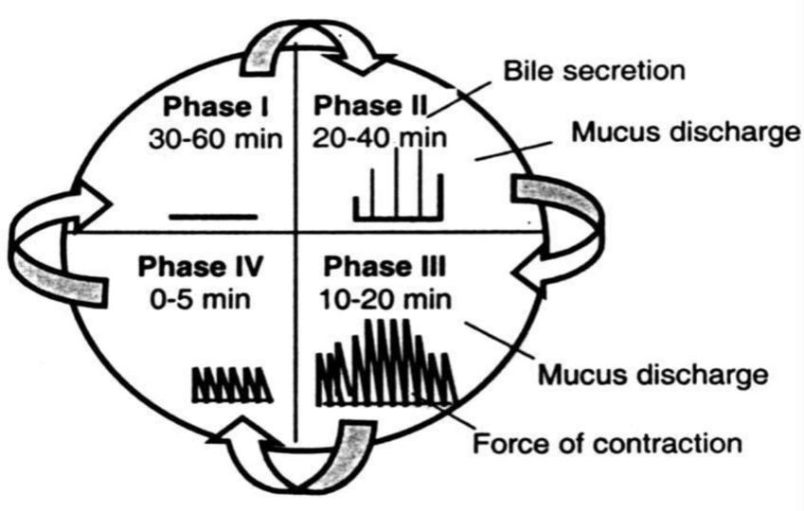

**Fig No.2 :Migrating Myoelectric Cycle**

**Gastric emptying time and motility:-**

The rate at which drugs are absorbed is largely influenced by gastric emptying time (GET) during both fasting and fed states. GET is the time it takes for a drug to pass from the stomach to the small intestine. As the small intestine is the primary site for drug absorption, GET can be considered the rate-limiting step.

In general, rapid gastric emptying increases the bioavailability of drugs. For medications that degrade quickly in the stomach's acidic environment, fast onset times are crucial. On the other hand, if a drug is poorly soluble at alkaline pH and primarily absorbed from the stomach or the proximal part of the intestine, delayed gastric emptying can facilitate dissolution and absorption.

**Need For Grdds**:

1.Conventional oral delivery is widely used in pharmaceutical Field to treat diseases. However, Conventional delivery had Many drawbacks and major draw-back is non-site specificity.

2.Some drugs are absorbed at specific site only. They Require release at specific site or a release such that Maximum amount of drug reaches to the specific site.

3. Pharmaceutical field is now focusing towards such drugs Which require site specificity.

4.Gastro-retentive delivery is one of the site specific delivery For the delivery of drugs either at stomach Or at intestine. It is Obtained by retaining dosage form into stomach and drug is Being released at controlled Manner to specific site either in Stomach, duodenum and intestine.

5.Unpredictable short gastric emptying time.

6..To extended release of drug in the stomach and proximal small intestine to treat certain Diseases.

7.It is especially suitable for the treatment of peptic ulcer which cause due to Helicobacter Pylori infection.

**Factors Affecting Gastric Retention**:

The factors that affects the gastric emptying of an oral dosage form are as follows,

Gastric residence time (GRT) plays a crucial role in the absorption of drugs. The factors that influence GRT include:

1. **Density**: The density of a dosage form affects its gastric residence time. A dosage form with a density less than the gastric fluid can lead to increased GRT.
2. **Size**: The size of a dosage form can influence its GRT. A dosage form with a diameter of 7.5 mm has been reported to have an increased GRT compared to one with a diameter of 9.9 mm.
3. **Shape**: The shape of a dosage form can also impact its GRT. Tetrahedron and ring-shaped devices can remain in the stomach for longer periods, with up to 90-100% retention at 24 hours.
4. **Single or multiple unit formulation**: Multiple unit formulations exhibit a more obvious release profile and are less likely to be impaired by unit failure. They also permit co-administration of dosage form units with different release profiles or containing incompatible substances.
5. **Fed or unfed state**: The GRT of a dosage form depends on the state of the individual. In the fasting state, the gastrointestinal motility is affected by the period of the Migrating Myoelectric complex (MMC), which can result in a shorter GRT. In contrast, the fed state is characterized by a delayed MMC, resulting in a longer GRT.
6. **Nature of meal**: The nature of the meal consumed can affect the GRT of a dosage form. Foods containing indigestible polymers, fatty acid salts, or high amounts of proteins and fats can slow down the gastric emptying rate and increase the GRT.
7. **Caloric content**: High-calorie meals, particularly those containing proteins and fats, can lead to a longer GRT, ranging from 4 to 10 hours.
8. **Frequency of feed**: Consuming multiple meals can result in a longer GRT due to the low frequency of the MMC.
9. **Volume of administration**: The volume of the liquid administered can affect the gastric emptying time. Larger volumes can lead to faster emptying.
10. **Food intake**: The GRT is generally longer in fed states.
11. **Nature, calorie content**: Indigestible polymers, fatty acid salts, high calorie content, acidity, and fat can increase GRT.
12. **Frequency of intake**: Low-frequency intake can result in a longer GRT.
13. **Posture**: The posture of the individual can also affect the GRT, with ambulatory states potentially resulting in a shorter GRT.
14. **Gender**: Research has shown that females tend to have shorter GRTs compared to males.
15. **Age**: Older individuals (above 70 years) may exhibit longer GRTs.
16. **Nature of drug**: Certain drugs, such as those that affect gastrointestinal transit time, can increase the GRT. For example, codeine, metoclopramide, and cisapride have been shown to increase the GRT.

**Approaches To Gastric Retention**

Various approaches have been pursued to increase The retention of an oral dosage form in the stomach, For example, bioadhesive approach in which the Adhesive capacity of Some polymer with Glycoprotein Is closely applied to the epithelial Surface of stomach. Other approaches include:

1. High density GRDDS
2. Low density GRDDS
3. Floating system
4. Raft forming agents
5. Magnetic system

**1.High density approach**:

For preparing such type of formulations, the Density of the pellets should be higher than the Stomach fluid.

It would be at least 1.50 g/ml. In this Type, the drug can be coated or mixed with heavy, Nontoxic materials

Such as barium sulfate, titanium Dioxide, etc.

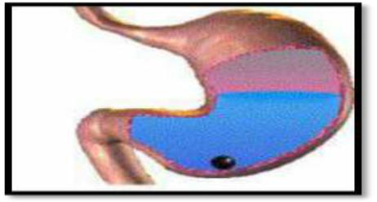

**Fig no.3: High Density GRDDS**

**2. Low density approach**:

Floating systems come under low density approach. In this approach, the density of pellets should be Less than 1 g/ml, so as to float the pellets or tablets In the gastric fluid and, release the drug slowly for A longer Period of time. This type is also called as Hydrodynamically Balanced System (HBS).

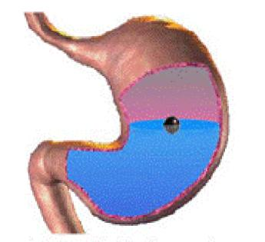

**Fig no.4 : Low density GRDDS**

**3) Floating Drug Delivery systems and its Mechanism**:

Floating drug delivery systems (FDDS) have bulk Density lesser than gastric fluids, so they remain Buoyant in the stomach without affecting the Gastric emptying rate for a prolonged period of Time. While The system is floating on the gastric Contents, the drug is released slowly at the desired Rate from the System .However, besides a minimal gastric content needed .To allow the proper achievement of the Buoyancy Retention principle, a minimal level of floating Force (F) is also required to keep the dosage Form Reliably buoyant on the surface of the meal. To Measure the floating force kinetics, a novel Apparatus For determination of resultant weight has Been reported in the literature. The apparatus Operates by Measuring continuously the force Equivalent to F (as a function of time) that is Required to maintain the Submerged object. The Object floats better if F is on the higher positive Side.. This apparatus helps in Optimizing FDDS with respect to stability and Durability of floating forces produced in order to Prevent The drawbacks of unforcable intragastric Buoyancy capability variations.

F-F buoyancy – Fgravity

= (Df- Ds) gv

Where, F= total vertical force,

Df = fluid density,

Ds= object density,

V= volume and

G= Acceleration due to gravity

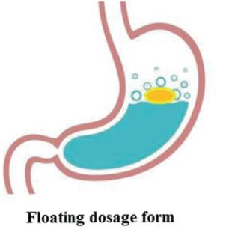

**Fig no. 5 Floating System**

3)**Raft forming system:**

Raft forming systems have received much attention For the drug delivery for gastrointestinal infections And disorders. The mechanism involved in the raft Formation includes the formation of viscous Cohesive Gel in contact with gastric fluids, wherein Each portion of the liquid swells forming a Continuous layer Called a raft. This raft floats on Gastric fluids because of low bulk density created By the formation of CO2. Usually, the system Ingredients includes a gel forming agent and Alkaline bicarbonates or carbonates Responsible for The formation of CO2 to make the system less Dense and float on the gastric fluids. Jorgen Et al Described an antacid raft forming floating system. The system contains a gel forming agent (e.g.sodium alginate), sodium bicarbonate and acid Neutralizer, Which forms a foaming sodium alginate Gel (raft), which when comes in contact with Gastric fluids, the Raft floats on the gastric fluids And prevents the reflux of the gastric contents (i.e. Gastric acid) into the Esophagus by acting as a Barrier between 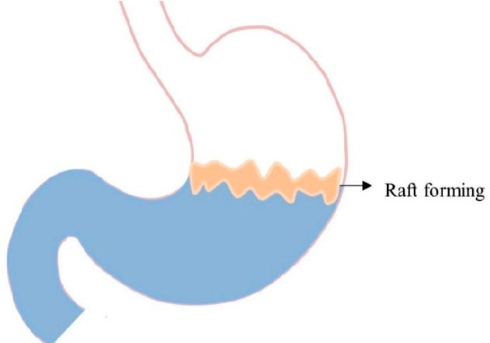the stomach and esophagus”.

**Fig no 6 : Raft forming system**

4.Magnetic system:-

These systms appear as small gastroretentive capsules Containing a magnetic material, whose elimination From The stomach is prevented by the interaction with a Sufficiently strong magnet applied to the body surface In The region of the stomach. Despite numerous reports About successful tests, the real applicability of Such Systems is doubtful because the desired results can be Achieved only provided that the magnet Position is Selected with very high precision. Probably, the Development of new convenientlv annlicd Magnetic field Sources will improve this concept.

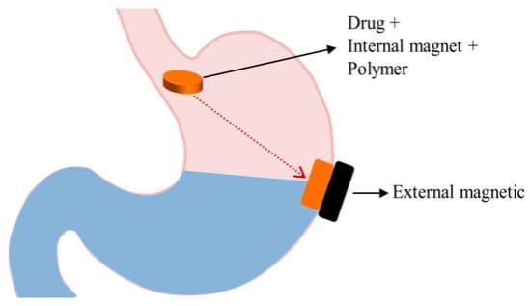

**Fig No.7: Magnetic System**

**Conclusion** :

Gastro retentive drug delivery system have emerged as An efficient means of prolonged retaining ability In the Stomach and thereby increase gastric residence time of Drugs and also improves bioavailability of Drugs. They Will significantly extend the period of time over which Drugs may be released and thus Prolong dosing intervals And increase patient compliance beyond the compliance Level of existing GRDDS. GRDDs will greatly improve The pharmacotherapy of the stomach itself through local Drug Release leading to high drug concentrations at Gastric mucosa which are sustained over a large period. GRDDS is much safer dosage form and have systemic. Localized actions as well GRDDS also reduces Dose Frequency there by minimize contra indication, systemic Toxicity, drug dependence. Based on the Literature Surveyed, it is concluded that Gastro retentive drug Delivery offers various potential advantages For drug with Poor bioavailability due their absorption is restricted to The upper gastrointestinal tract and They can be delivered Efficiently thereby maximizing their absorption and Enhancing absolute Bioavailability.

**Reference**

1. Setia M, Kumar K, Teotia D. Gastro-retentive floating beads a new trend of drug delivery System.

Journal of Drug Delivery & Therapeutics, 2018; 8(3): 169-180.

1. Ramanathan M, Manikandan S, Subramanian L, Solairaj P. Gastro retentive non-floating Drug delivery approach: a review. Journal of Drug Delivery & Therapeutics, 2018; 8(4): 20-23.

1. Tripathi J, Thapa P, Maharjan R, Jeong SH. Current State and Future Perspectives on Gastroretentive Drug Delivery Systems. Pharmaceutics, 2019; 11: 19.

1. Silva JBDa, Ferreira SBDeS, Freitas Ode, Bruschi ML. A critical review about Methodologies for the analysis of mucoadhesive properties of drug delivery systems. Drug Development and Industrial Pharmacy, 2017; 43(7): 1053-1070.

1. Katual MK, Gill NS, Singh G. Novel frontiers in buccal patches: a recent update. Journal Of Applied Pharmaceutical Sciences and Research, 2018; 1(3): 8-19.

1. Mishra SP, Nayak A, Mishra DK, Kumar A. Gastroretentive mucoadhesive microsphere For the management of gastric infection. Journal of Drug Delivery & Therapeutics, 2019; 9(4-s): 680-686.

1. Sahana Bhaduri K. Special approach to linger residence period of drug formulations For enhancement of bioavailability and therapeutic activity based on mucoadhesive Polymers.

International Journal for Pharmaceutical Research Scholars, 2019; 8(4): 1-18.

1. Kumar AMS, Bharath N, Rao MDS, Venkatesh P, Hepcykalarani D, Prema R. A review On mucoadhesive drug delivery systems. Res. J. Pharma. Dosage Forms and Tech, 2019; 11(4): 280287.

1. Warkari DR, Shivappa NN, Shaikh LA, Wadulkar DR. A review on mucoadhesive and Bioadhesion as a novel drug delivery system. World Journal of Pharmaceutical Research, 2018; 7(15): 203-213.

1. Hanafy NAN, Leporatti S, E-Kemary MA. Mucoadhesive Hydrogel Nanoparticles as Smart Biomedical Drug Delivery System. Appl. Sci, 2019;9: 825.

1. Puri V, Sharma A, Maman P. Rathore N, Singh I. Overview of mucoadhesive Biopolymers for buccal drug delivery systems. Int J App Pharm, 2019; 11(6): 18-29.

1. Komati S, Swain S, Eswara M, Rao B, Jena BR, Dasi V. Mucoadhesive multiparticulate Drug delivery systems: An extensive review of patents. Adv Pharm Bull, 2019; 9(4): 521-538.

1. Asati S, Jain S, Choubey A. Bioadhesive or mucoadhesive drug delivery system: A Potential alternative to conventional therap. Journal of Drug Delivery & Therapeutics, 2019; 9(4-A): 858867.

1. Perez-Gonzalez GL, Villarreal-Gomez LJ, Serrano-Medina A, Torres-Martinez EJ, Cornejo-Bravo JM. Mucoadhesive electrospun nanofibers for drug delivery systems: Applications of polymers and the parameters roles. International Journal of Nanomedicine 2019; 14: 5271-5285.

1. Parmar HK, Pandya KK, Pardasani LJ, Panchal VS, Tandel HT. A systematic review on Mucoadhesive drug delivery system. World Journal of Pharmaceutical Research, 2017; 6(09): 337366.

1. Pardeshi CV, Kulkarni AD, Sonawane RO, Belgamwar VS, Chaudhari PS, Surana SJ. Mucoadhesive nanoparticles: A roadmap to encounter the challenge of rapid nasal Mucociliary clearance. Indian Journal of Pharmaceutical Education and Research, 2019; 53(2): S17-S27.

1. Brahmbhatt D. Bioadhesive drug delivery systems: Overview and recent advance International Journal of Chemical and Life sciences, 2017; 6(3): 2016- 2024.

1. Kumar RS, Nuvati K. Mucosal Drug Delivery Systems: An Overview. Journal of Drug Delivery & Therapeutics, 2019; 9(4): 629-634.