Optimal Integration of Solar PV-Biomass Industrial Power Grids Using HOMER Pro: A Case Study of a Flattened Rice Mill

Aishaa*, Tanu Rizvib, Devanand Bhonslec

a M. Tech Scholar, Shri Shankaracharya Technical Campus, Bhilai, Chhattisgarh, India

b,c Department of Electrical Engineering, Shri Shankaracharya Technical Campus, Bhilai, Chhattisgarh, India

[aayeshakhan0105@gmail.com](mailto:aayeshakhan0105@gmail.com)

***Abstract*-The proposed study aims to optimize the integration of renewable energy sources, especially solar photovoltaic (PV) and biomass, in the electrical network of an industrial rice mill. The study focuses on achieving a balanced energy mix between grid electricity, biomass and solar photovoltaics. The project uses HOMER PRO, a comprehensive software platform to optimize microgrids and distributed energy resources. The study provides rigorous methodology, data modelling and economic analysis to estimate the sustainability of the proposed energy mix. The results show that the ideal location can minimize reliance on grid electricity, reduce operating costs and improve sustainability. Through extensive system, recreation data, and financial analysis, this research illustrates how energy displays may reduce dependency on the network, save operating costs, and improve item supportability. It focuses on the Straighten Rice Factory's use of solar photovoltaic (PV) and biomass in its electricity system. Using HOMER PRO, a complicated programming framework designed to simplify microgrids and recirculate energy, the review aims to achieve a reasonable energy mix of 70% matrix power, 20% biomass, and 30% solar PV. The evaluation demonstrates the framework model's potential to reduce network dependence, and functional costs, and enhance item maintainability via its whole process, reenactment information, and financial analysis.**

***Keywords-*: *Balanced, Biomass, HOMER Pro, Renewable energy, Simulation.***

I INTRODUCTION

The inclusion of renewable power sources, such as solar and biomass, into existing energy networks is an important step toward achieving stable energy goals. Recent government initiatives, such as the Green Hydrogen Strategy and the Energy Preservation Change Act of 2022, highlight the role that environmentally friendly electricity plays in reducing the byproducts of fossil fuels and strengthening the net. The Public Savvy Lattice Mission (NSGM) and the Public Activity Plan on Environmental Change (NAPCC) create a framework for integrating sustainable power into the matrix, enabling the application of astute framework innovations to regulate the variations of biomass and sunlight-based energy sources. The Service of New and Environmentally Friendly Power (MNRE) and the Focal Power Administrative Commission (CERC) play an important role in developing administrative standards and assisting with the implementation of sustainable power breakthroughs. The Environmentally Friendly Power Energy Hallway Venture and the Public Sun-based Mission are significant initiatives that develop environmentally friendly power transmission and framework reconciliation, ensuring that solar and biomass assets are properly harnessed and exploited.

A Flattened Rice Mill

Companies are integrating more environmentally friendly electricity into their business plans as they work to reduce their energy use and environmental impact. The focus of this research is a rice plant with a power output of 85 HP and a voltage of 140 kVA, located in Dewar Bhat, Chhattisgarh 491226, India. It is connected to a 33 kV lattice at 21° 31. 1°N, 70° 33°E. Location: 16035°S; scope: 44°20′W. Nine hours a day are worked by the organization, with the busiest months being December, January, June, and September. Companies integrate renewable energy sources into the power grid to reduce energy expenses and environmental impact. Homer Pro may be used to design coordinated energy frameworks that include solar, biomass, and power, as well as to assess the feasibility of coordinated energy ideas based on hypothesis and practice. Simplify the process to improve accuracy and reduce costs by combining power, biomass, and solar energy with HOMER PRO to create a hybrid energy framework. This will allow you to assess the financial and technical viability of the suggested energy mix and adjust the configuration to reduce costs while maintaining reliability.

II METHODOLOGY

To integrate solar PV and bio-based frameworks with a grid basis, numerous devices have been deployed as part of the investment's strategy to develop and provide the best functioning framework using HOMER PRO [1]. The primary objective is to meet industry demands while lowering carbon emissions and reducing network dependency. The importance of information collection in understanding the nature of the company's strength is discussed in terms of the idea employed to explain the project. The business is linked to a 33 kV grid via a 140 kVA connection and consumes around 14,650 kWh per month. The peak demand changes from 90 to 105 kVA, while the power rating alters from 0.98 to 0.99. This zone is open nine hours a day for fifteen days in November. Peak months are December through January and June through September. The price of electricity is separated into three categories: standard (Rs. 7.05/kWh), high (Rs. 8.46/kWh), and Rs. 5.64/kWh. The result of rice husk processing, which generates five tons daily is known as biofuel for the electric year. "Power balance and goals" are then established. Achieving 55% of the company's electricity demands from renewable sources is the aim; solar panels account for 30%, biomass for 25%, & grid for 45%. A framework for energy efficiency employing lithium-ion batteries for short-term storage is part of the project. An extra 1181 kWh of electricity is generated from renewable sources per year. Thus, we released the releases using HOMER PRO [2]. The PV system limit was estimated using the most recent solar thermal information and is expected to account for 30% of total energy consumption. The biomass generator was set to

60 kW based on the amount of rice husk available [3]. Clear characteristics for every unit, like decoration and replacement costs, were included using HOMER PRO. The biomass generator with a capacity of 60 kW is close to rice husk discharge. Each component's details, including fuel moisture content, operating expenses, replacement costs, capital costs, and rice husk bag value, were entered using HOMER PRO. There's also improvement and cost evaluation in addition to this approach [4].

A Modelling & simulation

The development using HOMER pro to lower the balanced cost of electricity (LCOE) and operational expenses, the optimal mix of grid, solar, and bioenergy sources was identified through planning [4]. The framework's effectiveness was assessed using financial and technical indicators such as annual energy efficiency, network utilization, fuel consumption, and seasonal outcomes [5]. A more precise estimation of labour costs was made possible by the use of different rates for taxes depending on peak, part-time, and regular working hours. The biomass generator's 0% efficiency was found by the first engineers in the morning to be the result of improper fuel supply settings. As a result, assessment and adjustments in this area are necessary [6]. When the criteria for the fuel supply were modified and solar photovoltaic systems were sufficient to stabilize the electricity supply, the biomass generator started working as planned. According to the overall findings, the energy mix consisted of 25% biomass, 30% solar, and 45% shell. The overall frame efficiency is increased by the lithium-ion battery frame's ability to store extra energy and minimize waste [5]. Other advantages of the demonstration include better materials for energy storage, a reduction in seasonal effects, and an increase in the availability of solar energy and solar energy systems to lessen reliance on the grid. In conclusion, this approach made it possible to thoroughly assess the system that coordinates environmental management in the HOMER PRO. It is replicable or applicable to comparable businesses that develop novel applications for biomass and solar energy [7].

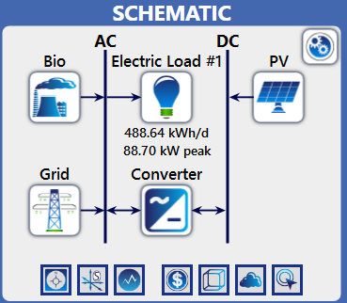

Fig.1. Schematic model of Proposed model in Homer pro

B Load Profile & Fuel Summary

This campaign permits the current framework to be optimized for a better energy balance by coordinating renewable resources (photovoltaics and solar and bio-based PV). By giving bounds based on the date and the bio, it lessens reliance on the frame. The grid continues to account for 40% of total energy. The power supply is divided into multiple sets by the HOMER PRO configuration.

|  |
| --- |
|  |
| Fig.2.Annual Solar GHI resources |
|  |
| Fig.3.Monthly Graph for average global solar radiation |
|  |
| Fig.4.Yearly Biomass fuel (rice husk) average usage graph |
| Fig.5. Seasonal Scaled load profile of flattened rice mil |
| Fig.6. Global solar daily load profile |

Solar PV- Furthermore, during peak power months, solar photovoltaics (PV) reduces reliance on the grid by producing electricity when sunlight is on its way, accounting for 35% of energy. Data about solar radiation at work was taken from standard IEEE data sets by the HOMER Genius project. The data comprises monthly solar information, expressed in kWh/m2/day, in addition to other pertinent meteorological data. The investment is situated in an area with solar radiation and [5.85] kWh/m2/day. The PV array's optimal efficiency throughout the year was ensured by designing it with sunlight and changes in solar power are the primary considerations. The model shows the inadequacies caused by thermal insulation and the effectiveness of the revolutionary technology, ensuring that the real energy efficiency is in line with the parameters projected according to the IEEE Solar information.

Grid- The arrangement transmits 40 per cent of total power, with a network buy limit of about 60 kW. It is designed to meet peak demand in situations where environmentally friendly power sources are insufficient.

Biomass Generator- Rice husk, a byproduct of the business, is used as fuel by biomass, which accounts for 25% of total energy and provides an eco-friendly power option. Nevertheless, difficulties starting biomass generators (due to their size and fuel concerns) necessitated reenactments to increase their output limit. By using renewable energy sources, the framework becomes less reliant on the lattice and produces less waste products from burning fossil fuels. An optimal energy mix is shown by HOMER Genius' improvement analysis, whereby excess power (1181 kWh/year) is stored using a lithium-particle battery strategy.

The complete usage of the financial resources guarantees the framework's dependability and lowers network consumption. Renewable Energy and Framework Management. It was decided to create a grid-based operating system that needed biomass and solar PV. This architecture is constrained by the need to separate the output from solar and biomass generators to save expenses and maintain a healthy energy balance.

System Control & Modernization

An operational strategy was developed where the grid acts as a backup, solar PV takes priority, and biomass follows. The system is controlled by varying the output of the biomass and solar generators to reduce costs and achieve the desired energy balance.

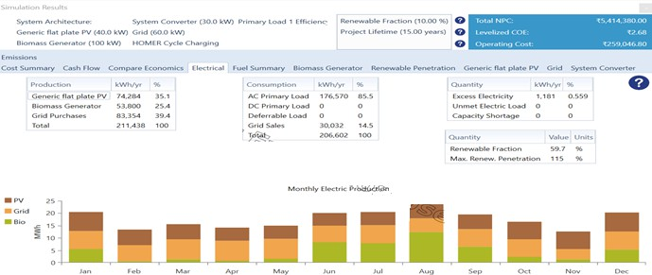

Fig.7.Simulation result of all Renewable sources

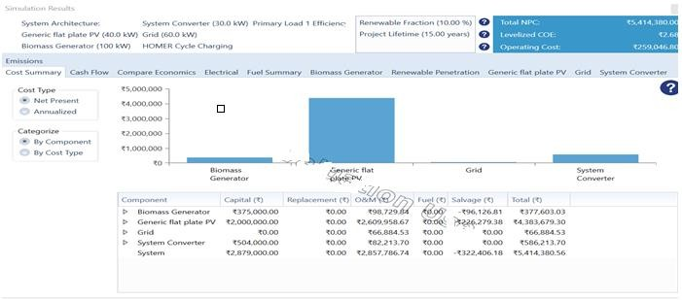

Fig.8.Cost Summary of the entire system after simulation

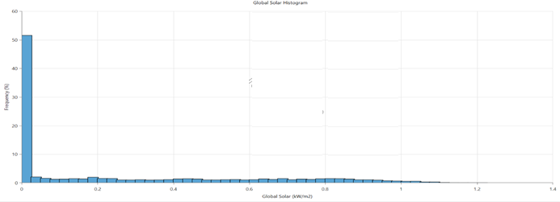

Fig.9.Global Solar Histogram graph

III RESULTS & DISCUSSION

|  |  |
| --- | --- |
|  | Regions of Chhattisgarh State in India”, International Journal of Energy Production & Management,9(1), 2024, pp:25-35. |
| [4] | T. Rizvi, S. P. Dubey, N. Tripathi, G. Shrivastava, S. P. Makhija and Md. K. Mohiddin, “FSPV-Grid system for an industrial subsection with PV price sensitivity analysis”, Sustainability,15(2495), 2023, pp:1-18. |
| [5] | T. Rizvi, S. P. Dubey and N. Tripathi, “Designing of a Feasible Low Pollutant Grid Integrated System for Steel Plant”, CSVTU Research Journal, 10(02), 2021,pp: 144-154. |
| [6] | T. Rizvi, N. Tripathi and S. P. Dubey, “Feasibility Analysis of a Grid Integrated Renewable Energy Systems in Heavy Industries”, Jour of Adv Research in Dynamical & Control Systems (JARDCS), 12(06), 2020, pp: 2289-2302. |
| [7] | T. Rizvi, S. P. Dubey and N. Tripathi, “Reconceptualizing the Application of Renewable Energy Sources in Industry: A Review”, International Research Journal of Engineering and Technology (IRJET),09(01), 2020, pp: 514-518. |
| [8] | A. K. Sharma and D. P. Kothari, “Floating Solar PV Potential In Large Reservoirs in India”, 2016,Ijirst –International Journal For Innovative Research In Science & Technology, 2 (11). |
| [9] | T. Rizvi, S. P. Dubey, N. Tripathi and S. P. Makhija, “FSPV- grid integrated system for efficient electrification of industrial subsection with grid price sensitivity analysis”. IEEE Sponsored Second International Conference on Advances in Electrical, Computing, Communications and Sustainable Technologies (ICAECT 2023), 2023. |
| [10] | M. Acharya and S. Devraj.”Floating Solar Photovoltaic (FSPV): A Third Pillar to Solar PV Sector?” TERI Discussion Paper: Output of the ETC India Project. The Energy and Resources Institute, New Delhi, India, 2019. |
| [11] | D. R. Aryani, T. A. Khairurraziq, G. R. Ramadhan, N. S. Wardana, F. Husnayain and I. Garniwa. “Simulation of Stand- Alone Floating Photovoltaic and Battery Systems”. IOP Conference Series Materials Science and Engineering,673(1), 2019, pp:1-7. |
| [12] | J. S. Choi. “Analysis of the Potential for Use of Floating Photovoltaic Systems on Mine Pit Lakes: Case Study at the Ssangyong Open-Pit Limestone Mine in Korea”. Energies, 2019,102. |
| [13] | Y. K. Choi. “A study on power generation analysis of floating PV system considering environmental impact”, International Journal of Software Engineering and its Applications 8(1), 2014,pp: 75–84. |
| [14] | N. Lee, U. Grunwald, E. Rosenlieb, H. Mirletz, A. Aznar., R. Spencer and S. Cox. “Hybrid Floating Solar Photovoltaics- Hydropower Systems Benefits and Global Assessment of Technical Potential”, Renewable Energy, 2020, pp: 1415-1427. |
| [15] | L. Liu, Q. Wanga, H. Lina, H. Lib, Q. Suna and R. Wennerstena “Power Generation Efficiency and Prospects of Floating Photovoltaic Systems”, The 8th International Conference on Applied Energy – ICAE2016, 2017,1136 – 1142. |
| [16] | T. Rizvi, S. P. Dubey, N. Tripathi and S. P. Makhija “A Comparative Analysis of FSPV-Grid and Grid-only systems for an Industrial Subsection”, IEEE Sponsored Second International Conference on Advances in Electrical, Computing, Communications and Sustainable Technologies (ICAECT 2022), 2022, pp:1-7 |
| [17] | A. N. Sahu, Yadav and K. Sudhakar. “Floating Photovoltaic Power Plant: A Review”. Renewable and Sustainable Energy Reviews 66, 2016, pp: 815–824. |
| [18] | K. Trapani and M. R. Santafe. “A Review of Floating Photovoltaic Installations: 2007–2013. Progress in Photovoltaics: Research and Applications" 23 (4), 2015, pp:  524–532. |

The suggested production strategy is workable, as demonstrated by HOMER PRO's regular outcomes. The basic setup of solar power generators and biomass power generators was adequate to cover the energy requirement. This can be seen in the below image which is the details of carbon emission in a system modelled in Homer Pro, which shows the reduced value of emitted carbon dioxide and other greenhouse gases.

A Economic Evaluation

The integration of daily and weekly arrangements can lower energy system running costs, according to economic evaluations. The cost of energy (LCOE), internal rate of return (IRR), and net present value (NPV) have been calculated to assess cash flow outside the regulatory system. It is evident from the data that the minimum design constraints and the reserves taken have a positive impact on environmental energy demand.

B Sensitivity Analysis

The results of the survey indicate that the primary factors influencing the framework's adoption are the cost of energy and fuel (rice husk). Variations in these factors impact the framework's economic efficiency.

C Ecological Impacts

This system reduces reliance on electrical power, lowers emissions of pollutants that deplete the ozone layer and integrates renewable energy sources. A way to manage pallet trash is to turn rice husks into biomass. Thus reduction in greenhouse gases from the environment increases weather by a small percentage but it is effective for our surroundings. It also helps a way better disposal of waste that as rice husk of the industry as it not only reduces the cost of disposal as well as making it an economic system. This can be seen in the below image which is the details of carbon emission in a system modelled in Homer Pro, which shows the reduced value of emitted carbon dioxide and other greenhouse gases.

IV CONCLUSIONS

The idea of integrating biomass and solar power systems into the industrial power grid of rice/poha mills is technically and financially feasible. It is incredibly accurate and cost-effective to place bio-electric rice husks into a fresh rice mill’s grid. An energy installation of 40% biomass, 25% solar panels, and 35% solar panels can save operating costs and improve conservation skills. Further research will look at additional implications. To increase reliability, future trials might investigate the effects of increasing biomass content and coordinate new energy storage systems.

REFERENCES

|  |  |
| --- | --- |
| [1] | Y. Zhou, F. J. Chang, L. C. Chang, W. D. Lee, A. Xu. C. Y. Huang and S. Guo. ”An Advanced Complementary Scheme of Floating Photovoltaic and Hydropower Generation Flourishing Water-Food-Energy Nexus Synergies”’, Applied Energy, 2020, 275(1), 2020.pp: 1-1 |
| [2] | S. Nirmal and T. Rizvi. ”A Review of Renewable Energy Systems for Industrial Applications”’, International Journal for Research in Applied Science & Engineering Technology (IJRASET),10(9), 2022,pp: 1740-1745. |
| [3] | . Rizvi, S. P. Dubey, N. Tripathi, M. Singh and M. Singh “Feasibility Analysis of FSPV-Grid Tied System in Urban |