**A PERFORMANCE EVALUATION STUDY OF SELECTED STOCKS IN 2024**

**Name:Nihar HG**

**Trimester4MBA**

**TERM PAPER**

**COLLEGE PES UNIVERSITY**

**Abstract**

In this Research the performance analysis of selected Stocks are analysed and examined using Different methods and techniques and it is explained by Following data and calculations.This research is helpful for the investors who are investing their money in the stock market as its provide the through analysis of the various stocks whether to invest or not And also it suggests the various stocks whether it is undervalued or overvalued as it is one of the important indicator for the investors who tries to invest in various stocks.The analysis of this various stocks are done for the year 2024 Month wise by collecting the stock prices of 12 months and corelations and beta whoch is one of the important indication in assessing the performance of stock are Analysed using calculation’s and figures.Key important metrics such as price changes during the period,trends in the market are used which will be helpful for the investors in choosing the right stock based on all the financial metrics and returns estimations.

This research offers useful insights to the investors who are beginning to invest in the stock market through these research the investors can easily pick the right stocks and maximize their returns and also they can build a strong portfolio.They can select the right stock in the different sector by seeing the stock price history and its movements year wise and also they can asses the return base on the historical trends and also they can examing whether stock prices are overpriced or underpriced And also beta calculation is done in this research to asses the risk of the stock that investor might face in investing in that particular stock with all these factors it suggests the investor in choosing the right stock and maximize their investment returns

**KEYWORDS**:Portfloio,performance Evaluation, Investment,Stock market indices

**“Introduction”**

Indian stock exchange is one of the oldest and ancient which began its operations on 1956 under the approval of government of india later BSE was established as one of the indices in the stock market to regulate all the transactions and acted as monetary body and later NSE was established and became a principal regulatory authoriy related to all the stock market related activities and also companies were also should be registerrd in NSE or BSE for its stock to be listed in the Stock market All the security related transactions of all the investors are bben regulated and monitored by NSE

These regulatory bodies have all the details of every investor and there transactions are done through NSE and BSE platform.They also monitor suspisious trading activities, illegal transfer of commodities or evading the security taxes,they also regulate monitory check of all the companies who are registerd under Nse OR Bse Whether they are indulge in any illegal practise such as tax evasion or displaying false returns that attracts the investors etc As these indices are regulated by the government all the tax collection money goes to the government.investor are also subjected to pay various taxes who invest in stock market such as LTCG and STCG from the returns that they get from the stock market.Many of the investors who have invested in various sectors also gets a divided based on their holdings and no of share they holds according to the company norms and regulations they might get a bonusshare rightissue etc it is mandatory for every company to declare dividends it indicated whether a company is making profit or not. Majority of the financial institution invest in stock market to maximize the profit as they have lakhs of deposited money they usually invest maximize returns and give the money return to the depositiories with intrest. Majority of foreign institution also invest in Indian stock market they deeply asses the company business and invest for long term.

The companies who register’s under stock exchange the 1st step is to set a proper price for the stock according to the company requiremnets the price should be set on the basis of company business growth,profit ROI,NPM,ROA etc After setting up the price the stock gest listed on stock exchange either on NSE or BSE The shares of the company will officially be listed and investors can buy or sell that stock.By listing the company on stock exchange the company enjoy good amout of profit as therir shares are being traded by these money they will reduce the debt that they have taken and also they will invest on further new projects or they will buy equipments machinery etc They can also further increase the profit margin and acquire market share in the sector and they will also invest in startup to uplift the youth.The companies also expand their business to various sectors due to strong brand that they have created in stock market which will help them generate profit and also it boosts the employment opportunity

For this research 9 stocks across different sectors are analysed and these stocks are registered under NSE and BSE indexes These stock are one of the most traded stocks in the stock market All the parmaters of the stock are analysed and findings are also provided whether to invest in that stock or not also based on calculation and analysis dtermination of stock whether it is undervalued or overvalued are justified in this research which will help the investor in selecting the right stock according to their willingeness and capblity to buy the stock for future or short term holdings

**Objectives of the Study**

* To examine the performances of various stock under different sector in 2024
* To analyse whether the stock are overpriced or underpriced
* To know the risk patterns of stock and determine to invest in that particular stock using beta values
* To know historical prices of various stocks in a year and also determine the nifty value of all the months
* To examine the stocks based on NIftyvalues and prices of various stock monthly wise and perform the Analysis

**“Review of literature”**

* “Ahmad”explains stock market is one of the most important Regulatory and principal body of every country that assess the profit or losess of evrery stock of any sectors who are registerd under stock exchange
* Ramesh(2004)Explains impact of how stock market has effected the individuals investments because of market crash recession and economic downturns.
* Patel(2008)explains the significance of Nifty how it has impacted the stocks and it has maximized the returns of shareholders who have invested in the top market cap stocks.
* Gupta(2019)Examines that investments in the stock markets have increased tremendously because of investors has build trusted in the returns that have been given to the investors compared to bank FDS
* Raj(2020)Explains that due to more investments that have been made by the investors in the stock market Government is also generating good amount of revenue by collecting security taxes such as LTCG AND STCG on returns also.
* Naveen(2000)The Government has regulated two principal bodies for monitoring the stock market they are NSE and BSE which will regulate all the transactions of every investors and companies and they also track illegal trading practises and they have the authority to
* Venkatesh(2021) Majority of all the sectors such as IT healthcare steel paints construction etc these stocks divided into various indices such as NiftyIT,NiftyHelathcare etc and Dividend will also be distributed to shareholder interms of no of shares holding according to the specific period

**“Methodology”**

In this research the main aim is to evaluate performances of various stocks in different sectors The data has been collected from secondary sources from Websites journals financial reports etc The analysis has done by interpreting the data of the various stocks till 1 year and analysis has been done using corelation that will determine the performance of the stock and also the relationship between variables.Beta calculation has been done to know the risk patterns of various stock that will help the investor knowing risk of investing in the stock this calculation is done by collecting the stock prices till 1 year and it is divided into 12 months to get the accurate results for the analysis of the research. In this research 9 stocks of various sectors are taken from it automobile Fmcg etc and data has been collected from BSE NSE websites prices of these stock are taken for 12 months and prices of these stock are taken for anlysis and calculations has been made using Excel to get accuate results for the research

After these calculation we can easily interpret whether the stock is overvalued or undervalued by these information it will be very helpful for the investors who are investing in stocks and also risk factors of these stock are also assed which will inform the investors that there is also subsequent risk in investing in stocks.the solution to minimize the risk is to diversify the investments across all the sectors so it helps to reduce the risk and maximize the investments in future.

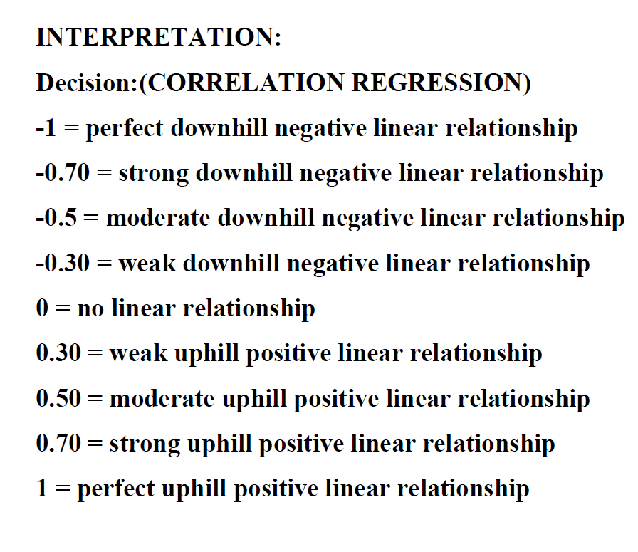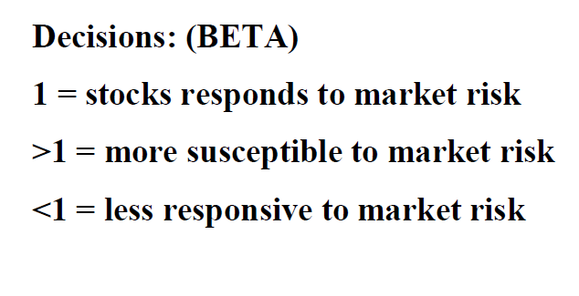

**“Analysis”**

**Banking sector ICICI BANK**

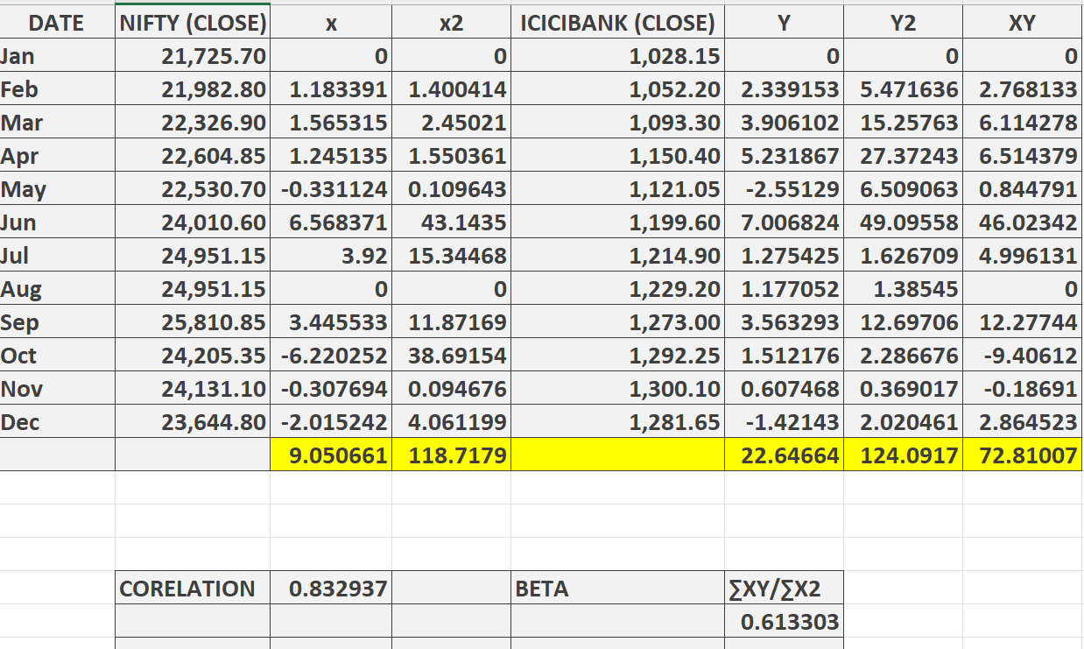



**Interpretation**

In the data set as the corelation is close to 1 we can tell that it has a strong positive relationship between nifty and ICICI bank meaning=As nifty increases significantly the stock of icici bank also increases this stock is very much influenced by the nifty index

**Beta**

Here the value is 0.61 explains that A stock is said to be less volatile if it is less than 1 which implies icici bank stock is expected to rise 0.61% if the index rises by 1% this stock is undervalued

**Axis Bank**

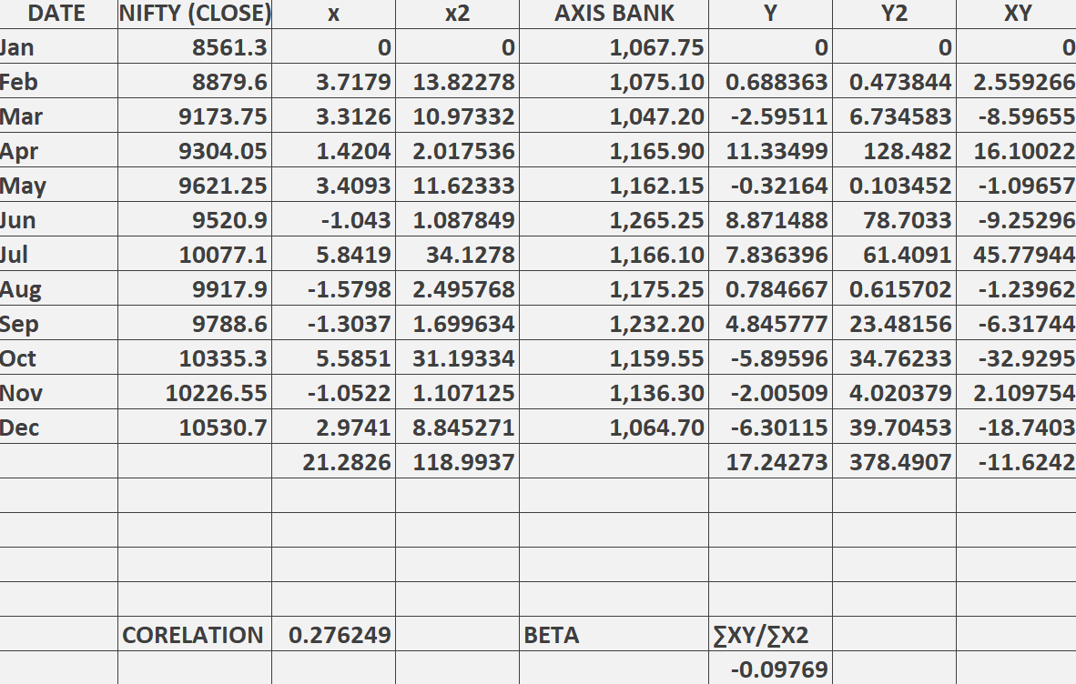

**Interpretation**

In this data set as the Correl value is closer to 0 than to 1 it indicates weak linear relationship between the two variables this implies that performances of axis bank is not heavily influenced by nifty outcome

**Beta**

As the beta value is negative in the data set the stock of axis bank is not heavly influenced by nifty and this stock is only concentrated on financial reports and profit results of the bank we can determine this stock is overvalued and this stock more responsive to market risk

**Biocon**

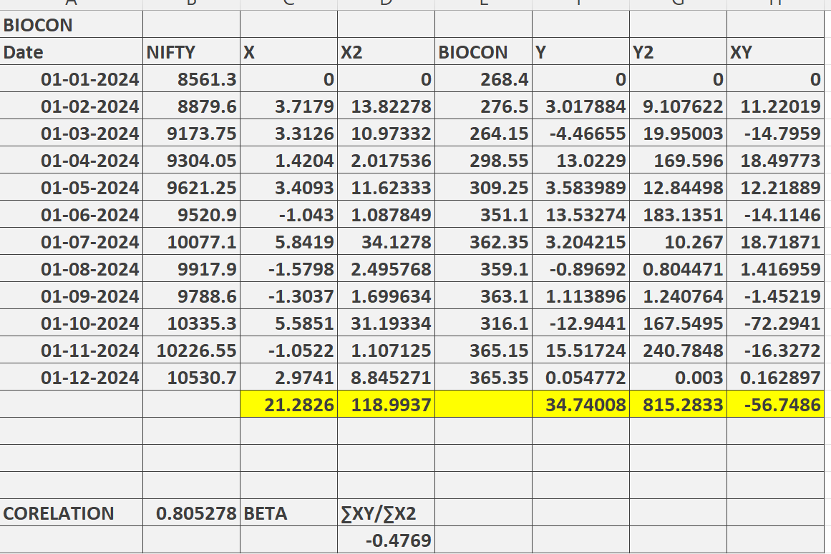

**Interpretation**

In this data set as the value of the corelation is 0.80 which indicated that it is closer to 1 and we can interpret has strong positive linera relationship between the variables which suggest that as the nifty index moves bioconstock also moves according to the index

**Beta**

As the beta value is -0.47 which indicates that this stock is not entirely dependent on nifty index this stock has the capacity to move without the support of index and we can determine that it also more responsive to risk

**TCS**

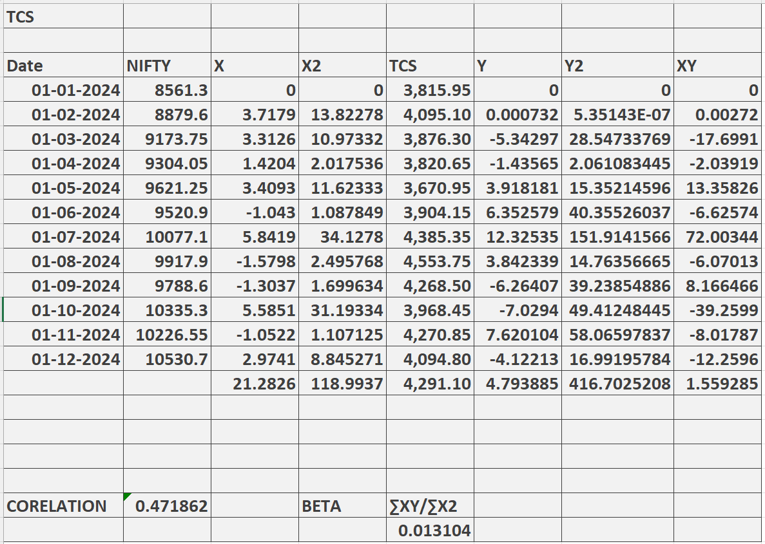

**Interpretation**

In this data set as the value of corelation is 0.47 indicates moderate positive relationship between variables which explains when the market rises also tcs stock prices also increses moderately as the value is not close to 1 other factors such as economic downturn,false news may impact the stock moderately

**Beta**

As the value is 0.013 it indicates that this stock is one of the low risk stock compared to other because this stock has performed excellently during the years and also provided good dividend to the shareholders this stock is undervalued as it has the capacity to reach 5000 in the future years

**Infosys**

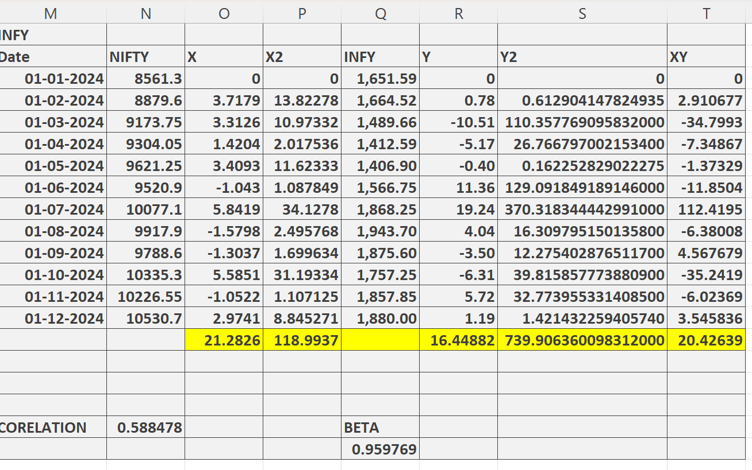

**Interpretation**

In this data set the correl value is 0.58 which is less than 1 that indicates moderate positive relationship between two variables when the market rises the stock of infy also rises according to the metric as the value is not close to 1 other factors such as economic downturn,false news may impact the stock moderately

**Beta**

As the value0.95 which indicates this stock is one of the low risk risk stocks as this stock has performed well during the years it has also potential to reach the price of 2000 easily during the following years the company has posesesd good profits and it has grown significantly year wise it has also declared good amount of dividend to their shareholders

**Ashok Leyland**

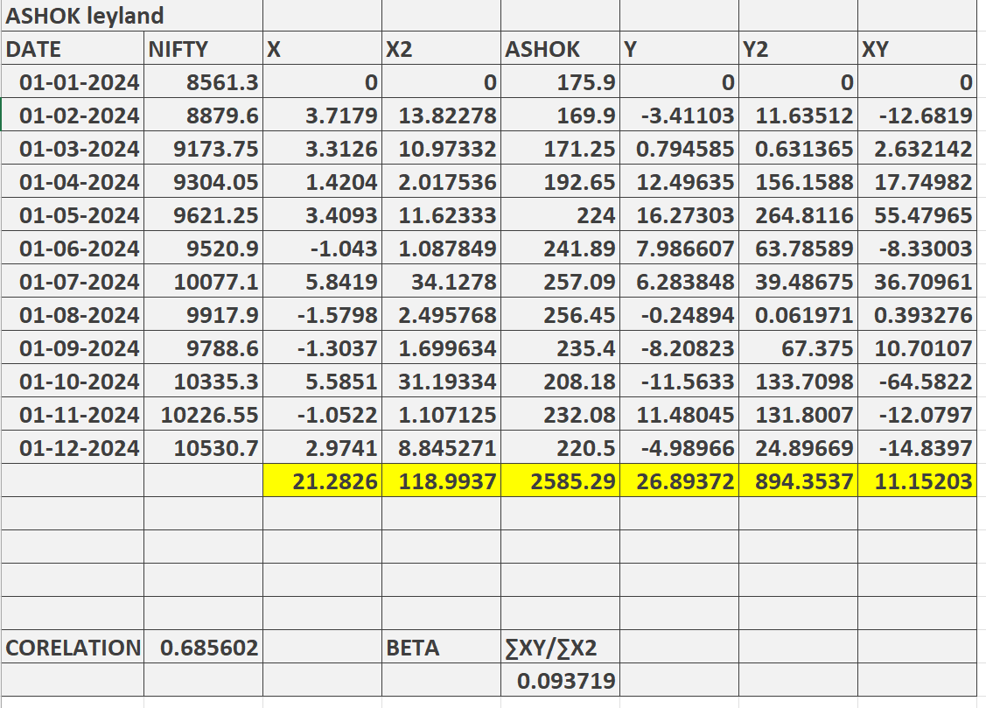

**Interpretation**

In this data set the value 0.68 indicates moderate positive relationship between two variables this stock is moderately corelated with the nifty index when it rises the stock also moderately increases metric as the value is not close to 1 other factors such as economic downturn,false news may impact the stock moderately or sometimes severely

**Beta**

As the value is 0.03 it signifies that this stock is one of the low risk stock as this stock performed well during the years the price of the stock has also been increased monthly wise and this stock has the potential to reach 250 in coming years as it is one of the good automobile stock that is liked by many investors because of the returns it has posted

**Apollo tyres**

|  |  |  |  |  |  |  |  |
| --- | --- | --- | --- | --- | --- | --- | --- |
| **APOLLO tyres** |  |  |  |  |  |  |  |
| **date** | **NIFTY** | **X** | **X2** | **APOLLO TYRES** | **Y** | **Y2** | **XY** |
| **01-01-2024** | **8561.3** | **0** | **0** | **540.5** | **0** | **0** | **0** |
| **01-02-2024** | **8879.6** | **3.7179** | **13.82278** | **518.5** | **-4.07031** | **16.56739** | **-15.133** |
| **01-03-2024** | **9173.75** | **3.3126** | **10.97332** | **466.45** | **-10.0386** | **100.7729** | **-33.2538** |
| **01-04-2024** | **9304.05** | **1.4204** | **2.017536** | **510.1** | **9.357916** | **87.5706** | **13.29198** |
| **01-05-2024** | **9621.25** | **3.4093** | **11.62333** | **463.5** | **-9.13546** | **83.4567** | **-31.1455** |
| **01-06-2024** | **9520.9** | **-1.043** | **1.087849** | **541.9** | **16.91478** | **286.1097** | **-17.6421** |
| **01-07-2024** | **10077.1** | **5.8419** | **34.1278** | **555.7** | **2.546595** | **6.485148** | **14.87696** |
| **01-08-2024** | **9917.9** | **-1.5798** | **2.495768** | **492.9** | **-11.3011** | **127.714** | **17.85342** |
| **01-09-2024** | **9788.6** | **-1.3037** | **1.699634** | **547.85** | **11.14831** | **124.2847** | **-14.534** |
| **01-10-2024** | **10335.3** | **5.5851** | **31.19334** | **504.95** | **7.830611** | **61.31846** | **43.73474** |
| **01-11-2024** | **10226.55** | **-1.0522** | **1.107125** | **509.65** | **0.930785** | **0.866361** | **-0.97937** |
| **01-12-2024** | **10530.7** | **2.9741** | **8.845271** | **529.4** | **3.875208** | **15.01724** | **11.52526** |
|  |  | **21.2826** | **118.9937** | **6181.4** | **18.0588** | **910.1633** | **-11.4055** |
|  |  |  |  |  |  |  |  |
|  |  |  |  |  |  |  |  |
|  |  |  |  |  |  |  |  |
| **CORELATION** | **0.05549** |  | **BETA** | **∑XY/∑X2** |  |  |  |
|  |  |  |  | **-0.095849375** |  |  |  |

**Interpretation**

As the value is 0.055 it indicates very weak relationship between two variables and it is independtly uncorrelated with the market and stock price movements mainly depends on companys factors such as profitability margin ROI etc

**Beta**

As the value is -0.09 which indicates that this stock has more risk when investor invest in this stock as the value is negative it might show investor negative returns also as it is not dependent on stock market indices and this stock is also overvalued and the price can be slightly reduced so that many investor may buy this stock.this stock is overvalued

**ITC**

|  |  |  |  |  |  |  |  |
| --- | --- | --- | --- | --- | --- | --- | --- |
| **ITC** |  |  |  |  |  |  |  |
| **DATE** | **NIFTY** | **X** | **X2** | **ITC** | **Y** | **Y2** | **XY** |
| **01-01-2024** | **8561.3** | **0** | **0** | **441.55** | **0** | **0** | **0** |
| **01-02-2024** | **8879.6** | **3.7179** | **13.82278** | **406.3** | **-7.98324** | **63.73213** | **-29.6809** |
| **01-03-2024** | **9173.75** | **3.3126** | **10.97332** | **428.35** | **5.427024** | **29.45259** | **17.97756** |
| **01-04-2024** | **9304.05** | **1.4204** | **2.017536** | **435.65** | **1.704214** | **2.904345** | **2.420665** |
| **01-05-2024** | **9621.25** | **3.4093** | **11.62333** | **426.45** | **-2.11179** | **4.459644** | **-7.19972** |
| **01-06-2024** | **9520.9** | **-1.043** | **1.087849** | **424.9** | **-0.36347** | **0.132107** | **0.379095** |
| **01-07-2024** | **10077.1** | **5.8419** | **34.1278** | **495.35** | **16.58037** | **274.9087** | **96.86087** |
| **01-08-2024** | **9917.9** | **-1.5798** | **2.495768** | **501.9** | **1.322297** | **1.74847** | **-2.08897** |
| **01-09-2024** | **9788.6** | **-1.3037** | **1.699634** | **518.15** | **3.237697** | **10.48268** | **-4.22099** |
| **01-10-2024** | **10335.3** | **5.5851** | **31.19334** | **488.8** | **-5.66438** | **32.08523** | **-31.6361** |
| **01-11-2024** | **10226.55** | **-1.0522** | **1.107125** | **476.75** | **-2.46522** | **6.077314** | **2.593905** |
| **01-12-2024** | **10530.7** | **2.9741** | **8.845271** | **483.65** | **1.447299** | **2.094676** | **4.304413** |
|  |  | **21.2826** | **118.9937** | **5527.8** | **11.13081** | **428.0779** | **49.70981** |
|  |  |  |  |  |  |  |  |
|  |  |  |  |  |  |  |  |
|  |  |  |  |  |  |  |  |
|  |  |  |  |  |  |  |  |
| **CORELATION** | **0.709631** |  | **BETA** | **∑XY/∑X2** |  |  |  |
|  |  |  |  | **0.4177515** |  |  |  |

**Interpretation**

The value in the data set 0.70 indicates strong positive relationship between variables which implies whenerver the nifty increases the stock price also increase significantly and the stock has perfomed very well during the years so this value is achieved and the price has been increased significantly monthly wise and it has posted good returns for the investors also who have invested in this stock

**Beta**The value is 0.41 which signifies that this stock has low risk factors when investors invested in this stock and it has also generated good returns as the price has been increased significantly As itc has doing its business across various sectors like fmcg paper industry hotels due to this it is one of the most traded stock in the stock market this stock has the potential to reach 550 in future years as it has diversified its business and achieved good profits. And this stock is undervalued

**HUL**

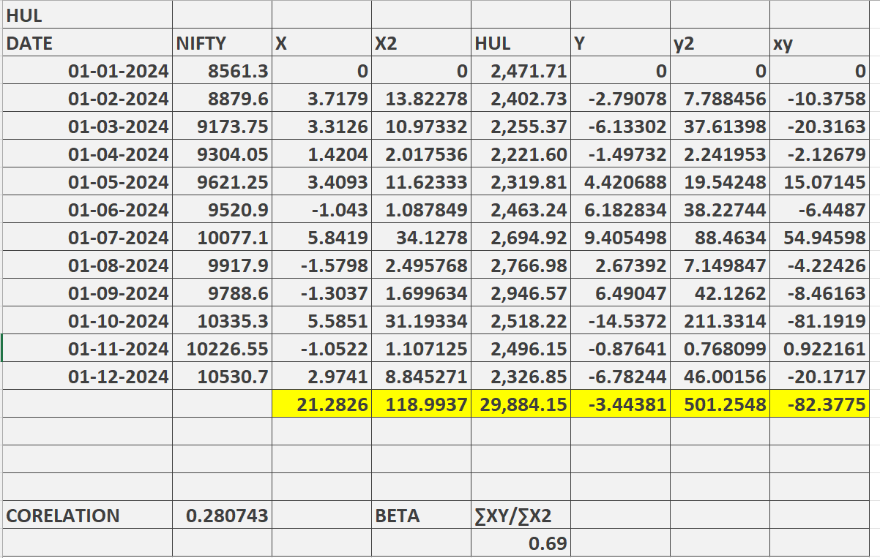

**Interpretation**

As the value is 0.28 is very close to 1 it indicates weak relationship between the two variables in the data set whenever the nifty increses the price of the stock may increase or decrese this stock is not full dependent on nifty the stock performs well due to earnings of profits that has been made the period its generated in the financial reports

**Beta**

As the beta value indicated 0.60 which signifies this stock is less responsive to risk factors as it been established a good brand image in the stock market HUL is one of the stock where it has diversified its business across various segments such as personal care home care etc and its products are one of the most sold products and liked by many individual due to this sales has been increased tremendously and it has captured good amount of market share compared to the competitors. comparing the price of the stock these stock is slightly overvalued

**Findings**

* In the banking sector stocks we found out that As the beta value is close to 1 which signifies that investors can easily but the stock and hold for long term As his sector has the potential to reach upper circuit And banking is one of the principal financial institutions where it has a large no of customers and it also generating good amount of revenue investors can buy this stock and hold it in their portfolio.Banking stocks has less risk compared to other stocks so it is one of the ideal stock to buy for the investors
* In the pharama sector stocks we found out that as beta value is negative this stock is considerd high risk stock compared to others so investors has properly analyse and buy this stock and this stock is not influenced by any market indices only this stock moves on quarterly sales annual reports generated by the company so this stock is not ideal for the investor to buy.
* it sector stocks is one of the most liked and preferd stock for the investors as in the analysis we found that this stocks has low risk when investor invests and it is also influenced by market indices As this sector generated good amount of revenue compared to other sectors and the price of this stocks is increasing rapidly during the years investors buy this stock and hold it for long term
* Automobile stocks analysed In this research are most influenced by heavy competition and it is also provide less margin. in the analysis the values are also not signifying good results this stock are considered high risk stock and it is not influenced by any market indices this stock can only perform well when it achieves good amount of profit when compared to its competitors
* FMCG stocks analysed in this research signify that this stock is underpriced in the market it has the capactity to reach further heights in the analysis the findings prove that this stocks are performing very well in the following years and the prices of this stocks are increasing day by day according to the analysis this stock is one of the low risk stocks compared to other sectors every investors must add this stock in their portfolio

**Conclusion**

The research is all about the perfomaces evaluation of various sectors in different sectors through the calcualtions analysis done in this research it will help the investors in choocing right stock in their portfolio through this reserch the investors can make right decision to buy or sell the stocks or hold for long term. According to the analysis made In this research determination of low risk or high risk stocks are also identified so that it will help the investors in knowing the risk patterns before investing.in this research Nifty indices is also ised in the calculation with these values we assed how stock moves when these indices move positive or negative. Many of the stock analysed in this study is greatly inflated by the market indexes only few stock do not get influenced it only moves because of the companys earnings andprofits earned better than the competitors. The investors has to consider all the factors befor e investing in the right stocks The main goal of this research is to inform stock market is not easy it also has various risk factors where chances of losing money is very high so the investors has to make good decision in buying the stocks he has to buy the stocks by seeing all the historical trends risk factors and whether the stock has the abilty to reach upper target or not by keeping in this mind he has to select the right stocks

The selection of stocks is the most important thing for investors has to consider, and this can only be accomplished when he his aware of stock historicalperformance.in this research analyses of various stock under different stocks are analysed

In this research I have taken 4 sectors and the analysis has been made.The correl value and beta are calculated to analyse the performance ofstocks. The research findings will assist investors in understanding how to manage their portfolios effectively. The study will help investors maintain their healthy portfolio by advising them on how to compare the performance of stocks with the market indexes.

**References**

