**Review Article**

**An Overview On Anemia**

**Deshmukh Ganesh S.*,Sangle Sagar S.**

**Shri Swami Samarth Institute of Pharmacy (Malwadi),Bota.Dist.-Ahmednagar, Maharashtra 422602**

Corresponding Author: DeshmukhGaneshS.*

Shri Swami Samarth Institute of Pharmacy (Malwadi),Bota

Dist. Ahmednagar, Maharashtra 422602

Email Id:ganeshdeshmukh2025@gmail.com

Mobile No:9021447300

**Abstract**

Anemia is a prevalent blood disorder characterized by reduced hemoglobin levels or a decreased number of red blood cells (RBCs), impacting about one-third of the global population. Its causes range from genetic predispositions and immune disorders to nutritional deficiencies, with notable risks in women of reproductive age, children, and the elderly. Anemia contributes to significant health complications, including increased morbidity and mortality in women and children, adverse birth outcomes, reduced productivity in adults, and hindered cognitive development in children. The main types of anemia include iron-deficiency anemia (IDA), vitamin deficiency anemia, aplastic anemia, hemolytic anemia, sickle cell anemia, and thalassemia. These types are classified by unique characteristics, underlying biological mechanisms, and specific RBC morphologies, although overlapping symptoms can complicate diagnosis. Key pathophysiological mechanisms in anemia involve an imbalance between RBC production and destruction, often linked to inadequate erythropoiesis, excessive RBC loss, or genetic hemoglobin disorders. Nutritional intervention remains a cornerstone in anemia prevention and treatment, particularly in cases caused by iron, vitamin B12, or folate deficiencies. Iron supplementation, combined with vitamin C to improve absorption, as well as B12 and folate supplementation, are effective treatments for deficiency-related anemias. Lifestyle adjustments, such as avoiding iron absorption inhibitors, further support treatment efforts. For severe cases, blood transfusions and medications that stimulate RBC production are utilized. Prevention, early diagnosis, and prompt treatment are essential to improving individual health outcomes and promoting community-wide well-being. By addressing anemia collectively, its prevalence can be reduced, contributing to a healthier, more productive population.

**Keywords:** anemia, red blood cells, hemoglobin, iron deficiency, vitamin B12, folate, erythropoiesis, pathophysiology, nutritional intervention.

**Introduction**

Anemia is a condition marked by a lower-than-normal concentration of hemoglobin (Hb) or a reduced number of red blood cells (RBCs), making it difficult to meet an individual’s physiological needs.[1] This condition affects about one-third of the global population and is linked to increased risks of illness and death in women and children, poor birth outcomes, reduced productivity in adults, and hindered cognitive and behavioral development in children.[2-5] Preschool children (PSC) and women of reproductive age (WRA) are particularly vulnerable to anemia.[6]

In men, a normal hemoglobin level ranges from 13 to 14 gm/dL, while in women, it ranges from 12 to 13 gm/dL. Levels below these ranges indicate anemia, which requires further testing to determine the cause.[7] Certain groups, such as pregnant women, may be prescribed iron supplements as a preventive measure. For severe cases, blood transfusions are the primary treatment, while medications that stimulate RBC production are reserved for those with severe anemia. The severity of anemia is classified based on hemoglobin levels, helping to gauge the condition's seriousness (Neufeld LM 2019).[8]

**Mild Anaemia :**Haemoglobin count 8 – 12 gm/dL

**Moderate Anaemia:**Haemoglobin count 5 – 8 gm/dL

**Severe Anaemia :** Haemoglobin count less than 5 gm/dL

**Types of anemia**

There are several common types of anemia, each with different causes, characteristics, and treatments:

**1. Iron-Deficiency Anemia:**

This is the most common type of anemia and is caused by a lack of iron, which is essential for hemoglobin production. It often results from blood loss (e.g., menstruation, surgery), insufficient iron intake, or poor absorption of iron. Symptoms include fatigue, weakness, pale skin, and shortness of breath. Treatment typically involves iron supplementation and dietary adjustments to increase iron intake.[9]

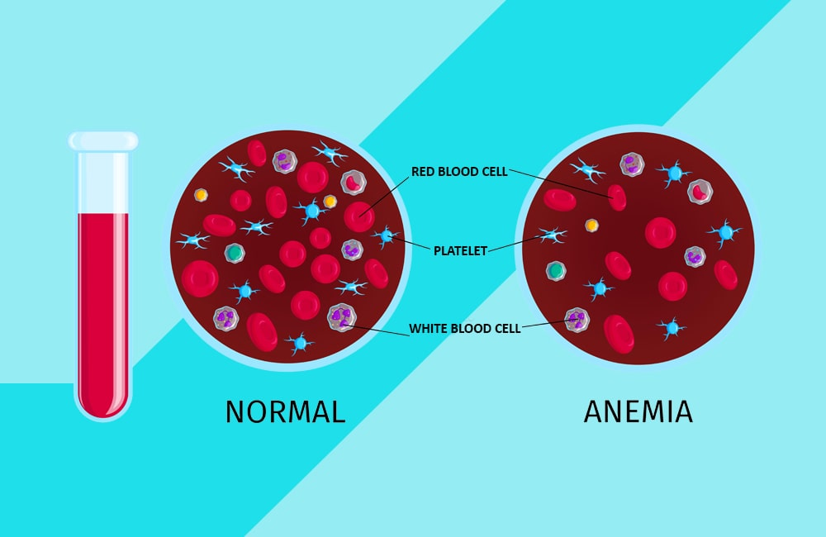

**Figure 1:** Iron deficiency anemia

**2. Vitamin Deficiency Anemia (e.g., Pernicious Anemia):**

This type is often caused by a deficiency in vitamin B12 or folate, both of which are necessary for red blood cell production. Lack of these vitamins can lead to abnormal red blood cells. Common in individuals with poor diets, malabsorption conditions, or those unable to absorb B12 due to autoimmune factors. Symptoms include tingling in the hands and feet, cognitive disturbances, and weakness. Treatment includes B12 or folate supplements.[10]

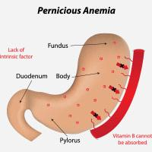

**Figure 2:** Pernicious anemia

**3. Aplastic Anemia**

A rare but serious condition where the bone marrow fails to produce enough red blood cells, white blood cells, and platelets. It may be caused by autoimmune diseases, exposure to toxins, certain medications, or viral infections. Symptoms include fatigue, frequent infections, and easy bruising. Treatments often include immunosuppressive therapies, blood transfusions, and sometimes bone marrow transplants.[11]

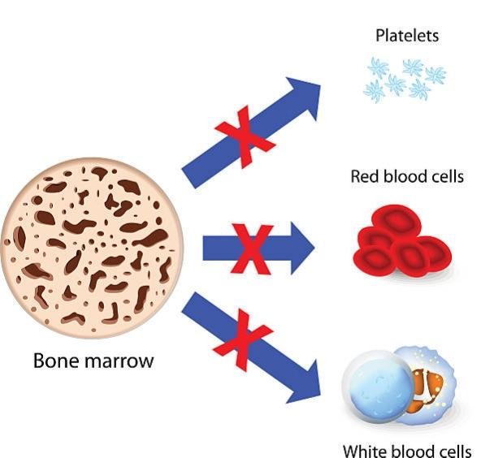

**Figure 3:** Aplastic Anemia

**4. Hemolytic Anemia**

This form occurs when red blood cells are destroyed faster than they can be produced, often due to autoimmune disorders, certain infections, or inherited conditions. Symptoms can include jaundice, dark urine, fatigue, and an enlarged spleen. Treatments depend on the underlying cause but may include medications, lifestyle changes, or, in severe cases, blood transfusions or splenectomy.[12]

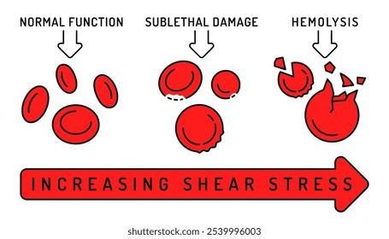

**Figure 4:** Hemolytic Anemia

**5. Sickle Cell Anemia**

An inherited form of anemia caused by a mutation in the hemoglobin gene, leading to crescent or “sickle”-shaped red blood cells that block blood flow and break down prematurely. Common symptoms include pain episodes, swelling, frequent infections, and delayed growth in children. Treatments focus on pain management, infection prevention, and in some cases, stem cell transplants.[13]

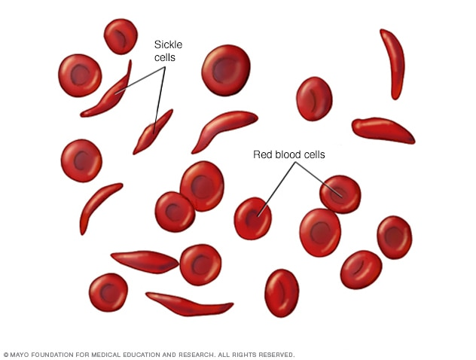

**Figure 5:** Sickle cell Anemia

**6. Thalassemia**

Another genetic form of anemia in which abnormal hemoglobin production leads to the destruction of red blood cells. There are various forms of thalassemia, ranging from mild to severe. Symptoms include fatigue, bone deformities, and, in severe cases, organ damage due to iron overload from frequent transfusions. Treatment often involves regular blood transfusions and chelation therapy.[14]

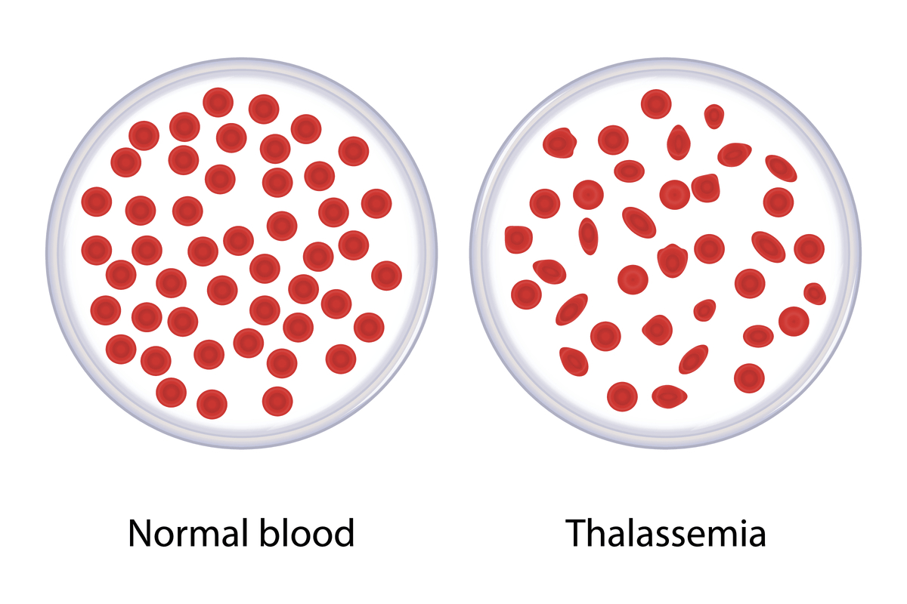

**Figure 6:** Thalassemia

**Etiology**

Anemia develops biologically when erythrocyte loss outpaces production, often due to either inadequate or ineffective erythropoiesis, which may stem from nutritional deficiencies, chronic inflammation, or genetic hemoglobin disorders, or due to excessive erythrocyte loss caused by hemolysis, bleeding, or both. Anemia is commonly categorized by its underlying biological mechanism, such as iron-deficiency anemia (IDA), hemolytic anemia, or anemia of inflammation (AI), as well as by the morphology of red blood cells (RBCs).[15]

Many anemias present with specific RBC morphologies that can aid in diagnosis. RBC morphologies can result from multiple causes, and anemia may arise from several factors simultaneously, even within the same patient. When this occurs, the hematological signs of one cause can be obscured by another. For instance, vitamin B12 or folate deficiencies typically result in macrocytic anemia. However, concurrent iron deficiency, which leads to microcytosis, may completely mask the effects of B12 or folate deficiency. While clinical indices exist to differentiate anemia etiologies based on RBC parameters (e.g., distinguishing IDA from β-thalassemia, both of which cause hypochromia and microcytosis), their accuracy in identifying specific causes can vary.[16,17]

**Pathophysiology**

The pathophysiology of anemia is highly variable and depends on its underlying cause. For example, in cases of acute hemorrhagic anemia, blood volume is restored with intracellular and extracellular fluid, diluting the remaining red blood cells (RBCs) and leading to anemia. In this case, both plasma and red cell volumes are reduced proportionally, which can temporarily create a false impression of normal hemoglobin and hematocrit levels.[18]

RBCs are produced in the bone marrow and released into the bloodstream, with about 1% of RBCs removed from circulation daily. An imbalance between RBC production and removal or destruction leads to anemia. The primary mechanisms behind anemia include the following:

**1. Increased RBC Destruction**

**Blood Loss:**

Acute: Due to events like hemorrhage, surgery, trauma, or menorrhagia

Chronic: Resulting from heavy menstrual bleeding, chronic gastrointestinal blood loss (e.g., from hookworm infection or ulcers), or urinary loss (e.g., due to benign prostatic hyperplasia, renal carcinoma, or schistosomiasis)[19]

**Hemolytic Anemia:**

Acquired: Related to immune reactions, infections, microangiopathic conditions, transfusions, or hypersplenism

Hereditary: Due to enzyme deficiencies (e.g., G6PD, pyruvate kinase deficiency), hemoglobin disorders (e.g., sickle cell disease), metabolic defects, or membrane abnormalities (e.g., hereditary spherocytosis and elliptocytosis)

**2. Deficient or Defective Erythropoiesis**

**Types by RBC Morphology:**

Microcytic

Normocytic, Normochromic

Macrocytic

**Nutritional treatment for anemia**

Nutritional treatment for anemia focuses on addressing deficiencies that impair red blood cell (RBC) production or function. The primary nutrients implicated are iron, vitamin B12, and folate, as these are essential for erythropoiesis (RBC production) and hemoglobin synthesis.

**1. Iron Supplementation**

Iron-deficiency anemia (IDA) is the most common nutritional anemia. Iron is a key component of hemoglobin, enabling oxygen transport in the blood. Low iron intake, poor absorption, or chronic blood loss can lead to IDA.[20,21]

**Treatment**

Oral Iron Supplements: Ferrous sulfate, ferrous gluconate, and ferrous fumarate are common forms. Vitamin C enhances iron absorption and is often recommended alongside iron supplements.

Dietary Sources: Foods rich in heme iron (e.g., red meat, poultry, and fish) are well absorbed. Non-heme iron from plant sources (e.g., beans, spinach, fortified cereals) is less easily absorbed, though its absorption improves with vitamin C.

**2. Vitamin B12 Supplementation**

Vitamin B12 is crucial for DNA synthesis in RBC production. Deficiency can lead to megaloblastic anemia, where RBCs are larger than normal (macrocytic). Vitamin B12 deficiency often occurs due to malabsorption (e.g., from pernicious anemia or gastrointestinal surgeries) or low dietary intake (common in strict vegan diets).

**Treatment**

Oral or Intramuscular B12: Treatment involves high-dose oral vitamin B12 or intramuscular injections, especially if absorption issues are present.[22]

Dietary Sources: Vitamin B12 is found in animal products like meat, fish, eggs, and dairy. Fortified foods and supplements are recommended for vegans.[23]

**3. Folate (Vitamin B9) Supplementation**

Folate is essential for DNA synthesis, and its deficiency, like B12, leads to macrocytic anemia. Folate deficiency can result from poor diet, malabsorption disorders, and increased needs during pregnancy.[24,25]

**Treatment:**

Oral Folate Supplements: Folic acid supplements are typically prescribed.

Dietary Sources: Rich sources include leafy green vegetables, legumes, nuts, and fortified cereals.

**4. Dietary and Lifestyle Adjustments**

Combining Iron with Vitamin C-Rich Foods: Enhances iron absorption, especially for plant-based iron sources.[26]

Reducing Iron Absorption Inhibitors: Foods and beverages like tea, coffee, and foods high in calcium can reduce iron absorption and are best consumed separately from iron-rich meals.

Balanced Diet: Ensures intake of essential nutrients, such as copper and vitamins A and C, which play supportive roles in erythropoiesis.[27]

**Conclusion**

Anemia is among the most common blood disorders and can arise from genetic factors, immune responses, or nutritional deficiencies. However, it is often preventable with the right precautions. Anyone experiencing symptoms of anemia should seek prompt medical evaluation and consult a healthcare professional. Early diagnosis and treatment are essential to promote a healthier future generation. By raising awareness and working together, we can reduce the prevalence of anemia. In essence, taking care of our health contributes to a happier and more fulfilling life.

**Reference**

1. World Health Organization. 2011 Haemoglobin concentrations for the diagnosis of anaemia and assessment of severity Accessed August 4, 2017 http://www.who.int/vmnis/indicators/haemoglobin.pdf.
2. Kassebaum NJ, Jasrasaria R, Naghavi M, et al. 2014 A systematic analysis of global anemia burden from 1990 to 2010. Blood 123: 615–624. [PubMed: 24297872]
3. 3. Black RE, Victora CG, Walker SP, et al. 2013 Maternal and child undernutrition and overweight in low-income and middle-income countries. Lancet 382: 427–451. [PubMed: 23746772]
4. Scott SP, Chen-Edinboro LP, Caulfield LE, et al. 2014 The impact of anemia on child mortality: an updated review. Nutrients 6: 5915–5932. [PubMed: 25533005]
5. Haider BA, Olofin I, Wang M, et al. 2013 Anaemia, prenatal iron use, and risk of adverse pregnancy outcomes: systematic review and meta-analysis. BMJ 346: f3443. [PubMed: 23794316]
6. Rasmussen K 2001 Is there a causal relationship between iron deficiency or iron-deficiency anemia and weight at birth, length of gestation and perinatal mortality? J. Nutr 131: 590S–603S. [PubMed: 11160592]
7. Haas JD & Brownlie T. 2001 Iron deficiency and reduced work capacity: a critical review of the research to determine a causal relationship. J. Nutr 131: 676S–688S; discussion 688S–690S. [PubMed: 11160598]
8. Walker SP, Wachs TD, Meeks Gardner J, et al. 2007 Child development: risk factors for adverse outcomes in developing countries. Lancet 369: 145–157. [PubMed: 17223478]
9. Camaschella, C. (2015). Iron-deficiency anemia. The New England Journal of Medicine, 372(19), 1832-1843.
10. Stabler, S. P. (2013). Vitamin B12 deficiency. The New England Journal of Medicine, 368(2), 149-160.
11. Young, N. S. (2018). Aplastic anemia. Annals of Internal Medicine, 168(9), 621-634.
12. Dhaliwal, G., & Cornett, P. A. (2004). Hemolytic anemia. American Family Physician, 69(11), 2599-2606.
13. Piel, F. B., Steinberg, M. H., & Rees, D. C. (2017). Sickle cell disease. The New England Journal of Medicine, 376(16), 1561-1573.
14. Cappellini, M. D., Cohen, A., Porter, J., Taher, A., & Viprakasit, V. (2014). Guidelines for the management of transfusion-dependent thalassaemia. Thalassaemia International Federation.
15. Braunstein EM 2017 Etiology of anemia 2 2017. Accessed December 5, 2018 https://www.merckmanuals.com/professional/hematology-and-oncology/approach-to-the-patient-with-anemia/etiology-of-anemia.
16. Hoffmann JJ, Urrechaga E & Aguirre U. 2015 Discriminant indices for distinguishing thalassemia and iron deficiency in patients with microcytic anemia: a meta-analysis. Clin. Chem. Lab. Med 53: 1883–1894. [PubMed: 26536581]
17. Metz J 2008 A high prevalence of biochemical evidence of vitamin B12 or folate deficiency does not translate into a comparable prevalence of anemia. Food Nutr. Bull 29: S74–S85. [PubMed: 18709883]
18. Badireddy M, Baradhi KM. StatPearls [Internet]. StatPearls Publishing; Treasure Island (FL): Aug 7, 2023. Chronic Anemia. [PubMed]
19. Amin SK, Antunes C. StatPearls [Internet]. StatPearls Publishing; Treasure Island (FL): Jul 17, 2023. Lower Gastrointestinal Bleeding. [PubMed]
20. Short MW, Domagalski JE. Iron deficiency anemia: evaluation and management. American Family Physician. 2013;87(2):98-104.
21. Tolkien Z, Stecher L, Mander AP, Pereira DIA, Powell JJ. Ferrous sulfate supplementation causes significant gastrointestinal side-effects in adults: a systematic review and meta-analysis. PLoS ONE. 2015;10(2):e0117383.
22. Green R, Allen LH, Bjørke-Monsen AL, et al. Vitamin B12 deficiency. Nature Reviews Disease Primers. 2017;3:17040.
23. Carmel R. How I treat cobalamin (vitamin B12) deficiency. Blood. 2008;112(6):2214-2221.
24. Lentz RD. Folate, B12, and MTHFR: a review. MedGenMed. 2005;7(2):56.
25. Bailey LB. Folate in health and disease. CRC Press. 2017.
26. Hurrell R, Egli I. Iron bioavailability and dietary reference values. American Journal of Clinical Nutrition. 2010;91(5):1461S-1467S.
27. Allen LH. Vitamin B12 metabolism and status during pregnancy, lactation and infancy. Advances in Nutrition. 2012;3(4):443-451.