**Herbal Cosmetic**

**Vaibhav N.Nathjogi *1 , Kartik D.Bharambe *2 , Dipesh S. Sonawane *3 , Ketan B. Nemade *4 , Akshay A. Patil *5 , Rupali N. Rathod *6**

*1,2,3,4,5 Author’s Department Of Pharmaceutics , Sumantai Institute Of Pharmacy , Bambrud kh. Pachora Dist. Jalgaon , Maharashtra, India .

*6 Asst.Prof, Department Of Pharmaceutics , Sumantai Institute Of Pharmacy , Bambrud kh. Pachora Dist. Jalgaon , Maharashtra, India .

Corresponding Author’s E-Mail ID : vaibhavnathjogi123@gmail.com

**1. Abstract:**   
  
Antioxidants are frequently used as the active ingredient in many cosmetics sold today.   
  
components. Free radicals, which can initiate a chain reaction, are known to be produced via oxidation reactions.   
  
responses that harm skin cells. As the quantity of free radicals increases, the   
  
skin pigmentation, dryness, elastosis, wrinkles, and photoaging. Antioxidants used topically may   
  
Eliminate the free radical intermediates to stop the chain reactions and prevent further oxidation.   
  
responses by becoming themselves oxidized; this could protect the skin from external stressors.   
  
brought on by free radicals.

It is commonly recognized that plants have the ability to naturally synthesize antioxidant molecules that may be able to regulate the oxidative stress brought on by oxygen and sunlight. Numerous commercial cosmetic items and patents contain different mixes of plant extracts. Various mixtures of several plant extracts, such as green tea, rosemary, grape seed, basil grape, blueberry, tomato, acerola seed, pine bark, and milk thistle, are typically found in cosmetic compositions. Natural antioxidants such as polyphenols, flavonoids, flavanols, stilbens, and terpenes (including carotenoids and essential oils) are present in these plant extracts. Pure natural ingredients like resveratrol, kojic acid, and quercetin are included in the composition of several commercial products. The key components for creating a successful product are selecting the appropriate active plant extracts or chemicals, verifying their efficacy, and ensuring their stability and synergistic effects in cosmetics.   
  
**KEY WORDS**: Skin defense mechanism, free radical, reactive oxygen species, natural antioxidant, cosmetics, and antioxidant assay.

**OVERVIEW OF COSMETICS**:   
Cosmetics are materials derived from a variety of sources and technically compounded substances that are used to cleanse, nourish, and moisturize the skin on the face and other body parts. They can be applied in a variety of ways to improve the appearance of the skin, treat imperfections, and relieve skin issues.[1] The word "cosmetic" refers to materials used to improve or beautify look; it comes from the Greek word "kosmeticos," which means to adorn and prepare.[2] Effective goods used widely around the world to maintain and brush the general appearance of the face and other body parts, such as the hand, mouth, finger, hair, lip, and eye, are called cosmetics. . Cosmetics come in a wide variety of forms, including as face packs, lotions, powders, shampoos, conditioners, and hair oils for nourished, smooth, and glowing skin and hair. These products are essential for both attractive men and women. Despite this, many chemical toxins, chemicals, poisonous materials, chemical dyes, and their derivatives are found in cosmetics, and these substances can lead to a host of health issues and side effects that can result in innumerable diseases. As a result, herbal cosmetics are required because the allopathic system is insufficient for health advantages. Nowadays, herbal cosmetics have emerged as the appropriate way out to the ongoing issues.[1

**Herbal Cosmetic**  
Herbal cosmetics are made up of phytochemicals derived from different plants that affect how the skin works and distribute nutrients that are good for healthy, radiant skin or hair. These phytochemicals, which come from different sources, have two uses: they can be used as skincare products. The botanical ingredients provide nutrients that are good for the nourished skin or hair and give the skin biological activity. Because herbal cosmetics have fewer adverse effects than conventional cosmetics, their demand is growing quickly. The fact that herbs and shrubs are used to make herbal cosmetics makes them advantageous. The natural ingredients in the herbs provide the skin with nutrition and other beneficial elements without having any undesirable or adverse effects. [1]

**COSMETIC ANTIOXIDANT:**

Superior anti-aging products for the face and skin rely heavily on antioxidants.   
Vitamins and minerals are the natural components that make up antioxidants. They are able to combat "free radicals," which harm proteins, lipids, and DNA. Damaged skin cells can hasten the aging process by causing dryness, wrinkles, and As their name suggests, antioxidants offer defense against oxidative processes. Because free radical oxidation reduces the flexibility and resilience of skin cells, it permanently deteriorates their support structure, which is the foundation of the aging process. The human body has a built-in defense system against harm caused by free radicals. Age and exposure duration reduce its protective ability, as the amount of free radicals produced surpasses the body's innate capacity to counteract them. skin, dull skin, dark bags under the eyes, and a reduction in skin pliability and suppleness. The deepest layer of the skin can be penetrated by antioxidants included in skin care products. Living cells may regenerate and repair themselves thanks to antioxidants. Skin that feels and looks younger is the end result. Açai oil, alpha lipoic acid, green and white tea, retinol, vitamin C, coenzyme Q10 (Co Q-10), isoflavones, polyphenols, curcumin, turmeric, pomegranate, rosemary, glutamate, slenium, and zinc are the antioxidants that have been most demonstrated to help with skin issues. [2]

**3. COSMETICS CLASSIFICATION**:   
  
**SKIN COSMETICS:**Skin care products and cosmetics are a part of daily grooming. For optimal health, the skin must be preserved and protected. The biggest organ in the body, the skin, divides and shields the internal and exterior environments. DNA, collagen, and cell membranes—the fundamental components of skin—are cumulatively harmed by environmental factors, air pollution, sun radiation exposure, and the aging process. The purpose of cosmetics and beauty products is merely to conceal and enhance the appearance of the skin; they will not alter or heal it. Because of the kinds of useful substances they contain, cosmetics—beauty products with therapeutic or drug-like effects—can alter the way the skin functions biologically. Certain skin care products are more than just skin coloring and embellishment. By promoting collagen formation and thwarting the damaging effects of free radicals, these products enhance the texture and functionality of the skin, preserving the integrity of the keratin structure and promoting overall skin health.   
Examples include moisturizers, bleaching chemicals, and sunscreen. [3][4][5]

**COSMETICS FOR HAIR:**   
  
Humans, in contrast to all other terrestrial mammals, have direct control over the appearance of their hair. The length, color, and style of one's hair can all be changed to suit one's desired appearance. People's perceptions of themselves and their physical appearance are greatly influenced by their hair color, style, and maintenance. Henna coloring and mud-based hair setting were two of the first hair cosmetic techniques used in ancient Egypt. Numerous ointments and tonics were suggested for hair beauty and as treatments for scalp conditions in ancient Greece and Rome. The first person to distinguish between medical treatments meant to cure illnesses and cosmetics used for aesthetic purposes was Henry de Mondeville.[6] However, the development of cosmetics with physiologically active chemicals, or "cosmeceuticals," has made it more difficult to distinguish cosmetics from medications today. The most common type of cosmetic hair care is shampooing. Although the main purpose of shampoos has always been to clean the hair and scalp, modern formulations are tailored to the differences in hair quality, hair care practices, and particular issues like treating oily hairs, dandruff, and androgenic alopecia, which are related to the superficial condition of the scalp [7].[7] For instance, hair growth accelerators, conditioning agents, and specific care components.

**EYE MAKE UP COSMETICS**:

Eye makeup has been a daily necessity for ladies across all kingdoms and eras.   
In addition to being windows into the human soul, eye care is a potent communication tool. A pair of sparkling eyes is a symbol of beauty and good looks. Eye makeup has been used for millennia to draw attention to the eyes. Various hues, fashions, and trends were employed to adorn the eyes during historical periods. Kohl, a black pigment or color, has been used for millennia to highlight eyelids, eyebrows, and lashes. Eyeshadows, mascara, eyeliners, eyebrow liners, fake eyelashes, and eye makeup remover are a few examples. [8]

**NAIL COSMETICS:**

Ancient Egypt and China are where nail coloring was first used. Wax, egg white, and flowers were combined to create the first nail paint. Another application for natural henna was as a nail colorant.   
Royalty was designated to wear certain colors, such as crimson, gold, and silver, whereas regular people were forced to wear lighter hues. Gold and silver were considered symbols of royalty in ancient China. Pale hues indicated weakness, but crimson and black stood for courage and strength. Gold, silver, and precious stones were used to make artificial nails during the Chou dynasty in China around 600 BC. In 1920, the Charles Revson Company—now known as Revlon—created the first modern nail paint. They created a nail polish that was modeled after the enamel paint used on automobiles. In 1932, the contemporary nail polish was introduced to the market. For instance, nail polish, a brush, and a cleaning. [9]

**OTHER COSMETICS:**

The skin under the eyes has almost no oil glands and no subcutaneous fat. In order to restore and heal this sensitive skin and lessen the symptoms of premature aging, it need protection and an abundance of moisture. The skin gets harsher, drier, and thinner with age. This illness is made worse by excessive exposure to the weather and environmental contaminants. Many topical skin-soothing treatments interfere with this process, but those for this area must be especially mild and specially made with substances that interact with the cells beneath the skin's surface to operate from the inside out without hurting the eyes. Numerous cosmeceutical eye creams provide the skin with healthy nutrients and natural emollients. Butcher's broom, chamomile, vitamin E, antioxidants (vitamins A, C, and E), green tea, tiare flower, Ginkgo biloba, cucumber, calendula, and a-bisabolol, an active component of chamomile, are among the other useful constituents. Yeast, which helps to firm out wrinkles, is a vital ingredient in eye lifting moisture cream, which addresses puffiness, irritation, and also guards against potential skin damage. The eye wrinkle cream typically contains carrot extract, squalene, wheat germ, and corn oil to help prevent the indications of aging. Aosain, an algal extract from seaweed, is an ingredient in eye firming fluid that keeps the skin supple.[7]

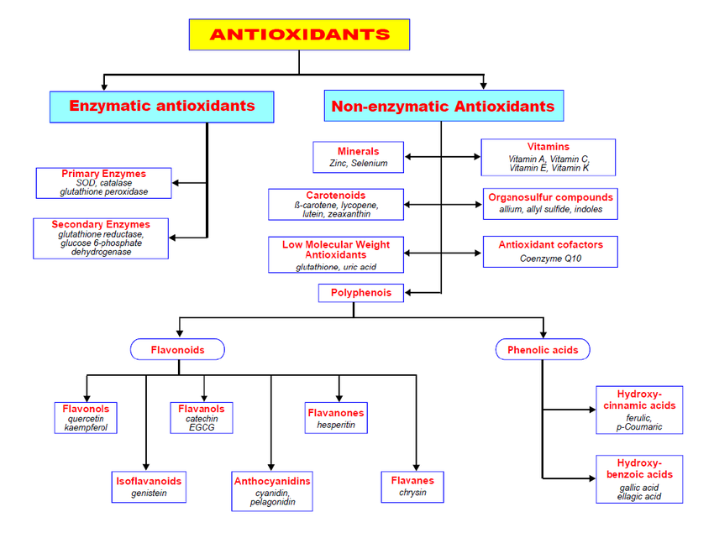

**Based on their mechanisms, antioxidants can be categorized into three groups**:

Primary antioxidants, which essentially act as scavengers or terminators of free radicals   
Tertiary antioxidants, which are focused on repairing damaged biomolecules, and secondary antioxidants, which are significant preventive antioxidants that work by delaying chain initiation.[10]   
  
  
**The purpose of antioxidants is to:**

1. Correct signs of aging, prevent sun damage, and improve skin tone.   
2. Antioxidants shield skin cells from harm and slow down the aging process. They also stop the breakdown of natural substances in cosmetic products, such as proteins, sugar, and lipids.

3. Antioxidants have been shown to increase skin brightness and reduce fine wrinkles, sun spots, and age spots.   
4. Herbal active components that serve as antioxidants are added to cosmetic bases to nourish and treat a variety of skin conditions.   
5. Antioxidants aid to make the skin smooth and light by acting as a cleanser, toner, moisturizer, sunblock, and face cream.   
6. Antioxidant-containing cosmetics have the following benefits: reduced cost, no negative side effects, environmental friendliness, safety, etc

**Natural antioxidants:** Since ancient times, several plants and their byproducts have been employed as medicines. The characteristics and mechanism of these plant extracts in skin care are still being investigated in a number of studies.[11]   
Antiaging products must include natural antioxidants that squelch free radicals. They might provide defense against environmental and other substances that could harm the tissues.[12]   
  
  
**As explained below, antioxidants affect oxidative processes at many levels:**   
• Defending against free radicals   
Removing oxidatively damaged biomolecules; binding with metal ions; and scavenging lipid peroxyl radicals.

The imbalance of prooxidant or antioxidant may results in oxidative damage of biomolecules such as lipids, proteins and DNA and has been termed as ‘oxidative stress’. Natural antioxidants which include minor lipids are if special interest in cosmetics and skin care formulation for protection against intrinsic and extrinsic aging. They also offer extended shelf life to vegetable oil-based formulations as well as protection of cell constituents of skin such as proteins, lipids and DNA. Many common natural oils such as rapeseed oil, sunflower oil and soyabean oil are rich in polyunsaturated fatty acids, mainly linolic and linoleic acids.

Natural antioxidants, which include minor lipids, are of particular interest in cosmetics and skin care formulations for protection against intrinsic and extrinsic aging; they also offer extended shelf life to vegetable oil-based formulations and protection of cell constituents of skin, such as proteins, lipids, and DNA. Many common natural oils, such as rapeseed oil, sunflower oil, and soybean oil, are rich in polyunsaturated fatty acids, primarily linolic and linoleic acids. An imbalance of prooxidants or antioxidants can lead to oxidative damage of biomolecules, which has been dubbed "oxidative stress. In addition to being important, these natural oils are also used as emollients in skin care products.   
The disadvantage of unsaturated oils, however, is their low shelf life both during storage and after application, as well as their high vulnerability to oxidation. Through various activities such ant tyrosinase, antelastase, and antioxidants, natural oils such as bergamot, lavender, rose, marjoram, and chamomile also demonstrate their cosmetic worth. Vitamins, proteins, enzymes, and antioxidants are examples of micronutrients that can directly scavenge lipophilic and hydrophilic pro-oxidants through topical administration. Vitamins, flavonoids, and polyphenols support the antioxidant defense system and may slow down the natural aging process.

Tocopherol is recovered from the tocopherol radical by vitamin C, which also moves the radical load to the aqueous compartment where antioxidant enzymes eventually remove it. Previously, it seemed that natural antioxidants have anti-inflammatory, photoprotective, and anti-aging properties. One of the best antioxidants in vivo is ascorbic acid, which makes it a sensible choice for topical photoprotectants that limit sunburn, cell division, and tumor development. In addition to vitamin C and E, polyphenolic compounds, carotene, and enzymes like SOD that are known to regenerate vitamin E, C, and glutathione are other naturally occurring antioxidants that have been investigated for their photoprotective effectiveness.

These substances change the chemical and physical characteristics of skin, which prevents UV rays from penetrating and prevents oxidative skin responses. Applying various plant extracts, especially flavonoids, has been shown to reduce both acute and long-term skin damage. Fruits and plants include polyphenolic chemicals called flavonoids, such as apigenin, catechin, epicatechin, alpha glycosyl rutin, and silymarin, which have antioxidant properties because of free phenolic groups [13].

**Cosmetics A mixture that includes antioxidants:**

Fragrances, fats, and oils found in dermatological and cosmetic compositions are all susceptible to auto-oxidation from air exposure, which results in chemical deterioration and an unpleasant odor. Antioxidants can be added to formulations to prolong their shelf life and preserve them. Antioxidants may dissolve in water, lipids, or both. Free radicals, which are created by sunlight, street air, vehicle pollution, and other environmental factors—particularly industrial sources—are neutralized by antioxidants. In the fight against aging and skin cancer, products based on antioxidants are equally as crucial as those that contain sunscreen. They cover the skin with a barrier that shields it from UV and infrared radiation.[13]

"

**I. Lycopene**

Red fruits and vegetables include the carotenoid lycopene, a potent antioxidant. In actuality, it is what gives them their red hue. In mouse models, its chemopreventive properties against photo-induced tumors have been demonstrated. Many skin care products contain lycopene, despite the fact that there is very little clinical evidence supporting its use. [14]

**4. NATURAL HERBS USED AS ANTIOXIDANTS IN COSMETICS:**

These substances and extracts, which come from a variety of plants, grains, and fruits, are used in the cosmetics industry as natural antioxidants because they can prevent oxidative damage to products or lessen oxidative stress on the skin.[15] Reactive oxygen species (ROS) are a primary source of oxidative stress, which hastens the aging process of the skin.[16] Extrinsic aging is linked to external elements that impact the aging process, such as pathogenic bacteria, UV radiation, and air pollution, while intrinsic aging is linked to the natural aging process. The main source of ROS generation is probably photoaging.[17] Antioxidant molecules can function as metal chelators, oxidative enzyme inhibitors, or enzyme cofactors. They can also be enzymes or low molecular weight antioxidants that give an electron to reactive species, stopping the radical chain reaction and avoiding the generation of reactive oxidants. Additionally, antioxidants can act as stabilizers to stop lipid rancidity. [18]   
Following table shows list of active agent, their natural sources and effects for skincare.

**We'll talk about some of the natural plants used in cosmetics next.**

**1. Anthocyanins**

The naturally occurring water-soluble pigments called anthocyanins, which are found in plants and vegetables, have a number of mechanisms that prevent oxidation. Anthocyanins offer numerous health advantages, from preventing chronic illnesses to enhancing skin appearance. According to a Japanese study, cyanidins, which are found in anthocyanins, are crucial for antioxidant activity.

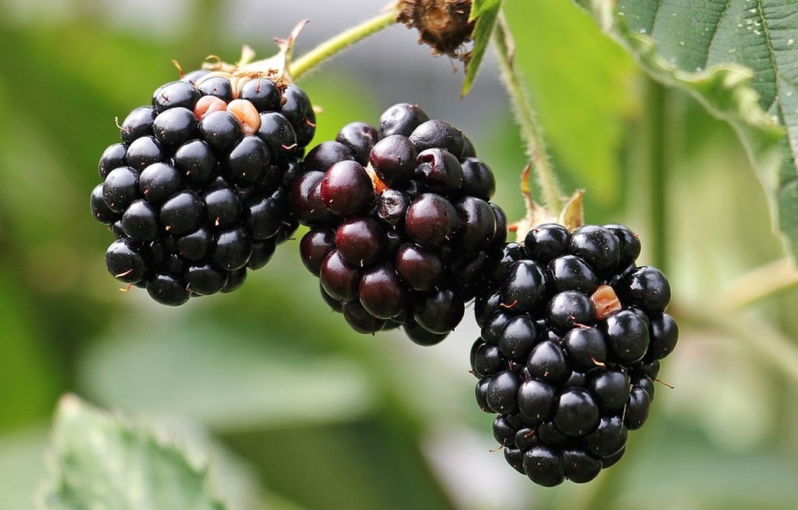

**• Synonym:R. plicatus.**

**• Source: Blackberry fruit**

**• Family:Rosaceae**

Another analysis also showed that cyanidins protect the lipids in the cell membrane by preventing oxidation. Furthermore, it was found that cyanidin inhibits oxidation four times more effectively than vitamin E. The black raspberry's anthocyanins exhibit an inhibitory effect on the growth and development of tumor cells. By reducing stimulating mediators that start the development of tumors and slowing down the growth of premalignant cells, they increase the rate of cell turnover and effectively affect the death of infected cells. [20]

**2. proanthocyanidin**  
OPC (proanthocyanidin) inhibits DNA mutations. Additionally, OPC inhibits elastase, preserving the skin's elastin integrity. It also works in concert with flavonoids, phenolic acids, and vitamins C and E to preserve and restore them. Research has shown that OPC in cream form is efficient at preventing the harmful effects of UV radiation from the sun.   
The primary defense against free radical species, which are the primary cause of many undesirable skin alterations, is provided by flavonoids and phenolic acids. It is generally known that they can be used to treat various skin conditions as well as to beautify and enhance the appearance of the skin. There is a constant need for protection from ultraviolet (UV) radiation and prevention of its negative effects because it can result in sunburns, wrinkles, decreased immunity to infections, premature aging, and cancer.   
[21]   
  
 **Fig.3 Geape seed**

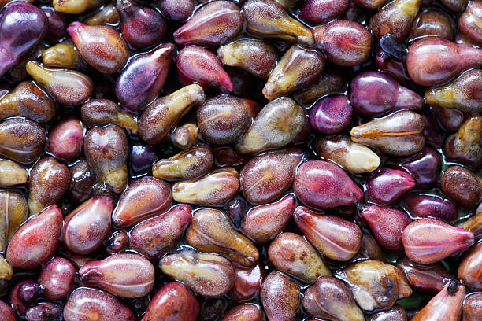

**• Synonym: Grain,pip,spore**

**• Source: Crushed seeds of grape plant**

**• Family: Vitaceae**

Grape seed proanthocyanidins (GSP) are potent oxidation inhibitors and scavengers of free radicals. In mice exposed to UV radiation that causes cancer, GSP inhibited the growth of skin tumors and reduced their size. Plants have long been used in medicine. Or Research and the creation of new cosmetic trends are based on beautification.   
Proanthocyanidin's cream formulation shows strong protection against the harmful effects of UV radiation. Applying OPC cream prior to sun exposure resulted in a reduced burning feeling. The primary alteration associated with skin aging is the breakdown of glycosaminoglycans and collagen filaments, which results in a reduction in skin thickness. Collagen fiber production was stimulated in the rat by transdermal administration of OPC and antioxidant. Furthermore, OPC has increased the amount of collagen synthesis in the fibroblast cell societies.

**3. Carotenoids**  
α-tocopherol, or vitamin E, is a strong antioxidant. This antioxidant can be applied topically to protect both acute and chronic UV damage. Only tocotrienol and alpha-tocopherol, the natural components of vitamin E, effectively reduce skin roughness when administered topically.

**Fig.4 Carotenoids**

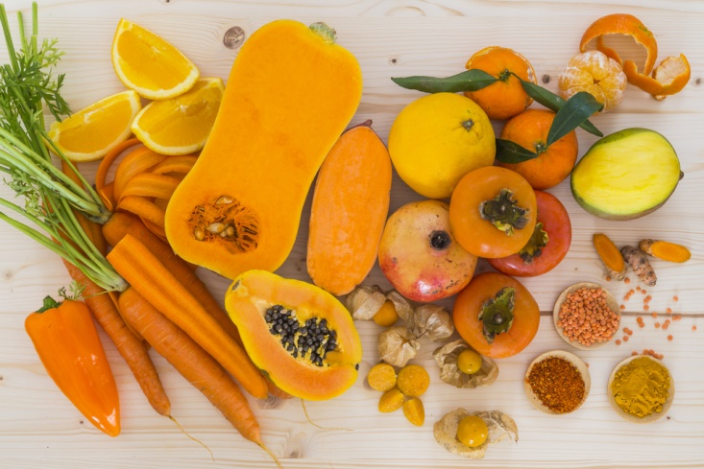

**• Synonym:Tocopherol**

**• Source: carrots, pumpkin,tomato**

**• Family:Alpha tocopherol**

Carotenoids are found in foods like apricots, oranges, grapefruit, carrots, and squash. Additionally, it lessens the severity and extent of wrinkles on the face. Vitamin E applied topically increases the stratum corneum's water-restriction limit and enhances hydration of the outermost layer of the epidermis. [22]   
  
 A balanced diet rich in supplements produces dietary carotenoids, which build up in the skin and have a strong correlation with UV protection. Long utilized in skin care products, oil is produced from the fruits and pulp of Hippophae rhamnoides, also known as sea buckthorn. In addition to being an emollient, vitamin E also scavenges free radicals. One of the best sources of vitamin E is wheat germ oil (Triticum vulgare). They suggest a remarkable antioxidant effect for topical anti-aging formulations or treatments. Furthermore, it keeps the skin hydrated and hydrates it. Tocopherols are abundant in hazelnut oil (Corylus avellana), sunflower oil (Helianthhus annuus), and sesame oil (Sesamum indicum).   
The oil from pumpkin seeds (Cucurbita pepo) deserves special recognition. It has a lipid composition that contains two kinds of antioxidant agents in addition to high levels of linoleic acid (43–53%) [23].

**4. Vitamin A**

Retinol is a highly beneficial active ingredient that has been scientifically shown to dramatically improve skin look when used properly and in the right formulation. The new natural retinol for vital and healthy skin, Bakuchiol, offers the same advantages as retinol but is more practical for sensitive skin that may be irritated and have a poor tolerance to retinoids.

**Fig.5 Bakuchiol**

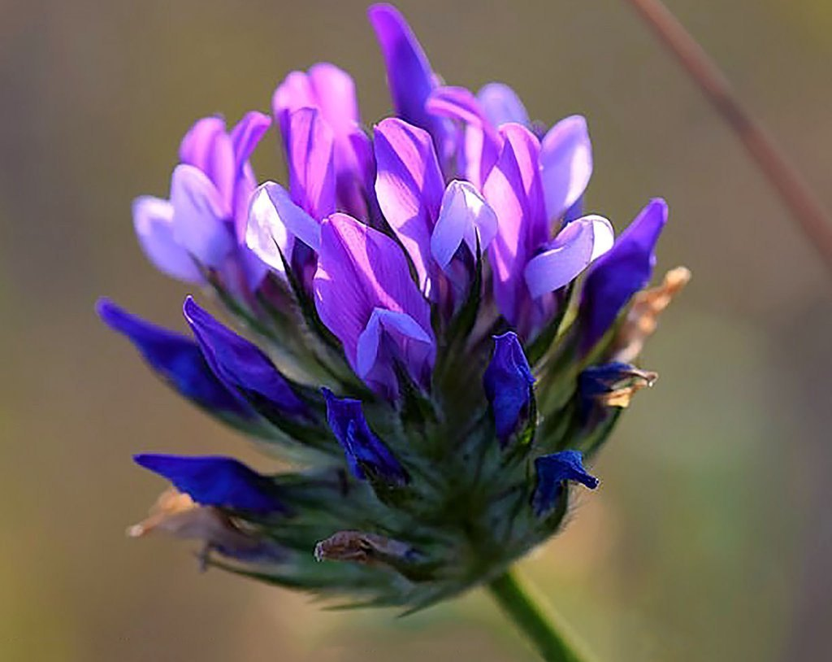

**• Synonym:Cullen corylifolium (LL**

**• Source:Milk**

**• Family:Fabaceae**

One of the key components of anti-aging products is retinol. The ability of retinol to promote skin renewal is essential for enhancing the overall appearance of the skin. Retinol may help to rejuvenate the skin by speeding up the rate of cell turnover. Additionally, it enhances the appearance of facial lines. When used topically, retinol-containing products (such as retinol skin cream) exhibit potent antioxidant activity that helps eliminate environmental free radicals [23]

.

**5. Resveratrol** Resveratrol is a member of the stilbene class of polyphenolic chemicals. Resveratrol is a fat-soluble substance that can exist in both cis and trans forms. Resveratrol is a polyphenolic phytoalexin that occurs naturally. It was discovered that resveratrol mediated anti-inflammatory effects, acted as an antioxidant and antimutagen, and caused human promyelocytic leukemia. differentiation of cells. Furthermore, it prevented carcinogenesis in a mouse skin cancer model and the formation of preneoplastic lesions in carcinogen-treated mouse mammary glands in culture.[23]

**Fig.6 Blueberries**

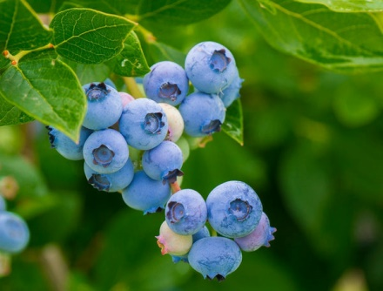

**• Synonym:Vaccinium fuscatum**

**• Source: Cyanococcusfruit**

**, • Family:Ericaceae**

Resveratrol antioxidants are abundant in blueberries. Rich in antioxidants, particularly anthocyanin, which gives them their deep blue color, blueberries also aid in eliminating free radicals from the blood, preventing the body from contracting cancer and other illnesses. Prior to UVB irradiation, topical administration of resveratrol to SKH-1 hairless mice significantly reduced UVB-generation of H2O2, leukocyte infiltration, and skin oedema. Long-term research has shown that topical resveratrol administration, both before and after treatment, inhibits the incidence of UVB-induced tumors and delays the initiation of skin carcinogenesis.[23]

Only grapes, wine, grape juice, cranberries, blueberry juice, peanuts, and peanut goods are known to contain resveratrol. According to research by Vastano et al., one of the best sources of resveratrol (2 960–3 770 ppm) is found in the roots of the weed Polygonum cuspidatum. Additionally, Veratrum grandiflorum leaves as well as Veratrum formosanum roots and rhizomes have been found to have high concentrations of resveratrol. Due to their laxative, anticancer, and anti-arteriosclerosis qualities, these three herbs have been widely employed in Chinese and Japanese traditional medicine.[23]

**6. Quercetin:**   
  
 Quercetin is a flavonoid that comes from plants. Fruits, vegetables, leaves, and grains are examples of sources. The term, which comes from quercetum (oak forest), has been in use since 1857. Quercetin is the most prevalent flavanol in the diet. Quercetin functions as an immunomodulator and has anti-inflammatory and antioxidant properties. It has been observed that a diet high in quercetin prevents the growth of skin cancer, mouth carcinogenesis, colonic neoplasia, and carcinogen-induced rat mammary cancer.vtumor development in mice using three models of skin carcinogenesis when topical treatment is used

Fig.7 Red onion

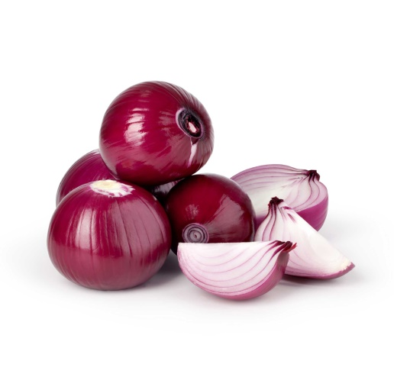

• Synonym:Allium Angolese Bake

• Source:Developing bulb

• Family:Amaryllidaceae

One of the most well-known food sources of quercetin is onions. Donions are by far the greatest source of quercetin among the onion family; a 100-gram chunk contains 39 milligrams of this potent flavonoid. It can be found in many common fruits, vegetables, drinks, and herbs.Onions have the highest amounts. The protective properties of eating fruits and vegetables against carcinogens and mutagens, particularly metals, may be explained by quercetin.When tested on humans as possible topical sunscreen ingredients, quercetin and rutin were shown to offer UVA and UVB protection. [23]

**7. Apigenin**In SKH-1 mice, apigenin was found to be efficacious in preventing UVA/UVB-induced skin carcinogenesis. They may also have advantageous antioxidant qualities and shield the plants from UV rays and diseases. abundant source of apigenin, an antioxidant.   
A common plant flavonoid found in fruits, vegetables, herbs, and beverages is apigenin. rich source of apigenin antioxidants Echinacea purpurea, that purple coneflower [23]

**Fig8.Purple coneflower**

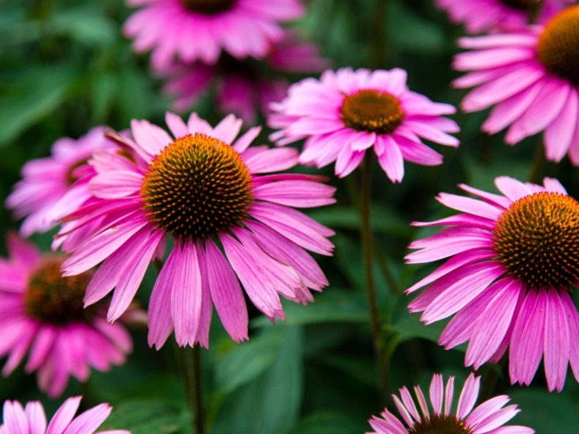

**• Synonym: Echinacea purpurea**

**• Source: Herbs, fruit, vegetables,and beverages**

**• Family:Asteraceae**

Apigenin inhibited NF-κB's nuclear translocation but not its ability to stimulate the expression of reporter genes. Apigenin is also present in marigold (Calendula officinalis), where it was demonstrated through the use of the mouse ear test that the action was caused by flavonoids, with apigenin outperforming indomethacin in the test. In addition to plants like carrot (Daucus carota), agrimony (Agrimonia eupatoria), arnica (Arnica montana), purple coneflower (Echinacea purpurea), and eyebright (Euphrasia officinalis), Artemisia (Artemisia inculta) and Cuminum cyminum, or cumin, also contain apigenin and luteolin and their derivatives. When used properly, all of these plants have been shown to have anti-inflammatory properties. [23]

**8. Silymarin:**

Milk thistle seed's active ingredients show that it is good for the skin. These consist of fatty acids, such as linoleic acid, vitamin E, and silymarin, which is actually a collection of three flavonoids.   
 The flavonoid component silymarin is present in milk thistle (Silybum marianum) seeds.   
The three phytochemicals that make up silymarin are silybin, silidianin, and silicristin. The most potent phytochemical is silybin. Antioxidants and protection are provided by milk thistle seeds for the skin. Although it has been used for generations as a herb for detoxification, it has recently gained popularity as a potent skin-healing plant.

**Fig 9.Milk Thist**

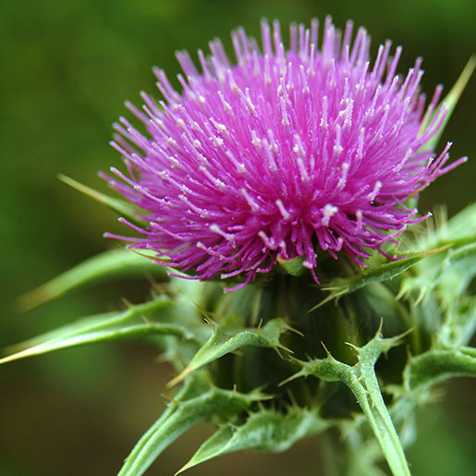

**• Synonym:Silybum marianum**

**• Source: seeds of milk thistle**

**• Family:Asteraceae**

It has been demonstrated that topical silymarin has a strong anticancer effect. UVB light caused 92 percent fewer tumors to form on the skin of hairless mice. Silymarin decreased apoptosis and UV-induced sunburn cell development. Since the outcome was unrelated to the action of sunscreen, an antioxidant mechanism might be to blame. In vivo, silymarin therapy stops oxidative damage and immunological suppression brought on by UVB rays. [23]

**9. Curcumin:**

The yellow spice turmeric contains a polyphenol called curcumin (diferuloylmethane).   
The yellow, odorless pigment known as curcumin was extracted from the turmeric (Curcuma longa) rhizome.   
Curcumin has antioxidant, anti-inflammatory, and antitumoral qualities. It also helps with cosmetic conditions including dyspigmentation. [24]

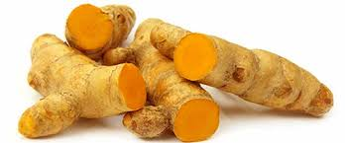 **Fig10.Rhizome of Turmeric (Curcuma longa)**

**• Synonym: Saffron Indian**

**• Source: Root of curcumin**

**• Family:Zingiberaceae**

It has been discovered that topical curcumin administration in CD-1 mice's epidermis markedly reduced UVA-induced ornithine decarboxylase (ODC) activity. Curcumin's capacity to scavenge reactive oxygen species (ROS) was thought to be the cause of its inhibitory effects. Curcumin can stop human epidermoid carcinoma A431 cells from going through apoptosis when exposed to UV light. [23][25]

**10. Vitamin E**  
 Vitamin E, also known as α-tocopherol, is an antioxidant that may shield plant and animal cell membranes from damage caused by light.It has been demonstrated that topical application of these antioxidants to the skin reduces both acute and chronic photodamage. Only the natural forms of vitamin E, alpha-tocopherol and tocotrienol, can significantly reduce wrinkle depth, facial line length, and skin roughness when administered topically. Vitamin E administered topically improves the stratum corneum's ability to bind water and hydrate it. The damaging collagenase enzyme, which regrettably rises in aging skin, is decreased by alpha-tocopherol.In addition to being an emollient, vitamin E scavenges free radicals. [23]

**Fig11.Triticum vlgare (wheat germ)**

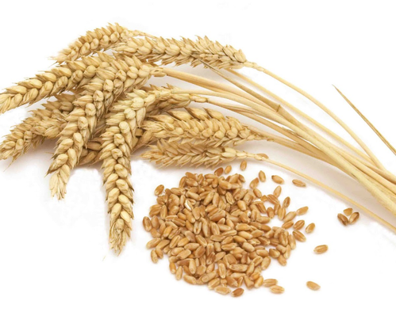

**• Synonym:Triticum sativum Lam**

**• Source:Seed, a cereal grain**

**• Family:Poacene**

In topical antiaging compositions, Triticum vulgare (wheat germ) oil exhibits exceptional antioxidant potential and is especially high in vitamin E. Good amounts of tocopherols can be found in extra virgin Corylus avellana (hazelnut), Helianthus annuus (sunflower), and Sesamumindicum (sesame) oils.More attention should be paid to the oil from Cucurbita pepo (pumpkin). It has two types of antioxidant chemicals, tocopherols and phenolics, which make up 59% of the antioxidant effects, and a lipid profile with significant levels of linoleic acid (43–53%).Its nutritional advantages make it particularly prized in Eastern and Central European and Middle Eastern healing folklore, where it is applied locally and taken orally to treat a variety of illnesses. It is only used in limited amounts in topical treatments because of its powerful, rich scent [23]

**11. Vitamin C**  
 The most significant internal and extracellular aqueous phase antioxidant in the body is vitamin C (L-ascorbic acid). [23] The complex set of enzymatic and non-enzymatic antioxidants that work together to shield the skin from reactive oxygen species (ROS) includes vitamin C, the most abundant antioxidant in human skin.

**Fig12.Rosehip seed**

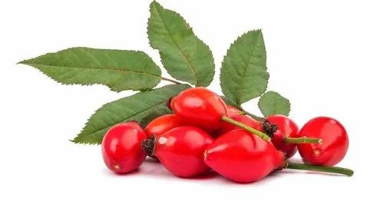

**• Synonym:Ascorbic acid**

**• Source: Citrus fruits such as limes,oranges and lemons andred peppers, kiwifruit**

**• Family:(L-ascorbic acid)**

Vitamin C is present in significant amounts and in its active form in The two main advantages of vitamin C for the skin are enhanced collagen synthesis and photoprotection.   
Vitamin C's anti-inflammatory qualities improve photoprotection. Over several months, photoprotection enables the skin to repair prior photodamage; collagen synthesis and MMP-1 suppression have been shown to reduce wrinkles; and tyrosinase and anti-Depigmenting solar lentigines are caused by inflammatory activity.[23]

**12. Green tea (GT):**  
Green tea, which comes from the Camellia sinensis plant, is a popular beverage and an antioxidant. The most prevalent and physiologically active of the four main polyphenolic catechins is epigallocatechin 3gallate (EGCG). In addition to their antioxidant properties, the green tea polyphenols (GTP) have anti-inflammatory and anti-carcinogenic properties. GTP can be applied topically or taken orally. Green tea is arguably the most researched antioxidant, with several in vitro and in vivo investigations.

**Figure 13. Green tea (GT)**

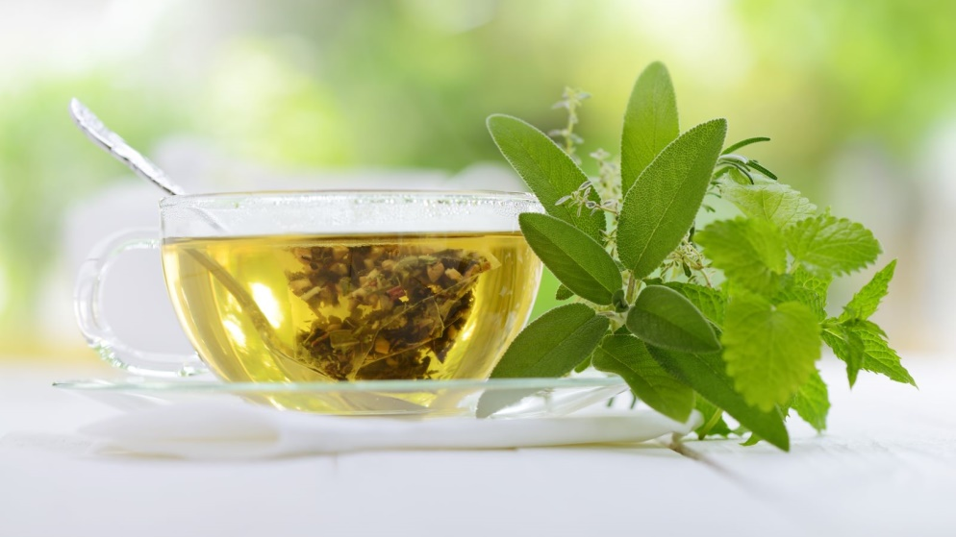

**• Synonym:Camellia Thea.**

**• Source:Tea contains preparedleaves and leaf buds ofThea sinensis Linn**

**• Family:Theaceae.**

GTPs have been demonstrated to inhibit chemo- and photo-carcinogenesis in mice, as well as to stop UV-induced oxidative damage and matrix metalloproteinase production when applied topically in vivo. GTPs decreased UV-induced erythema, sunburn cell count, immunosuppression, and DNA damage in human skin. Despite the paucity of human data, green tea is an ingredient in many over-the-counter products, and it makes sense to use them every morning in conjunction with sunscreen for photoprotection. The content of phenols in the different products is not standardized, and there are no controlled clinical trials for this antioxidant, like with the majority of them. [26]

**13. Pomegranate:**  
 The juice, seed, and peel of the fruit Punica granatum are among the parts from which pomegranate extracts can be made. The phenolic components in particular have strong antioxidant properties. It has been demonstrated that topical administration of the peel extract restores the in vivo activity of the enzymes catalase, peroxidase, and superoxide dismutase.In vitro, the fruit extract has been demonstrated to mitigate UVA-mediated damage and offer protection from the harmful effects of UVB light.Many skin care products contain pomegranate extract. [26]

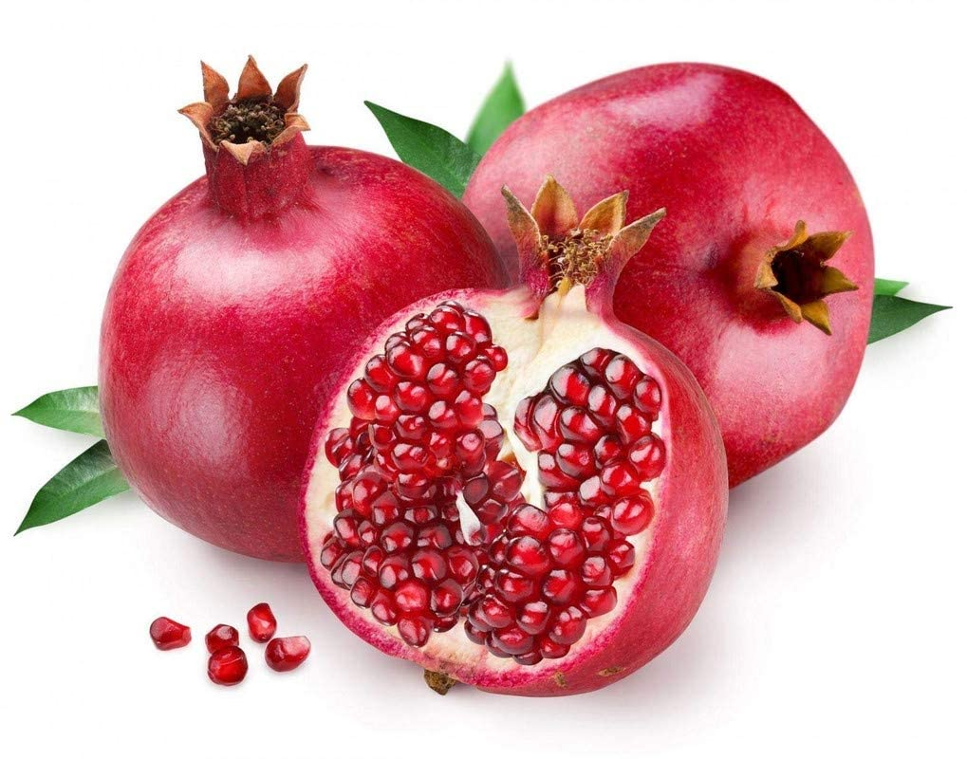 **Fig 14. Pomegranate**

**• Synonym: Punica granatum, lychee,pomelo,**

**• Source: shrub that produces a redfruit**

**• Family: Lythracea**

**Polyp henols:**  
 Resveratrol is one of thousands of different kinds of polyphenols that can be found in fruits, vegetables, green or black tea (also known as flavonoids), and other botanicals. According to Dr. Klein, these substances "have anti-inflammatory, immunomodulatory, and antioxidant qualities to prevent UV-induced skin photodamage."   
According to studies, applying and consuming products high in polyphenols topically helps repair DNA damage, enhance our skin's natural defenses against oxidative stress, and delay the onset of aging. [27]

**Fig,15: Polyphenol**

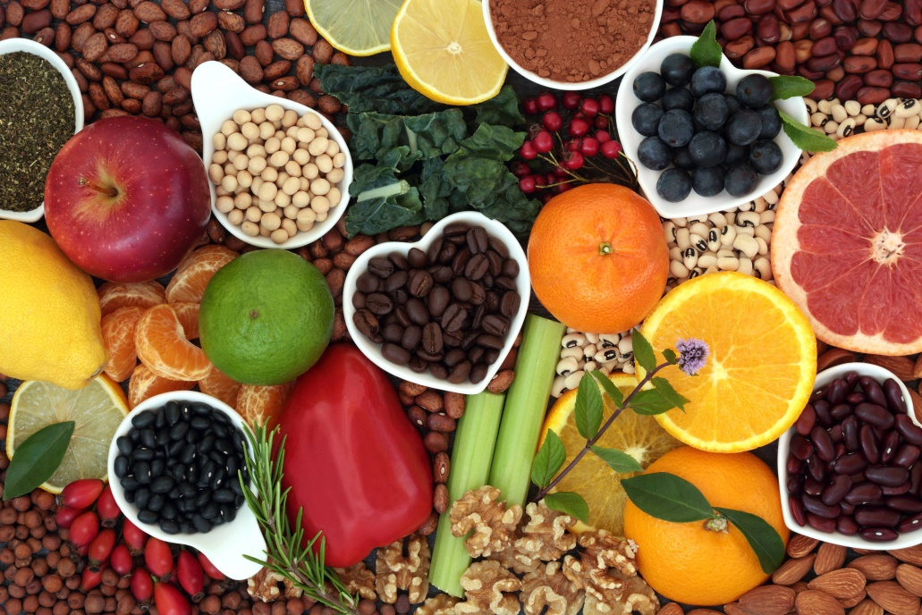

**• Synonyms:Lignans**

**• Source: Cocoa Powder, Flaxseeds, Olives, Berries, Coffee and Tea**

**• Family: Fabaceae**

**Ferulic Acid:**

When added to sunscreens, cosmetic lotions, and other skin care products, ferulic acid (4-hydroxy-3-methoxycinnamic acid), a strong antioxidant, is known to offer photoprotection to the skin. Additionally, it is thought to work in concert with beta-carotene and vitamins C and E. [28]

**Fig.16 Ferulic Acid**

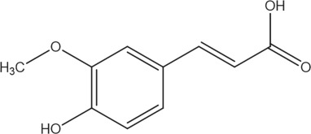

**• Synonym: Ferulate**

**• Source: Rice, Wheat, Oats, Pineapple, Grasses, Vegetables**

**• Family: Phenolic Acids**

**Herbs or formulations used in natural cosmetics have the following general positive effects:**   
  
  
• Sundaryaprasadka, or herbal cosmetics, enable everyone to feel good about themselves and beautiful.   
• Every person aspires to be beautiful in order to satisfy their senses. Not all beauty is associated with women; males can also be concerned about their appearance.   
• Natural beauty is a gift, and cosmetics aid in showcasing and enhancing people's physical attributes. • The idea of beauty and cosmetics is as old as humanity and civilization. The preparation called as Saundaryaprasadak is a representation of the cosmetic base that coincides with Ayurveda.

• Heal burns and wounds by using the protective qualities   
• Have anti-inflammatory qualities, which reduce pain, swelling, and itching.   
• Promote skin circulation to hasten the elimination of dead skin cells.   
• Because of their antibacterial qualities, they shield the skin from infections.   
• Prevents dry skin and minimizes wrinkles with hydrating properties.   
• Herbs' antioxidant qualities aid in the treatment of skin tissue damage caused by radicals.   
• Certain herbs have antibacterial properties and nourish the skin.   
• Applying certain compounds topically, such as soy, improves hyperpigmentation, increases skin suppleness, regulates oil production, and provides moisturizing benefits.

• Certain herbs, such as chamomile, provide cutaneous advantages and enhance the flexibility and texture of skin.   
• Ayurvedic herbs have emollient properties and lessen pruritus and photodamage symptoms.   
• Fruits like pomegranates operate as a photo-chemopreventive agent and promote epidermal regeneration.[29]

**5. PURPOSE OF USING HERBAL COSMETICS:**

The ability of herbs to prevent disease and promote health makes them significant. The goals of using herbal cosmetics are as follows. [30]

**• Safe for use:**

It is safe to use natural cosmetics. They have been tested and are hypoallergenic Dermatologists have confirmed that it is safe to use anywhere, at any time. People don't have to be concerned about developing skin rashes or itching because they are composed of natural substances. [30]   
  
**• Suitable for all skin types:**

Natural cosmetics like foundation, eye shadow, and lipstick are suitable for all skin tones, regardless of how dark or pale you are. Women who have sensitive or oily skin can also utilize them without worrying about worsening their skin condition.[30]

**• Numerous options:**

Compared to synthetic items, these are more reasonably priced. They are sold for a low price during sales and are provided at reasonable costs. According to a WHO estimate, 80% of people worldwide rely on natural goods for their medical needs due to the negative side effects and growing expense of contemporary medicine.[30]   
  
**• No adverse effects:**

Synthetic cosmetics have the potential to irritate your skin and result in acne. They may cause your skin to become dry or greasy by obstructing your pores. One need not be concerned about them when using natural cosmetics.Since the natural ingredients are safe, they can be applied anywhere, at any time. [30]

**• Cosmetics:**

Within the beauty industry, cosmetics is the sector with the quickest rate of growth. Cosmetic-pharmaceutical products known as "cosmeceuticals" are designed to enhance the appearance and health of the skin by delivering a certain outcome, such as sun protection, anti-aging, or acne treatment.[30]

**6. OVERVIEW AND FINAL COMMENT**   
  
 The term "cosmetic" refers to the substance used to enhance or beautify appearance. These days, one of the most significant aspects of people, particularly for the younger generation, is their beauty. Nowadays, it's fairly common to find natural ingredients in many skin care products. Herbs with antioxidant qualities that are used to prepare cosmetics are said to have no negative side effects. Synthetic agents are included in the majority of items on the market. Antioxidants are added to cosmetic formulations to extend their shelf life and shield human cells from harm. Due to the scientific and social appeal of these herbal treatments, the Indian market is overflowing.

An important part of antiaging formulas are the natural antioxidants that squelch free radicals. They might provide defense against environmental and other substances that could harm the tissues. provide defense against skin conditions brought on by exposure to UV rays. Resveratrol, curcumin, quercetin, and caffeic acid are a few examples of the chemical families that have been studied for their photo-chemo-preventive properties: flavonoids, terpenes, polyphenols, alkaloids, and catechins. These antioxidants have been proposed as a useful tactic to reduce the oxidative damage caused to the skin by UV exposure. Because they can defend themselves against UV rays, plants can also shield humans from UV rays. Both black and green teas have photoprotective qualities. Antioxidant flavonoids, a primary lipophilic antioxidant found in vitamin E, can reduce both acute and long-term damage. The most potent antioxidant found in a logical contender for photoprotection to prevent sunburn, cell division, and tumor development is ascorbic acid. Products for anti-aging, anti-inflammatory, UV protection, moisturizing, and hair conditional employ the antioxidant-rich herbal plant. Flavonoid   
,polyphenols, vitamin A, vitamin E ,and BHT and BHA are major antioxidant used in   
cosmetology preparation. As dermatological treatments, they can be used to treat a variety of skin conditions.

**7. REFERENCES:**

**8**. Riya A, Geeta G, HERBAL ACTIVE INGREDIENTS USED IN SKIN COSMETICS

**9**. Asian J Pharm Clin Res, Vol 12(9), 2019, 7-15

**10**. Mohinder Singh, PhD, The Role of Antioxidants in Dermatological & Cosmetic Formulas

**11**. Balch PA, Balch JF. In: Prescription for nutritional healing. 3rd ed. Vonore: Avery Publishing Group; 2000.

**12**. Turkington CA, Dover JS. In: The encyclopedia of skin and skin disorders. 2nd ed. Facts on file, 2002.

**13**. Duber SD. Natural cosmeceuticals: Driving personal care growth today and tomorrow. Neutraceuticals World 2003;6:58-60.

**14**. Trüeb RM. The value of hair cosmetics and pharmaceuticals. Dermatology 2001;202:275-82.

**15**. Grollier JF, Rosenbaum G. A cosmetic composition for the treatment of hair, in particular oily hair, based on extract of yarrow ( Achillea millefolium L ). US Patent 4948583. 1990

**16**. Prof. Farhan J. Ahmad , Dr. Javed Ali , Dr. Rabea Parveen " Book of Pharmaceutical science" Pathshala Publication 2-6

**17**. Nail polish. http://en.wikipedia.org/wiki/Nail_polish. [accessed on 2011 Jun 10].

**18**. Neha Pandey, Shashi Pandey Rai Biochemical Activity and Therapeutic Role of Antioxidants in Plants and Humans Publisher: CAB International, Oxfordshire, UKEditors: N K Dubey October 2014

**19**. Sonia Parashar, Hitender Sharma, Munish Garg Antimicrobial and Antioxidant activities of fruits and vegetable peels: A review Journal Pharmacognosy and Phytochemistry 2014; 3 (1): 160-164

**20**. M.S. Ashawat, Swarnlata Saraf1*, Herbal Cosmetics: “Trends in Skin Care Formulation” Phcog Rev. Vol, 3,(5), 82-89, 2009

**21**. Sonia Parashar, Hitender Sharma, Munish Garg , A review Journal of Pharmacognosy and Phytochemistry , Antimicrobial and antioxidants activities of fruits and vegetables peels: A review ,2014; 3 (1): 160-164

**22**. I. Bogdan Allemann, MD; L. Baumann, MD antioxidant used in skin care formulations, by STL Volume 13 number-September 17178

**23**. He, H.; Li, A.; Li, S.; Tang, J.; Li, L.; Xiong, L. Natural components in sunscreens: Topical formulations with sun protection factor (SPF). Biomed. Pharmacother. 2020, 134, 111161. [CrossRef] [PubMed]

**24**. Zhang, S.; Duan, E. Fighting against skin aging: The way from bench to bedside. Cell Transplant. 2018, 27, 729–738. [CrossRef] [PubMed]

**25**. Farage, M.A.; Miller, K.W.; Elsner, P.; Maibach, H.I. Intrinsic and extrinsic factors in skin ageing: A review. Int. J. Cosmet. Sci. 2008, 30, 87–95. [CrossRef] [PubMed]

**26**. Bose, B.; Choudhury, H.; Tandon, P.; Kumaria, S. Studies on secondary metabolite profiling, anti-inflammatory potential, in vitro Photoprotective and skin-aging related enzyme inhibitory activities of Malaxis acuminata, a threatened orchid of nutraceutical I J. Photochem. Photobiol. B Biol. 2017, 173, 686–695. [CrossRef]

**27**. Radava R. Koraćand Kapil M. Khambholja, Potential of herbs in skin protection from ultraviolet radiation Pharmacogn Rev. 2011 Jul-Dec; 5(10): 164–173.Riya A, Geeta G, HERBAL ACTIVE INGREDIENTS USED IN SKIN COSMETICS

**28**. Asian J Pharm Clin Res, Vol 12(9), 2019, 7-15

**29**. Radava R. Koraćand Kapil M. Khambholja, Potential of herbs in skin protection from ultraviolet radiation Pharmacogn Rev. 2011 Jul-Dec; 5(10): 164–173.

**30**. Riya A, Geeta G, HERBAL ACTIVE INGREDIENTS USED IN SKIN COSMETICS

**31**. Asian J Pharm Clin Res, Vol 12(9), 2019, 7-15

**32**. Radava R. Koraćand Kapil M. Khambholja, Potential of herbs in skin protection from ultraviolet radiation Pharmacogn Rev. 2011 Jul-Dec; 5(10): 164–173.

**33**. Serena Gianfaldoni, Georgi Tchernev, Use of Curcumin in Psoriasis Open Access Maced J Med Sci.2018 Jan 25; 6(1): 218–220.

**34**. García-Bores AM, Avila JG. Natural products: Molecular mechanisms in the photochemoprevention of skin cancer. Rev Latinoamer Quím 2008;36:83-102.

**35**. I. Bogdan Allemann, MD; L. Baumann, MD antioxidant used in skin care formulations, by STL Volume 13 number-September 17178

**36**. <https://www.dermstore.com/blog/antioxidants-in-skin-care/>

**37**. Davinder Kumar, Gajendra Rajora, Om Parkash, Himanshu, Mamta Antil, Virender Kumar“Herbal cosmetics: An overview”, International Journal of Advanced Scientific Research ISSN: 2456-0421; Impact Factor: RJIF 5.32 Volume 1; Issue 4; July 2016;Page No. 36-41

**38**. Davinder Kumar, Gajendra Rajora, Om Parkash, Himanshu, Mamta Antil, Virender Kumar“Herbal cosmetics: An overview”, International Journal of Advanced Scientific Research ISSN: 2456-0421; Impact Factor: RJIF 5.32 Volume 1; Issue 4; July 2016;Page No. 36-41