

Name -Rajashekar N.B

Trimester -4th MBA

Topic-Profitability and shareholder wealth creation.

College name -PES university

Abstract

This study examines the tricky courting among profitability and shareholder wealth creation,emphasizing their awesome but interconnected roles in comparing enterprise performance.Profitability, measured throgh key metrics which includes net income margin,return on equity,and earnings in keeping with proportion,focuses a corporation’s potential to generate steady returns, even as shareholder wealth is assessed via inventory rate appreciation,dividend yields, and economic price era.By way of analyzing the financial overall performance of businesses across three major sectors—Aerospace and Defence,Agrochemicals,and Air delivery—this studies offers insights into how profitability translates into shareholder wealth below various commercial enterprise environments, governance systems,and competitive pressures.The method consists of quantitative records evaluation and regression modeling to perceive traits, relationships,and zone-unique financial strengths and weaknesses.The findings reveal large versions across sectors, with a few agencies excelling in profitability and revenue at the same time as others face challenges due to higher prices or decrease net well worth.The have a look at offers precious insights for traders, analysts, and stakeholders,allowing higher choice-making and strategic making plans to optimize shareholder fee.This research contributes to expertise the dynamic interplay between profitability and shareholder wealth advent,highlighting its significance in fostering sustainable business.

Introduction

In a Changing of the business world,it creates more impact business proprietor,make the right decisions,and make the important work it is main role of the businesses.Shareholder wealth is often measuring the company ability to create value.There is connection between the profitability and shareholders wealth is not the same apart from the businesses.The share holder wealth is estimation by the measures such as stock price appreciation on the dividend yields.and is connected to a company financial data and performance.there is different measures of financial health,profitiability measures such as net profit margin,return on equity,earnings per share,are main tool to measure the company capacity to create value.the connection between profitability and shareholders wealth is equal to businesses.Each business functioning of various business enivornment,competation and goverance,which impact how earnings of profits can converted to shareholder value

Objectives

Profitability objectives

Increasing the net income,Concentrating on earning more of the revenues than the costs.

Maintaining the consistency profits to enables the long term durability.

To build the strong competitive performance and expansion of the revenue.

To mainly concentrate on the investments and projects to get the higher returns

Share holder Wealth Creation Objectives

Providing the bonus shares that can create the wealth to its shareholders.

Concentrating on mainly on the shareholders returns from buybacks and dividends it helps to generate the wealth.

To execute strategies that can maximize the firm value in the long term.

To maintaining the consistency of the finance to prevent and enabling the investing on the shareholders.

Literature review

Stewart 1994 –The eva stands for among many financial business models and claims that the quality of EVA is almost 50% good than it can changes shareholders of the wealth.

Jefferey john Todd and Anjan-It is study analysis performance of the financial.it calculates and measuring for 25 companies 1988-1992.It get the result and conveys more accurate it analysis the data of the value of the shareholder value.and get the returns of the earns the shareholders and the minimum price and exceeding of the remaining they recompensing the shareholders of the Sequential and risk.

Yahaya Mahmood – it related information and list topics it conveys the how much they have earned greater and it articulating with returns and company’s value ,economic value added,regular income or cash flow.

Krumm and Vries- The creation of the values through the Real estate of the holding company.they find the companies are under regular tension from the from the shareholders.they mainly concentrate on the different competitive and preventing and involving the increase value of the shareholder price.trend to the outside non essential services.

Karbhari and Mokthar- it analyze and the effect of the ISO 9000 registration in the corporate.They identify the performance accurate share-holder value of the returns earning per share value

Research Methodology

The studies technique for this look at focuses on analyzing the monetary performance of businesses within 3 foremost sectors: Aerospace and Defence,Agrochemicals, and Air shipping.The have a look at employs a mixed-strategies approach, combining quantitative statistics analysis with qualitative insights to apprehend the relationship between profitability and shareholder wealth creation.

facts collection

The studies is based on secondary information received from economic reviews, enterprise publications,and publicly to be had organisation information.Key metrics inclusive of sales,internet income, internet worth,overall property, and operational costs are extracted for evaluation.The study period covers latest economic years, making sure relevance and accuracy in the findings. unique businesses representing every zone—together with Hindustan Aeronautics and Bharat Electronics for Aerospace and Defence,UPL and Bayer Crop technological know-how for Agrochemicals, and Interglobe Aviation and SpiceJet for Air shipping—are blanketed to offer sectoral representation.

information evaluation

The monetary statistics is analyzed the usage of statistical tools and fashions to establish the relationship between profitability and shareholder wealth introduction. the subsequent strategies are hired:

Descriptive-information: To summarize the economic overall performance metrics across sectors and companies.

Comparative-analysis:To examine sectoral and,inter-organisation overall performance using charts and tables.

Regression evaluation: A,simple linear regression model is used to decide the relationship among profitability (independent variable) and shareholder wealth creation (based variable).The regression results consist of R-squared values,F-records, and coefficients to degree the strength and importance of the relationship.

Visualization equipment:Bar charts, pie charts,and overall performance tables are used to present findings in a visually available way.

Variables

Independent-Variable:Profitability signs,inclusive of internet profit margin, return on fairness,and income per percentage.

dependent Variable: Shareholder wealth advent,measured via stock charge appreciation,dividend yields, and go back on funding.

quarter-particular analysis

The method consists of a targeted evaluation of sectoral overall performance:

Aerospace and Defence: agencies are evaluated based on sales,net income,and asset allocation.

Agrochemicals: Emphasis is positioned on internet really worth,sales, and uncooked fabric fees.

Air shipping: sales,net income,and operational charges are assessed to focus on challenges and opportunities.

Statistical importance

The look at ensures the reliability of its findings through trying out for statistical importance inside the regression analysis.The F-statistic and p-value are used to verify the validity of the regression model,at the same time as the coefficients offer insights into the diploma of effect of profitability on shareholder wealth advent.

Data analysis

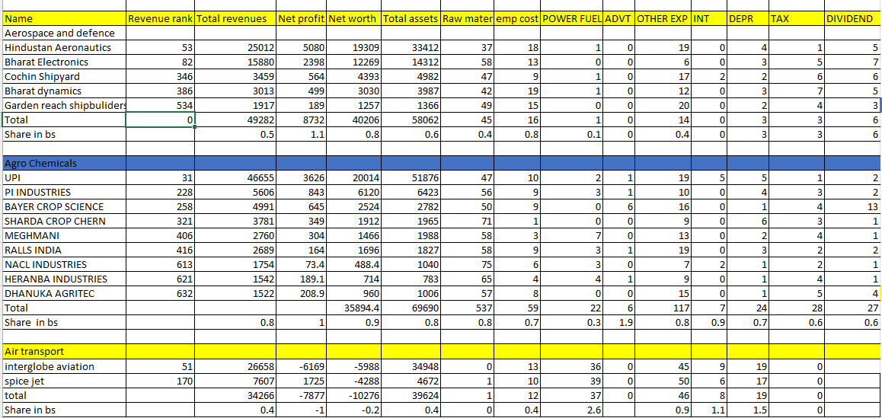

The financial performance of various companies throughout 3 sectors: Aerospace and Defence, Agro chemicals, and Air transport.

Aerospace and Defence:This sector is conveys by using Hindustan Aeronautics,with the very best sales and net profit.however, it also has the good overall assets and raw materials prices.Bharat Electronics follows intently,with a strong net earnings and a enormous proportion of overall assets.

Agro chemicals:UPI leads this region in sales and internet income.however, PI Industries boasts the good net worth and total belongings.drastically,Bayer Crop technological know-how has a higher percentage of general assets and raw material expenses.

Air transport: Interglobe Aviation holds the pinnacle spot in revenue,however it also inculdes the best net loss. SpiceJet, despite reduce sales,has a high-quality net income.basic,the table exhibits varation of financial strengths and weaknesses across sectors and organizations.even as a few corporations excel in sales and profitability,others may also have better expenses or lower net really worth.This information can be precious for buyers and analysts to measure the economic fitness and potential of those business

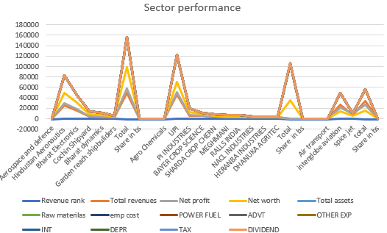

The image provides a region overall performance review, in all likelihood for the economic yr2023-2024.It includes records on sales rank,overall revenue, net profit, net really worth,and general property for numerous sectors like Aerospace and protection,Agro chemical substances,and Air shipping.inside each area, person organizations are listed and their financial overall performance is visualized the usage of a bar chart.The data suggests that the Aerospace and protection quarter has the best revenue rank and total revenue, at the same time as Air shipping has the lower.Net profit and net worth range across overall sectors,with a few sectors displaying advantageous traits and others bad. general assets are typically high throughout all sectors. basic, the chart offers a visual illustration of the financial performance of various sectors.It highlights key metrics like revenue,earnings,net well worth,and belongings, permitting for a quick comparison between sectors.The breakdown of expenses into categories like raw materials and worker fees gives further insights into the operational expenses related to each region.however,it is crucial to note that the chart doesn't offer precise timeframes or context for the statistics. with out this records,it's tough to decide developments or make significant comparisons through the years

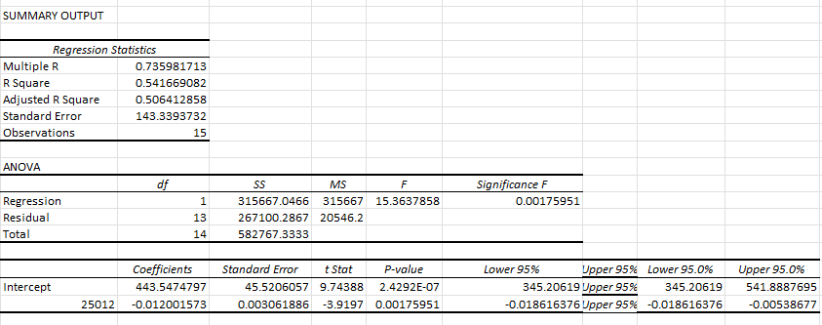

The regression information table suggests the outcomes of a simple linear regression analysis.The R-squared value of zero.fifty four indicates that 54% of the variance in the dependent variable can be defined by means of the independent variable.The F-statistic is tremendous(p-fee < zero.001), suggesting that the regression version is statistically extensive.The coefficients table shows that the intercept is 443.547and the slope is -0.012.Because of this for each unit increase in the independent variable, the depended variable is predicted to lower through zero.012 gadgets.  
The ANOVA table suggests that the regression version is statistically significant, with an.F-statistic of 15.36 and a p-value of less than 001 zero.The coefficients desk indicates that the slope of the regression line is -0.012 ,because of this that for ever unit increase and growth within the single in depend-variable,the depend variable is expected to decrease by means of 0.012 devices.The intercept of the regression line is 443.547,which means that that the predicted value of the structured variable while the impartial variable is 0 is 443.547

The pie chart titled "revenue Rankings"illustrates the distribution of revenue shares across various sectors,companies,and,categories. It highlights key industries along with Aerospace and Defence, Agrochemicals, and Air transport,along specific entities like Hindustan Aeronautics, Bharat Electronics, Bayer Crop technology, and others.each segment of the chart represents a percent proportion of general sales,with first rate participants including "total" and"Hindustan Aeronautics,"every accounting for 12%.Smaller shares are found in sectors like Agrochemicals, represented by corporations which includes Bayer Crop science (7%) and Sharda Crop Chem (6%). a few labels, such as "percentage in bs" and "total,"seem multiple instances,doubtlessly indicating specific contexts, together with business segments or mixture totals. The chart's use of shade coding enables to distinguish among the numerous participants and gives a clean visual illustration of the revenue distribution.

Conclusion

The examine concludes that at the same time as profitability and shareholder wealth introduction are closely related,the connection is stimulated via sectoral dynamics, operational charges, and outside elements.Aerospace and Defence emerged because the most stable area, showcasing sturdy revenue and profitability metrics.Agrochemicals highlighted the significance of strategic fee control,whilst the Air delivery area underscored the effect of operational efficiency on monetary overall performance.The findings emphasize the need for groups to adopt tailored techniques that cope with region-precise challenges, optimize operational prices,and and beautify shareholder cost.This research affords treasured insights for traders,policymakers,and companies,enabling them to make informed decisions concerning economic fitness and lengthy-time period value creation.future research may want increase on these findings by means of incorporating a broader dataset and exploring the impact of macroeconomic factors on profitability and shareholder wealth

Reference

[www.business](http://www.business)- standard.com

[www.bse.com](http://www.bse.com)

www.nse.com

grow.com