**Optimization of the Process Parameters for the Extraction of Bio surfactant from Gmelina Arborea**

**Eze, Kenneth Afamefuna* 1; Wali Henry Uchechukwu 2; Chukwudi Maduabuchi 3**

1, 2, 3, Department of chemical Engineering Enugu State University of Science and Technology, Enugu

Corresponding author email: Kenneth.eze@esut.edu.ng

**ABSTRACT**

Chemically produced surfactants (synthetic) hardly degrade and as a result, it is toxic and thus a contaminant to the environment. Bioactive compounds such as saponins (bio surfactant) are eco- friendly and biocompatible and therefore are potential replacement for synthetic surfactants. This study optimizes the extraction conditions of the saponin compounds from *Gmelina Arborea,* plant leaves using Response Surface Methodology (RSM). Qualitative and quantitative phytochemical characterization of the bioactive compounds contained in the plant leaves were also determined and the result showed that flavonoids, phytates, and saponins are present in concentrated form while tannins are present in trace amounts. The quantitative screening showed Alkaloids (121.05 mg/100 g), Cardiac glycosides (11.54 mg/100 g), Flavonoids (108.61 mg/100 g), Phenolics (28.44 GAE/ g), Phytates (112.81 mg/100 g), Saponins (164.53 mg/100 g) and Tannins (56.62 mg/100 g). The effect of four independent process variables- temperature, time, % of solvent and particle size on one response variable % saponin content were determined and the result showed an adequate interactions of the variables. The model produced a satisfactory fitting of the experimental data with regards to % saponin content of (R2 of 0.9739, p<0.0001) .An optimum extraction of (96.9 %) is obtained at temperature (60 °C), time (60mins), solvent of 75% and particle size of 0.6205 mm . This study demonstrates clearly that gmelina arborea leaves is a good source of bio surfactant.

**Keywords:** Bio surfactant, saponin, gmelina, optimization, Extraction, RSM

**INTRODUCTION**

Surfactants are compounds which contain hydrophobic and hydrophilic parts that decrease the surface and interfacial tension between surfaces. (Maneerat, 2005). Saponins are bioactive compounds that are produced from plant and animals. Biosurfactants so named because they are gotten from living things and possesses some characteristics that offer advantages over synthetic surfactants. These features are high surface and interfacial activity, tolerance to temperature, pH, and ionic force, low toxicity, availability, specificity, biocompatibility, and biodegradability Franzetti, et al., (2014). Due to these promising benefits, they are extensively used for industrial and medicinal purposes (Muthusamy et al., (2008).

Surfactants are a class of compounds with a diverse and significant role in various segments of the market including petroleum industry, soaps and detergent industry, environmental pollution abatement, and even in the food and beverage industry (Cameotra, et al., 2010). As a result of these extensive applications, it creates problem to the environment due to its difficulty to degrade. There is absolute need to source for an environmental friendly alternative to synthetic surfactants. Many methods are employed for the extraction of saponin from plants especially these days that there is increased awareness in the use of plant materials to many illnesses (Azmir et al., 2013). These methods are maceration, Soxhlet, and reflux extraction, where the green technologies are ultrasound-assisted, microwave-assisted, and accelerated solvent extraction (Henz et al., 2013). In this research, solvent extraction was use because of its simplicity, low cost and high yield of the bioactive materials.

*Gmelina* belongs to the family [Lamiaceae](https://en.wikipedia.org/wiki/Lamiaceae) (Rogier, 2012) and classified as follows: Kingdom: Plantae, Phylum: Magnoliophyta, Class: Magnoliopsida , Subclass: Asteridae. Order: Lamiales. Studies have shown that the whole part of the plant can be used for medicine. It improves digestion, memory, helps overcome giddiness and is useful in burning sensation, fever, thirst, emaciation, heart diseases, nervous disorders and piles (Mada et al., 2012). It can also be used for many other purposes such as provision of oxygen or consumption of carbon dioxide more especially in industrial areas. There are different bioactive compounds that can be found in good quantities and in various part of the plant that result to the numerous potential application or uses of the plant and some of those bioactive compounds include : tannins, phenolic, saponins, alkaloids, terpenes, and flavonoids (Warrier et al., 2021)].

2.0 **MATERIALS AND METHODS**

**Materials**

Chemicals and equipment used in this study include; distilled water, H2SO4, volumetric flasks, beakers, conical flasks, furnace, measuring cylinder, funnel, electronic weighing balance, water bath with thermostat, stop watch, ultraviolet spectrophotometer (Model 721G, product number: 071113030129) and oven (model No: OHG-9030A, Search Tech Instruments, British Standard, mechanical grinder, hot plate, filter plate, filter cloth, standard sieve, methanol, bowl, distilled water.

**Sample collection and preparation**

The plant (leaves) where collected from Obollo-Afor, Lat. 6.920592476 and Long 752099387in Udenu Local Government Area of Enugu State, Nigeria. The leaves where washed with distilled water to remove dust and other unwanted particles that maybe on the surface of the leaves. The plant was placed in different trays and was sun dried for a period of 14days. The samples where grinded into a very fine particle size to allow more interfacial area contact with the solvent during extraction for high yield of extract, using a mechanical grinder.

**Extraction of Biosufactant (Saponin)**

The ground sample (gmelina arborea), was weighed and soaked in a bowl with the ratio 20g of grounded sample to 100ml of methanol and hand shake for interval and allowed to settle for a total soaking time of 3 days and then filtered using a filter paper and filter cloth, giving a mixture of methanol and the extract. The methanol was removed using a distillation unit (hot plate) and the extract was weighed. The percentage yield was calculated using the equation (1):

$\% yield = \frac{final weight of sample}{initial weight of sample} ×100\%$ (1)

**Phytochemical Characterization**

Standard methods used by previous researchers (Marcano, and Hasenawa 1991; Omotioma and Onukwuli 2019) were employed for the phytochemical analysis of the samples.

**Qualitative Analyses of the Sample**

For the alkaloids detection, 1g of each sample was transferred into test tube. 3 drops of dilute hydrochloric acid were added and stirred. It was then filtered. The filtrate was tested carefully with alkaloid reagents; Mayer’s reagent (Cream ppt), Dragendorff’s reagent (Orange-brown ppt). In the detection of cardiac glycosides, 1ml of the sample, 5ml water and 2ml glacial acetic acid were mixed in a vessel. One drop of FeCl3 was added. Then, 1ml conc. H2SO4 was added. There was an appearance of brown ring. For the determination of flavonoids, 25 ml water was added to 1g of sample. It was put in an oven at 100 oC for 15 min. 5ml of NH4OH was added to 2ml of the sample. Then 1ml conc. H2SO4 was added. There was an appearance of yellow color indicating the presence of flavonoids. The presence of phenols was determined by adding a few drops of 1% (w/v) solution of ferric chloride followed by 1% (w/v) gelatin in sodium chloride of the same concentration. The formation of a precipitate indicated the presence of phenols. For the determination of saponins, 1g of sample was boiled in 40ml of water, and then filtered. 10ml of the filtrate was shaken vigorously. Formation of froth was noticed. 3 drops of oil were added, and the mixture was shaken. Emulsion of the oil was noticed. For the determination of tannins, 1g of the sample was added to 25ml of water. It was then put in oven at 100 oC for 15 min. To 1ml of the sample, 10 ml water was added and then boiled. 3 drops of 0.1 % FeCl3 were added. A green colour appeared indicating the presence of tannins.

**Quantitative analyses of the sample**

Alkaloids

20ml of 10% acetic acid in ethanol was added to the 1g of sample. The mixture was shaken and allowed to settle for 4 hours. It was then filtered. The filtrate was evaporated to about a quarter of its original volume. One drop of concentrated ammonium hydroxide was added. The precipitate formed was filtered through a weighed filter paper. The filter paper was left to dry in the oven at 60oC.

Cardiac glycosides

1g of the sample was placed in the oven 100 0C for 15min. 1ml of the sample plus 5ml water was added to 2ml glacial acetic acid plus one drop of FeCl3.  Also, 1ml conc. H2S04 was added. The absorbance of the resulting solution was measured at 410nm.

Flavonoids

0.5ml of 2% AlCl3 methanol solution was added to 0.05ml sample solution. After 1hr at room temperature, yellow color appeared indicating the presence of flavonoids. Flavonoids content as mg/g was determined.

Phenols

0.2% formic acid was added to 2g of the sample and left to settle for 2 minutes. It was then filtered. With the aid of pipette, 2ml of the filtrate was put into a test tube and 0.5ml folin-ciocalteau reagent was added. It was left for 20 minutes for color development. The absorbance at 765nm was read and the concentration for a standard graph was obtained. It is expressed as GAE/g (Gallic Acid Equivalent).

Phytate

Ferric ammonium sulphate was added to 0.5ml of the sample in a test tube. The test tube was heated in water bath for 30 minutes. It was cooled and centrifuged. To 1ml of the supernatant, 1.5 ml of 2, 2-bipyridine solution was added. Measurement was carried out at 519nm, with distilled water as blank.

Saponins

Into 1g of sample 15 ml ethanol was added and put in a water bath at 55oC for 4 hours. It was filtered and the residue was washed twice with 20% ethanol. The sample was reduced to about 5 ml in the oven. 5ml of petroleum ether was added to the concentrated sample inside a separating funnel. The petroleum ether layer was discarded and 3ml of butanol was added to it. It was washed with 5ml of 5% sodium chloride. It was put in the oven to evaporate to dryness, and the residue was weighed.

Tannins

1g of the sample was extracted with 25ml of the solvent mixture of 80:20 acetone: 10% glacial acetic acid for 5 hours. It was filtered and the absorbance measured at 500nm. The absorbance of the reagents blank was also measured. The concentration of tannin (taking into consideration any dilution factor) was obtained.

**Experimental Design**

The effects of four factors, extraction time (minutes), extraction temperature (OC), particle size (mm) and % of methanol on the total saponin content were studied using response surface methodology. By using this design, the four variables were tested at different levels: extraction time at 30, 60 and 90 minutes, extraction temperature at 30, 60 and 90 ºC, % of methanol at 50, 75 and 100 % and particle size of 0.4 mm to 0.8 mm. Experimental matrix design, with levels of the independent variables (factors), are shown in table 2. The Design Expert (Version 8.0.5, Stat-Ease Inc.,Minneapolis) statistical software was employed to analyze the experimental data in RSM.

**RESULTS AND DISCUSSION**

**The Quantitative and Qualitative Phytochemical Analysis Result of The extract**

The qualitative and quantitative results of the phytochemical analyses of the extract are presented in table 1. Gmelina contain various degrees of the following phytochemicals; alkaloids, cardiac glycosides, flavonoids, phenolics, phytates, saponins and tannins. These phytochemicals are commonly found in plants (Buchwesihaija, 2019; Banat et al., 2010; Shekhar, et al., 2015 and Sachdev, et al., 2013). Presence of concentrated flavonoids, concentrated phytates, concentrated saponins and tannins (in trace) showed that the plant extracts are suitable for extraction purposes. Cardiac glycosides were too little to be observed.

Table 1: Phytochemical analysis of the Gbonelina Extract

|  |  |  |
| --- | --- | --- |
| Phytochemicals | Gmelina Arborea | |
| Qualitative analysis | Quantitative analysis |
| Alkaloids (mg/100g) | ++ | 121.05 |
| Cardiac glycosides (mg/100g) | - | 11.54 |
| Flavonoids (mg/100g) | ++ | 108.61 |
| Phenolics (GAE/g) | + | 28.44 |
| Phytates (mg/100g) | ++ | 112.81 |
| Saponins (mg/100g) | +++ | 164.53 |
| Tannins (mg/100g) | + | 56.62 |

*+++ (highly concentrated), ++ (concentrated), + (in traces), and – (too little to be observed qualitatively).*

**RSM Results**

The RSM results of the percentage Saponin content as a function of particle size, percentage of solvent, temperature and time are presented in Table 2. The highest Saponin content of 96.9was obtained particle size 0.6205mm, percentage of solvent of 75%, temperature of 60oC and time of 60minutes. The interactions among the considered variables were further analyzed using graphs.

**Table 2: Experimental desisgn matrix and result of the Percentage Saponin Content**

|  |  |  |  |  |  |  |
| --- | --- | --- | --- | --- | --- | --- |
| Std | Run | Factor 1  A:Time  Minutes | Factor 2  B:Temperature  oC | Factor 3  C:% Solvent  % | Factor 4  D:Particle size  Mm | Response 1  % of saponin |
| 4 | 1 | 90 | 90 | 75 | 0.6205 | 85 |
| 29 | 2 | 60 | 60 | 75 | 0.6205 | 96.5 |
| 14 | 3 | 60 | 90 | 50 | 0.6205 | 75 |
| 25 | 4 | 60 | 60 | 75 | 0.6205 | 96.3 |
| 23 | 5 | 60 | 30 | 75 | 0.841 | 63 |
| 5 | 6 | 60 | 60 | 50 | 0.4 | 70 |
| 7 | 7 | 60 | 60 | 50 | 0.841 | 72 |
| 28 | 8 | 60 | 60 | 75 | 0.6205 | 96.41 |
| 8 | 9 | 60 | 60 | 100 | 0.841 | 60 |
| 11 | 10 | 30 | 60 | 75 | 0.841 | 55 |
| 26 | 11 | 60 | 60 | 75 | 0.6205 | 96.23 |
| 16 | 12 | 60 | 90 | 100 | 0.6205 | 65 |
| 3 | 13 | 30 | 90 | 75 | 0.6205 | 50 |
| 22 | 14 | 60 | 90 | 75 | 0.4 | 65 |
| 1 | 15 | 30 | 30 | 75 | 0.6205 | 55 |
| 20 | 16 | 90 | 60 | 100 | 0.6205 | 80 |
| 17 | 17 | 30 | 60 | 50 | 0.6205 | 55 |
| 2 | 18 | 90 | 30 | 75 | 0.6205 | 70 |
| 9 | 19 | 30 | 60 | 75 | 0.4 | 55 |
| 12 | 20 | 90 | 60 | 75 | 0.841 | 75 |
| 6 | 21 | 60 | 60 | 100 | 0.4 | 60 |
| 10 | 22 | 90 | 60 | 75 | 0.4 | 75 |
| 19 | 23 | 30 | 60 | 100 | 0.6205 | 52 |
| 15 | 24 | 60 | 30 | 100 | 0.6205 | 63 |
| 13 | 25 | 60 | 30 | 50 | 0.6205 | 70 |
| 24 | 26 | 60 | 90 | 75 | 0.841 | 65 |
| 21 | 27 | 60 | 30 | 75 | 0.4 | 63 |
| 18 | 28 | 90 | 60 | 50 | 0.6205 | 83 |
| 27 | 29 | 60 | 60 | 75 | 0.6205 | 96.9 |

**Analysis of variance (ANOVA)**

The analysis of variance (ANOVA) is used to statistically proof the adequacy of the model and it is presented in Table 3. The Model is significant with F-value of 75.66 as there were only 0.01% chances that the model would not be significant due to the noise. All the terms, A, B, C and their combinations are significant as their P-values were less than 0.0500. Time gave the highest F- value (313.37) which implies that it has the strongest effect and therefore, the most important parameter in the extraction of saponin. This result is supported by Eze et al., (2024) who reported that time is a critical parameter in the extraction of bioactive compounds. The lack of fit teat carried out was not significant. The Predicted R2 of 0.9251 is in reasonable agreement with the Adjusted R2 of 0.9739, the difference is less than 0.2. The adequacy of Precision is 27.016 which is well above 4. This shows that the model is highly adequate (Chrzanowski et al., 2012; Nitschke et al., 2018). The adequacy of the model is further confirmed by the coefficient of determination R2 of 0.9870 as shown in Table 2. This implies that 98.70% of the total parameters were explained by the model thus confirming it’s adequacy ( Eze et al., 2024; Wang et al., 2006; Ashraf et al.,2017)

**Table 3: ANOVA of Percentage of Saponin Content**

|  |  |  |  |  |  |  |
| --- | --- | --- | --- | --- | --- | --- |
| **Source** | **Sum of Squares** | **Df** | **Mean Square** | **F-value** | **p-value** |  |
| **Model** | 6004.36 | 14 | 428.88 | 75.66 | < 0.0001 | Significant |
| A-Time | 1776.33 | 1 | 1776.33 | 313.37 | < 0.0001 |  |
| B-Temperature | 36.75 | 1 | 36.75 | 6.48 | 0.0233 |  |
| C-% Solvent | 168.75 | 1 | 168.75 | 29.77 | < 0.0001 |  |
| D-Particle size | 30.33 | 1 | 30.33 | 5. 88 | 0.0119 |  |
| AB | 100.00 | 1 | 100.00 | 17.64 | 0.0009 |  |
| AC | 0.0000 | 1 | 0.0000 | 0.0000 | 0.0010 |  |
| AD | 0.0000 | 1 | 0.0000 | 0.0000 | 0.0023 |  |
| BC | 2.25 | 1 | 2.25 | 0.3969 | 0.0388 |  |
| BD | 0.0000 | 1 | 0.0000 | 0.0000 | 0.0040 |  |
| CD | 1.0000 | 1 | 1.0000 | 0.1764 | 0.0080 |  |
| A² | 1530.15 | 1 | 1530.15 | 269.94 | < 0.0001 |  |
| B² | 1555.16 | 1 | 1555.16 | 274.35 | < 0.0001 |  |
| C² | 1179.36 | 1 | 1179.36 | 208.05 | < 0.0001 |  |
| D² | 1843.63 | 1 | 1843.63 | 325.24 | < 0.0001 |  |
| **Residual** | 79.36 | 14 | 5.67 |  |  |  |
| Lack of Fit | 79.08 | 10 | 7.91 | 114.66 | 0.0002 | Not significant |
| Pure Error | 0.2759 | 4 | 0.0690 |  |  |  |
| **Cor Total** | 6083.72 | 28 |  |  |  |  |
| **Std. Dev.** | 2.38 |  | **R²** | 0.9870 | | |
| **Mean** | 71.15 |  | **Adjusted R²** | 0.9739 | | |
| **C.V. %** | 3.35 |  | **Predicted R²** | 0.9251 | | |
|  |  |  | **Adeq Precision** | 27.0160 | | |

Mathematical analysis of the RSM.

A mathematical model of the regression analysis is shown in equation (1).

% of Saponin content = 96.468 + 12.1667 A + 1.75 B + -3.75 C + 0.166667 D + 5 AB + 2.25488e-15 AC + 1.48275e-15 AD + -0.75 BC + 7.52247e-16 BD + -0.5 CD + -15.359 A2 + -15.484 B2 + -13.484 C2 + -16.859 D2 (2)

Where A, B, C, D are linear terms while A2, B2 and C2 are the quadratic terms.

**Graphical model of the percentage Saponin content**

The graph of the predicted versus actual percentage of the Saponin content is shown in Figure 1. The points clustered along the line of best fit, which shows that the predicted is in reasonable agreement with the experimented value which is an indication that the model can be used to describe the reduction process.

The three-dimensional (3-D) plots of the percentage Saponin versus the considered factors of Time (A), Temperature (B), Percentage of solvent (C) and Particle size (D) are shown in Figures 2. The optimum percentage of Saponin content obtained was 96.9% at temperature 60oC, time 60minutes, and particle size of 0.05mm. The nature of the variation of the response to the considered factors showed that percentage Saponin content is dependent on particle size, percentage of solvent, temperature and time.

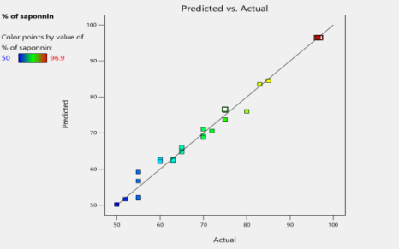

**Figure 1: Predicted versus actual percentage Saponin content.**

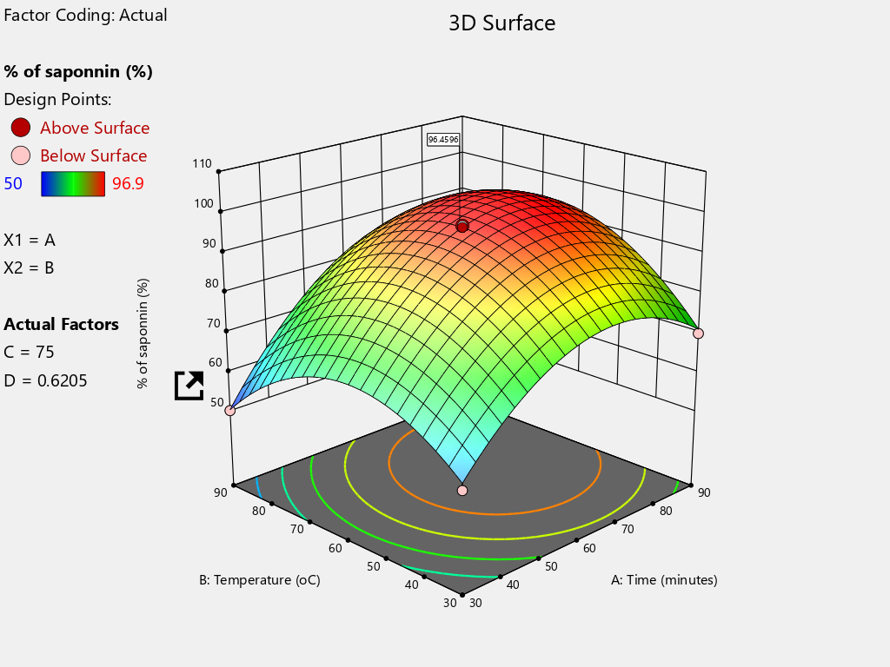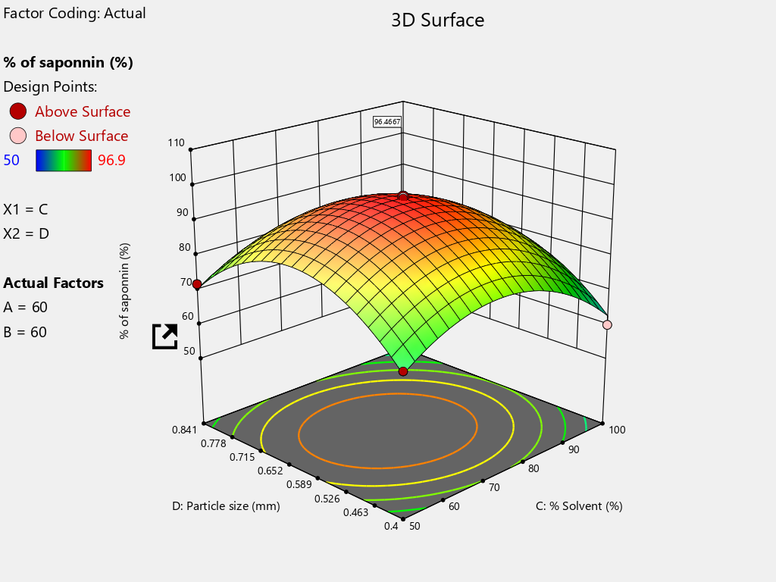

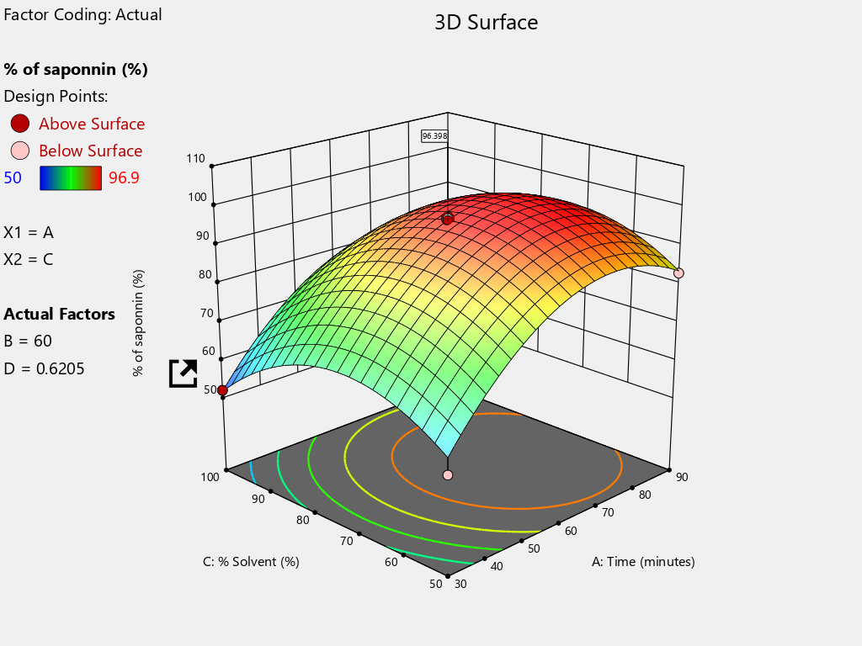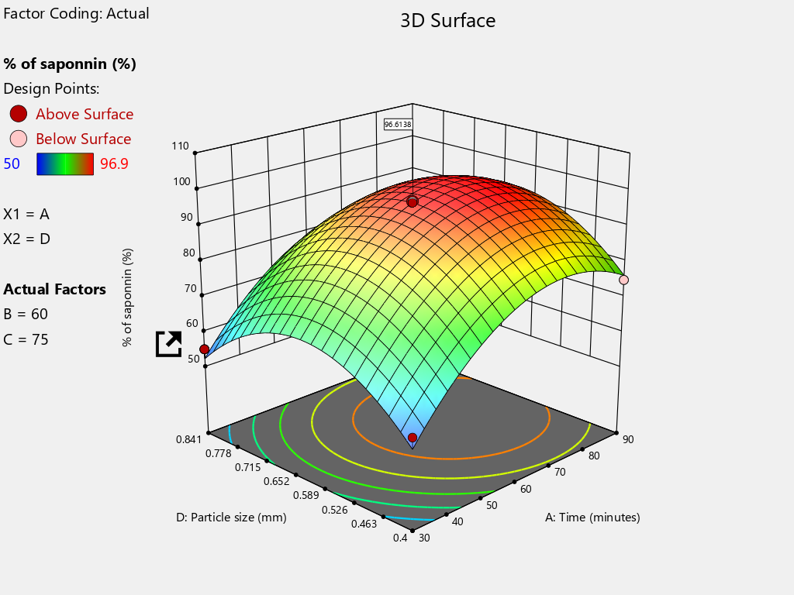

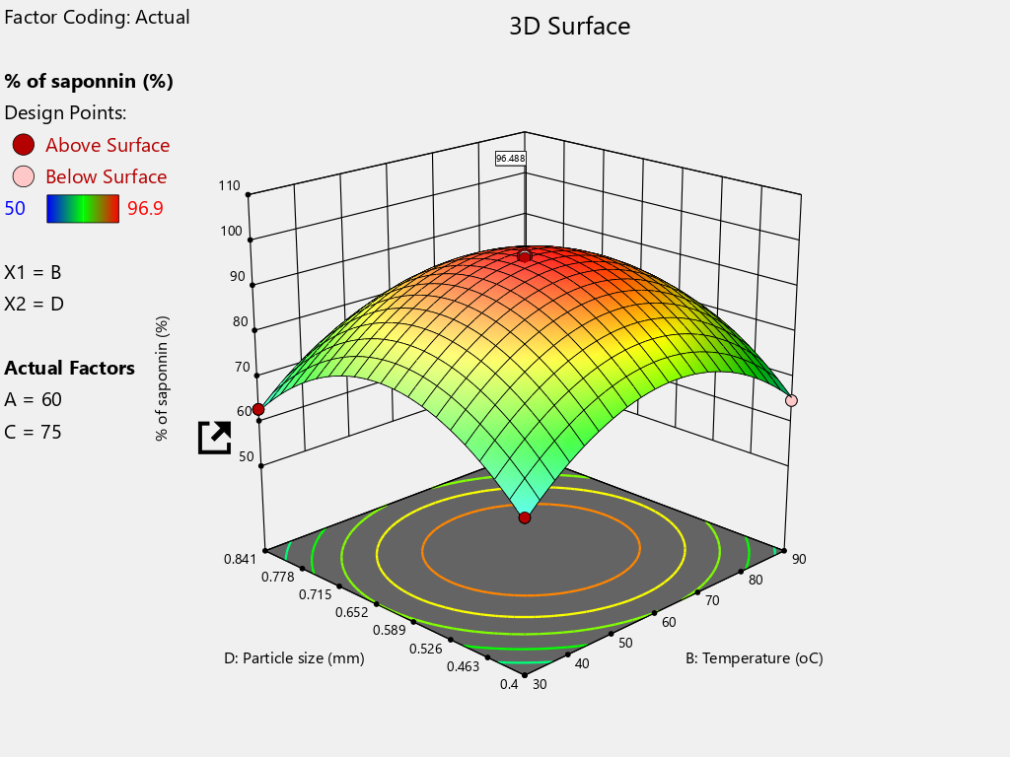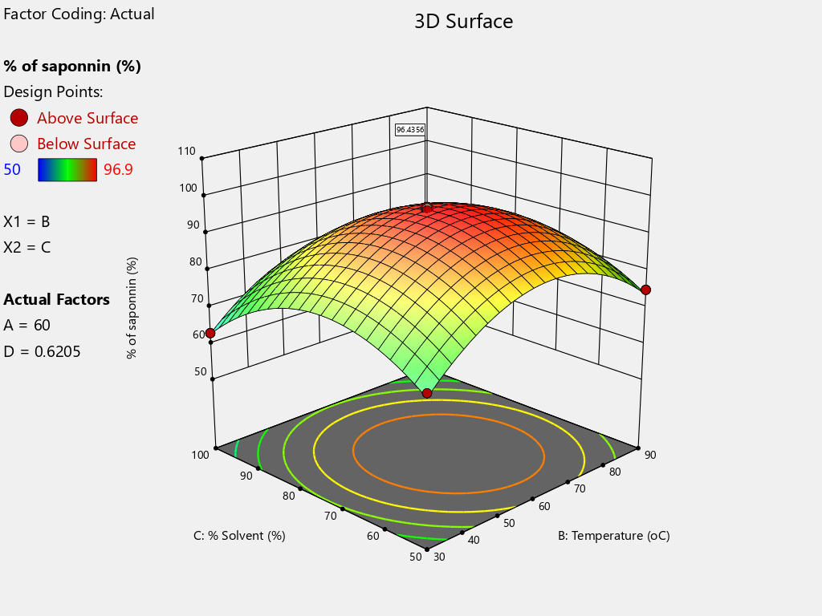

Fig 2: 3D Surface plots of % Yield of Saponin and time, temperature, % solvent and particle size

**Validation of the optimal result**

The validation of the experimental result is presented in Table 4. The results were validated by determining the percentage deviation of the predicted from the experimental value [18, 19] .The percentage deviation is 3.09% which is less than 5%. Thus, the Design Expert Software (DES) is adequate for the optimization of the extraction process.

**Table4: Validation of the optimal results**

|  |  |  |  |  |  |
| --- | --- | --- | --- | --- | --- |
| Particle size(mm) | Temperature (oC) | Time (min) | Experimental Saponin (%) | Predicted Saponin  (%) | Percentage deviation  (%) |
| 0.6205 | 60 | 60 | 99.52 | 96.43 | 3.09 |

**CONCLUSION**

The phytochemical analyses shows that saponin are present in the (Gmelina Arborea). The optimum yield of 164.53 mg/100 g biosurfactant (saponin) were found to be at temperature (60 oC), time (60 min), % of solvent (75 %) and particle size (0.6205 mm). The study also showed that time play the most significant role in biosufactant production

**REFERENCE**

Ashraf, M.A., Hussain, I., Rasheed, R., Iqbal, M., Riaz, M. and Arif, M.S. (2017) Advances in microbe-assisted reclamation of heavy metal contaminated soils over the last decade: a review. J Environ Manag, 198, 132–143, DOI: [10.1016/j.jenvman.2017.04.060](https://doi.org/10.1016/j.jenvman.2017.04.060)

Azmir, J., Zaidul, I. S. M., Rahman, M. M., Sharif, K. M., Mohamed, A., Sahena, F., et al. (2013) Techniques for extraction of bioactive compounds from plant materials: A re-view. Journal of Food Engineering, 117 (4), 426–436. https://doi.org/10.1016/j.jfoodeng.2013.01.014

Banat, I. M., Franzetti, A., Gandolﬁ, I., Bestetti, G., Martinotti, M.G., Fracchia, L., et al. (2010). Microbial biosurfactants production, applications and future potential. Appl. Microbiol. Biotechnol. 87, 427–444. doi: 10.1007/s00253-010-2589-0.

Buchwesihaija, J. (2009). Photochemical as Green corrosion inhibitors in various corrosive media, A review. Tanz. J. Sci., 35. 77 – 91.

Cameotra, S.S., Makkar, R.S., Kaur, J. and Mehta, S.K. (2010). Synthesis of biosurfactants and their advantages to microorganisms and mankind. In Biosurfactants261–280. (2010)

Chrzanowski L., Ławniczak L., Czaczyk K. (2012). Why do microorganisms produce rhamnolipids? World J. Microbial. Biotnol., 28, 401–419. doi: [10.1007/s11274-011-0854-8](https://doi.org/10.1007%2Fs11274-011-0854-8)

Eze, K.A., Aka, C.C, and Dim, E.C (2024). Extraction, characterization and optimization of phenolic compounds from Siam weed (Chromolaena odorata . International Journal of Engineering Research Updates, 2024, 06(02), 026–034 https://doi.org/10.53430/ijeru.2024.6.2.0027

Franzetti, A., Gandolfi, I., Fracchia, L., Van, H.J., Gkorezis, P., Marchant, R., et al. (2014). Biosurfactant use in heavy metal removal from industrial effluents and contaminated sites. Biosurfactants Prod. Util. Technol. Econ., 159, 361–369. DOI:[10.1201/b17599-20](http://dx.doi.org/10.1201/b17599-20)

6. Heng, M. Y., Tan, S. N., Yong, J. W. H., & Ong, E. S. (2013). Emerging green technologies for the chemical standardization of botanicals and herbal preparations. Trends in Analytical Chemistry, 50, 1–10. DOI:[10.1016/j.trac.2013.03.012](http://dx.doi.org/10.1016/j.trac.2013.03.012)

Mada, S. B., Garba, A., Muhammad, A., Muhammad, A. and Adekunle, D. O., (2012), Phytochemical Screening and Antimicrobial Efficacy of Aqueous and Methanolic Extract of Magnifera Indica (mango stem bark). World Journal of Life, Science and Medical Research, 2(2), 81-85

Maneerat, S. (2005). Bio surfactants from marine microorganisms. Songklanakarin Journal of Science and Technology, 27(6), 1263 -1272.

Marcano, L. and Hasenawa, D. (1991). Analysis of Phytochemicals in Leaves and Seeds, Agronomy Journal, 83, 445-452. (1991)

Muthusamy K., Gopalakrishnan S., Ravi T. K., Sivachidambaram P. (2008) .Biosurfactants: properties, commercial production and application. Curr. Sci., 94 (6), 736–747.

Nitschke, M. and Silva, S.S.E. (2018) Recent food applications of microbial surfactants. Crit Rev Food Sci Nutr , 58, 631–638, doi: 10.1080/10408398.2016.1208635

Omotioma M. and Onukwuli O. D. (2019). Phytochemical and Thermodynamic Studies of Pawpaw Leaf (Asimina trilola). Extract as Corrosion Inhibitor of Zinc in KOH Medium. Journal oftheNigerianSocietyofChemical Engineers, 34(1), 53-61.

Rogier, K. (2012). "A revision of the genus Gmelina (Lamiaceae)". Kew Bulletin, 67 (3), 293–329.

Sachdev, D.P. and Cameotra, S.S. (2013) Biosurfactants in agriculture. Appl Microbial Biotechnol, 97, 1005–1016. DOI: [10.1007/s00253-012-4641-8](https://doi.org/10.1007/s00253-012-4641-8)

Wang, L., & Weller, C. L. (2006). Recent advances in extraction of nutraceuticals from plants. Trends in Food Science and Technology, 17, 300–312. <https://doi.org/10.1016/j.tifs.2005.12.004>

Warrier, R.R, Priya, S.M, Kalaiselv, R. (2021). Gmelina arborea- an indigenous timber species of India with high medicinal value: A review on its pharmacology, pharmacognosy and phytochemistry. J Ethnopharmacol. doi: 10.1016/j.jep.2020.113593.