**The study of the anti allergic activity of the natural products from marine source or organism.**

Author Name:- Mr.Sagar Shivaji Sangle

Mr.Sumeet Ramdas Borchate

Email ID:-sumeetborchatesb02@gmail.com

**ABSTRACT:**

Allergic diseases have become more common in recent years, affecting over 20% of the global population. The primary treatments for allergies today are topical corticosteroids and antihistamines, but these drugs can cause adverse side effects and drug resistance with long-term use. This underscores the importance of finding alternative anti-allergic agents from natural sources. The unique conditions of the marine environment—such as high pressure, low temperatures, and limited light—support the creation of highly functional and diverse natural products. This review discusses anti-allergic secondary metabolites with various chemical structures, including polyphenols, alkaloids, terpenoids, steroids, and peptides, primarily derived from fungi, bacteria, macroalgae, sponges, mollusks, and fish. It also employs molecular docking simulations using MOE to explore how some representative marine natural products may interact with the H1 receptor. This review provides valuable insights into the structures and anti-allergic activities of marine-derived compounds, offering a useful reference for natural products with immunomodulatory effects.

**Keywords:** anti-allergic agents; secondary metabolites; marine species; molecular docking simulations.

**1.INTRODUCTION**

Allergic diseases have become a significant global health concern, classified as major chronic conditions worldwide. Common types of allergic diseases include allergic asthma, rhinitis, anaphylactic shock, hay fever, and dermatitis. The first description of pollen allergy dates back to 1870, at a time when the understanding of allergic diseases was limited. The prevalence of asthma, especially among children, began to rise in the 1960s, and by 1990, it reached epidemic proportions due to factors such as increased sensitivity to indoor allergens, poor diet, lack of physical activity, and shallow breathing habits. Food allergies have also seen a marked increase since 1990, now reaching epidemic levels. Studies from the UK indicate that while the prevalence of conditions like eczema and hay fever may be stabilizing or even declining, the incidence of systemic allergic diseases continues to grow. The burden of allergic diseases is becoming increasingly evident, with environmental changes such as urbanization, industrialization, and shifting lifestyles believed to contribute to this rising prevalence. Despite the growing impact of these diseases, current treatments primarily involve corticosteroids and antihistamines, which, while effective, come with various side effects such as drowsiness, dry mouth, and other discomforts.

The use of natural products to treat allergies has gained significant attention due to the increasing demand for alternative therapies. Approximately 71% of the Earth's surface is covered by oceans, which host a highly complex ecosystem. Life in the oceans dates back over four billion years, and over this vast period, marine biodiversity has flourished, comprising marine plants, animals, and microorganisms. The distinct environmental conditions of the ocean—such as high salinity, pressure, low temperatures, limited nutrients, hypoxia, and minimal light—have led to the production of a wide variety of metabolites unique to marine organisms. These conditions result in secondary metabolites with distinct characteristics compared to those found in terrestrial organisms. Marine secondary metabolites exhibit numerous biological activities, including anti-tumor, anti-inflammatory, anti-allergic, antiviral, and antibacterial effects.

**2.Materials and Methodology for Literature Review**

This review includes original research articles published in English from 1992 to 2022. In 2022, extensive database searches were conducted on PubMed, Web of Science, MDPI, Elsevier, and Springer Link using keywords such as "anti-allergy" + "marine organisms," "anti-allergy" + "mangrove plants," "anti-allergy" + "marine algae," "anti-allergy" + "sea corals," "anti-allergy" + "marine microorganisms," and various combined keyword searches. Only studies directly aligned with the focus of this review were selected. The aim of this review is to summarize recent research on anti-allergic compounds derived from marine plants, animals, and microorganisms, providing comprehensive information relevant to the topic. To aid understanding, we have categorized marine organisms into three sections: marine plants, marine animals, and marine microorganisms, to describe the anti-allergic activities of compounds produced by each group.

**3. Chemical Structures and Biological Activities of Anti-Allergy Compounds Derived from Marine Plants.**

**3.1 MARINE PLANTS:**

The compounds were assessed for anti-allergic activity, with comparisons to EGCG, a known anti-allergic agent. Results showed that the compounds inhibited the release of leukotriene B4, prostaglandin E2, histamine, and reduced COX-2 mRNA expression. Compounds 3, 8, and 9 had the strongest inhibitory effects, comparable or superior to EGCG. Matsui et al. isolated three compounds from Sargassum carpophyllum that inhibited prostaglandin D2, TNF-α, and β-hexosaminidase release in RBL-2H3 cells, with IC50 values of 50.7, 35.9, and 43.5 µM. At 40 µM, all compounds reduced ROS production, and compound 13 lowered Ca2+ levels.

Marine polyphenols, known for anti-allergic properties, play a role in human health. Li et al. isolated three compounds from Ecklonia cava, which reduced histamine release by 23.97%, 44.26%, and 34.54% at 100 µM. They also inhibited histamine release from KU812F and RBL-2H3 cells stimulated with calcium ionophore A23187 and blocked FcεRI and IgE binding. Compounds 1 and 3 showed the strongest effects, with IC50 values of 31.65 µM (RBL-2H3), 44.20 µM (KU812F), 38.87 µM (RBL-2H3), and 65.81 µM (KU812F). These compounds demonstrated dose-dependent anti-allergic activity. Han et al. studied eckol (compound 2) from Ecklonia cava in an IgE/BSA allergic model, showing it inhibited mast cell activation and cytokine production at 100 µg/mL.

Compounds from brown algae also show strong anti-allergic properties. Onodera et al. compared peridinin (compound 14) from Symbiodinium sp. and fucoxanthin (compound 15) from Petalonia fascia. They found that peridinin was more effective in inhibiting delayed-type hypersensitivity when applied topically. Peridinin may help prevent eosinophil migration to eotaxin and inhibit eotaxin production, offering potential for treating allergic inflammation.

Chen et al. studied fucoidan from Cladosiphon okamuranus, finding that its local application in mice boosted Treg cell development and increased TGF-1 secretion, suppressing Th2 cell-mediated immunity. Fucoidan also lowered serum IgE levels and memory B cells, easing allergic dermatitis in a DNCB-induced mouse model. It inhibited mast cell degranulation and reduced histamine, IL-4, and IL-13 production in P815 cells treated with C48/80. Notably, fucoidan’s effects were similar to corticosteroids but without the side effects in vivo.

Yu et al. investigated the anti-allergic effects of alginate from Laminaria japonica and found it reduced serum IgE and histamine levels in OVA-induced mice. It also inhibited mast cell activation, showing promise as an anti-allergic agent. Alginate helped restore the balance between T cell populations by preventing the development of Th0 cells into Th2 cells, lowering IL-4 and increasing IFN-γ levels. It also raised Treg cell numbers in spleen tissue, further supporting its anti-allergic effects.

Liu et al. studied R-phycocyanin (RPC) from Porphyra haitanensis in antigen-sensitized mice and mast cells. RPC significantly lowered tropomyosin-specific IgE levels, histamine release, and mast cell degranulation. It also suppressed IL-4 and IL-13 production, inhibiting Th2 cell differentiation and reducing allergic reactions.

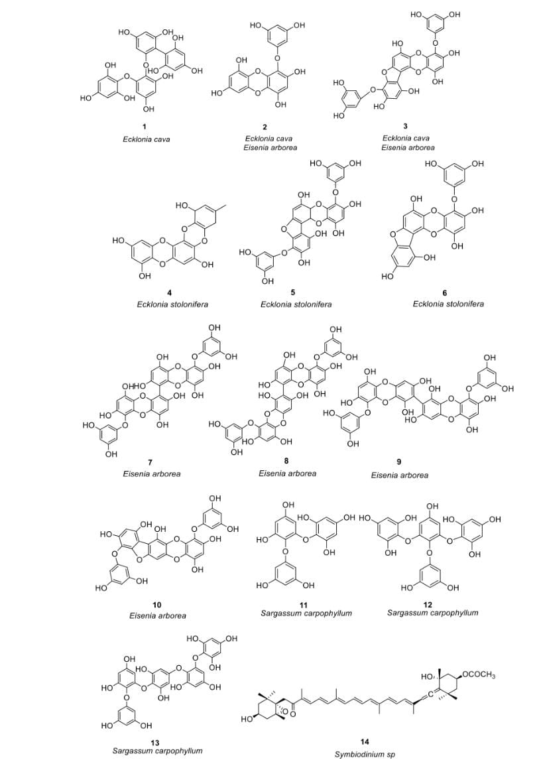

**3.2 Crude Extracts from Marine Plants as Potential Sources of Anti-Allergic Activity.**

Kim et al. [38] found that Ecklonia cava extracts reduced allergic responses in OVA-sensitized mice, lowering Th2 cytokines like IL-4 and IL-5, which are key in allergic reactions. Han et al. [39] investigated copper algae extract (SHE) and found it reduced β-hexosaminidase and histamine release, suppressed mast cell degranulation, and decreased FcεRI binding to IgE on BMCMCs. It also regulated cytokine and chemokine expression.

Herath et al. [40] studied Sargassum horneri ethanol extract (SHE) in mice with asthma induced by particulate matter (PM). SHE reduced STAT5 and GATA3 mRNA, blocked Th2 polarization, and lowered Th2 cytokines such as IL-4, IL-5, and IL-13. It also decreased mast cell activation, serum IgE, and Th2/Th17 responses triggered by PM exposure.

Jung et al. [41] used ethanol extraction to obtain Laurencia undulata (LU), rich in polyphenols, and found it suppressed allergic reactions in OVA-induced asthma in mice. Shi et al. [42] studied sulfated polysaccharides from Porphyra haitanensis (PHPS), which promoted Treg/Th1 cytokine production, including IL-10 and IFN-γ, both with and without allergens.

Han et al. [43] incorporated red algae sulfated polysaccharides (RASP) into effervescent tablets, showing that RASP reduced serum IgE, mast cell protease-1, histamine, and IL-4. It also increased IFN-γ, promoting Th1 differentiation and balancing Th1/Th2 cytokines.

These natural products regulate Th1/Th2 immune responses, controlling allergic reactions. Algae, including green algae like Enteromorpha compressa, have anti-allergic compounds. Raman et al. [44] observed that Enteromorpha compressa reduced IgE levels induced by allergens like ovalbumin and enhanced immune function. Cryptomonas also showed anti-allergic effects.

Lee et al. [45] tested Polyopes affinis extract on Th2-mediated airway inflammation in asthmatic mice, finding that it inhibited allergic responses and reduced ovalbumin-specific IgE by 72%. Mangroves, such as Lumnitzera racemosa, also exhibit anti-allergic properties. Acharyya et al. [46] found that its ethanol extract reduced symptoms like sneezing, nasal pain, and inhibited TDI-induced allergic reactions, while decreasing lymphocytes, neutrophils, and eosinophils.

**4. An Overview of Marine Natural Products with Anti-Allergy Properties**

Marine natural products, sourced from organisms like algae, sponges, and mollusks, have shown promise in allergy treatment due to their bioactive compounds. These substances possess anti-inflammatory, antioxidant, and immunomodulatory properties. Studies have identified marine-derived compounds that help alleviate allergy symptoms by inhibiting histamine release, reducing inflammation, and regulating immune responses. This review examines various marine natural products with anti-allergic potential, their mechanisms, and their potential therapeutic applications in allergy management.

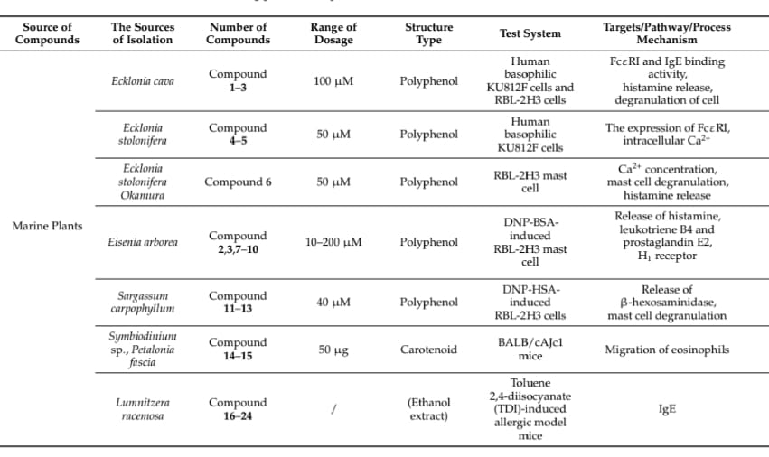

**5.Potential Mechanisms of Representative Natural Products in Allergy**

Food allergens (e.g., peanuts, cockroaches) and certain drugs trigger allergic reactions. Marine-derived metabolites can help by inhibiting Th2 cell activation, blocking IgE binding to FcεRI receptors, and preventing histamine release through mast cell degranulation.

When allergens enter the body, they activate Th2 cells, leading to IgE production. IgE binds to FcεRI receptors on mast cells, triggering calcium influx and degranulation, releasing histamine and other mediators that cause allergic symptoms. Targeting these pathways is key to allergy treatment.

Marine compounds inhibit IgE-FcεRI binding, histamine release, mast cell degranulation, and cytokine production. They also regulate calcium influx and Th1/Th2 cell balance.

Mast cells degranulate when IgE binds allergens, releasing histamine and triggering allergic reactions. Calcium influx activates signaling pathways that promote degranulation, regulated by SNARE proteins.

Blocking IgE binding to FcεRI can prevent allergic reactions. Marine natural products can reduce IgE binding, inhibit FcεRI expression, and prevent degranulation, offering potential allergy treatments.

In conclusion, inhibiting mast cell degranulation is crucial for anti-allergic therapies. Marine compounds offer several mechanisms to block allergic responses. Although some histamine antagonists show promise, side effects remain a challenge in developing effective allergy treatments.

.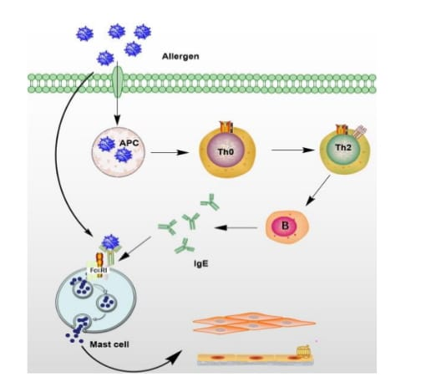

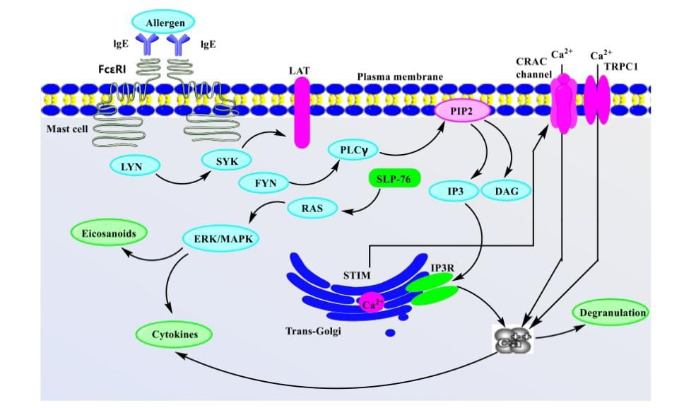

**5 . DISCUSSION AND FUTURE PROSPECTS**

Allergy treatments typically involve topical glucocorticoids and antihistamines, but long-term use can cause side effects and resistance. Corticosteroids may lead to weight gain and swelling, while antihistamines can cause dizziness and drowsiness. To address these issues, new drug targets and mechanisms are needed for more effective treatments with fewer side effects. This review explores marine-derived natural products as potential anti-allergic treatments. Marine organisms offer a rich source of bioactive compounds with promising therapeutic potential.

Marine natural products, especially polyphenols from brown algae, show anti-allergic properties along with antioxidant and anti-inflammatory effects. Terpenoids from marine animals, particularly sponges, also offer anti-allergic benefits. Sponges play a significant role in marine microbial biodiversity.

This review uses molecular docking (MOE) to investigate how marine compounds affect histamine release. One key interaction involves ASP107, a residue in amine receptors. Docking studies of 18 marine-derived compounds targeting H1R receptors highlighted compounds 14 and 37. Compound 14 showed a strong hydrogen bond with Asp107 and a docking energy of −8.2685 Kcal/mol, while compound 37 had a binding energy of −5.6156 Kcal/mol. Both compounds showed promising affinity for H1R, suggesting their potential as selective H1R antagonists, though further research is needed.

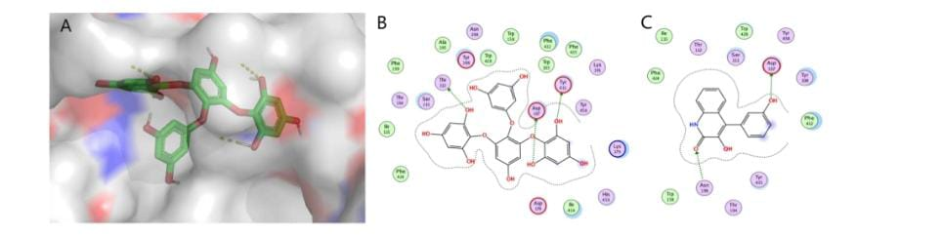

In conclusion, we hope that this review serves as both a comprehensive source of information on the anti-allergic properties and structures of marine natural products, and a valuable reference for understanding how these compounds can inhibit allergic reactions and modulate the immune system. Although there are currently limited studies focused on anti-allergic marine natural products, recent discoveries of secondary metabolites with significant biological activity highlight their potential. Continued exploration of these compounds remains a promising strategy for the development of new anti-allergic drugs.

**References**

1. Kang, S.Y.; Song, W.J.; Cho, S.H.; Chang, Y.S. Time trends of the prevalence of allergic diseases in Korea: A systematic literature review. Asia Pac. Allergy 2018, 8, e8. [CrossRef] [PubMed]

2. Oztop, N.; Demir, S.; Unal, D.; Beyaz, S.; Terzioglu, K.; Olgac, M.; Gelincik, A. Predictive factors of recurrence after omalizumab cessationvo in the elderly with urticaria: A real-life study. Allergy Asthma Proc. 2022, 43, 519–528. [CrossRef] [PubMed]

3. Fried, A.J.; Oettgen, H.C. Anti-IgE in the treatment of allergic disorders in pediatrics. Curr. Opin. Pediatr. 2010, 22, 758–764. [CrossRef] [PubMed]

4. Freidhoff, L.R.; Marsh, D.G. Relationship among Asthma, Serum IgE Levels and Skin Test Sensitivity to Inhaled Allergens. Int. Arch. Allergy Immunol. 2009, 100, 355–361. [CrossRef]

5. Platts-Mills, T.A. The allergy epidemics: 1870–2010. J. Allergy Clin. Immunol. 2015, 136, 3–13. [CrossRef] [PubMed]

6. Gupta, R.; Sheikh, A.; Strachan, D.P.; Anderson, H.R. Time Trends in allergic disorders in the UK. Thorax 2007, 62, 91–96. [CrossRef] [PubMed]

7. Prescott, S.; Nowak-W˛egrzyn, A. Strategies to prevent or reduce allergic disease. Ann. Nutr. Metab. 2011, 59 (Suppl. S1), 28–42. [CrossRef]

8. Imura, H.; Chen, J.; Kaneko, S.; Matsumoto, T. Analysis of Industrialization, Urbanization and Land-use Change in East Asia According to the DPSER Framework. In Proceedings of the 1999 NIES Workshop on Information Bases and Modeling for Land-Use and Land-Cover Changes Studies in East Asia; Kyushu University: Fukuoka City, Japan, 1999.

9. Zhao, J.; Bai, J.; Shen, K.; Xiang, L.; Huang, S.; Chen, A.; Huang, Y.; Wang, J.; Ye, R. Self-reported prevalence of childhood allergic diseases in three cities of China: A multicenter study. BMC Public Health 2010, 10, 551. [CrossRef]

10. Croom. Current Review of Allergic Diseases. Clin. Exp. Allergy 1999, 29, 1433. [CrossRef]

11. Nielsen, D.; Dahl, R. Comparison of intranasal corticosteroids and antihistamines in allergic rhinitis: A review of randomized, controlled trials. Am. J. Respir. Med. 2003, 2, 55–65. [CrossRef]

12. Haefner, B. Drugs from the deep: Marine natural products as drug candidates. Drug Discov. Today 2003, 8, 536–544. [CrossRef]

13. Milia’n, E.; Dıáz, A.M. Allergy to house dust mites and asthma. P. R. Health Sci. J. 2004, 23, 47–57.

14. Chen, B.; Laws, E.A. Is there a difference of temperature sensitivity between marine phytoplankton and heterotrophs? Limnol. Oceanogr. 2016, 62, 806–817. [CrossRef]

15. Blunt, J.W.; Carroll, A.R.; Copp, B.R.; Davis, R.A.; Keyzers, R.A.; Prinsep, M.R. Marine natural products. Nat. Prod. Rep. 2012, 29, 8–53. [CrossRef]

16. Carté, B. Biomedical Potential of Marine Natural Products. Bioscience 1996, 46, 271–286.

17. Mlcek, J.; Jurikova, T.; Skrovankova, S.; Sochor, J. Quercetin and its anti-allergic immune response. Molecules 2016, 21, 623. [CrossRef] [PubMed]

18. Ribeiro-Filho, J.; Piuvezam, M.R.; Bozza, P.T. Anti-allergic properties of curine, a bisbenzylisoquinoline alkaloid. Molecules 2015, 20, 4695–4707. [CrossRef] [PubMed]