INTELLIGENT SKIN DISEASE IDENTIFICATION AND CARE GUIDANCE SYSTEM

**Ankitha R 1, Saba Nida 2, Chandana S 3, Vaishnavi Pai N 4, Sahana. P. Shankar 5**

1 Student, Department of CSE, M.S. Ramaiah University of Applied Sciences, Bangalore, Karnataka, India

2 Student, Department of CSE, M.S. Ramaiah University of Applied Sciences, Bangalore, Karnataka, India

3 Student, Department of CSE, M.S. Ramaiah University of Applied Sciences, Bangalore, Karnataka, India

4 Student, Department of CSE, M.S. Ramaiah University of Applied Sciences, Bangalore, Karnataka, India

5 Assistant Professor, Department of CSE, M.S. Ramaiah University of Applied Sciences, Bangalore, Karnataka, India

**ABSTRACT**

The skin, a vital protective barrier for internal organs, is prone to infections caused by viruses, fungi, or dust, leading to conditions like eczema and acne that affect millions globally. Early detection and diagnosis of skin diseases are crucial to prevent severe complications and ensure effective treatment. This study focuses on developing a neural network-based website to detect 23 skin diseases, offering related videos, articles, and suggestions for nearby dermatologists. A convolutional neural network (CNN) using the DenseNet architecture was employed for model training on the DERMNET dataset. The system achieved a 90.5% accuracy rate at 48 epochs, implemented using Python. With further enhancements and a larger dataset, the solution holds significant potential for improving skin disease management and awareness.

**Keywords:** Skin Disease, DenseNet , CNN(convolution neural network),Dermatologist, DERMNET

1. **INTRODUCTION**

Skin conditions are among the most prevalent diseases, often caused by viruses, bacteria, allergies, or fungal infections. They can alter the skin’s color or texture and are frequently infectious, chronic, and sometimes linked to severe complications like skin cancer. Early diagnosis is crucial to prevent the progression and spread of these diseases. However, diagnosing and treating skin conditions often require significant time, money, and resources. Many people lack awareness about the type and stage of their skin conditions, leading to delayed recognition and treatment. This delay is compounded by symptoms that may appear months after the onset of the disease, further exacerbated by the general public's limited knowledge of medical care.

Diagnosing skin conditions can be challenging and may require costly laboratory tests for accurate identification. Advanced technologies like lasers and photonics have improved diagnostic accuracy but remain expensive and limited. To address this, we propose DermaLens, a website leveraging Convolutional Neural Networks (CNNs) for skin condition detection. CNNs, widely used in image processing, analyze uploaded images of affected skin to classify diseases. The platform provides users with tailored articles, videos, and nearby dermatologist recommendations. This solution aims to make skin disease diagnosis more accessible and efficient. The paper discusses the website's workflow, accuracy, and results, highlighting its potential to raise awareness, promote early diagnosis, and educate users about their skin health. DermaLens combines cutting-edge AI with practical resources to empower users in managing skin conditions.

1. **LITERATURE SURVEY**

In [1] The authors proposed a prototype for skin disease detection using CNNs, trained on DermNet dataset with five classes of skin diseases, which achieved 73% accuracy. They merged image processing techniques with machine learning for diagnosis and mentioned the possibility of improvement with more extensive data.

In [2] The authors have identified an intelligent system for predicting skin diseases using CNN-SVM and have developed that into a mobile Android application. They have used 3000 images to develop this algorithm showing highly accurate detection of the skin diseases, also going on to recommend the necessary treatment for it. It is a Intelligent System for Skin Disease Prediction using Deep Learning.

In [3] The authors have compared the qualities of object identification methods with the intention of finding the most suitable approach toward skin disease detection and came to a conclusion that CNN-based techniques are best.

In [4] The authors analyzed under-sampling, oversampling, and augmentation data preprocessing techniques for performance enhancement of the MobileNet model in skin disease classification.

In [5] The authors reviewed the current skin disease diagnosis methodologies, with a particular emphasis on those using machine learning and image processing techniques. Various computational methods have been analyzed, including CNNs for feature extraction and classification of skin images. This survey has also discussed the drawbacks of traditional dermatological diagnostic techniques and the potential role of automated systems in increasing accuracy and efficiency in skin disease detection.

In [6] The authors discussed the existent computerized systems for diagnosing skin diseases by a critical analysis of several disadvantages and pitfalls that could be improved. Several deep learning model comparisons have been provided, and the possible interest of Residual Neural Network(s) in enhancing classification performance has been discussed for more accuracy and swiftness. From this survey, the following points emerge: ResNet might outperform the classic system in dealing with more challenging skin disease datasets with great accuracy.

In [7] The authors have proposed detection of skin diseases employing image processing and machine learning techniques. They used the feature extraction technique with a CNN pretrained model and multiclass classification using SVM. It successfully detects three types of skin diseases: eczema, melanoma, and psoriasis, while the total accuracy is 100**%.**

1. **ABBREVIATIONS AND ACRONYMS**

CNN (Convolution Neural Network), SVM (Support Vector Machine), DenseNet (Densely Connected Convolutional Networks , ResNet (Residual Neural Network).

1. **METHODOLOGY**

**i. DATASET**

The Dermnet dataset in Kaggle website is chosen. The dataset is based on 23 different types of skin diseases. The dataset distribution is shown in Fig.1 . There are total 19,600 images including train and test images.

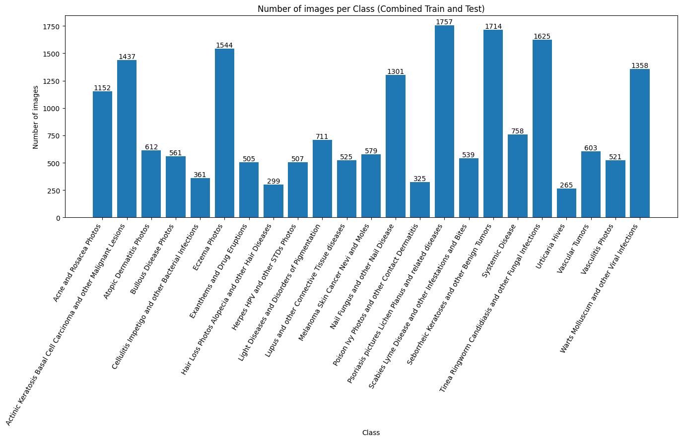

Fig.1. Dataset Distribution

**ii. DATA PRE-PROCESSING AND MODEL TRAINING**

In the above dataset, out of 23 diseases only 8 diseases contain more than 1000 images hence dataset set is highly diverse in nature. So, the classes which has more than 1405 image count has been undersampled and the classes which has less than 1405 image count has been oversampled. The dataset distribution sampling is shown in Fig.2.

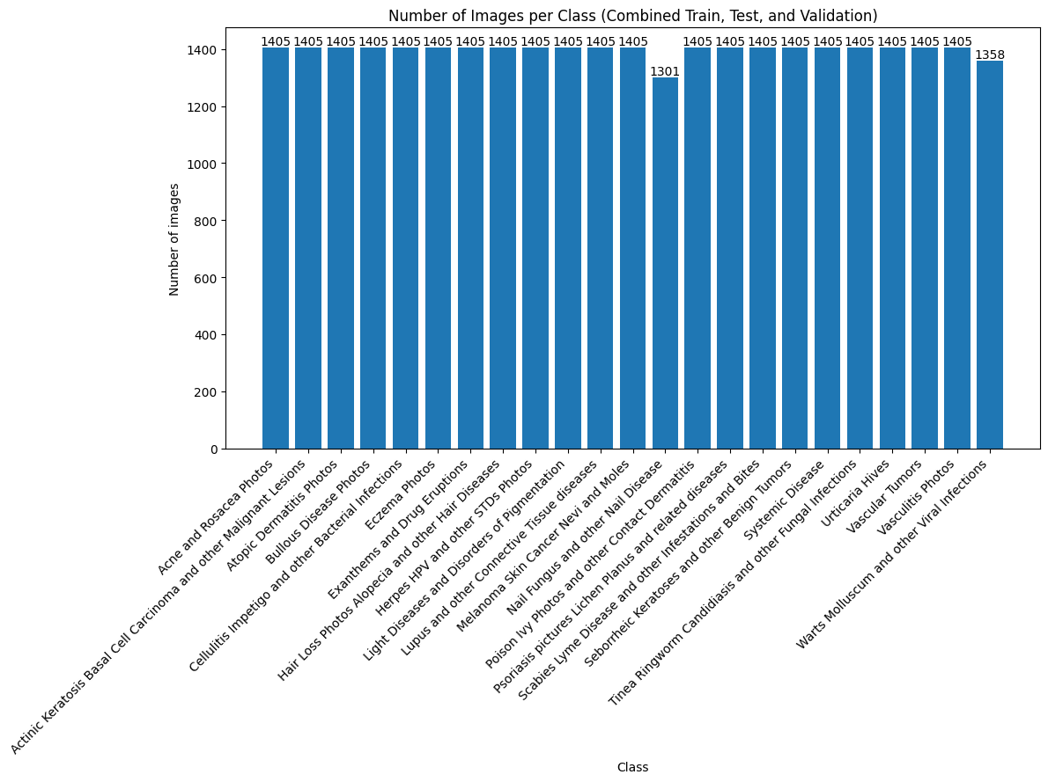

Fig.2. Dataset Distribution after Pre-processing

The images used for training, validation, and testing were selected at a 80 %, 10 %, and 10 % image percentage. Training is done using CNN.

A CNN layer extracts low-level features like edges and colors by convolving an image with filters. To reduce computational complexity, a pooling layer compresses this data by downsizing feature maps. Multiple such layers are stacked to capture intricate features based on image complexity. The output is flattened and passed to fully connected layers for classification, where high-level features are learned through nonlinear combinations. Backpropagation refines the model during training, enabling it to distinguish dominant features for accurate image classification. In CNN training, an epoch represents one complete pass through the entire training dataset by the model. During each epoch, the model updates its weights through backpropagation to minimize error and improve accuracy. Multiple epochs allow the model to iteratively refine its ability to identify and classify image features. Too few epochs may lead to underfitting, while too many can result in overfitting, so an optimal number is chosen to balance learning and generalization.

Keras and TensorFlow are widely used for implementing CNNs in tasks like image classification. TensorFlow provides the backend framework for efficient computation, while Keras offers a user-friendly API to build, train, and evaluate deep learning models. They enable the easy creation of convolutional, pooling, and fully connected layers. Additionally, these libraries support GPU acceleration for faster training over multiple epochs. They also provide tools for monitoring training, such as visualizing metrics and loss curves

**iii. MODEL TRAINING AND EVALUATION**

Using the DenseNet architecture, the validation dataset is evaluated at the end of each epoch to compute validation accuracy and assess the model's performance. DenseNet updates its weights through training data, leveraging its densely connected layers for efficient feature propagation and reuse, repeating the process over multiple epochs. Fig.3. shows the model training with 48 epochs. Validation data at each epoch ensures the reliability of the learned weights. Approximately 90.5% accuracy is obtained.



Fig.3. Model Training with 48 epochs

Accuracy and loss graphs are generated, comparing training and validation metrics. These graphs are crucial for evaluating DenseNet's performance and determining the most accurate model configuration. Fig.4. represents the Training and Validation accuracy curve. Fig.5. represents the Training and Validation loss curve.

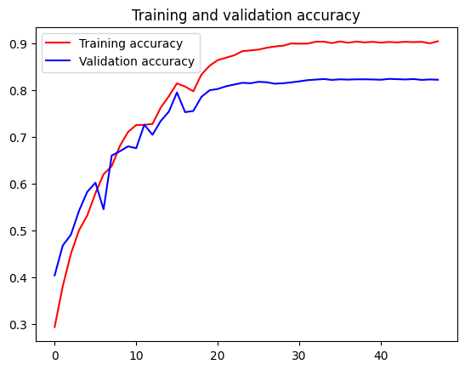

Fig.4. Training and Validation accuracy curve

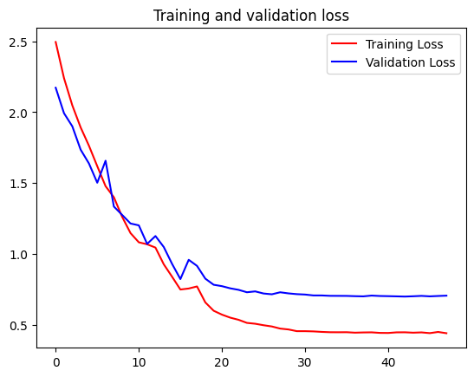

Fig.5. Training and Validation loss curve

**iv. WEBSITE DEVELOPMENT**

The website is designed to assist users in diagnosing skin conditions and providing comprehensive support. Users can upload photos of their skin, which are analyzed by a CNN deep learning model using DenseNet to predict potential diseases and assess their severity. Based on the detected condition, the platform offers relevant articles, videos, and dermatologist recommendations to help users better understand and manage their condition. Additionally, integrated location services enable users to find nearby dermatologists for further consultation. The website also collects feedback from users to continuously improve its accuracy, functionality, and user experience. It will be validated using real-time user inputs to ensure reliable predictions and personalized services. Fig.6. shows the workflow and architecture of the DermaLens website. Fig.7. represents Overview and user interface of the website. Fig.8. represents the recommendation of dermatologists nearby.

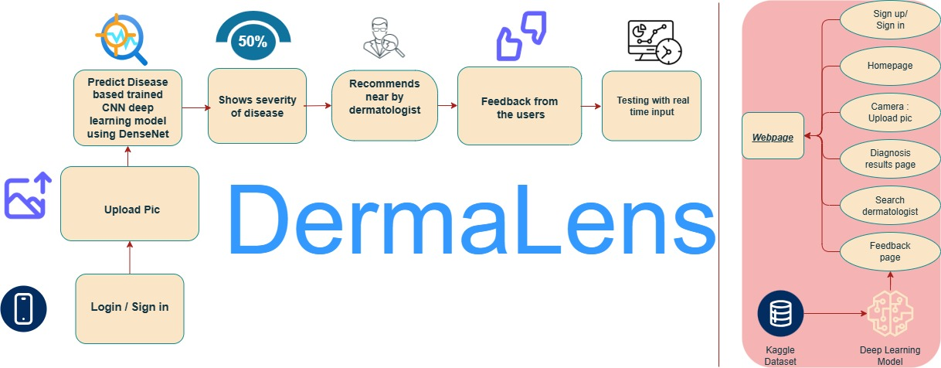

Fig.6. Workflow and Architecture of the DermaLens Website

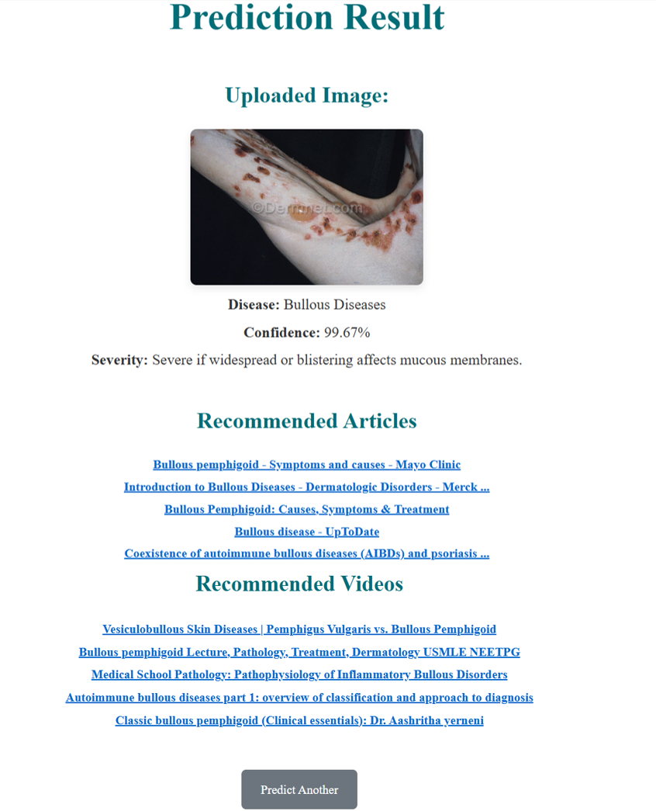

Fig.7. Overview of the website

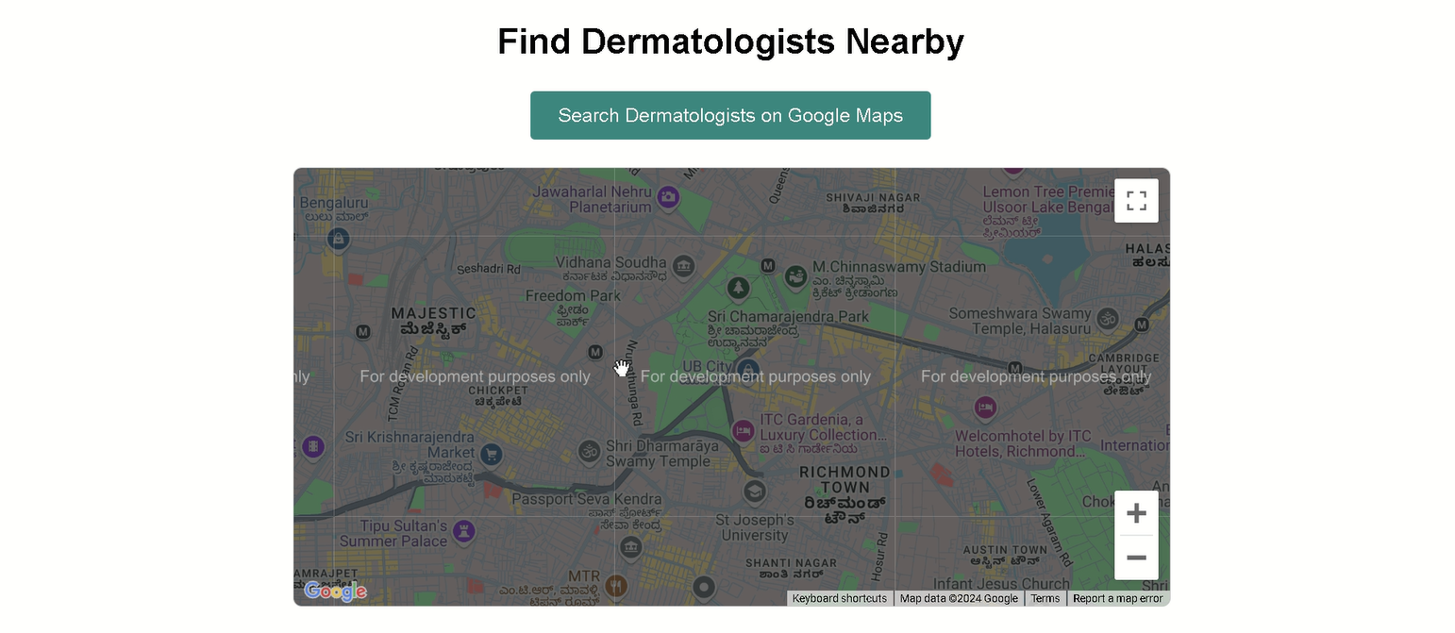

Fig.8. Recommendation of Dermatologists nearby

1. **CONCLUSION**

A CNN model using DenseNet architecture has been developed to classify skin diseases from a diverse dataset. Imbalances in the dataset were addressed through pre-processing techniques such as oversampling and undersampling, ensuring balanced and effective training. The model's performance, validated over 48 epochs, showed reliable accuracy of 90.5% and loss metrics. This model is integrated into the user-friendly DermaLens web platform, which allows users to upload skin images for analysis. The platform provides personalized benefits, including condition-specific resources, dermatologist recommendations, and location-based services for finding nearby specialists. It enhances accessibility to dermatological care, offering early detection and remote self-assessment of skin conditions. Users gain awareness and support for managing their conditions conveniently from home. Real-time user feedback ensures continuous refinement of the platform, making it a reliable, practical, and scalable tool for addressing skin diseases. This approach bridges the gap between technology and healthcare, empowering individuals with accessible and accurate dermatological solutions.

1. **REFERENCES**
2. Rimi, T. A., Sultana, N., & Foysal, M. F. A. (2020, May). Derm-NN: skin diseases detection using convolutional neural network. In 2020 4th International Conference on Intelligent Computing and Control Systems (ICICCS) (pp. 1205-1209). IEEE.
3. Elngar, A. A., Kumar, R., Hayat, A., & Churi, P. (2021, August). Intelligent system for skin disease prediction using machine learning. In *Journal of Physics: Conference Series* (Vol. 1998, No. 1, p. 012037). IOP Publishing.
4. Maduranga, M. W. P., & Nandasena, D. (2022). Mobile-based skin disease diagnosis system using convolutional neural networks (CNN). International Journal of Image, Graphics and Signal Processing, 12(3), 47.
5. Velasco, J., Pascion, C., Alberio, J. W., Apuang, J., Cruz, J. S., Gomez, M. A., ... & Jorda Jr, R. (2019). A smartphone-based skin disease classification using mobilenet cnn. arXiv preprint arXiv:1911.07929.
6. Inthiyaz, S., Altahan, B. R., Ahammad, S. H., Rajesh, V., Kalangi, R. R., Smirani, L. K., ... & Rashed, A. N. Z. (2023). Skin disease detection using deep learning. *Advances in Engineering Software*, *175*, 103361.
7. Sharma, M., Jain, B., Kargeti, C., Gupta, V., & Gupta, D. (2021). Detection and diagnosis of skin diseases using residual neural networks (RESNET). International Journal of Image and Graphics, 21(05), 2140002.
8. ALEnezi, N. S. A. (2019). A method of skin disease detection using image processing and machine learning. Procedia Computer Science, 163, 85-92.
9. Bhadula, Shuchi, et al. "Machine learning algorithms based skin disease detection." International Journal of Innovative Technology and Exploring Engineering (IJITEE) 9.2 (2019): 4044-4049.
10. Likhitha, S., & Baskar, R. (2022, December). Skin cancer classification using CNN in comparison with support vector machine for better accuracy. In 2022 11th International Conference on System Modeling & Advancement in Research Trends (SMART) (pp. 1298-1302). IEEE.
11. Aziz, A., Hartono, R., & Abdilah, R. (2020, June). Decision Support System for Detection of Skin Diseases in Smart Health development planning. In IOP Conference Series: Materials Science and Engineering (Vol. 858, No. 1, p. 012051). IOP Publishing.
12. Kumar, N & Kumar, P & Pramodh, K & Karuna, Yepuganti. (2019). Classification of Skin diseases using Image processing and SVM. 1-5. 10.1109/ViTECoN.2019.8899449.
13. Li, H., Pan, Y., Zhao, J., & Zhang, L. (2021). Skin disease diagnosis with deep learning: A review. *Neurocomputing*, *464*, 364-393.
14. Patnaik, S. K., Sidhu, M. S., Gehlot, Y., Sharma, B., & Muthu, P. (2018). Automated skin disease identification using deep learning algorithm. *Biomedical & Pharmacology Journal*, *11*(3), 1429.
15. Niranjana, R., Hemadarshana, T., Ilakkya, S., Krishnan, R. S., Epziba, J. J., & Preetha, T. (2024, June). Enhanced Skin Diseases Prediction using DenseNet-121: Leveraging Dataset Diversity for High Accuracy Classification. In *2024 3rd International Conference on Applied Artificial Intelligence and Computing (ICAAIC)* (pp. 1270-1278). IEEE.
16. Pramesti, E., Mutiara, A. B., & Refianti, R. (2023, December). Implementation of Deep Learning Using Convolutional Neural Network for Skin Disease Classification with DenseNet-201 Architecture. In *2023 Eighth International Conference on Informatics and Computing (ICIC)* (pp. 1-6). IEEE.
17. Bello, A., Ng, S. C., & Leung, M. F. (2024). Skin Cancer Classification Using Fine-Tuned Transfer Learning of DENSENET-121. *Applied Sciences*, *14*(17), 7707.
18. Zhang, B., Zhou, X., Luo, Y. *et al.* Opportunities and Challenges: Classification of Skin Disease Based on Deep Learning. *Chin. J. Mech. Eng.* 34, 112 (2021).