ABSTRACT:

The present study was undertaken to assess the nutritional quality of food served in university hostels at Lucknow. Food was estimated for macronutrients, micronutrients, and recommendations for dietary allowances. Data regarding students' dietary intake and health status were also collected. Nutritional care for students living in hostels is important because they are in a critical growth period. Adolescence is a time of rapid physical and mental development, and students need a balanced diet to meet their nutritional requirements.

However, hostel diets often fall short of recommended nutritional standards. This is a cause for concern, as proper nutrition is essential for students' overall health and well-being.

Studies have shown that hostel diets are often deficient in key nutrients, imbalanced, and poorly planned. This can lead to a number of health problems, including fatigue, weight gain, and even malnutrition. There is a particular need for more research on the diets of boys in hostels, as their nutritional needs may differ from those of girls.

1.INTRODUCTION:

Nutrition is the scientific exploration of how living organisms interact with the food they consume to support health, growth, and overall well-being. It delves into the composition of nutrients, their roles in the body, how they are absorbed and utilized, and their impact on health. Essential for proper bodily function, nutrients are classified into macronutrients (carbohydrates, proteins, and fats) and micronutrients (vitamins and minerals).

A cornerstone of nutritional science is promoting healthy eating habits aligned with dietary guidelines. These recommendations, tailored to specific populations and cultural contexts, emphasize balanced nutrition. Nutrition is intricately connected to metabolism, the body's process of converting nutrients into energy, building tissues, and producing waste products. This connection underscores the importance of nutrition in public health initiatives aimed at preventing nutritional deficiencies and improving overall well-being. In clinical settings, nutrition plays a pivotal role in managing and preventing diseases, with dietitians and nutritionists providing personalized dietary guidance.

Nutritional requirements of adolescents have received scant attention, with limited studies evaluating boys' hostel diets. Adolescence is a period of nutritional stress, emphasizing the importance of maintaining energy balance. Hostel residents reportedly have greater energy needs compared to day scholars. Studies across various educational institutions in the country have highlighted nutritionally deficient, imbalanced, and poorly planned diets in hostels. Several researchers have also noted deficiencies in important nutrients within hostel diets. Aguiar, V. L., Silva, M. C., & Claro, H. M. (2017).

Hostel authorities bear the responsibility of providing not only appetizing but also nutritionally balanced meals to their residents. Without systematic assessments, it's challenging to determine if these standards are being met. This study aims to evaluate the nutritional quality of hostel food services, holding administrations accountable and advocating for necessary enhancements through nutritional assessments.

The study was conducted in Babasaheb Bhimrao Ambedkar University (BBAU) is a Central University in Lucknow, Uttar Pradesh.

At the university, there are a total of 8 hostels, four for girls and four for boys. This study only examines the boys’ hostels of the university. The four hostels for boys are as follows:

* Ashoka boys’ hostel
* Kanishka boys’ hostel
* Siddhartha boys’ hostel
* Residential coaching center (hostel)

2.METHODOLOGY:

For the appropriate “Study on nutritional evaluation of university hostel food in Lucknow”. Were selected and use in distant ways of describing and quantifying the data. Hence, to guide and maintain the validity of research outcomes.

2.1 Study design:

A study design is the architecture of any a description of how the study was collected. the current research was carried out by Cross Sectional Study.

2.2 Sampling Procedure:

This is a Purposive sampling technique has done in BBAU of Lucknow. The random sampling to decide the total number of samples: 100. 25 members from each of the four hostels.

2.3 Tools of the study:

The investigator conducted the survey through various means, including visits, interviews, personal inquiries, and observations. The questionnaire designed for the dietary survey was specifically tailored to gather details on their meal patterns, frequency of consuming different food items.

a) 24-hour diet recall method:

The nutritional intake of hostel mates is analyzed using a 24-hour diet recall method, wherein data on total energy, carbohydrates, fats, and proteins per meal are calculated by referring a book called Nutrition Science by B Sri Lakshmi (each and every ingredient of a food article is examined)

b) Statistical analysis:

Data collected were analyzed through MS excel and presented in the form of percentage and mean. And compared total mean data with average recommended nutritional values by RDA.

3.RESULTS AND DISCUSSION:

Nutritional mean data of Ashoka boy’s hostel:

* K. Cal = 2056.84
* Carbohydrates = 308.92
* Fat = 73.44
* Protein = 73.08

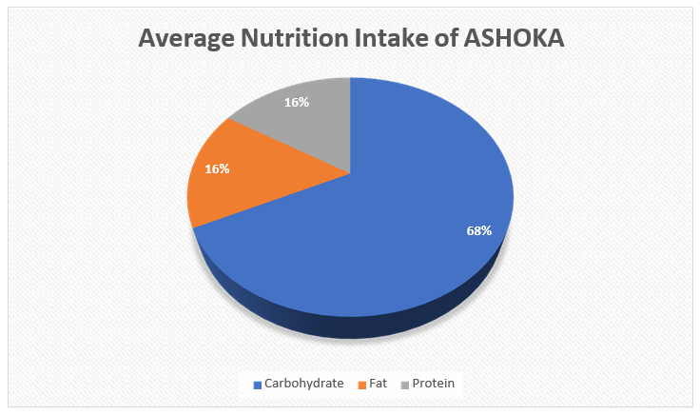

Figure 3.1 Nutritional intake of Ashoka (mean)

Nutritional mean data of Kanishka boy’s hostel:

* K. Cal = 1739.96
* Carbohydrates = 238.64
* Fat = 56.28
* Protein = 64.4

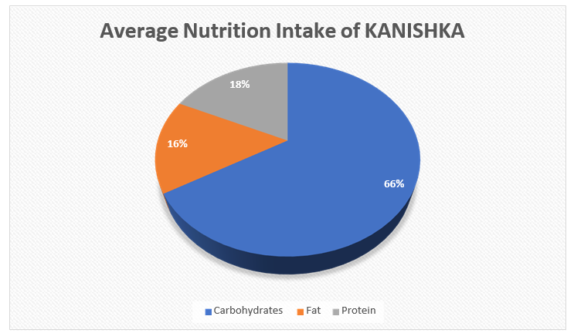

Figure 3.2 Nutritional intake of Kanishka (mean)

Nutritional mean data of Siddhartha boy’s hostel:

* K. Cal = 1904.2
* Carbohydrates = 285.92
* Fat = 62.68
* 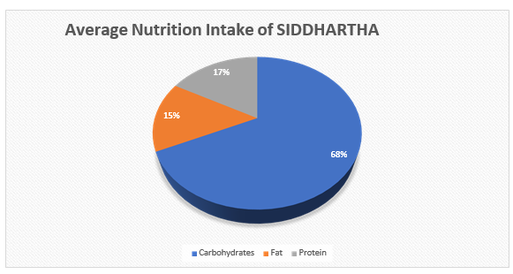Protein = 71.28

Figure 3.3 Nutritional intake of Siddhartha (mean)

Nutritional mean data of RCA:

* K. Cal = 1793
* Carbohydrates = 262.24
* Fat = 60.24
* Protein = 68.68

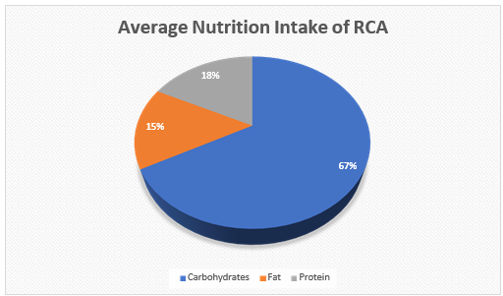

Figure 3.4 Nutritional intake of Residential coaching center (mean)

Total nutritional mean data of 4 hostels:

* K. Cal = 1873.5
* Carbohydrates = 273.93
* Fat = 63.16
* Protein = 69.36

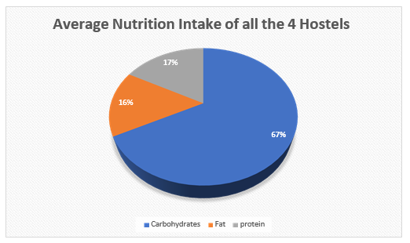

Figure 3.5 Percentage of Average nutrition intake

Comparison between hostels:

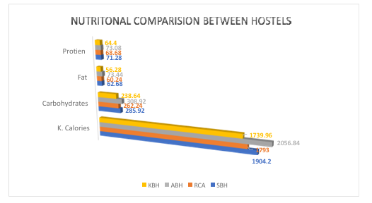

Figure 3.6 Comparison of nutrition intake between hostels

Ashoka hostel maintain good diet when compared to other three hostels Ashoka comes in first place, Residential coaching academy on second, Siddhartha on third and lastly Kanishka.

Kanishka > Siddhartha > Regional coaching academy > Ashoka

Comparison between total nutritional mean value hostels and average recommended nutritional value for students by RDA:

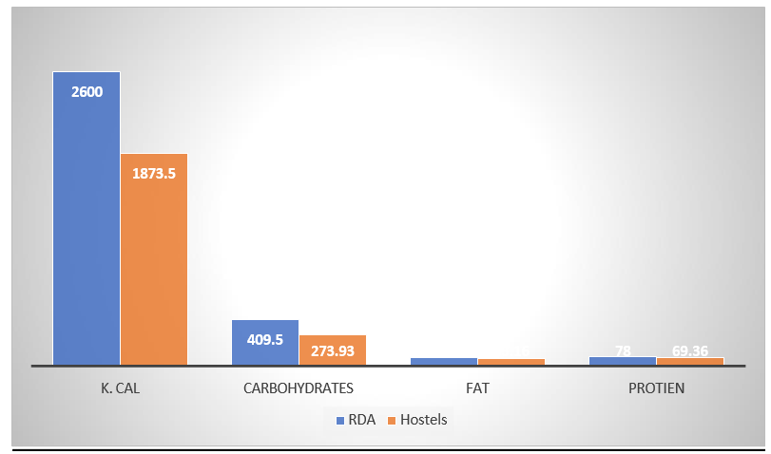

## Figure 3.7 Comparison between nutritional intake with RDA

Table 3.1 Difference of macros and total energy consumption with RDA regulations

|  |  |
| --- | --- |
| Calories | 726.5 K. Cal |
| Carbohydrates | 135.57 gm |
| Fat | 8.84 gm |
| Protein | 8.64 gm |

Based on observations, there is a drastic difference in calorie count and carbohydrate count. Protein and fat content differ slightly as well.

4.CONCLUSION:

Understanding the nutritional intake of hostel inmates allows for the monitoring of their overall health and well-being. It helps identify deficiencies or excesses in essential nutrients, enabling timely intervention to prevent malnutrition or diet-related health issues. Analyzing nutrition intake provides valuable data for educational purposes, empowering hostel inmates with knowledge about balanced diets, portion control, and the importance of incorporating nutrient-rich foods into their meals.

The nutrition intake of the four hostel inmates per meal are collected through 24-diet recall questionnaire in this the data is plotted that includes K. Cal, Protein, Fat and Carbohydrates of every meal like Breakfast, Lunch, Dinner and also Evening snack are presented.

The total mean value of nutritional intake across all hostels has been calculated and is presented in this section. It also includes a comparative illustration of the nutritional intake across the four hostels. Furthermore, data regarding the recommended average nutritional intake for students by the Recommended Dietary Allowances (RDA) is provided. Finally, a comparison between the total nutritional mean value and the recommended nutritional values by RDA is presented.

A nutritional comparison was conducted among the four hostels to determine which one offers a more nutritious food selection maintain good diet when compared to other three hostels Ashoka comes in first place, Residential coaching academy on second, Siddhartha on third and lastly Kanishka.

A nutritional comparison was conducted between the overall nutritional mean value of the hostels and the average recommended nutritional value for students according to the Recommended Dietary Allowances (RDA). The results show that, there is a drastic difference in calorie count and carbohydrate count. Protein and fat content differ slightly as well.

By examining nutrition intake patterns, hostel management can tailor meal plans to better meet the dietary needs and preferences of inmates. This can enhance satisfaction levels and promote healthier eating habits among residents. Proper nutrition plays a crucial role in supporting cognitive function, energy levels, and overall performance. Analyzing nutrition intake helps identify areas for improvement that can positively impact the academic or professional pursuits of hostel inmates.

5.REFERENCES:

Aguiar, V. L., Silva, M. C., & Claro, H. M. (2017). Food intake of university students: A systematic review. Revista de Nutrição, 30(6), 847-865. doi:10.1590/1678-98652017000600016

Brunner, E. J., Bryant, D. M., Smiciklas-Wright, H., & Lien, S. (2011). Dietary patterns and nutrient intake among adolescents: The National Health and Nutrition Examination Survey (NHANES), 2001–2006. Journal of the American Dietetic Association, 111(3), 429-437. doi:10.1016/j.jada.2010.12.015

Dorey, A. L., & McCool, C. (2009). Awareness of nutrition among school students through media.ResearchGate. doi:10.13140/RG.2.2.17205.62404

Fernandes, C. M., Pereira, M. C., & Silva, C. M. (2018). Dietary intake and food patern among University students. ResearchGate. doi:10.13140/RG.2.2.21527.65604

Fisher, J. O., & Rolls, E. T. (1991). Reward value of sweet taste: Dependence on dopaminergic systems.Brain Research, 563(1-2), 308-319. doi:10.1016/0006-8950(91)90714-8

Khoury, B., Aramouni, F., & Barbour, E. K. (2016). Dietary patterns and nutrient intake of university students in Jordan. Nutrition Journal, 15(1), 78. doi:10.1186/s12937-016-0159-x

Nguyen, L. T., & Popkin, B. M. (2011). Changes in dietary patterns and nutrient intakes among Vietnamese adolescents from 1992 to 2002. Public Health Nutrition, 14(3), 425-433. doi:10.1017/S1368980010002256

Soriano, J. M., Irazusta, J., & Cervera, P. (2001). Dietary patterns and nutrient intakes in Spanish university students. Public Health Nutrition, 4(6A), 567-573. doi:10.1079/PHN2001117