**Design of AC to DC Converter Topology for Fast Electrical Vehicle charging station**

1Suvigya Srivastava, 2Abhay Chaturvedi

*1M.Tech Scholar, Technocrats Institute of Technology, Bhopal (M.P.), INDIA,*

*Mail id-6707suvigya94@gmail.com*

*2Assistant Professor, Technocrats Institute of Technology, Bhopal (M.P.) INDIA,*

*Mail* [*id-abhaytit@gmail.com*](mailto:id-abhaytit@gmail.com)

**ABSTRACT**

The rapid adoption of electric vehicles (EVs) necessitates the development of efficient and reliable fast charging stations. This work presents a comparative analysis of various existing power converter topologies with the proposed topologies that are used in fast EV charging stations, focusing on their efficiency, cost, complexity, and performance. The study covers traditional and emerging converter topologies, including isolated and non-isolated designs, multi-level converters, and soft-switching techniques. Key performance metrics such as device count, charging voltage and source harmonics are evaluated. The analysis highlights the trade-offs between different topologies, providing insights into the optimal design choices for specific applications. The findings indicate that while non-isolated topologies offer higher efficiency and lower cost, isolated topologies provide better safety and flexibility. Multi-level converters show promise in reducing harmonic distortion and improving power quality, while soft-switching techniques enhance efficiency and thermal performance. This comparative study aims to guide engineers and designers in selecting the most suitable power converter topology for fast EV charging stations, ultimately contributing to the advancement of EV infrastructure and the acceleration of sustainable transportation solutions.

1. Introduction

The increasing adoption of electric vehicles (EVs) has created a pressing need for efficient and reliable charging infrastructure. Fast charging stations, capable of significantly reducing charging time, are pivotal to the widespread acceptance of EVs as a sustainable alternative to internal combustion engine vehicles [1,2]. Among the critical components of these charging stations is the AC to DC converter, which plays a key role in converting the alternating current (AC) from the grid into the direct current (DC) required to charge EV batteries.Designing an AC to DC converter topology for fast EV charging presents unique challenges, including the need for high power density, energy efficiency, power quality, and reliability [3,4]. Additionally, the converter must comply with stringent grid connection standards and provide features such as bidirectional power flow to enable vehicle-to-grid (V2G) applications. These requirements necessitate innovative designs that integrate advanced control strategies, wide-bandgap semiconductor devices, and thermal management systems [5,6]. This paper focuses on the design and analysis of AC to DC converter topologies tailored for fast EV charging stations. The study highlights the technical considerations involved, such as harmonic distortion minimization, power factor correction, and thermal performance optimization. Furthermore, the analysis explores different topologies, including conventional rectifier-based designs, modular multilevel converters, and resonant converters, to identify the most suitable solutions for high-power EV charging applications. By addressing these aspects, this research contributes to the ongoing efforts to develop efficient, cost-effective, and scalable charging systems that align with the goals of reducing environmental impact and enhancing the user experience in the EV ecosystem[7]. The findings and recommendations aim to serve as a guideline for engineers, researchers, and policymakers involved in the advancement of EV charging technology.

1. **Proposed AC-DC Converter Topologies**

The proposed Converter is the modification of Vienna Rectifier circuit with the additional switches. The presented topology will work for the single-phase AC to DC converter for fast electrical vehicle charging stations. This topology is applicable to on board charging i.e at house hold applications.

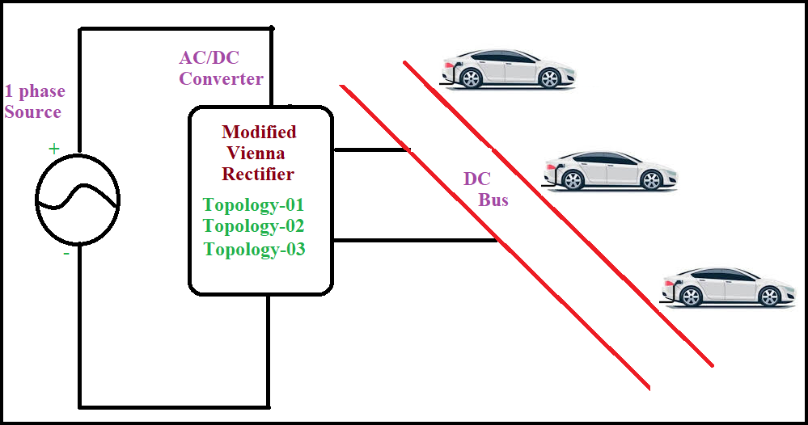

**Figure 2.1: Functional Block Diagram of EV charging Structure**

The employed topology involves a single-stage Vienna rectifier configuration. The input structure of these configurations features an inductor, denoted as L, with the resistor R representing the resistive components within the inductor. The configuration described in this study closely resembles that of a single-phase T-type inverter, where the external switches of the inverter are substituted by the diodes present in the rectifier. In these rectifier topologies, the internal switch operates when the upper capacitor is undergoing charging. The minimized alterations in the circuit contribute to reduced total harmonic distortion (THD) in the line current due to the switching frequency, thereby leading to an enhancement in the power factor at the source side. Notably, this converter, referred to as the split capacitor, incorporates two capacitors positioned at the output side, effectively reducing the voltage stress imposed on the power semiconductor switches[8,9].

**Converter Topology-01**

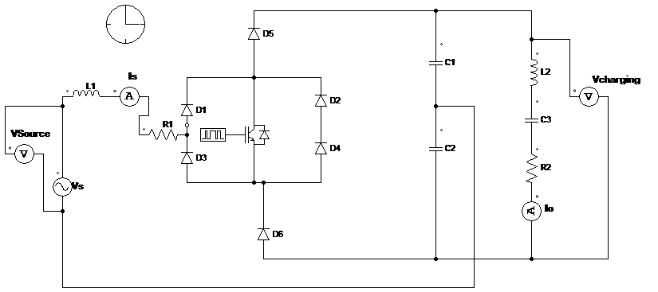

Figure 2.2: Circuit of Converter Topology -01 for EV charging

In this configuration, a power factor correction controller is employed to ensure a consistent output voltage and generate a sinusoidal input current. Nevertheless, the utilization of only one semiconductor switch and six diodes in this topology leads to a reduction in system efficiency [10,11]. One notable benefit is the limited voltage stress on each component, which translates to a reduction of half the total DC bus voltage during each interval. Through analytical approximations, the semiconductor's average and RMS current ratings have been computed. By integrating an inductor on the input side, converters of this kind can enhance both power quality on the input side and the DC output voltage [12, 13].

Converter Topology 2

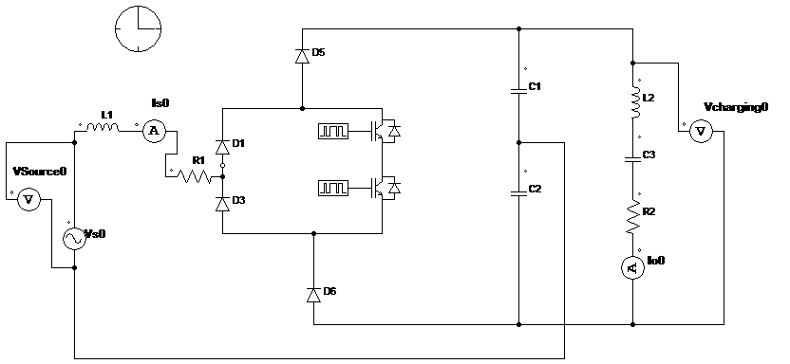

Figure 2.3: Circuit of Converter Topology -02 for EV charging

In Topology 2, the currents flowing through the freewheeling diodes, I D2 and I D4, as well as the capacitor surge current, I C, remain unchanged from Topology 1. However, the current through the MOSFET is divided between two separate MOSFETs. To alleviate the voltage stress on the switches, two capacitors are linked in parallel to help minimize losses within the switches.

Converter Topology 3

Topology 3 addresses the lack of inherent voltage regulation in both Topology 1 and Topology 2, which can lead to excessive voltage swell at the DC output. This drawback prompts the need for consistent voltage adjustments. Topology 2 manages voltage swell by employing two anti-parallel connected switches to regulate the voltage. In contrast, Topology 3 maintains the same freewheeling diode current as the others. However, it distinguishes itself by employing a switch composed of two MOSFETs. This distinction helps alleviate the voltage stress on the switches and reduces the circuit to only two diodes, minimizing diode losses.

This design modification contributes to reduced diode losses and lowers the switch rating, resulting in cost reduction and improved efficiency. In this topology, the switches are linked at the rear connection of the MOSFETs. During the positive half cycle, MOSFET S1 and the diode of S2 conduct, while during the negative half cycle, MOSFET S2 and the diode of S1 are in conduction.

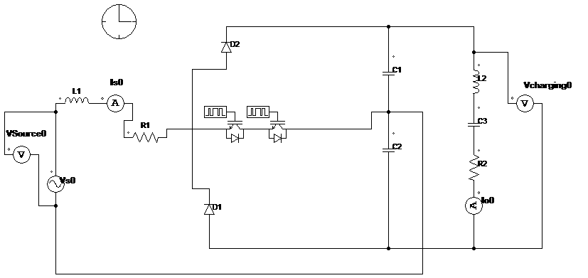

Figure 2.4: Circuit of Converter Topology -03 for EV charging

1. **Simulation Setup in PSIM**

To evaluate the performance of the proposed topology, PSIM software is used for detailed simulation. The following steps outline the simulation setup:

1. **Circuit Design:** Design the proposed topology circuit using PSIM software.
2. **Component Selection:** Select appropriate components such as switches, diodes, inductors, capacitors, and control elements.
3. **Parameter Setting:** Define the parameters for each component, including ratings, switching frequencies, and control methods.
4. **Simulation Configuration:** Configure the simulation parameters, including time step, total simulation time, and output variables.
5. **Control Scheme Implementation:** Implement proper control schemes such as PWM (Pulse Width Modulation) for switching control.
6. **Running Simulation:** Run the simulation and observe the results.
7. **Data Analysis:** Analyze the simulation data to evaluate the performance metrics such as efficiency, THD, voltage stress, and current ripple.
8. **Result & Discussions**

An evaluation of the three AC to DC Converter topologies was performed at a frequency of 40 kHz. Among these topologies, Topology 3 exhibited the best performance within the input voltage range of 200 V to 600. Beyond 200 V, Topology 1 experiences increased switching losses due to a higher number of switches. As a result, Topology 3 demonstrates superior efficiency compared to Topology 1, maintaining higher efficiency over a broad input voltage range. Additionally, Topology 3 has fewer switches than the other two topologies, which leads to reduced losses and consequently greater efficiency.

* **AC to DC Converter Topology-1**

The simulation results for Topology 1 demonstrate several key performance aspects. Firstly, the charging voltage reaches a stable value of 210 V, as depicted in Figure 4.1. This indicates that Topology 1 is effective in achieving the desired charging voltage under the given operating conditions. Furthermore, the load current, shown in Figure 4.3, has a pulsating DC nature. This characteristic of the load current can be mitigated by using active filters, which convert the pulsating DC into pure DC, ensuring a smoother and more consistent output suitable for sensitive applications.

Moreover, the ability to maintain a sinusoidal source voltage while keeping the THD at 6% highlights the efficiency of Topology 1 in minimizing power losses and ensuring stable operation. The use of active filters to convert pulsating DC to pure DC further enhances the overall performance of the rectifier, making it suitable for applications where a stable and clean DC output is required.

**Figure 4.1: Battery Charging Voltage of the Converter Topology -01**

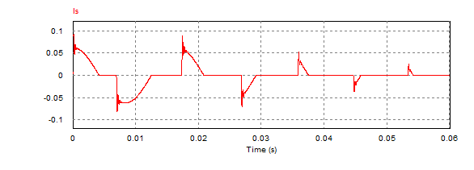**Figure 4.2.: Input Source current of the Converter Topology-01**

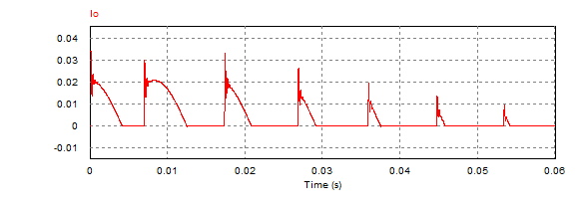**Figure 4.3: Output current of the Converter Topology-01**

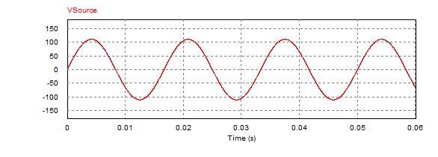**Figure 4.4: Source current of the Converter Topology-01**

The source voltage is maintained as sinusoidal, which is crucial for reducing electrical noise and ensuring the efficient operation of the rectifier. The input voltage's total harmonic distortion (THD) is measured to be 6% of the fundamental frequency as shown in figure 4.4. This level of THD is relatively low, indicating that Topology 1 produces a clean input signal with minimal harmonic interference, which is essential for maintaining power quality and reducing the potential for harmonic-related issues in the electrical system.

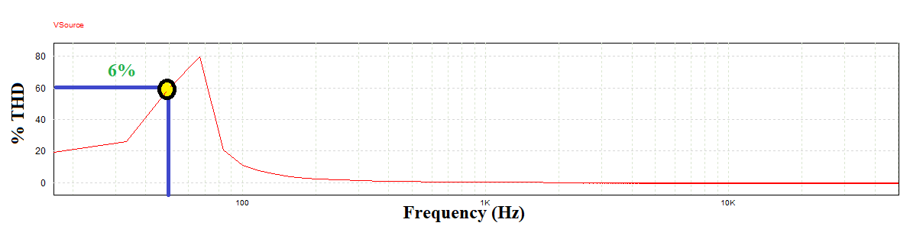**Figure 4.4: % THD of the Source voltage of Converter Topology-01**

* **AC to DC Converter Topology-2**

The simulation results for Topology 2 indicate that the charging voltage reaches 210 V, as illustrated in Figure 4.6. Additionally, the load current, depicted in Figure 4.8, exhibits a pulsating DC characteristic. This pulsating nature of the load current can be converted into pure DC by employing active filters. The source voltage remains sinusoidal throughout the simulation, and the total harmonic distortion (THD) of the input voltage is observed to be 6.4% of the fundamental frequency.

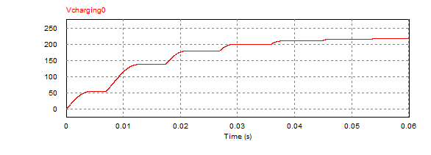**Figure 4.6: Battery Charging Voltage of the Converter Topology -02**

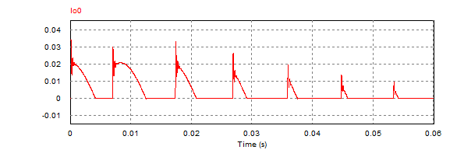**Figure 4.8: Output current of the Converter Topology-01**

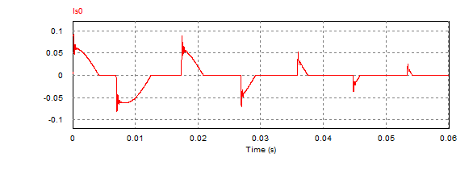**Figure 4.7.: Input Source current of the Converter Topology-02**

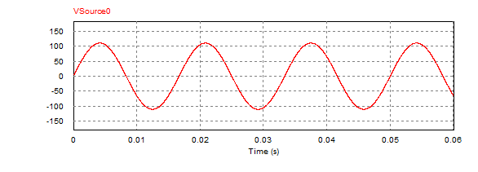**Figure 4.9: Source current of the Converter Topology-02**

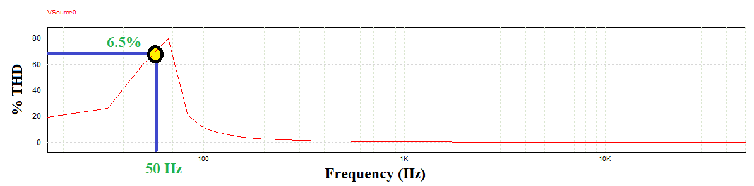

**Figure 4.10: % THD of the Source voltage of Converter Topology-02**

* **AC to DC Converter Topology-3**

The simulation results for Topology 3 indicate that the charging voltage reaches 210 V, as illustrated in Figure 4.11. Additionally, the load current, depicted in Figure 4.12, exhibits a more pulsating DC characteristic as compare to topologies 1 & 2. This pulsating nature of the load current can be converted into DC by employing filters circuit. The source voltage remains sinusoidal throughout the simulation, and the total harmonic distortion (THD) of the input voltage is observed to be 6.4% of the fundamental frequency.

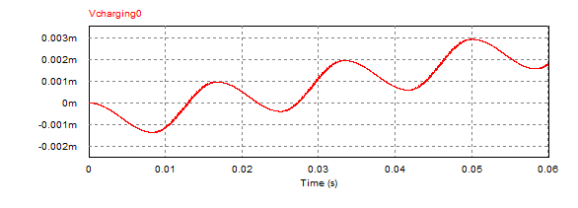**Figure 4.11: Battery Charging Voltage of the Converter Topology -03**

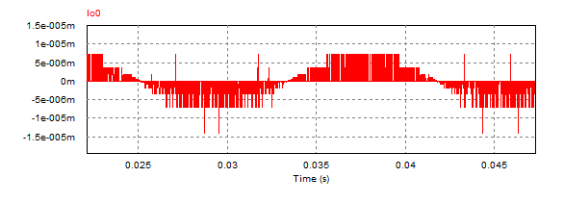**Figure 4.12: Output current of the Converter Topology-01**

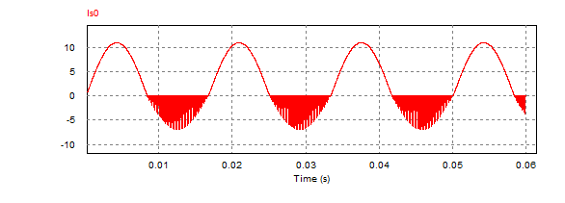**Figure 4.13.: Input Source current of the Converter Topology-02**

**Figure 4.14: Source current of the Converter Topology-02**

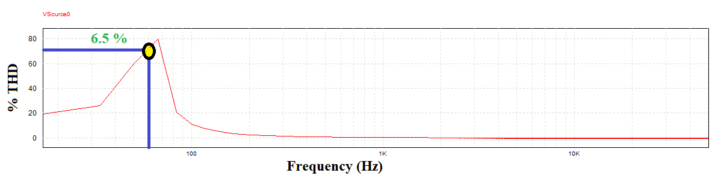**Figure 4.14: % THD of the Source voltage of Converter Topology-02**

1. **Conclusion**

The simulation of power converters for single-phase EV charging stations using PSIM software highlights the trade-offs between different topologies. Topology 1, while capable of handling high power, suffers from increased switching losses and reduced efficiency at higher voltages. Topology 2 offers a balanced approach with moderate complexity and stable performance across a wide voltage range. Topology 3, with its lower switch count, provides the highest efficiency and simplest design, making it the most favorable option for efficient and reliable power conversion.

**REFRENCES**

1. Burla, S., Dash, R., Shukla, S. P., & Dwivedi, A. (2023, September). Improved Gravitational Search Algorithm based Hysteresis controller for Grid integrated SPV system. In 2023 IEEE 2nd International Conference on Industrial Electronics: Developments & Applications (ICIDeA) (pp. 620-624). IEEE.
2. Chattoraj, J., Dwivedi, A., & Pahariya, D. Y. (2017). Enhancement of power quality in SAPS system with multilevel inverter. Int. J. Eng. Sci. Res. Technol., 6(5), 779-788.
3. Dwivedi, A. (2012). International Journal of Engineering Sciences & Management Benefits of Standalone Power Supply System. Int. J. of Engg. Sci. & Mgmt.(IJESM), 2(1), 62-65.
4. Dwivedi, A., & Pahariya, Y. (2017). Design and Analysis of 1.4 MW Hybrid Saps System for Rural Electrification in Off-Grid Applications. International Journal of Energy and Power Engineering, 11(11), 1143-1147.
5. Dwivedi, A., & Pahariya, Y. (2018). Design of Continuous Mode Hybrid Standalone Power Station with Hybrid Controller to Select the Best Optimal Power Flow.
6. Dwivedi, A., & Pahariya, Y. (2021). Design and analysis of hybrid multilevel inverter for asymmetrical input voltages. Journal of Electrical Engineering & Technology, 16(6), 3025-3036.
7. Dwivedi, A., & Pahariya, Y. (2023). Techno-economic Feasibility Analysis of Optimized Stand-alone PV and Hybrid Energy Systems for Rural Electrification in INDIA. Journal of The Institution of Engineers (India): Series B, 104(4), 911-919.
8. Gupta KK, Ranjan A, Bhatnagar P, Kumar Sahu L, Jain S (2016) Multilevel inverter topologies with reduced device count: a review. IEEE Trans Power Electron 31(1):135–151.
9. Luo H, Dong Y, Li W, He X (2014) Module multilevel-clamped composited multilevel converter (M-MC2) with dual T-type modules and one diode module. Journal of Power Electron 14(6):1189–1196.
10. Pradeep Kumar VVS, Fernandes BG (2017) A fault tolerant single phase grid connected inverter topology with enhanced reliability for solar PV. IEEE J Emerg Sl Power Electron 5(3):1254–1262.
11. Rajput, A.S., Dwivedi, A., Dwivedi, P., Rajput, D.S., Pattanaik, M. (2022). Read–Write Decoupled Single-Ended 9T SRAM Cell for Low Power Embedded Applications. In: Smys, S., Bestak, R., Palanisamy, R., Kotuliak, I. (eds) Computer Networks and Inventive Communication Technologies . Lecture Notes on Data Engineering and Communications Technologies, vol 75. Springer, Singapore.
12. Dwivedi, A., Moyal, V., Jhapte, R., Verma, S., Jain, A., Kumar, V., & Nigam, P. (2024). Intelligent Energy Storage System for Standalone PV Systems: Optimizing Battery Performance with Ultra capacitors. Library Progress International, 44(3), 13873-13882.
13. Dwivedi, A., Moyal, V., Jhapte, R., Verma, S., Chandrakar, M. K., Kumar, V., & Nigam, P. (2024). Design and Analysis of Modified AC to DC Converter Topology for Fast Electrical Vehicle Charging. Library Progress International, 44(3), 13883-13893.