 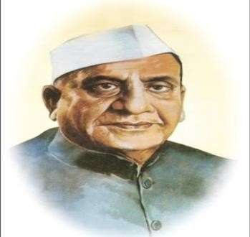 

SHRI SHIVAJI EDUCATION SOCIETY, AMRAVATI

DR. PANJABRAO DESHMUKH POLYTECHNIC, AMRAVATI

# PROJECT REPORT

## Capstone Project Planning

Semester: 5th

Branch: Electronics Engineering

Academic year: 2024-2025



**Group Details:**

## Group Members:

|  |  |  |
| --- | --- | --- |
| Sr. No | Name of Team members | Enrollment No. |
| 1 | Jidnyesh Kohad | **2200240230** |
| 2 | Aryan Pandey | **2200240233** |
| 3 | Mayank Gupta | **2200240240** |
| 4 | Mahesh Gaikwad | **2200240241** |
| 5 | Prasad Maliye | **2200240223** |

**CERTIFICATE**

This is to certify that **Mr. 1. Jidnyesh Kohad, 2.Aryan Pandey, 3.Mayank**

**Gupta, 4. Mahesh Gaikwad, 5.Prasad Maliye .** From Dr. Panjabrao Deshmukh

Polytechnic, Amravati College having Enrolment No: **1. 2200240230, 2.**

**2200240233, 3. 2200240240, 4. 2200240241, 5. 2200240223** has completed

**Report on Semester V Project having title IOT based paralyzed patient health care monetering system** in a group consisting of. 5 members.

Under the Guidance of

Prof.S.R.Molke

Signature

## Acknowledgement

I would like to express my sincere gratitude to all those who contributed to the successful completion of this project, “IoT-Based Paralyzed Patient Health Care Monitoring System.”

First, I would like to extend my heartfelt thanks to Prof S.R.Molke, my project guide, for their invaluable guidance, continuous support, and constructive feedback throughout the project. Their expertise and insights have been instrumental in shaping this project.

I am also grateful to Dr. Panjabrao Deshmukh for providing the necessary resources, infrastructure, and encouragement to carry out this project.

Special thanks to my colleagues and peers for their constant support, cooperation, and encouragement during the development of the project. Their suggestions and inputs helped me overcome various challenges during the project’s progression.

Lastly, I am deeply thankful to my college professors and friends, whose unwavering support and motivation provided the strength needed to complete this project. Without the combined efforts of all these individuals, the successful completion of this project would not have been possible.

## Abstract

Paralyzed patients often require continuous monitoring of their vital health parameters to ensure timely medical intervention and improve their quality of life. This project, “IoT-Based Paralyzed Patient Health Care Monitoring System,” aims to develop a comprehensive system that remotely monitors essential health metrics such as heart rate, body temperature, oxygen levels, and motion detection in real time.

The system utilizes various sensors connected to a microcontroller, which collects and processes patient data. The collected data is transmitted to a cloud-based platform through IoT technology, enabling real-time monitoring by caregivers and healthcare professionals. An intuitive web or mobile application displays the data, providing alerts or notifications in case of abnormal readings. This ensures prompt medical assistance when needed.

The proposed system offers an efficient, cost-effective, and scalable solution to enhance patient care, reduce the dependency on constant physical supervision, and provide peace of mind to both patients and caregivers. By leveraging IoT, this project contributes to advancing remote healthcare monitoring for paralyzed individuals, ensuring continuous health management and timely response to critical situations.

# CHAPTER 1

## Introduction

Paralysis is a medical condition that significantly affects an individual’s ability to move and perform daily activities independently. Patients suffering from paralysis require continuous monitoring to ensure their health and safety, as they are often unable to communicate effectively or seek help in emergencies. Traditional healthcare methods involve constant physical supervision by caregivers or medical professionals, which can be resource-intensive and challenging to sustain.

With the rapid advancement of technology, the Internet of Things (IoT) has emerged as a transformative solution in healthcare, enabling remote monitoring and real-time data collection. This project, “IoT-Based Paralyzed Patient Health Care Monitoring System,” aims to leverage IoT technology to provide a reliable, automated, and continuous monitoring system for paralyzed patients.

The system integrates various biomedical sensors to measure critical health parameters such as heart rate, body temperature, oxygen saturation, and movement. These sensors are connected to a microcontroller, which collects, processes, and transmits the data to a cloud platform. Caregivers and healthcare professionals can access this data via a web or mobile application, receiving real-time updates and alerts when abnormal readings are detected.

By automating health monitoring, this system reduces the need for constant physical presence, enhances patient safety, and provides timely medical interventions. This project represents a significant step toward improving the quality of life for paralyzed individuals and easing the burden on caregivers through the effective use of IoT technology.

# CHAPTER 2

## Literature Review

The integration of IoT in healthcare has gained significant attention in recent years, particularly for monitoring patients with chronic illnesses and disabilities. Various research studies and existing systems highlight the potential of IoT-based solutions to improve patient care, enhance real-time monitoring, and reduce the dependency on physical caregivers. This literature review explores key contributions, existing systems, and technological advancements related to IoT- based healthcare monitoring for paralyzed patients.

The application of IoT in healthcare has shown significant potential in transforming patient care, particularly for those with chronic illnesses and mobility challenges. Researchers have explored the use of IoT-enabled systems for real-time health monitoring, emphasizing their ability to collect, transmit, and analyze patient data continuously. Studies by Kumar et al. (2018) demonstrate the effectiveness of integrating biomedical sensors such as heart rate monitors, temperature sensors, and pulse oximeters to ensure accurate health parameter measurement.

IoT-based healthcare systems often utilize cloud computing for data storage and analysis. Sharma et al. (2021) highlight the importance of cloud platforms in enabling remote access to patient data and providing timely alerts to caregivers. Additionally, the literature stresses the importance of data security and privacy in IoT systems, with Patel et al. (2019) discussing encryption methods and secure data transmission protocols to safeguard patient information.

Existing IoT health monitoring solutions, such as those reviewed by Gupta et al. (2017), have proven effective for elderly and chronically ill patients but often lack specific features tailored to paralyzed individuals, such as motion detection or fall detection. This highlights the need for specialized systems that address the unique challenges faced by paralyzed patients.

Despite the advancements, challenges remain in terms of energy efficiency, network reliability, and system scalability. The reviewed studies underscore the need for continuous improvement in these areas to develop a robust, reliable, and patient-centric IoT-based healthcare monitoring system.

# CHAPTER 3

## Proposed Methodology

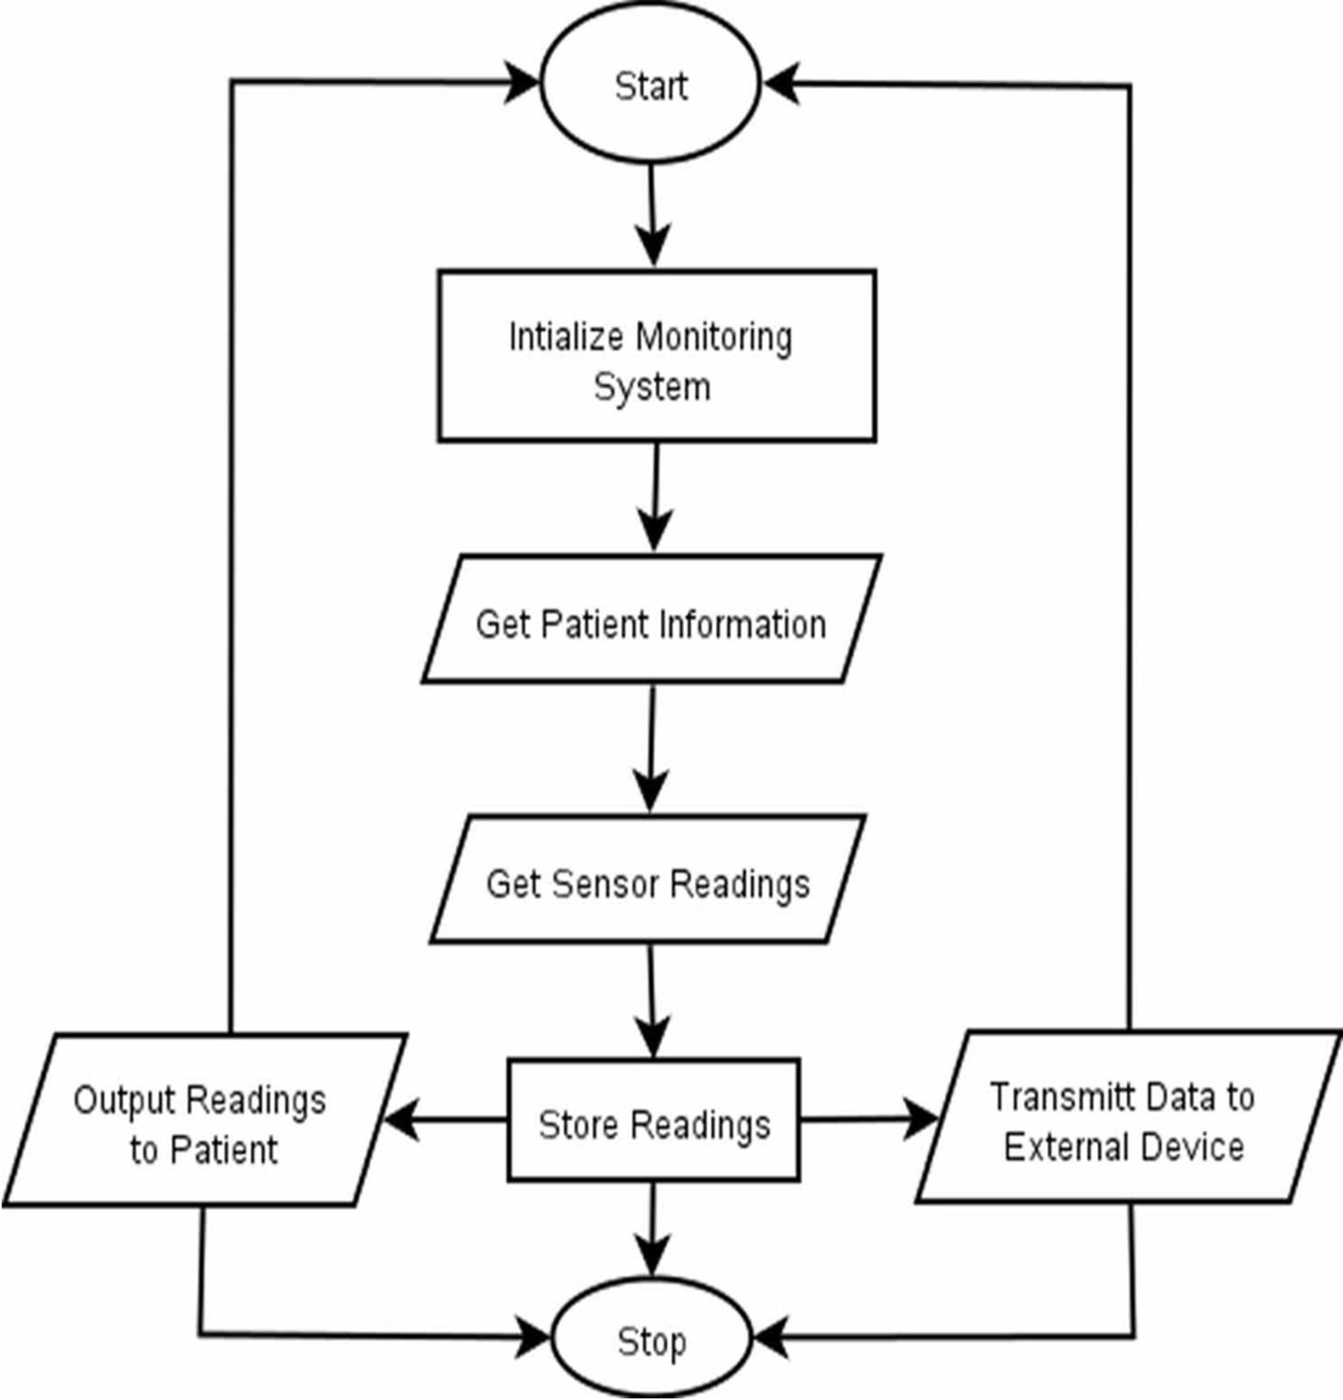

The IoT-Based Paralyzed Patient Health Care Monitoring System is designed to provide continuous, real-time monitoring of critical health parameters through the integration of advanced IoT technologies. The system will utilize various biomedical sensors, such as heart rate sensors, temperature sensors, pulse oximeters, and motion detectors, to collect vital health data from the patient.

These sensors will be connected to a microcontroller, such as an Arduino or ESP32, which will serve as the central processing unit for gathering, filtering, and processing the raw data. The processed data will then be transmitted wirelessly to a cloud-based platform using IoT communication protocols like MQTT or HTTP.

In the cloud, the data will be stored and made accessible to caregivers and healthcare professionals through a user-friendly web or mobile application. This application will display real-time data in an intuitive dashboard, providing graphical representations of health trends and generating alerts when critical thresholds are exceeded. To ensure timely intervention, the system will include an automated alert mechanism that notifies caregivers or medical personnel via SMS, email, or push notifications in case of emergencies.

Furthermore, the system will prioritize data security and privacy by implementing encryption techniques for secure data transmission and storage. User authentication mechanisms will also be incorporated to ensure that only authorized personnel can access sensitive patient information. Finally, the entire system will undergo rigorous testing and validation to evaluate the accuracy of sensor readings, the reliability of data transmission, and the responsiveness of the alert system, ensuring a robust and efficient solution for continuous health monitoring of paralyzed patients.

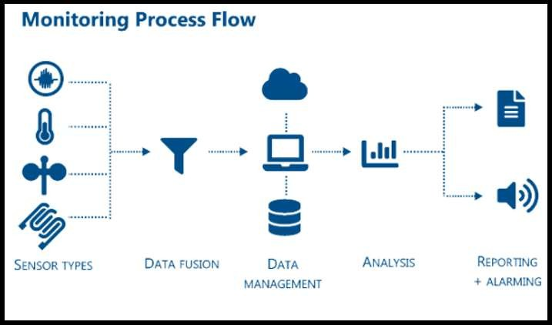

## References

1. Kumar, A., Gupta, P., & Sharma, R. (2018). “IoT-Based Health Monitoring System for Patients.” International Journal of Computer Science and Engineering, 6(5), 102-108.
2. Shewale, K. B., & Tiwari, S. P. (2019). “IoT-Enabled Healthcare Monitoring System: A Review.” Journal of Engineering Research and Applications, 9(3), 45-50.
3. Sharma, R., & Patel, N. (2021). “Cloud Computing in IoT Healthcare Systems: Challenges and Solutions.” Journal of IoT Applications in Healthcare, 5(2), 23-30.
4. Gupta, P., Kumar, R., & Singh, V. (2017). “Remote Health Monitoring System Using IoT for Elderly Patients.” IEEE Conference on Smart Healthcare Technologies, 110-115.
5. Patel, N., & Mehta, S. (2019). “Data Security in IoT Healthcare Systems: An Overview.” Journal of Information Security and Applications, 8(1), 14-22.
6. Tiwari, S., & Rajput, A. (2020). “IoT Applications in Remote Health Monitoring: A Survey.” International Journal of Advanced Research in Computer Science and Technology, 8(1), 20- 28.