REVIEW ON USE OF 3D PRINTING IN TRANSPORTATION INDUSTRY
Utkarsh Kumar

PG Student, Department of Civil Engineering, Galgotias University, Greater Noida, Uttar Pradesh, India Email: utkarshkumar071@gmail.com

ABSTRACT

3D printing, unlike other manufacturing processes, being an additive process has emerged as a viable technology for the production of engineering components. The aspects associated with 3D printing such as less material wastage, ease of manufacturing, less human involvement, very less post processing and energy efficiency makes the process sustainable for industrial use. The paper discusses numerous 3D printing processes, their advantages and disadvantages. A comprehensive description of different materials compatible for each type of 3D printing process is presented. The paper also presents the various application areas of each type of process. A dedicated section on industry 4.0 has also been included. The literature studied revealed that although the field of 3D printing has evolved to a great extent, there are still issues that need to be addressed such as material incompatibility and the cost of the materials. Future research could be undertaken to develop and modify the processes to suit a broad range of materials. To broaden the range of applications for 3D printed parts, more focus needs to be laid on developing cost effective printer technologies and materials compatible for these printers.

Keywords:

Introduction
The construction industry has been one of the least technologically advanced industries in the world, characterized by slow, labour-intensive, and time-consuming processes. However, recent advancements in 3D concrete printing have opened up new possibilities for faster, more precise, and more sustainable construction practices. Traditionally, constructing a building or infrastructure involves multiple stages, including designing, procuring materials, and assembling. This process is time-consuming and labour- intensive, and the construction industry has been plagued with delays, cost overruns, and safety concerns [1], [2], [3], [4]. Although, 3D printing technology can potentially revolutionize the construction industry by significantly reducing the time and labour required to build structures. One of the key benefits of 3D printing in construction is the speed and precision of the process. Unlike traditional construction methods, which require manual labour, 3D printing technology can create complex and intricate shapes with incredible speed and accuracy. This can result in faster construction times, reduced labour costs, and more efficient use of resources [5], [6], [7], [8]. The 3D printing technology can reduce the waste generated during construction, thus making the process more sustainable. Traditional construction methods often result in a significant amount of waste, as materials are cut to size and assembled on-site [9], [10], [11]. In contrast, 3D printing technology can reduce waste by producing building components with greater precision, using only the necessary amount of material. Additionally, 3D printing technology can use sustainable materials, such as recycled plastic or biodegradable materials, which can reduce the carbon footprint of the construction industry [12], [13], [14]. Furthermore, 3D printing technology has the potential to revolutionize the design and functionality of structures. With 3D printing, it is possible to create intricate and complex designs that would be difficult or impossible to achieve using traditional construction methods [15], [16], [17], [18]. 3D printing technology allows architects and engineers to develop strategies that incorporate curves, angles, and intricate details, leading to visually stunning and functional structures. Four examples of vertical 3DP in architecture.

Fig. 1 represents four applications of vertical 3DP, including (a) an in-situ wall with a shell and fills application, (b) a solid geometry component, (c) a panel component, and (d) in-situ walls and columns. 3D printing technology, stemming from layer-by-layer fabrication of 3D structures based on computer- aided design (CAD) drawings, has emerged as an innovative and versatile technology platform[26].

It offers promising opportunities for companies seeking to enhance manufacturing efficiency and can print various materials, including thermoplastics, ceramics, graphene-based materials, and metals [27]. The adoption of 3D printing technology has the potential to revolutionize industries, enabling faster production and cost reduction. Moreover, it gives consumers more significant input in the final product, leading to customized specifications. With manufacturing facilities closer to consumers, the process becomes more flexible, responsive, and quality-controlled while reducing the need for global transportation through fleet tracking technology, thus saving energy and time [28]. This technology finds wide applications in agriculture, healthcare, automotive, and aerospace industries, fostering mass customization and open-source designs [29].

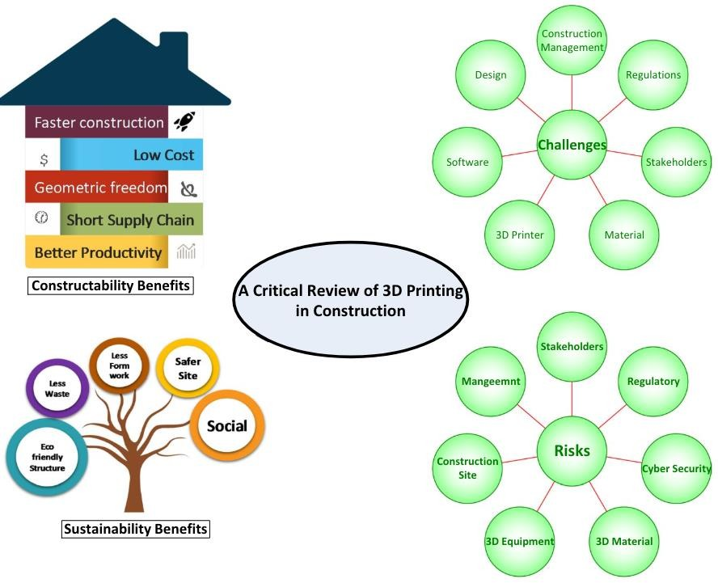

Types of processes in 3D printing
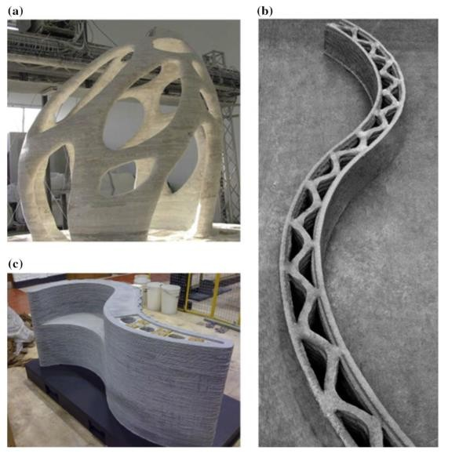
In order to satisfy the need for printing intricate models with high resolutions, methods of AM have been developed. Rapid Prototyping has played an important part in the advancement of AM technologies. AM Technologies are based on three main types which are sintering whereby the temperature of the material is raised without being liquified to compose complex sharp resolution prototypes, melting- where electron beams are used to melt the powders and stereo lithography which uses a method referred to as photo polymerization, which uses an associate ultraviolet laser. This laser is dismissed over a photopolymer resin vat so that torque-resistant ceramic components are ready to encounter utmost temperatures [2]. As per ASTM (American Society for Testing and Materials), AM have been divided into seven processes which include VAT Photo polymerisation, Material Jetting, Binder Jetting, Material Extrusion, Powder Bed Fusion, Sheet Lamination, and Direct Energy Deposition [3]. Some of the main methods have been addressed in depth in the subsequent sections focusing on the work involved in each process, benefits and drawbacks, materials used in different processes, and applications of various 3D printing processes.
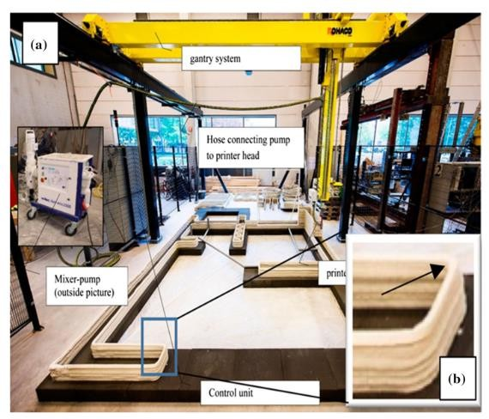

Stereolithography (SL)

Era of 3D printing started in the late 20s and SL is the earliest 3D printing process ever introduced in the market and the first ever 3D printers set in motion were stereolithographic/ SL machines that were used to manufacture 3D models, 3D prototypes, 3D parts and patterns. Although many studies in the area of 3D printing were conducted in the 1970s, this process was introduced and patented by Charles Hull in 1984 [4]. Before defining the term Stereolithography, one needs to understand how the SL process works. To begin the process, a CAD file is generated on the system and this file is converted into STL file type. This STL file type provides the geometric data required by a 3D printer to manufacture an object. The four main parts which contribute to the formulation are ultraviolet (UV) curable photopolymer liquid, perforated table, laser source, and a computer to control the process. After reading the STL file type, 3D printers start working in such a way that the perforated table gets immersed in the liquid tank. As the table moves downwards, the liquid polymer encounters the table through the perforated holes. The instant the liquid comes in contact with the table, the UV laser hits the upper surface of the photo liquid polymer making it hardened instantly. This table then again moves downward, to create a layer-by-layer geometry and each consecutive layer is fused starting with the base layer. After the completion of the last layer, the 3D printed part is immersed into another resin so that the 3D printed model gets separated from the liquid polymer. After this process, the bonding between all the layers gets strong in that particular resin and this 3D printed model is now allowed to bake in a UV curing oven. Inside this oven, at the predetermined temperature, all the layers harden up, strength increases, and the desired surface finish is obtained. Thus, all these processes finally lead to the finished object.

  - Fused deposition modelling (FDM)

FDM is a procedure that uses thermoplastic filament that has been parched to its melting point and then thrust out layer upon layer toform a 3D object [5,50]. FDM technology was introduced by Scott Crump during the early Nineteen Nineties by Stratasys INC, USA introduced this. The 3D printers used for FDM contain a support base that is related to some degree of freedom and it has an arrangement such that it will move in a vertical direction. Aboard with the bottom plate, there’s an associate extruder that connects the filament and is liable for heating of the filament up to its freezing point and so extrudes it layer by layer with the assistance of a nozzle to form the required object. The extruder has the supply to maneuver in all three directions (x, y and z). The reason that it’s called fused deposition modeling is that the adjacent layers get consolidated to one another whereas deposition is completed by the extruder and therefore the 3D printer is liable for modeling of the item [57]. Counting on the surface end needed, the ultimate product is dipped in resin as similar in the SL method. the layers harden up, strength increases, and the desired surface finish is obtained.

  - Binder jetting (BJ)

Binder Jetting uses a modified version of Inkjet technology. Massachusetts Institute of Technology (MIT) introduced this process [9]. Instead of using lasers to bind this process, it uses an inkjet to bind the objects. It uses a 2D printer technology in inkjet and goes up in layers forming a 3D project. In this process, with the help of a printhead, moving on two axes, a liquid binder is precisely deposited. This process also begins like any other 3D printing process, that is by creating a 3D drawing and then importing it into printer software. Since constant supply is required during printing, thus, a dispenser ensures that supply by placing powder in it that is to be used. Following the application of a powder sheet of varying thickness, the printing head attaches the binder according to the specification. Before continuing onto the subsequent layer, the solvent containing the binder is desiccated using fluorescent or electric lamps. After that, the powder bed is de-escalated and a new sheet of powder is applied. The binder is then placed in a furnace after the completion of the cycle.
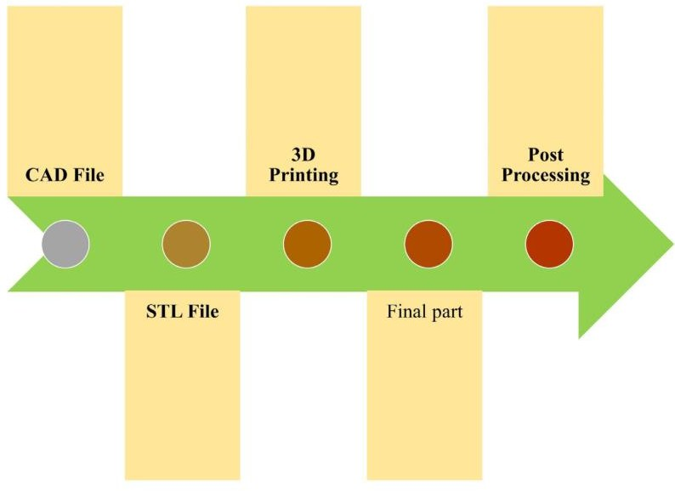
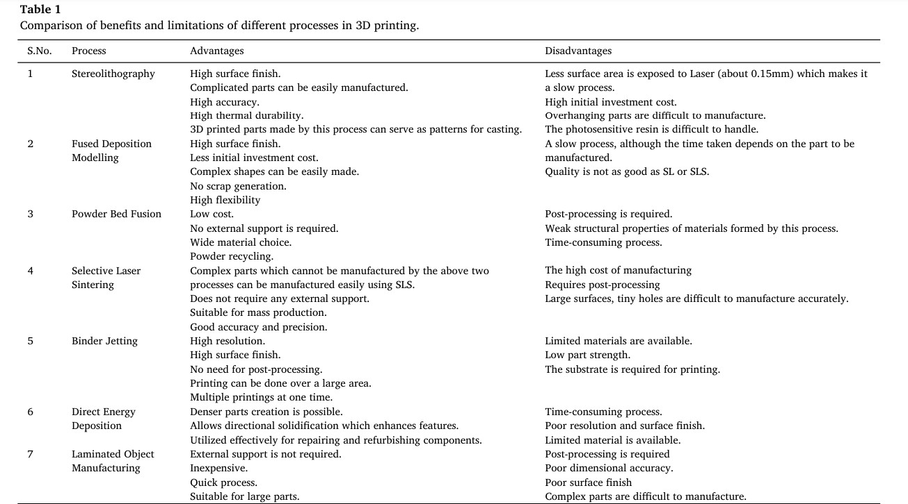

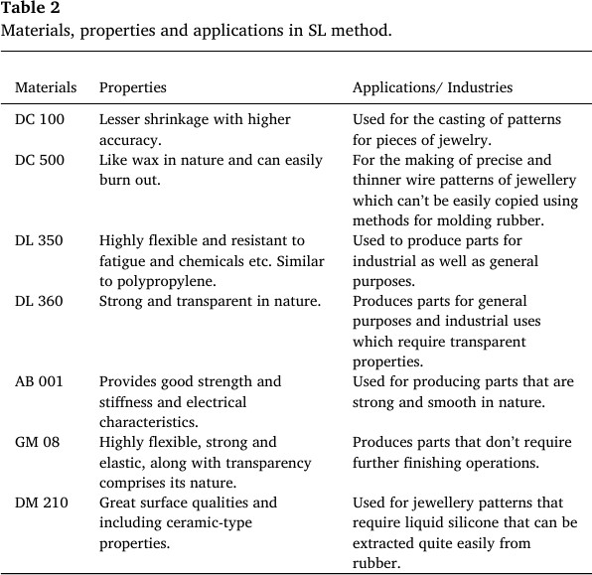

Applications of 3D printing
Each of the processes discussed so far is of utmost use to achieve the manufacturing of products in the least possible time with minimum wastage. Also, the processes aid in forming complex structures with supreme quality at enormous ease. Industries are being modernized and revolutionized with the help of 3D printing. The mode of manufacturing is gradually shifting from traditional to non-conventional processes (3D printing). It requires intensive knowledge of materials and their respective properties.
With the current knowledge of materials and processes, some modifications have been done in the traditional techniques using 3D printing.

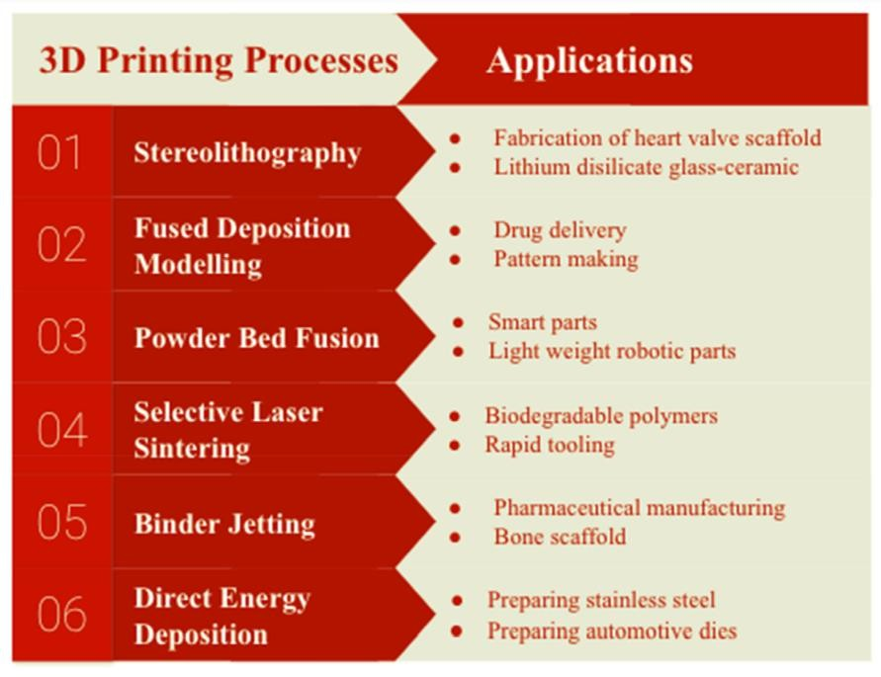

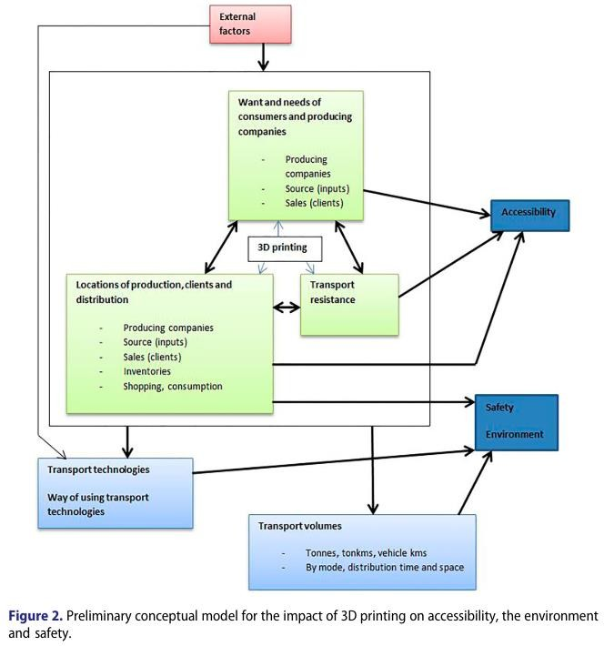

Challenge to Transportation
3D printing will offer numerous opportunities to provide new approaches and solutions to existing transportation issues, while also providing efficient ways to work and develop projects. At the same time, the technology is likely to pose many challenges to the way transportation agencies plan and conduct their business. For example, timeframes for decision-making and planning horizons will shrink.
Transport patterns are likely to shift and the 20 to 30 year transportations plans could be substantially obsolete quickly. Additionally, the shifts in transportation logistics could seriously affect the need for and the financing of major port and intermodal capital projects dependent on increasing overseas supply chain goods and traffic. These circumstances will require transportation decision makers to be agile and decisive.

Materials Used In 3D Printing
The materials used in 3D printing should have certain specifcations to be compatible with the technology. Research shows that the most common materials used in 3D printing are: cementitious materials, polymer materials, and metallic materials [14, 52]. Fused deposition modeling (FDM) or fused flament fabrication (FFF) focus on printing objects through melting of polymer [53]. Polymer materials are usually used for aesthetic purposes because of its lack of structural properties. This material will provide a low-risk option for implementing additive manufacturing technology in construction [14]. The most popular polymer base printing materials are ABS (Acrylonitrile Butadiene Styrene) and PLA (Polylactic Acid). They both are thermoplastic polymers, which means that they melt at high temperatures and go back to a solid state after cooling down [53]. PLA is considered to be more sustainable than ABS since it is biodegradable [10]. Metallic properties are also popular as a construction material; however, 3D-printed structures that consist of only metallic materials are quite heavy. Cementitious materials are the most used material in the technologies mentioned earlier, such as contour crafting and concrete printing. The concrete used in 3D printing should be a high-performance concrete. Le et al. [54] stated that a highperformance concrete has been developed that can build architectural and structural components without formworks. The World’s Advanced Saving Project (WASP) has created a 3D-printed house using earth materials. The materials used raw soil, straw, rice husk, and lime. The total cost of the materials used in the house amounted to 900 euros [53]. Quality and specifcations play a major role in determining the efectiveness of concrete. There are four properties to ensure a successful 3D-printed structure:

Pumpability, which is defned as the ease in which the material is pumped through the 3D printers pump ;
- Printability or extrudability [55], which is the ease inwhich the material is pumped out of the nozzle of the printer;
- Buildability, which is the resistance to deformation of the deposited material under load, and
- Open time, which is the period where the pumpability, printability, and buildability are at an acceptable range[14,16].

On top of these properties, other factors afect the successful printing of concrete. The printing speed afects the properties of the printed concrete and would determine whether there are weak joints between the layers. Similarly, the printing direction would afect the overall concrete properties [56]. As for the concrete mixes that would be compatible with 3D printing, Ghafar et al. [26] state that printable materials are usually a mix of bulk materials, such as soil or crushed stone, mixed with Portland cement or fly ash, and workability additives. Additionally, Lim et al [16] state that a high-performance cement-based mortar has been developed. The composition of the mortar consists of sand, reactive cementitious compounds, and water. A study performed on high-performance printing concrete showed that the optimization mix consisted of cement, fy ash, and silica fume [57]. Another study performed regarding the concrete mixes used for 3D printing concluded that the types of aggregates that were able to be printed successfully included an adequate number of river sand and combination of river sand and limestone-based concrete mixtures [58]. However, it was determined that most of limestone-based mixtures were not printable.
Moreover, the mix with the highest strength levels was obtained for the river sand and limestone mixture [58].
Another aspect of the material to take into consideration is the reinforcements. This is an important factor to ensure that the structure does not collapse. Reinforcement remains one of the challenges of 3D printing in construction. One method of reinforcement of 3D-printed structures is placing the reinforcing steel bars manually between the layers before or during printing [25]. However, this method is challenging since the steel rebar creates an obstacle for the movement of the printer head. As a solution, a hollow structure can be printed and the rebars can be installed afterward with inflled concrete to connect the steel reinforcement with the printed structure [59]. Reinforcing 3D-printed structures with steel, however, alleviates the automated luxury introduced by the technology, since a considerable amount of labor is needed [29].

The steel reinforcements also increase construction time and cost [60]. Another method of reinforcing that is more suited for 3D printing is by using fber-reinforced concrete, instead. This method would fully automate the process and ofers greater geometrical accuracy, reduced manufacturing time as well as a decrease in labor cost [25]. An ultra-high-performance fber-reinforced concrete, which is reinforced with steel fbers, has been developed. A study conducted using this type of concrete has been found to have favorable characteristics and therefore satisfes the requirements of most structural applications [61]. This type of concrete has been reinforced with steel. however, other fbers, such as glass or carbon fibers can also be used for reinforcement[25]. Current standards in the building and construction industry are not suited for the new materials and technology as per the specifications.
With the introduction of fber-reinforced concrete in the application of 3D printing in construction, certain codes and standards are needed. Current standards in the building and construction industry are not suited for the new materials and technology [25]. Guidelines should be developed for the steel reinforcements in regard to the bonding between the rebars and the printed structure. Design codes should also be developed for the fber-reinforced concrete, in particular, the mix ratio to ensure that the structure.

BENEFITS OF 3D PRINTING IN CONSTRUCTION

3D Printing in construction is a new technology being implemented, therefore there are still uncertainties in its application. However, it is a promising new technology and has many potential benefts. The benefts may be categorized into two groups: constructability and sustainability. Figure 10 shows the groups and their corresponding benefits, whereas on the other hand Table 1 shows the main benefts along with their sources.

CONSTRUCTIONALITY BENEFITS

    - Faster Construction
Time is an important factor for any construction project. Reducing construction duration adds many benefits to clients such as starting the operations phase and generating revenues early, and reducing overhead costs and releasing resources for other projects. 3D printing provides the ability to construct faster. The speed of construction is much faster than traditional methods [3, 10, 72]. As mentioned in Sect. 2.5, a house can be printed in 24 h. This would increase the scale of construction and will aid in mass production. Many advantages are ofered by automated building construction, such as superior construction speed and higher degree of customization [13]. Construction time can be greatly reduced using 3D printing technologies. For example, the printing time for a structural wall was reduced to 65 h from 100 h by 3D printing.

Lower Cost

3D printing reduces the cost of construction [17, 71, 72]. The cost of construction elements is reduced as well as the cost of transporting materials and storing them [3, 10]. Since the machine only requires one operator, the cost of labor is decreased. In the case of the 3D-printed office in Dubai, the laborers involved were seven workers to install building components, ten electricians, and specialists to handle the MEP and one worker monitored the printer. The labor cost of this office was 60% lower than traditional buildings of the same size [69]. Less labor-intensive operations in multiple segments of the Building and Construction industry was also noticed [48]. In addition to reduction in labor cost, 3D printing results in reducing the formwork installation and removal costs. Supervision cost will also be reduced as the number of site engineers, among others, will be reduced. Additionally, faster construction will reduce the indirect cost.

More Geometric Freedom

The technology allows for more geometrical and design freedom than traditional methods [17, 72]. Designing and constructing structures that would not be possible by other means is one of the advantages that spur interest in the technology [75]. The 3D-printed house in Denmark by 3D Printhuset mentioned earlier was built without straight lines, except for the doors and windows, to show the extent of the geometrical freedom. It is very easy to print the high-cost curved buildings that are hard to build in other ways. Thus, architects may have an open mind and make breakthroughs in the design process. Meanwhile, this helps realize the integration of architecture and arts [52]. The 3D printing process enables developers to design structures that are difcult to produce using the current manual construction practice [17, 76].

Shorter Supply Chain

3D printing allows shrinking the supply chain. By printing objects on demand, 3D printing eliminates lead time of materials that need expedited delivery [14]. This process hence increases productivity that would have been decreased by late deliverables [14]. Using raw earth materials also eliminates lead time of materials hence shortening the supply chain. AM of construction materials has been one of the emerging advanced technologies that aim to minimize the supply chain in the construction industry through autonomous production of building components directly from digital models without human intervention and complicated formworks [26].

Improve productivity

Construction automation has shown the potential to increase construction productivity [77]. AM is seen as a way of addressing construction productivity challenges [14]. The construction sector is under increasing pressure to improve its efciency and efectiveness, reducing environmental impacts, material use, and costs [43].

Sustainability Benefts

    - Sustainable and eco-friendly structures

Implementing 3D printing in the construction industry will be sustainable and economically friendly [10, 72]. One of the reasons that it is eco-friendlier than traditional methods. is the reduction of waste. Moreover, the concrete mix used in the 3D-printed house in Denmark contained recycled materials such as tiles and the walls were insulated with recycled cellulose fber [71]. Moreover, the potential of using low impact materials such as raw earth materials and geopolymers adds to the sustainability of the structures. Perrot et al. [80] assessed the possibility of printing structures using earth materials. The carbon emission of geopolymers production is 80% less than Portland cement production [82]. CyBe [72] also claims that with 3D printing, the CO2 emissions are reduced. This results in a signifcant decrease in the energy consumption in construction and an improvement in the production efciency [52].

Less waste

The 3D printing technology reduces the amount of waste produced during construction [17]. Since the technology is a type additive manufacturing, the materials used are ftted to the output produced and therefore produce virtually zero waste [75]. Furthermore, 3D printing uses raw materials like sand that can be recycled and re-used [26]. It is estimated that 3D printing saves 30–60% of construction waste [28]. Wet construction processes are minimized, so that building erection process generate less material wastes and dust compared to traditional methods [10]. It provides a resourceefcient construction sector with lightweight structural components, which will help in reducing waste generation, emissions and global resource consumption [43, 83]. As only the required amount of materials will be needed, the printing process will eliminate unnecessary waste of materials, thus reducing the environmental impacts of the production/construction process [17].

Reduced formwork

Camacho et al. [14] also mentioned reduction in formwork as another beneft of AM. This process, which is needed in traditional construction, is eliminated, and hence the wastes that would have resulted from those formworks are disregarded. With AM construction, the structure is directly molded and formed on-site, without the need of wooden forms that regular concrete requires [50]. Reducing the use of formwork has an environmental impact as it reduces the amount of wood and therefore trees’ use [14].

5.2.4.Safer sites

Safety is a major concern in the construction industry because fatalities and injuries from construction work bring great losses to individuals, organizations, and societies as a whole [84]. 3D printing reduces the number of injuries and fatalities onsite as the printers will be able to do most of the hazardous and
dangerous works [10]. This beneft is because 3D printing allows for automation of the construction process. AM could provide services to the construction industry by reducing exposure of on-site workers to harsh environments and by automating some of the construction tasks [14].

Challenges of 3D printing in construction

The previous section discussed the several benefts of 3D printing in construction. As with any disruptive technology, 3D printing has several disadvantages. Social disadvantages include the negative efect on the existing construction workforce. 3D printing will reduce the need for large numbers of construction workers. Although this is considered a beneft as it reduces labor cost, it is also a disadvantage to those workers whose jobs will be at risk. That may create social problems in some communities that rely on construction activities. The quality of the fnal product also may be considered a disadvantage. The surface quality could be rough due to the printing process. At the current state of technology, 3D-printed buildings might not live up to the expectations of end users due to its design and material limitations. The size of the design is strictly constrained by the chamber volume of the 3D printer. Currently, 3D printing is not suitable for larger-scale projects. There are also geometrical limitations where the printer is restricted by specifc possibilities. Another disadvantage is the cost, and currently, it is expensive to construct using 3D printing. The initial equipment cost may be prohibitive. The transportation cost of the printer is both challenging and expensive. One of the disadvantages is the material being used. The concrete should be workable to pass through the nozzle of the robot, this would require a specifc type of concrete which might have lower quality and high costs. The limited availability of suitable material is considered a disadvantage. The disadvantages of requiring special material to be used in 3D printing are discussed further in the material- related challenges section. Implementing and advancing the use of 3D printing in the construction industry is still in its infancy stage and faces a number of challenges.

6.1Material-related challenges

This group includes the challenges that are related to the construction material such as printability, buildability and open time. The desired concrete for 3D printing requires certain specifcations that are diferent from traditional construction; therefore, new materials have to be used in construction, because of the new technology requirements [10].

Printability

Printability refers to the ability of the material to be pumped and printed. Lim et al. [16] defned pumpability as the ease and reliability with which material is moved through the delivery system, and printability as the ease and reliability of depositing material through a deposition device. The material has to have the right consistency to be able to be pumped out of the nozzle of the 3D printer [17]. If the material is too hard, pumping it through the pipe to reach the nozzle would be hard and energy-consuming, and if the material is too soft, the precision for placing the material would not be accurate and would collapse easily. The workability and the mix proportion of concrete plays a major role in the pumpability and printability of concrete [27]. To be considered good quality, the material must have the desired printability, to be able to
be extruded from the nozzle, and buildability, to be able to maintain its shape [17, 57, 58].

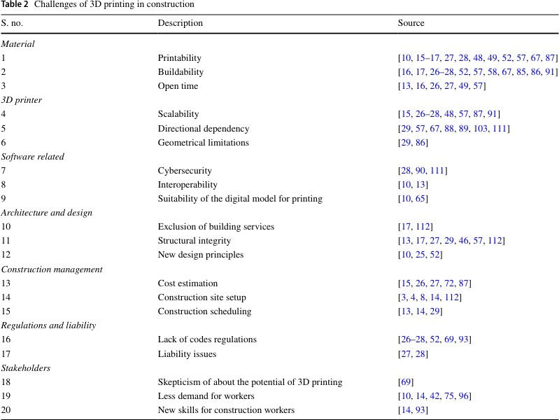

Buildability

Lim et al. [16] defned buildability as the resistance of deposited wet material to deformation under load. The material should be quick hardening to be used in 3D printing [17]. Indeed, if the material needs an extended time to harden, it would collapse and would not hold its shape. 3D printing also has high requirements for construction materials. Due to the high speed of 3D printing, the materials have to solidify very quickly. Traditional construction materials fail to meet this need, and a special R&D job is required [52]. In addition, the concrete should bond together to form each layer and have sufcient level of
buildability to enable it to lie down correctly, remain in position, and be stif enough to support further layers without collapsing [17, 57]. Hence, the concrete has to support itself as it cures [85]. Because the material is extruded in a wet state, the build-up of layers must be in a manner such that they are self-supporting in order to avoid collapse, imposing somewhat of a restriction on possibilities for realizing some geometries [86].

Open time

Lim et al. [16] defned open time as the period where the printability and buildability are consistent within acceptable tolerances. Extrusion works particularly well when it is performed continuously, but problems such as overprinting (too much material deposited) arise when the material fow is interrupted and under- printing (a pause in deposition that does not coincide with nozzle movement) when restarting [16].

3D-printer-related challenges 7.1.Scalability
Scalability is a problem common to most existing 3D printing processes, where the size of the design is
strictly constrained by the chamber volume of the 3D printer. This issue is more pronounced in the building and construction industry, where it is impractical to have printers that are larger than actual buildings [48]. 3D printing also faces a challenge since the technology is not ready for large-scale projects. Another issue is that automated construction is not suitable for large scale products [87]. Most existing 3D printing systems for building and construction are based on a gantry, which can only print structures whose sizes are at most as large as that of the gantry itself. Some arm-based systems have been demonstrated; however, the reach of the robotic arm limits the sizes of the printed structures [48]. Cablebased robots are proposed as an alternative to Gantry robots [39]. These robots are easier to install and less costly than Gantry robots; however, their control is relatively complex.

Directional dependency

Directional dependency is believed to be an attribute of layered manufacturing process, hence 3D printing [88]. The printing direction has a major infuence on the load-bearing capacity and strength properties of the material [89]. Most 3D-printed geometries require a flament to be linear deposited. Filament has a direction, and therefore creates the issue of directional dependency [29]. Compared to traditional construction that uses cast iron, the printed specimen has mixed isotropic and anisotropic properties in diferent directions, whereas cast specimens have isotropic properties in all directions.

Geometrical limitations

Although 3D printing provides geometrical freedom, it also has its limitations. 3D printing seems to imply that a CAD fle can be produced independent of process planning; however, this is not true for 3D concrete printing. The method of printing is limited by specifc geometrical possibilities [29]. One example of a geometry not achieved with 3D printing that can be achieved by traditional methods is straight edge corners. Moreover, the obtained dimensions have some errors compared to the ideal ones set in the CAD model. These errors can have several sources, where the accuracy of the robot system is the main one.

Risks of 3D printing in construction projects

Although the use of the new technology may reduce some construction risks due to the reduction of the number of construction workers, it may bring additional risks. As discussed in Sect. 4, there are several challenges related to the use of 3D printing. These challenges can create risks for the construction projects. The risks may be categorized into seven groups: 3D printing material, 3D printing equipment, construction site and environment, management, stakeholders, regulatory and economic, and cyber security risks. shows the main risks along with their sources.

Discussion and conclusions

Current literature on 3D printing and transport studies does not provide a systematic model of the impact of 3D printing on transport and related (policy relevant) areas such as traffic safety, location decisions, accessibility, environmental effects, infrastructure needs, welfare, income, employment, consumption patterns and satisfaction (Frazier, Citation2014).
3D printing is likely to be a game changer for transportation and the agencies that support it. We are at the cusp of 3D printings’ global implementation. The technology will affect all aspects of transportation be it planning and management, maintenance and operations, capital development and finance, or human resources and legal. Transportation systems will be changed, many seriously. Understanding the technology and its impact on our transportation now is critical to making near term and future business and capital decisions. 3D printing can issue in creativity. the main conclusions are as follows:
- 3D printing has the potential to revolutionize the construction industry. 3D printing, along with advances in Industry 4.0, has a high potential to lead to a more efficient and sustainable construction.
- Despite the major advances in 3D printing technology, as reported in the literature, the application of 3D printing in construction is still in the infancy stage. There is a long way for it to reach its potential and warrant a widespread implementation. Research is still underway in several areas especially in the robotic and material aspects.
- The main challenge is adapting the robotic system to large scale construction projects such as villas and high-rise building. Normally, the robotic system is tailored to small and confned workspace. In construction, the robotic system needs to be adapted to a larger and more open workspace.
- 3D printing requires specifc material properties. Most reviewed research focused on meeting the constraints of the 3D printer. However, more research is needed to meet the design and strength constraints in addition to the 3D printer constraints.
- The limitations of the 3D printer technology, the quality of the fnal product, and the complexity of the construction process are the main reasons for the low adoption rate of 3D printing in construction.

3D printing will defnitely be part of the future of the construction industry. However, several challenges still need to be addressed before 3D printing can become a viable solution

REFERENCES

- Gerbert P, Castagnino S, Rothballer C, Renz A, Filitz R. The transformative power of building information modeling, March 08, 2016 Boston Consulting Group. 2016. https://www.bcgpe rspectives.com/content/articles/engineered-products-projectbusiness-digital-engineering- construction/. Accessed 28 Jan 2019.
- Horvath J. Mastering 3D printing (technology in action). Berkeley: Apress; 2014. https://doi.org/10.1007/978-1-4842-0025-4.
- Maskuriy R, Selamat A, Maresova P, Krejcar A, Olalekan David O. Industry 4.0 for the construction industry: review of management perspective. Economies. 2019;68(7):
- https ://doi.org/10.3390/economies7030068. 4. Bock T. The future of construction automation: technological disruption and the upcoming ubiquity of robotics. Autom Constr. 2015;59:113 –21. https://doi.org/10.1016/j.autco n.2015.07.022.
- García de Soto B, Agustí-Juan I, Hunhevicz J, Joss S, Graser K, Habert G, Adey B. Productivity of digital fabrication in construction: cost and time analysis of a robotically built wall. Autom Constr. 2018;92:297–311. https://doi.org/10.1016/j. autcon.2018.04.004.
- Brettel M, Friederichsen N, Keller M, Rosenberg M. How virtualization, decentralization and network building change the manufacturing landscape: an industry 4.0 perspective. Int J Mech Aerosp Ind Mechatron Manuf Eng. 2014;8(1):37–44.
- Oesterreich TD, Teuteberg F. Understanding the implications of digitisation and automation in the context of industry 4.0: a triangulation approach and elements of a research agenda for the construction industry. Comput Ind. 2016;83:121–39. https ://doi.org/10.1016/j.compind.2016.09.006.
- Dallasegaa P, Raucha E, Linderb C. Industry 4.0 as an enabler of proximity for construction supply chains: a systematic literature review. Comput Ind. 2018;99:205–25. https://doi. org/10.1016/j.compind.2018.03.039.
- Alaloul WS, Liew MS, Zawawi NW, Mohammed BS. Industry revolution IR 4.0: future opportunities and challenges in construction industry. In: MATEC web of conferences 203, 2010. 2018. https://doi.org/10.1051/matecconf/201820302010.
- Hager I, Golonka A, Putanowicz R. 3D printing of buildings and building components as the future of sustainable construction? Procedia Eng. 2016;151:292–9. https://doi.org/10.1016/j. proeng.2016.07.357.
- Noorani R. 3D printing: technology, applications, and selection. Boca Raton: CRC Press; 2018.
- Kietzmann J, Pitt L, Berthon P. Disruptions, decisions, and destinations: enter the age of 3D printing and additive manufacturing. Bus Horiz. 2015;58(2):209–15. https://doi.org/10.1016/j. bushor.2014.11.005.
- Davtalab O, Kazemian A, Khoshnevis B. Perspectives on a BIM-integrated software platform for robotic construction through contour crafting. Autom Constr. 2018;89:13–23. https
://doi.org/10.1016/j.autcon.2018.01.006.
- Camacho D, Clayton P, O’Brien W, Seepersad C, Juenger M, Ferron R, Salamone S. Applications of additive manufacturing in the construction industry: a forward-looking review. Autom Constr. 2018;89:110–9. https://doi.org/10.1016/j.autcon.2017.12.031.
- Yossef M, Chen A. Applicability and limitations of 3D printing for civil structures. Civ Constr Environ Eng Conf Present Proc. 2015;35:87–99.
- Lim S, Buswell RA, Le TT, Austin SA, Gibb AG, Thorpe T. Developments in construction-scale additive manufacturing processes. Autom Constr. 2011;21:262–8. https://doi. org/10.1016/j.autcon.2011.06.010.

- Wu P, Wang J, Wang X. A critical review of the use of 3D printing in the construction industry. Autom Constr. 2016;68:21–31. https://doi.org/10.1016/j.autcon.2016.04.005.
- PMBOK. A guide to the project management body of knowledge. 6th ed. Newtown Square: Project Management Institute Standards Committee, PMI; 2017.
- Barber R. Understanding internally generated risks in projects. Int J Project Manag. 2005;23(8):584–90. https://doi. org/10.1016/j.ijproman.2005.05.006.
- ANDI. The importance and allocation of risks in Indonesian construction projects. Constr Manag Econ. 2006;24(1):69–80. https ://doi.org/10.1080/01446190500310338.
- El-Sayegh S. Risk assessment and allocation in the UAE construction industry. Int J Project Manag. 2008;26(4):431–8. https ://doi.org/10.1016/j.ijproman.2007.07.004.
- Jung K-Y, Roh M-S. A study for an appropriate risk management of new technology deployment in nuclear power plants. Ann Nucl Energy. 2016;99:157–64. https://doi.org/10.1016/j. anucene.2016.08.013.
- Conner BP, Manogharan GP, Meyers KL. An assessment of implementation of entry-level 3D printers from the perspective of small businesses. Rapid Prototyp J. 2015;21(5):582–97. https
://doi.org/10.1108/RPJ-09-2014-0132.
- Malone D. 2017. https://www.bdcne twork .com/europ e%E2%80%99s-frst-3d-printed-building-has- been-completed. Accessed 22 Feb 2019.
- Paul S, Van Zijl G, Tan M, Gibson I. A review of 3D concrete printing systems and materials properties: current status and future research prospects. Rapid Prototyp J. 2018;24(4):784–98. https://doi.org/10.1108/RPJ-09-2016-0154.
- Ghafar S, Corker J, Fan M. Additive manufacturing technology and its implementation in construction as an eco-innovative solution. Autom Constr. 2018;93:1–11. https://doi.org/10.1016/j. autcon.2018.05.005.
- Uppalla S, Tadikamalla M. A review on 3D printing of concrete—the future of sustainable construction.
I-Manager’s J Civ Eng. 2017;7(3):49–62. https://doi.org/10.26634/jce.7.3.13610.
- Labonnote N, Rønnquist A, Manum B, Rüther P. Additive construction: state-of-the-art, challenges and opportunities. Autom Constr. 2016;72:347–66. https://doi.org/10.1016/j.autco n.2016.08.026.
- Bos F, Wolfs R, Ahmed Z, Salet T. Additive manufacturing of concrete in construction: potentials and challenges of 3D concrete printing. Virtual Phys Prototyp. 2016;11(3):209–25. https
://doi.org/10.1080/17452759.2016.1209867.
- Tay YWD, Panda B, Paul SC, Noor Mohamed NA, Tan MJ, Leong KF. 3D printing trends in building and construction industry: a review. Virtual Phys Prototyp. 2017;12(3):261–76.
- Shakor P, Nejadi S, Paul G, Malek S. Review of emerging additive manufacturing technologies in 3D printing of cementitious materials in the construction industry. Front Built Environ. 2019;4:85.
- Hamidi F, Aslani F. Additive manufacturing of cementitious composites: materials, methods, potentials, and challenges. Constr Build Mater. 2019;218:582–609. https://doi.org/10.1016/j. conbuildmat.2019.05.140.
- ISO/ASTM52900-15. Standard terminology for additive manufacturing—general principles— terminology. West Conshohocken: ASTM International; 2015.
- Gibson I, Rosen D, Stucker B. Additive manufacturing technologies: 3D printing, rapid prototyping, and direct digital manufacturing. 2nd ed. New York: Springer; 2015. https://doi. org/10.1007/978-1-4939-2113- 3.
- D-shape.com. D-shape building process. 2019. https://d-shape .com/the-technology/d-shape-building- process/. Accessed 7 Apr 2019.

- Xu J, Ding L, Love P. Digital reproduction of historical building ornamental components: from 3D scanning to 3D printing. Autom Constr. 2017;76:85–96. https://doi.org/10.1016/j.autco n.2017.01.010.
- Yeon J, Kang J, Yan W. Spall damage repair using 3D printing technology. Autom Constr. 2018;89:266–74. https://doi. org/10.1016/j.autcon.2018.02.003.
- Mueller RP, Howe S, Kochmann D, Ali H, Andersen C, Burgoyne H, Chambers W, Clinton R, De Kestellier X, Ebelt K, Gerner S, Hofmann D, Hogstrom K, Ilves E, Jerves A, Keenan R, Keravala J, Khoshnevis B, Lim S, Metzger P, Meza L, Nakamura T, Nelson A, Partridge H, Pettit D, Pyle R, Reiners E, Shapiro A, Singer R, Tan W-L, Vazquez N, Wilcox B, Zelhofer A. Automated additive construction (AAC) for earth and space using in-situ resources. In: Proceedings of the ffteenth biennial ASCE aerospace division international conference on engineering, science, construction, and operations in challenging environments (Earth & Space 2016). Reston: American Society of Civil Engineers; 2016. http://oro.open.ac.uk/45865 /1/3Dadditive_paper_fnal.pdf. Accessed 15 Dec 2019.
- Ingaglio J, Fox J, Naito CJ, Bocchini P. Material characteristics of binder jet 3D printed hydrated CSA cement with the addition of fne aggregates. Constr Build Mater. 2019;206:494–503.
- Shakor P, Sanjayan J, Nazari A, Nejadi S. Modifed 3D printed powder to cement-based material and mechanical properties of cement scafold used in 3D printing. Constr Build Mater. 2017;138:398–409.
- Lowke D, Dini E, Perrot A, Weger D, Gehlen C, Dillenburger B. Particle-bed 3D printing in concrete construction: possibilities and challenges. Cem Concr Res. 2018;112:50–65. https:// doi.org/10.1016/j.cemconres.2018.05.018.
- Khoshnevis B, Hwang D, Yao KT, Yeh Z. Mega-scale fabrication by contour crafting. Int J Ind Syst Eng. 2006;1(3):301–20. https://doi.org/10.1504/IJISE.2006.009791.
- Craveiro F, Bartolo H, Gale A, Duarte J, Bartolo P. A design tool for resource-efcient fabrication of 3D- graded structural building components using additive manufacturing. Autom Constr. 2017;82:75–83. https://doi.org/10.1016/j.autco n.2017.05.006.
- Duballet R, Baverel O, Dirrenberger J. Classification of building systems for concrete 3D printing. Autom Constr. 2017;83:247–58. https://doi.org/10.1016/j.autcon.2017.08.018.
- Gosselin C, Duballet R, Roux P, Gaudillière N, Dirrenberger J, Morel P. Large-scale 3D printing of ultra-high performance concrete: a new processing route for architects and builders. Mater Des. 2016;100:102–9. https://doi.org/10.1016/j.matde s.2016.03.097.
- Zareiyan B, Khoshnevis B. Efects of interlocking on interlayer adhesion and strength of structures in 3D printing of concrete. Autom Constr. 2017;83:212–21. https://doi.org/10.1016/j.autco n.2017.08.019.
- Apis Cor. We print buildings. http://www.apis-cor.com/en/. Accessed 15 Dec 2019.
- Zhang X, Li M, Lim J, Weng Y, Tay Y, Pham H, Pham Q. Large-scale 3D printing by a team of mobile robots. Autom Constr. 2018;95:98–106. https://doi.org/10.1016/j.autco n.2018.08.004.
- Barnett E, Gosselin C. Large-scale 3D printing with a cablesuspended robot. Addit Manuf. 2015;7:27–
44. https://doi. org/10.1016/j.addma.2015.05.001.
- https://www.constructionweekonline.com/products-servi ces/257548-video-cobod-set-to-ship-worlds- largest-3d-printerto-saudi-arabia.
- Kothman I, Faber N. How 3D printing technology changes the rules of the game. J Manuf Technol Manag. 2016;27(7):932–43. https://doi.org/10.1108/JMTM-01-2016-0010.
- Feng L, Yuhong L. Study on the status quo and problems of 3D printed buildings in China. Glob J Hum Soc Sci H Interdiscip. 2014;14(5):7–10.
- 3D Printers, WASP, Leading Company in the 3D printing industry. 2019. https://www.3dwasp.com/en/. Accessed 15 Dec 2019.
- Le T, Austin S, Lim S, Buswell R, Gibb A, Thorpe T. Mix design and fresh properties for high- performance printing concrete. Mater Struct. 2012;45(8):1221–32. https://doi.org/10.1617/s1152 7-012- 9828-z.

- Buswell RA, Leal de Silva WR, Jones SZ, Dirrenberger J. 3D printing using concrete extrusion: a roadmap for research. Cem Concr Res. 2018;112:37–49.
- Cemex Ventures. Benefts of 3D printing in construction. 2019.
https://www.cemexventures.com/benefits-of-3d-printing-in-const ruction/. Accessed 19 Jan 2019.
- Le T, Austin S, Lim S, Buswell R, Law R, Gibb A, Thorpe T. Hardened properties of high-performance printing concrete. Cem Concr Res. 2012;42(3):558–66. https://doi.org/10.1016/j.cemco nres.2011.12.003.
- Papachristoforou M, Mitsopoulos V, Stefanidou M. Evaluation of workability parameters in 3D printing concrete. Procedia Struct Integr. 2018;10:155–62. https://doi.org/10.1016/j.prost r.2018.09.023.
- Wangler T, Lloret E, Reiter L, Hack N, Gramazio F, Kohler M, Flatt R. Digital concrete: opportunities and challenges. Rilem Tech Lett. 2016;1:67–75. https://doi.org/10.21809/rilemtechl ett.2016.16.
- Hambach M, Volkmer D. Properties of 3D-printed fber-reinforced portland cement paste. Cem Concr Compos. 2017;79:62– 70. https://doi.org/10.1016/j.cemconcomp.2017.02.001.
- Doo-Yeol Y, Young-Soo Y. A review on structural behavior, design, and application of ultra-high- performance fber-reinforced concrete. Int J Concr Struct Mater. 2016;10(2):125–42. https://doi.org/10.1007/s40069-016-0143-x.
- Ducoulombier N, Chateau C, Bornert M, Caron J-F, Weitkamp T, Perrin J. Characterisation and
modelling of interfacial damage in fbre reinforced concrete for 3D printing in construction. In: 10th international conference on fracture mechanics of concrete and concrete structures, June 2019, Bayonne, France. https://doi. org/10.21012/FC10.235562.
- Bos F, Bosco E, Salet T. Ductility of 3D printed concrete reinforced with short straight steel fbers. Virtual Phys Prototyp. 2019;14(2):160–74.
- Feng P, Meng X, Zhang H. Mechanical behavior of FRP sheets reinforced 3D elements printed with cementitious materials. Compos Struct. 2015;134:331–42.
- Arayici Y, Egbu CO, Coates SP. Building information modelling (BIM) implementation and remote construction projects: issues, challenges, and critiques. J Inf Technol Constr. 2012;17:75–92.
- Robichaud L, Anantatmula VS. Greening project management practices for sustainable construction. J Manag Eng. 2011;27(1):48–57. https://doi.org/10.1061/(ASCE)ME.1943- 5479.0000030.
- Feng P, Meng X, Chen J, Ye L. Mechanical properties of structures 3D printed with cementitious powders. Constr Build Mater. 2015;93:486–97. https://doi.org/10.1016/j.conbuildma t.2015.05.132.
- Zhang J, Hu Z. BIM- and 4D-based integrated solution of analysis and management for conficts and structural safety problems during construction: 1. Principles and methodologies. Autom Constr. 2011;20(2):155–66. https://doi.org/10.1016/j.autco n.2010.09.013.
- World Economic Forum. Winsun: demonstrating the viability of 3D printing at the construction scale. 2016. https://futureofco nstruction.org/case/winsun/. Accessed 15 Dec 2019.

