## Review on Bamboo in the Railway Industry: A green Solution for Track Construction

### Rishabh Bhatnagar

PG Student, Department of Civil Engineering, Galgotias University, Greater Noida,Uttar Pradesh, India

Email: [rishabhbhatnagar13@gmail.com](mailto:rishabhbhatnagar13@gmail.com)

### ABSTRACT

The railway industry has shown a strong interest in utilizing sustainable materials, including recycled materials and composites, in construction 1

Bamboo is characterized as a renewable, biodegradable and energy efficient natural resource with a great potential as a sustainable structural building material. It has high strength to weight ratio compared to conventional materials such as concrete, timber and steel.These species will reach their maximum height, between 15 m and 30 m, within 2 months to 4 months. It takes 3 years to 8 years for bamboo to reach its maximum strength. Diameters of this plant range from 5 cm to 15 cm . A lot of researches have been completed at the Ningbo University to promote the application of the laminated bamboo panel since 2005 . Many researchers have devoted themselves to develop bamboo and bamboo products as new modern structural building materials. Bamboo reinforced concrete has a long history of research and applications in civil engineering . Moreover, due to its rapid growth rate, bamboo is considered an environmentally friendly material. However, there are certain factors that limit the widespread deployment of bamboo in the railway industry 1

**Keywords**: bamboo; railway; bamboo railway sleepers; sustainable construction material;

## Introduction

Recently, the demand for composite materials as an alternative to existing timber sleepers has risen due to the increasing resource requirements in today’s modern industrialized world (1). Recently, interest in bamboo utilization has increased alongside the demand for alternative wood and lignocellulosic raw materials (2). Several studies have reported the use of bamboo culm in various products, such as bioenergy. (3) The diversity of bamboo species provides a challenge in determining the appropriate use of bamboo species. A total of 1642 bamboo species from 75 genera have been identified worldwide s. Recently, in many parts of the world, bamboo has been tried as an environmentally sustainable building material. The significant feature of bamboo is its immense vitality and one particular species has been known to grow over 1.25 m in 24 hours. Bamboo grows well in light-sandy soil with good draining facilities for excess water.

The advantages of bamboo are: (4)

1. Possesses high tensile strength when compared to steel, which makes it as a suitable reinforcement material.
2. It is an extremely light-weight material and the progress can be achieved without the necessity of skilled craftsmen and heavy machinery, such as cranes.
3. It is a versatile shock absorbing material which makes its application useful in the construction of lightweight houses in seismically active hilly regions.
4. It is a sustainable and renewable material due to its exceptionally fast growth.
5. The transportation costs are very minimal when compared to other construction related materials

## Versatility and Durability

Bamboo exhibits remarkable versatility and durability, making it an attractive material for various applications. There are several studies on the variation of anatomical characteristics within the bamboo culm. anatomically, the bamboo culm tissue is mostly parenchyma and the vascular bundles. The vascular bundles are composed of vessels, sieve tubes with companion cells, and fibers. The cell compositions of the bamboo culm are about 50% parenchyma, 40% fiber, and 10% conducting tissues (vessels and sieve tubes) with some variation according to species (Liese 1987). Moreover, the anatomical characteristics of bamboo also vary within culms, such as in the radial and axial directions.

(5). Bamboo culm develops in one period of growth by a delicately timed cell elongation process with some cell division. When new culms appear, they already have attained their ultimate diameter. Unlike trees, bamboos have no secondary thickening growth. Naturally, the culm is straight, hollow, and cylindrical with node and internode parts (6)

## Low Embodied Energy and Carbon Footprint

With appropriate preservation techniques, bamboo can withstand outdoor conditions and retain its durability for many years [23]. Bamboo is considered an environmentally friendly material due to its rapid growth rate, high yield per acre, and minimal need for pesticides or fertilizers (1). This is mainly due to the involvement of numerous complex processes that require high-power machinery (e.g., sanding machines, hot plate presses, and vacuum bumpers) and materials (e.g., antimold preservatives and adhesives). CO2 emissions during the transport phase primarily range between 100 and 200 kg and are significantly influenced by the distance of transportation (Figure 1c). These bamboo CO2 emissions are much lower than those of concrete sleepers because of the lower weight and size of bamboo products The emitted amount is significantly smaller compared to the CO2 uptake through manufacturing raw materials for concrete sleepers, which is about 306.4 kg (7).

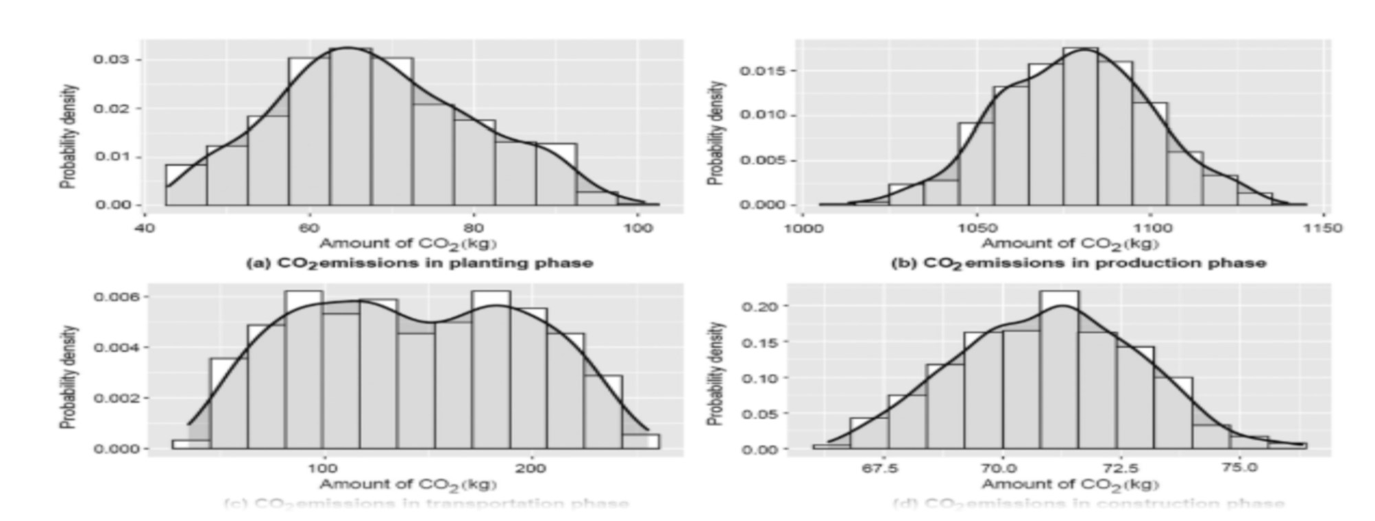

Figure 1. Bamboo CO2 emissions by phases in (a) planting phase, (b) production phase, (c) transportation phase, and (d) construction phase (7)

## Lightweight and Easy to Handle

Bamboo possesses inherent characteristics and physical properties that make it lightweight and easy to handle (2) . Additionally, bamboo has a low density relative to traditional building materials like wood, metal, or concrete, further contributing to its lightweight nature (8) It can be carried or loaded onto vehicles without the need for heavy machinery or specialized equipment. This makes bamboo a practical choice for projects requiring mobility and efficient logistics, such as railway track construction.

## Limitations

Despite the presence of over 1200 bamboo species worldwide, the variations in geometric and mechanical properties of bamboo culms. . Therefore, high conservation in choosing bamboo for construction applications is needed. As a result, bamboo has primarily been utilized in applications with low technological complexity and limited added value. (9)

## Paper Outline

Here, in this section, a flowchart is presented to show the paper approach for a better understanding of how bamboo can be employed as a railway sleeper Four steps are designed to provide enough information about new types of bamboo products suitable for sleeper construction. In the first step, the main target is to show that bamboo materials are gaining importance as an alternative to timber and other materials due to several compelling reasons. Afterwards, it is explained that, first, bamboo is an incredibly sustainable resource. It is one of the fastest-growing plants on Earth, with some species maturing in just a few years. In contrast, trees used for timber can take decades, or even centuries, to reach maturity. This rapid growth rate makes bamboo a highly renewable and eco-friendly option for construction and manufacturing. In comparison with other materials such as concrete and steel, bamboo possesses impressive strength and durability, making it a viable alternative to traditional materials like concrete or timber for railway sleepers. Bamboo has excellent load-bearing capacity and can withstand heavy weights and constant stress, making it suitable for the high pressure exerted by trains and maintaining track stability. Then, in the third section, bamboo products are introduced with related features. In the fourth section, the current application of bamboo is reviewed and limitations, numerical modeling, and some suggestions are presented. Finally, future prospects and studies needed for more employment of bamboo in the railway industry are discussed. (10)



FIGURE 2 - Bibliometric analysis of 1000 researchers worked on bamboo application in structures extracted from VOSviewer from a Web of Science data source.

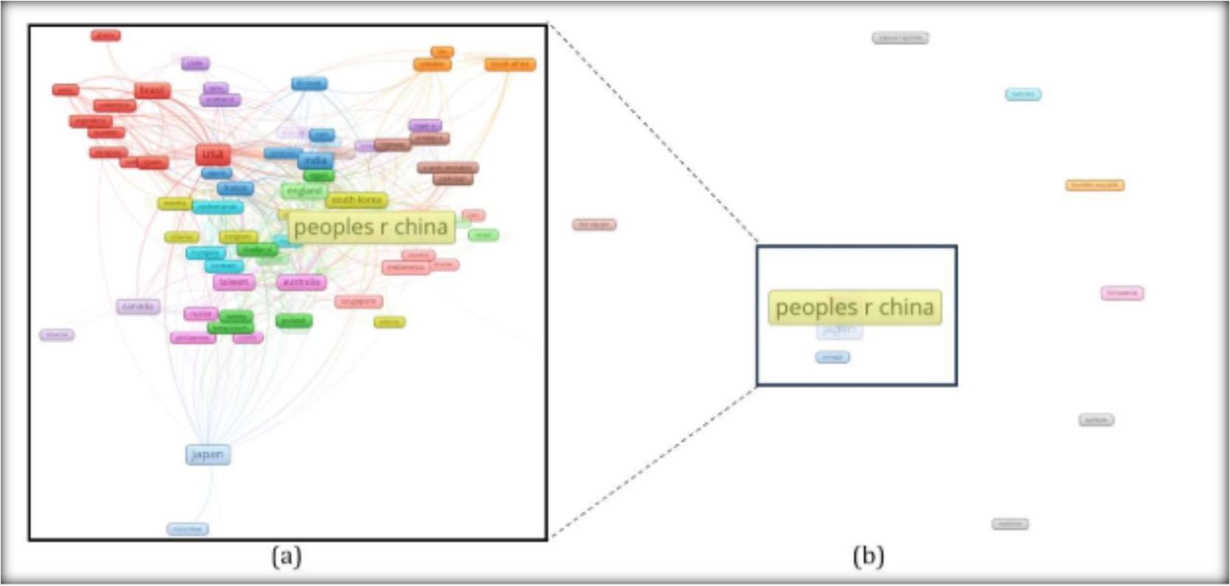

Figure 3. Bibliometric analysis of 104 countries worked on the application of bamboo in structures extracted from VOSviewer from a Web of Science data source; (a) group of countries with joint collaboration, and (b) the connection between countries with joint colaboration.

## Bamboo Construction Material and Fabrication

Bamboo products can compete with other railway sleeper materials such as concrete, wood, and

steel because they have high strength and stiffness compared to their weight (11).

As shownin Figure, stiffness and strength divided by mass per volume of four common construction materials, such as concrete, steel, wood, and bamboo, are compared. Bamboo shows higher performance compared to concrete and wood in terms of stiffness/mass per volume andhigher strength than concrete, steel, and wood in terms of strength/mass per volume. Inthe following sections, more specifications are presented about bamboo products

Stiffness and strength/mass per volume of various materials used for railway sleeper manufacturing (12).

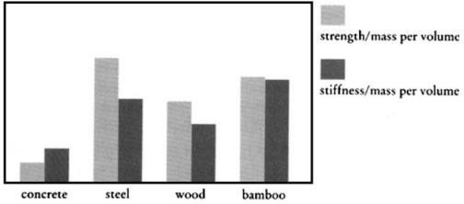

* 1. ***Bamboo* Structure**

Bamboo exhibits a hollow internal structure with tube-like sections between the nodes, where longitudinal fibers are aligned within a matrix of lignin (see Figure 5a). The thickness of the culm wall gradually decreases from the base to the top of the bamboo culm . The slender bamboo fibers, which are long, tapered at both ends, and sometimes forked, also vary in density within the culm wall, with a decrease in density from the outer wall to the inner wall. (13) A cross-section micrograph of bamboo is presented in Figure 5b. Based on the distribution density of longitudinal vascular bundles and corresponding chemical components, bamboo can be divided into four components: the outer layer, the fresh layer, the inner layer, and the nodal area (Figure 5c,d). The size of the vascular bundles gradually increases from the outer layer to the fresh layer, reaching its maximum size in the inner layer (14). The high density and hardness of the outer layer make it difficult to compress, while the softness of the inner layer makes it prone to stretching and cracking(13)

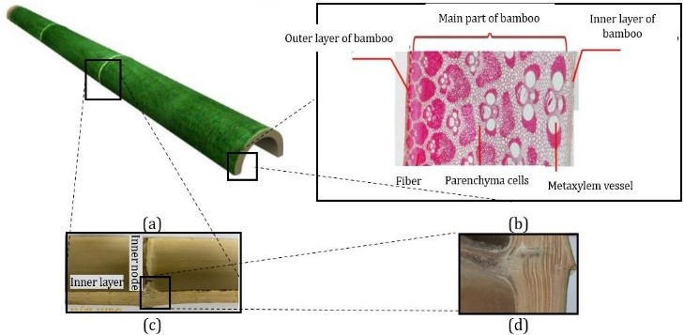

**Figure 5.** Bamboo structure: (**a**) culm, (**b**) microstructure, (**c**) node, and (**d**) node structure (13,14)

## Bamboo Mechanical Properties

Raw bamboo has significantly lower mechanical properties than treated bamboo products. Table 1 shows that each bamboo product has mechanical properties suitable for being used in construction. However, a wide range of differences in the mechanical properties of bamboo can be seen in this table. It can be a disadvantage to employ bamboo as a construction material for railway sleepers. Among all listed bamboo products, bamboo scrimber shows the highest mechanical properties, higher than wood.

**Table 1.** Mechanical properties of different bamboo products [15-18].

**Material Compressive Tensile Elasticity Rupture Density Water**

|  |  |  |  |  |  |  |
| --- | --- | --- | --- | --- | --- | --- |
|  | **Strength** | **Strength** | **Modulus** | **Modulus** |  | **Absorption** |
| Unit |  | MPa |  |  | g/cm3 | (%) |
| Bamboo (treated) | 31.47–34.03 | 90–145 | 9.37–14.27 | 130–205 | 1–1.22 | 6–19 |
| Bamboo (untreated) | 18.96–22.28 | 40–83 | - | - | 1–1.3 | 12–26 |
| Bamboo scrimber | 70.5–199.3 | 227.6–364.8 | 13.5–32.3 | 178.5–398 | 0.72–1.3 | - |
| Bamboo plywood | 57.7–86 | 3.2–205 | 8.8–15.37 | - | 0.66–1.12 | - |
| Bamboo bar | 55 | 120–370 | 10–17 | - | - | - |

# Bamboo Plywood

The development of the bamboo plywood production process stemmed from the need for a simple bamboo processing technology that could enhance the performance of bamboo products without altering their original thickness and width . Producing plywood from bamboo enhances its qualities, such as moisture-proofing, water resistance, corrosion resistance, and resistance to salt damage [19]. Bamboo plywood becomes significantly harder and stronger than standard wood, exhibiting a tensile strength that is 1.5 to 2 times greater than that of wood [20]. Another method for producing bamboo plywood is through bamboo lamination (Figure 6) [16]. In this process, bamboo culms are split into splits using a sizing and splitting machine [21]. These splits are then refined into strips, which are subsequently bonded together using resin to create a laminate

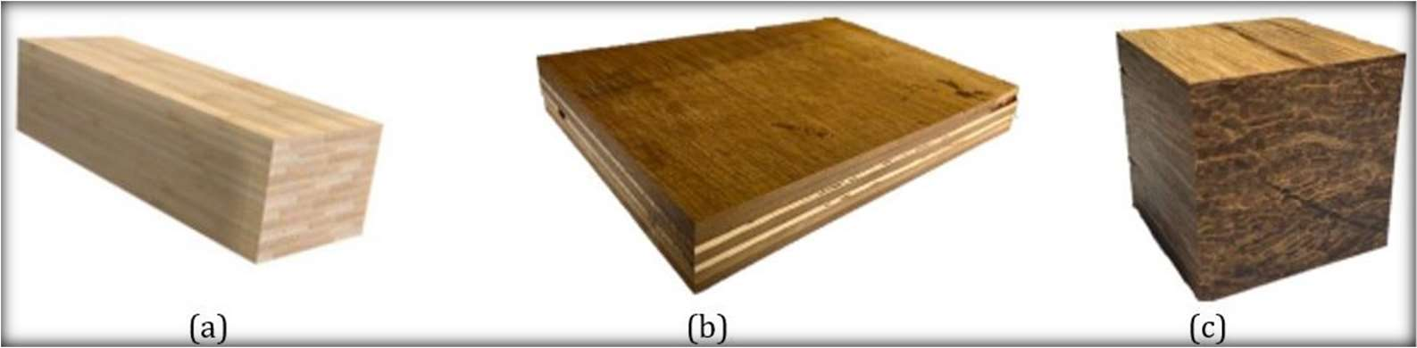

**Figure 6.** An overview of bamboo plywood with different laminate layers (**a**) laminated bamboo, (**b**) laminated flattened bamboo, (**c**) Bamboo scrimber (22)

# Bamboo Scriber Fabrication

In response to the growing industry and demand for sustainable construction products, bamboo is being utilized to create engineered bamboo composites, which aim to standardize the shape and reduce material property variations (13). The production process of bamboo scrimber typically involves several steps, as illustrated in Figure 7. These steps include truncation and splitting of bamboo, softening, removal of the bamboo’s outer skin, drying, sizing, assembly, and hot- pressing . However, with advancements in technology, certain steps have been omitted in the large-scale production of bamboo scrimber . The main processes involved now include truncation and splitting, defibering, drying, dipping, assembly, cold-pressing, and heat curing or hot-pressing .(25)

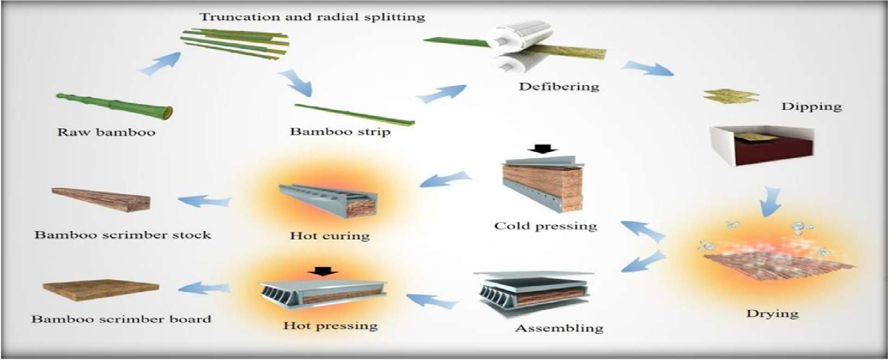

**Figure 7.** Process of bamboo scrimber production line (25)

# Some example of bamboo flattering process

Few articles on bamboo flattening were found, but many patents are published, especially in China. Up to 2015, Chinese patents account for about 74% of all the patents on bamboo flattening, Japanese accounts for 17% and Korean 5% [14]. The principles or ideas in some methods are similar. In this paper, only some examples are presented.

By Zhang 1988 (China)(31) In China, Bamboo culm flattening was first reported by Zhang [26] in 1988. He tested different softening and pressing methods . Half-tubular bamboo culms were used in his report. The outer node ridges and inner node diaphragms were removed before softening with hot water. Softened bamboo culms were then pressed with hot press. Three different processes were tested (Fig. 8):

(1) the softened culms were pressed directly (Fig.8); (2) softened culms were pressed gradually (Fig. 9);

(3) softened culms were pressed gradually through a continuous press . The device used for process (1) and (2) was simple, but many deep cracks were found during process , and the efficiency was very low with process (2). Due to the irregular shape of some bamboo culms, such as different size of two ends and crook in longitudinal direction of culm, it was very difficult to design a suitable machine for process (3) at that time. The author focused more on process and improved the flattening bamboo quality (less deep cracks) by making grooves on inner surface. However, at that time no special apparatus with high efficiency for making grooves was invented, thus the process was restricted.

By Parkkeeree et al. 2014,2015 (Thailand)(32) Parkkeeree and his colleagues reported a flattening process on black sweet bamboo (Dendrocalamus asper) with hot linseed oil . Culms were cross-cut into hollow specimens of 150 mm long to remove the nodes before splitting it longitudinally into half. The outer surface was removed and the specimen thickness was reduced from the inner surface to around 3

mm. The half-tubular culms were soaked in water before being compressed by two flat stainless steel plates. The two plates with bamboo culms were immersed in hot linseed oil during flattening. Temperature of hot oil ranged from 80 C to 180 C. To achieve a final degree of flatness of over 90%, linseed oil of a temperature of at least 110 C was needed, but to avoid immediate springback after the removal of applied load, linseed oil of a temperature of at least 120 C was required. In this method, the thickness of culm wall was limited and considerable labors were required for reducing culm wall

By Liu et al. 2013 (China) Liu et al. (33) did flattening tests on 4-year-old moso bamboo (Phyllostachys

pubescens) with a special device as shown in Bamboo culms were cut into 250 mm long and sliced into onethird circumference bamboo pieces. They were soaked in water until saturation. The device were heated to 180 C before placing and preheating bamboo piece on the worktable. The sample was clamped between the baffles and the initial horizontal forces required were exerted by rotating the adjustment screw. Then the hot press was closed slowly and gently. Subsequently, the horizontal forces was continuously adjusted with the change of the height of bamboo piece and the pressure of hot-press until the sample was completely flattened. The authors reported that over 78% of 108 total samples were flattened successfully. However, the process is controlled manually with very low efficiency



Fig 8 :- Three different processes of bamboo culm flattening

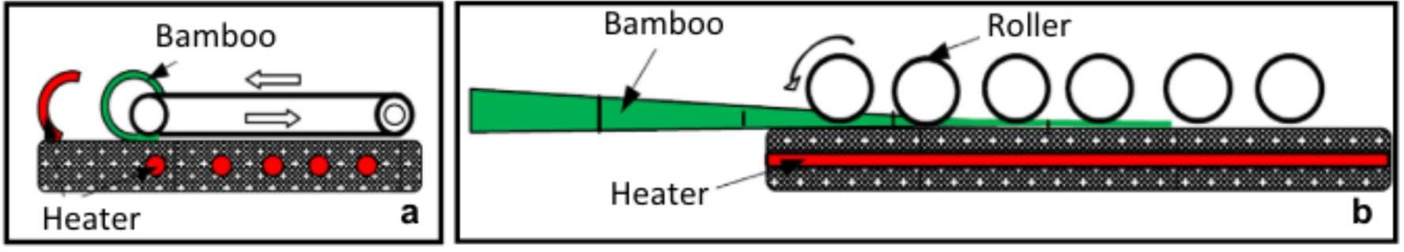

Fig 9 :- Two different processes of bamboo culm flattening by Park

As discussed above, by making non-penetrating indentations, grooves or cuts on inner surface of bamboo culms can increase circumference of inner layer and thus reduce the difference of circumference between inner and outer layer. In 1988 Zhang [31] proposed this idea. However, at that time no apparatus with high efficiency was invented. In recent years, many patents of the apparatuses were published [33], and some have been industrialized. After visiting some factories, two efficient processes were summarized.

(1) Green bamboo culms were cross cut into 30–80 cm long and the outer node ridges and inner node diaphragms were removed efficiently by special apparatuses. They were longitudinally slit along its entire length before being softened in a sealed container at around 190 C with saturated highpressure (around 1.25 Mpa) steam for 5–10 min. The slit became large after softening. After being removed from container, softened bamboo culms were immediately inserted into a machine with two steel rollers (Fig. 9), the upper one with smooth surface and the lower one with many protrusions. Bamboo culms passed through the two rolling rollers with inner surface towards the lower roller. Thus a plurality of indentations were made on the inner surface and the softened bamboo culms were almost flattened. They were then transferred to a double-surface planer to be flattened completely and the outermost layers (cortex and pith periphery) were planed at the same time. This process has already been industrialized with good efficiency. However, due to the different thickness of bamboo culm wall along longitudinal direction, the process cannot be used for long bamboo culms.

Long bamboo culms can be flattened with this process. Same as process (1), bamboo culm with slit was softened before flattening. Long bamboo culm was flattened gradually by a device as shown in Fig.

The device is composed of a set of rollers with diagonal knives on surface. The width of rollers varied from small to large gradually. (33) The first roller contacted the arc center of opened bamboo culm. Bamboo culm was and flattened gradually with a plurality of parallel and cross diagonal cuts, with angle formed by the cuts and the grain direction ranging between 10 to 60, which can direct and reduce cracks on its inner surface. The two processes above have been industrialized in China with relatively high efficiency (31). Flattened bamboo is widely used for flooring, chopping boards, furniture, etc. However, there are indentations or cuts on the inner surface of flattened bamboo and their depth is not always well controlled. It may affect the quality of final products. Inappropriate distribution density and depth of indentations or cuts might cause cupping distortion of flattened bamboo board after drying.

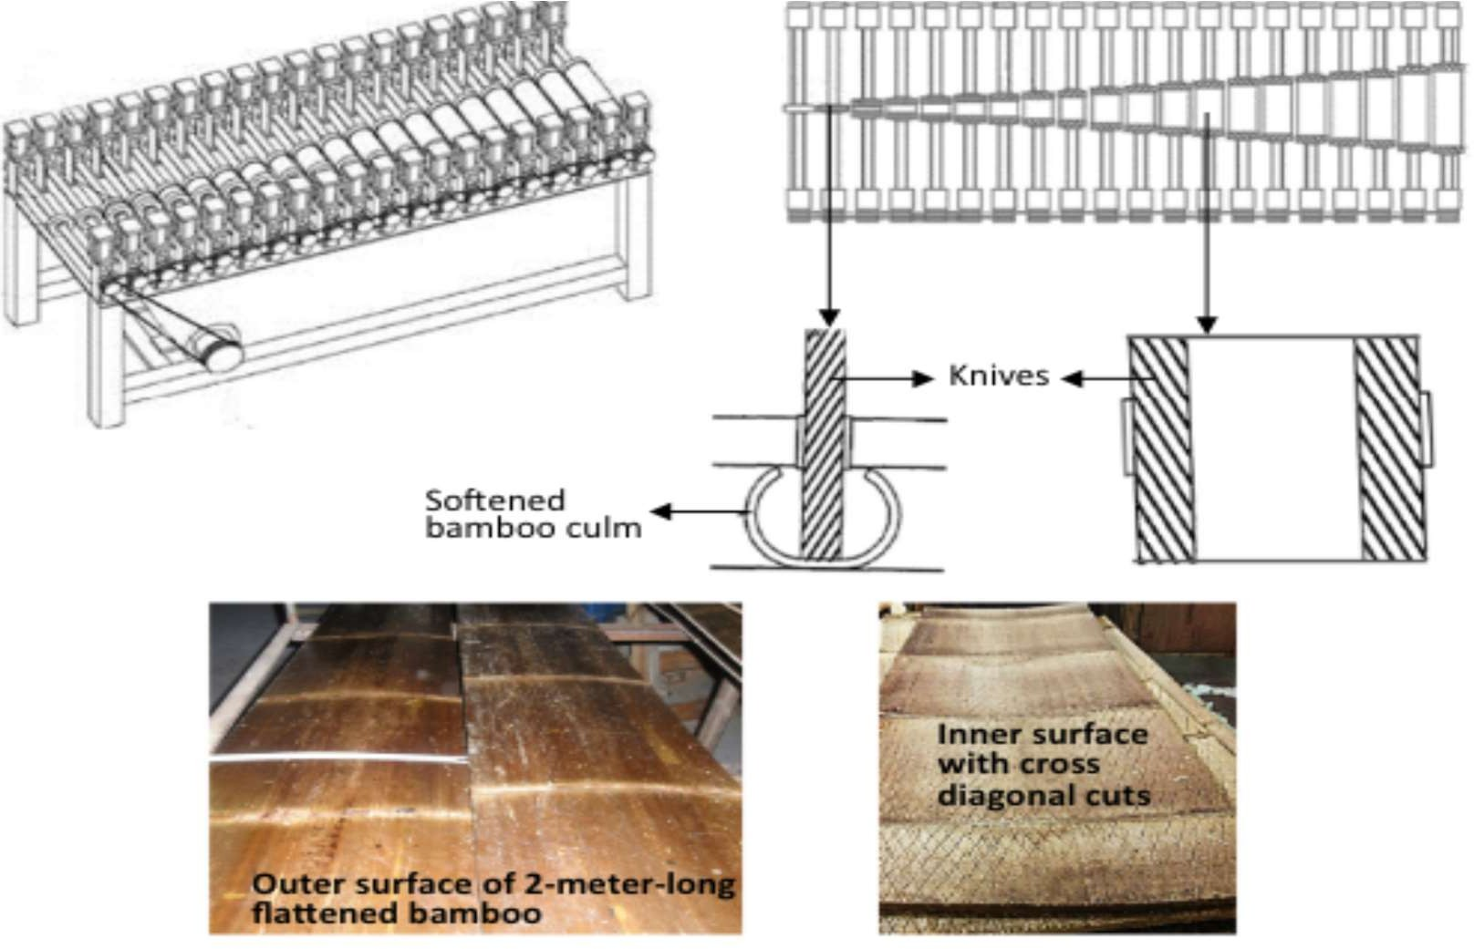

Fig 10 : - Bamboo flattening by making diagonal cuts on inner surface. Top left: flattening device. Top right: top view of the flattening device (30-33)

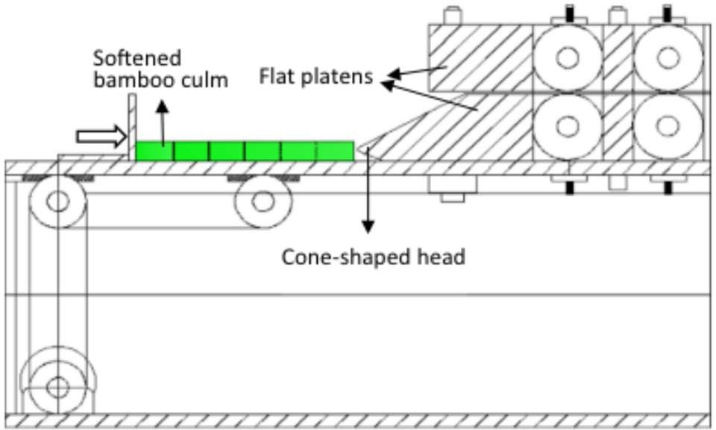

Fig. 11. A schematic diagram of press with a cone-shaped head and flat platens used for bamboo flattening

# Application of Bamboo in the Railway Industry

* 1. **Background**

Bamboo has been increasingly applied in various aspects of the railway industry, show- casing its versatility and potential benefits. For instance,used bamboo nets to improve soil density, offering an environmentally friendly alternative for soil en- hancement . The bamboo nets, measuring 10 cm in diameter and 5 m in length, achieved a density degree of 96.5% based on sand cone density tests. Through their study, they found that by using a resin content of 15.5%, targeting a density of 0.8 g/cm3, applying a hot-pressing time of 0.65 min/mm, and setting a hot-pressing temperature of 170 *◦*C, an optimal modulus of rupture value of 70.08 MPa was achieved (26)

In their research, The study findings revealed that this laminated composite ex- hibited a low density of 0.73 g/cm3, resulting in a specific modulus of 13.03 GPa cm3/g. Moreover, it demonstrated a vibration damping ratio of 6.61% and an impact toughness of

14.16 J/cm2. These characteristics were significantly superior to those of other wood-based composites, such as Birch plywood (BP), which is commonly used for high-speed rail floors. In a separate study, developed laminated bamboo–wood composite lumber for railway applications. This composite lumber consists of two thin curtain boards with a thickness of 3–4 mm as the surface material, along with three layers of wood boards with a thickness of 10–15 mm forming the interior structure. This com- posite lumber offers several advantages over solid bamboo boards, including increased strength, improved resistance to abrasion, lower density, better nail holding capacity, and cost-effectiveness. Currently, the product is undergoing testing on railway flat wagons.

The intention behind these bamboo-inspired bionic tubes (BT) was to use them as energy absorbers in rail vehicles. The research results indicated that the BT specimens exhibited significantly enhanced energy absorption (EA) compared to the CT specimens. In experimental tests, the BT specimens showed an increase of 93.1% in EA, while simulated tests demonstrated an increase of 101.8% in EA. Additionally, the mean load values rose from

74.2 kN and 68.3 kN to 143.4 kN and 137.9 kN for the BT specimens, respectively, indicating a substantial improvement incrashworthiness.

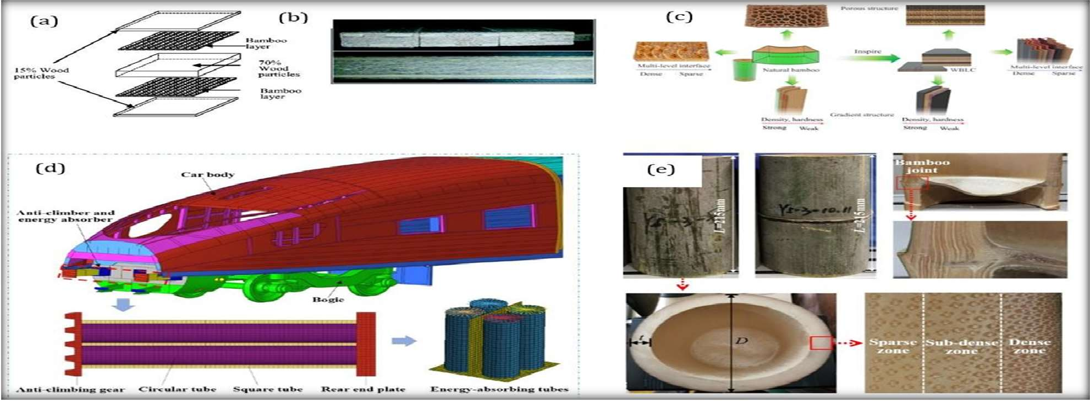

**Figure 12.** (**a**) Preparation and (**b**) cross-section of a real composite sleeper, (**c**) process to produce a bamboo laminate composite for the flooring of railroad cars, (**d**) application of energy-absorbing CTs in rail vehicles, and (**e**) bamboo samples and the detailed structures (27,28,29)

* 1. Bamboo Sleeper Application Challenges

Bamboo, despite its many advantages, may present several disadvantages when used as a sleeper on railway tracks. One notable drawback is its light weight, which can lead to reduced lateral resistance . This can potentially affect the stability and integrity of the railway track, especially under heavy loads or during high-speed train operations . Another concern related to bamboo sleepers is their durability, particularly in regions with variable weathering action. Bamboo is susceptible to weather-induced deterioration, such as fungal decay, cracking, or rotting, which can compromise its structural integrity over time . This vulnerability to weathering raises concerns about the long-term performance and reliability of bamboo sleepers on railway tracks. Furthermore, limited data exists on the long-term performance of bamboo sleepers in railway applications. Comprehensive studies and field trials assessing the durability, maintenance requirements, and overall performance of bamboo sleepers are relatively scarce. The results for the fiber bamboo sleeper and the plywood sleeper are reported from the authors’ experiments. Application of bamboo fiber reduces the bending strength of concrete sleepers; however, it lightens the weight of concrete sleepers by 10%. The bamboo plywood sleeper is the cheapest among other types of sleepers. All prices are extracted from a sleeper-selling website

**Table 2.** A comparison of the flexural strength and total weight of different types of sleepers.

|  |  |  |  |  |  |
| --- | --- | --- | --- | --- | --- |
| **SFleexpuerralType** | **Middle Strength (MPa)** | | **Average Amount a Sleeper (kg)** | **for Ref.** | **Price $** |
| Timber | 70–110 | | 60 | [5] | 20 |
| steel | 120 | | 64 | [14] | 500 |
| Concrete | 110 | | 375 | [23] | 28 |
| FFU composite  Plastic sleeper | 142  68 | | 100–120  100 | [22]  [25] | 45  6/kg |
| Bamboo fiber | concrete | 70 | 345 | _ | 25 |
| sleeper  Bamboo plywood sleeper 100 | | | 60–75 | _ | 15 |

**4 . Future Prospects and Discussion**

Bamboo products, such as plywood and bamboo scriber, have shown promising me- chemical features that make them potential alternatives to timber sleepers. However, further studies are

necessary to assess their long-term performance, resistance to temper- nature variance, and weathering effects. Additionally, more research, both numerical and experimental, is needed to explore the application of bamboo products in ballast mats and under sleeper pads, particularly in terms of their damping properties when combined with elastic materials like recycled tires. The use of bamboo in sleeper construction can provide benefits such as protecting the elastic layer from abrasion caused by ballast particles and contributing to vibration attenuation. However, when considering bamboo as a fiber mixed with conventional concrete or as laminates, certain concerns arise. The mechanical performance of railway concrete sleepers may be compromised when using bamboo fibers, as they are typically extracted from culms and may not provide sufficient reinforcement. Moreover, the bonding and stress between laminate layers in bamboo plywood sleepers may lead to premature failure. To address these concerns, various methods have been suggested, including the use of high-strength resin and carbon fiber- reinforced polymer (CFRP) reinforcement in similar

# 5. Conclusions

Bamboo has been considered a low-quality product for construction by emerging new technologies to manufacture bamboo products such as plywood, bamboo scrimber, and laminates. This material provides better properties than wood and composites with high stiffness, strength/mass per volume, and low carbon emission features.

* More than 104 countries have contributed to bamboo publications with around 4119 papers. These contributions have increased in recent years, which shows the attention given by researchers even in those countries without bamboo as a local plant.
* One of the main defects regarding the application of bamboo is the wide range of properties that can be found in the same bamboo products. However, the mechanical properties of bamboo products greatly increase, but the high difference between the mechanical properties of the elements of the structures may cause failure.
* Bamboo plywood and scrimber are the main products that are suitable for railway sleeper production in terms of their durability and mechanical performance. These products can provide moisture-proofing, water resistance, corrosion resistance, and resistance to salt damage.
* The application of bamboo in the railway industry has not been well extended com- pared with other parts of structural science. This material has mostly been used for soil improvement. However, considering its properties, it has the potential to be widely used in railway sleeper manufacturing, as has been studied so far. The shortcoming for more application of bamboo in the railway industry is the concerns about its weathering and long- term performance, as there are no such studies

# References

1. The Application of Bamboo in the Railway Industry: A Sustainable Solution for Track Construction Xinrui He 1, Wenli Jia 2,*, Yuxiang Dong 1 and Mohammad Siahkouhi 3
2. Flexuralbehavioroflightweightbamboo–steelcompositeslabs Yushun Li a,n, HuangyingShen a, WeiShan b, TianshiHan
3. Ultimate Load Behaviour of Bamboo-Reinforced Lightweight Concrete Beams IS. Ghavami
4. Bamboo Reinforced Concrete Slabs for Fence WallsSuppiah Subramaniam1 & Venugopal M.1
5. Engineered bamboo for structural applications. In *Nonconventional and Vernacular Construction Materials*; Elsevier: Amsterdam, The Netherlands, 2020 Sharma, B.; van der Vegte, A.
6. Bamboo as a Sustainable Building Material—Culm Characteristics and PropertiesKitti Chaowana 1, Supanit Wisadsatorn 2 and Pannipa Chaowana
7. . Improving the mechanical performance of timber railway sleepers with carbon fabric reinforcement: An experimental and numerical study. Siahkouhi, M.; Li, X.; Han, X.; Jing, G
8. A review of agro-potential waste’s as constituent in railway sleepers. Khong, S.; Yee, J.; Doh, S.; Chin, S.
9. Modification of Concrete Railway Sleeper Mix Design, Using a Hybrid Application of Steel Fibers
10. . Bond quality and durability of cross-laminated flattened bamboo and timber Yang, S.; Li, H.; Fei, B.; Zhang, X.; Wang, X
11. A Comparative Study of Bamboo Reinforced Vs Steel Reinforced Concrete Structure Swatej Rathod1, Abhishek Parab2, Anishka Tamkhane3,
12. An environmental, economic and practical assessment of bamboo as a building material for supporting structures P. van der Lugt a, A.A.J.F. van den Dobbelsteen a,*, J.J.A. Janssen
13. Development of bamboo scrimber: a literature review Yuxiang Huang1 , Yaohui Ji2 and Wenji Yu1*
14. An overview on bamboo culm flattening Chang-Hua Fang, Ze-Hui Jiang, Zheng-Jun Sun, Huan- Rong Liu, Xiu-Biao Zhang, Rong Zhang, Ben-Hua Fei
15. Development of bamboo zephyr composite and the physical and mechanical properties. *J. Korean Wood Sci. Technol.* 2022 Sumardi, I.; Alamsyah, E.M.; Suhaya, Y.; Dungani, R.; Sulastiningsih, I.M.; Pramestie, S.R.
16. A. Review on manufacturing and fundamental aspects of laminated bamboo products for structural applications. *Constr. Build. Mater.* 2022 Kumar, D.; Mandal
17. Shear properties of composite cross-laminated bamboo panels. *Eur. J. Wood Wood Prod.*

2022, Li, Z.; Xia, M.K.; Shi, J.J.; Wang, R

1. . Mechanical properties of bamboo through measurement of culm physical properties for composite fabrication of structural concrete reinforcement. *Front. Mater.* 2019, Javadian, A.; Smith, I.F.; Saeidi, N.; Hebel, D.E
2. Anisotropy attenuation of reconstituted bamboo lumber by orthogonal layup process. *Compos. Commun.*2023, Qiu, Z.; Zhu, W.; Fan, H.
3. Acoustic emission characteristics of different bamboo and wood materials in bending failure process. *J. Renew. Mater.* 2022, Wang, T.; Wang, Z.; Yang, Y.; Zhou, J.
4. Selected properties of laboratory-made laminated-bamboo lumber. *Holzforschung* 1998, Lee, A.W.; Bai, X.; Bangi, A.P.
5. Bamboo-based composites: A review on fundamentals and processes of bamboo bonding. *Compos. Part B Eng.* 2022, Nkeuwa, W.N.; Zhang, J.; Semple, K.E.; Chen, M.; Xia, Y.; Dai, C.
6. Effects of heat treatment on the properties of bamboo scrimber. *J. Wood Sci.* 2016, Shangguan, W.; Gong, Y.; Zhao, R.; Ren, H.
7. preparation, pyrolysis and pilot production a bamboo scrimber with halogen-free, flame- resistance and low-smoke. *Ind. Crops Prod.* 2023, Peng, R.; Yang, F.; Yin, W.; Du, C.; Liu, C.; Chen, S.; Shan, Y.; Shao, Y.; Wang, Y. Facile
8. Development of bamboo scrimber: A literature review. *J. Wood Sci.* 2019 Huang, Y.; Ji, Y.; Yu, W
9. Development of bamboo zephyr composite and the physical and mechanical properties. *J. Korean Wood Sci. Technol.* 2022 Sumardi, I.; Alamsyah, E.M.; Suhaya, Y.; Dungani, R.; Sulastiningsih, I.M.; Pramestie, S.R.
10. Optimum processing parameters for wood-bamboo hybrid composite sleepers. *J. Reinf. Plast. Compos.* 2014, Xiao, S.; Lin, H.; Shi, S.Q.; Cai, L
11. D.C. Analysis of Soil Improvement Using Bamboo Net-System on Railway. *J. Phys. Conf. Ser.* 2019, Erlangga, A.W.; Priyanto, S.; Laynardo,
12. Crashworthiness of bamboo-inspired circular tubes used for the energy absorber of rail vehicles. *Acta Mech. Sin.* 2022, Liu, K.; Yu, Z.; Wang, K.; Jing, L.
13. Lateral displacement of different types of steel sleepers on ballasted track. *Constr. Build. Mater.* 2018, Jing, G.; Fu, H.; Aela, P.
    1. STUDIES OF BAMBOO PLYWOOD—— I. THE SOFTENING AND FLATTENING OF

BAMBOO Zhang Qisheng

* 1. Mechanisms of bamboo flattening in hot linseed oil, Eur. J. Wood Wood Prod. 73 T. Parkkeeree, N. Matan, B. Kyokong,
  2. Study on a bamboo stressed flattening process, Eur. J. Wood Wood Prod. 71 (3) (2013 [29] J. Liu, H. Zhang, L. Chrusciel, B. Na, X. Lu
  3. NIBE. Classificatietabel. In: NIBE. Basiswerk Duurzaam & Gezond Bouwen – De´ leidraad bij het realiseren van duurzame en gezonde woning- en utiliteitsbouw (Suppl. 4). Naarden, Netherlands: NIBE Publishing; February 2003.
  4. Designing and building with bamboo. Beijing, China: INBAR Janssen JJA.
  5. Particle flow code in 2 and 3 dimensions, Minneapolis, 2014. C. Itasca, PFC
  6. Y shape railway sleepers from fiber reinforced foamed urethane, 2013 V. Ungureanu, A. Maris ,
  7. Numerical modelling of granular materials with spherical discrete particles and the bounded rolling friction model, Appl. Railway Ballast, Comput. Geotechn. 85 (2017) 220–229 J. Irazábal,

F. Salazar, E. Oñate,

* 1. A numerical investigation on the lateral resistance of frictional sleepers in ballasted railway tracks, Proc. Inst. Mech. Eng., Part F: J. Rail Rapid Transit. 230 (2) (2014) 440–449. J. Ali Zakeri,

M. Esmaeili, A. Kasraei, A. Bakhtiary

* 1. Behaviour of the track in hot weather-Rail thermal forces for jointed and CWR track, 2017. C. Ciobanu,
  2. Shakedown behaviors of railway ballast under cyclic loading, Constr. Build. Mater. 155 (2017) 1206–1214. J. Xiao, D. Zhang, K. Wei, Z. Luo,