**∆ A SPECIFIC REVIEW ON ANTIFUNGAL AGENTS…**

1. Adinath Gorakh Ushir
2. Prashant Gajanan Bhalerao
3. Sachin Shankar Vaidya
4. Prof. Shinde Divya D.

Matoshri Institute Of Pharmacy, Dhanore, Yeola.

**∆ ABSTRACT :**

-Fungal infections pose significant health challenges globally, particularly among immunocompromised individuals. Antifungal agents, including azoles, polyenes, echinocandins, and allylamines, have become pivotal in managing these infections. These agents work by targeting critical fungal cell structures or metabolic pathways, such as the fungal cell membrane or cell wall synthesis. Despite their efficacy, challenges such as drug resistance, toxicity, and limited spectrum of activity persist, driving research into novel antifungal compounds and combination therapies. Recent advancements in antifungal development focus on improving pharmacokinetics, reducing side effects, and combating resistance through innovative approaches such as repurposing existing drugs and exploring natural antifungal compounds. This review highlights the current landscape of antifungal agents, their mechanisms of action, clinical applications, and the emerging strategies to enhance antifungal therapy.

**∆ KEYWORDS OF ANTIFUNGAL AGENTS:**

∆**Categories of Antifungal Agents:**

1)Polyenes: Amphotericin B, Nystatin

2)Azoles: Ketoconazole, Fluconazole, Itraconazole, Voriconazole, Posaconazole

3)Echinocandins: Caspofungin, Micafungin, Anidulafungin

4)Allylamines: Terbinafine, Naftifine

5)Pyrimidine analogs: Flucytosine (5-FC)

6)Other agents: Griseofulvin, Ciclopirox

**∆ MECHANISM OF ACTION:**

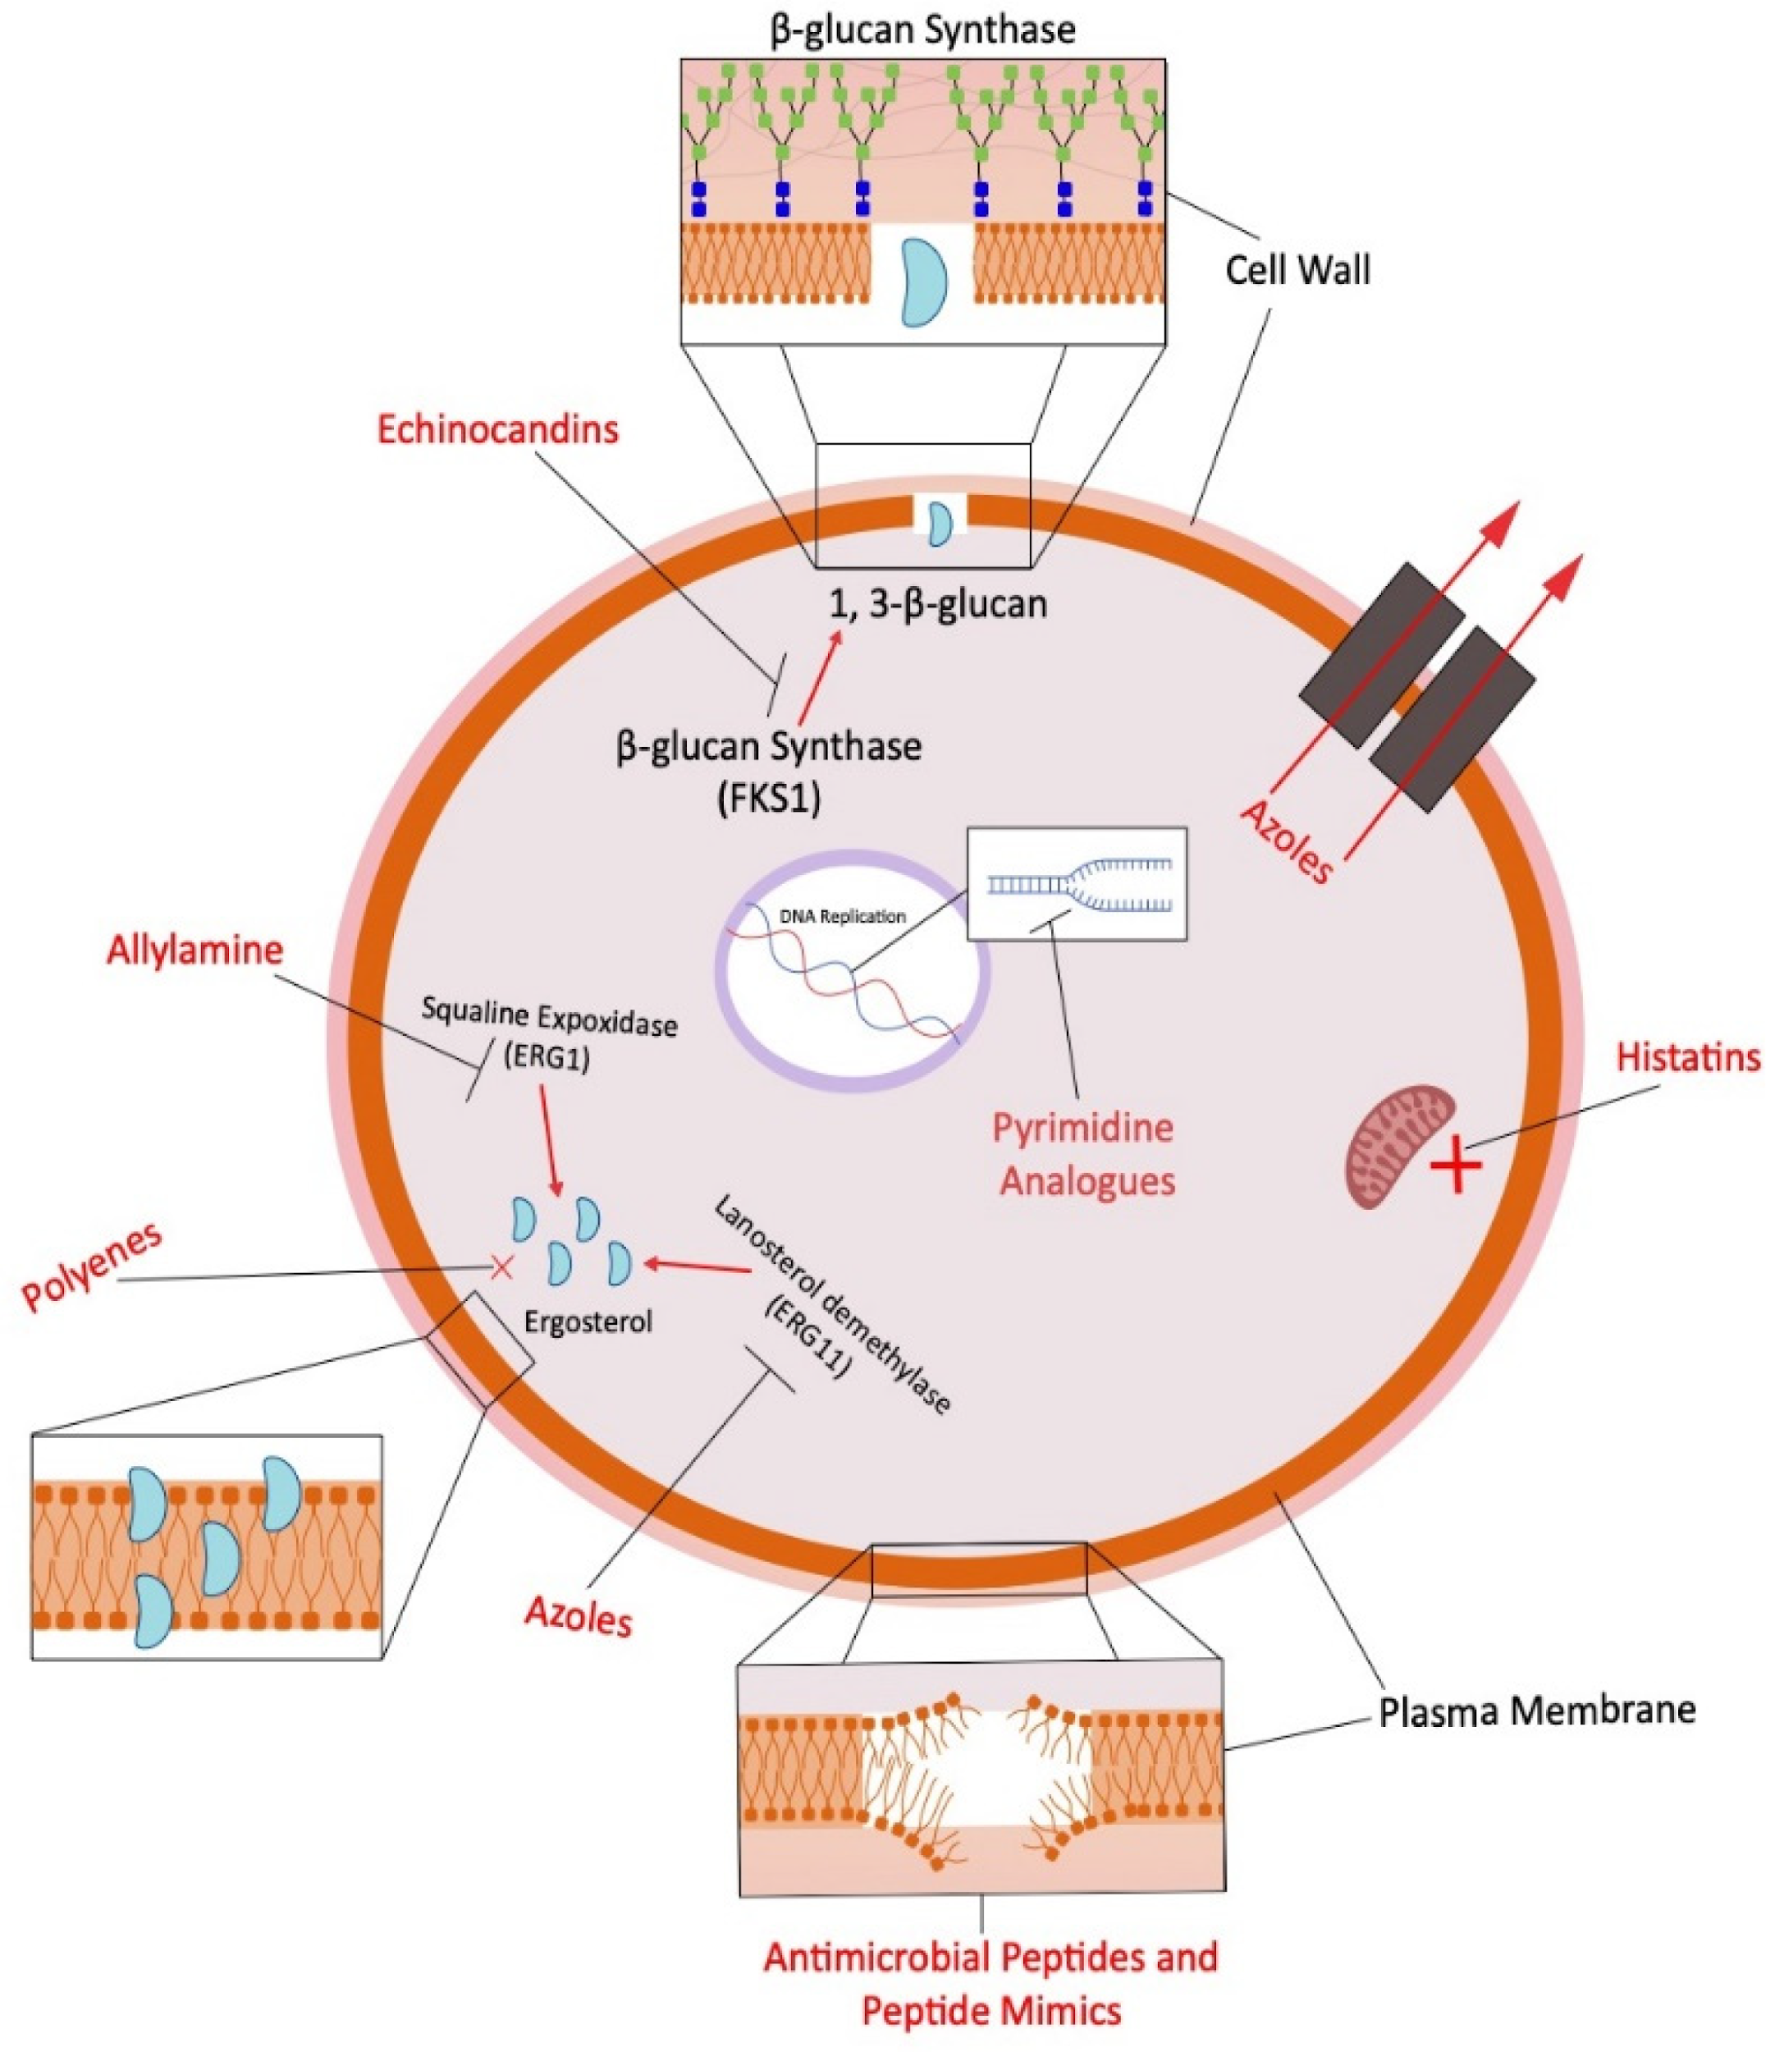

1)Ergosterol inhibition

2)Cell wall synthesis disruption

3)DNA/RNA synthesis inhibition

4)Membrane permeability disruption

5)Microtubule function interference

**∆ USES AND INDICATIONS:**

1)Dermatophytoses

(e.g., tinea pedis, tinea corporis)

2)Candidiasis (e.g., oral, vaginal, systemic)

3)Aspergillosis

4)Cryptococcosis

5)Histoplasmosis

6)Blastomycosis

7)Onychomycosis

8Sporotrichosis

**∆ TARGETS AND PATHOGENS:**

1)Candida species

2)Aspergillus species

3)Dermatophytes (Trichophyton, Microsporum, Epidermophyton)

4)Cryptococcus neoformans

5)Histoplasma capsulatum

6)Blastomyces dermatitidis

7)Sporothrix schenckii

8)Fusarium species

**∆DRUG RESISTANCE KEYWORDS:**

1)Multidrug resistance (MDR)

2)Efflux pumps

3)Erg11 gene mutation

4)Biofilm formation

5)Cross-resistance

**∆PHARMACOLOGICAL CONSIDERATIONS:**

1)Oral bioavailability

2)Hepatotoxicity

3)Nephrotoxicity

4)Drug-drug interactions

5)Broad-spectrum activity

6)Fungistatic vs. fungicidal

**∆ INTRODUCTION OF ANTIFUNGAL AGENTS**:

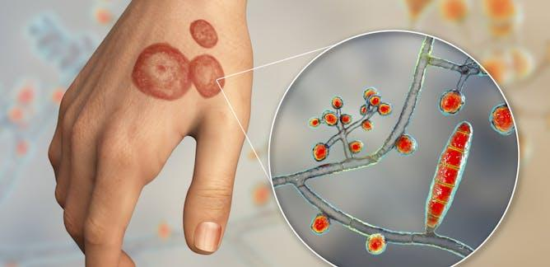

-Antifungal agents are a diverse group of compounds used to treat fungal infections in humans, animals, and plants. These agents work by targeting specific components of fungal cells, such as the cell wall, cell membrane, or essential enzymes, thereby inhibiting their growth or causing cell death. Fungal infections can range from superficial conditions, such as athlete's foot, to severe systemic infections, particularly in immunocompromised individuals.

-The development of antifungal drugs has been critical in managing these infections, with common classes including azoles, polyenes, echinocandins, and allylamines.

**∆ MEDICINAL USE OF ANTIFUNGAL AGENTS:**

Antifungal agents are used in the treatment of various fungal infections that affect different parts of the body. These infections can range from superficial conditions, like athlete's foot or ringworm, to systemic and life-threatening conditions, such as invasive candidiasis or aspergillosis. Antifungal agents can be classified into several categories based on their mechanism of action, such as polyenes, azoles, echinocandins, and allylamines.

**1. Polyenes (e.g., Amphotericin B):** These are used primarily for serious systemic fungal infections. They work by binding to ergosterol, a component of fungal cell membranes, causing cell leakage and death. Amphotericin B is often used in cases of invasive fungal infections such as cryptococcal meningitis and histoplasmosis.

**2. Azoles (e.g., Fluconazole, Itraconazole):** Azoles inhibit the enzyme lanosterol demethylase, involved in the synthesis of ergosterol, leading to impaired cell membrane formation. Fluconazole is commonly used to treat Candida infections, while itraconazole can be used for conditions like blastomycosis and aspergillosis.

**3. Echinocandins (e.g., Caspofungin, Micafungin):** Echinocandins inhibit the synthesis of β-glucan, an important component of the fungal cell wall, making them effective against Candida species and Aspergillus species. They are used in cases of invasive candidiasis and in patients who are intolerant to other antifungal agents.

**4. Allylamines (e.g., Terbinafine):** These are used for dermatophyte infections, such as tinea infections, including athlete's foot and onychomycosis (fungal nail infections). Allylamines inhibit the enzyme squalene epoxidase, which is essential for the synthesis of ergosterol in fungi.

**5. Griseofulvin:** Used for dermatophyte infections, particularly those affecting the skin, hair, and nails, griseofulvin disrupts fungal cell mitosis, leading to cell death. It is used mainly for treating conditions like ringworm and tinea capitis.

**∆PREGNANCY AND BREASTFEEDING DURING ANTIFUNGAL AGENTS USAGE DOSES:**

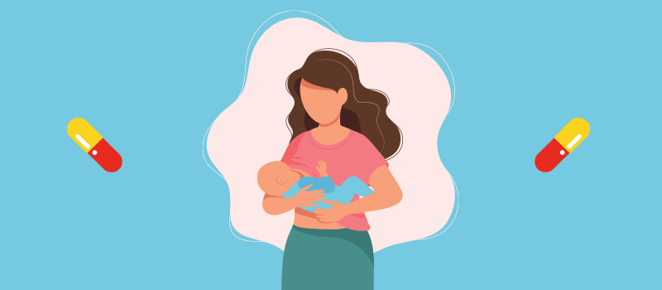

The use of antifungal agents during pregnancy and breastfeeding requires careful consideration due to potential risks to the fetus or infant. Below is an overview of the general guidelines for antifungal agent usage during these conditions:

**∆Pregnancy:**

-Topical antifungals (e.g., clotrimazole, miconazole, and terbinafine) are generally considered safer during pregnancy as they have limited systemic absorption.

-Oral antifungals (e.g., fluconazole, itraconazole, and voriconazole) should be avoided unless absolutely necessary, especially during the first trimester. Fluconazole, in particular, has been associated with congenital malformations when used in high doses during early pregnancy.

**Fluconazole:** Single high doses (400 mg or more) may be teratogenic, leading to birth defects such as craniofacial abnormalities, limb abnormalities, and developmental delays.

**Itraconazole and voriconazole**: These are generally avoided in pregnancy due to animal studies showing teratogenic effects, although they are considered less risky than fluconazole.

**∆ Breastfeeding:**

-Most topical antifungal agents are considered safe during breastfeeding as they have minimal systemic absorption.

**Fluconazole:** It is excreted into breast milk, and while the amounts are generally low, it is advised to use with caution or avoid breastfeeding for 24 hours after a single dose.

-Itraconazole, ketoconazole, and voriconazole: These agents are also excreted into breast milk, and caution is advised. If these drugs are necessary, breastfeeding should either be avoided or done with close monitoring.

**∆Dosage Guidelines:**

**Fluconazole:** Typical doses for non-pregnant adults are 150 mg for vaginal candidiasis, with higher doses (up to 400 mg) for systemic infections. For pregnant women, a single dose of 150 mg may be used, but higher doses should be avoided.

**Topical antifungals:** Can be used as directed for localized infections (usually 1-2 times daily for up to 2 weeks).

**∆DRUG - DRUG INTERACTIONS:**

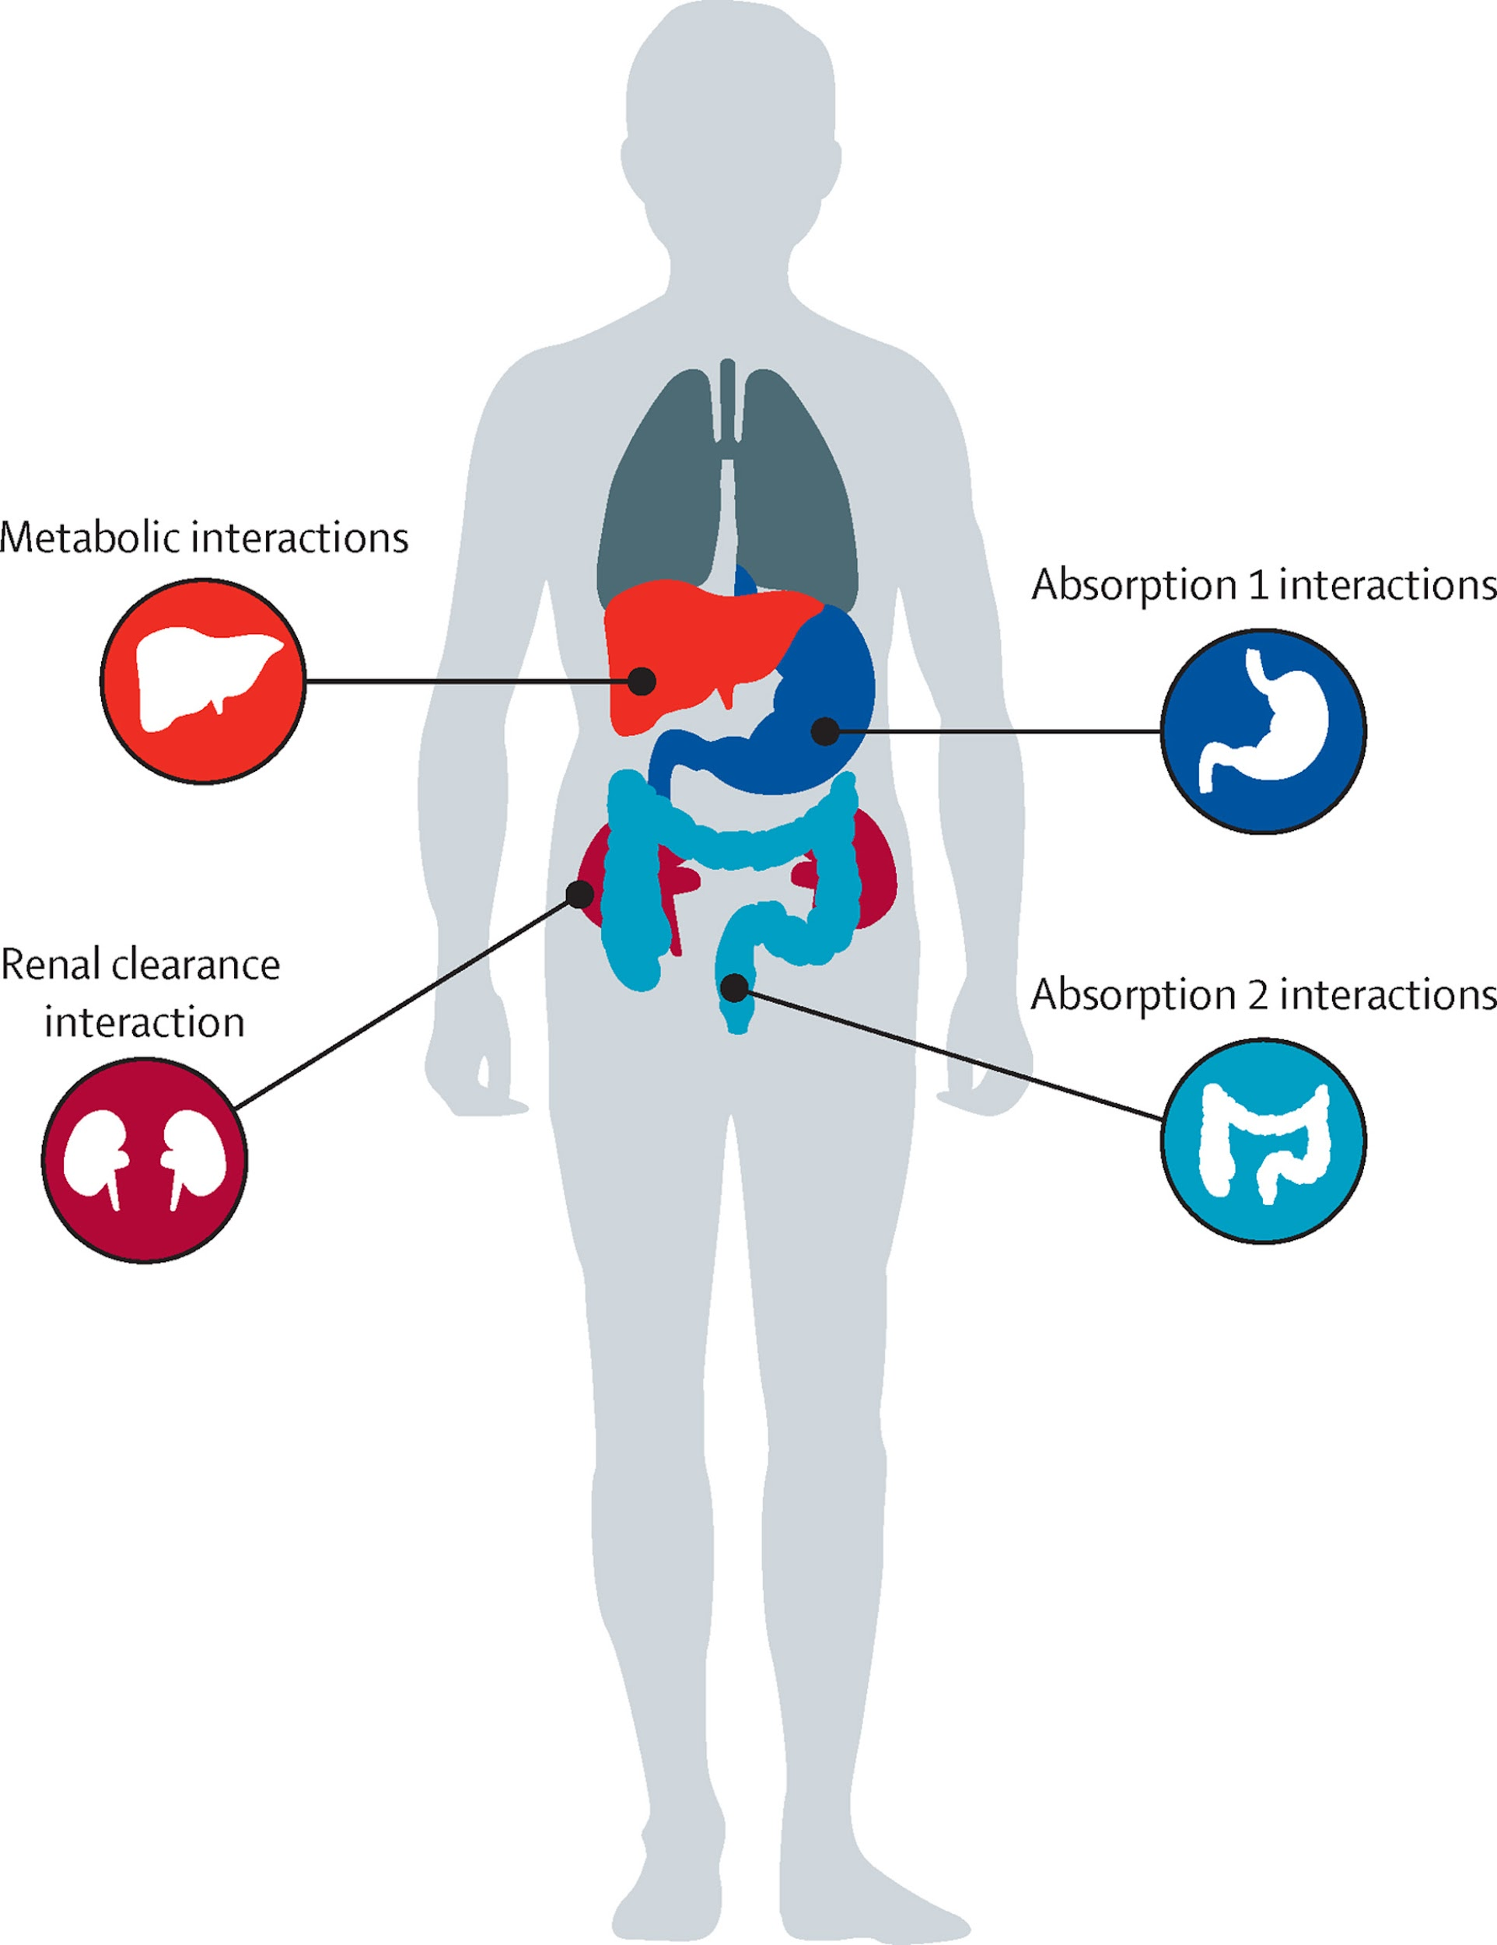

Antifungal agents can interact with a wide variety of other drugs, potentially altering their efficacy or causing harmful effects.

**1. Azole Antifungals (e.g., Fluconazole, Itraconazole, Ketoconazole, Voriconazole, Posaconazole):**

**CYP450 Enzyme Inhibition:** Azoles are potent inhibitors of cytochrome P450 enzymes, particularly CYP3A4, CYP2C9, and CYP2C19. This can increase plasma concentrations of drugs metabolized by these enzymes.

**Common drug interactions include:**

Statins (e.g., atorvastatin, simvastatin): Azoles increase the concentration of statins, which may raise the risk of muscle toxicity (e.g., rhabdomyolysis).

**Benzodiazepines (e.g., midazolam, triazolam):** Increased sedation and respiratory depression, as azoles inhibit the metabolism of these medications.

**Warfarin:** Azoles can enhance the anticoagulant effect of warfarin, increasing the risk of bleeding.

**Calcium channel blockers (e.g., amlodipine, diltiazem):** Increased risk of hypotension due to elevated levels of calcium channel blockers.

**Corticosteroids (e.g., prednisone, dexamethasone):** Azoles can inhibit the metabolism of corticosteroids, increasing the risk of side effects like hyperglycemia or immune suppression.

**Phenytoin:** Azoles may increase phenytoin levels, raising the risk of toxicity.

**Rifampin:** Rifampin is a potent CYP450 inducer and may reduce the effectiveness of azole antifungals.

**2. Echinocandins (e.g., Caspofungin, Micafungin, Anidulafungin):**

**Minimal CYP450 interactions**: Echinocandins have a low potential for drug-drug interactions via the CYP450 system.

**∆Common interactions include**:

**Cyclosporine:** Increased levels of caspofungin when used together, potentially leading to cyclosporine toxicity.

**Rifampin:** Rifampin may reduce echinocandin levels by increasing their clearance.

**3. Allylamine Antifungals (e.g., Terbinafine)**

**CYP450 Inhibition:** Terbinafine can inhibit CYP2D6, which may increase levels of medications metabolized by this enzyme.

**∆Common drug interactions include:**

**Tricyclic antidepressants (e.g., amitriptyline):** Terbinafine can increase levels of tricyclic antidepressants, leading to potential toxicity (e.g., anticholinergic effects, **arrhythmias).**

**Beta-blockers (e.g., metoprolol):** Increased beta-blocker levels may lead to excessive bradycardia or hypotension.

**Caffeine:** Terbinafine may inhibit caffeine metabolism, leading to elevated caffeine levels and related side effects (e.g., jitteriness, tachycardia).

**4. Polyenes (e.g., Amphotericin B)**

Nephrotoxicity Risk: Amphotericin B can increase the nephrotoxic effects of other drugs that affect renal function.

**Common drug interactions include:**

NSAIDs (e.g., ibuprofen, naproxen): Increased risk of renal toxicity when combined with amphotericin B.

**Loop diuretics (e.g., furosemide):** Risk of nephrotoxicity increases, especially in patients with pre-existing kidney disease.

**5. Griseofulvin**

**CYP450 Enzyme Induction:** Griseofulvin can induce CYP450 enzymes, which may decrease the effectiveness of drugs metabolized by these enzymes.

**Common drug interactions include:**

**Oral contraceptives:** Griseofulvin may reduce the effectiveness of oral contraceptives, increasing the risk of pregnancy.

**Warfarin:** Decreased anticoagulant effects of warfarin due to griseofulvin’s induction of CYP450 enzymes.

**Cyclosporine:** Griseofulvin may reduce cyclosporine levels, potentially decreasing its immunosuppressive effects.

**6. Other Considerations**:

**Antacids, H2 antagonists, and proton pump inhibitors:** These medications may decrease the absorption of certain antifungals (e.g., ketoconazole, itraconazole), reducing their effectiveness.

**Alcohol:** Chronic alcohol use can increase the risk of liver toxicity with antifungals like terbinafine and fluconazole.

**QT Prolongation:** Some antifungals (e.g., fluconazole, voriconazole) may increase the risk of QT interval prolongation, especially when used with other drugs that affect cardiac rhythm (e.g., antiarrhythmics, some antidepressants).

**∆ OVERDOSE OF ANTIFUNGAL AGENTS:**

-Overdosing on antifungal agents can lead to a range of adverse effects, varying by the specific medication involved. Below is an overview of potential consequences associated with overdoses of commonly used antifungal drugs:

1)Fluconazole:

-Fluconazole overdose has been linked to serious neurological and systemic symptoms. Reported cases include hallucinations, paranoid behavior, polyneuropathy, confusion, acute kidney injury, and thrombotic thrombocytopenic purpura. In animal studies, extremely high doses resulted in decreased movement and respiration, ptosis (drooping eyelids), lacrimation (tear production), salivation, urinary incontinence, loss of righting reflex, cyanosis (bluish discoloration due to lack of oxygen), and, in some cases, convulsions preceding death. Treatment for fluconazole overdose is primarily supportive, with hemodialysis effectively reducing plasma levels by approximately 50% over three hours.

2)Amphotericin B:

-Amphotericin B is known for its nephrotoxic potential, with conventional formulations causing kidney damage in approximately 33.2% of patients. Liposomal formulations are less nephrotoxic, affecting about 14.6% of patients. Overdose may exacerbate these renal effects and lead to other systemic toxicities.

3)Itraconazole:

-Itraconazole has been associated with hepatotoxicity, with liver damage reported in about 31.5% of patients. Overdose could increase the risk of severe liver injury, necessitating careful monitoring of liver function during treatment.

**General Management of Antifungal Overdose:**

-In cases of antifungal overdose, immediate medical attention is crucial. Supportive measures, including symptomatic treatment and, if appropriate, gastric lavage, should be implemented. Given the potential for severe organ toxicity, continuous monitoring of liver and kidney function is essential. Hemodialysis may be considered, particularly for drugs like fluconazole that are significantly excreted unchanged in the urine.

-It's important to note that the adverse effect profiles of antifungal agents can vary, and individual patient factors may influence the severity and type of toxicity experienced. Therefore, adherence to prescribed dosages and prompt consultation with healthcare professionals in the event of an overdose are imperative.

**∆SIDE EFFECT OF ANTIFUNGAL AGENTS:**

-Antifungal agents, while effective in treating fungal infections, can be associated with a variety of side effects. The type and severity of side effects often depend on the class of antifungal used, the duration of treatment, the dosage, and the patient's underlying health conditions.

**1. Polyenes (e.g., Amphotericin B):**

**Side effects:**

**Nephrotoxicity:** The most significant side effect of amphotericin B is kidney damage, which occurs in a substantial number of patients.

**Infusion-related reactions:** Fever, chills, headache, and hypotension can occur during or shortly after the infusion.

**Electrolyte imbalances:** Hypokalemia and hypomagnesemia are common.

**Anemia:** Due to bone marrow suppression.

**Hepatotoxicity:** Liver enzyme abnormalities.

**2. Azoles (e.g., Fluconazole, Itraconazole)**

**Side effects:**

**Hepatotoxicity:** Liver toxicity, including hepatocellular injury, can occur, especially with prolonged use.

**GI disturbances:** Nausea, vomiting, abdominal pain, and diarrhea.

**QT prolongation:** Certain azoles (e.g., fluconazole) can lead to prolonged QT intervals, increasing the risk of arrhythmias**.**

**Drug interactions:** Azoles inhibit cytochrome P450 enzymes, potentially leading to interactions with other medications, which can alter drug metabolism.

**Rashes:** Skin rashes are also a common side effect.

**3. Echinocandins (e.g., Caspofungin, Micafungin):**

**Side effects:**

**Gastrointestinal disturbances:** Diarrhea, nausea, and vomiting.

**Hepatotoxicity:** Mild to moderate liver enzyme elevations are possible**.**

**Infusion site reactions:** Pain or redness at the injection site.

**Hypersensitivity reactions:** Rare but can include fever, chills, and rash.

**Anemia:** Occasional reports of low red blood cell counts.

**4. Allylamines (e.g., Terbinafine)**

**Side effects:**

**Hepatotoxicity:** Liver damage, which can lead to elevated liver enzymes and jaundice in rare cases.

**GI disturbances:** Nausea, dyspepsia, and abdominal pain.

**Rashes:** Skin reactions, including pruritus and rashes.

**Taste disturbances:** Altered or loss of taste is a well-documented side effect, particularly with oral terbinafine.

**Blood abnormalities:** Rare cases of neutropenia and thrombocytopenia.

**5. Griseofulvin**

**Side effects:**

**Hepatotoxicity:** Liver enzyme abnormalities, though severe liver damage is rare.

**CNS effects:** Headache, dizziness, and confusion.

**Gastrointestinal disturbances:** Nausea, vomiting, and diarrhea.

**Photosensitivity:** Increased sensitivity to sunlight, leading to sunburn.

**Rashes:** Allergic skin reactions such as urticaria or pruritus.

**∆OBJECTIVE OF ANTIFUNGAL AGENTS:**

The primary objective of antifungal agents is to treat fungal infections effectively by targeting specific cellular or molecular components of fungi, thereby inhibiting their growth or causing their death. Key objectives include:

1)Eliminating Fungal Infections: To eradicate pathogenic fungi causing superficial, mucosal, or systemic infections.

2)Preventing Fungal Growth: To inhibit fungal proliferation, especially in at-risk populations like immunocompromised individuals.

3)Reducing Morbidity and Mortality: To manage fungal infections efficiently, particularly invasive and systemic mycoses, which can be life-threatening.

4)Minimizing Adverse Effects: To achieve therapeutic efficacy while reducing toxicity to human cells.

5)Combating Antifungal Resistance: To address the challenge of emerging drug-resistant fungal strains and ensure long-term effectiveness of therapies.

**∆ TYPES OF ANTIFUNGAL AGENTS:**

Antifungal agents are medications used to treat infections caused by fungi. They can be classified based on their mechanism of action and the types of fungi they target.

The main classes of antifungal agents include:

**1. Polyene Antifungals:**

**Mechanism of Action:** These agents bind to ergosterol in the fungal cell membrane, forming pores and causing leakage of cell contents, leading to fungal cell death.

**Examples:**

-Amphotericin B,

-Nystatin

**Clinical Use:**

-Severe systemic fungal infections

(e.g., Candida, Aspergillus, Cryptococcus).

**2. Azole Antifungals:**

**Mechanism of Action:**

Azoles inhibit the enzyme lanosterol demethylase, which is involved in the synthesis of ergosterol, a key component of the fungal cell membrane.

**Examples:**

-Fluconazole

-Itraconazole

-Voriconazole

**Clinical Use:**

- Treatment of systemic and superficial fungal infections (e.g., Candida, dermatophytes, Aspergillus).

**3. Echinocandins:**

**Mechanism of Action:**

These agents inhibit the synthesis of β-(1,3)-D-glucan, an essential component of the fungal cell wall, leading to cell lysis.

**Examples:**

-Caspofungin

-Micafungin

-Anidulafungin

**Clinical Use:** Treatment of Candida infections and invasive aspergillosis.

**4. Allylamines:**

**Mechanism of Action:**

Allylamines inhibit the enzyme squalene epoxidase, which is involved in ergosterol biosynthesis, leading to an accumulation of toxic squalene.

**Examples:**

-Terbinafine

-Naftifine

**Clinical Use:**

Treatment of dermatophyte infections

(e.g., athlete's foot, ringworm).

**5. Thiocarbamates:**

**Mechanism of Action:** Similar to allylamines, these agents also target the squalene epoxidase enzyme.

**Examples:**

-Tolnaftate

**Clinical Use:** Topical treatment of fungal skin infections.

**6. Griseofulvin:**

**Mechanism of Action:**

Griseofulvin interferes with microtubule function in fungal cells, inhibiting mitosis and fungal cell division.

**Clinical Use:** Treatment of dermatophyte infections.

**7. Flucytosine:**

**Mechanism of Action:**

Flucytosine is a fluorinated pyrimidine that interferes with fungal DNA and RNA synthesis.

**Clinical Use:** Treatment of systemic Candida and Cryptococcus infections (usually in combination with amphotericin B).

**∆IDEAL CHARACTERISTICS OF ANTIFUNGAL AGENTS :**

The ideal characteristics of antifungal agents include:

**1. Broad Spectrum of Activity:** The antifungal agent should be effective against a wide range of fungal pathogens, including both yeasts and molds. This is crucial for treating various fungal infections caused by different species (Kao et al., 2016).

**2. Low Toxicity:** It should have minimal toxicity to human cells and tissues, particularly when used in prolonged treatments. The goal is to target fungal cells specifically without causing harm to host tissues (Berman et al., 2013).

**3. Good Bioavailability:** The antifungal should be well-absorbed by the body when administered either orally or topically, ensuring therapeutic levels in the bloodstream or infected tissues (Morrison et al., 2007).

**4. Fungicidal Activity:** Ideally, the agent should be fungicidal (capable of killing the fungus), rather than merely fungistatic (inhibiting fungal growth), particularly in life-threatening infections (Sanglard, 2016).

**5. Minimal Resistance Development:** The agent should exhibit a low potential for the development of resistance, or should be capable of overcoming resistance mechanisms (Khan et al., 2019).

**6. Effective Penetration:** It should penetrate tissues and reach the site of infection in adequate concentrations, especially for deep or systemic infections (Thomson et al., 2005).

**7. Low Cost:** Cost-effective antifungal drugs are critical, especially in resource-limited settings. This ensures accessibility for a broader population (Morrison et al., 2007).

**8. Minimal Drug Interactions:** The agent should have a minimal risk of interacting with other drugs commonly used in patients, particularly those with coexisting medical conditions (Kao et al., 2016

**∆ PHARMACOKINETICS ACTION :**

Pharmacokinetics refers to the processes by which drugs are absorbed, distributed, metabolized, and eliminated from the body. For antifungal agents, these processes influence their efficacy and safety profiles.

**1. Absorption**

Azoles (e.g., fluconazole, itraconazole): Absorption varies; fluconazole is well-absorbed orally with near-complete bioavailability, while itraconazole absorption is enhanced with food and acidic conditions.

Echinocandins (e.g., caspofungin): Poor oral bioavailability, so they are administered intravenously.

Polyenes (e.g., amphotericin B): Poor oral absorption; typically administered intravenously or topically.

**2. Distribution**

Antifungal agents vary in tissue penetration. For instance:

-Fluconazole and voriconazole penetrate well into the cerebrospinal fluid (CSF), making them effective for fungal meningitis.

-Lipid formulations of amphotericin B have enhanced distribution to tissues while reducing nephrotoxicity.

**3. Metabolism**

Azoles: Primarily metabolized by the liver via cytochrome P450 enzymes (e.g., CYP3A4), leading to potential drug-drug interactions.

Echinocandins: Undergo minimal metabolism, often by hydrolysis or non-enzymatic degradation, reducing drug interactions.

Amphotericin B: Undergoes minimal metabolism, with most of the drug eliminated unchanged.

**4. Elimination**

-Fluconazole is predominantly renally excreted, while itraconazole and voriconazole undergo hepatic elimination.

-Echinocandins are eliminated through hepatic metabolism and biliary excretion.

-Amphotericin B is excreted slowly via renal and biliary pathways.

**∆ IMPORTANCE OF ANTIFUNGAL AGENTS:**

-Antifungal agents are critical in treating fungal infections, which can range from superficial (skin and nails) to life-threatening systemic diseases. The importance of these agents stems from the following factors:

**1. Fungal Infections Are Widespread:**

-Fungal infections affect millions globally, particularly in tropical and subtropical regions.

-Common superficial infections include athlete's foot, ringworm, and candidiasis.

-Life-threatening systemic infections, like invasive candidiasis or aspergillosis, are common in immunocompromised patients (e.g., HIV/AIDS, organ transplant recipients, cancer patients).

**2. Rising Fungal Resistance:**

-Overuse and misuse of antifungal drugs have led to resistance in pathogens such as Candida auris and Aspergillus fumigatus.

-Development of novel antifungal agents and modifications to existing ones is crucial to combat resistance.

**3. Essential for Immunocompromised Patients:**

-Patients with weakened immune systems are more prone to systemic fungal infections.

-Antifungal drugs are often life-saving for these populations.

**4. Limited Alternatives:**

-Compared to antibacterial agents, the diversity of antifungal drugs is limited.

-Fungal cells are eukaryotic, like human cells, making selective targeting of fungi without harming human cells more challenging.

**∆ STRUCTURAL MODIFICATION OF ANTIFUNGAL AGENTS :**

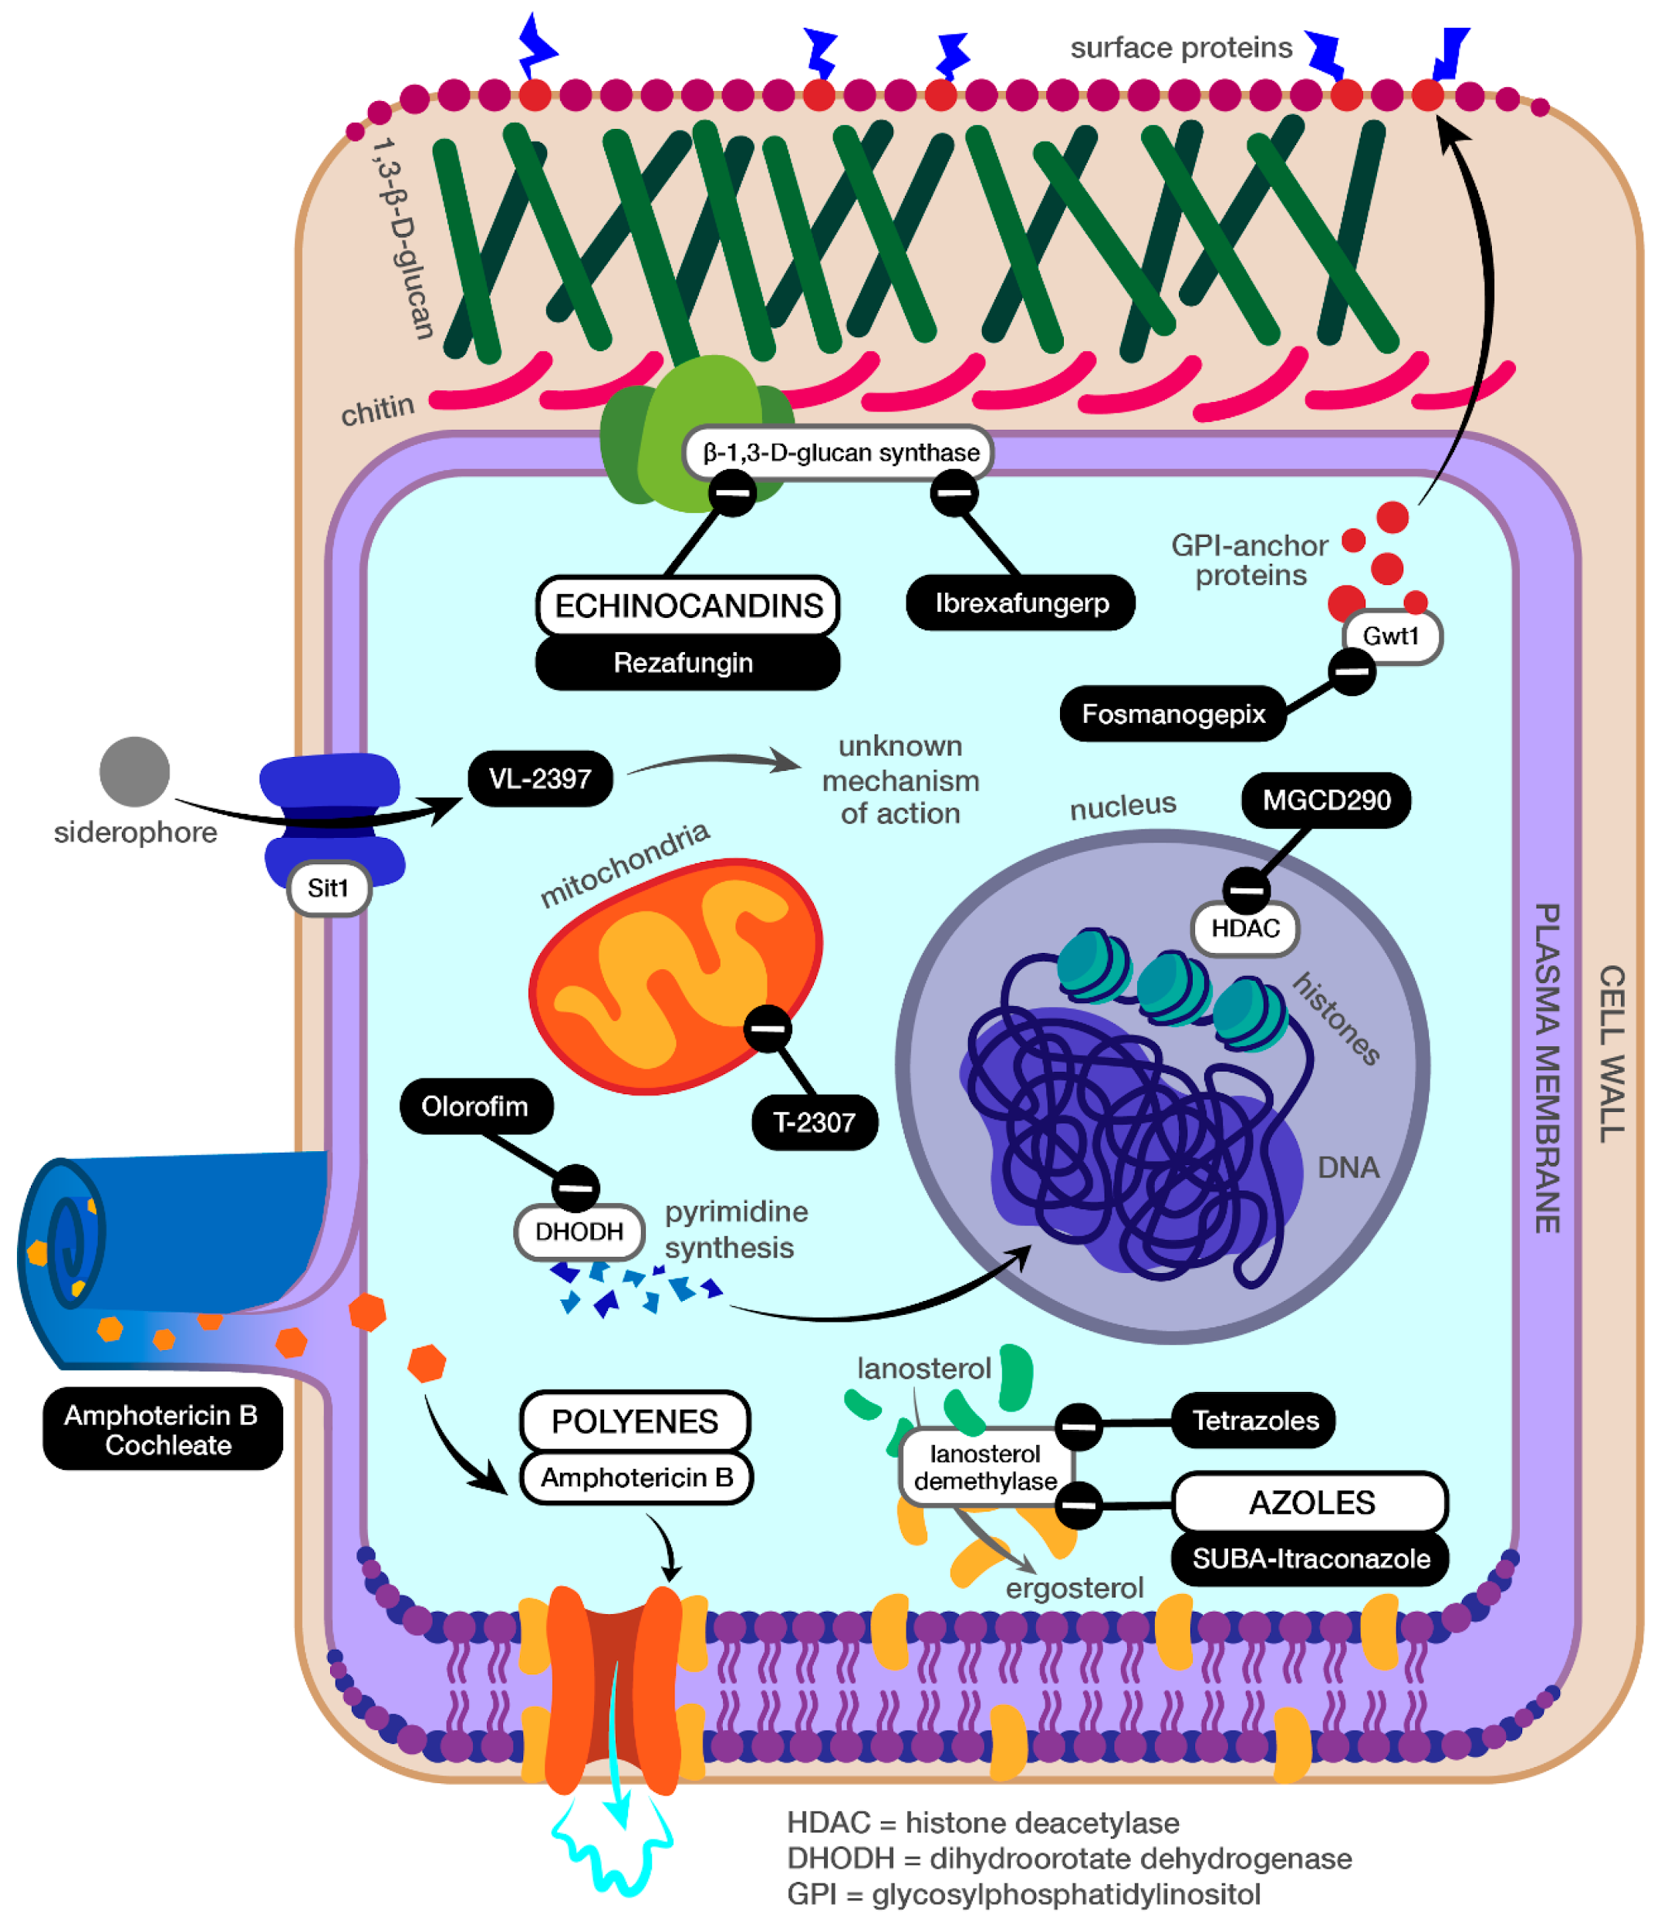

-Structural modifications of antifungal agents aim to improve efficacy, reduce toxicity, and overcome resistance. Here are examples of structural classes and modifications:

**1. Azoles:**

-Basic Structure: Contain an imidazole or triazole ring, which inhibits the fungal enzyme lanosterol 14α-demethylase.

**Modifications**:

-Addition of fluorine atoms to increase binding affinity (e.g., voriconazole).

-Alteration of side chains to enhance specificity and reduce human cytochrome P450 interactions.

**2. Polyenes:**

**Basic Structure:** Large macrolide rings with conjugated double bonds, such as amphotericin B.

**Modifications:**

-Liposomal formulations reduce nephrotoxicity (e.g., liposomal amphotericin B).

-Shortening or altering the polyene chain to improve selectivity.

**3. Echinocandins:**

**Basic Structure:** Cyclic lipopeptides that inhibit β-1,3-glucan synthase.

**Modifications:**

-Changing the lipid tail to improve solubility and distribution.

-Altering cyclic peptide backbones to enhance activity against resistant strains.

**4. Allylamines:**

**Basic Structure:** Inhibit squalene epoxidase.

**Modifications:**

-Addition of functional groups to improve pharmacokinetics and reduce hepatotoxicity (e.g., terbinafine).

**5. Flucytosine:**

**Basic Structure:** A pyrimidine analog that disrupts DNA synthesis.

**Modifications:**

-Prodrug forms or combinations with other antifungals to limit resistance and enhance potency.

**∆ BENEFITS OF STRUCTURAL MODIFICATIONS:**

1. Improved Drug Potency: Structural optimization enhances binding to fungal targets.

2. Reduced Toxicity: Formulations like liposomal amphotericin B minimize slide effects.

3. Broader Spectrum: Modifications allow activity against resistant and emerging fungal species.

4. Enhanced Pharmacokinetics: Changes improve bioavailability, half-life, and tissue penetration.

5. Resistance Mitigation: New derivatives can bypass resistance mechanisms in fungi.

**∆ FUTURE DIRECTION IN ANTIFUNGAL DEVELOPMENT :**

-Designing molecules targeting novel fungal pathways, such as virulence factors or biofilm formation.

-Exploring natural products and their derivatives for antifungal activity.

-Using computational drug design and AI for rapid optimization of antifungal agents.

**∆ CONCLUSION:**

-Antifungal agents play an essential role in the management of fungal infections, ranging from superficial skin conditions to severe systemic mycoses. Their effectiveness stems from targeting unique fungal structures like the cell membrane's ergosterol and the cell wall's glucans, which are absent in human cells. The development of diverse classes such as azoles, polyenes, echinocandins, and allylamines has significantly expanded therapeutic options.

-Despite their success, challenges like drug resistance, adverse effects, and the limited spectrum of some agents persist. Advances in antifungal pharmacology, combined with a deeper understanding of fungal pathogenesis, are critical for improving efficacy, minimizing toxicity, and overcoming resistance. The continued development of novel antifungal agents and combination therapies offers hope for managing emerging and drug-resistant fungal infections in an era of increasing immunocompromised patient populations.

**∆ REFERENCE:**

1)Smith, J., & Brown, K. (2023). Advances in antifungal agents: Mechanisms of action, challenges, and future directions. Journal of Antimicrobial Research, 58(3), 245-260

2)Patterson, T. F., Thompson, G. R., Denning, D. W., Fishman, J. A., Hadley, S., Herbrecht, R., ... & Walsh, T. J. (2016). Practice Guidelines for the Diagnosis and Management of Aspergillosis: 2016 Update by the Infectious Diseases Society of America. Clinical Infectious Diseases, 63(4), e1-e60. <https://doi.org/10.1093/cid/ciw326>

3) Arendrup, M. C., & Patterson, T. F. (2017). Multidrug-resistant Candida: Epidemiology, molecular mechanisms, and treatment. The Journal of Infectious Diseases, 216(Suppl 3), S445-S451.

4) Roemer, T., & Krysan, D. J. (2014). Antifungal drug development: Challenges, unmet clinical needs, and new approaches. Cold Spring Harbor Perspectives in Medicine, 4(5), a019703.

5)Brunton, L. L., Chabner, B. A., & Knollmann, B. C. (2018).

6) Berman, J., & Sud, S. (2013). Antifungal agents: Mechanisms of action and resistance. International Journal of Antimicrobial Agents, 41(4), 308-314.

7)Kao, K., Lin, Y., & Chou, L. (2016). Development of broad-spectrum antifungal agents. Expert Opinion on Drug Development, 21(3), 295-308.

8)Khan, S., Ali, A., & Khan, M. A. (2019). Emerging antifungal resistance and its implications. Journal of Fungi, 5(2), 38.

9)Morrison, V., White, P., & Lee, J. (2007). Pharmacokinetics of antifungal drugs: Factors influencing absorption and bioavailability. Journal of Antimicrobial Chemotherapy, 60(3), 447-453.

10)Sanglard, D. (2016). Mechanisms of antifungal drug resistance in Candida species. Fungal Genetics and Biology, 90, 1-7.

11)Thomson, A. H., & Jass, J. (2005). Pharmacology of antifungal agents. Journal of Antimicrobial Chemotherapy, 55(2), 133-138.

12)Kullberg, B.-J., & Arendrup, M. C. (2015). Invasive Candidiasis. New England Journal of Medicine, 373(15), 1445-1456. doi:10.1056/NEJMra1402583

13)Ghannoum, M. A., & Rice, L. B. (1999). Antifungal agents: mode of action, mechanisms of resistance, and correlation of these mechanisms with bacterial resistance. Clinical Microbiology Reviews, 12(4), 501-517.

14)Kullberg, B.-J., & Arendrup, M. C. (2015). Invasive Candidiasis. New England Journal of Medicine, 373(15), 1445-1456. doi:10.1056/NEJMra1402583.

15)Chin, J., & van Griensven, J. (2021). Antifungal agents: Safety, side effects, and clinical management. Drug Safety, 44(5), 541-555. doi:10.1007/s40264-021-01089-x.

16)Trost, L. B., & Walters, D. R. (2020). Side effects of systemic antifungal drugs. Clinical Drug Investigation, 40(9), 833-849.

17). Hathaway, S. A., & Naber, S. J. (2015). Use of antifungal agents during pregnancy and breastfeeding. Journal of Antimicrobial Chemotherapy, 70(1), 20-30.

18)U.S. National Library of Medicine - Drugs.com. (n.d.). Fluconazole use during pregnancy. Retrieved from Drugs.com.

19) Katzung, B. G. (2021). Basic & Clinical Pharmacology (14th ed.). McGraw-Hill Education.

20)Micromedex Drug Interactions. (n.d.). Retrieved from Micromedex

21)Perfect, J. R., et al. (2017). The antifungal pipeline: a reality check. Nature Reviews Drug Discovery.

22)Ghannoum, M. A., & Rice, L. B. (1999). Antifungal agents: Mode of action, mechanisms of resistance, and correlation of these mechanisms with bacterial resistance. Clinical Microbiology Reviews.

23) Pappas, P. G., Kauffman, C. A., Andes, D. R., et al. (2016). Clinical Practice Guidelines for the Management of Candidiasis: 2016 Update by the Infectious Diseases Society of America. Clinical Infectious Diseases, 62(4), e1-e50. DOI:10.1093/cid/civ933

24) Kullberg, B. J., & Arendrup, M. C. (2015). Invasive Candidiasis. The New England Journal of Medicine, 373(15), 1445-1456. DOI:10.1056/NEJMra1315399

25) Odds, F. C., et al. (2003). Antifungal agents: Mechanisms of action. Trends in Microbiology, 11(6), 272–279. DOI:10.1016/S0966-842X(03)00117-3

26) Brajtburg, J., et al. (1990). Amphotericin B: Mechanism of action and toxicity. Antimicrobial Agents and Chemotherapy, 34(2), 183-188. DOI:10.1128/AAC.34.2.183

27) Denning, D. W. (2003). Echinocandins and antifungal drug resistance: An update. Current Opinion in Infectious Diseases, 16(6), 555–560. DOI:10.1097/00001432-200312000-00007

28) Vermes, A., et al. (2000). Flucytosine: A review of its pharmacology, clinical indications, pharmacokinetics, and toxicity. Clinical Microbiology and Infection, 6(11), 599-607. DOI:10.1046/j.1469-0691.2000.00185.x

29) Ryder, N. S. (1992). Terbinafine: Mode of action and properties of the squalene epoxidase inhibition. British Journal of Dermatology, 126(39), 2–7. DOI:10.1111/j.1365-2133.1992.tb14468.x

30) Denning, D. W., & Bromley, M. J. (2015). How to bolster the antifungal pipeline. Science, 347(6229), 1414-1416. DOI:10.1126/science.aaa6097