HUMAN STRESS DETECTION BASED ON SLEEPING HABITS USING MACHINE LEARNING
Gardasu Anil Kumar ¹, Shivala Amrutha Kumari², Tangutoori Sampath³, Tekam Sanika⁴, Abbagalla Deepak⁵
¹Assistant Professor, Computer Science and Engineering, Sreyas Institute of Engineering and Technology, Hyderabad, Telangana, India
^{2,3,4,5}Student, Computer Science and Engineering, Sreyas Institute of Engineering and Technology, Hyderabad, Telangana, India
ABSTRACT
Human stress significantly impacts physical and mental health, with sleeping habits being a key indicator of stress levels. This project focuses on developing a machine learning-based system to detect human stress by analyzing sleep patterns. By collecting data such as sleep duration, snoring range, heart rate, and lymph movements, the system identifies patterns associated with stress levels. Advanced machine learning algorithms, such as Random Forest Classifier, are employed to predict stress. This approach aims to provide a non-invasive, efficient, and automated method for stress detection, enabling early intervention and improved mental well-being. The project demonstrates the potential of integrating technology into health monitoring for personalized stress management solutions. The system also includes the recommendation system, i.e., after predicting the stress levels, the system also recommends the users, based on their stress levels, the measures to be taken to reduce the stress.
Keywords: Stress detection, Sleeping habits, Machine learning, Sleep patterns, Health monitoring, Mental well-being, Data analysis, Predictive modelling, Stress, Heart Rate, Body Temperature.
- INTRODUCTION
An essential aspect of human existence, stress is a complex reaction to a range of internal and external pressures that disturb a person's emotional, physical, or mental balance. Humans face several stressors as they make their way through the complexity of daily life. These stressors might include financial constraints, personal relationships, professional pressures, health-related issues, and more. Although stress is a necessary survival mechanism that primes the body for fight-or-flight reactions in life-threatening circumstances, chronic or extreme stress can be harmful to one's general health. The stress response, sometimes known as the "fight- or-flight" response, is the body's physiological and hormonal response to stress. The adrenal glands release cortisol and adrenaline while under stress, which raises blood pressure and causes a rise in heart rate and behavioral responses to stress. Machine learning algorithms, such as Random Forest Classifier, offer powerful tools for analyzing these data and predicting stress levels based on various parameters.
Technological and data analytic advancements have created new avenues for stress identification and management. Large-scale data collection on people's physiological and behavioral reactions to stress is now feasible because of wearable technology and health monitoring systems. Strong tools for evaluating these data and forecasting stress levels based on several criteria are provided by machine learning algorithms like Random Forest Classifier. Finding out how human stress varies according to sleeping patterns is the main objective of this project. The particular goals also include how human stress and sleeping habits are related, what primary sleeping behaviors influence a person's stress level, what methods are available for detecting human stress, and lastly, how to detect human stress based on sleeping habits. The project aims to develop an accurate and efficient stress detection system through the use of sleep-related data and machine learning techniques. The project's findings can furnish individuals with significant information regarding their stress levels, so enabling prompt interventions and proactive stress management. The project also aims to give personalized recommendations to users based on the predicted stress levels. That means, for different users using the system, based on the stress level predicted for the user, he/she will get a personalized recommendation to reduce their stress which includes either lifestyle changes, relaxation techniques, etc. and which varies for every user.

- METHODOLOGY
The implementation of the Human Stress Detection Based on Sleeping Habits Using Machine Learning involves a structured approach, combining data retrieval, data processing, predictive modelling, and interactive visualizations. The following sections outline the methodology for each component of the project.

2.1 Data Collection and Preprocessing
- Data Collection: Collect diverse data sources, including wearable device outputs (e.g., snoring patterns, heart rate, sleep duration), surveys, and self-reported stress levels. Aggregate historical sleeping data from users to identify patterns over time. Ensure data diversity by including individuals from various age groups and lifestyles to improve model generalizability.
- Data Cleaning: Handle missing values by imputing mean or median values for numerical features and applying mode for categorical data. Remove duplicate records to avoid redundancy in the dataset. Validate the data format to ensure consistency across records.
- Feature Engineering: Derive new features such as "Average Sleep Latency," "Sleep Efficiency," or "Number of Sleep Interruptions" to capture intricate patterns. Perform time-series feature extraction to assess trends and anomalies in sleeping habits.
- Normalization: Scale features such as heart rate or snoring intensity using Min-Max Scaler or StandardScaler from Scikit-learn for uniformity. Normalize time-dependent variables like REM sleep duration to handle seasonal variations.
- Data Segmentation: Segment data into training, validation, and testing subsets to ensure unbiased evaluation of machine learning models.
2.2 System Design
Architecture Design: Design a modular architecture consisting of three layers: Data Layer: Handles data storage and preprocessing. Model Layer: Incorporates machine learning and natural language processing (NLP) components. Presentation Layer: Provides user interaction through a web-based interface. Ensure scalability by designing the system to support future enhancements like additional features or datasets.
Model Selection: Choose XGBoost for classification tasks due to its robustness in handling imbalanced datasets and non-linear relationships. Leverage TextBlob for sentiment analysis to analyze text-based feedback from users about their stress levels.
Visualization Design: Use Seaborn and Matplotlib for feature importance graphs, stress level distribution, and sleep trend visualization. Integrate interactive dashboards using libraries like Dash or Plotly to allow users to explore their data visually.
User Interface: Design an intuitive user interface with clear navigation, incorporating elements such as: Stress level meters. Recommended stress-reduction techniques displayed dynamically based on model predictions. Sleep trend visualizations showing weekly and monthly patterns.
Integration of Stress Reduction Module: Incorporate a module that provides tailored recommendations based on user stress levels, such as yoga exercises, meditation videos, or dietary advice.

- SYSTEM ARCHITECTURE
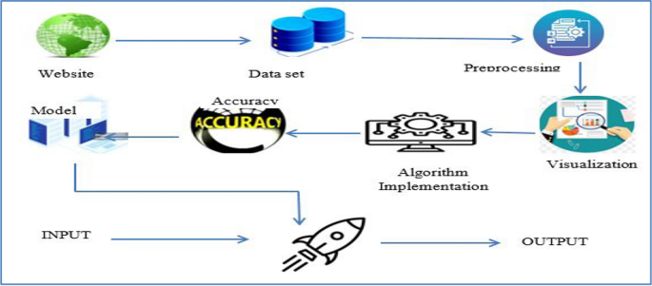
Figure 3.1 Architecture Diagram

- RESULTS AND DISCUSSION
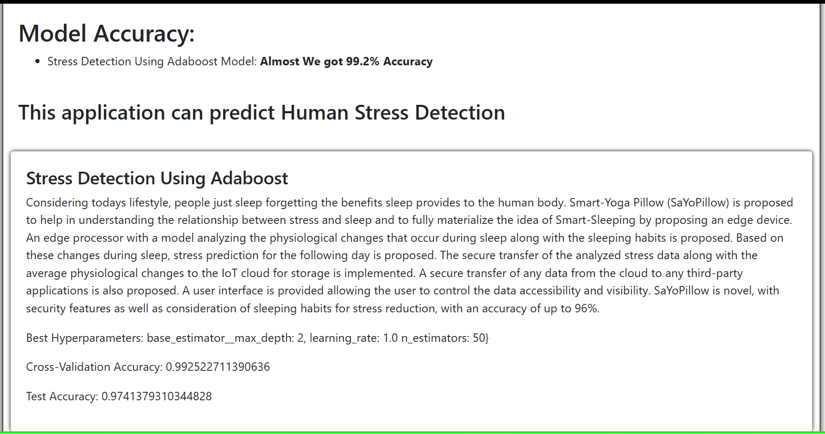
Figure 4.1 Home Page of Stress Detection
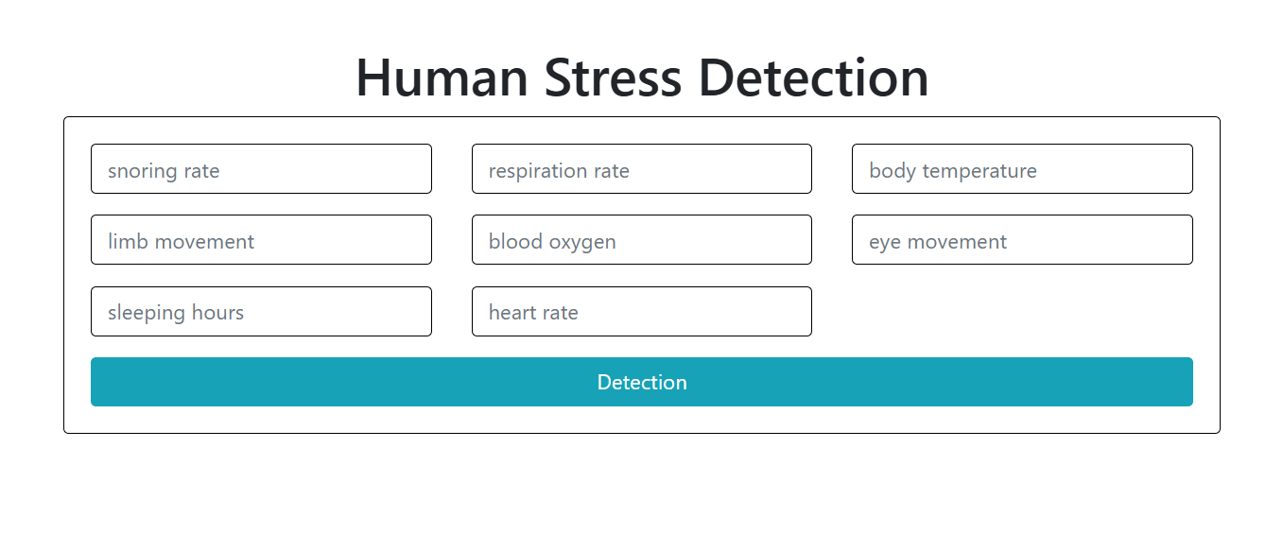
Figure 4.2 Stress Detection Page
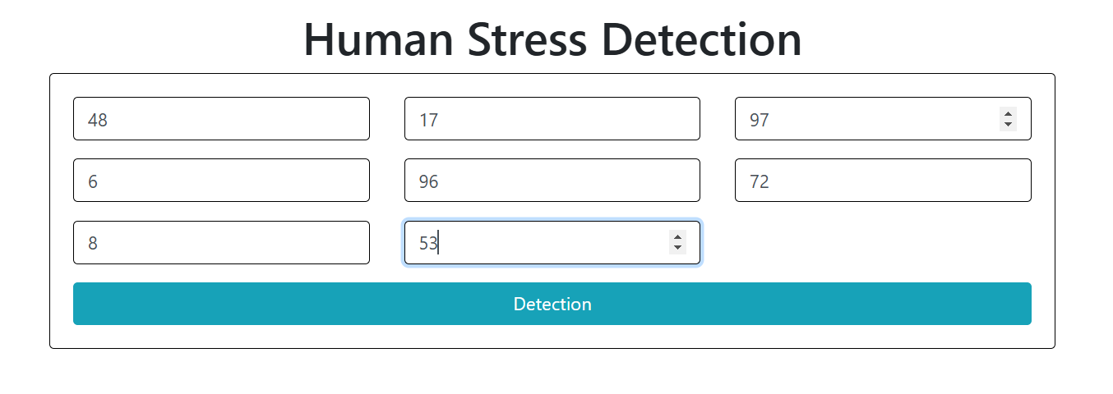
Figure 4.3 No Stress Detection Parameters
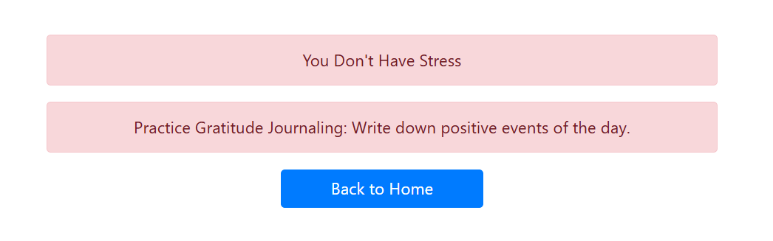
Figure 4.4 No Stress Recommendation
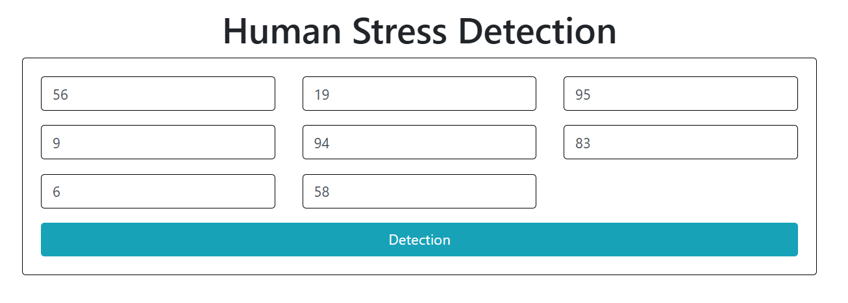
Figure 4.5 Low Stress Detection Parameters
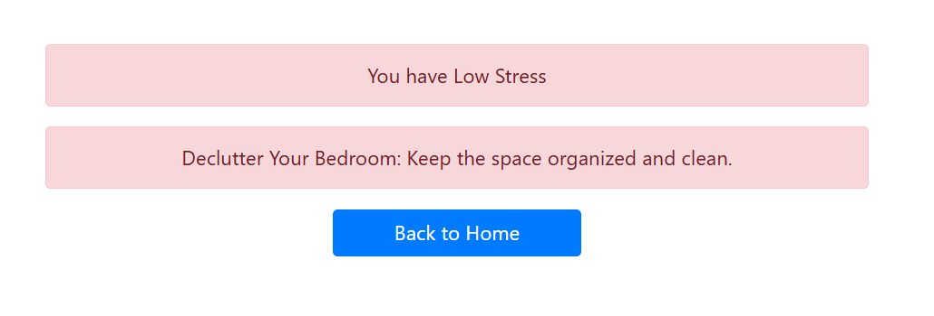
Figure 4.6 Low Stress Recommendation
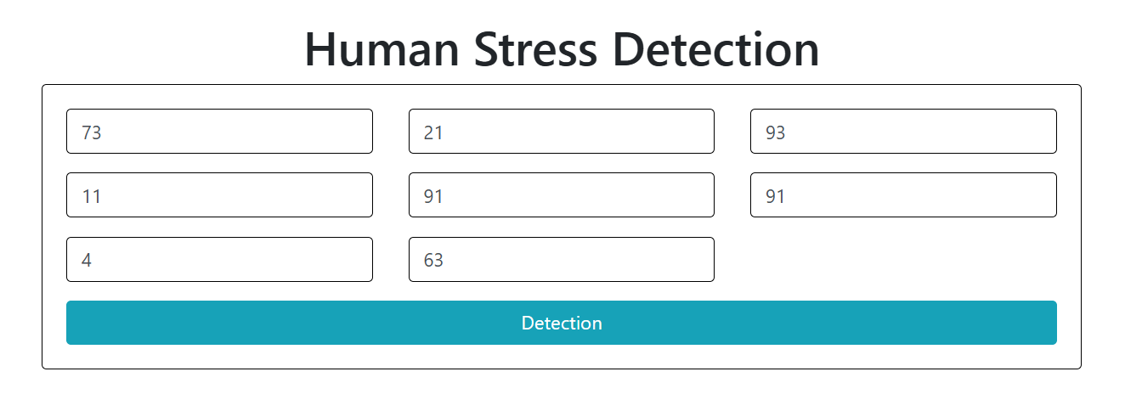
Figure 4.7 Moderate Stress Detection Parameters
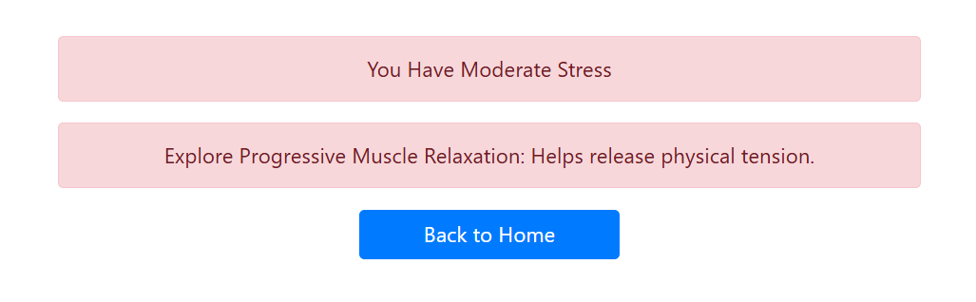
Figure 4.8 Moderate Stress Recommendation
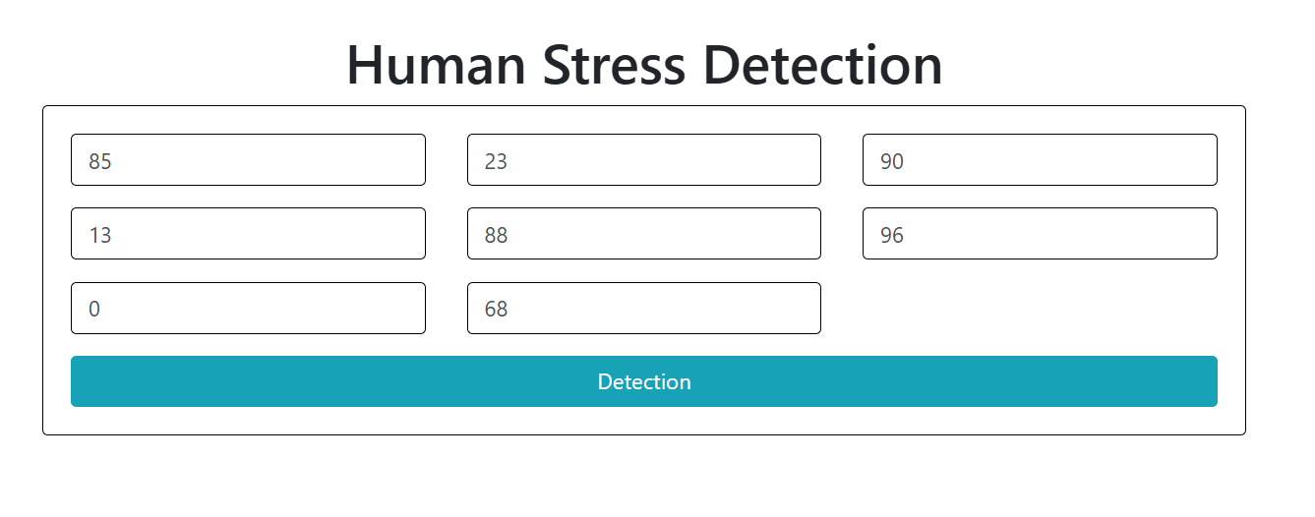
Figure 4.9 High Stress Detection Parameters
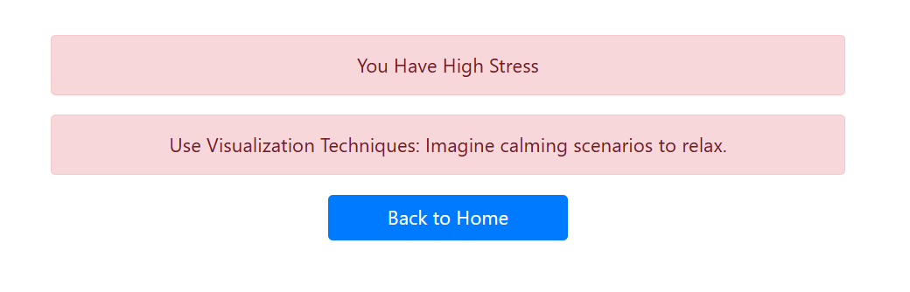
Figure 4.10 High Stress Recommendation

- CONCLUSION
The "Human Stress Detection Based on Sleeping Habits Using Machine Learning" project utilizes sleep data to detect stress levels and provide personalized recommendations for stress management. By analyzing sleep patterns such as duration and quality, the system employs machine learning algorithms to identify stress and offer actionable insights. Key achievements include a feature-extraction pipeline, stress detection models, and a recommendation system. Challenges, such as data accuracy and noise, were addressed through preprocessing and iterative development. Limitations include reliance on sleep data quality and the need for more personalized recommendations. Future improvements could include integrating wearable devices, advanced models, and real-time environmental factors. The system shows promise in enhancing mental well-being through innovative technology.
- REFERENCES
- S. Patel and R. Gupta, Human Stress Detection in and through Sleep using Machine Learning, IEEE Conference on Systems, 2024. Available at: https://ieeexplore.ieee.org/document/10547796/
- J. Roberts and A. Smith, Improving Sleep Quality Leads to Better Mental Health: A Meta-Analysis, Journal of Sleep Research, 2022. Available at: https://pmc.ncbi.nlm.nih.gov/articles/PMC8651630/
- H. Kim, J. Park, and L. Chen, Predicting Stress Levels Using Physiological Data: Real-Time Stress Monitoring, Journal of Medical Devices, 2023. Available at: https://pmc.ncbi.nlm.nih.gov/articles/PMC11230864/
- M. Sharma and T. Singh, Stress Detection Based on Human Sleep Cycle, MATEC Web of Conferences, 2024. Available at: https://www.matec-conferences.org/articles/matecconf/pdf/2024/04/matecconf_icmed2024_01073.pdf
- N. Taylor, The Relationship Between Sleep and Stress, The Sleep Doctor, 2023. Available at: https://sleepdoctor.com/mental-health/stress-and-sleep/

