AI-Enhanced Sustainable Agriculture: Harmonizing Environmental Conservation with Agricultural Prosperity for Future Generations

By Aditya B Dhruva, student at National Institute of Technology, Tiruchirappalli

Dhruva Bhaskara, Senior Director

Contact Email ID:- [adityadhruva2003@gmail.com](mailto:adityadhruva2003@gmail.com)

Contact number: 9035885103

**Abstract:**

The agricultural sector, a cornerstone of India's economy, faces numerous challenges such as climate change, soil degradation, and inefficient resource management. To address these issues and drive sustainable growth, the integration of artificial intelligence (AI) has emerged as a promising solution. By analysing key parameters, including soil composition, weather patterns, crop health, and market trends, AI-powered systems can provide valuable insights for precision agriculture. This approach enables farmers to optimise resource allocation, minimise waste, and maximise yields. Furthermore, AI can facilitate the development of intelligent farming tools and machinery, automating tasks and reducing labour costs.AI can also be employed for processing of the crops, transportation and logistics in order to ensure there are minimal middlemen when it reaches the end consumer. By harnessing the power of AI, India can position itself at the forefront of agricultural innovation and ensure a prosperous future for its farming communities. We can also ensure farming remains as a sustainable career for the forthcoming generations along with the protection of the environment.

**Keywords:**

Artificial Intelligence, Cloud computing, Parameters, Agriculture, Sustainability.

**Compliance with ethical standard:**

1. Conflict of Interest: The authors declare they have no conflict of interest.
2. Ethical Approval: This article does not contain any studies with human participants or animals performed by any of the authors.
3. Informed consent: Not applicable

**Source of Funding:**

This research received no external funding and was entirely self-funded by the authors.

**Backdrop of the agricultural situation in India:**

To gain a deeper understanding of the agricultural landscape in India, it is essential to examine key factors that influence farming practices and productivity. This analysis will focus on four primary areas: **major farming states, soil composition** , **irrigation sources**, and **crop diversity**. By delving into these aspects, we can develop a more nuanced understanding of the factors that drive agricultural development and the challenges that need to be addressed to ensure a sustainable and prosperous future for India's farming communities.

* **Major Farming states:**

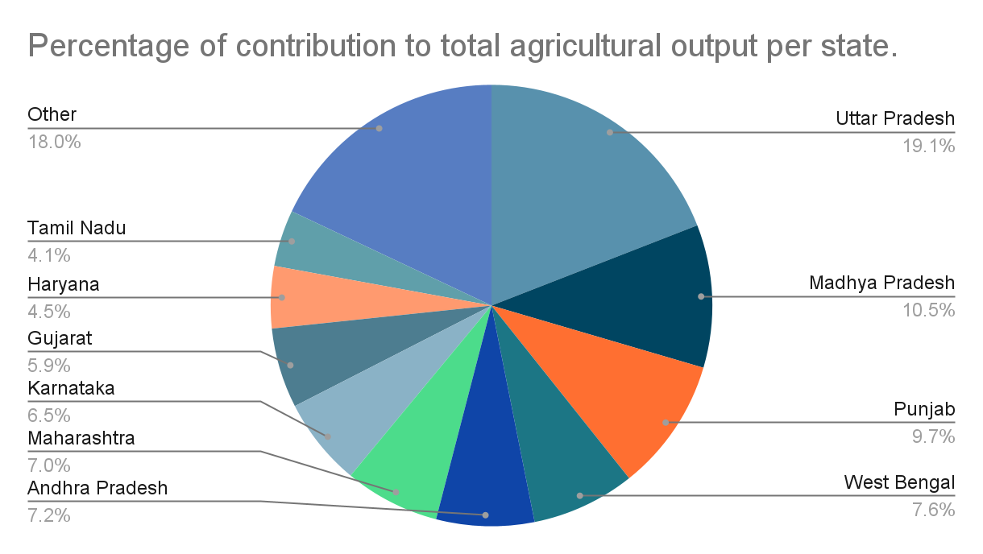

* **Soil Composition and types:**

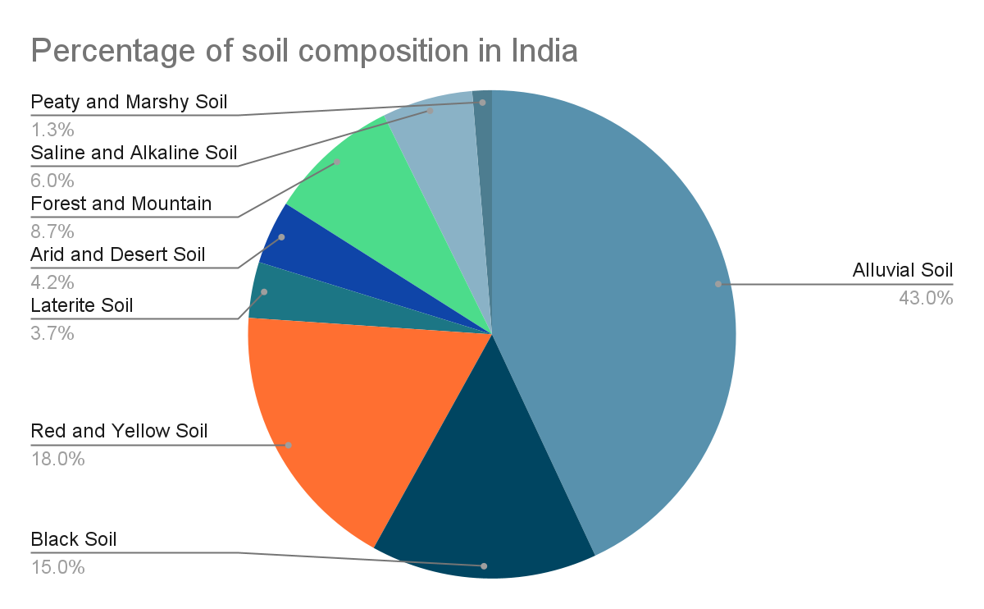

* **Irrigation sources:**
  + 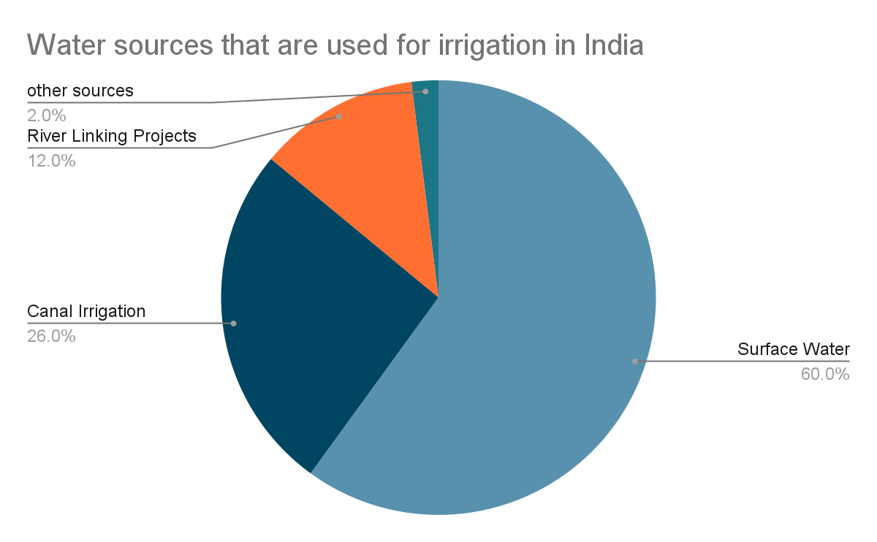
* **Crop Diversity:**

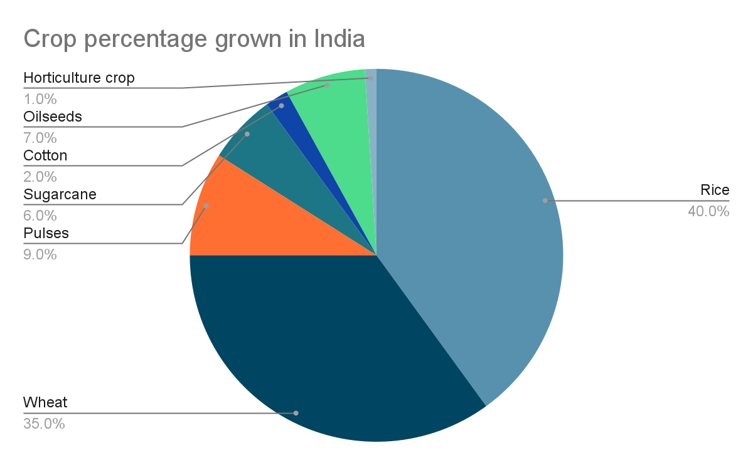

**Economics of the Agriculture sector in India:**

The agriculture sector contributes 17% to the GDP of the nation and provides employment to 58% of the population. The agriculture sector is supposed to grow at a rate of 3.06% from 2024 to 2029. The market size of the agriculture sector is also supposed to be estimated to increase from USD 372.94 billion in 2024 to USD 473.72 billion by 2029.

But it also faces some drawbacks which is environmental degradation which is causing significant losses to the agricultural sector. The other drawbacks include income issues faced by the farmers leading to a lesser number of future generation people taking up the career of farming, infrastructure deficiencies, and slow acceptance for adoption of modern technology.

**Proposed Solution using Artificial Intelligence:**

An AI model is a computational framework designed to perform tasks that typically require human intelligence. These tasks include recognizing patterns, making decisions, and predicting outcomes. AI models are trained using large datasets and algorithms to learn from data and improve over time.

AI models transform sustainability as follows:

* Optimising Resource Use: AI models can analyse data from sensors and satellites to optimise the use of water, fertilisers, and pesticides, reducing waste and environmental impact.
* Monitoring and Predicting Environmental Changes: AI models can process vast amounts of climate data to predict weather patterns, track climate change, and monitor natural disasters in real-time. AI can help monitor wildlife populations and biodiversity, providing critical data for conservation efforts.
* Sustainable Supply Chains: AI can assess climate risks for investments, helping investors make more sustainable choices. AI can identify and support green investment opportunities, driving funds towards sustainable projects.
* Reducing Carbon Footprint: AI can track and manage carbon emissions across various sectors, helping organisations meet their sustainability goals.

The integration of AI models in agriculture is revolutionising the way farmers make decisions about crop cultivation. These intelligent systems can analyse a multitude of factors, including soil health, historical crop performance, and weather patterns, to recommend the most suitable crops for a given location and time of year. For instance, the XAI-CROP algorithm employs explainable artificial intelligence principles to provide farmers with clear insights into the recommendation process, ensuring transparency and aiding in informed decision-making. On this many research papers have been written, but we shall be focussing on the business aspect on how we shall implement it, and how it will affect the income of the farmers.

**Business Model:**

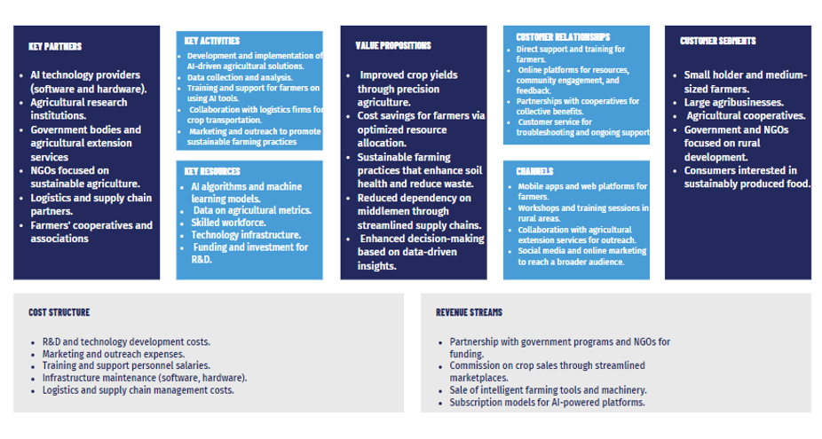

**Implementation of the idea:**

1. The first step would be to implement the data collection procedure techniques. This can be done by fitting IoT sensors with the implementation of fog computing which would then place it in the centralised server.
2. Selection of AI model: We cannot use all problems to fit one model, thus based on the situation we have to choose the right AI model.
3. After that would be to develop an AI model to develop a user interface for conveying the information to the farmer.
4. With growing global warming, the AI model must also suggest the usage of effective technology for water irrigation and which crop can be used for that region such that it sustains that weather.
5. Give information to the farmer on what amount of labour would be needed for growing the crop and how much must be spent for it depending on the market price.
6. Keep the farmer abreast with the latest policy and rules for the agriculture sector with policies encompassed by the local, and central government.
7. Analysing the market demand both locally and globally for the crop that has to be grown.
8. Next, upon harvesting the crop the AI model must convey the farmer the following thing:
   1. Which buyer to sell it to, to ensure the output of the farm reaches the consumer with minimal middlemen interference.
   2. Decision to be taken by that farmer with what to be done with the output in order to maximise profit for the farmer.
   3. For that particular farm of the farmer, which next crop would be best to grow next.
9. Processing the outputs of the farm sold by the farmer to a finished product, with minimal adulteration and minimal damage to the environment using AI.
10. Improvising the logistics using AI for better transportation.

**Future Implications on the economy:**

* AI could potentially increase agricultural yields by 5-10% in developing countries, leading to increased food production and reduced food insecurity.
* AI-driven supply chain management could reduce food waste by 10-20%, leading to significant economic savings.
* AI-powered precision agriculture could increase farmer incomes by 10-20% through improved yields and reduced costs.
* AI can help reduce the environmental impact of agriculture by 10-20%, leading to cost savings and improved sustainability.

**Conclusion:**

By strategically integrating AI into sustainable farming practices and supply chain management, India can significantly enhance agricultural productivity and improve the economic well-being of its farming communities. AI-powered solutions offer the potential to optimise resource allocation, minimise waste, and maximise yields, leading to increased production and higher incomes for farmers. Furthermore, the implementation of AI can position India as a global leader in sustainable agriculture, demonstrating its commitment to innovation and environmental stewardship. We are focussing on developing this further and then make this into a full fledged working model in the local villages around Bangalore and observe the results.

**References:**

* "Artificial Intelligence in Sustainable Agriculture: Enhancing Efficiency and Reducing Environmental Impact" by S. Kumar, D. Singh, and A. Kumar.
* Precision Agriculture: A Guide to Using Information Technology for Sustainable Agriculture by M. A. Sprague and M. J. Helmer.
* Exploring The Impact Of Artificial Intelligence On Sustainable Agriculture: A Case Study Of Precision Farming" by A. K. Singh and S. Kumar.
* Reports from the Indian Council of Agricultural Research (ICAR)
* Reports from the Ministry of Agriculture and Farmers' Welfare
* Reports from organisations like McKinsey, BCG, and Deloitte on AI in agriculture.