BILLY - BUDDY AGAINST CYBER BULLYING

Sanda Naveen Reddy 1, A.V. Divakara Reddy 2, Podamekala Sudheer3, M Obulsubba Reddy 4

1 ,2, 3 ,4, Students, Computer Science Engineering Block Chain, Presidency University, Bengaluru

Arshiya Lubna Associate Professor, Computer Science Engineering, Presidency University, Bengaluru.

***Abstract:***

Cyberbullying is an extremely pervasive issue affecting individuals in their digital lives, with serious psychological and social implications. This paper introduces Billy - Buddy Against Cyberbullying, an AI-powered chatbot designed to provide real-time support, education, and intervention for victims of online harassment. Using natural language processing and machine learning techniques, Billy identifies harmful interactions, provides coping strategies, and connects users with professional resources as needed. The study is concerned with the design, functionality, and impact of Billy, focusing on its role as a proactive companion in promoting safer online environments.

The main goal of Billy is to make the internet a safer place by being an active and supportive virtual friend. With its user-friendly interface, Billy can identify harmful language patterns in real-time messages, comments, or posts. It responds immediately, such as warning users about the impact of their words or advising victims on how to handle bullying situations. Features like anonymized reporting mechanism to alert guardians, moderators or trusted entities about incidents without exposing the victim's identity are offered by Billy. One of Billy's functionalities stands on education and awareness. It utilizes all kinds of interactivity that has been attached with modules or quizzes, so people understand and come to be equipped with correct and constructive behavior regarding cyberbullying. Other functionalities of the program are emotional wellness, utilizing mindfulness exercises for promoting positive psychological status, using motivational prompts or, when deemed appropriate, to contact professional experts. Billy is designed to seamlessly integrate with social media platforms, messaging apps, and online forums through APIs and browser extensions. It maintains the highest data privacy and regulation compliance, keeping all user interactions safe and confidential. The AI model is in a constant process of evolution and learning from new instances of bullying, thus improving detection capabilities, and promoting inclusivity in various languages and cultural contexts. In summary, Billy is a holistic approach to addressing cyberbullying through real-time intervention, education, and emotional support. It creates a culture of empathy and responsibility in online interactions, thus empowering individuals to navigate the digital world confidently and respectfully.

I. Introduction

Today's digital, hyperconnected world has totally changed the way we interact and share information. However, cyberbullying is the dark side that is associated with this revolution in our interaction, learning, and sharing. It has affected millions of people around the globe, especially among the youth. This leaves them with lasting emotional and psychological scars. Therefore, there is an urgent need to develop a proactive solution against it. Here comes Billy - Buddy Against Cyberbullying as a compassionate digital ally to combat online harassment and create safer virtual spaces. Billy isn't a gadget; it is a companion. With state-of-the-art natural language processing, artificial intelligence, Billy recognizes and neutralizes incidents of cyberbullying as soon as it happens.

Whether detecting malicious use of language, or emotional healing, Billy makes sure one feels safe navigating this electronic world. And this amazing company wants the online world to become an exciting, kinder, empathetic, and more supportive community. Billy's goal is to create a safe virtual space where all of its citizens, whether children, teens, or adults, can share and connect freely without the possibility of being bullied or harassed. Creating awareness and offering practical tools enables one to fight cyberbullying and to develop resistance. Together, we can make this virtual world a positive place where people treat each other kindly and with respect. Billy is designed to seamlessly integrate with social media platforms, messaging apps, and online forums through APIs and browser extensions. It maintains the highest data privacy and regulation compliance, keeping all user interactions safe and confidential. The AI model is in a constant process of evolution and learning from new instances of bullying, thus improving detection capabilities and promoting inclusivity in various languages and cultural contexts.

II. literature review

Cyberbullying has become an increasingly pervasive problem in the age of the internet, affecting both young and old, as well as individuals of all races and cultures. The psychological, emotional, and social effects of cyberbullying require novel interventions to mitigate the impact. Of all these technological developments, conversational agents and chatbots have been one of the recent focuses because they can address sensitive topics like bullying. Billy is a buddy against cyberbullying, and this represents a new concept of utilizing AI to deal with this very pressing issue. Cyberbullying prevalence has been well documented in literature. The studies, for instance, by flowlike et al. (2014), point out that anonymity of online environments increases the severity of bullying behavior. Victims experience anxiety, depression, and loss of self-esteem, making the solutions more urgent and in demand- accessible and scalable. Traditional approaches, such as counseling and school- based interventions, have proven effective but are usually resource-limited and carry stigma. Therefore, the use of AI-driven solutions, like Billy, in anti-cyberbullying interventions will increase accessibility and engagement. Chatbots for mental health and well-being, including Wombat and Replica, have established that AI can be effective in providing emotional support and gaining user trust (Fitzpatrick et al., 2017). These systems use NLP to facilitate relevant conversations with users, providing help and advice in terms of coping mechanisms. Building off this, Billy extends functionality only to cyberbullying applications. By detecting abusive speech, providing instant help and support, and teaching user etiquette in digital contexts, research that calls for proactive as well as preventative action, Billy aligns with recommendations.

Moreover, gamification and interactive design principles that can be included in a chatbot like Billy will improve user engagement. Gamified interventions have been shown to increase retention rates and reinforce positive behaviors (Hamari et al., 2014). For younger audiences, such as children and teenagers, these features can make anti-cyberbullying messages more relatable and memorable. Furthermore, Billy's potential to offer anonymity and 24/7 availability addresses critical barriers in traditional support systems.

The ethical considerations of deploying AI solutions in sensitive contexts are also a focus of contemporary research. Privacy, data security, and algorithmic bias are concerns that must be addressed to ensure that tools like Billy are trustworthy and inclusive. Studies by Binns et al. (2018) emphasize the importance of transparent AI systems to build user confidence and mitigate risks of harm.

In summary, Billy—this cyberbullying buddy in AI technology and psychological research

—is an amalgamation toward a crucial issue that the present society needs to face; it has been designed around evidence-based practices and reflects a scalable, user-friendly, and effective intervention. As further research and development occurs in this field, those tools will continue to advance to keep up with all the new and changing evolutions in cyberbullying. Many studies highlight the need for proactive intervention and educational tools that can help reduce the negative impacts of cyberbullying. Peer- support systems, as well as AI-based solutions, are considered promising approaches in early detection and prevention

III. PROPOSED METHODOLOGY

Digitalization has made thousands of things possible but simultaneously brought tremendous challenges for which cyberbullying has come to the fore as an important issue. To meet this, Billy as virtual buddy against cyberbullying can become the solution through its provision of instant assistance, preventive measures and sensitization mechanism. Therefore, the proposed method is being designed with the usage of NLP, Sentiment Analysis and User Centric Features that will keep cyberspace free of bullying. 1. Real-Time Detection of Harmful Content

Billy will utilize advanced NLP algorithms to monitor text-based activities on social media sites, chat applications, and forums. The system will capture harmful language such as abuse, threats, and hatred speech. It will take advantage of sentiment analysis with contextual evaluation for precise determination. For instance, it will distinguish between good fun and malicious speech based on tone, context, or repetition.

1. **User Alerts and Content Moderation**

Upon identifying harmful content, Billy will promptly notify users about potential violations of community guidelines. For minor cases, it will suggest more positive ways to express thoughts, fostering a culture of constructive communication. In severe cases, Billy will flag the content for moderators or automatically block its visibility to protect the targeted individual.

1. **Personalized Support System**

Billy will be a companion to the victims of cyberbullying. Whenever a user reports an incident, Billy will empathize and give resources such as coping strategies, connections to counseling services, and guides on reporting abuse to platform authorities. A chatbot feature will also provide real-time emotional support to users who feel isolated or distressed.

1. **Education and Awareness Campaigns**

To be proactive against cyberbullying, Billy will add educational tools for parents, educators, and students. There will be interactive modules, games, and quizzes on digital etiquette, emotional intelligence, and the power of standing up against bullying. These tools will raise a generation that is informed of the repercussions of online harassment.

1. **Privacy and Ethical Considerations**

The proposed method would prioritize user privacy and ethical considerations. All interactions would be encrypted, and data collection would be minimized. Users would have control over their data, with clear opt- in/opt-out options. Billy's algorithms would be designed to avoid bias and ensure fair treatment for all individuals, regardless of their background.

1. **Community Engagement and Feedback Loop**

Billy will have a feedback mechanism that will improve its performance continually. Users will be able to report false positives, suggest feature enhancements, and share experiences to improve the system. Community forums and partnerships with advocacy organizations will help align Billy with the needs of diverse user groups.

The proposed method for Billy integrates technology, empathy, and education to handle cyberbullying issues holistically. Through real-time detection, personalized support, and awareness campaigns, Billy aims to create a safer and more respectful digital environment. Continuous improvement and collaboration can make Billy a reliable buddy in the fight against cyberbullying.

security measures, including data encryption and access controls, are diligently implemented.

Define cyberbullying and its effects on the victim, especially children and teenagers.

Identify common scenarios where cyberbullying occurs, such as social media, online gaming, and messaging platforms.



1. **Target Audience Analysis**

Focus on vulnerable groups, such as school students, young adults, and educators.

Understand their challenges and expectations for a support tool.

1. **Solution Design**

Develop Billy as a virtual buddy with the following key features:

Detection: Use NLP to identify harmful or abusive content in real-time.

Prevention: Educate users on cyber etiquette and the consequences of cyberbullying.

Support: Provide emotional support through positive reinforcement and suggest coping strategies.

Reporting: Facilitate easy reporting

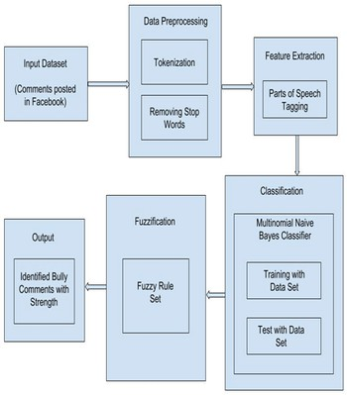

Data Collection: Gather a diverse dataset of bullying and non-bullying language for training.

NLP Model Development: Train an AI model to detect harmful language and context. Integration: Implement Billy into platforms like chat apps, social networks, and educational portals.

User Interface: Develop a user-friendly interface that is kid-friendly with easy navigation.

FIG 5: INTERFACE OF WEB SITE

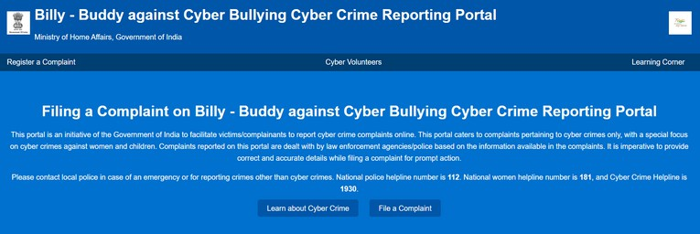

FIG 6: CHAT-BOT

FIG 9: OUR DOCTORS DETIALS

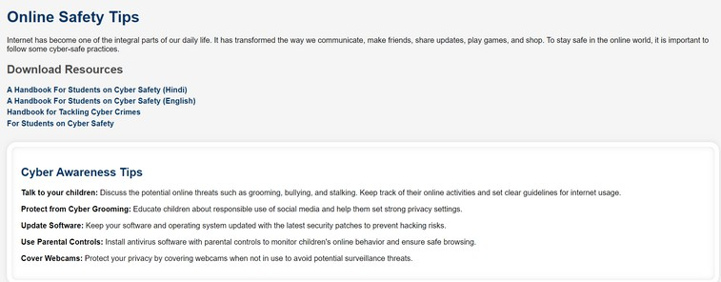Moreover, the personalization and accuracy of responses are significantly improved through the application of machine learning algorithms. By analyzing user data, these chatbots are c.

FIG 10: CONTACT SUBMISSIONS

Finally, ML-powered chatbots also play a crucial role in data management and analytics. By collecting and analyzing user interactions in real time, they yield valuable data regarding

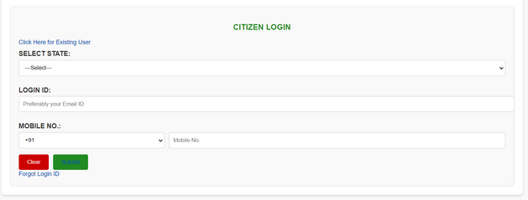

V. CONCLUSION

The initiative to develop and implement a machine learning-driven customer support chatbot for hospital websites constitutes a noteworthy advancement in the modernization of healthcare communication. Through the application of sophisticated natural language processing (NLP) and machine learning (ML) techniques, this chatbot effectively mitigates significant challenges related to patient interactions and operational efficiency. It provides responses that are instantaneous, accurate, and contextually appropriate, thereby augmenting patient satisfaction while simultaneously alleviating the workload experienced by hospital personnel.

The design features of the chatbot facilitate adaptability and scalability, ensuring its effectiveness is maintained even when faced with increased demand. Its capability for continuous learning enables the system to adapt to evolving patient requirements and shifts in hospital operations, which is essential for sustaining relevance and operational effectiveness over time. Furthermore, the incorporation of analytics derived from data empowers hospitals to make judicious decisions, thereby enhancing service quality and allowing for the proactive management of patient concerns.

The achievements of this chatbot exemplify the transformative influence of artificial intelligence and machine learning within the healthcare sector. As the system is poised for further The main objective of this program is to empower individuals on how to detect, prevent, and counter cyberbullying in today's digital world. Cyberbullying has become a widespread concern in this modern era because of social media and Internet communication, and it affects many people irrespective of their age group. Through the character Billy, the program will design an approachable and trust-worthy source for victims who will feel free to report cases of cyberbullying, ask for help, and raise their voices against harassment through the Internet

Billy is a symbol and guide, providing advice, strategies, and resources to handle cyberbullying. The program often includes educational campaigns, interactive tools, workshops, and support systems to empower individuals to safely navigate the online world. It promotes the idea of being a "buddy" to others online—acting as a supportive presence for those who may be experiencing harm or distress in the digital environment

The chatbot's capabilities may also be expanded to include the integration of real-time health data derived from wearable devices, which would allow for a more proactive approach to patient care. This evolution could extend to assisting users with In sum, "Billy - Buddy Against Cyberbullying" is a worthwhile and important step against the worst effects of cyberbullying, arming the next generation and their communities with the tools to craft.

In a nutshell, "Billy - Buddy Against Cyber Bullying" is a reminder of how important it is to stand up against online harassment. The journey of Billy and his supportive buddy highlights the negative impact of cyberbullying on mental health and well- being. It emphasizes the need for empathy, kindness, and awareness in the digital world where the lines between reality and the virtual space often blur. This will ensure a safety for all users on the network while teaching the younger minds the way to detect cyberbullying, to raise complaints, and even intervene on such instances. Finally, Billy's experience learns that we can all together form our "buddies" with fighting cyberbullying as "friends" and hence be more courteous, compassionate, and respected.

"Billy - Buddy Against Cyberbullying" is a step forward in creating a safer digital environment for individuals, particularly for vulnerable groups. By leveraging advanced natural language processing (NLP) and machine learning technologies, Billy acts as a vigilant companion that detects, prevents, and educates users about the harmful effects of cyberbullying.

Billy's proactive approach fosters a sense of security and accountability within online communities, empowering users to engage in healthier, more positive digital interactions. Furthermore, its focus on raising awareness and providing emotional support underlines the project's commitment to mental well-being and social responsibility.

As cyberbullying continues to evolve in form and intensity, solutions like Billy demonstrate the power of technology in tackling societal challenges. Through continuous innovation, user feedback, and community collaboration, Billy can contribute to building a more inclusive and respectful digital world.

REFERENCES

[1] Smith, P. fl., et al. (2008). "Cyberbullying: Its Nature and Impact in Secondary School Pupils." Journal of Child Psychology and Psychiatry, 49(4), 376-385.

[2] flowalski, R. M., & Limber, S. P. (2007). "Psychological, Physical, and Academic Correlates of Cyberbullying and Traditional Bullying." Journal of School Health, 77(5), 309-317.

**Falade, P. V. (2024).** Deciphering ChatGPT's Impact: Exploring Its Role in Cybercrime and Cybersecurity. International Journal of Scientific Research in Computer Science and Engineering, 12(2).

**Faraz, A. (2022).** Protectbot: A Chatbot to Protect Children on Gaming Platforms. Rochester Institute of Technology.

[3] Belsey, B. (2005). "Cyberbullying: An Emerging Threat to the ‘Always On’ Generation." Bullying.org

[4] Jiang, L., & Lee, S. S. (2020). "The Role of Online Platforms in Combatting Cyberbullying." Social media + Society, 6(2), 1-12.

[5] Levan, M., & Holtz, fl. (2014). "Preventing Cyberbullying through Education and Peer Support." Journal of Adolescent Health, 55(2), 127-132.

[6] Willard, N. E. (2007). "Cyberbullying and Cyberthreats: Responding to the Challenge of Online Social Aggression, Threats, and Distress." Research Press

[7] Bauman, S. (2010). "Cyberbullying in a Rural Context: A New and Different Challenge." Journal of School Violence, 9(3), 233-247.

[8] Schenk, A. M., & Fremouw, W. J. (2012). "Prevalence and Psychological Correlates of Cyberbullying in a Community Sample of Adolescents." Journal of Youth and Adolescence, 41(7), 564-576.

[9] Levan, M., & Holtz, fl. (2014). "Preventing Cyberbullying through Education and Peer Support." Journal of Adolescent Health, 55(2), 127-132.

[10] Willard, N. E. (2007). "Cyberbullying and Cyberthreats: Responding to the Challenge of Online Social Aggression, Threats, and Distress." Research Press

[11] Bauman, S. (2010). "Cyberbullying in a Rural Context: A New and Different Challenge." Journal of School Violence, 9(3), 233-247.

[12] Schenk, A. M., & Fremouw, W. J. (2012). "Prevalence and Psychological Correlates of Cyberbullying in a Community Sample of Adolescents." Journal of Youth and Adolescence, 41(7), 564-576.

**[13] Hinduja, S., & Patchin, J. W. (2015).** Digital dating abuse among a national sample of US youth. Journal of Interpersonal Violence, 36(23-24), 11088-11108.

[14] **Kiritchenko, S., Nejadgholi, I., & Fraser, K. C. (2018).** Confronting abusive language online: A survey from the ethical and human rights perspective. Journal of Artificial Intelligence Research, 71, 431-478.

[15] **Kowalski, R. M., Giumetti, G. W., Schroeder, A. N., & Lattanner, M. R. (2014).** Bullying in the digital age: a critical review and meta-analysis of cyberbullying research among youth. Psychological Bulletin, 140(4), 1073.

[16] Wright, M. F. (2014). "The Role of Parenting in Cyberbullying." Cyberpsychology, Behavior, and Social Networking, 17(4), 272-277.

[17] **Morin, H. K., Bradshaw, C. P., & Kush, J. M. (2018).** Adjustment outcomes of victims of cyberbullying: The role of personal and contextual factors. Journal of School Psychology, 70, 74-88.

[18] **MR, N. K., Vishwachetan, D., DM, M. A., Dayananda, K. J., Manasa, K. J., & Nanda, K. V. (2024, February).** An Efficient Approach to Deal with Cyber Bullying using Machine Learning: A Systematic Review. In 2024 Second International Conference on Emerging Trends in Information Technology and Engineering (ICETITE) (pp. 1-8). IEEE.

[19] **Sanu, E., & Mummigatti, M. (2023, November).** Design of Chatbot to Prevent Cyberbullying from Social Media. In 2023 International Conference on Sustainable Communication Networks and Application (ICSCNA) (pp. 1437-1441). IEEE.