**AUTONOMUS HUMAN -TRACKING ROBOT CAR**

J Ramesh1, P Amulya2, K Bhavani3, D Jahnavi4, N Sathwik5

1Assistant Professor, Department of ECE, Jyothishmathi Institute of Technology & Science Karimnagar

2,3,4,5 B.Tech Final Year Students ,Department Of ECE In Jyothishmathi Institute of Technology & Science, Karimnagar

**ABSTRACT**

The Human-Following Robot Car using Arduino is designed to autonomously follow a human target in real-time. The system uses an Arduino microcontroller, ultrasonic/infrared sensors, and motor drivers for movement control and tracking. The robot continuously detects the human’s position, adjusting its speed and direction as needed. Integrated obstacle detection ensures safe navigation without collisions. The project demonstrates a cost-effective, efficient solution for applications like personal assistance, elderly care, and delivery automation. It highlights the potential of robotics to enhance automation in everyday tasks.

**1.INTRODUCTION**

Human-following robots are a significant innovation in robotics, aimed at creating systems capable of autonomously detecting, tracking, and following a target individual. These robots find applications in various fields, including personal assistance, healthcare, and logistics. This project focuses on designing a human-following robot using cost-effective components such as an Arduino Uno microcontroller, IR sensors, ultrasonic sensors, and an L298 motor driver. The IR sensors are used to detect the presence of a human or a marker, while ultrasonic sensors measure the distance between the robot and the target, ensuring precise tracking and safe operation. Additionally, the ultrasonic sensors help in obstacle detection, allowing the robot to navigate safely in its environment. The Arduino Uno serves as the central processing unit, processing sensor data and controlling the robot’s movement. The L298 motor driver is employed to regulate the speed and direction of the motors, enabling smooth and accurate navigation.This project highlights the integration of basic electronic components and sensors to create an autonomous robot. The system is designed to follow a target while maintaining a safe distance and avoiding obstacles, making it suitable for controlled environments. Its cost-effective design and simplicity make it an excellent platform for educational purposes, prototype development, and further research. With future advancements, the robot can be enhanced with more sophisticated technologies for improved functionality and adaptability in complex environments.

**2.LITERATURE SURVEY**

**2.1 Existing system**

**• Simple Motion Planning**

The existing system employs a basic motion planning algorithm that is suitable for simple and controlled scenarios but falls short in handling complex environments. This limitation becomes evident when navigating through intricate terrains with irregular paths, narrow passages, or dynamic obstacles. The algorithm's inability to predict and adapt to changes in the environment hinders its performance in real-time applications, making it unsuitable for scenarios with moving objects such as vehicles or pedestrians. Moreover, the system often fails to compute optimal paths in such conditions, leading to inefficiencies in time and energy usage. As a result, the current approach is inadequate for applications that require precision, adaptability, and robust navigation in challenging settings.

**• Safety Concerns**

The current system lacks essential safety features, which poses significant risks during operation. The absence of a reliable obstacle avoidance mechanism increases the likelihood of collisions, potentially causing damage to equipment, people, and property. Furthermore, the system does not include emergency response protocols, such as an emergency stop function, which are critical in mitigating the impact of unforeseen events like sensor malfunctions or loss of control. This deficiency makes the system hazardous in high-risk scenarios where safety is paramount. Additionally, the lack of fail-safe mechanisms limits the system’s reliability and increases the potential for accidents, reducing its suitability for deployment in real-world applications.

**2.2 Disadvantages of the Existing System**

**Limited Scalability**: The simple algorithms used cannot be easily scaled to more complex or larger environments.

**Poor Real-Time Decision Making**: The system cannot react quickly to unexpected changes in the environment, reducing its reliability in dynamic settings.

**High Maintenance Risk**: The lack of advanced safety features increases the risk of frequent damage and higher maintenance costs.

**Low User Confidence**: The absence of robust safety and planning features may deter potential users from adopting the system.

**Unsuitability for Critical Applications**: In industries such as healthcare, transportation, or defense, where precision and safety are non-negotiable, the current system falls short of required standards.

**2.3 Proposed system**

The proposed system is a Human-Following Robot Car powered by an Arduino microcontroller, designed to autonomously track and follow a human target in real-time. This system leverages ultrasonic and infrared sensors to detect and process the position of a human, enabling smooth and dynamic navigation. By continuously analyzing sensor data, the robot adjusts its speed and direction to maintain a consistent following distance, ensuring seamless operation without manual intervention. Furthermore, obstacle detection mechanisms are integrated to enhance safety by avoiding collisions. This cost-effective solution, built on the Arduino platform, utilizes readily available components, making it accessible and easy to develop.Compared to existing systems, the proposed solution offers enhanced tracking accuracy, improved motion planning, and increased reliability. Its modular design allows for scalability and future upgrades, such as GPS integration for navigation or machine learning for advanced recognition. The system is highly versatile, finding applications in logistics, healthcare, retail, and construction. For instance, it can assist warehouse workers by carrying goods, aid medical staff in transporting supplies, or enhance the shopping experience by carrying customer items. The proposed system demonstrates significant potential for improving efficiency and automation in various domains, providing a reliable and user-friendly solution for real-world needs

**Working**

The block diagram represents an Arduino-based robotic system designed for tasks like obstacle avoidance or autonomous navigation. At its core, the Arduino serves as the central controller, receiving input from sensors and controlling the output devices. The system utilizes IR sensors and an ultrasonic sensor to detect obstacles, measure distance, or follow a line. These sensors send input signals to the Arduino, which processes the data and decides the appropriate actions. The Arduino communicates with an L298 motor driver, which acts as an interface to control the motors. The motor driver amplifies the control signals from the Arduino and drives four motors (Motor 1, Motor 2, Motor 3, and Motor 4) to enable movement in different directions, such as forward, backward, or turning. The entire system is powered by a power supply, ensuring smooth operation of the Arduino, sensors, motor driver, and motors. This setup is commonly used in robotic applications for efficient and autonomous operation.

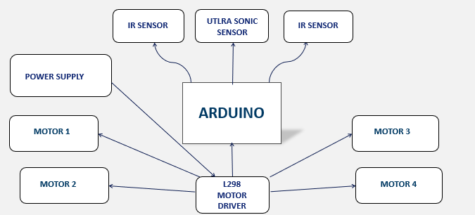

**Figure 1:** Working

**Arduino Uno**

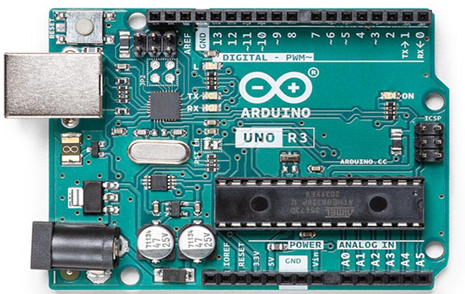

**Figure 2. Arduino Uno**

Arduino Uno is an open-source microcontroller board based on the Microchip AT mega328P microcontroller and developed by Arduino.cc. The board is equipped with sets of digital and analog I/O pins that may be interfaced to various expansion boards (shields) and other circuits. The board has 14 digital I/O pins (six capable of PWM output), 6 analog I/O pins, and is programmable with the Arduino IDE (Integrated Development Environment), via a USB B cable. It can be powered by the USB cable or by an external 9-volt battery, though it accepts voltages between 7 and 20 volts. It is similar to the Arduino Nano and Leonardo. The hardware reference design is distributed under a Creative Commons Attribution Share-Alike 2.5 license and is available on the Arduino website. Layout and production files for some versions of the hardware are also available.

**L298n Motor Driver Shield**

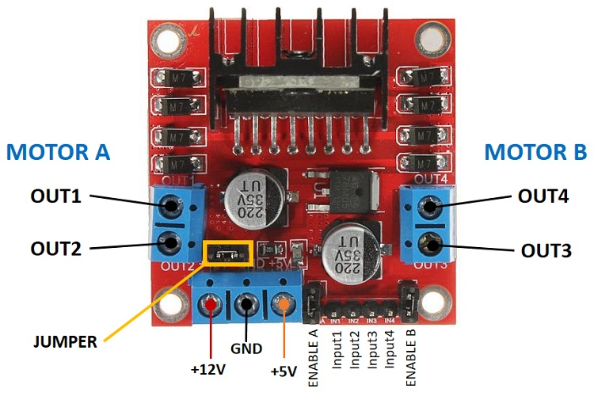

**Figure 3. L298n motor driver**

The L298N motor driver is a commonly used dual H-bridge motor driver module that allows you to control the speed and direction of two DC motors simultaneously. It is especially popular for robotics projects due to its simplicity and ability to handle moderate power requirements. Here's an overview of its key features and functionality:

Key Features:

1. Dual H-Bridge Design: Enables independent control of two motors.
2. Wide Voltage Range: Operates at motor supply voltages ranging from 5V to 35V.
3. Current Capacity: Can handle up to 2A per channel with proper heat dissipation.
4. Built-in Heat Sink: Prevents overheating during operation.
5. Logic Voltage: Compatible with logic levels of 3.3V or 5V for microcontrollers like Arduino or Raspberry Pi.
6. PWM Control: Allows for speed adjustment using pulse-width modulation (PWM).

**3 Result**

Several experiments were conducted to evaluate the performance of the human-following robot. The ultrasonic and infrared sensors were thoroughly tested and found to be accurate within a range of 4 meters. Subsequently, tests were performed to ensure that the robot maintained a specific distance from the target object. The serial communication between the Arduino, motor shield, and various motors was also examined. Based on the results of these experiments, necessary adjustments were made to the processing and control algorithms. Upon completing the evaluations, it was observed that the robot performed exceptionally well, successfully following the target person wherever they moved. Thus, the objective of achieving effective Human-Robot interaction was accomplished.

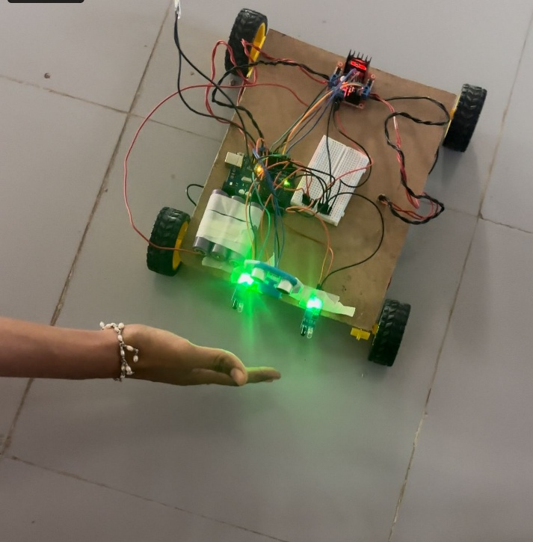

**figure 4. robot Car**

**5.Conclusion**

This paper presents a successful prototype implementation of a human-following robot. The robot is designed not only with detection capabilities but also with the ability to follow a subject efficiently. During the prototype development, a focus was placed on ensuring the robot's operations are as efficient as possible. Various tests were conducted in different conditions to identify and resolve issues in the algorithm. The integration of multiple sensors into the system provided additional advantages for performance enhancement. The human-following robot functions as an autonomous vehicle that can recognize obstacles, adjust its movement, and follow the subject to maintain its position on the correct path.

This project utilizes components such as Arduino, motors, and various sensors to accomplish its objectives. It required the cooperation of different parts to communicate effectively, which expanded the understanding of electronics, mechanical systems, and programming integration.

The core focus of this framework was to design and develop an autonomous following truck using an ultrasonic sensor, capable of tracking a person in unstructured environments. The autonomous truck uses ultrasonic sensors, motor drivers, and a microcontroller to perform its tasks. This approach offers a new perspective in the field of robotics. The autonomous truck has potential applications in reducing labour in certain tasks, and it holds significant promise for the future development of robotic systems.

**5.REFERENCES**

[1] Md Jahidul Islam, Hong, Jungseok Hong and Sattar. 2015. Person Following by Autonomous Robots: A Categorical Overview. Access 22/02/2022.

<https://www-users.cse.umn.edu/~islam034/papers/ijrr19_person.pdf>

[2] Arduino Uno. Wikipedia, 2022. Accessed 22/02/2022.

[Arduino Uno - Wikipedia](https://en.wikipedia.org/wiki/Arduino_Uno)

[3] L293D Motor Driver Shield . .Proto supplies 2022. Accessed 23/02/2022.

<https://protosupplies.com/product/l293d-v1-motor-driver-shield/>

[4]Ultrasonic Sensor HC-SR04. Piborg, 2022. Accessed 23/02/2022. <https://www.piborg.org/sensors-1136/hc-sr04>

[5] Infrared Sensor. Solarduino, 2022. Accessed

https://solarduino.com/infrared-ir-sensor-module-with-arduino/

[6]23/02/2022. Light Emitting Diodes. Accessed 27/02/2022.

http://hyperphysics.phy astr.gsu.edu/hbase/Electronic/leds.html

[7]Stefan–Boltzmann law. Wikipedia. 2022. Accessed 23/02/2022. <https://en.wikipedia.org/wiki/Stefan%E2%80%93Boltzmann_law>

[8]TT DC Motor. 2022.Last minute engineers. Accessed 23/02/2022. <https://lastminuteengineers.com/l293d-dc-motor-arduino-tutorial/>

[9]Danielle D. 2021. The ultimate guide to the 18650 Battery. Fenixlighting. Ac cessed on 23/02/2022.

[https://www.fenixlighting.com/blog/the-ultimate-guide to-the-18650-battery/](https://www.fenixlighting.com/blog/the-ultimate-guide%20to-the-18650-battery/)

[10]L293D Motor Driver Shield. Sunfounder, 2018. Accessed 5/5/2022. <http://wiki.sunfounder.cc/index.php?title=L293D_Motor_Driver_Shield>

[11]Arduino IDE. Wikipedia, 2022. Accessed 22/02/2022.

https://en.wikipe dia.org/wiki/Arduino