**SMART RETAIL MANAGEMENT SYSTEM**

**Srishti Saundarya1, Shreya Sharma2, Rithik Kumar MB3**

1Student, CSE, TJIT, Bengaluru, Karnataka, India

2Student, CSE, TJIT, Bengaluru, Karnataka, India

3Student, CSE, TJIT, Bengaluru, Karnataka, India

**ABSTRACT**

The Smart Retail Management System utilizes Internet of Things (IoT) technology to enhance retail operations and customer experience. By implementing IoT devices like Load cells and RFID tags, the system enables real-time inventory tracking and customer behavior analysis. A cloud-based platform processes this data, offering insights for efficient inventory management. SRMS aims to optimize stock levels, reduce operational costs, and improve customer satisfaction in the retail sector.

**Keywords:** Smart Retail, IoT, inventory management, RFID technology

1. **INTRODUCTION**

A Smart Retail management system using IoT integrates RFID technology and load cells to streamline retail operations and enhance efficiency. RFID tags are used for automated product identification and inventory management, reducing manual errors and saving time. Load cells measure the weight of products, enabling real-time stock monitoring and accurate billing. The IoT framework connects these components, providing centralized control and real-time updates. This system minimizes human intervention, enhances accuracy, and improves the overall shopping experience for customers.

1. **METHODOLOGY**

The methodology for an IoT-based Smart Retail Management System using RFID and load cells involves the following steps:

**2.1 System Design**

Develop a framework integrating RFID readers for product identification and load cells for weight measurement.

* 1. **IoT Integration:**

RFID tags capture product details, while load cells provide real-time weight data. Connect sensors to a centralized system via IoT platforms for real-time data transmission.

1. **MODELING AND ANALYSIS**

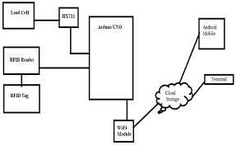

**Figure 1:** Smart Retail Management system

1. **RESULTS AND DISCUSSION**

**1. Efficient Inventory Management**: Real-time tracking and automated updates using RFID and load cells minimized errors and improved stock accuracy.

2. **Enhanced Billing Accuracy**: Weight-based validation ensured precise billing and reduced discrepancies.

3.**Improved Customer Experience**: Faster checkout processes and transparent billing enhanced overall satisfaction.

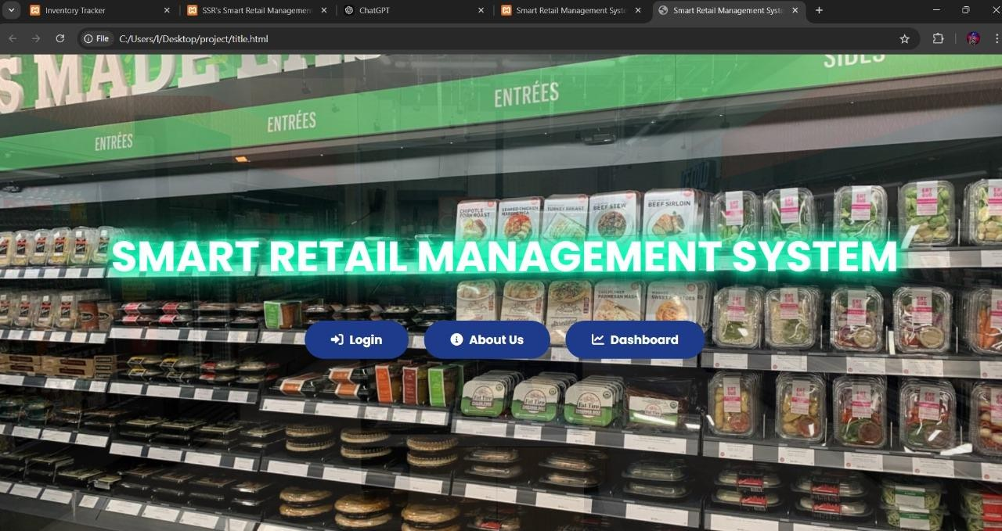

**Figure 2:** Dashboard of SRMS

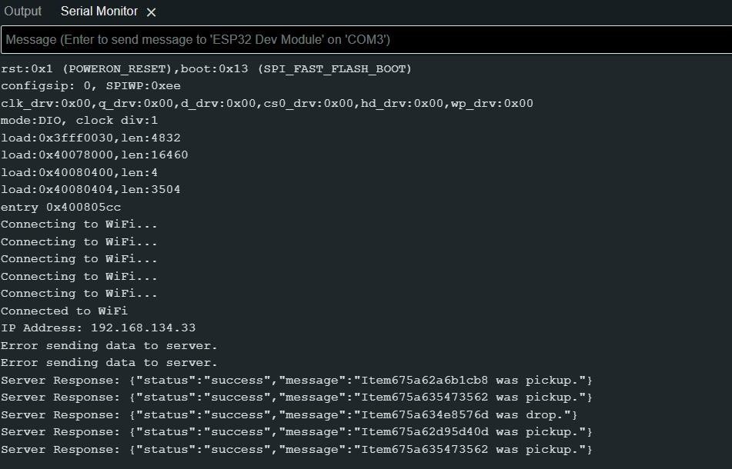

**Figure 3:** Product Recognition

1. **CONCLUSION**

The IoT-based Smart Retail Management System successfully automated inventory management and billing processes using RFID and load cells, reducing manual effort and errors. It enhanced operational efficiency and improved customer satisfaction with real-time updates and accurate transactions. The system demonstrates scalability and potential for future enhancements like AI integration for advanced analytics.

1. **REFERENCES**
2. Kumar, R., & Singh, P. (2023). IoT in Retail: Enhancing Efficiency through Automation. International Journal of Advanced Research in Computer Science, 14(2), 45-50.
3. Smith, J., & Lee, K. (2022). Integration of RFID and Load Cells in Smart Inventory Systems. Journal of Internet of Things Research, 10(3), 123-129.
4. Shepard, S. (2005). RFID: Radio Frequency Identification. McGraw Hill Professional.
5. Gubbi, J., Buyya, R., Marusic, S., & Palaniswami, M. (2013). Internet of Things (IoT): A Vision, Architectural Elements, and Future Directions. Future Generation Computer Systems, 29(7), 1645-1660.