**INTERNATIONAL JOURNAL OF PROGRESSIVE RESEARCH IN ENGINEERING MANAGEMENT AND SCIENCE (IJPREMS)**

[**www.ijprems.com**](http://www.ijprems.com/)

[**editor@ijprems.com**](mailto:editor@ijprems.com)

**SOFTWARE ENGINEERING: AN OVERVIEW OF CURRENT TRENDS AND FUTURE DIRECTIONS**

**Shoaib Shabir, Saif Ali**  
Software Engineer, Department of Research and Development, e2open, Bangalore, India.  
Analyst II, Department of Software Development, Indore, Madhya Pradesh, India.

**ABSTRACT**

Program Design is the foundation of advanced mechanical headway, driving developments over businesses. This survey paper investigates the current patterns, techniques, and challenges in program building while analysing its future potential. Points such as Dexterous techniques, DevOps hones, Manufactured Insights in computer program advancement, and headways in computer program quality confirmation are examined. The paper concludes by highlighting the significance of economic hones and intriguing approaches in forming a long-standing time in computer program engineering.

Keywords: Program Building, Spry, DevOps, Counterfeit Insights, Computer program Quality Confirmation.

**INTRODUCTION**

Program design (SE) plays an essential part in the advanced age, empowering the advancement of strong, adaptable, and effective computer program frameworks. With the exponential development of innovation, SE has advanced into a multifaceted teach-enveloping plan, improvement, testing, and support. This paper gives a comprehensive survey of key trends, challenges, and openings within the field. A centre on the appropriation of Dexterous and DevOps strategies, integration of Fake Insights (AI) apparatuses, and the accentuation on program quality affirmation underscores the significance of SE in cultivating mechanical advancement and unwavering quality.  
  
**Evolution of Software Engineering**

The history of SE dates back to the 1960s when the "program emergency" highlighted the require for orderly approaches to program improvement. Over time, it has developed to incorporate organized programming, object-oriented ideal models, and model-driven advancement, tending to issues of complexity and versatility. Present-day SE grasps hones like Dexterous, DevOps, and Nonstop Conveyance, reflecting its flexibility to changing requests.

**METHODOLOGY**

This survey is based on an examination of existing writing, case ponders, and industry reports to distinguish winning patterns and rising developments in program building. The inquire about incorporates:

**2.1 Literature Review**

A precise audit of later distributions, diaries, and conference procedures related to SE techniques, instruments, and systems. Key sources incorporate IEEE, ACM Advanced Library, and other high-impact diaries.

**2.2 Industry Insights**

Experiences from driving organizations actualizing cutting edge SE hones, centring on case considers illustrating the affect of Dexterous, DevOps, and AI-driven devices. Interviews with industry specialists and overviews conducted among program experts moreover give subjective information.

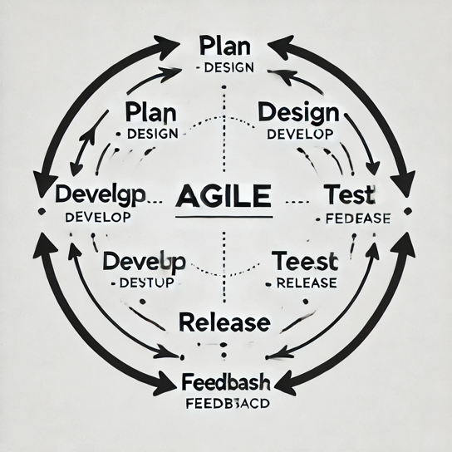**MODELING AND ANALYSIS**

**Figure 1: Agile Development Workflow.**

**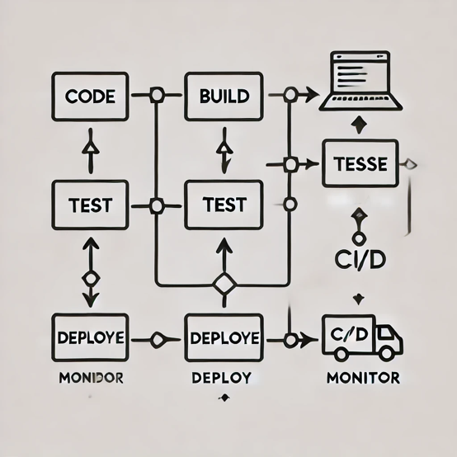  
Figure 2: DevOps Pipeline Workflow.**

**  
Figure 3: AI Applications in Software Engineering.**

Key headways and models in computer program designing are categorized as takes after:

**3.1 Agile and DevOps Methodologies**

* **Agile Frameworks:** Accentuation on iterative advancement cycles to improve adaptability and collaboration. Well known techniques incorporate Scrum, Kanban, and Extraordinary Programming (XP). Real-world applications illustrate moved forward group efficiency and speedier conveyance cycles.
* **DevOps Practices:** Integration of improvement and operations to streamline program conveyance and sending. Devices such as Jenkins, Docker, and Kubernetes encourage robotization and make strides framework unwavering quality.

**3.2 Artificial Intelligence in SE**

* **AI-Driven Advancement:** Mechanized code era, blunder location, and investigating utilizing apparatuses like GitHub Copilot and Tabnine. AI quickens advancement by lessening manual intervention.
* **Machine Learning Models:** Improving prescient upkeep and chance evaluation through models prepared on authentic information, empowering proactive issue determination.

**3.3 Software Quality Assurance**

* **Automation Tools:** Selenium, JUnit, and CI/CD pipelines for comprehensive testing. Test robotization guarantees consistency and spares time amid relapse testing
* **Metrics and KPIs:** Centre on unwavering quality, execution, and security measurements to guarantee high-quality program. Measurements such as code scope, deformity thickness, and Cruel Time To Recuperation (MTTR) are commonly utilized.



**RESULTS AND DISCUSSION**

**4.1 Industry Appropriation Trends**

An expanding number of organizations are leveraging Spry and DevOps to decrease time-to-market whereas keeping up tall program quality benchmarks. For occasion, companies like Netflix and Amazon utilize microservices engineering nearby CI/CD pipelines to realize consistent arrangement and versatility.

**4.2 Challenges**

* **Complexity Administration:** Taking care of the complexity of advanced computer program frameworks, especially in conveyed and cloud situations. Progressed reliance administration devices are basic to moderate these issues
* **Security Vulnerabilities:** Developing concerns over cybersecurity dangers in program improvement. Procedures like risk modelling, secure coding hones, and normal entrance testing offer assistance to address these challenges.

**4.3 Opportunities**

* **Supportability:** Creating energy-efficient program frameworks to diminish natural affect. Green coding hones and eco-friendly information centres are rising patterns.
* **Intrigue Collaboration:** Joining bits of knowledge from areas like information science, UX plan, and cognitive science to make user-centric and shrewdly computer program arrangements. Collaborative instruments like Figma and Miro empower consistent cross-functional collaboration.



**CONCLUSION**

Software Building proceeds to advance, driven by progressions in strategies, apparatuses, and advances. This paper highlights the transformative affect of Spry, DevOps, AI, and quality affirmation hones. Future bearings incorporate prioritizing supportability, improving cybersecurity measures, and cultivating intrigue collaboration to address the ever-growing requests of the advanced scene. In addition, the joining of AI and machine learning will likely rethink the way computer program frameworks are planned, created, and kept up, clearing the way for a more intelligent, more productive future.



**ACKNOWLEDGEMENTS**

The creator recognizes the bolster and direction of colleagues and the motivation from the broader computer program designing community.



**REFERENCES**

1. **T. Mohana Priya, Dr. M. Punithavalli & Dr. R. Rajesh Kanna, Machine Learning Calculation for Advancement of Upgraded Bolster Vector Machine Method to Foresee Stretch, Worldwide Diary of Computer Science and Innovation: C Program & Information Designing, Volume 20, Issue 2, No. 2020, pp 12-20.**
2. **Ganesh Kumar and P. Vasanth Sena, “Novel Artificial Neural Networks and Logistic Approach for Detecting Credit Card Deceit,” International Journal of Computer Science and Network Security, Vol. 15, Issue 9, Sep. 2015, pp. 222-234.**
3. **Gyusoo Kim and Seulgi Lee, “2014 Payment Research”, Bank of Korea, Vol. 2015, No. 1, Jan. 2015.**
4. **Chengwei Liu, Yixiang Chan, Syed Hasnain Alam Kazmi, Hao Fu, “Financial Fraud Detection Fluid: Based on Random Forest,” International Journal of Economics and Finance, Vol. 7, Issue. 7, pp. 178-188, 2015.**
5. **Hitesh D. Bambhava, Prof. Jayeshkumar Pitroda, Prof. Jaydev J. Bhavsar (2013), “A Comparative Study on Bamboo Scaffolding and Metal Scaffolding in Construction Industry Using Statistical Methods,” International Journal of Engineering Trends and Technology (IJETT) – Volume 4, Issue 6, June 2013, Pg. 2330-2337.**