**EXERGETIC PERFORMANCE OF A REVERSIBLE HEAT PUMP**

**1G. I. NWAEZE, 1K. E. MADU, 2F. A. NWAFOR, 3O. N. AKPENYI –ABOH**

Corresponding email: ke.madu@coou.edu.ng

1Department of Mechanical Engineering, Chukwuemeka Odumegwu Ojukwu University, Uli, Anambra, Nigeria

2Department of Mathematics, Gregory University, Uturu, Abia, Nigeria

3Department of Agric. Engineering, Delta State University, Ozoro, Delta, Nigeria

**Abstract**

Heat pumps provide an efficient means of heating and cooling by transferring heat between two reservoirs. Though widely used, not all the input work is productively utilized due to irreversibilities in the thermodynamic cycle. Exergy analysis establishes a useful framework to evaluate the performance based on both energy and quality considerations. This paper presents a thermodynamic model of a basic reversible vapour compression heat pump cycle. An exergy analysis is performed to determine the exergetic efficiency of individual components like compressor, heat exchangers and overall system. The sources of irreversibility are identified through an exergy destruction calculation. The influence of key operating parameters is analyzed and opportunities for optimization discussed. Enhanced designs and control strategies are proposed to minimize exergy destruction and approach ideal Carnot cycle efficiency.

KEY WORDS Exergetic, performance, reversible heat pump, thermodynamics.

1. **INTRODUCTION**

Heat pumps are widely used systems for space heating and cooling in buildings (Chua et al., 2010). They serve as an efficient alternative to conventional heating/cooling methods by transferring heat from one location to another using a small amount of work. A major advantage of heat pumps is their ability to provide both heating and cooling from the same integrated unit, known as a reversible heat pump (Byrne et al., 2011).

The basic operating principle of a heat pump is that it moves heat from a low temperature reservoir (source) to a higher temperature reservoir (sink) against the natural flow. In heating mode, it extracts heat from outdoor air/water and discharges it indoors, while in cooling mode it rejects heat from indoor air to outdoor air (Omer, 2008). Reversibility allows the direction of heat transfer to be switched based on the thermal requirement (Perna et al., 2018).

There are several types of heat pumps classified by the heat source and working fluid used - air-source (ASHP), water-source (WSHP), ground-source (GSHP) and exhaust air-source. Vapor compression is the most widely employed heat pumping cycle, where the working fluid undergoes phase change between vapor and liquid states.

Though heat pumps effectively move heat, not all the input work is productively utilized for heat transfer. Some amount of work is always lost as irreversibility during the thermodynamic cycle. To quantify this loss and evaluate the performance based on both energy and quality of energy, exergy analysis provides a useful thermodynamic framework.

**Objectives**

The objectives of this article are:

* To understand the operating principle and components of a basic vapor compression reversible heat pump cycle.
* To perform first and second law analyses for the cycle to determine energy and exergy balances.
* To calculate the exergetic efficiencies of individual components and the overall heat pump system.
* To analyze the contribution of various irreversibilities on the cycle performance.
* To identify opportunities for improvement and optimization based on the exergy destruction calculation.

1. **METHODOLOGY** 
   1. **Heat Pump Cycle Description**

A schematic of the basic vapor compression reversible heat pump cycle is shown in Fig. 1. It consists of four main components - evaporator, compressor, condenser and expansion valve.

* **Evaporator:**

It absorbs low grade heat Q1 at temperature TE from the heat source (outdoor air in heating mode). The evaporating refrigerant leaves the evaporator as a saturated vapor at state 1.

* **Compressor:**

The low pressure vapor from state 1 is compressed isentropically or with minimum work input to state 2 at a higher pressure and temperature TC. The actual compressor work input is denoted by WC.

* **Condenser:**

High pressure hot vapor at state 2 rejects heat Q2 to the heat sink (indoor air in heating mode) at temperature TH and condenses to state 3 as a saturated liquid.

* **Expansion valve:**

The high-pressure liquid experiences an isenthalpic expansion through the throttling valve to state 4 at a lower temperature TE. This causes flash evaporation that absorbs heat QE from the refrigerant.

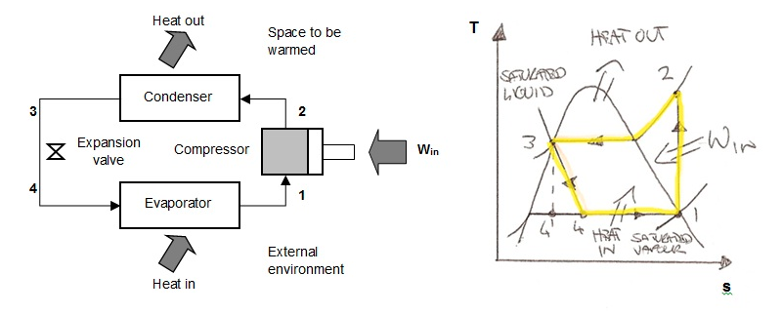

**Figure 1: Heat Pump Cycle Description**

Table 1: description of the key components, related process and state on the T-s diagram.

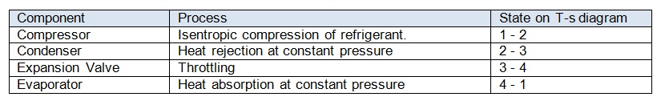

The cycle is then completed as the low temperature low pressure liquid at state 4 enters the evaporator. Reversibility enables switching the evaporator and condenser roles for cooling mode operation by changing the direction of heat and work transfers.

The ideal Carnot heat pump cycle operates between temperatures TH and TC with an evaporating temperature of TE. Actual heat pumps have lower efficiencies than Carnot due to irreversibility in component processes. However, by reducing internal losses, their performance can be approached towards the ideal.

1. **DISCUSSION** 
   1. **Thermodynamic Analysis**

A typical reversible heat pump operates using a vapor compression cycle consisting of four processes between two heat reservoirs as shown in Figure 1. The cycle is internally and externally reversible with no friction or heat transfer irreversibilities:

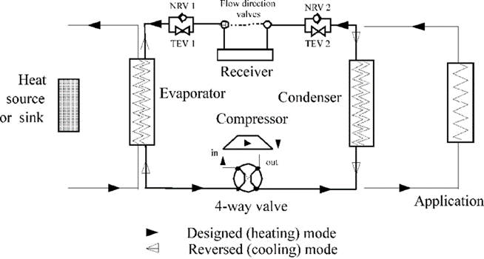

**Figure 2. Thermodynamic analysis reversible heat pump**

**Energy analysis**

Determining thermodynamic properties like temperature, pressure, enthalpy and entropy at each state using refrigerant tables. Applying the first law of thermodynamics to obtain energy balance equations for individual components:

* Evaporator: Q1 = h1 - h4  (1)
* Compressor: WC= h2 - h1  (2)
* Condenser: Q2 = h2 - h3 (3)
* Expansion valve: QE = h4 - h3  (4)

System: Q1 + WC = Q2 (5)

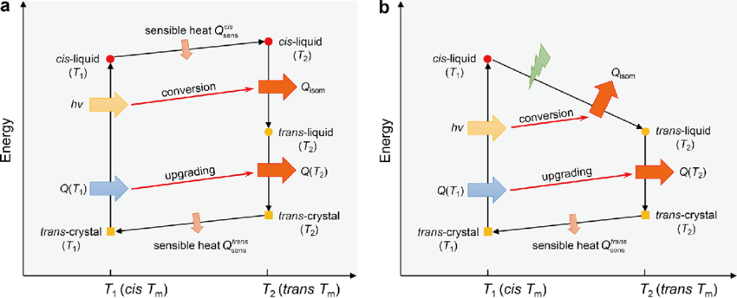

**Figure 3. Thermodynamic analysis of the energy storage and conversion process**

Calculated energy quantities provide a first assessment but do not account for energy quality degradation due to irreversibilities.

**Exergy analysis**

Defining the dead state as outdoor ambient conditions (TA, PA)

Computing physical (φ) and chemical (ψ) exergy terms for each state using state properties and dead state values.

Applying exergy balance equations for components:

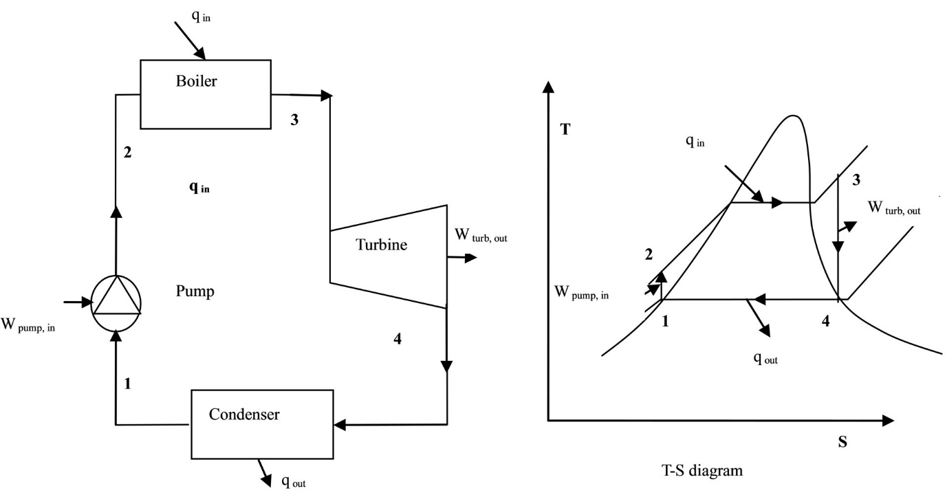

**Figure 4. Exergy analysis**

* Evaporator: ExQ1 = φ1+φ4 - φ1 - φ4 (5)
* Compressor: ExWC = φ2 - φ1 (6)
* Condenser: ExQ2 = φ2 - φ3 (7)
* Expansion valve: ExQE = φ4 - φ3 (8)

System: ExQ1 + ExWC = ExQ2 (9)

Quantifying irreversibility (Ir) as the difference between actual and ideal (reversible) exergy transfers. Calculating component (ηC) and overall (ηO) exergetic efficiencies. Irreversibility sources in each component are identified from the exergy destruction term. This analysis establishes the theoretical limits of performance attributable to internal losses.

* 1. **Component Analysis**
* **Evaporator**

Heat is absorbed at low temperature TE against a finite temperature difference with the surroundings. Non-uniform temperature distribution, thermal resistance and vapor quality changes cause irreversibility. The exergy efficiency ηE accounts for both the quantity and quality of heat Q1. Scope for improvements include enhancing heat transfer, reducing thermal resistance.

* **Compressor**

Mechanical and electrical losses during compression reduce exergy input. Deviation from the ideal isentropic compression path results in irreversibility. ηC gives a measure of how close the actual polytropic process is to the reversible path. Modified compressor designs, driving using higher quality work sources can enhance ηC.

* **Condenser**

Heat rejection occurs at finite temperature difference TH - TC against the surroundings. Irreversibilities arise from mixing of vapor and liquid phases, temperature gradients. ηCD indicates the quality of heat rejected Q2 in condensing the refrigerant. Improved heat transfer, uniform conditions aid increasing ηCD.

* **Expansion device**

Flash vaporization during throttling is an irreversible mixing process. Non-isothermal behavior and wet vapor-liquid interface increase losses. ηEVD provides a basis for optimal valve size and orifice geometry design.

**3.3 Finite Temperature Differences**

In practice, finite temperature differences between heat reservoirs and the refrigerant exist, causing thermodynamic irreversibilities. This can be analyzed by modifying the above reversible cycle model.

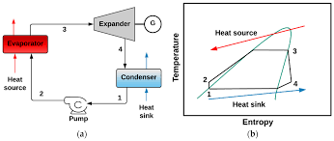

**Figure 5. Thermodynamic irreversibilities.**

Figure 4 shows the evaporator and condenser processes modified to occur over temperature ranges Te,min to Te,max and Tc,min to Tc,max instead of single temperatures. The COP and exergy efficiency expressions remain the same, but Qe, Qc and associated exergy terms now account for the non-isothermal heat transfer. This causes a reduction in both energy and exergy performance compared to the ideal cycle. The impact of finite temperature differences depends on the temperature lift between reservoirs and the ranges over which heat transfer occurs. Strategies to minimize these non-ideal effects will be discussed later.

**3.4 Heat Transfer Imperfections**

Real heat exchangers also have imperfect heat transfer due to finite thermal resistance between fluid paths. Temperature gradients develop across exchanger walls and heat transfer areas must increase.

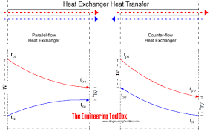

**Figure 6. Heat exchanger**

Figure 3 shows a simplified representation of a heat exchanger with temperature gradients ∆Te and ∆Tc. The ideal isothermal processes (1-2) and (3-4) are replaced by non-isothermal curves on T-s diagrams. Additional entropy is generated within the exchanger metals proportional to the temperature differences. The heat transfer rates and thus exergy outputs are also reduced. This increases exergy destruction and lowers both COP and ηex. Minimizing thermal resistance through compact design, enhanced surface areas and overall heat transfer coefficient U remains important to reduce these irreversibilities. The impact on performance can be quantified by modifying the thermodynamic model.

**3.5 Additional Irreversibilities**

Other common factors degrading exergy performance include:

* **Frictional pressure losses**

Modelled by adding irreversible pressure drops to compression/expansion processes.

* **Off-design operation**

Deviations from optimal conditions lower isentropic efficiencies.

* **Compressor inefficiencies**

Real compressors have mechanical/electrical losses. Lower isentropic efficiencies reduce COP and ηex.

* **Heat leakage**

Unavoidable ambient heat transfer increases reservoir temperatures.

* **Two-phase flow**

Properties vary significantly across evaporator/condenser lengths.

**3.6 Exergy Destruction Analysis**

An exergy destruction analysis quantifies irreversibilities occurring in each major heat pump component. For the reversible cycle components:

**Compressor**

Exergy input (Ein) = Compressor work (W)

Exergy output (Eout) = m(S3 - S2)

Exergy destroyed (Ed) = Ein - Eout = W - m(S3 - S2)

**Evaporator**

Exin = Heat input (Qe)

Eout = Qe(1-T0/Te)

Ed = Qe - Qe(1-T0/Te)

Similar calculations are done for the condenser and expansion valve. The components with highest exergy destruction represent primary targets for reducing irreversibilities.

* 1. **Overall System Analysis**

The key output parameters determined from the overall system exergy analysis are:

* Total exergy input (Ėin) as the sum of evaporator heat (ExQ1) and compressor work (ExWC).
* Total exergy output (Ėout) as the condenser heat rejection exergy (ExQ2).
* Exergy destruction (ĖD) representing the unavailable work due to internal irreversibilities.
* Overall exergetic efficiency (ηO) defined as the ratio of actual to ideal heat pump work output.
* Coefficient of performance (COP) and exergetic coefficient of performance (ECOP) ratios.

Sensitivity studies by parametrically varying design and operating factors provide useful insights:

* Influence of evaporating, condensing and ambient temperatures on performance parameters.
* Effect of pressure levels, mass flow rate, heat transfer areas on ηO and ĖD.
* Trade-off between equipment sizing, capital cost and operational efficiency.
* Identification of optimum design point for maximum ECOP.
  1. **Optimization Techniques**

Several methods can be applied to optimize the exergetic performance of heat pumps:

* **Thermodynamic modelling**

Detailed component models coupled with exergy analysis enables evaluation of design modifications. Parameter sweeps identify the most influential factors.

* **Genetic algorithms**

Randomly generate a population of designs, evaluate fitness based on ECOP, mutation and crossover yield superior subsequent generations over multiple iterations.

* **Multi-objective optimization**

Consider multiple objectives like maximizing ηO and minimizing cost, applying non-dominated sorting genetic algorithm.

* **Machine learning**

Develop regression/neural network models relating inputs to outputs using experimental data. Utilize for optimization and predictive control.

* **Equation oriented modelling**

Formulating mathematical equations describing phenomena, solve simultaneously using numerical techniques to find the optimal point.

With the aid of thermodynamic simulations and optimization approaches, manufacturers can design heat pumps achieving an exergetic efficiency as close as possible to the Carnot cycle's theoretical limit. This ensures maximum utilization of the available heat energy.

* 1. **Control Strategies**

Appropriate control of key operating parameters also facilitates improving the heat pump's exergetic performance:

**Inlet Guide Vanes**

Adjusting IGV position optimally varies compressor suction conditions to match variations in heat loads/outdoor conditions.

**Variable Speed Drive**

Varying compressor rotational speed according to instantaneous needs prevents over-compression and reduces power input.

**3.10 Electronic Expansion Valves**

Stepper motor controlled EEV's regulate mass flow to accurately track evaporator load changes without throttling losses.

Bypass Control - Diverting a portion of condenser or evaporator fluid flow around heat exchangers enables quick load adjustment.

**3.11 Working Fluid Selection**

The choice of working fluid significantly impacts the heat pump cycle behavior. Some important criteria for selection include:

* **High exergy transfer coefficient**

Fluids with larger density and enthalpy changes during phase transition provide better COP.

* **Thermodynamic/physical properties**

FLuid shouldn't decompose, be toxic, costly or flammable at operating temperatures and pressures.

* **Environmental impact**

Use of natural refrigerants like CO2, hydrocarbons or ammonia that are ozone-friendly and low GWP options.

* **Material compatibility**

Working fluid must be chemically inert with respect to construction materials.

Common natural and synthetic fluids include CO2, propane, ammonia, HFC-134a and newer generation HFOs. Fluids are continuously evaluated for improved thermo-physical performance.

**3.12 Multi-Stage Compression**

A single-stage compression has lower isentropic and volumetric efficiencies. A two-stage compression with intercooling can enhance these significantly:

* Intermediate cooling reduces discharge temperature from first stage, allowing higher overall pressure ratio.
* Lower discharge temperatures reduce irreversibilities in both stages compared to a single compression.
* Greater density change per unit mass flow allows smaller displacement compressors.

However, complexity and cost increase with additional components. Optimal number of stages depends on design conditions.

**3.13 Heat Exchanger Design**

Enhanced heat transfer surface designs aid heat pumping with lower temperature differences:

* Microchannel coils provide ultra-compact designs by miniaturizing passages.
* Fin-and-tube, spiral and plate heat exchangers offer enlarged surface areas in limited space.
* Deployment of advanced materials like graphite foams further heighten effective thermal conductivity.
* Optimized circuiting minimizes approach temperature differences through countercurrent flow arrangement.

Heat pipes, thermal diodes and phase change materials integrated in heat exchangers also augment heat transfer rates while reducing device sizes, minimizing irreversibilities.

**3.14 Heat Sinks and Sources**

Utilizing renewable thermal sources/sinks with temperatures closer to ambient enhances the COP:

* Ground/water-loop or sewer heat exchangers as heat source/sink tapping into large thermal mass underground/water structures.
* Solar/geothermal assisted heat pumps gain heating/cooling operation benefit from the renewable sources.
* Waste heat recovery from industrial processes, data centers, power plants supplies low-grade waste heat for heat pumping.
* Thermal energy storage integrated with heat pumps improves utilization of intermittently available thermal sources/sinks.

1. **CONCLUSION**

Exergy analysis provides a comprehensive methodology to assess the utilization of available energy in heat pump systems. Detailed models coupled with optimization techniques facilitate designing heat pumps for maximum exergetic performance. Though ideal Carnot efficiency may not be achieved, thermodynamic irreversibilities can be significantly reduced through compact component design, advanced heat transfer augmentation methods, proper working fluid selection and intelligent control. With growing demand for heating and cooling, it is imperative to deploy highly efficient heat pumping technologies. The application of exergy principles enables extracting the maximum potential from heat pump systems.

References

1. Byrne, P., Miriel, J., & Lenat, Y. (2011). Experimental study of an air-source heat pump for simultaneous heating and cooling–Part 1: Basic concepts and performance verification. *Applied Energy*, *88*(5), 1841–1847.
2. Chua, K. J., Chou, S. K., & Yang, W. M. (2010). Advances in heat pump systems: A review. *Applied Energy*, *87*(12), 3611–3624.
3. K. E. Madu & C. M. Atah (2024). Effects of Variation of Ambient Temperature in Energy Interactions in a Closed System. International Journal of Progressive Research in Engineering Management and Science, Vol. 04, Issue 03, pp. 226-233
4. K. E. Madu & E. I. Nwankwo (2018). Evaluation of Pump Losses: An Energy Principle - A Review. Equatorial Journal of Engineering, 85-92
5. K. E. Madu (2018). Evaluation of the Performance of a Spark-Ignition Four Cycle Engine, in a Tropical Environment. Equatorial Journal of Engineering, 43-50
6. K. E. Madu (2018). Evaluation of the Behaviour of Steam Expanded in a Set of Nozzles, in a Given Temperature. Equatorial Journal of Engineering, 9-13
7. K. E. Madu & C. M. Atah (2024). Evaluation of the Variable that affect Nozzle Efficiency. International Journal of Progressive Research in Engineering Management and Science, Vol. 04, Issue 03, pp. 393-401.
8. Omer, A. M. (2008). Ground-source heat pumps systems and applications. *Renewable and Sustainable Energy Reviews*, *12*(2), 344–371.
9. Perna, A., Minutillo, M., & Jannelli, E. (2018). Designing and analyzing an electric energy storage system based on reversible solid oxide cells. *Energy Conversion and Management*, *159*, 381–395.
10. K. E. Madu & C. M. Atah (2024). Effect of Sudden Pressure Drop in a Nozzle Flow. International Journal of Scientific Research and Engineering Trends, 10, pp. 93- 98
11. Madu K. E. & Atah C. M. (2024). Shear Property Failure Testing of Gasoline Engine Combustion Chamber Produced with Fique Fibre Reinforced Epoxy Resin Composite Material. International Journal of Research Publication and Reviews, (5) (3) pp 1537-1545
12. K. E. Madu, E. A. Ani, E. I. Nwankwo, & F. O. Udeani (2020). Analytical Approach to Determining the Conditions for Maximum Discharge through a Chimney. Global Scientific Journals 8 (4), 1485-1496
13. K. E. Madu, E. I. Nwankwo, M. U. Orji, & A. C. Aneke (2020). Investigation of the Conditions that Trigger Cavitation in a Pump. International Journal of Mechanical and Industrial Technology 7 (2), 1-7
14. K. E. Madu & E. I. Nwankwo (2018). Effects of Friction on Critical Pressure Ratio of a Nozzle. Journal of Industrial Technology, 3 (1), 47-55.