**AUTONOMOUS SELF DRIVING CAR**

# Sana Subramanyam1, Kasam Neeraja2, Marri Ganesh3, Vadlakonda Srinidhi4, Gajula Rohith5

1Assistant Professor, Department of ECE, Jyothishmathi Institute of Technology & Science Karimnagar, Telangana, 505481, India.

2,3,4,5 B.Tech Final Year Students, Department of ECE In Jyothishmathi Institute of Technology & Science, Karimnagar, Telangana, 505481, India.

# ABSTRACT

This project focuses on the development of an autonomous self-driving car utilizing an Arduino Uno microcontroller, ultrasonic sensors, and a servo motor. The car is programmed in C to navigate independently by emitting ultrasonic waves, measuring distances, and determining optimal paths to avoid collisions. The integration of ultrasonic sensing and servo motor technology enables the vehicle to detect obstacles, adjust its direction, and adapt efficiently to its surroundings, ensuring seamless autonomous navigation. This design leverages AI-assisted sensors and decision-making systems to enhance the functionality of the car, highlighting its potential to reduce accidents, lower fuel consumption, and improve mobility. By eliminating the need for human intervention, the project demonstrates how advanced automation can address challenges in obstacle avoidance and navigation. The innovative use of low-cost components, such as the Arduino Uno, combined with intelligent control algorithms, showcases a scalable approach to advancing autonomous vehicle technology. This system not only exemplifies the practical application of real-time data processing and sensor integration but also contributes to broader efforts in making self-driving cars a safer, more efficient alternative for modern transportation. The project underscores the transformative impact of autonomous vehicles on mobility and safety, while exploring innovative solutions to existing challenges in autonomous driving.

**Keywords:** self-driving car, Arduino Uno, Ultrasonic sensors, Servo motor, Collision avoidance, Autonomous navigation, Mobility enhancement.

# 1. INTRODUCTION

Self-driving cars are designed to navigate and make decisions independently, without human intervention. These vehicles use a combination of sensors to detect their surroundings, including pathways, road signals, and environmental factors. Autonomous cars offer several benefits over traditional vehicles, such as reduced fuel costs, enhanced safety, increased mobility, and improved customer satisfaction.

One of the main advantages is the potential to significantly reduce traffic accidents, which are often caused by human errors like distraction, impaired driving, or poor judgment.

By removing human drivers and enabling vehicles to communicate with each other, self-driving technology aims to lower accident rates.

With rapid advancements in technology, especially in areas like information technology, data analysis, and communication, the development of autonomous vehicles is progressing quickly. The goal is to create vehicles that can mimic human driving behaviour, requiring sophisticated sensors and cognitive abilities like memory, decision-making, and learning. Researchers are using image recognition and deep learning techniques to develop AI-powered self-driving systems, which rely on a network of cameras, sensors, and communication tools to process data and make driving decisions.

Although prototypes are crucial for refining designs, they often differ from final production models due to variations in materials and manufacturing processes. Despite their high cost, prototypes allow engineers to address design issues and optimize functionality before moving to production. Methods like rapid prototyping help streamline the design process, enabling faster identification and resolution of potential problems.

# 2.LITERATURE SURVEY

## 2.1 Existing system

**Motion-Based Navigation and Control**

The existing system relies on manual input for navigation, offering basic forward movement with the ability to stop or change direction. This motion-based approach limits the system's autonomy and responsiveness. Obstacle avoidance is reactive, with the system stopping upon encountering obstacles without intelligent pathfinding to navigate around them. This results in reduced efficiency when navigating through complex environments with multiple obstacles.

**Safety and Sensor Integration**

The system uses a fixed ultrasonic sensor that only monitors the forward direction, limiting its ability to detect obstacles from different angles and increasing the risk of unexpected collisions. The decision-making process is reactive, focusing on safety by stopping in response to obstacles rather than proactively assessing the environment for better navigation strategies.

These limitations in sensor integration and reactive decision-making affect the system's overall adaptability and efficiency in dynamic settings.

## 2.2 Limitations of the Existing System

**1. Limited Navigation Control:** It only allows for basic forward movement with manual direction control or stop-and-go operation. This means it lacks the ability to autonomously navigate or plan its path.

**2. Reactive Obstacle Avoidance:** The system simply stops when it encounters an obstacle. It doesn't have the intelligence to plan a detour or find an alternative path.

**3. Limited Sensor Integration:** The ultrasonic sensor is fixed, restricting its ability to detect obstacles to the forward direction. This limits its awareness of the surrounding environment.

**4. Reactive Decision Making:** The system relies on a reactive approach, meaning it only responds to obstacles when they are detected. This can lead to inefficient navigation and potential collisions.

## 2.3 Proposed system

The proposed system represents a significant advancement over the existing system, offering a suite of enhancements aimed at improving navigation, obstacle avoidance, and overall efficiency.

Firstly, navigation control transitions from basic manual operation to fully autonomous capabilities. By incorporating ultrasonic sensors and a servo motor, the system gains the ability to actively detect and navigate its surroundings. This proactive approach allows for more complex and dynamic movement patterns, surpassing the limitations of simple forward motion and manual direction control.

Secondly, obstacle avoidance evolves from a reactive strategy to a proactive one. The system can now dynamically

identify obstacles and select the optimal path by scanning its surroundings. This intelligent path finding capability eliminates the need for the system to simply stop upon encountering an obstacle, leading to more efficient and robust navigation in challenging environments.

Thirdly, sensor integration is enhanced through the use of a servo motor that enables multi-directional scanning with the ultrasonic sensor. This 360-degree perception of the environment provides a more comprehensive understanding of the surroundings, allowing the system to make informed decisions and navigate with greater precision and safety.

Finally, decision-making shifts from a reactive approach to a proactive one. The system can now dynamically scan

its surroundings, analyse the information, and decide the best direction to proceed using comparison logic.

# Working

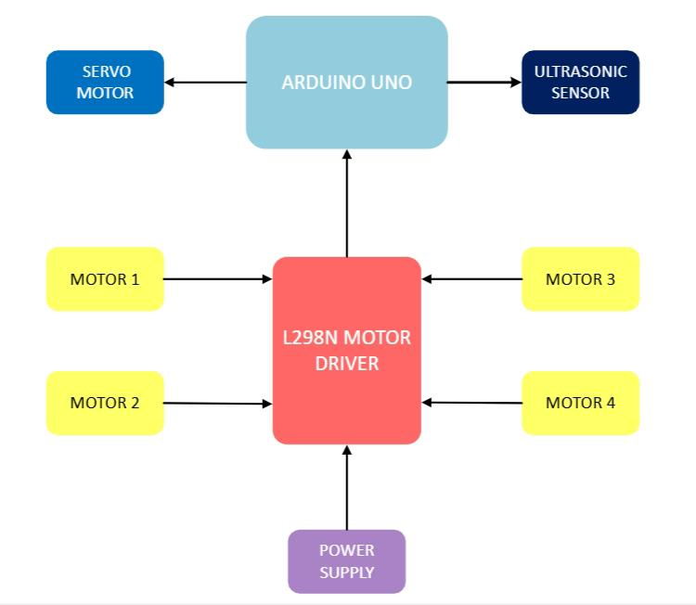

**Figure 1:** Working

This block diagram depicts an autonomous self-driving car system. At its core is an Arduino microcontroller, responsible for processing information and controlling the vehicle's actions. An ultrasonic sensor detects obstacles, measuring their distance.

The Arduino interprets this data and sends commands to an L298N motor driver.

The motor driver then amplifies these signals, controlling four motors that drive the car forward, backward, or enable turning.

A servo motor is included for precise steering or other movements. The entire system is powered by a dedicated power supply. This setup allows the car to navigate autonomously, reacting to its environment and making decisions based on sensor readings.

**Arduino Uno**

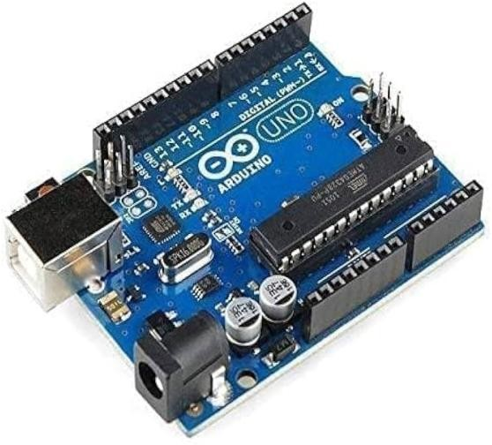

**Figure 2:** Arduino Uno

The Arduino Uno is an open-source microcontroller board built around the Microchip ATmega328P microcontroller, developed by Arduino.cc. It features a range of digital and analog I/O pins that can be connected to various expansion boards (shields) and other circuits. The board includes 14 digital I/O pins (six of which support PWM output) and 6 analog input pins. It is programmed using the Arduino Integrated Development Environment (IDE) via a USB B cable. Power can be supplied either through the USB connection or an external 9-volt battery, with the board supporting input voltages between 7 and 20 volts. It shares similarities with the Arduino Nano and Leonardo models.

The design files for the Arduino Uno, including layout and production details for some versions, are available under the Creative Commons Attribution Share-Alike 2.5 license on the Arduino website.

Arduino is a versatile electronics platform combining user-friendly hardware and software. It can interpret various inputs such as light from a sensor, button presses, or online data and convert them into outputs like motor activation, LED illumination, or online publication. Programming the board involves writing instructions in the Arduino language (based on Wiring) using the Arduino Software (IDE), which is derived from Processing.

**L298N Motor Driver Shield**

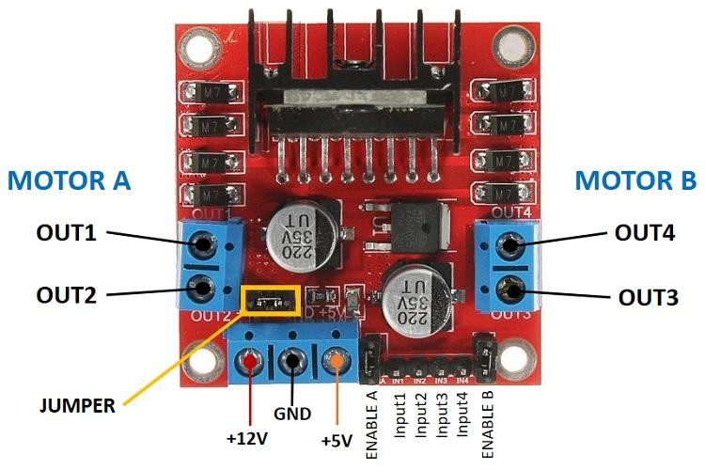

**Figure 3:** L298N Motor Driver

The L298N motor driver is a commonly used dual H-bridge motor driver module that allows you to control the

speed and direction of two DC motors simultaneously. It is especially popular for robotics projects due to its simplicity and ability to handle moderate power requirements.

**Key Features:**

1. Dual H-Bridge Design: Enables independent control of two motors.
2. Wide Voltage Range: Operates at motor supply voltages ranging from 5V to 35V.
3. Current Capacity:Can handle up to 2A per channel with proper heat dissipation.
4. Built-in Heat Sink: Prevents overheating during operation.
5. Logic Voltage: Compatible with logic levels of 3.3V or 5V for Microcontrollers like Arduino or Raspberry Pi.
6. PWM Control: Allows for speed adjustment using pulse-width modulation (PWM).

**Servo Motor**

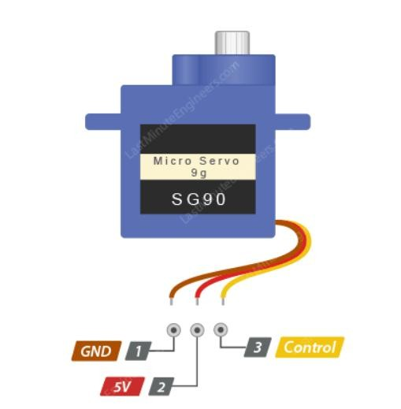

**Figure 4:** SG90 Servo Motor

A servo motor is a rotary actuator that provides precise control of angular position, speed, and torque. It consists of a motor, a feedback mechanism, and a control circuit. Servo motors are widely used in robotics, automation, and control systems due to their ability to maintain accurate position control.

A servo motor consists of three main components:

**A motor:** This can be either a DC motor or an AC motor depending on the power source and the application requirements. The motor provides the mechanical power to rotate or move the output shaft.

**A sensor:** This can be either a Potentiometer, an encoder, a resolver, or another device that measures the position, speed, or torque of the output shaft and sends feedback signals to the controller.

**A controller:** This can be either an analog or a digital circuit that compares the feedback signals from the sensor with the desired setpoint signals from an external source (such as a computer or a joystick) and generates control signals motor's voltage or current accordingly. to adjust the motor’s voltage or current accordingly.

**Key Features:**

1. Precise Position Control: Capable of rotating to a specific angle with high accuracy.
2. High Torque: Delivers consistent torque across a wide range of speeds.
3. Compact and Lightweight: Easy to integrate into systems with limited space.
4. Wide Range of Motion: Typically offers a movement range of 0° to 180°, with some models supporting full 360° rotation.
5. Fast Response Time: Quickly adjusts to position changes, making it suitable for dynamic applications.
6. Low Power Consumption: Efficient operation, ideal for battery-powered devices.
7. Easy Integration: Compatible with most microcontrollers and can be controlled using PWM (Pulse Width Modulation) signals.

# RESULT

Several experiments were conducted to evaluate the performance of the Autonomous Self Driving Car. The

ultrasonic sensor and servomotor thoroughly tested and found to be accurate within a range of 2 meters. Subsequently, tests were performed to ensure that the car maintained a specific distance from the target object. The serial communication between the Arduino, motor shield, and various motors was also examined. Based on the results of these experiments, necessary adjustments were made to the processing and control algorithms. Upon completing the evaluations, it was observed that the robot performed exceptionally well, successfully following the target person wherever they moved. Thus, the objective of achieving effective Self Driving Car interaction was accomplished.

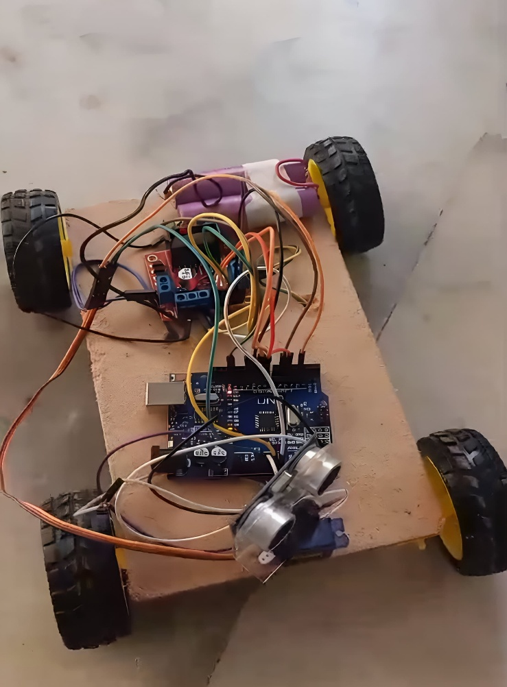

**figure 5:** Self Driving Car

# CONCLUSION

Self-driving cars tend to result in fewer accidents due to the elimination of human error. The adoption of autonomous vehicles is expected to increase in the coming years, making our roads safer and enhancing productivity by saving travel time. These vehicles can also reduce costs associated with accidents, improve fuel efficiency, and lead to significant financial savings. In the future, we may witness highly efficient highways with autonomous intersections, allowing vehicles to travel seamlessly to their destinations without stopping. The environmental benefits could be substantial, making the shift toward self-driving cars worthwhile.

To summarize, users highlight the importance of monitoring the driver's condition, including both physical impairments (such as alcohol or drug influence) and cognitive distractions. Maintaining control in situations requiring manual intervention is crucial, as is providing clear, low-distraction information to prepare the driver for upcoming transitions of control.

In response, we developed a project that automatically detects objects in front of the vehicle, scans the left and right sides, and calculates distances. The vehicle then moves in the direction with the maximum distance available. This project helped us gain valuable experience in C++ programming, algorithm development, and flowchart creation, which ultimately improved the functionality and efficiency of our project.

# REFERENCES

1. Arduino Uno. Wikipedia, 2022. Accessed 22/02/2022.

[Arduino Uno - Wikipedia](https://en.wikipedia.org/wiki/Arduino_Uno)

1. Arduino Self-Driving Car with Ultrasonic Sensors.

<https://github.com/abhineetraj1/arduino-self-driving-car>

1. Servo Motor – an overview.

<https://www.sciencedirect.com/topics/computer-science/servo-motor>

1. ARDUINO, "Arduino Integrated Development Environment (IDE)," 14 June 2023.

https://docs.arduino.cc/software/ide[-v1/tutorials/arduino-ide-v1-basics.](https://docs.arduino.cc/software/ide-v1/tutorials/arduino-ide-v1-basics) [Accessed June 2023].

1. Interface L298N DC Motor Driver Module with Arduino.

[In-Depth: Interface L298N DC Motor Driver Module with Arduino](https://lastminuteengineers.com/l298n-dc-stepper-driver-arduino-tutorial/)

1. Q. Memon, M. Ahmed, S. Ali, A. Rafique and W. Shah, "Self-driving and driver relaxing vehicle, 2nd International Conference on Robotics and Artificial Intelligence (ICRAI), pp. 170-174, November 2016.
2. Self-Driving Car Technology for a Reliable Ride – Waymo Driver.

<https://waymo.com/waymo-driver/>