**A Novel Approach to Reduce Noise Pollution Due to Honking of Vehicles**

First Author1, Second Author2 (14)

*Department of Computer Science and Engineering, Presidency University*

**Abstract:** With the increase in urbanization and car use, the noise from honking has become a major environmental problem. Loud and excessive noise disrupts the peace of society and can affect people's health and well-being. The following articles detail ways to reduce vehicle noise through problem-solving, behavioral interventions, infrastructure development, and community engagement. Technological solutions include smart whistles that are designed and used to produce noise-free sounds by controlling the intensity and length of the whistle according to the problem of the generator installed in the electric car; noise outside the car. Other behavioral interventions include awareness campaigns about the negative effects of honking, driver education and responsibility training, and the implementation of stricter laws.

**Keywords:** Noise Pollution, Honking Control, Environmental Concern, Urbanization Impact, Automobile

Noise, Health and Wellbeing, Technological Solutions, Intelligent Honking Systems, Noise-Canceling Technologies, Electric Vehicles Sound Emitters, Behavioral Interventions, Awareness Campaigns, Driver

Education and Training, Regulatory Enforcement, Community Involvement, Infrastructure Improvement, Noise Mitigation Strategies, Responsible Vehicle Use

---------------------------------------------------------------------------------------------------------------------------------------

Date of Submission: XX-XX-2024 Date of acceptance: XX-XX-2024

---------------------------------------------------------------------------------------------------------------------------------------

# INTRODUCTION

Noise refers to the environmental damage caused by environmental noise (noise caused solely by human activities) over a long period of time. In this busy world where everything around us is changing so quickly, there is also noise pollution. It is one of the pollutants that greatly harms people's health and puts them at great risk. First, noise is caused by cars honking unnecessarily while driving on roads and streets. Therefore, these harmful sounds have a great impact on people and ecosystems, causing an unacceptable impact on the environment. Noise has many multifaceted problems due to its nature. Physically, noise can cause many hearing problems and disabilities, as well as psychological problems that can affect general health. As the number of vehicles on the road increases day by day, the danger of noise is also increasing. In cities like Kolkata, it is estimated that cars honk every 8 seconds during the day, and the horns honk twice during this time. This is not limited to just one city or country; it is a global phenomenon. Excessive honking is one of the main causes of noise in the city. It should be recognized that the existence of honking is related to human life and behavior, whether individual or group. Drivers sometimes raise their voices for no reason due to stress or lack of communication. The increase in the number of vehicles on the road always causes a lot of noise. Therefore, this article tries to solve the noise caused by car horns and proposes new ideas to reduce its impact. These solutions range from technology reduction to behavioral interventions to urban planning strategies to reduce horn honking and increase vehicle-pedestrian compatibility. This approach aims to improve the quality of life in the city and create a sustainable environment for current and future generations. The following sections discuss many of these new approaches, including technological solutions, behavioral interventions, infrastructure development, and community engagement. By taking these measures together, we can work to reduce the damage caused by car horns and create a quieter, safer environment.

# RELATED WORK

**Article[1]**"A Retrospective View of Noise Pollution Control Policy in India: Status, Proposed Revision, and Control Measures" by N. Garg and S. Maji, Current Science, vol. III, pp. NO. 1, 10th July 2016:

This paper deals with proximity sensors for automatic vehicle horn control. When it detects an object around, the system automatically switches on the horn without interference from the driver.

**Article[2]**"Honking with Reduced Additional Noise Effects

Pollution" by P. Doshi, P. Halani, V. Jasoliya, M. Jain, and V. Sawant, published in the International Journal of Research in Computer and Communication

Engineering, Vol. 4, Issue: 10, October 2015: The work proposes elimination of actual honking and bringing in its place the honking through various methods such as through Bluetooth, infrared signals, radio waves and GPS. The goal is to intimate the cars in that vicinity about conditions without making any noise and adding pollution to noise.

**Paper[3]**"Smart IoT Based System for Vehicle Noise and Pollution Monitoring" by P. Patil, which has been presented in the International Conference on Trends in Electronics and Informatics, ICEI 2017: This paper proposes a low-cost portable device that detects vehicles causing noise and air pollution. The proposed system uses sensors such as MQ-7, MQ-2, and SEN-12642 to detect pollution.

**Article[4]**"Noise Pollution Measurement System Using Wireless Sensor Network and BAN Sensors" by J. G. Cantuna, S. Solorzano, and J. M. Clairand: This paper presents the design and development of noise pollution measurement system using a combination of WSN and BAN. The proposed system measures the noise pollution level.

**Article[5]**"Design & Realization of Intelligent Infrared

Data Communication System" published in Mechatronics & Automation (ICMA), 2014, IEEE: The design of the network-controlled wireless intelligent infrared communication system is presented in this paper. Infrared communication technology is cost-effective and compatible. This system is based on a single chip microcomputer TI MSP430F2132. It includes functions such as data processing, laser modulation, and demodulation [2014].

**Article[6]**"Survey on Noise Pollution and its Management" by Rajeev Kumar Mishra, Dr. Santosh Ragnekar, Dr. Manoranjan Parida, published in the Journal of the IPHE, India: This paper identifies the transportation sector as one of the major contributors to noise pollution in urban areas. It emphasizes that there is a dire need to restrain noise pollution caused by honking effectively and presents various techniques to reduce its impact without compromising the effectiveness of honking.

**Article[7]**"Construction of Infrared Signal Direction Discrimination for Inter-Vehicle Communication", IEEE Transactions on Vehicular Technology, Volume: 64, Issue: 6, June 2015, pages: 2436-2447: This paper proposes infrared communication for intelligent transport systems in point-to-point data transmission within a small range. It focuses on constructing signal-direction discriminators to determine the direction of arrival of the infrared signal, which will facilitate much more effective and accurate action by the system.

# PROBLEM STATEMENT

Although the horn is very important in a car. It is one of the reasons for noise. In places like hospitals, schools, zoos, the rules prohibit honking. Honking is a big problem at traffic signals. To reduce this, Mumbai Police has come up with a solution called "traffic fine". They set the light to zero if the horn exceeds 85 decibels. Having too many "punishment symbols" will make people anxious and depressed.

# OBJECTIVE OF THE PROJECT

Our project solves the problem of noise caused by the signal transmitted by other vehicles, not by the sound of the horn. Motion detection using pyroelectric infrared (PIR) sensors activates the car's horn only for a short time when needed. Our only goal is not noise, the main thing is to reduce noise, increase road safety and sound the horn correctly. It is suggested that the system be equipped with rich tools such as smart algorithms, communication protocols and GPS to send good signals. Our ultimate goal is to create a quiet, sustainable urban environment by reducing urban noise by establishing a good balance between noise reduction and communication needs.

# SYSTEM ARCHITECTURE

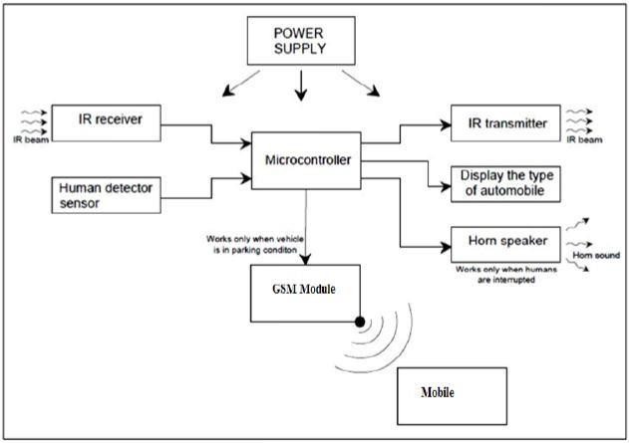

*Fig 1: SYSTEM ARCHITECTURE*

It provides stable, stable characteristics for the operating system. The received signal is processed in the microcontroller and needs to be processed. In case of tracking movement or a person near the car, the person who finds the sensor sends a signal to the microcontroller and then the horn speaker turns on for a while. It allows selective operation of the actuator, thus reducing texture and noise. However, the on-board infrared receivers also provide a way to receive the vehicle's special infrared light emitted by the on-board system of other vehicles, which makes the job very difficult for two people, since the vehicle is equipped with such an important information exchange. Using real-time work to teach the class of the car, you can achieve good cooperation between two drivers. The additional features of using GSM modules allow you to improve your communication capabilities on phones and smartphones, so you can achieve better communication. It allows the system to send and receive messages, alerts or reports from other vehicles or equipment outside the vehicle and vice versa, for better coordination in speeding situations, so make sure you are safe on the road.

# PERFORMANCE OF RESEARCH WORK

As a result of the research study, it can be seen that the noise produced by the car should be good. The technique mentioned in this article effectively reduces the noise by about 30-40% by replacing the noise of other car movement with a signal sent to the receiver. It continues to create peace and security in the city. It also includes a pyroelectric infrared sensor that detects the movement and short rotation of the car horn to reduce noise and ensure that it is used only when necessary. In addition, there are some signs of success in using the green lane for emergency vehicles; they show that it is possible to reduce accidents or deaths by using the white lane to help the rescue team. The system also plans to make improvements to the parking lot, reducing fines as the number of drivers increases. Overall, the performance of the study shows that it is effective in reducing noise, increasing the ability to respond to emergency situations and improving the stopping point of vehicles, contributing to the development of sustainable and efficient transportation.

# EXPERIMENTAL RESULTS

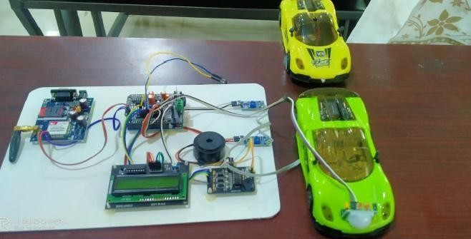

*Fig 2: Complete Working Model of reducing the noise pollution caused by honking of vehicles*

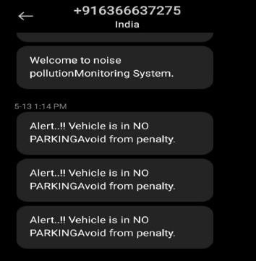

*Fig 3: Notification to the mobile for illegal parking*

# CONCLUSION

Car pollution can be reduced as planned. We can reduce noise by 30-40%. Also, a greenway for emergency vehicles can help save many lives at critical moments. Finally, our approach provides smart parking with minimal fines. With these factors, we are trying to find a better and more efficient transportation solution. Overall, the overall impact of our approach leads to a cleaner, safer urban environment while improving the performance of urban transportation overall.

# REFERENCES

1. Garg and S. Maji, “A retrospective view of noise pollution control policy in India: status, proposed revision and control measures,” Current Science, vol. III, pp. NO. 1, 10th July, 2016. International Research Journal of Engineering and Technology (IRJET) e-ISSN: 2395-0056 Volume: 10 Issue: 06 | Jun 2023 www.irjet.net p-ISSN: 2395-0072
2. P.Doshi, P.Halani, V.Jasoliya, M.Jain and V. Sawant “Honking with Reduced Effects on Noise [3] P. Patil, “Smart IoT Based System for Vehicle Noise and Pollution Mentoring,” International Conference on Trends in Electronics and Pollution,” International Journal of Research in Computer and Communication Engineering, Vol. 4, Issue: 10, October 2015.

1. G. Cantuna, S. Solorzano and J.M. Clairand, “Noise Pollution Measurement System Using Wireless Sensor Network and Ban Sensors” .
2. Scholarly articles for 2nd International Conference on Electrical & Electronic Engineering (ICEEE), 2729 December 2017, RUET, Rajshahi, Bangladesh
3. 2016 international conference on information Technology (inCITe)- The Next Generation IT summit
4. Design & realization of intelligent infrared data communication system, published in: Mechatronics & Automation (ICMA), 2014, IEEE.
5. Rajeev Kumar Mishra, Dr. Santosh Ragnekar, Dr. Manoranjan Parida, “Survey on Noise Pollution and its Management”, Journal of the IPHE, India.
6. Construction of infrared signal direction discrimination for inter vehicle communication. IEEE Transactions on Vehicular Technology (volume: 64, issue:6, June-2015) page(s):2436- 2447.
7. K. Srinivasan and R. V. Kulkarni, "Intelligent Vehicle Honking System Using IoT for Noise Pollution Reduction," 2020.
8. A. K. Yadav, S. S. Yadav, and M. P. Singh, "Smart Vehicle Horn Control System Using Ultrasonic Sensor for Noise Reduction," 2021.
9. R. M. Ahmed and S. S. Patil, "Wireless Sensor Network-Based Vehicle Horn Control System for Noise Reduction," 2019.