**The Synthesis and Development Process of Cefiderocol.**

Prof. Tandale L. D, Ms. Dumbre Shivani K.

Department of Pharmaceutical Chemistry

Shri Swami Samarth Institute of Pharmacy, Malwadi (Bota).

India -422602

Email id: [shivanidumbre1810@gmail.com](mailto:shivanidumbre1810@gmail.com)

* **ABSTRACT**

**Objective:**This article reviews the available data on the chemistry, spectrum of activity, pharmacokinetic and pharmacodynamic properties, clinical efficacy, and potential place in therapy of cefiderocol.

**Data sources:**A literature search through PubMed, Google Scholar, and ClinicalTrials.gov was conducted (2009 to March 2020) using the search terms *cefiderocol* and *S-649266*. Abstracts presented at recent conferences, prescribing information, and information from the US Food and Drug Administration (FDA) and the manufacturer's website were reviewed.

**Study selection and data extraction:**All relevant published articles, package inserts, and unpublished meeting abstracts on cefiderocol were reviewed.

**Data synthesis:**Cefiderocol is the first siderophore antibiotic to be approved by the FDA. It was shown to be active against a wide range of resistant Gram-negative pathogens, including multidrug-resistant (MDR) *Pseudomonas aeruginosa, Acinetobacter baumannii*, Enterobacteriaceae, and *Stenotrophomonas maltophilia*. Cefiderocol was studied in the treatment of adult patients with complicated urinary tract infections (cUTIs) and nosocomial pneumonia and was well tolerated.

**Relevance to patient care and clinical practice:**The approval of cefiderocol provides a new option in the treatment of cUTIs and potentially treatment of nosocomial pneumonia caused by resistant Gram-negative pathogens. Given the higher mortality observed with cefiderocol, its use in the treatment of CR Gram-negative infections should be carefully considered.

**Conclusion:**Cefiderocol shows promising activity against MDR Gram-negative pathogens. Its use in the treatment of serious infections caused by CR Gram-negative bacteria needs further evaluation in phase III clinical studies.

**Keywords**

antibiotics; cephalosporin; complicated urinary tract infections; infectious diseases; siderophore.

* **Introduction :**

Cefiderocol, sold under the brand name Fetroja (by Shionogi) among others, is an antibiotic used to treat complicated urinary tract infections when no other options are available.

It is indicated for the treatment of multi-drug-resistant Gram-negative bacteria including Pseudomonas aeruginosa.

It is given by injection into a vein.

Cefiderocol is in the cephalosporin family of medications. It was approved for medical use in the United States in November 2019, and in the European Union in April 2020.

In September 2020, cefiderocol (Fetroja) received FDA approval as supplemental New Drug Application (sNDA) for treatment of hospital-acquired bacterial pneumonia (HABP) and ventilator-associated bacterial pneumonia (VABP) when caused by Gram-negative bacteria resistant to other antibiotics. It is on the World Health Organization's List of Essential Medicines.

Cefiderocol is a cephalosporin antibacterial drug that inhibits cell wall synthesis and causes cell death.

It binds to penicillin-binding proteins (PBPs) and prevents the linking of peptidoglycan layers.

Cefiderocol is an iron carrier cephalosporin that achieves drug accumulation through a unique "Trojan horse" strategy into the bacterial periplasm.

It shows high antibacterial activity against multidrug-resistant (MDR) Enterobacteriaceae and MDR non-fermentative bacteria.

* **History :**
* Discovery and Early Development (2005-2010)

1.Cefiderocol was discovered by Shionogi & Co., Ltd. in Japan.

* Preclinical Studies (2010-2012)

1. Shionogi conducted preclinical trials to evaluate cefiderocol's pharmacokinetics, pharmacodynamics, and efficacy.

* Regulatory Approvals (2019-2020)

1. FDA (US): approved cefiderocol (Fetroja) on November 14, 2019, for cUTIs.

2. EMA (EU): approved cefiderocol (Fetroja) on April 23, 2020, for cUTIs and HABP/VABP.

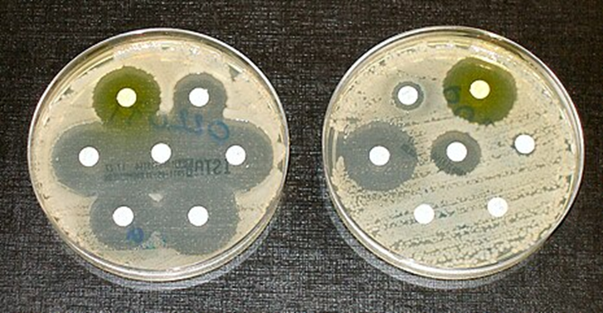

* **Structure:**

Molecular weight: 752.21 g/mol. Molecular formula: C30H34ClN7O10S2

* **Synthesis :**

Boron tribromide mediated demethylation of aromatic methyl ether 1, generating corresponding aromatic phenol 2 in 58% yield. Substitution reaction between 2 and 1-(chloromethyl)-4-methoxybenzene 3 gave compound 4, which was then treated with aqueous sodium hydroxide to give 5 in 70% yield over two steps.

Compound 5 then reacted with 1-(2-aminoethyl)pyrrolidine 6, affording amide 7 in 67% yield. Coupling of 7 with iodide 8, followed by acetylchloride/KI promoted reduction of sulfoxide to sulfide, aluminium trichloride mediated debenzylation, and acid promoted removal of the Boc group and ester hydrolysis gave cefiderocol (I) in 33% yield.A diagram of chemical formulas

Compound 9 was transformed into hydroxylamine 10 in the presence of methylhydrazine (Scheme 2) [17]. Treatment of 10 with α-ketoacid 11 gave 12, which then reacted with hydrochloride 13 to produce the key intermediate 14. Treatment of 14 with 3-chloroperbenzoic acid (m-CPBA) resulted in oxidized 15, followed by treatment with potassium iodide in

tetrahydrofuran (THF), providing cefiderocol subunit 8.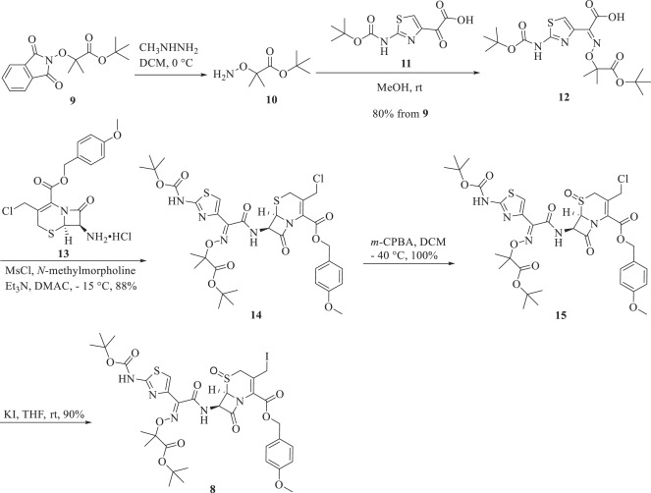

* **Mechanism Of Action :**
* Chelating iron

Cefiderocol's C-3 side chain chelates ferric iron, forming a complex that's active against bacteria.

* Penetrating the periplasmic space

Cefiderocol's siderophore-like properties allow it to enter the periplasmic space of gram-negative bacteria.

* Inhibiting penicillin-binding proteins (PBPs)

Cefiderocol binds to PBPs, which inhibits the synthesis of peptidoglycan in the bacterial cell wall, leading to cell death.

* Overcoming β-lactam resistance

Cefiderocol is stable against extended-spectrum beta-lactamases (ESBLs), serine-type carbapenemases, and metallo-type carbapenemases.

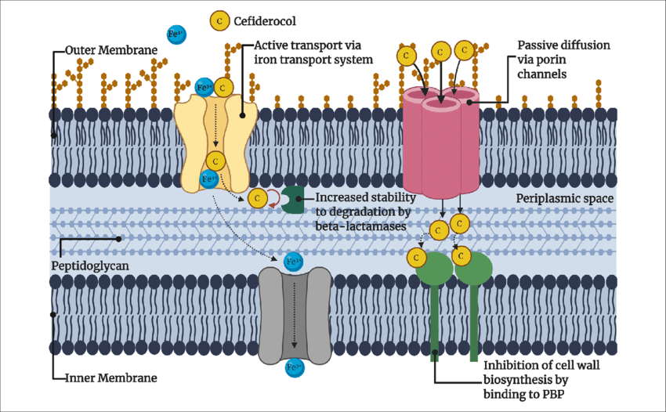

* **Pharmacokinetic :**
* Absorption-

Administration: IV infusion- Bioavailability: 100% (IV)

* Distribution- Volume of distribution (Vd): 12-15 L
* Metabolism

Minimal hepatic metabolism (<10%)

No significant CYP enzyme involvement

* Excretion-

Primary route: Renal excretion (>90%)

Elimination half-life (t1/2): 2-3 hours

* **Pharmacodynamics properties:-**
* Inhibits bacterial cell wall synthesis
* Binds to penicillin-binding proteins (PBPs)
* Bactericidal activity against Gram negative bacteria
* **Development process :**

Cefiderocol was developed by Shionogi and is sold under the trade name Fetroja. The development of cefiderocol involved the following steps:

* Starting material

Cefiderocol was developed from 2-chloro-3,4-dimethoxybenzoic acid (CEFID-001)

* Demethylation

CEFID-001 was demethylated to create 2-chloro-3,4-dihydroxybenzoic acid (CEFID-002)

* Combining antibiotics

Cefiderocol combines the features of the antibiotics ceftazidime and cefepime .

* Discovery to Approval (2005-2019)

1. Discovery (2005-2010): Identified lead compound, synthesized derivatives, and evaluated in vitro/in vivo.

2. Preclinical (2010-2012): PK/PD, toxicology, and microbiology studies.

3. Phase 1 (2012-2013): First-in-human trials.

4. Phase 2 (2014-2015): Dose-finding and proof-of-concept studies.

5. Phase 3 (2016-2018): Pivotal trials comparing cefiderocol to meropenem.

6. Regulatory Submissions (2019): FDA (US) and EMA (EU).

7. Approval (2019-2020): FDA (US) on Nov 14, 2019; EMA (EU) on Apr 23, 2020.

* **Scale Up Techniques :**
* Chemical Synthesis

1. Reactor scale-up

2. Batch processing optimization

3. Continuous flow reactors

4. Process intensification

* Fermentation

1. Bioreactor scale-up

2. Feed strategy optimization

3. Cell line optimization

4. Process control automation

* Purification

1. Crystallization optimization

2. Chromatography scale-up

3. Filtration optimization

4. Distillation scale-up

* Formulation

1. Lyophilization optimization

2. Encapsulation scale-up

3. Sterile filling optimization

4. Process automation

* Process Analytical Technology (PAT)

1. Online monitoring

2. Real-time analytics

3. Feedback control systems

4. Statistical modelling

* cGMP Compliance

1. Facility design

2. Equipment qualification

3. Process validation

4. Documentation control

* Scale-Up Strategies

1. Linear scale-up

2. Parallel processing

3. Continuous processing

4. Hybrid approaches

* **Uses :**
* Approved Uses:

1. Complicated Urinary Tract Infections (cUTIs)

2. Hospital-Acquired Bacterial Pneumonia (HABP)

3. Ventilator-Associated Bacterial Pneumonia (VABP)

* Potential Uses:

1. Intra-abdominal infections

2. Skin and soft tissue infections

3. Sepsis

4. Febrile neutropenia

* Targeted Pathogens:

1. Pseudomonas aeruginosa

2. Escherichia coli

3. Klebsiella pneumoniae

4. Carbapenem-resistant Enterobacteriaceae (CRE)

* Special Populations:

1. Immunocompromised patients

2. Critically ill patients

* Administration:

1. IV infusion (30-60 minutes)
2. 2 grams every 8 hours

* **Side Effect :**
* Common (≥5%):

1. Diarrhea

2. Infusion site reactions

3. Constipation

4. Rash

* Rare but Serious:

1. Severe hypersensitivity

2. Anaphylactic shock

3. Stevens-Johnson syndrome

* Contraindications:

1. Hypersensitivity to cefiderocol/cephalosporins

2. Severe hypersensitivity to beta-lactam antibiotics.

* **ADR :**
* Very Common (≥10%):

1. Diarrhea

2. Infusion site reactions

3. Nausea

* Common (1-10%):

1. Rash

2. Pruritus

3. Abdominal pain

4. Headache

* Uncommon (0.1-1%):

1. Anaphylaxis

2. Hypersensitivity

3. CDAD

4. Seizures

* Rare (<0.1%):

1. Stevens-Johnson syndrome

2. Toxic epidermal necrolysis

3. Hepatic failure

4. Renal failure

* **Toxicity:**
* Toxicity Profile:

1. Hepatotoxicity: Elevated liver enzymes

2. Nephrotoxicity: Renal impairment, acute kidney injure

3. Hematotoxicity: Anemia, thrombocytopenia

4. Neurotoxicity: Seizures, encephalopathy

5. Allergic reactions: Anaphylaxis, hypersensitivity

* Toxicity Levels:

1. LD50 (lethal dose): >2000 mg/kg (oral), >1000 mg/kg (IV)

2. NOAEL (no observed adverse effect level): 100 mg/kg/day

* Toxicity Monitoring:

1. Liver function tests (LFTs)

2. Renal function tests (RFTs)

3. Complete blood counts (CBC)

4. Electrolyte monitoring

* Contraindications:

1. Hypersensitivity to cefiderocol/cephalosporins

2. Severe renal impairment (CrCl <30 mL/min)

* **Conclusion :**

Cefiderocol is a novel, broad-spectrum antibiotic effective against Gram-negative bacteria, including carbapenem-resistant Enterobacteriaceae (CRE) and multidrug-resistant Pseudomonas aeruginosa (MDR-PA).

* Key Benefits:

1. High efficacy against resistant pathogen.

2. Low propensity for resistance development

3. Favorable safety profile

4. IV administration for hospitalized patients

* Future Directions:

1. Expanded clinical trials for additional indications

2. Combination therapy studies

3. Development of oral formulations

4. Continued monitoring of resistance patterns

* Impact:

Cefiderocol addresses critical unmet needs in treating antibiotic-resistant infections, offering hope for improved patient outcomes and reduced mortality rates.

* **References:**
* Clinical Trials

1. FDA: Cefiderocol (Fetroja) Approval (2019)

2. Cefiderocol Studies

3. NCT02321885: Cefiderocol vs. Meropenem for cUTI

4. NCT02423567: Cefiderocol vs. Meropenem for HABP/VABP

* Journal Articles

1. Lancet Infect Dis: Cefiderocol for Gram-negative infections (2020)

2. NEJM: Cefiderocol versus Meropenem for Complicated Urinary Tract Infections (2019)

3. J Antimicrob Chemother: Cefiderocol pharmacokinetics and pharmacodynamics (2018)

4. Antimicrobial Agents Chemother: Cefiderocol activity against carbapenem-resistant Enterobacteriaceae (2017)

* Guidelines

1. IDSA/SHEA: Guidelines for Antibiotic Stewardship (2020)

2. ESCMID: Guidelines for the diagnosis and treatment of infections caused by carbapenem-resistant Enterobacteriaceae (2020)

3. CDC: Antibiotic Resistance Threats in the United States (2019)

* Regulatory Agencies

1. FDA: Cefiderocol Label (2020)

2. EMA: Cefiderocol Summary of Product Characteristics (2020)

3. PMDA Japan: Cefiderocol Approval (2018)

* "Fetcroja EPAR". European Medicines Agency (EMA). 24 February 2020. Retrieved 29 April 2020. This article incorporates text from this source, which is in the public domain.
* Fetcroja Product information". Union Register of medicinal products. Retrieved 3 March 2023.
* World Health Organization (2021). World Health Organization model list of essential medicines: 22nd list (2021). Geneva: World Health Organization.
* Harnan SE, Woods B, Schmitt L, Kearns B, Srivastava T, Scope A, et al. Protocol for the technology evaluation of cefiderocol for treating severe aerobic Gram-negative bacterial infections. Health Technol Assess 2021.
* Hawkey PM, Warren RE, Livermore DM, McNulty CA, Enoch DA, Otter JA, et al. Treatment of infections caused by multidrug-resistant gram-negative bacteria: report of the British Society for Antimicrobial Chemotherapy/Healthcare Infection Society/British Infection Association Joint Working Party. J Antimicrob Chemother 2018.
* Munita JM, Arias CA. Mechanisms of antibiotic resistance. Microbiol Spectr 2016.
* Hawkey PM. Multidrug-resistant Gram-negative bacteria: a product of globalization. J Hosp Infect 2015.
* McNulty CAM, Boyle P, Nichols T, Clappison P, Davey P. Don’t wear me out – the public’s knowledge of and attitudes to antibiotic use. J Antimicrob Chemother 2007.
* Public Health England. English Surveillance Programme for Antimicrobial Utilisation and Resistance (ESPAUR) Report 2019 to 2020. London: UK Health Security Agency; 2020.
* Hughes S, Gilchrist M, Heard K, Hamilton R, Sneddon J. Treating infections caused by carbapenemase-producing *Enterobacterales* (CPE): a pragmatic approach to antimicrobial stewardship on behalf of the UKCPA Pharmacy Infection Network (PIN). JAC-Antimicrob Resist 2020;2(3):dlaa075.
* World Health Organization. WHO Publishes List of Bacteria for Which New Antibiotics Are Urgently Needed. Geneva, Switzerland: World Health Organization; 2017.
* World Health Organization. Global Priority List of Antibiotic-Resistant Bacteria to Guide Research, Discovery, and Development of New Antibiotics. Geneva, Switzerland: World Health Organization; 2017.
* Tan X, Kim HS, Baugh K, Huang Y, Kadiyala N, Wences M, et al. Therapeutic options for metallo-β-lactamase-producing *Enterobacterales*. Infect Drug Resist 2021.
* Ito A, Kohira N, Bouchillon SK, West J, Rittenhouse S, Sader HS, et al. In vitro antimicrobial activity of S-649266, a catechol-substituted siderophore cephalosporin, when tested against non-fermenting Gram-negative bacteria. J Antimicrob Chemother 2016.
* Ito A, Nishikawa T, Matsumoto S, Yoshizawa H, Sato T, Nakamura R, et al. Siderophore cephalosporin cefiderocol utilizes ferric iron transporter systems for antibacterial activity against Pseudomonas aeruginosa. Antimicrob Agents Chemother 2016.
* Portsmouth S, van Veenhuyzen D, Echols R, Machida M, Ferreira JCA, Ariyasu M, et al. Cefiderocol versus imipenem-cilastatin for the treatment of complicated urinary tract infections caused by Gram-negative uropathogens: a phase 2, randomised, double-blind, non-inferiority trial. Lancet Infect Dis 2018.
* Wunderink RG, Matsunaga Y, Ariyasu M, Clevenbergh P, Echols R, Kaye KS, et al. Cefiderocol versus high-dose, extended-infusion meropenem for the treatment of Gram-negative nosocomial pneumonia (APEKS-NP): a randomised, double-blind, phase 3, non-inferiority trial. Lancet Infect Dis 2021.
* Bassetti M, Echols R, Matsunaga Y, Ariyasu M, Doi Y, Ferrer R, et al. Efficacy and safety of cefiderocol or best available therapy for the treatment of serious infections caused by carbapenem-resistant Gram-negative bacteria (CREDIBLE-CR): a randomised, open-label, multicentre, pathogen-focused, descriptive, phase 3 trial. Lancet Infect Dis 2021.
* Tsuji M, Hackel M, Echols R, Yamano Y, Sahm DF. In Vitro Activity of Cefiderocol Against Globally Collected Carbapenem-Resistant Gram-Negative Bacteria Isolated from Urinary Tract Source: SIDERO-CR-2014/2016. Poster presented at: IDWeek, Arlington, VA, 2017.
* Nguyen S, editor. In Vitro Antibacterial Activity of Cefiderocol against a Multi-National Collection of Carbapenem Non-Susceptible Gram-Negative Bacteria Isolated from Respiratory, Blood, Skin/Soft Tissue and Urinary Sources of Infection: SIDERO-WT-2014-2017. New Orleans, LA: ASM; 2017.
* Zhanel GG, Golden AR, Zelenitsky S, Wiebe K, Lawrence CK, Adam HJ, et al. Cefiderocol: a siderophore cephalosporin with activity against carbapenem-resistant and multidrug-resistant Gram-negative bacilli. Drugs 2019
* Shionogi. European Medicines Agency. Annex I: Summary of Product Characteristics Fetcroja 1g.
* National Institute for Health and Care Excellence. Cefiderocol for Treating Severe Drug-Resistant Gram-Negative Bacterial Infections. London.