**Abstract**

People have understood the advantages of employing plants to meet their basic needs for beautiful, healthy skin since ancient times. Products for cleansing, beautifying, and promoting an attractive appearance are known as cosmetics. It has been demonstrated that cosmetics containing natural ingredients, including herbs, are highly successful in meeting the unique requirements of many skin types. The goal of this project is to create and assess a herbal face pack using herbal elements for cosmetic purposes. Neem, Multani mitti.

**INTRODUCTION**

The mulberry belongs to the Moraceae family's Morus class. There are 24 species of Morus, and at least 100 varieties are known to exist [1]. Chinese pharmaceuticals have historically used mulberry branches, bark, and clears out [2]. Mulberries are grown for the production of natural products in the majority of European countries [3, 4]. Natural product extricates or individual chemical ingredients extracted from these extricates have been described, as has the Mallotus's natural action. Human LDL oxidation triggered by copper was inhibited by flavanols, glycosides extracted from mulberry extracts [quercetin 3-(-malonyl glucoside), rutin, and isoquercitin] [5]. Green tea polyphenols, which are included in some edible oils and fricasseed products, are shown to have a more grounded antioxidative movement than tocopherols and BHA [6]. Additionally, it was discovered that ginger extracts had a stronger ability to inhibit lipid oxidation when used as an antioxidant in sunflower oil [7].

In mice lacking apolipoprotein E, mulberry leaf powder predicted atherosclerosis [10]. When compared to the control, the group-supported diet that contained 1% mulberry leaf seems to reduce atherosclerotic damage in the aortae by 40%. The methanolic extract of Indian mulberry eliminates the Epstein-Barr infection's constrained anti-tumor-promoting effect when tested using the restraint test [11]. and a Morus rubra extract's phytoestrogens appeared to be active at specific formative phases [12]. Chu et al. [9] used capillary electrophoresis with aerometric location. According to reports, mulberry clears include proteins, carbs, calcium, press, β-carotene, ascorbic acid, vitamin B1, folic acid, and vitamin D. They have been shown to have strong antioxidative, diuretic, hypoglycemic, and hypotensive properties, independent of their use as creepy crawly bolsters [8].

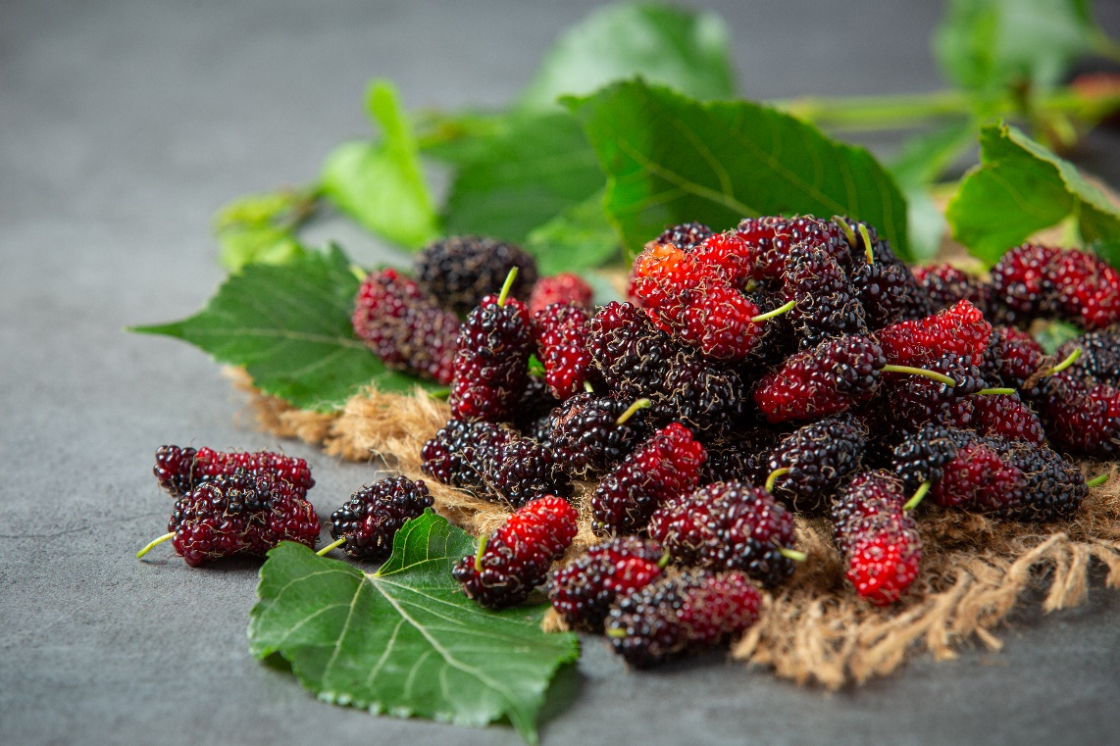

Figure No.1: Mulberry Plant (Leaves, Fruit, Stem)

**DIFFERENT ACTIVITIES OF MULBERRY**

1. HYPOGLYCEMIC ACTIVITYA

condition known as hypoglycemia may occur when the body's blood sugar level falls too low. The ineffectiveness of the insulin the pancreas produces is the cause of diabetes mellitus. Elevated blood glucose levels and unsettled effects on the digestion of carbohydrates, fats, and proteins are hallmarks of diabetes mellitus, a chronic illness. A deficiency of the blood sugar-lowering hormone affront, which occurs in type 1 diabetes or insulin-dependent diabetic mellitus (IDDM), contributes to these metabolic deviations from the norm. Type 2 diabetes, also known as non-insulin-dependent diabetes mellitus (NIDDM), can be brought on by hyperglycemia from excessive hepatic glucose synthesis, abnormal β cell activity, or target cell affront resistance.[13] Since 1990, the use of domestic remedies has increased significantly in the United States.[17] Long-term damage, failure, and disappointment of several organs are linked to diabetes's persistent hyperglycemia.[14] Hyperlipidemia is the outcome of accelerated lipolysis caused by impaired glucose consumption in diabetic rats [16,15].

1. ANTI-OBESITY ACTIVITY

Corpulence is defined as excessive or aberrant fat accumulation that compromises one's health. Morus alba (family: Mulberry), commonly referred to as mulberry in Korea, originated in northern China and spread from India to the Center East, southern Europe, and, more recently, North America. The roots and bark have been shown to have antibacterial [18], antioxidant, and hypoglycemic properties [19,20], as well as neuroprotective, anti-ulcer, pain-relieving, and anti-inflammatory properties [21,22] based on pharmacological investigations. Additionally, by inhibiting oxidative stretch, the mulberry leaf extract increases the uptake of glucose by rodent adipocytes and reduces the improvement of adipocytes in white fat tissue extracted from db/db mice [23, 24]. The creepy-crawly pathogen Cordyceps militaris (C. militaris) belongs to the Ascomycota and is commonly used in East Asian and Chinese medicines [25, 26]. After being isolated from C. militaris, cordycepin can be used to treat cancer [27], tumors [28], bacteria [29], and antioxidants [30]. In our previous study, we described how the extract of Morus alba takes off matured with C. militaris (EMfC) affects adipocytes isolated from SD rats in a lipolytic manner [31]. Regardless, no point-by-point analysis was conducted to evaluate the weight-inhibiting effect of EMfC.

1. HEPATOPROTECTIVE ACTIVITY

It's possible that medication-induced liver damage is a serious health concern that affects not only medical professionals but also the pharmaceutical business and drug regulatory agencies [32]. There are other ways that drug-induced damage might begin, such as a coordinated adverse effect, an immunological reaction, or a dynamic metabolite that is influenced by the drug [33]. By inhibiting dihydrofolate reductase, MTX is efficiently accumulated in the liver, where it is broken down and stored in a polyglutamated form, lowering folate levels [35]. A common anti-rheumatic and cytotoxic chemotherapeutic expert for cancers and various incendiary illnesses, methotrexate (MTX) medication is a fundamental analogue of folic corrosive [33, 34]. The widespread use of MTX and its long-term effects have drawn doctors' attention to the potential negative side effects of the medication [36].

1. ANTI-CANCER ACTIVITY

Numerous therapeutic plants have chemicals that impact certain organs as well as antibacterial, antiviral, anti-inflammatory, anti-cancer, immunostimulatory, and antioxidant qualities. The mulberry leaf methanolic extract demonstrates effective cytotoxic action on cancerous cells. One of the main methods of treating cancer is chemotherapy, which uses chemicals or natural substances to destroy tumor cells. Its effects are systemic and can have a variety of negative consequences [29]. In 2012, there were around 8 million deaths and 14 million new cases of cancer worldwide, making it a leading cause of illness and mortality. According to the pertinent projections, there would be 13 million cancer-related fatalities and 22 million new cancer cases each year by 2030 [31]. The goal of successful stomach cancer treatment, including other [32].

1. ANTI-INFLAMMATORY ACTIVITY

An innate immune response, inflammation is produced by many immune cells, including macrophages, to protect the body from harmful agents like germs and viruses. Morin, a flavonoid found in mulberries, may have strong anti-inflammatory properties. Prolonged inflammation brought on by inflammatory mediators is thought to be the root cause of a number of human diseases, such as septic shock, atherosclerosis, cancer, and joint pain [32, 33]. Inducible nitric oxide synthase (INOS) produces NO, one of the inflammatory mediators, which contributes to a variety of disease processes, including diabetes, obesity, and cancer. [37]

1. ANTI-DIABETIC ACTIVITY

Globally, the prevalence of diabetes mellitus (DM) is steadily rising. 382 million were diagnosed with DM in 2013, and it is generally projected that this number would increase to 592 million by 2035.[1] Insulin resistance characterizes the pathophysiology of type 2 diabetes (T2DM), while total loss of insulin secretion due to pancreatic injury characterizes the pathophysiology of type 1 diabetes (T1DM). Persistent diabetes mellitus can lead to severe consequences, including atherosclerosis, hypertension, retinopathy, neuropathy, nephropathy, and miniature scale- and macrovascular problems [2]. In any event, the medications that are now on the market have been shown to have a number of adverse effects, including hypoglycemia, impaired insulin secretion, upset stomach, and liver and kidney impairment [4]. Thus, achieving near-normal blood glucose levels through effective blood glucose control is the main goal of diabetes care. Although insulin therapy is necessary for patients with type 1 diabetes, oral hypoglycemic medications are sometimes used as an adjuvant treatment. As of right now, the Food and Drug Administration in the US has authorized metformin (Met) as an oral hypoglycemic medication for adolescents with type 1 diabetes [3]. Additionally, the use of some medications that have been linked to severe hepatotoxicity or cardiovascular adverse effects has been forbidden. Plant-derived phytochemicals with little adverse effects have since been extensively studied for the treatment of diabetes mellitus.

CONCLUSION

Natural face packs or masks are used to increase blood flow, revitalize the muscles, maintain skin suppleness, and remove pollution from the skin's pores. Homegrown beauty care products have the advantage of being non-toxic, which reduces the usefulness of some items for adversely sensitive reactions and time-tested use. Because they have less adverse effects than pharmaceutical prescriptions, which are more secure, characteristic medications are more appropriate. Domestic formulations are in high demand in the global market. A herbal face pack made of various plant powders and gel can prove to be a highly successful endeavor. Therefore, throughout the current investigation, we have discovered excellent qualities for the face packs and have discovered the helpful benefits of using face packs as a cosmetic for people.

REFERENCE

1. Orhan E, Ercisli S. Genetic relationships between selected Turkish mulberry genotypes (Morus spp) based on RAPD markers. Genet. Mol. Res. 2010 Nov 3;9(4):2176-83.
2. Zhishen J, Mengcheng T, Jianming W. The determination of flavonoid contents in mulberry and their scavenging effects on superoxide radicals. Food chemistry. 1999 Mar 1;64(4):555-9.
3. Ercisli S. A short review of the fruit germplasm resources of Turkey. Genetic Resources and Crop Evolution. 2004 Jun;51:419-35.
4. Katsube T, Imawaka N, Kawano Y, Yamazaki Y, Shiwaku K, Yamane Y. Antioxidant flavonol glycosides in mulberry (Morus alba L.) leaves isolated based on LDL antioxidant activity. Food chemistry. 2006 Jul 1;97(1):25-31.
5. Koketsu M, Satoh YI. Antioxidative activity of green tea polyphenols in edible oils. Journal of Food Lipids. 1997 Mar;4(1):1-9.
6. Salariya AM, Habib F. Antioxidant activity of ginger extract in sunflower oil. Journal of the Science of Food and Agriculture. 2003 May 15;83(7):624-9.
7. Sastri , B.N. 1962 . “ Raw Materials ” . In The Wealth of India (CSIR) Vol. 6 , 429 – 439 . New Delhi , India
8. Chu Q, Lin M, Tian X, Ye J. Study on capillary electrophoresis–amperometric detection profiles of different parts of Morus alba L. Journal of Chromatography A. 2006 May 26;1116(1-2):286-90.
9. Harauma A, Murayama T, Ikeyama K, Sano H, Arai H, Takano R, Kita T, Hara S, Kamei K, Yokode M. Mulberry leaf powder prevents atherosclerosis in apolipoprotein E-deficient mice. Biochemical and Biophysical Research Communications. 2007 Jul 6;358(3):751-6.
10. Murakami A, Jiwajinda S, Koshimizu K, Ohigashi H. Screening for in vitro anti-tumor promoting activities of edible plants from Thailand. Cancer letters. 1995 Aug 16;95(1-2):139-46.
11. Maier CG, Chapman KD, Smith DW. Phytoestrogens and floral development in dioecious Maclura pomifera (Raf.) Schneid. and Morus rubra L.(Moraceae). Plant Science. 1997 Dec 5;130(1):27-40.
12. Fajans SS, Cloutier MC, Crowther RL. Clinical and etiologic heterogeneity of idiopathic diabetes mellitus. Diabetes. 1978 Nov 1;27(11):1112-25.
13. Lyra R, Oliveira M, Lins D, Cavalcanti N. Prevention of type 2 diabetes mellitus. Arquivos Brasileiros de Endocrinologia & Metabologia. 2006;50:239-49.
14. Morel DW, Chisolm GM. Antioxidant treatment of diabetic rats inhibits lipoprotein oxidation and cytotoxicity. Journal of lipid research. 1989 Dec 1;30(12):1827-34.
15. Granner DK. Hormones of the pancreas and gastrointestinal tract. In: Murray RK, Granner RK, Mayes PA, Rodwell VW, editors. Harper’s Biochemistry. 24th ed. Connecticut, USA: Appleton and Lange; 1996. Pp. 586–7.
16. Eisenerg DM, Davis RB, Ettner SL. Trends in alternative medicine use in the United States, 1990- 1997: Results of a follow-up national survey. JAMA. 1998;280:1569–75.
17. Gunjal S, Ankola AV, Bhat K. In vitro antibacterial activity of ethanolic extract of Morus alba leaf against periodontal pathogens. Indian Journal of Dental Research. 2015 Sep 1;26(5):533-6.
18. Raman ST, Ganeshan AK, Chen C, Jin C, Li SH, Chen HJ, Gui Z. In vitro and in vivo antioxidant activity of flavonoid extracted from mulberry fruit (Morus alba L.). Pharmacognosy Magazine. 2016 Apr;12(46):128
19. Wang Y, Xiang L, Wang C, Tang C, He X. Antidiabetic and antioxidant effects and phytochemicals of mulberry fruit (Morus alba L.) polyphenol enhanced extract. PloS one. 2013 Jul 30;8(7):e71144.
20. Jo SP, Kim JK, Lim YH. Antihyperlipidemic effects of stilbenoids isolated from Morus alba in rats fed a high-cholesterol diet. Food and chemical toxicology. 2014 Mar 1;65:213-8.
21. Chan WeiChiang [Chan W, Lye PhuiYan LP, Wong SiuKuin WS. Phytochemistry, pharmacology, and clinical trials of Morus alba.
22. Ann JY, Eo H, Lim Y. Mulberry leaves (Morus alba L.) ameliorate obesity-induced hepatic lipogenesis, fibrosis, and oxidative stress in high-fat diet-fed mice. Genes & nutrition. 2015 Nov;10:1-3.
23. Sugimoto M, Arai H, Tamura Y, Murayama T, Khaengkhan P, Nishio T, Ono K, Ariyasu H, Akamizu T, Ueda Y, Kita T. Mulberry leaf ameliorates the expression profile of adipocytokines by inhibiting oxidative stress in white adipose tissue in db/db mice. Atherosclerosis. 2009 Jun 1;204(2):388-94.
24. Sung GH, Hywel-Jones NL, Sung JM, Luangsa-Ard JJ, Shrestha B, Spatafora JW. Phylogenetic classification of Cordyceps and the clavicipitaceous fungi. Studies in mycology. 2007 Jan 1;57:5-9.
25. De Silva DD, Rapior S, Sudarman E, Stadler M, Xu J, Aisyah Alias S, Hyde KD. Bioactive metabolites from macrofungi: ethnopharmacology, biological activities and chemistry. Fungal Diversity. 2013 Sep;62:1-40.
26. De Silva DD, Rapior S, Fons F, Bahkali AH, Hyde KD. Medicinal mushrooms in supportive cancer therapies: an approach to anti-cancer effects and putative mechanisms of action. Fungal Diversity. 2012 Jul;55:1-35.
27. Pao HY, Pan BS, Leu SF, Huang BM. Cordycepin stimulated steroidogenesis in MA-10 mouse Leydig tumor cells through the protein kinase C pathway. Journal of Agricultural and Food Chemistry. 2012 May 16;60(19):4905-13.
28. Kim JR, Yeon SH, Kim HS, Ahn YJ. Larvicidal activity against Plutella xylostella of cordycepin from the fruiting body of Cordyceps militaris. Pest Management Science: formerly Pesticide Science. 2002 Jul;58(7):713-7.
29. Ramesh T, Yoo SK, Kim SW, Hwang SY, Sohn SH, Kim IW, Kim SK. Cordycepin (3?-deoxyadenosine) attenuates age-related oxidative stress and ameliorates antioxidant capacity in rats. Experimental gerontology. 2012 Dec 1;47(12):979-87.
30. Lee MR, Kim JE, Yun WB, Choi JY, Park JJ, Kim HR, Song BR, Choi YW, Kim KM, Hwang DY. Lipolytic effect of novel extracts from mulberry (Morus alba) leaves fermented with Cordyceps militaris in the primary adipocytes derived from SD rats. Laboratory Animal Research. 2017 Jul;33:270-9.
31. uan L, Kaplowitz N. Mechanisms of drug-induced liver injury. Clinics in liver disease. 2013 Nov 1;17(4):507-18.
32. Bayram M, Ozogul C, Dursun A, Ercan ZS, Isik I, Dilekoz E. Light and electron microscope examination of the effects of methotrexate on the endosalpinx. European Journal of Obstetrics & Gynecology and Reproductive Biology. 2005 May 1;120(1):96-103.
33. Vardi N, Parlakpinar H, Cetin A, Erdogan A, Cetin Ozturk I. Protective effect of ?-carotene on methotrexate–induced oxidative liver damage. Toxicologic pathology. 2010 Jun;38(4):592-7.
34. Biernat J, Sendur R, Pawlik W, Brzozowski T. Dual role of sensory neuropeptides in methotrexate-induced liver damage. Gastroenterologia Polska/Gastroenterology. 2010 May 1;17(3).
35. ssabeagloo E, Taghizadiyeh M, Kermanizadeh P. Hepatoprotective effect of taurine against oxidative stress due to methotrexate in rat. [37] Feren?ík M, Štvrtinová V, Hulin I, Novak M. Inflammation—a lifelong companion: Attempt at a non-analytical holistic view. Folia microbiologica. 2007 Mar;52(2):159-73. [
36. Kim HY, Goo JH, Joo YA, Lee HY, Lee SM, Oh CT, Ahn SM, Kim NH, Hwang JS. Impact on inflammation and recovery of skin barrier by nordihydroguaiaretic Acid as a protease-activated receptor 2 antagonist. Biomolecules & therapeutics. 2012 Sep;20(5):463.
37. Cai Z, Cai Z, He T, Zhao Z, Yin Y, Shen C, Yin X, Chen Z, Dan C, Zhang B. Comparative effectiveness of hyperthermic intraperitoneal chemotherapy for gastric cancer: A systematic review and network meta-analysis protocol. Medicine. 2018 Aug 1;97(33):e11949.