“Survey of AR Furniture Visualizer ”

# Abstract

In today’s world of digital change, one of the biggest challenges in selling furniture online is making sure customers feel confident that the furniture they pick will fit and look good in their space. When people buy furniture, they need to check if the style, size, and color match the area where they plan to place it. With the right tools, buyers can see how flexible and suitable the furniture will look in their specific space. To sell furniture online successfully, these problems need to be solved. Augmented Reality (AR) can help with this. Some apps in the furniture industry use AR and mobile technology to let customers customize products online.

**Keywords:** Augmented reality, ARSDKs ,Sceneform SDK , ARCore ,3Dmodels.

# INTRODUCTION

India’s online shopping industry is growing fast. However, growth alone isn’t enough; to succeed, the e-commerce sector must regularly adopt new technologies. One such innovation could be augmented reality (AR), which can attract both existing and new customers. For our Furnished software, we chose the furniture industry as our focus in the e-commerce space. Although there are only a few major players in the furniture market right now, there’s still a lot of room for growth, especially for those who can offer something unique using AR. This app aims to use AR to show customers all the products in their online store in the most efficient way, saving time and resources. With AR, you can place virtual objects in your real surroundings, while virtual reality (VR) takes you into a completely digital world created by developers. Virtual Reality is recognized as a great teaching method for workers in industries, especially those who work in dangerous conditions. On the other hand, Augmented Reality (AR) is used in various areas like design and modeling. AR software works by analyzing images taken from the device’s back camera. It then displays product information, 3D models, tracks features, and identifies locations that are overlaid on a real-world image.

# LITERATURE SURVEY

* **Paper Name:** Android Application Development using Android Studio and PHP Framework.

**Author:** Akshay Singh, Sakshi Sharma and Shashwat Singh.

**Abstract :** The creation of an application for the Android mobile platform is discussed in this article. Mobile Development has contributed a significant amount of work to a variety of projects, including video and music players, game applications, picture viewers and editors, and more. This article focuses mostly on the Linux Version 2.6-based Android architecture as its primary topic of discussion. It is an open-source operating system for mobile phones that is based on Linux. To a large extent, the Android application development process makes use of the Java programming language. The Android Software Development Kit (SDK) is a collection of application programming .

* **Paper Name:** Capabilities of ARCore and ARKit Platforms for AR/VR Applications

**Author:** Pawe l Nowacki, Marek Slawomir Woda

**Abstract :** In their study titled ”ARCore versus ARkit,” Pawe Nowacki and Marek Slawomir Woda analyzed and contrasted the capabilities of each of these apps. The authors constructed test apps, defined comparative criteria for both platforms, and carried out comparison experiments. The findings that were obtained may be helpful in selecting the appropriate framework in order to expedite the prototype and development of contemporary AR/VR apps. • **Paper Name:** A Survey of Augmented Reality

**Author:** Ronald T. Azuma

**Description :** Ronald Azuma’s paper ”A Survey of Augmented Reality” provides an overview of the state of the art in augmented reality (AR) technology. The paper begins by defining AR and identifying the three key components of an AR system: a display, a tracking system, and a computer. Azuma then presents an overview of the various types of AR displays, including optical see through, video see-through, and spatially augmented reality. Overall, Azuma’s paper provides a comprehensive survey of the state of the art in AR technology.

* **Paper Name:** Application development using Flutter

**Author:** Nisha Shah

**Description :** Nisha Shah’s paper ”Application Development using Flutter” provides an overview of the Flutter framework for building mobile applications. The paper begins by introducing the Flutter framework and highlighting its key features, including hot reload, reactive programming, and a customizable UI toolkit. the paper discusses the advantages of using Flutter for mobile application development, including faster development cycles, cross-platform compatibility, and improved performance. They concluded that different AR devices are available, although they have certain restrictions.

# Proposed system

* A furniture shopping app for Android that uses AR (Augmented Reality) technology.
* Users can place 3D models of furniture in their real space using their phone’s camera.
* The app connects to an online furniture catalog and includes a shopping cart feature.

# Architecture

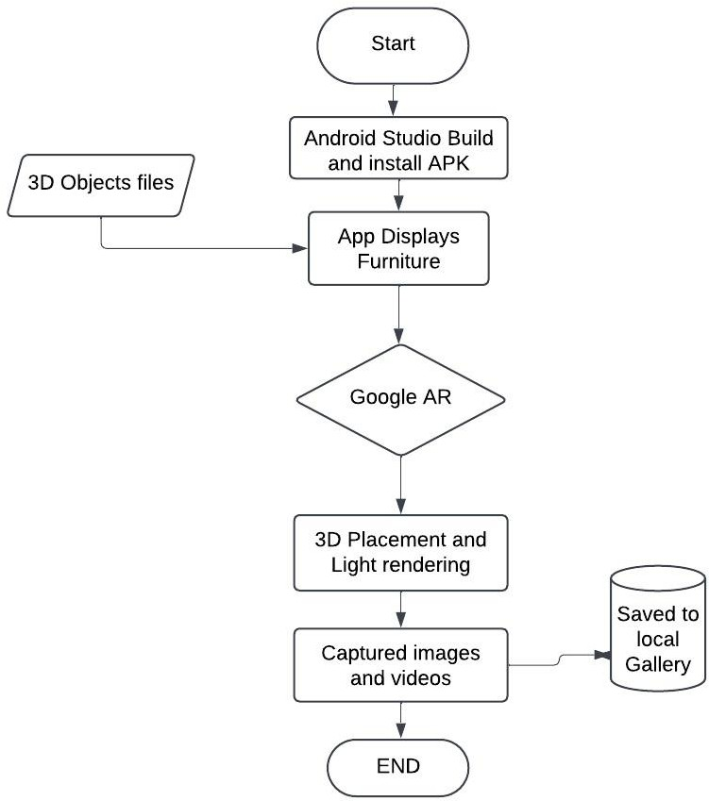

* **Start:** This is where everything begins.
* **3D Object Files:** These are files (usually in .obj format) that contain 3D models of furniture. They are needed for the AR app to show 3D objects in the real world.
* **Build and Install APK in Android Studio:** The app is created using Android Studio, and the APK file (which is the app installer) is put on the device. This step gets the AR app ready to run on an Android phone or tablet.
* **App Displays Furniture:** After installing the APK and opening the app, it shows a list or options of furniture items. This lets the user pick which piece they want to see in their room.
* **Google AR Services:** Google AR Services (probably ARCore for Android phones) help in finding surfaces, sizing objects, and giving precise AR positioning. These services work with ARKit to scan floors and place objects.
* **3D Placement and Light Rendering:** The app positions 3D objects in the scene and adds lighting to make them look real and blend naturally into the surroundings, using the room’s detected light.
* **Captured Images and Videos:** Users can take pictures or record videos of the room with the virtual furniture using the app’s camera feature.
* **Saved to Local Gallery:** The photos and videos are saved directly to the phone or tablet’s gallery, so users can view or share them later.
* **End:** This is the end of the process.

# Conclusion

Launching the app will change the way people buy furniture by offering a more engaging, tailored, and easy-to-use experience for shoppers. This initiative marks a big leap in the furniture retail sector, using advanced technology to completely reshape how people shop.

# Reference

1. A. Marmoset. 2021. Basic Theory of PhysicallyBased Rendering. [online] Available at:https://marmoset.co/posts/basic-theoryofphysically-based-rendering Accessed:10 May 2021.
2. Grid Dynamics Blog. 2021. How to build an AR app with ARCore and Scenefor [online] Available at: [https://blog.griddynamics.com/latest-arcoreand-](https://blog.griddynamics.com/latest-arcoreand-sceneformfeatures-) [sceneformfeatures-](https://blog.griddynamics.com/latest-arcoreand-sceneformfeatures-)Take-creation-of-ar-appsto-thenext-level [Accessed 10 May 2021].
3. Akshay Singh, Sakshi Sharma and Shashwat Singh. Article: Android Applica- Tion Development using Android Studio and PHP Framework. IJCA Proceedings on Recent Trends in Future Prospective in Engineering and Management Technology RTFEM 2016(1):5-8, July 2016.
4. Nowacki, Pawel Woda, Marek (2020) Capabilities of ARCore and ARKit Plat-

Forms for AR VR Applications. 10.1007/978-3-030-19501- 4 36

1. Fox, Dylan Li, Alyssa Pandey, Anu Kar, Rohan Singh, Rajandeep. (2019). Aug- Mented Reality for Visually Impaired People (AR for VIPs). 10.13140/RG.2.2.30196.78723
2. Sahu, C.K., Young, C. And Rai, R., 2021. Artificial intelligence (AI) in augmented Reality (AR)-assisted manufacturing applications: a review. International Journal of Production Research, 59(16), pp.4903-4959.
3. Kulkarni, P. D. (2022). Interior Design Using Augmented Reality. International Journal of Scientific Research in Engineering and Management,06(04),5092–5096. <https://doi.org/10.55041/ijsrem12532>
4. Zollmann, S., Langlotz, T., Grasset, R., Lo, W. H., Mori, S., Regenbrecht, H. (2021). Visualization Techniques in AugmentedReality: A Taxonomy, Methods And Patterns. IEEE Transactions on Visualization and Computer Graphics, 27(9), 3808– 3825. <https://doi.org/10.1109/TVCG.2020.298624>.
5. Reuksupasompon, P., Aruncharathorn, M., Vittayakorn, S. (2018). AR DevelOpment for Room Design. Proceeding of 2018 15th International Joint Conference on Computer Science and Software Engineering, JCSSE 2018, 1–6.
6. Perannagari, K. T., Chakrabarti, S. (2020). Factors influencing acceptance of Augmented reality in retail: insights from thematic analysis. International Journal of Retail and Distribution Management, 48(1), 18–34.
7. Cruz, E., Orts-Escolano, S., Gomez-Donoso, F., Rizo, C., Rangel, J. C., Mora,H., Cazorla, M. (2019). An augmented reality application for improving shopping Experience in large retail stores. Virtual Reality, 23(3), 281–291.
8. V, E. S. S., Abhimanyurajesh, M., Akshaykumar, M., Akhinraj, C. (2019)Furniture Shopping Based On Augmented Reality. 8(3), 614– 619.
9. Ahmed, T. T., Vijaya Shetty, S., Samirasimha, R., Sushmitha Bedere, J.(2018). Performance Evaluation of Augmented Reality based 3D Modelling Furniture Application. 2018 International Conference on Advances in Computing, Communications and Informatics, ICACCI 2018, 2426–2431.
10. More, T. R., Modage, A., More, V., More, K. (2017). “Furniture Layout Application using Augmented Reality.” Ijarcce, 6(5), 470– 471.
11. Su, G. E., Sunar, M. S., Ismail, A. W. (2020). Device-based manipulation Technique with separated control structures for 3D object translation and rotation in Handheld mobile AR. International Journal of Human Computer Studies, 141(November 2018), 102433
12. Dhavle, S. N. (2021). Furnished: An Augmented Reality based Approach Towards Furniture Shopping. 10(05), 451–455.
13. Mori, S., Saito, H. (2018). An overview of augmented visualization: Observing The real world as desired. APSIPA Transactions on Signal and Information Processing, 7(2018)