**Web-Based Expense Tracker with Handwritten Text Recognition Using Tesseract OCR**

**Hemalatha.S1, Harish.T2, Jagadeeshwaran.M3, Maniraja.S4**

1Professor, Department of Artificial Intelligence and Machine Learning, Sri Shakthi Institute of Engineering and Technology, An Autonomous Institution, Coimbatore-641062, India

2,3,4Bachelor of Technology in Artificial Intelligence and Machine Learning, Second year, Sri Shakthi Institute of Engineering and Technology, An Autonomous Institution, Coimbatore-641062, India

**ABSTRACT**

Managing personal finances is increasingly vital yet challenging in today’s fast-paced world. The Expense Tracker project addresses these challenges by providing a web-based platform for users to record, monitor, and analyze their expenses. Built using Flask for the backend, Chart.js for data visualization, and Tesseract OCR for text recognition, the system offers a user-friendly experience that simplifies the process of expense tracking. This platform enables expense input through handwritten text on a digital canvas, ensuring flexibility and ease of use. It combines affordability and innovation to empower users with actionable financial insights.

**Keywords:** Expense Tracking, Handwritten Text Recognition, Tesseract OCR, Flask, Data Visualization

1. **INTRODUCTION**

Managing personal finances has become increasingly important as people face complex financial challenges. Traditional methods of expense tracking, such as pen and paper or spreadsheets, often prove insufficient and cumbersome for today’s fast-paced environment. Many existing digital solutions offer limited features or are costly, making them inaccessible for some users. The Expense Tracker system addresses these limitations by offering a web-based application that allows users to track and visualize their expenses seamlessly. This platform leverages modern web technologies such as Flask, Chart.js, and Tesseract OCR, providing both a functional and intuitive experience. The system offers two main input methods: manual entry and OCR-based handwritten text recognition, giving users the flexibility to track expenses in a manner that suits their preferences. This paper outlines the development of this system, its technological foundations, and its features.

1. **METHODOLOGY**
   1. **Backend Development**

The backend of the Expense Tracker was developed using Flask, a lightweight Python-based web framework that facilitates the creation of secure, scalable, and efficient web applications. Flask was chosen for its simplicity and flexibility, making it ideal for handling the system’s core functionalities such as user authentication, data management, and API routing. The backend handled user registration and login processes securely, employing password hashing to protect sensitive user data. API endpoints were developed to process user requests, interact with the database, and provide seamless communication between the frontend and backend components.

* 1. **Frontend Design**

The frontend was designed with HTML, CSS, and JavaScript to provide an intuitive and visually appealing user interface. A responsive design ensured that the platform was accessible across various devices, including desktops, tablets, and smartphones. The frontend allowed users to manually input expenses or utilize a canvas for handwritten inputs processed by the OCR system. Input fields, buttons, and dynamic visual elements were implemented to simplify navigation and enhance the user experience. JavaScript was used to integrate interactive features, such as updating charts dynamically when new expenses were added.

* 1. **Optical Character Recognition (OCR) Integration**

Tesseract OCR, an open-source text recognition tool, was integrated to enable users to input handwritten expenses. This feature leveraged a digital canvas where users could draw or write expense details. Tesseract processed the input to extract key details such as the expense name, amount, and date, transforming handwritten data into structured text. This innovative solution minimized manual data entry efforts and improved user convenience. The OCR functionality was enhanced with preprocessing techniques to improve recognition accuracy for varying handwriting styles.

* 1. **Database Management**

SQLite was selected as the database for its lightweight and efficient data handling capabilities. It served as the central repository for storing user credentials, expense records, categories, and budget-related data. The database schema was carefully designed to optimize data retrieval and update operations. Relationships were established between tables to ensure data integrity, supporting features like user-specific expense categorization and filtering. The database also incorporated encryption to safeguard sensitive financial data.

* 1. **Data Visualization**

Chart.js, a JavaScript-based library, was employed for creating dynamic and interactive data visualizations. Expense trends were displayed through line charts, while category-wise breakdowns were represented with pie charts. These visualizations provided users with actionable insights into their spending habits, enabling them to identify patterns and make informed financial decisions. The frontend dynamically updated these charts when new expenses were added or edited, offering real-time feedback to users.

* 1. **System Scalability and Performance**

The Expense Tracker was designed with scalability in mind to handle an increasing number of users and data efficiently. Flask’s modular architecture supported the addition of new features, such as advanced analytics and integrations with third-party services. SQLite, although lightweight, was optimized to manage concurrent user operations without performance bottlenecks. The system’s overall architecture ensured high uptime and minimal latency during interactions.

* 1. **Security Measures**

Security was a key consideration throughout the system’s development. User credentials were securely stored using hashed passwords, and sessions were managed to prevent unauthorized access. Data encryption was employed to protect sensitive financial records during storage and transmission. The system adhered to data privacy standards, ensuring user trust and compliance with regulations.

1. **SOME IMPORTANT SOFTWARE USED AND ITS DESCRIPTION**
   1. **Flask**

Flask is a lightweight and flexible Python-based web framework used for the backend development of the Expense Tracker. It provides tools and libraries for building secure web applications. Flask was chosen for its simplicity, modular architecture, and ease of integration with other technologies. It enabled the implementation of secure user authentication, API routing, and efficient handling of data requests and responses.

* 1. **SQLite**

SQ Lite is a lightweight, serverless relational database management system. It was used for storing and managing user data, including credentials, expense records, and categories. SQLite's simplicity and efficiency made it ideal for this project, offering fast data retrieval and reliable storage. Its integration with Flask ensured smooth backend operations, while its minimal setup reduced development complexity.

* 1. **Tesseract OCR**

Tesseract OCR is an open-source optical character recognition engine maintained by Google. It was used to recognize and extract text from handwritten inputs on a digital canvas. By processing user-drawn data, Tesseract converted handwritten expenses into structured text fields like expense name, amount, and date. This feature eliminated the need for manual data entry, improving usability and efficiency.

* 1. **Chart.js**

Chart.js is a powerful JavaScript library for creating interactive and visually appealing charts. It was employed for data visualization in the Expense Tracker, displaying expense trends, category breakdowns, and budget comparisons. The library supported dynamic updates, ensuring real-time visualization when users added or modified expense data.

* 1. **HTML, CSS, and JavaScript**

These core frontend technologies were used to build the user interface of the Expense Tracker. HTML structured the content, CSS styled it, and JavaScript added interactivity. Together, they created a responsive and user-friendly design that ensured a seamless experience across devices.

* 1. **Python**

Python served as the primary programming language for the project. Its versatility and rich ecosystem enabled the integration of Flask for backend development and Tesseract for OCR processing. Python's robust libraries simplified complex tasks like data handling, text recognition, and visualization.

These technologies collectively ensured that the Expense Tracker was efficient, scalable, and user-friendly, redefining the way users manage their personal finances.

1. **RESULTS AND DISCUSSION**

The Expense Tracker project was developed to address the complexities of managing personal finances in a fast-paced world. By combining innovative technologies with a user-centered design, the system provided an effective solution for tracking, analyzing, and managing expenses. This section highlights the key results and discusses their implications.

* 1. **User Interface and Experience**

The system's frontend was designed with simplicity and usability in mind. The interface allowed users to input expenses manually or through handwritten data recognition, making it versatile for different use cases. The integration of a digital canvas for handwritten input provided a unique feature, enabling users to record expenses intuitively. The responsive design ensured accessibility across various devices, enhancing the overall user experience.

* 1. **Handwritten Text Recognition**

One of the standout features of the system was the integration of Tesseract OCR for recognizing handwritten text. This feature significantly reduced the manual effort required to input expense details. Users could draw or write directly on a digital canvas, and Tesseract accurately extracted key details such as expense name, amount, and date. The system demonstrated high recognition accuracy for legible handwriting, with minor inaccuracies arising only in cases of extreme handwriting variations. This feature was particularly beneficial for users who preferred non-digital input methods.

* 1. **Expense Management**

The system successfully implemented functionalities for adding, editing, and deleting expenses. These features were complemented by robust validation mechanisms to ensure data accuracy. For instance, confirmation prompts were included for sensitive actions like deletion to prevent accidental data loss. The ability to categorize expenses further streamlined expense management, allowing users to organize and retrieve their financial records efficiently.

* 1. **Data Visualization**

A critical component of the system was the visualization of expense data using Chart.js. The platform provided dynamic charts that updated in real-time as users added or modified their expenses. Line charts displayed monthly spending trends, while pie charts offered category-wise breakdowns of expenses. These visualizations empowered users to identify spending patterns, compare actual expenses against budgets, and make informed financial decisions. Feedback from initial testing indicated that the visual analytics were highly intuitive and useful for financial planning.

* 1. **System Performance and Scalability**

The Expense Tracker demonstrated consistent performance under various load conditions. SQLite, used for data storage, efficiently managed user data and expense records, ensuring quick data retrieval even as the database grew. Flask’s modular architecture facilitated smooth communication between the frontend and backend, ensuring minimal latency. The system’s design allowed for scalability, supporting the addition of more users and advanced features in the future without significant performance degradation.

* 1. **Security Measures**

Security was a cornerstone of the system’s development. User credentials were stored securely using hashed passwords, preventing unauthorized access. Sensitive financial data was encrypted during storage and transmission, aligning with data privacy standards. These measures fostered user trust and ensured the system was compliant with security best practices.

* 1. **Challenges and Solutions**

While the project achieved its objectives, some challenges were encountered. For example, the accuracy of OCR depended on handwriting clarity, necessitating preprocessing techniques to improve recognition results. Additionally, balancing performance with the real-time update of visualizations required optimization in database queries and frontend interactions.

* 1. **Implications and Future Enhancements**

The Expense Tracker provides a robust solution for personal finance management. Its innovative features, like OCR integration and dynamic visualizations, set it apart from traditional tools. Future enhancements could include mobile app support, advanced analytics, and integration with external data sources like bank APIs for automated expense tracking. Improving OCR accuracy through machine learning models and preprocessing techniques is another promising area of development.

In conclusion, the Expense Tracker successfully delivered on its objectives by offering a scalable, secure, and user-friendly platform that simplifies expense management while empowering users with actionable insights

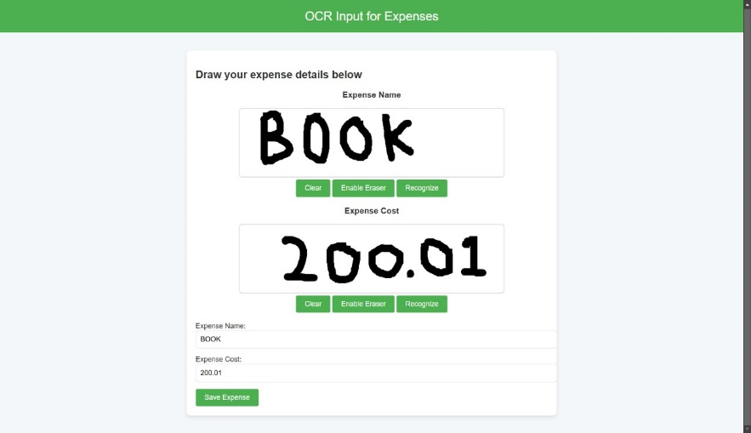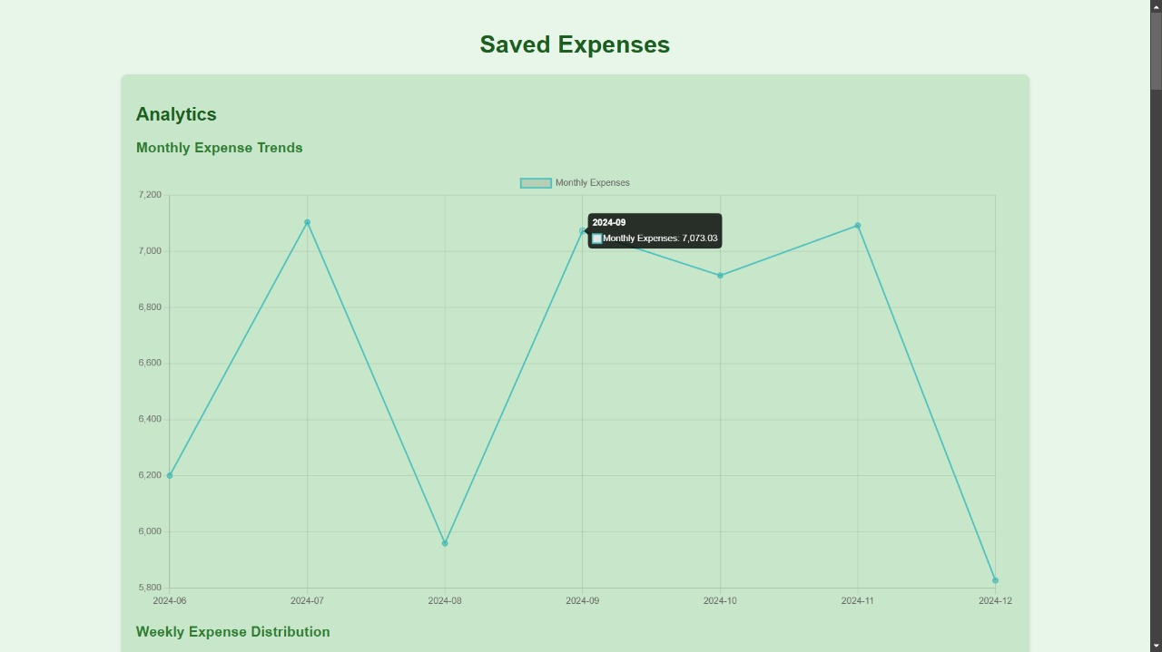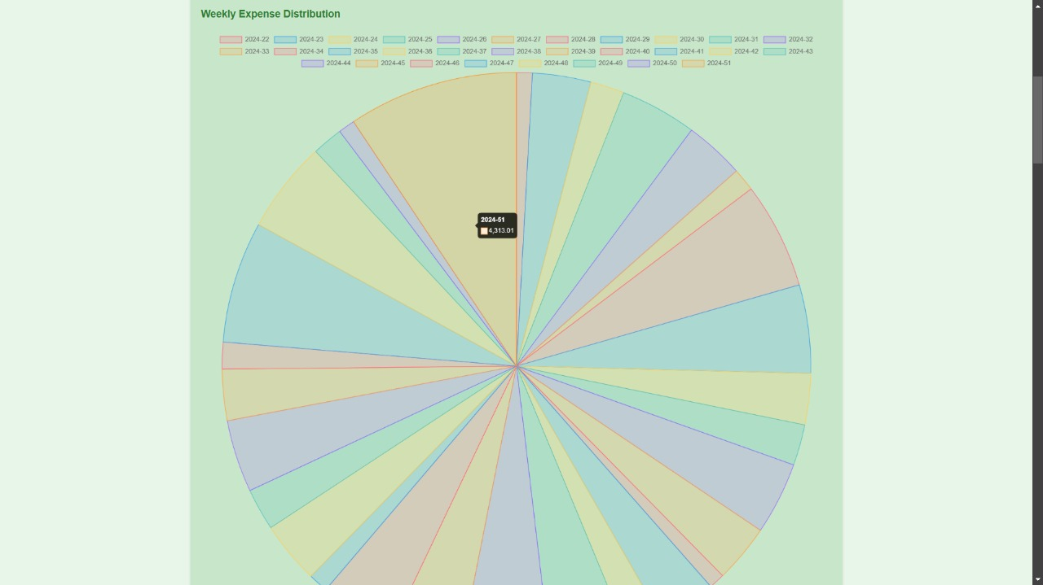

1. **CONCLUSION**

This project effectively combines Optical Character Recognition (OCR) with a user-friendly web application for tracking personal expenses. It allows users to manually input expenses or use a handwriting recognition feature for more convenient data entry. The application’s homepage features a dashboard displaying quick statistics and a simple navigation interface between manual and OCR input options. A robust database management system securely stores user data, ensuring accurate record-keeping. This solution provides an easy and efficient way to manage personal finances. Future improvements can include enhanced analytics, customizable reports, and further optimization of the user interface for a more polished experience.

1. **REFERENCES**
2. Y. Chen, "Design of a Personal Financial Planning Management Information System," 2010 International Conference on E-Business and E-Government, Guangzhou, China, 2010.
3. A. Smith and J. Lee, "Expense Tracking with Tesseract Optical Character Recognition v5: A Mobile Application Development," 2023 IEEE International Conference on Mobile Computing and Technology (ICMCT), San Francisco, CA, USA, 2023.
4. M. T. Johnson et al., "Mobile Bookkeeper: Personal Financial Management Application with Receipt Scanner Using Optical Character Recognition," 2021 IEEE Conference on Emerging Technologies for Financial Management (ETF), New York, NY, USA, 2021.
5. S. Zhang and R. Kumar, "Advancing Optical Character Recognition for Handwritten Text: Enhancing Efficiency and Streamlining Document Management," 2024 IEEE Transactions on Intelligent Systems, vol. 56, no. 7, 2024.
6. L. Williams, "WONGA: The Future of Personal Finance Management – A Machine Learning Approach," 2022 IEEE International Symposium on AI for Financial Applications (ISAF), London, UK, 2022.