GARBAGE COLLECTION MONITORING SYSTEM USING IoT WITH OPTIMIZED COLLECTION EFFICIENCY

¹T.Sudha,²G.Laxminarayanan,³R.Dinesh,⁴D.Logesh,⁵S.Namasivayam,⁶N.Ravindaran
^{1,2}Assistant Professor,Department of Instrumentation and Control Engineering,Sri Manakula Vinayagar Engineering College,Puducherry,India
^{3,4,5,6}Student, Instrumentation and Control Engineering,Sri Manakula Vinayagar Engineering College,Puducherry,India
¹sudha.ice@smvec.ac.in,²laxminarayanan1689@gmail.com,³ksrdinesh2004@gmail.com,⁴logeydani2004@gmail.com,
⁵namasivayam2611@gmail.com,⁶ravimax2508@gmail.com

Abstract— Junk Collection is a structure expected to administer waste from its cause to its last evacuation. This joins arrangement, transportation and expulsion of waste alongside watching and rule. Waste grouping procedures move for the most part among different countries and districts. Local waste collection organizations are often given by close by government masters. Curbside arrangement is the most broadly perceived technique for evacuation in numerous countries, wherein waste is accumulated at standard stretches by specific trucks. Waste assembled is then moved to an appropriate evacuation locale. Customarily, in our city we see that waste is accessible in out of dustbin. It makes unhygienic conditions for people similarly as disagreeableness to that spot leaving horrendous aroma. Nowadays, metropolitan territories with making economies experience drained waste grouping organizations, inadequately regulated and uncontrolled dumpsites which heighten the natural elements. Waste variety methodology in such countries is an on-going test and many fight due to fragile foundations and fast urbanization. The sharp, sensor based dustbin will condemn no nonsense of waste in it and send the message direct to the metropolitan organization. As shown by the filled level of the dustbin, the vehicles from the common association will pick the briefest route with the help of the "TRANSPORTATION SOFTWARE", which will save their time. It weighs on "Electronic INDIA". The system is essential. In case there is any issue with any rigging later on, that part is successfully replaceable with new one right away.
Keywords— Internet of Things, Ultrasonic Sensor, Solar Panel, Wi-Fi Module, LCD, Atmel AVR Microcontroller

I. Introduction
Ordinarily, in our city we seen that garbage was available in out of dustbin. For Individuals it makes unhygienic conditions just as grotesqueness to that spot leaving awful stench and furthermore Realizing the need of the Internet in regular daily existence, we chose to give free Wi-Fi to individuals in return of a cleaner encompassing with an interesting activity. Presently days a quick development of metropolitan populace in ongoing time. Because of expanding populace of urban areas or states the city or states can faces numerous issues like ecological issue in which expanding trash squander, expanding different kind of illnesses and make

medical condition. In late time Garbage squander assortment and its administration is basic issue.
For that In India 2 October 2014 Indian Prime Minister reported Clean India Mission dispatched by Government of India. In this mission covering 4,041 urban areas and framework of nation. Rousing by these mission we proposed the brilliant Wi-Fi dustbin framework for savvy trash squander

assortment. The work proposed in this paper outlines how the Smart receptacle arrangement enables cleaning public territory like Railway stations, Global store, Colleges, Hotels and so on to distinguish tidiness issues continuously. Accordingly, the framework can help in expanding in general efficiency and neatness.
Nowadays, metropolitan networks with making economies experience drained waste collection organizations, insufficiently managed and uncontrolled dumpsites and the issues are declining. Waste arrangement procedure in such countries is an on-going test and many fight due to frail foundations and quick urbanization. Proposed in this paper outlines how the Smart canister arrangement engages cleaning public region like Railway stations, Global store, Colleges, Hotels and so forth to identify tidiness issues progressively. Along these lines, the framework can help in expanding generally profitability and neatness.
Nowadays, metropolitan territories with making economies experience exhausted waste arrangement organizations, insufficiently supervised and uncontrolled dumpsites and the issues are declining. Waste collection methodology in such countries is an on-going test and many fight in light of slight foundations and quick urbanization.
Waste grouping methods move for the most part among different countries and regions. Local waste arrangement organizations are habitually given by close by government authorities. Curbside combination is the most broadly perceived strategy for expulsion in numerous countries, where waste is assembled at standard ranges by specific trucks. Waste assembled is then transported to a fitting expulsion district. Sufficiently managing waste is critical in developed countries. Waste the chiefs may eat up to half of a city's budgetary arrangement, anyway serve a little bit of the general population. Once in a while, up to 60%of waste isn't being gathered, it is frequently essentially consumed by the side of the road. It can dirty drinking water, it can spread illness to individuals living close by. Improving appropriate waste administration will diminish contamination, reuse helpful materials and make more efficient power energy. The splendid, sensor based dustbin will condemn true to form of waste in it and send the message really to the common organization. According to the filled level of the dustbin, the vehicles from the city organization will pick the briefest path with the help of the "TRANSPORTATION SOFTWARE", which will save their time. It underlines on "Cutting edge INDIA". The system is essential. In case there is any issue with any equipment later on, that part is adequately replaceable with new one right away.
We understand that Garbage makes harm nearby environments, and it is a danger to plant and human life. To evade all such circumstances we will execute a venture called IOT Based Smart Garbage. At the point when someone dumps waste into a dustbin the canister cinders an exceptional code, which can be utilized to access free Wi-Fi. Sensor check trash fills in dustbin or not and Router gives Wi-Fi to client. Significant portion of our task relies on the working of the GPRS Module basic for its usage. The principle point of this task is to improvement of a brilliant city vision.
II. LITERATURE SURVEY
Sudharani Ashok Garage et al.,[1] It cautions the status of trash containers just as assists with keeping dry and wet trash independently so various cycles fertilizing the soil, reusing, cremation will be applied to various types of trash. By hinting the warning of trash filled, the quantity of outings of the trash gathering vehicle will be likewise decreased.
Vinoth Kumar et al.,[2] It uses sensors to show if the canisters are made up for or shortcoming. Right when filled a carrier gets a message to clean the canister and an android application through which the customer can find a container near him to throw the trash. A web laborer is also been set up through which the metropolitan pros moreover get information about the containers in their overall region.
Sathish Kumar et al.,[3]The guideline subject of the work is to develop a sharp watchful junk prepared system for an authentic refuse the chiefs. This paper proposes a sharp prepared structure for waste room by offering a caution hint to the city web specialist for second cleaning of dustbin with proper affirmation subject to level of rubbish filling. Exactly when the truck come closer to the holders, the RFID starts talking with the RFID tag and send all information. This information cycle uses controlling Hut. This Hut is S.M.S Technology. The GPS and GPRS arranging laborers are used to look at data of changed zones.
SagnikKanta [4] The camera catches the pictures for trash containers persistently and the Radio recurrence Identification(RFID), GPS and GIS send these pictures for work station.
Andrei Borozdukhin et al.,[6] This comprises of two sections: programming and exceptional flagging hardware. The gear is put as an afterthought dividers of the canister which comprises of two sections: one is the beneficiary transmitter and sensor. Sensor is utilized to show the degree of the container which is associated with the transmitter that sends a sign of completion of the canister to the collector at the worker have. A chief is named at the worker side whose employment is to locate the most brief course and personal it to the transporter to gather it in a short time frame.
Thompson A.F [7] It has an online stage for the affiliation and checking of waste arrangement, discarding and passing on, etc This is incorporated the client, specialist and limit. The client is the device which can get to the pages and structures used by web application for instance PDAs, phones, workstations, etc the work zone is a program that dispatches the application and makes it performs over the web.
In [8], the proposed framework depicts that the degree of trash in the dustbins is recognized with the assistance of Sensor frameworks, and conveyed to the approved control room through GSM framework. Miniature regulator is utilized to interface the sensor framework with GSM framework. A GUI is additionally evolved to screen the ideal data identified with the trash for various chose areas. This will assist with dealing with the trash assortment effectively.
In [9], it depicts the utilization of our model Smart Bin in dealing with the waste assortment arrangement of a whole city. The organization of sensors empowered brilliant receptacles associated through the cell network creates a lot of information, which is additionally examined and imagined at continuous to pick up bits of knowledge about the status of waste around the city. This paper additionally targets empowering further examination in the subject of waste administration. S.
Kanta et al.[10]worked on productive trash assortment frameworks with remote sensor organization and mores center around IoT . S. Kumar et al. taken a shot at the framework which looks at the was level over the dustbins by utilizing Sensors stems. When it distinguished quickly this framework cautions to concern approved through GSM/GPRS. A. Arber et al. have dissected a circulated cross-layer submit convention (CLCP) for information conglomerations and its help for question based quest for IoT application.
J. Joshi et al.[11]have proposed an answer about the Smart Bin is an association of dustbins which facilitates the chance of IoT with Stack Based Front End approach of joining Wireless Sensor Network with base on programming. N. Kumar et al. have proposed a splendid prepared system for waste space by offering an alert hint to the city web laborer for second cleaning of dustbin with proper affirmation reliant on level of junk filling. They have used ultrasonic sensor, RFID, Arduino UNO to check the level of junk filled in the dustbin and frightened the common web laborer if refuse is filled.
W. Reshmi et al.[12] developed a structure with usage of biosensor sensor, weight sensor and height sensor to recognize surge of the misfortune in the buildup repository and the level of defilement achieved by bothersome noxious gases from the compartment. In this structure sensors unit were used for identifying, microcontroller for controlling and for correspondence GSM module is used. V. Catania et al. proposed a system where consume grouping is made by steady checking the level of canister's entirety through sensors set inside the holders.
III. IOT BASED GARBAGE COLLECTOR
In the proposed framework the trash cans sends the information to demonstrate that they are over 90% full and ought to be purged. The data is gotten by means of the site or from the data gave from the control room. In the site, the limit of the compartment is shown, which is taken as a premise to design the best course for squander assortment dump trucks head out just to those holders that really should be purged.

A ultrasonic sensor is presented in the garbage can and perceives the fill level paying little notice to what exactly has been spared inside. The whole system contains Ultrasonic Sensor, Avr Board, IOT Module, Solar Panel (Power Supply).

The sensor is fixed on to the compartment and the relationship between the avr board and sensor is made with the help of interfacing wires. The working framework is dealt with into the avr board. The Iota module is moreover connected with the comparable avr board with the help of wires. The power deftly to the system is given with the help of a sun based board.

As a rules for proposing the new structure for squander the board framework, a few issues in squander the executives will be thought of:

- Absence of data about the gathering time and territory.

- Absence of legitimate framework to screen the trucks and garbage cans that has been gathered progressively.

- There is no assessment to the measure of strong waste inside the canister and the encompassing territory because of the dispersing of waste

- There is no snappy reaction to critical cases like truck mishap, breakdown, long-lasting sitting.
- There is no snappy method to reaction to customer's grievances about uncollected waste.
- There is no investigation of discovering best course way of gathering waste
IV. IMPLEMENTATION

The framework is executed with the assistance of various modules which are clarified in this segment alongside code pieces.

User
The client opens the site, he can login utilizing Username and secret phrase and can have the option to see the status of the containers

- Status
As the force gracefully is turned on, the message "Shrewd WASTE MANAGEMENT" is shown on the LCD. Figure 1 illustrate it.
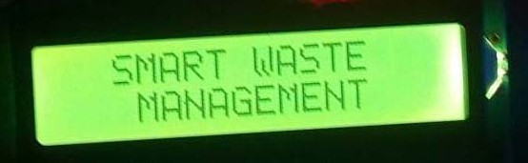
Figure 1.Initial message displayed on LCD

- ULTRASONIC Sensor (HC-SR04)

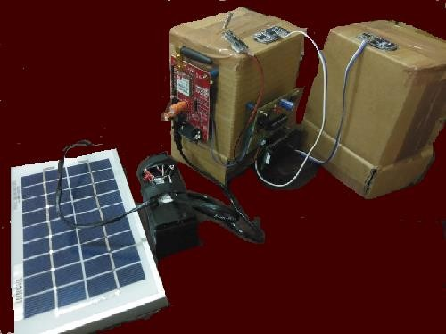
This Ultrasonic Sensor gives sign of the degree of trash/wastage filled in trash receptacle and Ultrasonic Sensor are put at the Peak of the canister and the running separation of the sensor is 2-500 cm's, concealed point to <15 degrees. The going exactness can reach to 3mm


- GSM Module
GSM module is associated with a Network; this permits utilizing the GPRS and SMS to impart over the portable organization for this task. Control signals originated from regulator shipped off cloud utilizing GSM Module.
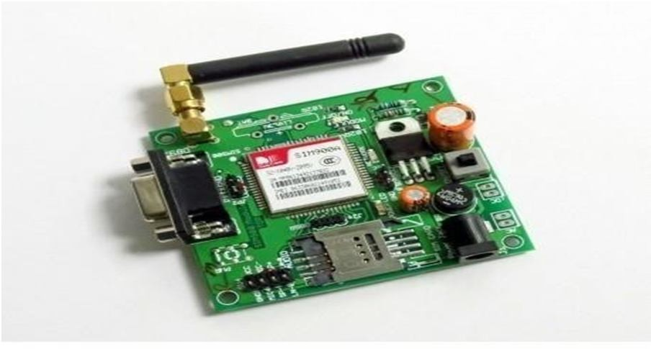
- Liquid Crystal Display
LCD's have been gotten generally famous over late a very long time for Data/data obvious in many keen gadgets. The Display gadgets are generally constrained by regulators. They causes complex/to convolve gadgets simpler to work.
Functional Block Diagram
Savvy Garbage framework incorporate Solar Panel for the force distribution over the circuits. Sunlight based board have the rating of 12v Solar voltaic cells retain the daylight and spare the force in battery for additional utilization while we doesn't having power. These framework are inbuilt with the Garbage container and it power up the Ardunio Board. Ardunio board Programmed for trash measure utilizing C language. While Power is turned ON the framework began. Figure 2 represents the functional block diagram.
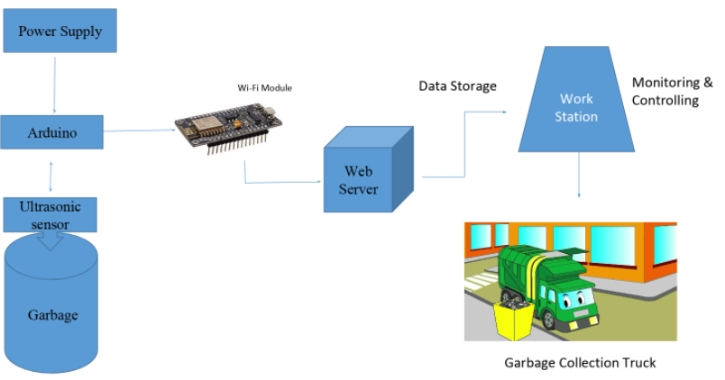
Figure 2: Functional Block diagram
Trash Bin 1 and 2 are associated with the ardunio. While the ultrasonic sensor pass the wave on the trash canister and it consequently investigation the worth like 0 to 100. The figure 3 shows the Trash bin with power supply at the point when the vale arrive at 100 its show the expression "Trash is full" and it Send the message to Control.
Figure 3: Trash bin with power supply
Control Room Supervisor Transfer the message and screen the Garbage level customary way. Also, even specialists and drivers can Monitor the trash level through the Website. Where the Garbage level is refreshed each 10min. In this way, laborers can undoubtedly follow the Garbage which one is full or not. Below Image figure 4 shows the Garbage level with Dustbin determined.

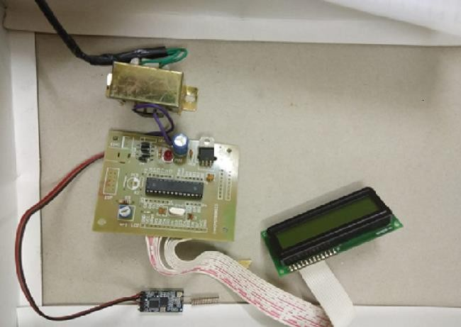
Figure 4: Indication of garbage level in the dustbin

V. THINKSPEAK
Thing Speak™ is an IoT assessment stage organization that grants you to aggregate, picture, and separate live data streams in the cloud. You can send data to Thing Speak from your contraptions, make second impression of live data, and send cautions using web organizations like Twitter® and Twilio®. Thing Speak has consolidated assistance from the numerical enlisting programming MATLAB from MathWorks, permitting Thing Speak customers to inspect and imagine moved data using Mat lab without requiring the procurement of a Mat lab grant from Mathworks. With MATLAB examination inside Thing Speak, you can form and execute MATLAB code to perform preprocessing, discernments, and assessments. Thing Speak has a comfortable relationship with Mathworks, Inc. For sure, the whole of the Thing Speak documentation is united into the Mathworks' MATLAB documentation page and regardless, enabling enrolled Mathworks customer accounts as genuine login accreditations on the Thing Speak website.[5] The terms of service[6] and insurance policy[7] of ThingSpeak.com are between the agreeing customer and Mathworks Thing Speak engages originators and scientists to demonstrate and amass IoT systems without setting up laborers or making web programming. Key capacities of Thing Speak include:
- Configure devices to send data to Thing Speak using a REST API or MQTT.
• Total data on-demand from devices and pariah sources.
• Get moment representations of live or verifiable sensor information
• Preprocess and analyze your assembled data using facilitated MATLAB.
• Run your IOT examination consequently dependent on timetables or functions.
• Follow up on your data and pass on using outcast organizations like Twilio or Twittez.

The primary figure shows the consequence of dustbin 1 and 2 . Figure 5 shows the consequence of dustbin 1 and 2 these both give us the subtleties as diagram which is simple for examination Purposes. The previous data can also be obtained using this graph. It gives us the date, time and location of each bins
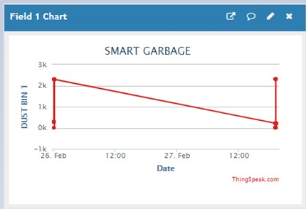

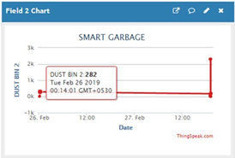
Figure 5: The date, time and location of dust bins

VI.CONCLUSION
Our essential point of this venture is to give an answer for unsanitary natural condition in a city and this execution of keen trash container marker gives an answer. In the whole world, squander assortment is a significant testing one. On the off chance that it isn't appropriately arrange or cleaned which will causes part of infections and ruin the green climate. In a large portion of the urban communities the flooded trash containers are making an offensive smell and making an unhygienic climate. Also, this is prompting the fast development of microbes and infections which are causing various sorts of sicknesses. To conquer these circumstances productive trash assortment frameworks are getting created dependent on IoT.
There are many existing ability component are accessible for taking care of just as overseeing waste. Yet, there is missing for social occasion data is a significant testing task. In our task, we have built up a proficient waste assortment and checking framework and Technology is been utilized to give better waste disposal strategies in metropolitan territories. We have utilized sensors to show if the containers are topped off to certain level and a site is connected through which a transporter gets a message to clean the canister.
The principle bit of leeway of this venture is that is lessens framework, working and upkeep costs by up to 30%. It spares time as keen vehicle vehicles go just to the filled compartments or containers. This decreases the all out number of outings of trash assortment vehicle and henceforth lessens the general consumption related with the trash assortment. The utilization of it is made much more powerful by the utilization of sunlight based boards so as to dodge the outer force gracefully and a site is considerably more powerful than an application regarding unadulterated adaptability to refresh the substance.

VII .REFERENCES

[1] S. M. Sonal Chakole, Priya Khadse, Shiruti Shinganjude, Prajakta Pimple, Snehal Shahane, “Real Time Smart City Garbage Collection and Monitoring System Using GSM and GPS,”vol. 4, issue 3, pp.291, March, 2017.
[2] N. T. Xun, “Garbage Bin Monitoring For Smart
Residence,” University Tunku Abdul Rahman, 2018.
[3] A.Anitha, “Garbage Monitoring System using IoT,”, IOP Conf. Ser.: Mater. Sci. Eng. 263 042027, 2017.
[4] K. A. Mustafa M.R, “Smart Bin: Internet of
Things Garbage Monitoring System,” MATEC
Web of Conferences 140, 01030, 2017.
[5] U. M. Anish Mohan, S.Gokul, A.Senthilkumar, Harish
P, “IOT based on Smart Waste Management in Smart
Cities,”International Journal on Recent and
Innovation Trends in Computing and Communication
, vol. 6, issue 3, pp. 68 -73, 2018.
[6] Zohari, M. H, Bala, V, & Abd Ghafar, A. S.
,“Server monitoring based on IoT using ThingSpeak
,”Journal of Electrical Power and Electronic Systems
,vol.1, issue 2 , 2019.
[7] B. Vinothkumar, K. Sivaranjani, M. Sugunadevi and
V. Vijayakumar, "IOT Based Garbage
Management System", International Journal of
Science and Research (IJSR), vol. 6, pp. 99- 101,
March 2017
[8] FH potsdam, “Fritzing,” 2018. [Online].
Available:http://fritzing.org/learning/get - started.
[Accessed: 28 -Oct-2018]

