**[Predictive Analytics for Crops](https://github.com/Tushar25v/Predictive_Analytics_for_Crops)**

**Manjusha N Mahamune1, Harshad S Varale2, Rakshitha TC3, Nisarga R4, Navya R5**

1Assistant Professor, Department of Computer Science and Engineering, T. John Institute of Technology, Bengaluru-560083, Karnataka, India

2,3,4,5Student, Department of Computer Science and Engineering, T. John Institute of Technology, Bengaluru-560083, Karnataka, India

**ABSTRACT**

This paper presents the development of a crop prediction system leveraging Internet of Things (IoT) and Machine Learning (ML) to optimize agricultural productivity. Using real-time data collected from IoT sensors, the system evaluates critical environmental factors like soil moisture, pH, temperature, and humidity. It employs advanced machine learning algorithms to recommend the most suitable crops for specific environmental conditions. The solution aims to empower farmers by providing data-driven insights, improving crop yield, and promoting sustainable farming practices. This user-friendly system integrates cloud-based accessibility to ensure remote real-time monitoring and decision-making.

**Keywords:** Crop Prediction, Machine Learning, IoT, Sustainable Farming, Data Analytics

1. **INTRODUCTION**

Agriculture remains the backbone of the global economy, yet traditional practices face challenges such as climate change, resource depletion, and inefficient decision-making. IoT and ML technologies offer innovative solutions for overcoming these hurdles by introducing precision agriculture. IoT sensors provide real-time environmental data, which, when analyzed through ML algorithms, enables data-driven crop recommendations tailored to specific conditions. This paper focuses on the design and implementation of a scalable crop prediction system aimed at enhancing productivity and sustainability.

1. **METHODOLOGY**

This study integrates IoT and ML to collect, process, and analyze agricultural data for crop prediction. The methodology involves deploying IoT sensors to capture environmental parameters, processing the data using machine learning models, and providing real-time predictions through a mobile application.

**2.1 Data Collection**

IoT sensors, including soil moisture sensors, pH meters, temperature monitors, and humidity sensors, are deployed to collect environmental data. These sensors are integrated with an Arduino microcontroller and ESP8266 Wi-Fi module for real-time data transmission to a Firebase Realtime Database.

**2.2 Data Processing and Prediction**

The system uses Decision Tree Regression to analyze sensor data and predict suitable crops. The training dataset comprises historical agricultural data, including crop requirements and environmental conditions.

**2.3 System Architecture**

The proposed architecture incorporates:

1. Hardware: Sensors, Arduino, ESP8266
2. Software: Firebase, Python libraries (NumPy, Scikit-learn), and Flutter for the mobile interface
3. Cloud Integration: Ensures remote accessibility and real-time data analytic

**2.4 User Interface**

A mobile application developed using Flutter provides an intuitive interface for farmers. It displays real-time environmental conditions, crop predictions, and actionable recommendations**.**

1. **MODELING AND ANALYSIS**

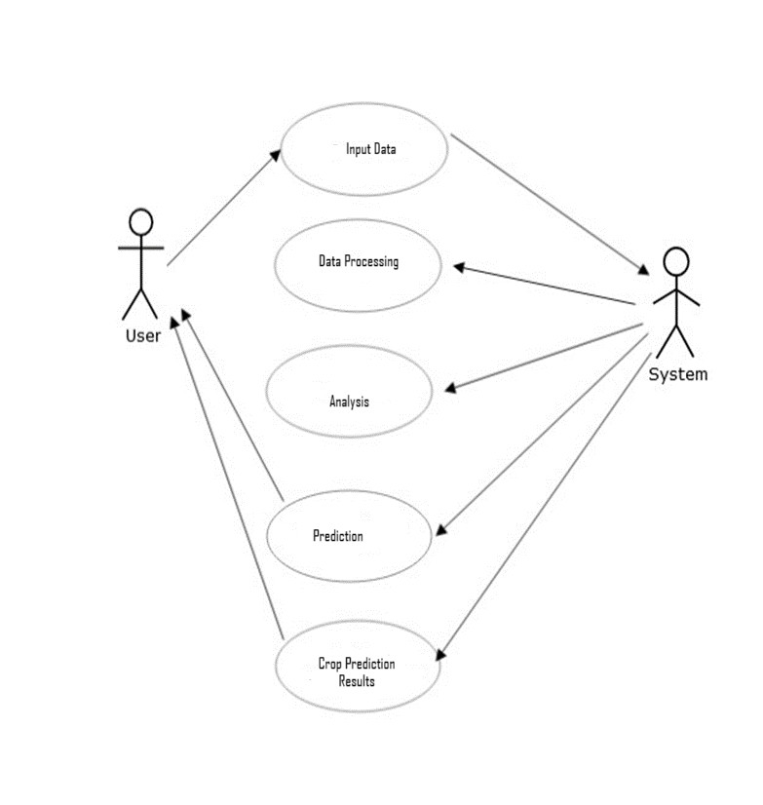

**Figure 1:** Procedure followed.

1. **RESULTS AND DISCUSSION**

The system was tested on a dataset comprising environmental parameters and crop yields. Key outcomes include:

* Accuracy: The Decision Tree Regression model achieved a prediction accuracy of 85%, with room for improvement through more extensive training datasets.
* User Accessibility: The mobile application facilitated seamless data visualization and decision-making.
* Sustainability: Optimized resource use and reduced crop failure risk were observed, promoting sustainable farming practices.

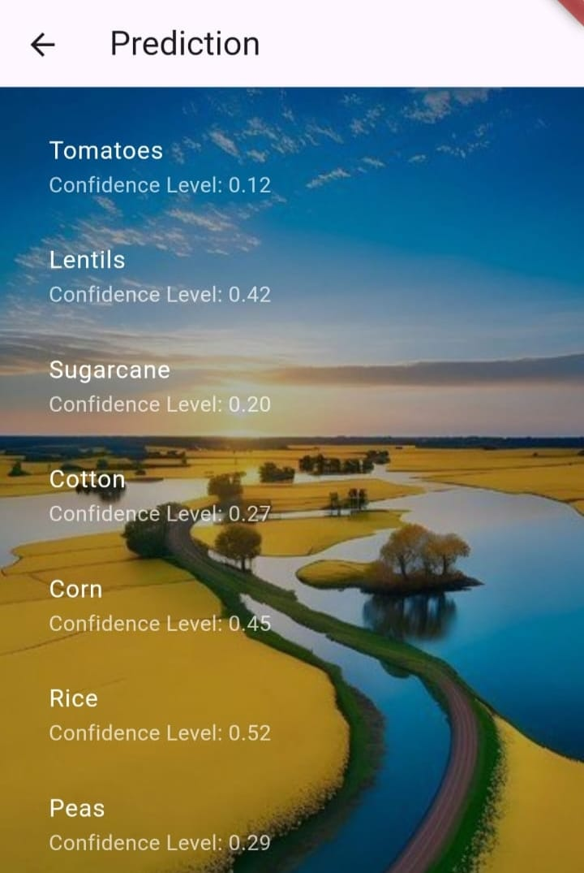

**Figure 2:** Page displaying types of crops to be cultivated.

1. **CONCLUSION**

This crop prediction system exemplifies the potential of IoT and ML in revolutionizing agriculture. By providing farmers with precise, data-driven insights, the system enhances productivity, minimizes resource waste, and fosters sustainable practices. Future work will focus on expanding the crop database and integrating market analytics to further optimize farming decisions.

1. **REFERENCES**
2. Prof. D.S. Zingade ,Omkar Buchade ,Nilesh Mehta ,Shubham Ghodekar ,Chandan Mehta “Crop Prediction System using Machine Learning”
3. Ashwani kumar Kushwaha, Swetabhattachrya “crop yield prediction using agro algorithm in hatoop”
4. Pijush Samui, Venkata Ravibabu Mandla, Arun Krishna and Tarun Teja “Prediction of Rainfall Using Support Vector Machine and Relevance Vector Machine”.
5. Himani Sharma, Sunil Kumar “A Survey on Decision Tree Algorithms of Classification in Data Mining”.
6. Pavan Patil, Virendra Panpatil, Prof. Shrikant Kokate “Crop Prediction System using Machine Learning Algorithms”.
7. Girish L, Gangadhar S, Bharath T R, Balaji K S, Abhishek K T “Crop Yield and Rainfall Prediction in Tumakuru District using Machine Learning”.
8. Rahul Katarya, Ashutosh Raturi, Abhinav Mehndiratta, Abhinav Thapper “Impact of Machine Learning Techniques in Precision Agriculture”
9. Saeed Khaki,Lizhi Wang and Sotirios V. Archontoulis, CNN-RNN schema for Crop Yield Prediction , Frontiers in Plant Science, v. 10, 2019
10. Thomas van Klompenburg,Ayalew Kassahun and Cagatay Catal, “Crop yield prediction using machine learning: A systematic literature review”, Computers and Electronics in Agriculture, Volume 177
11. Vishal Vats, Naveen Kumar, Arun Kumar, crop yield prediction using machine learning algorithms,2018.
12. Kalimuthu M, Vaishnavi P and Kishore M 2020 Crop prediction using machine learning 2020 Third International Conference on Smart Systems and Inventive Technology (ICSSIT) pp 926-32 doi: 10.1109/ICSSIT48917.2020.9214190
13. Gulati P and Jha S K 2020 Efficient crop yield prediction in India using machine learning techniques International Journal of Engineering Research & Technology (IJERT) ENCADEMS – 2020 vol 8 Issue 10.
14. Mahendra N, Vishwakarma D, Nischitha K, Ashwini and Manjuraju M. R 2020 Crop prediction using machine learning approaches, International Journal of Engineering Research & Technology (IJERT) vol 9 Issue 8 (August 2020).
15. Kalimuthu M, Vaishnavi P and Kishore M 2020 Crop prediction using machine learning 2020 Third International Conference on Smart Systems and Inventive Technology (ICSSIT) pp 926-32 doi: 10.1109/ICSSIT48917.2020.9214190.
16. Medar R, Rajpurohit V S and Shweta S 2019 Crop yield prediction using machine learning techniques IEEE 5th International Conference for Convergence in Technology (I2CT) pp 1-5 doi: 10.1109/I2CT45611.2019.9033611.