**AUTOMATIC POTHOLE DETECTION SYSTEM.**

1 K .Kirti, 2 W.Yash, 3 C.Nihal, 4 W. Nikhil, 5 Pof.Vairalkar, 6 Prof.T.Vivekanand.

1,2,3,4 Student, 5. Professor, 6.HOD.

Department of Computer science and engineering.

Govindrao Wanjari College Of Engineering And Technology,Nagpur, India

**Abstract :** Automatic Pothole Detection While Driving the main theme of the design is Smart Vehicles Electric vehicle/ Electric vehicle motor and battery technology. The arising need to help road accidents has ultimately came important aspect of moment's developing world, the graph has taken a high rise in once 5 times. And numerous families being victims of this situation have suffered a lot. 60 of road accidents are passed due to uneven roads and interferers in the line. we came up with a an idea to descry potholes and humps in an automatic manner. and the person driving will be conceded about the pothole. An automatic pothole sensor using ultrasonic detector, which detects the potholes with the help of ultrasonic detector including longitude, latitude and depth of pothole and road humps. After seeing it sends the signal to GPS receiver through Arduino WiFi module which also displays the details in the TV and a android operation. This design can be used in the transport department as the importing and exporting is substantially done in night times and this sensor helps to warn the motorists. As this product has low manufacturing bring the price might not differ important and is surely affordable for a common man, due to its range of price the deals will rise to peaks and the manufacturer also has reasonable profit.

**Index Terms**- Ultrasonic detector, Arduino WiFi module, GPS receiver.

1. INTRODUCTION

Number vehicles. The number of reported accidents is exponentially adding due to poor road conditions. The roads are deteriorating with further operation and lower conservation. Due to the poor road conditions motorists find it delicate to ascertain the manholes, bumps etc. which leads to major accidents. During the stormy season, potholes get filled with water and the motorist is unfit to distinguish its presence or depth which can lead to life hanging disasters. It's dangerous to travel by road without any warning sign, especially during night. In order to avoid this accidents, a warning system is needed which will descry and distinguish the potholes, manholes, bumps etc. on road face before it's encountered with so that the motorist gets enough response time. For this a system should be developed which will descry the blights on the road. The high provocation behind making a pothole discovery system is to prop motorists in colorful aspects and there ore help them in avoiding a possible accident. All these reasons prompt the need to get information of similar bad road conditions that can advise the motorist. A system that warns the motorist about potholes in its path, well in advance so that motorist gets a reasonable response time is being proposed then.

**II.LITERATURE CHECK**

1) Exploration work in this area falls into the following broad orders. In one, data from several vehicles are transferred to a central position for road conservation operations. In another order, exploration is directed towards helping the motorist avoid potholes. Different ways for detecting potholes use ultrasonic detector, camera, ray and infra red imaging. Potholes and other obstacles are detected and the motorist is advised ahead of time. This information regarding bad road conditions like cracks, potholes etc are transferred to other vehicles to warn them of the road condition, and the position is notified using GPS( global positioning system).

1. The FPGA grounded system for pothole discovery proposed in uses a low cost vision grounded motorist backing system over FPGA platform for discovery and avoidance of the pothole on road. It uses an FPGA model to emplace image processing algorithm to achieve affair in real time. Then a vision grounded approach is used since the pothole were different generally from the background face. A CCD camera which operates in the visible diapason band is taken as the seeing device and FPGA for videotape processing to descry the potholes.

3) The nonstop road damage discovery using regular service vehicle proposed in( 4) used a system that continuously monitors the road network for face damage like pothole and cracks. The system correspond of a structured light detector and a camera mounted on vehicle that travel the roads on a regular base. It makes use of detector and outfit formerly present on the vehicle like GPS. Then a ray line striper which sends out a aeroplane of red light and a camera to capture the image is used. Only the projected ray line is taken from the image and is converted into world coordinates via triangulation. With the ray line stripe bon can acquire 3D images with high resolution up to many measures. Its installed inside the frontal cushion of a machine and another camera is

used to record the images of the road. The data is continuously collected while the vehicle is on its route. In addition to the 3D data from the ray detector and the image data, the speed of vehicle and the position is recorded by using GPS. To produce the 3D image, the speed and exposure of the vehicle is to be known. At the end of the route, the data is downloaded on a garçon and by final analysis, the position of the pothole, cracks are determined.

The video tape taken by the camera was a sluice of images at 15 Hz, while the stripe was taken at 120 Hz. The vehicle state is also recorded by using a GPS unit in the vehicle and the acceleration, haste and several other amounts are recorded. The maximum speed of the vehicle was14.8 m/s. To produce the 3D chart of the road, the vehicle state and the several stripe of data shots is demanded. The pavement crack discovery system through localized threshold proposed in considers cracks on the pavements. numerous styles have been cooked to identify the cracks on pavement. Then image processing is done to descry the cracks. For the use of image, external factors similar as murk and indecorous lighting might affect in noise. Localized thresholding is enforced by dividing the images into lower blocks and relating a original threshold and chancing the crack pixels using the threshold of each block. relating the intensity and the relative values of the RGB factors of the image, the region of interest is attained from the original image. The image is converted into black and white to identify the being cracks. The image processing undergoes three phases, they're preprocessing, thresholding and post processing. The preprocessing stage involve filtering and other medium to convert the image into suitable form for thresholding medium.

**III. SYSTEM DESIGN**

**3.1. Phase of project**

The first phase of the design involves selection of the correct source( Electromagnetic/ Ultra- sound/ combined) to find the range and depth of dry and water filled potholes and the design of the overall system which includes the selection of frequency of the source for discovery. In the alternate phase, perpetration of the overall system and an advanced algorithm for motorist alert generation should be tried.

**3.2. Design Requirement for mode of detection**

The important requirement of this project is the mode of detection.

While choosing the source for detection we should consider the following conditions.

1)It should penetrate water and should reflect from hard surface like road, rocks, bricks etc.

2)Attenuation coefficient should be less.

By considering these two factors, we selected two sources for detection of pothole.

1)Ultrasound

2)Electromagnetic waves

**3.3.Lidar technology**

We use Lidar technology( light discovery and ranging) in our operation. It's analogous to optic seeing technology that measures the distance to a target object by illuminating the object with light froma ray and using a camera to capture the images of the object. It uses visible light to descry objects with high delicacy. Lidar technology is used in aircrafts to descry targets on earth. It illuminates the objects under water and we get the image of the object, therefore detecting objects aquatic. Lidar technology can also be used to measure the depth of water. It has colorful other operations in different fields. Lidar is used in robotics for object bracket, for carrying the megacity and country chart. Lidar can be used to produce three dimensional topographical charts and for the checks of geographical regions. In our operation we consider Lidar technology for bracket ofpotholes. We use light from a ray ray and a camera to capture the images of the road. Indeed Radar works in the same fashion as lidar technology which uses radio swells rather of light beats. Both technologies estimate distance by the time detention between transmission and event of a reflected palpitation.

**3.4. Multimodal Sensing System**

For the discovery of dry and water- filled potholes a multimodal seeing system is designed. An ultrasonic transducer of 40 kHz for detecting dry potholes and a blue ray diode of 405nm along with a camera for detecting dry as well as water- filled potholes is proposed. By using ultrasonic detector we will get the range and the depth of dry pothole. In the case of water filled potholes,ultrasonic signals will hit the water face and will get reflected down and downgraded in water due to impedance mismatch between air and water. Only some sound swells from the face will get back to the receiver. therefore only the range of the water- filled pothole can be attained. To descry and get the depth of water- filled pothole, a blue ray ray which can access the water is used. therefore the depth of water- filled potholes can be estimated. By assessing the affair from both the detectors the range and depth of the water filled pothole can be attained. By using one single sensor won't give exact information of a pothole, because on road

**IV. POTHOLE DETECTION USING ULTRASONIC SENSOR**

The fashion of distance dimension using ultrasonic detector in air includes nonstop surge and palpitation echo technique.In palpitation echo fashion, a burst of sound beats are transferred through the medium and reflected by an object. The time taken for the beats to propagate from transmitter to receiver is commensurable to the distance of object. For contact lss dimension of distance, the device has to depend on the target to reflect the beats back to itself. The handicap needs to have proper exposure. The breadth of the entered signal get downgraded and it's a function of nature of the medium and the distance between the transmitter and the handicap. The time of flight gives the distance dimension. In the time of flight system of distance dimension, position of attenuation is high. Especially in air medium and this limits the distance range. Ultrasonic Sensor(RKI-1540): The detector used in this operation is RKI- 1540( 9) which is shown in Fig4.1. The detector uses a 5V force. This detector is a high performance ultrasonic range finder. It's compact and measures a wide range from 2 cm to 4 m. Its frequence is 40 kHz. This ranger is perfect for any robotic operation, or any other systems taking accurate ranging information. This detector can be connected directly to the digital I/ O lines of a micro regulator and distance can be measured in time needed for travelling of sound signal.

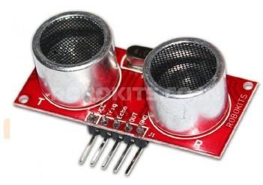

4.1.1 Design Requirement

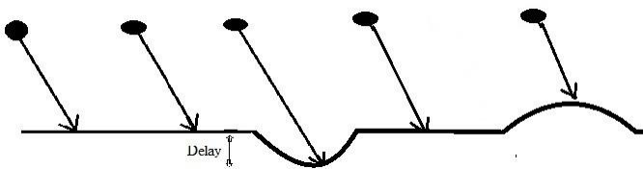

Figure 4.2: Delay schematic

In pothole discovery the main factor is the detention involved. Figure4.2 shows the schematic ofdelay.The timing unit should spark the ultrasonic detector to emit short sound palpitation and the receiver listens to the echo and determines the presence of a discontinuity before it sends the coming palpitation i.e., the echo from road and the echo from pothole will be different.

The ultrasonic detector is placed 1m above the road on the vehicle. So the average roundtrip time is 1m. The discontinuity is the outlier from this average distance. To descry the potholes, this discontinuity should be detected. The receiver will be getting echo continuously. With the echo the distance can be calculated. Any outlier in the round- trip time is considered as a discontinuity. Hence an algorithm to descry the discontinuity is needed. And when a discontinuity is detected, a clear warning has to be generated to warn the motorist.

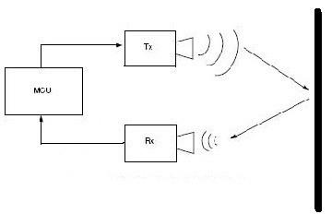

Figure 4.3: Block Diagram

4.2 Working

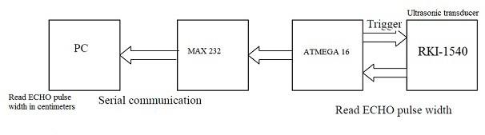

Figure 4.4: Block diagram of the system

CONCLUSIONS

By using this project we can conclude that when vehicle was enters into the critical the speed of the vehicle will automatically reduce and after the critical zone the vehicle moves with normal speed. With this project we can reduces the accidents at the critical zones and we can reduces the speed of the vehicle from rash driving

REFERENCES

1) www.ijcsit.com/docs/Volume%204/Vol4Issue6/ijcsit2013040653.pdf

2) www.google.co.in/patents/US5485161

3) www.mecs-press.org/ijisa/ijisa-v5-n9/IJISA-V5-N9-10.pdf

4) www.indjst.org/index.php/indjst/article/view/93045

5) https://en.wikipedia.org/wiki/Vehicle_tracking_system

6) https://en.wikipedia.org/wiki/Global_Positioning_System

7) www.mycollegeproject.com/ECE_Projects.html

8) www.colorado.edu/geography/gcraft/notes/gps/gps_f.html.