## ABSTRACT

The aim of this work is to formulate and evaluate an herbal face pack for glowing skin by using natural herbal ingredients. Everybody wants to get a fair and charming skin. Now a day, acne, black heads, pimples are common among persons who suffer from it. According to Ayurveda, skin problems are normally due to impurity in blood. Herbal face packs are used to simulate blood circulation, rejuvenate the muscles and help to maintain the elasticity of the skin and remove dirt from skin pores. The advantage of herbal cosmetics is their non toxic nature, reduce the allergic reactions and time tested usefulness of many ingredients. Thus in the present work, an attempt has been made in formulating an ideal face pack suitable for all skin types. The face pack were prepared and evaluated for various parameters like color, appearance, pH, consistency, wash ability, antimicrobial activity. Herbal face packs or masks are used to stimulate blood circulation, rejuvenates them muscle and help to maintain the elasticity of the skin and removes dirt from skin pores. Thus in the present work, we found good properties for the face pack. Majority of the cosmetic products available in market are of synthetic origin and causes numerous side effects when used for longer period of time. One of the solutions for this problem is use of herbal cosmetics. Herbal cosmetics are considered safe for routine use with minimal side effects.

**KEY WORDS :** Face Pack, Herbal, Non-toxic, Aloe vera, Turmeric, Formulation, Evaluation.

## INTRODUCTION

Cosmetics are products that used to clean, beautify, enhance someone's appearance, or change their look.The herbal paste used on the face to treat acne, blemishes, scars, and pigmentation is called "mukha lepa" in Ayurveda. "Mukha lepana" is the term for applying a herbal preparation on the skin.

"Mukha lepa" is used for as facial therapy. This herbal paste is applied to the face to treat pigments, scars, markings, acne, and pimples.(1)

A face pack is a smooth powder that is applied to the face. These preparations, which come in liquid or paste form, are applied to the face and allow to dry and solidify into a film that tightening, strengthening and cleansing the skin.(2)

In this study, natural substances such as Multani mitti, turmeric, aloe vera, sandalwood, orange peel powder, and gramme flour are used to prepare a herbal face pack for glowing skin . For different types of skin, herbal face packs are necessary. natural face packs and masks can help you obtain silky, healthy, and smooth skin.(3)

Various herbs and plants have been used by the science of ayurveda to formulate cosmetics that are both attractive and protective against environmental factors. The natural ingredients in botanicals provide the body with nutrients and other beneficial minerals without having any adverse reactions. The Drugs and Cosmetics Act defines cosmetics as items that are meant to be rubbed, poured, sprinkled, or sprayed on, introduced into, or applied in any other way to the human body or any portion of it in order to cleanse, beautify, promote attractiveness, or change appearance. The cosmetic is not comes under the drug license preview.(4)

Face packs are available in different types and forms,

1. including plastic masks (wax-based, latex-based, or vinyl- based)
2. hydrocolloid masks: gel masks (ready to use)
3. argillaceous masks: clay-based or earth-based (ready-to-use or dry powder form) (5)

Due to their easy availability and lower cost, herbs are now commonly used as therapeutic agents. Since ancient times, people have utilized herbs to clean, beautify, and heal a variety of skin conditions. Although the face's skin makes up the majority of the body, some typical skin conditions include Young people often have dark circles, pimples, acne, and black heads, which make their faces less fair. Ayurveda states that free radicals in the blood and environmental factors are typically the cause of skin issues. (6)

## BENEFITS

1. The face pack provides skin nourishment.
2. It lowers scars, marks, acne, and pimples. Neem and tulsi helps in reducing pimples and acne, controlling excessive sebum production from sebaceous glands, and eliminating dangerous germs from acne lesions.
3. It helps in the removal of dead skin cells from the face.
4. These are providing the skin a calming and relaxing impact.
5. Regular usage of the face pack improves complexion, skin texture, and radiance.
6. Applying a face pack may reduce the negative impacts of pollutants and hard weather.
7. They helps in minimizing the skin's premature aging.
8. They stop the skin from sagging and developing fine lines and wrinkles.
9. To improve skin radiance, cleanliness, and nourishment, some precautions are helpful. (7)
10. The effects of these face masks on the skin are relaxing and soothing.
11. They help to rapidly restore the skin's lost shining and freshness.
12. Natural face packs make the skin look younger and healthier.
13. It maintains the suppleness of the skin.
14. By using face packs effectively, it is possible to successfully resist the negative effects of pollutants and extreme weather. (8)

## PRECAUTIONS

1. The face pack is applied based on your skin type.
2. Consulted a skin specialist before to using any natural face therapy.
3. Keep the medication on the face for no more than 15 to 20 minutes, then wash it off to rinse it clean completely.
4. The face should be fully dry before applying the face pack.
5. Do not scrub vigorously .
6. Because the skin around the eyes is very delicate, avoid using face packs in the "eye zone." The skin surrounding the eyes may get damaged during the face pack removing process. (7)

## ADVANTAGES

1. There are no negative impacts from herbal products.
2. It helps get rid of dead cells in our skin.
3. The cost of herbal products is low.
4. Herb-based products are easily available.
5. It is used to add beauty to our skin. (8)
6. Herbal face packs can provide you smooth, radiant skin and are safe.
7. Encourage balanced skin tone and use natural remedies for skin ailments
8. The non-toxic nature of cosmetics made from herbs is one of their advantages.
9. For a variety of skin issues, including acne, pimples, blemishes, etc., face powders are important. (4)
10. Make the muscles stronger.
11. Maintain the elasticity of the skin.

12. Remove any debris that has trapped.

1. The increase in blood flow.
2. It nourishes the epidermis of the face.
3. It supplies vital nourishment to the epidermis.(1)
4. They assist in quickly restoring the skin's lost radiance and glow.
5. Using natural facial masks on a daily basis improves skin texture, discoloration, and shine.
6. Cleaner skin and more refined pores are the results of facial masks.
7. Frequent usage of face masks helps lessen wrinkles, dark spots, fine lines, and other aging symptoms.
8. They provide the skin a uniform tone.
9. They provide the skin moisture.
10. They assist with controlling oily skin.(9)

## DISADVANTAGES

1. The effects of herbal cosmetics are slower as compared to allopathic formulations.
2. The majority of natural medications are not readily accessible. The manufacturing process is difficult and time-consuming.
3. No pharmacopoeia specifies the exact steps or components that must be utilized in every herbal face pack.(4)
4. Its strong plant scent may offend some people.
5. Has a tingling sensation on the skin that may be a bit painful; can be a little difficult to wipe off.(1)
6. Because the skin type of each portion of our face varies.
7. There are cases when the face pack takes longer to dry.
8. It may be the source of the irritation.Face packs may sometimes make skin red.
9. People with dry skin may find it difficult to use face packs.(9)

## Literature Review

* + **Ramakrishna S., Gopikrishna UV (2021) -**Everyone aspires to have attractive, fair skin. Acne, black heads, and pimples are frequent among those who have it these days.The purpose of herbal face packs is to simulate circulation, rejuvenate muscles, preserve skin elasticity, and clear the pores of debris. Herbal cosmetics have the advantage of being non-toxic, lowering allergic reactions, and having many substances that have been shown to be effective over time. The combined pack's dry powders demonstrated good flow characteristics, making them appropriate for a face pack.
  + **Sachin Somwanshi, Ramdas Dolas (2017)-** The use of herbal components made it possible to create cosmetics without any adverse effects.Herbal face packs are regarded as a long-lasting and effective method of improving skin look.The formulation of the herbal face pack using naturally occurring substances such as multani mitti, turmeric, aloe vera, sandalwood, orange peel, neem, and nutmeg is therefore an excellent attempt in the present study.
  + **Mrs vaishnavi N karad, Dr. Rahul A. Sonawane (2023):** In order to handle skin issues including acne and pimples, this study evaluates the use of herbal elements in cosmetics, particularly herbal face packs. According to the study, these products have the properties of common skincare formulations and are stable both physico-chemically and microbiologically. The combination, which includes papaya, sandalwood, aloe vera, and turmeric, lowers acne and increases fairness. Additionally, the study passes a number of evaluation procedures, indicating that polyherbal formulations have the ability to avoid skin issues.
  + **Amit A. Shimpi, Arvind S. Pawara (2023):** For various kinds of skin issues, including cosmetics, herbal supplements provide a secure and efficient remedy. In order to ensure stability and composition, this study attempts to make a herbal face pack with natural elements such as multani mitti, turmeric, aloe vera, sandalwood, orange peel, neem, and nutmeg. Vitamins are included in the Natural Face Pack to promote healthy, glowing skin.
  + **Yamini Gawande, Mithilesh Rajpande(2023):**Acne and pimples can be treated with herbal preparations such as face packs, masks, and scrubs. Acne is reduced and fairness is enhanced by a mixture of herbs. Polyherbal formulations provide a variety of solutions for preventing skin problems after passing evaluation tests. The purpose of this study was to create and evaluate a polyherbal face pack for radiant skin that uses natural components.
  + **Sanket avhad , Amol A. Dixit (2022):** Acne and pimples can be treated with herbal preparations such as face packs, masks, and scrubs. Acne reduces and fairness is enhanced by a mixture of herbs. Polyherbal formulations provide a variety of remedies for preventing skin problems after passing evaluation tests. In addition to enhancing fairness and smoothness, the pack aims to reduce skin issues like wrinkles, acne, pimples, and dark circles.

## METHOD AND MATERIALS

1. **TURMERIC**

**Scientific Name:** Curcuma Longa

**Family:** Zingiberaceae

**Genus:** Curcuma (10)

**Chemical Constituents:** curcumin(diferuloylmethane),dimethoxy curcumin &bisdemethoxycurcumin.(11)

**Description:**Turmeric and curcumin have been studied in numerous clinical trials for various human diseases and conditions, with no high-quality evidence of any anti-disease effect or health benefit.There is no scientific evidence that curcumin reduces inflammation, as of 2020. There is weak evidence that turmeric extracts may be beneficial for relieving symptoms of knee osteoarthritis.

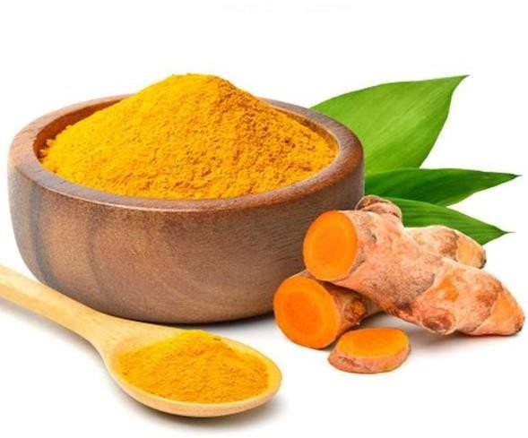

**Fig.1 Turmeric (Haldi)**

**Uses:**

1. Turmeric has Anti-Inflammatory And Anti-Allergic Activity.
2. It Is Best Blood Purifier And Helps In Wound Healing. It Possesses Best Blood Purification Action So It Is Used In All Disease With Blood Impurities Origin.
3. Haridra Rejuvenator Of Skin And Revitalizes Skin; Delays The Signs Of Aging Like Wrinkles.(10)
4. Turmeric can increase antioxidant capacity of body.
5. Curcuma can boost brain-derived neurotrophic factor.
6. May provide glow and lustre to the skin.(11)

## MULTANI MITTI

**Scientific Name:** Calcium bentonite, Bentonite Clay, Fuller's Earth.

**Chemical Constituents:** Silica, iron oxide,lime,magnesia and water .

**Description :**Multani mitti benefits the skin in a variety of ways, including by reducing pore size, eliminating blackheads and whiteheads, fading freckles, relieving sunburns, cleansing the skin, boosting blood circulation, improving complexion, and minimising acne and blemishes. They also give the skin a glowing appearance because they are rich in healthy nutrients. Acne

may be lessened by the astringent and adsorbent qualities of multani mitti. It might accomplish this by reducing inflammation and soaking up extra sebum and oil in the afflicted areas. In general, mullani mitti is regarded as secure. However, it could result in little skin irritation. This clay, which contains a variety of minerals, is frequently used in cosmetics and personal care items.(12)

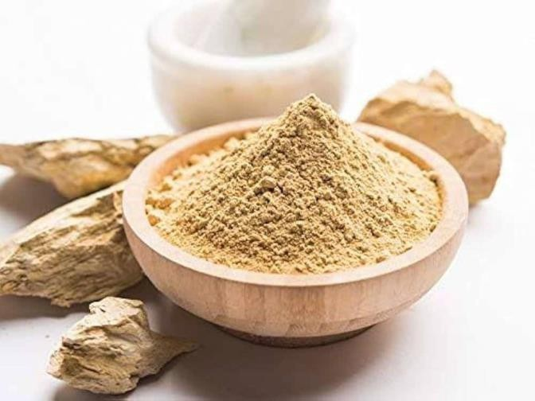

**Fig.2 Multani Mitti (Calcium Bentonite)**

**Uses:**

1. Fight acne and pimples.
2. Removes excess sebum and oil, deep

cleanses skin removing dirt, sweat and impurities.

1. Evens out skin tone and brightens complexion.
2. Treats tanning and pigmentation.
3. helps skin by different ways like diminishing pore sizes, removing blackheads and whiteheads fading freckles, soothing sunburns, cleansing skin, improving blood circulation, complexation, reducing acne and blemishes.
4. gives a glowing effect to a skin as they contain healthy nutrients.(13)

## SANDALWOOD

**Scientific Name:** Santalum album Linn.(Chandana)

**Family:** Santalaceae

**Chemical Constituents:** Sesquiterpene alcohols, alpha-Santalol,beta-santalol, Santene.

**Description:** Sandalwood powder is enriched antioxidants, antimicrobial activity that helps to maintain the structure of the skin cells intact. It

also reduces dryness and replenishes the moisture, while increasing elasticity of skin. Due to the rich antioxidant component, sandalwood can help

prevent wrinkles by fighting free radical formation. Also shows skin protective action and protect skin against environmental damage, helps to maintain skin healthy and cool.

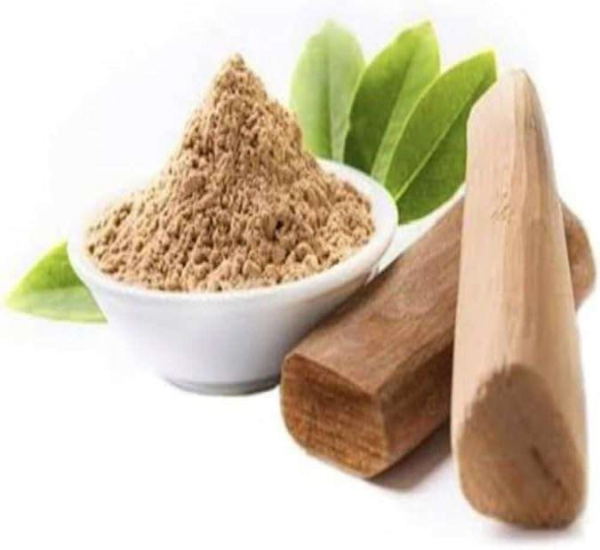

**Fig.3 Sandalwood**

**Uses:**

1) Anti-tanning property. 2)Anti-aging property.

1. Skin softening effect.
2. Pimple and acne treatment.
3. Clear complexion.
4. Sandalwood has an anti-tanning and anti-aging property.
5. It also helps in many ways like toning effect, emollient, antibacterial property, cooling astringent property, soothing and healing property.
6. Sandalwood as an effective herbs to treat acne vulgaris.
7. Sandalwood herbs show some anti-inflammatory ,antiseptic activity.
8. Reduces the appearance of scars and blemishes.(13)

## LEMON PEEL

**Scientific Name**: Citrus limon (Lemon)

**Family**: Rutaceae

**Genus**: Citrus

**Chemical Constituents**: Citric acid, Limonene , Citral , Vitamin C, Hesperidine,.(14)

**Description**: Lemons are well-known for their purifying properties and are a great source of vitamin C and citric acid. You can enhance your drinking water by adding a few freshly cut lemon wedges.The usage of lemons as a natural remedy for skin disorders including acne and age spots is becoming more and more popular due to the health advantages of consuming them.Potential advantages of using lemon to your skin The natural acidity and vitamin C content of lemons are the reasons behind the alleged skin advantages of using them. The following are some uses for lemons.

**Acne treatment**: Because of its high acidity, lemon juice has astringent properties. Low pH ingredients can aid in reducing oil and irritation, which may be factors in the development of acne. Additionally, a form of alpha hydroxy acid (AHA) called citric acid can aid in the breakdown of dead skin cells that cause blackheads and other non-inflammatory forms of acne.

**Antimicrobial Effects :** Propionibacterium acnes, the bacteria that causes inflammatory acne, may be reduced by lemons' antibacterial properties. Lemon also has antifungal properties that may help cure scalp fungus, which may occur with seborrheic dermatitis, and Candida rashes.

**Lightening of skin spots or hair:** Citrus compounds, such as lemon, may also be effective in lightening acne scars, age spots, and facial hair.

**Treatment for psoriasis and dandruff:** Lemon juice has been shown to help reduce skin patches linked to psoriasis and dandruff because it can eliminate dead skin cells. Lemon's natural citric acid content is considered to be responsible for the sloughing-off effects since AHAs exfoliate the skin.

**Increased collagen:** According to some supporters of applying lemon to the skin, the citrus fruit is a natural way to boost collagen in the skin around the face. As people age, a protein called collagen naturally degrades, leading to wrinkles and fine lines.

**As an antioxidant:** vitamin C may help defend collagen from free radical damage, resulting in smoother skin.

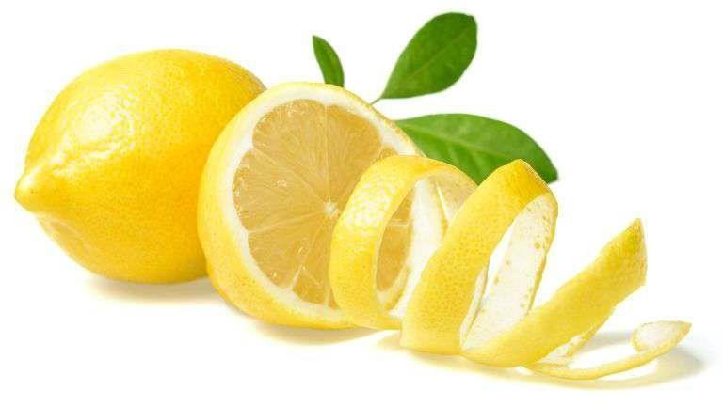

**Fig.4 Lemon Peel**

## ALOE VERA

**Scientific Name:** Aloe Barbadensis Miller **Family:** Asphodelaceae (Liliaceae) **Genus:** Aloe

**Chemical Constituents:** Barbaloin, Beta barbaloin.(11)

**Description:** For ages, people have known and used the aloe vera plant for its health, beauty, medical, and skin-care benefits. The Arabic word “Alloes,” which means “shining bitter material,” is the source of the name Aloe vera, while the Latin word “vera” signifies “true.” Greek scientists viewed aloe vera as the cure- all 2000 years ago. Aloe was known to the Egyptians as “the herb of immortality.” The aloe vera plant is used in dermatology nowadays for a variety of treatments. Aloe Barbadians miller is the scientific name for aloe vera. It is a perennial,

shrubby or arborescent, Xerophytic, succulent, pea-green plant that is a member of the Liliaceae family. Africa, Asia, Europe, and America‟s bald weather are where it primarily grows. It can be hinge in Tamil Nadu, Gujarat, Maharashtra, Rajasthan, and Andhra Pradesh in India. (12)

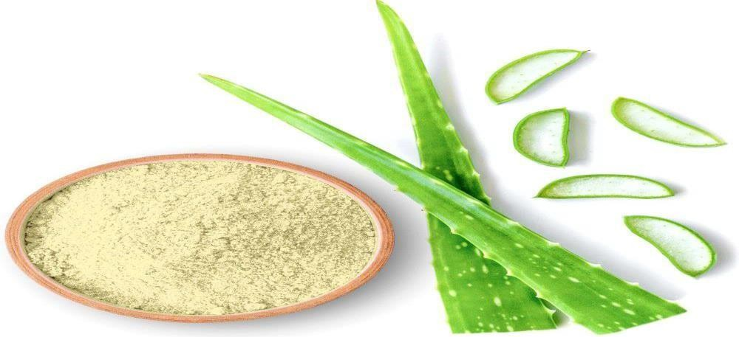

**Fig.5 Aloe Vera**

**Uses:**

1. Prevent premature aging.
2. Hydrate the skin.
3. Natural glow to skin.(11)
4. Aloe vera is effective in a treatment of wounds or burns.
5. It is promoted as a moisturizer.
6. anti-irritant to reduce chafing of the nose.
7. Also helps to speed up skin cell reproduction as much as eight times.(10)

## GRAM FLOUR

**Scientific Name:** Cicer arietinum(Chana)

**Family:** Fabaceae

**Genus:** Cicer

**Description:** Due to chickpeas are high in magnesium, they can help minimize wrinkles and fine lines on the skin. By restoring balance to the body's fatty acid balance, it improves skin suppleness, eliminates wrinkles, and smoothes out fine lines. It also keeps wrinkles from appearing too soon. can reduce inflammation, dryness, and sensitivity symptoms, as well as lighten hyperpigmented skin.

**Uses:**

1. Prevent acne.
2. It cleans,tightens and protects dead skin(15)
3. Removes tanning.
4. Reduces Redness and irritation.
5. Have antibacterial property.(16)

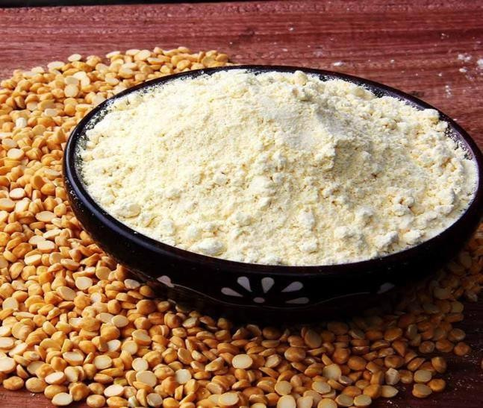

## Fig.6 Gram Flour

**PROCEDURE FOR FACE PACK APPLICATION**

* + Take the prepared face pack powder into a bowl as needed to create a smooth paste.
  + Add 3-4ml of rose water or water.
  + Apply this paste all over your face, give it 10 to 15 minutes to dry.
  + After the powder has dried, gently scrape the pack from the skin and wash it off with water.
  + The face pack also works as a scrub when it is gently worked into the skin for a few minutes.(17)

## METHODS OF EVALUTION

1. **ORGANOLEPTIC EVALUATION:** The physical characteristics, such as appearance, color, odor, texture, grittiness, and washability, which were evaluated manually for it's physical properties.(18)
2. **PHYSICOCHEMICAL EVALUATION:** Physicochemical parameters, such as moisture content, extractive values, pH, and ash values, were determined.(18)
   1. **Determination of moisture content:** The moisture level of plant medications matters greatly because improper drying could cause the active ingredients to deteriorate enzymatically.
      * Loss on drying (LOD) was used to calculate the moisture content.

Accurately weigh 3 grams of the powdered drug , transfer it to a weighted petri dish, and place it in a hot air oven set between 100 and 108°C Weighing was done until the weight remained constant.

* 1. **Determination of extractive values:** The main application of extractive values is the identification of contaminated or exhausted medications. It helps in assessing the product's purity and quality. Additionally, it provides knowledge about the characteristics of the chemical constituents. A lower extractive value suggests adulteration, the addition of exhausted material, or improper drying, storing, or formulating procedures.
     1. **Water soluble extractive value:** macerate 5 grams of precisely weighed material for 24 hours in a stoppered flask using 100 milliliters of chloroform water. For the first six hours, shake frequently. Rapidly filter through filter paper into a 50 ml cylinder, then dry off 25 ml of the aqueous extract in a tared flat bottomed shallow dish.

Dry entirely in an oven set at 105°C after evaporating on a water bath, then weigh the residue. It should be kept in a desiccator. Determine the percentage w/w of water-soluble extractive value using the air-dried drugs after the extract has been dried to a consistent weight.

* + 1. **Alcohol soluble extractive value:** macerate 5 grams of precisely weighed material with 100 milliliters of 90% alcohol in a 100 milliliter stoppered flask for a whole day. For the first six hours, shake frequently. Rapidly filter through filter paper into a 50 ml cylinder, then collect the filtrate and dry off 25 ml of alcoholic extract in a shallow dish with a tared flat bottom. On a water bath, evaporate until totally dry, then weigh the residue at 105°C. It should be kept in a desiccator.

Using the air-dried drugs as a reference, determine the percent w/w of alcohol soluble extractive value after drying the extract to a constant weight.

* 1. **Determination of pH:** This involves calculating the product's acidity or alkalinity using a scale from 0 to 14. The face pack's pH in rose water was determined.
  2. **Determination of Ash values:** The product's ash content is the residue left over after complete combustion. Ash value is a measure used to assess a drug's identity or purity. A high ash value indicates adulteration, contamination, substitution, or carelessness in the product's manufacturing. The following methods can be used to determine ash values.
     1. **Total Ash Value:** This value can be used to identify low-quality, exhausted items as well as an excess of earthy, sandy material in drugs. A crucible that had been previously illuminated and tared was filled with roughly 2-4 grams of the prepared sample. After evenly spreading the material across the crucible, the heat was gradually increased until the material turned white, or carbon-free. After cooling in a desiccator, it was weighed. The air-dried sample was used to calculate the percentage of total ash.
     2. **Acid Insoluble Ash value:** A measure of earthy stuff. A watch glass was placed above the crucible with the total ash after 25 milliliters of HCl had been applied. For 5 minutes, gently boil.

After being cleaned with 5 milliliters of hot water, the watchglass was placed inside the crucible. After gathering the insoluble material on ashless filter paper, hot water was used to neutralize it. After being moved to the original crucible, the filter paper containing the insoluble material was dried on a hot plate and ignited to constant weight. After 30 minutes of cooling in a desiccator, they were weighed. The percentage of acid-insoluble ash was determined using the air-dried sample as a reference.

* + 1. **Water soluble ash value:** This is the weight difference between total ash and residue after a water treatment. It is employed to determine whether or not water has drained the substance.

25 milliliters of water were added to the crucible with the whole ash, and it boiled for 5 minutes. An ashless filter paper was used to collect the insoluble material. cleaned with hot water and set aflame for 15 minutes at a temperature of no more than 450ºC in a crucible. weighed after cooling.The percentage of water-soluble ash was determined using the air-dried sample as a reference.

1. **RHEOLOGICAL EVALUATION:** It provides a general understanding of the product's viscoelastic flow behavior. For the formulation, physical data such as the bulk density, Hausner's ratio, Carr's index, tapped density, and angle of repose were measured and analyzed.(18)
   1. **Angle of repose:** The steepest dip or angle of descent with respect to the horizontal plane that a granular material may be piled to without stumping is known as the angle of repose or critical angle of repose. It is essential to the design of particulate matter processing, storage, and conveyance systems. Quantifying the powder's flow characteristics is also helpful because it affects the cohesiveness of the various particles. The height (H) above a piece of paper that is positioned on a horizontal surface is calculated using the fixed funnel cone method. Carefully, the prepared pack was poured down the funnel until the top of the conical pile just brushed the funnel's tip.

Here „R‟ denotes the radius of the conical heap.

The equation for calculating angle of repose(a) is, a= 𝐭𝐚𝐧−𝟏(𝑯/𝑹)

* 1. **Tapped Density:** Mechanically tapping a graduated measuring cylinder filled with a powder sample results in an increased bulk density known as the tapped density. A powder's compressibility and flow characteristics can both be predicted using its tap density. A graduated cylinder can be used to measure the package volume. Using a funnel, 25 grams of weighed formulation powder were gradually added to the cylinder. After observing the starting volume, the sample was tapped until there was no further volume loss.

After tapping, the value was recorded.

The equation for calculating the tapped density is,

**TappedDensity(g/mL)=M/Vf**

where ,M is the mass in grams and

Vf is the tapped volume in milliliters.

* 1. **Bulk Density:** The volume of all the pores in the powder sample is included in the bulk density value. Bulk density is a technique used to describe how particles or granules are packed. The graduated cylinder was gradually filled with 25 grams of weighed powder. It was remarked how much space the powder took up.

The formula for calculating bulk density is, D = 𝑴/𝑽

Where, D = bulk density, M = mass of particles,

V = total volume occupied by them.

* 1. **Hausner's Ratio:** This ratio can be utilized to forecast the characteristics of powder flow since it is connected to interparticle friction.

The equation for measuring the Hausner‟s ratio is, Hausner‟s ratio = 𝒂𝒑𝒑𝒆𝒅 𝒅𝒆𝒏𝒔𝒊𝒕𝒚/𝒃𝒖𝒍𝒌 𝒅𝒆𝒏𝒔𝒊𝒕𝒚

* 1. **Carr's Index:** An indirect way to estimate powder flow from bulk density is to use Carr's index. It has a direct correlation with particle size and relative flow rate cohesiveness. It is a straightforward, quick, and widely used technique for controlling powder flow characteristics.

The equation for measuring it is,

% compressibility = 𝒕𝒂𝒑𝒑𝒆𝒅 𝒅𝒆𝒏𝒔𝒊𝒕𝒚−𝒃𝒖𝒍𝒌 𝒅𝒆𝒏𝒔𝒊𝒕𝒚/𝒕𝒂𝒑𝒑𝒆𝒅 𝒅𝒆𝒏𝒔𝒊𝒕y.

* 1. **Particle size:** This parameter influences a number of characteristics, including grittiness and spreadability. The microscope approach was used to determine the particle size in accordance with a standard procedure.(11)

1. **IRRITANCY TEST:** Mark a 1 sq. cm. area on the dorsal surface of the left hand. Time was recorded after applying a set amount of prepared face packs to the designated area. Any irritability, redness, or swelling was assessed and reported at regular intervals for up to 24 hours.(19)
2. **STABILITY STUDIES:** stability tests of the obtained formulation was carried out by storing it for a month at various temperatures. The formulation's packed glass vials were kept at room temperature, 35°C, and 40°C. Physical characteristics such color, odor, pH, consistency, and feel were examined.(19)

## FUTURE PERSPECTIVE

The future of herbal face packs looks promising, as they are non-toxic, have fewer side effects than synthetic products, and are in increasing demand. Herbal face packs can be used to:

**Improve skin health:** Herbal face packs can help rejuvenate skin, improve blood circulation, and remove dirt from pores. They can also help with acne, pimples, scars, and marks.

**Treat skin conditions:** Herbal face packs can help with premature aging, wrinkles, and fine lines.

**Reduce allergic reactions:** Herbal cosmetics are non-toxic and can reduce allergic reactions.

**Use ingredients with a long history of use:** Many ingredients used in herbal face packs have been used for a long time.

When formulating an herbal face pack, you can consider the type of skin and the desired properties of the face pack. For example, you can use oils like coconut oil, jojoba oil, or almond oil for a nourishing and moisturizing face pack.

## CONCLUSION

Herbal face packs have been found to be an excellent way to make skin look glowing. The entire study is important for supporting product claims because of its positive impacts on humans. Because natural medicines are safer and have fewer adverse effects than synthetic ones, their components are more widely accepted. On the international market, there is an increasing demand for herbal formulations.

After examination, the combined pack's dried powders demonstrated good flow characteristics, making them appropriate for a face pack. According to an organoleptic evaluation, the pack has a pleasant and smooth smell. The pack's flow characteristics were validated by rheological results, which showed that it was free- flowing and non-stick. There was no irritation and the formulation was stable in every way.

Tests of stability showed that the pack was inert. To determine its practical advantages for people, more optimization research on its many characteristics is needed.

## REFERENCE

1. Diksha Dhiman, Hamisha, Mr. Rajesh Kumar, Dr. Rajesh Gupta. Review Article: Herbal Face Pack. International Journal of Novel Research and Development- Volume8, issue 3 March 2023, c198-c204.
2. Sachin Somwanshi, Ramdas Dolas. Formulation and Evaluation of Cosmetic Herbal Face Pack for Glowing Skin. International Journal of Research in Ayurveda and Pharmacy- August 2017, Research Article ,8(Suppl 3),199-203.
3. Sanket A. Avhad, Amol A. Dixit, Shweta S. Bhakare, Jayashri K. Akiwate, Digvijay U. Aswale, Rahul v. Anbhule. Formulation and Evaluation of Polyherbal Face Pack. Journal of Drug Delivery and Therapeutics- 2022, Research Article,12(5):153-155.
4. Ravindra Kalyan Narwade, Prachi Murkute, Deepak Sudhakar Surase. Formulation and Evaluation Herbal Face Pack Powder for Glowing Skin.International Journal of Pharmaceutical Sciences-2024, Research Article,Vol2, issue 5, 235-246.
5. Yamini Gawande, Mithilesh Rajpande, Namrata Mane, Nilima Sakharkar, Dr. Narendra Dighade. Formulation and Evaluation of Polyherbal Face Pack. IRE Journal ,Vol 7 issue1-July 2023, 293-299.
6. Ravi Kumar, Komal. Formulation and Evaluation of Herbal Face Pack. Asian Journal of Pharmaceutical Research- January-March 2021, Research Article , vol 11(1),9-12.
7. Kalyani Arun Chaudhari. A Review Paper On Formulation and Evaluation of Herbal Face Pack.International Research Journal of Modernization in Engineering Technology and Science-May 2023,vol:05/issue:05,7430-7434.
8. Ms. Ankita V. Kalmulkar, Patange Kalyani, Paul Priti, Pawade Rupesh, Pawar Pragati .Formulation and Evaluation of Herbal Face Pack: Review Article. Journal of Emerging Technologies and Innovative Research-2014,vol:10,issue:12,f187-f195.
9. Sakshi Unhawane, Vishal Narsale , Nikhil Jadhav. Formulation and Evaluation of Herbal Face Pack. International Journal of Pharmaceutical Sciences -2024, Research Article,vol:2,issue:6,977-986.
10. Mr. Rutik P. Ankushe, Mr. Abhijit A. Pawar, Miss. Manisha K. Pakhare . A Review Literature on Herbal Face Pack. International Journal of Creative Research Thoughts-vol:11,issue:5, May 2023,k774-k786.
11. Ms. Vaishnavi N. Karad, Dr. Rahul A. Sonawane. A Review on Polyherbal Face Pack. International Journal of Creative Research Thoughts-Vol:11,issue:12, December 2023, g713-g718.
12. Roshan Yadav, Hiranmoy Saha, Arsh Chanana. Formulation and Evaluation of Herbal Face Pack. World Journal of Pharmaceutical Research- January 2023,Research Article, vol:12, issue:2,1164- 1175.
13. Mr. Dnyaneshwar Dahifale. Formulation and Evaluation of Herbal Face Pack . International Journal of Pharmaceutical Research and Applications-December 2023,Vol 8, issue 6,1764-1779.
14. Kristeen Cherney, Jamie Cesanek, Jen Anderson, Does Applying Lemon to your Face Helper or Hurt your Skin, September 7,2023, <http://www.healthline.com/health/lemon-for-face>.
15. Rahul Abasaheb Wadavkar, Kiran Waghmare, Samjay Garje, Gaffer Sayyad, A Review: Formulation and Evaluation of Herbal FacePack, Vol:1/issue 04/ April 2024, 398-402.
16. Abhijit R. Raut , Pranali R. Gajbhiye, Jagdish V. Manwar. Formulation, Development and Optimization of Polyherbal Face Pack For Skin Ailments. International Journal of Pharmaceutical Sciences- 2024,Research Article, Vol:2/issue 3, 747-753.
17. Iram Rajpoot, Mujahid Mohabbat, Nasiruddin Ahmad Farooqui. Formulation and Evaluation of Herbal Face Pack by Using Natural Ingredients. IJPS- September-October 2023, Research Article,vol:82/issue01.005, 29-34.
18. Ramakrishna S., Gopikrishna UV, Formulation and Evaluation of Herbal Face Pack, Journal of Emerging Technologies and Innovative Research,Vol 8, issue 12/ December 2021, f179-f186.
19. Shingane Pooja Vyankati, Sul Sukanya ajinath , Dr. Santosh Jain, Chavan ramkrashna shesherao, Formulation and Evaluation of Herbal Face Pack for Glowing Skin, International Journal of Creative Research Thoughts, Vol:11/issue:6/June 2023,b340-354.