"An experimental investigation to Use of Bottom Ash and Pond Ash in S-Glass Fiber Concrete"

Prof. Kamlesh Kumar Choudhary¹, Anurag Tiwari²
¹Assistant Professor & HOD, Department of civil engineering, Saraswati Institute of Engineering & Technology, Jabalpur, India
²PG Student, Department of civil engineering, Saraswati Institute of Engineering & Technology, Jabalpur, India
ABSTRACT
This study investigates the feasibility of using bottom ash and pond ash as partial replacements for sand in S-Glass fiber concrete. The aim is to explore the potential of these waste materials to enhance the properties of concrete while simultaneously addressing environmental concerns related to their disposal. M30 grade concrete, Various mixtures of bottom ash, pond ash, sand, cement, and S-Glass fibers were prepared and tested for compressive strength, splitting tensile strength, and flexural strength. The results indicate that incorporating bottom ash and pond ash in concrete mixtures led to improvements in mechanical properties. Furthermore, the addition of S-Glass fibers contributed to enhanced durability and crack resistance.
The workability of nominal concrete Mix designation MC -1 is 73 mm and by using of bottom ash and pond ash in S-glass fiber concrete’s workability MC-5 is 79 mm. Compressive strength of the nominal concrete Mix designation MC -1 is 24.10 MPa and by using of bottom ash and pond ash in S-glass fiber concrete’s compressive strength MC-5 is 26.15 MPa with Increase strength in 8.50% more at 7 days of curing of Cubes. Compressive strength of the nominal concrete Mix designation MC -1 is 31.99 MPa and by using of bottom ash and pond ash in S-glass fiber concrete’s compressive strength MC-6 is 36.40 MPa with Increase strength in 13.79 % more at 28 days of curing of Cubes. Splitting Tensile strength of the nominal concrete Mix designation MS -1 is 2.88 MPa and by using of bottom ash and pond ash in S-glass fiber concrete’s Splitting Tensile strength MS-6 is 3.33 MPa with Increase strength in 15.71 % more at 7 days of curing of Cylinders. Splitting Tensile strength of the nominal concrete Mix designation MS -1 is 3.21 MPa and by using of bottom ash and pond ash in S-glass fiber concrete’s Splitting Tensile strength MS-6 is 3.55 MPa with Increase strength in 10.57 % more at 28 days of curing of Cylinders. Flexural Tensile strength of the nominal concrete Mix designation N-Mix- B-(1-2-3) is 4.86 MPa and by using of bottom ash and pond ash in S-glass fiber concrete’s Flexural Tensile strength MB4-B-(13-14-15) is 5.35 MPa with Increase strength in 9.98 % more at 28 days of curing of Beams.

Keywords:
Sand, Bottom Ash, Pond Ash , Nominal Concrete ,S-Glass Fiber Concrete, Compressive Strength, Cubes, Splitting Tensile Strength , Cylinders ,Flexural Tensile Strength, Beams.
- INTRODUCTION
Use of Bottom Ash and Pond Ash in Concrete: In thermal power plants, bottom ash and pond ash are byproducts of burning coal. Because of their pozzolanic qualities, these minerals are frequently employed as additional cementitious ingredients in the formation of concrete. Through appropriate processing and utilization, bottom ash and pond ash can lessen the dependency on conventional cement sources such as Portland cement, hence improving the sustainability of concrete production.
1.1 Ordinary port land cement (OPC)
Ordinary port land cement (OPC) is the basic Portland cement and is best suited for use in general concrete construction. It is of three types, 33 grades, 43 grades, 53 grades. One of the important benefits is the faster rate of development of strength. Portland slag cement is obtained by mixing Portland cement clinker, gypsum and granulated blast furnace slag in suitable proportion and grinding the mixture to get a thorough and intimate mixture between the constituents. This type of cement can be used for all purposes just like OPC. It has lower heat of evolution and is more durable and can be used in mass concrete production.
1.2 Fine Aggregate
Fine aggregate most of which passes through a 4.75 mm. IS sieve and contains only that much coarser material as is permitted by the specifications. Sand is generally considered to have a lower size limit of about 0.07 mm. Material between 0.06 mm and 0.002 mm is classified as silt, and still smaller particles are called clay. The soft deposit consisting of sand, silt and clay in about equal proportions is termed loam.
1.3 Coarse Aggregates
In this study, coarse aggregates of size 40 mm and 20 mm conforming to specifications as given in IS: 383- 1970 is used. Pycnometer test is carried out to find the specific gravity of aggregates. Sieve analysis has been done to find the fineness modulus of aggregate.
1.4 Pond Ash
Certain materials used in civil engineering replace cement with Silica fume, a binding agent. This article covers the methods Pond ash, a by-product of thermal power plants, exhibits distinct chemical properties that are crucial for its potential applications in construction and environmental management. The characterization of pond ash typically involves analyzing its chemical composition, which includes the presence of various oxides and elements.
1.5 Bottom ash
Bottom ash is a non-combustible residue left over after the combustion process in a power plant, boiler, furnace, or incinerator. It's the coarser part of coal ash, making up about 10% of the waste, and settles at the bottom of the boiler instead of floating into the exhaust stacks. Bottom ash is made up of inert materials like sand, stones, and ash from burnt material, as well as metals that are embedded in the residual waste. It has an angular texture and a color that ranges from gray to black, with grain sizes that can be as fine as sand or as coarse as gravel.
  - S -Glass fiber
S-Glass fiber is a type of glass fiber that is known for its high strength and excellent thermal stability. It is primarily used in applications where superior mechanical properties are required, such as in aerospace, military, and high-performance sporting goods. The composition of S-Glass fiber typically includes silica (SiO2) and other oxides that enhance its performance characteristics.
1.7 Water
Concrete is a composite material made primarily of four key ingredients: cementitious material, fine aggregates, coarse aggregates, and water. Among these components, water plays a crucial role in the formation and strength of concrete. The following sections will detail the importance of water in concrete, the effects of excess water, and considerations regarding water quality.

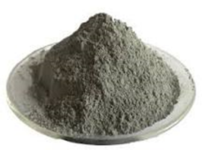 | 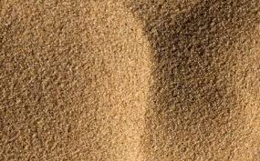 | 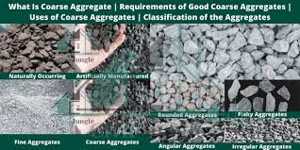 | 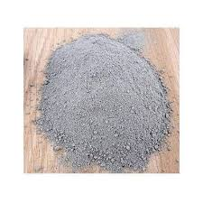 | 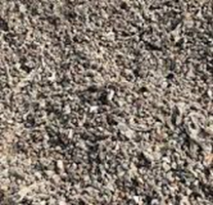 | 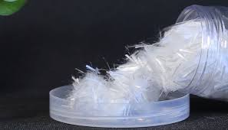 | 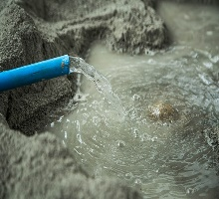
Cement (OPC) | Fine Aggregate | Coarse Agg. | Pond Ash | Bottom ash | S -Glass fiber | Water
Figure no 1; Ingredients of Mix Concrete

- THE OBJECTIVES OF THE STUDY ARE
- To find the workability of concrete for different percentage replacement of FA with pond ash and bottom ash.
- Replace a portion of the natural fine aggregate and the fine aggregate at varied ratios of 10%, 20%, 30%,40% and 50% with pond ash and bottom ash.
- The Compressive-strength, and split tensile-strength behavior should be studied by using available equipment’s in the laboratory.
- To determine compressive strength of hardened concrete at 7 & 28 days of curing & compare various mixes in Cube (150mm x150mm x150mm).
- To determine Split tensile-strength at 7 & 28 days of curing & compare various mixes in Cylindrical (150mm x 300mm ).
- To determine Flexural tensile-strength at 28 days of curing & compare various mixes in Beams (150mm x150mm X 700mm ).

- METHODOLOGY
Their use in S-Glass fiber concrete improves the strength and durability of the material. The goal of the current study is to determine the impact of replacing Pond Ash and Bottom Ash with fine aggregate, respectively, on the performance of in S-Glass fiber concrete grade M30. The ratios of cement, fine aggregate, and coarse aggregate were Mix design with a water/cement ratio of 0.45 and the addition of super plasticizer Conplast 430. The mix design was based on the IS: 10262-2009 method. Pond Ash and Bottom Ash was used partially replace the natural fine aggregate in concrete at various ratios of 10%, 20%, 30%, 40% & 50% An experiment was carried out using M30 grade concrete. Results are taken as a Cylindrical and Cubes are casted to check the Split tensile strength and compressive of concrete at 7 days and 28 days.
Table 1: Test matrix for Cube in % | Table 2: Test matrix for Cube in Weight
Mix C % FA% PA% BA% CA% Water % S-Glass Fiber %  MC -1 100 100 0 0 100 100 100  MC -2 100 50 0 50 100 100 100  MC -3 100 50 10 40 100 100 100  MC -4 100 50 20 30 100 100 100  MC -5 100 50 30 20 100 100 100  MC -6 100 50 40 10 100 100 100  MC -7 100 50 50 0 100 100 100 | Mix C kg/m3 FA kg/m³ PA kg/m3 BA kg/m³ CA kg/m³ W kg/m S-Glass Fiber  MC -1 414.00 837.02 0.00 0.00 1124 .79 186.00 0.00  MC -2 414.00 418.51 0.00 418.51 1124 .79 186.00 3.00  MC -3 414.00 418.51 83.70 334.81 1124 .79 186.00 3.00  MC -4 414.00 418.51 167.40 251.11 1124 .79 186.00 3.00  MC -5 414.00 418.51 251.11 167.40 1124 .79 186.00 3.00  MC -6 414.00 418.51 334.81 83.70 1124 .79 186.00 3.00  MC -7 414.00 418.51 418.51 0.00 1124 .79 186.00 3.00
- OBSERVATIONS & RESULT DISCUSSION

4.1 Workability of various concrete mixes design for slump cone test
Table 3: Workability of various concrete mixes design | Graph 1: Workability of various concrete mixes design for slump cone test
Mix Designation | Slump Value Vibrators not used (in mm)
MC -1 | 73
MC -2 | 74
MC -3 | 76
MC -4 | 77
MC -5 | 79
MC -6 | 78
MC -7 | 75

4.2 Compressive Strength
Table 4 : Compressive strength for M30 at 7 days.  Mix designation Load (KN) Compressive Strength (N/mm2) Strength (N/mm2) Average % Increase in strength at 7 days  MC-1 541.00 24.04 24.10 0.00  541.00 24.04  545.00 24.22  MC-2 552.00 24.53 24.64 2.23  553.00 24.58  558.00 24.80  MC-3 556.00 24.71 24.93 3.46  561.00 24.93  566.00 25.16  MC-4 575.00 25.56 25.66 6.47  576.00 25.60  581.00 25.82  MC-5 586.00 26.04 26.15 8.50  587.00 26.09  592.00 26.31  MC-6 589.00 26.18 26.03 8.01  585.00 26.00  583.00 25.91  MC-7 570.00 25.33 25.75 6.84  585.00 26.00  583.00 25.91 | 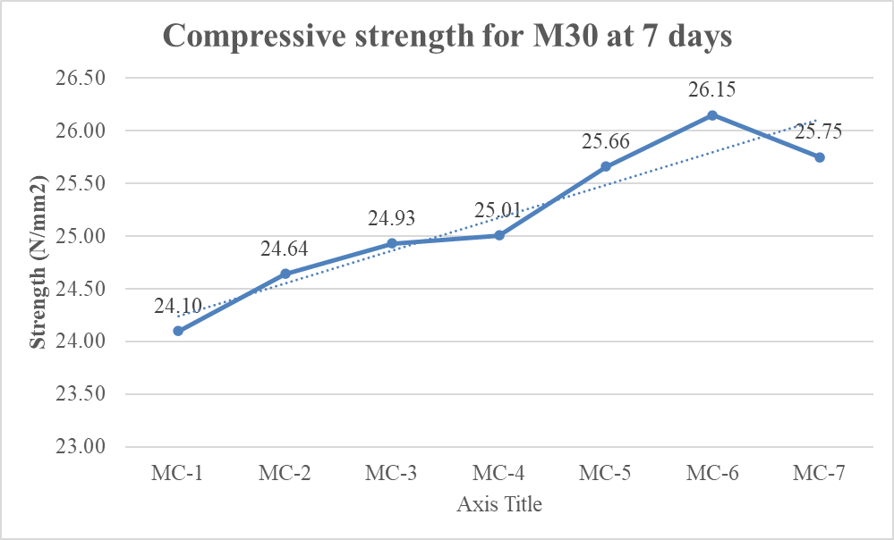  Figure 2 : Compressive strength for M30 at 7 days.
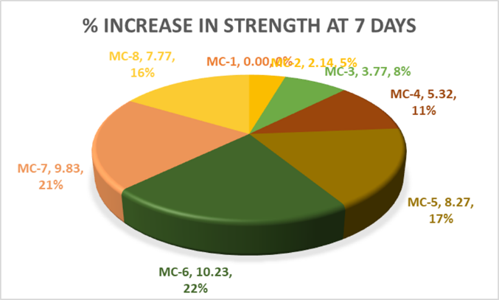
Graph 2 : Pi-Chart of increase Compressive strength for M30 at 7 days.
Table 4 : Compressive strength for M30 at 7 days.  Mix designation Load (KN) Compressive Strength (N/mm2) Strength (N/mm2) Average % Increase in at 28 days  MC-1 31.82 24.04 24.10 0.00  32.09 24.04  32.04 24.22  MC-2 32.87 24.53 24.64 2.23  33.58 24.58  33.84 24.80  MC-3 33.76 24.71 24.93 3.46  34.42 24.93  34.32 25.16  MC-4 34.92 25.56 25.66 6.47  35.07 25.60  35.33 25.82  MC-5 35.47 26.04 26.15 8.50  35.60 26.09  35.78 26.31  MC-6 36.22 26.18 26.03 8.01  36.44 26.00  36.53 25.91  MC-7 35.02 25.33 25.75 6.84  34.36 26.00  34.44 25.91 | 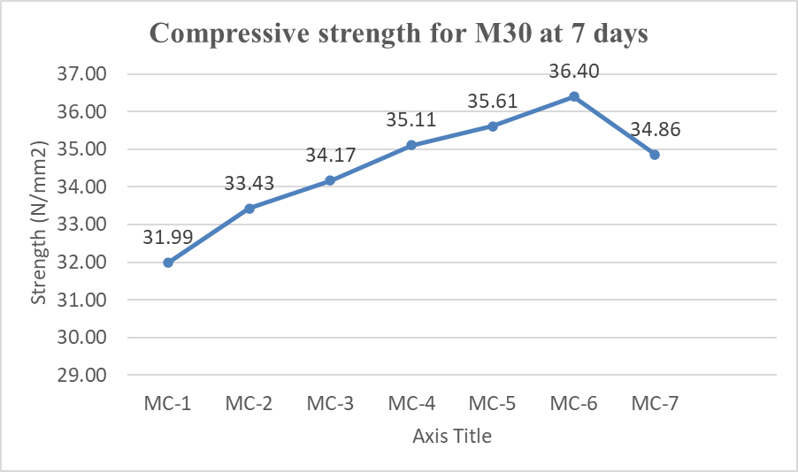  Figure 3 : Compressive strength for M30 at 28 days.
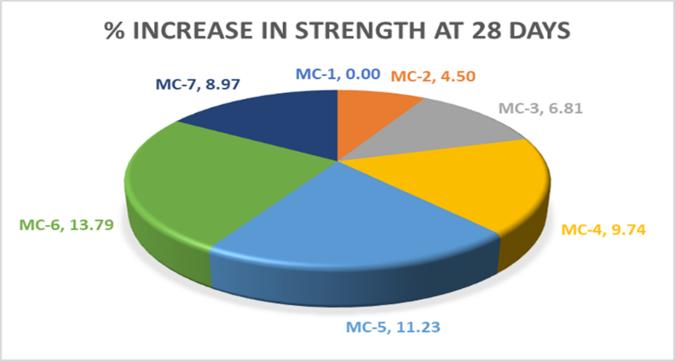
Graph 3 : Pi-Chart of increase Compressive strength for M30 at 28 days.
4.3 Flexural Strength(fb)N/mm2
Table no. 5; Flexural Strength(fb)N/mm2 at 28 Days
Beam No. | Weight | Length | Distance Between fracture & the nearer support(a) | Load at failure (P) | Flexural Strength  (fb) | Average Strength | % Increase in strength at 28 days
 | gm | mm | mm | KN | N/mm² | N/mm² | %
N-Mix-  B-(1-2-3) | 41600.00 | 600.00 | 213.00 | 27.15 | 4.83 | 4.86 | 0.00
 | 41425.00 | 600.00 | 212.00 | 27.35 | 4.86
 | 41600.00 | 600.00 | 215.00 | 27.50 | 4.89
MB1-  B-(4-5-6) | 41550.00 | 600.00 | 213.00 | 27.45 | 4.88 | 4.92 | 1.15
 | 41600.00 | 600.00 | 214.00 | 27.65 | 4.92
 | 41600.00 | 600.00 | 211.00 | 27.85 | 4.95
MB2-  B-(7-8-9) | 41425.00 | 600.00 | 210.00 | 28.10 | 5.00 | 5.04 | 3.75
 | 41600.00 | 600.00 | 209.00 | 28.55 | 5.08
 | 41600.00 | 600.00 | 211.00 | 28.45 | 5.06
MB3-  B-(10-11-12) | 41425.00 | 600.00 | 211.00 | 29.05 | 5.16 | 5.17 | 6.45
 | 41600.00 | 600.00 | 209.00 | 28.90 | 5.14
 | 41550.00 | 600.00 | 211.00 | 29.35 | 5.22
MB4-  B-(13-14-15) | 41600.00 | 600.00 | 214.00 | 30.10 | 5.35 | 5.35 | 9.98
 | 41425.00 | 600.00 | 214.00 | 29.85 | 5.31
 | 41600.00 | 600.00 | 213.00 | 30.25 | 5.38
MB5-  B-(16-17-18) | 41550.00 | 600.00 | 215.00 | 29.45 | 5.24 | 5.18 | 6.63
 | 41600.00 | 600.00 | 213.00 | 29.15 | 5.18
 | 41600.00 | 600.00 | 214.00 | 28.85 | 5.13
MB6-  B-(19-20-21) | 41425.00 | 600.00 | 211.00 | 28.55 | 5.08 | 5.02 | 3.34
 | 41600.00 | 600.00 | 210.00 | 28.25 | 5.02
 | 41600.00 | 600.00 | 209.00 | 27.95 | 4.97
MB7-  B-(22-23-24) | 41425.00 | 600.00 | 214.00 | 28.10 | 5.00 | 5.02 | 3.22
 | 41550.00 | 600.00 | 214.00 | 28.30 | 5.03
 | 41600.00 | 600.00 | 213.00 | 28.25 | 5.02

- CONCLUSION
- The primary objective of the work is to analyze the use of bottom ash and pond ash in S-glass fiber concrete. M30 grade concrete that contains bottom ash and pond ash along with fine particles was compared to conventional concrete.
- The workability of nominal concrete Mix designation MC -1 is 73 mm and by using of bottom ash and pond ash in S-glass fiber concrete’s workability MC-5 is 79 mm.
- Compressive strength of the nominal concrete Mix designation MC -1 is 24.10 MPa and by using of bottom ash and pond ash in S-glass fiber concrete’s compressive strength MC-5 is 26.15 MPa with Increase strength in 8.50% more at 7 days of curing of Cubes .
- Compressive strength of the nominal concrete Mix designation MC -1 is 31.99 MPa and by using of bottom ash and pond ash in S-glass fiber concrete’s compressive strength MC-6 is 36.40 MPa with Increase strength in 13.79 % more at 28 days of curing of Cubes .
- Flexural Tensile strength of the nominal concrete Mix designation N-Mix- B-(1-2-3) is 4.86 MPa and by using of bottom ash and pond ash in S-glass fiber concrete’s Flexural Tensile strength MB4-B-(13-14-15) is 5.35 MPa with Increase strength in 9.98 % more at 28 days of curing of Beams.

REFERENCES
- Specification for 33,43,53 Grade ordinary Portland cement IS 269 – 2015.
- Specification for coarse and fine aggregate IS 383-2016.
- Methods of test for aggregate for concrete particle size and shape IS 2386 (Part I) 1963
- Methods of test for aggregate for concrete estimation of deleterious materials and organic impurities. IS 2386 (Part II) 1963.
- IS: 456 – code of practice for plain and reinforced concrete.
- IS: 383 – specifications for fine and coarse aggregate from natural sources for concrete.
- IS: 2386 – methods of tests for aggregate for concrete. (nine parts)
- IS: 2430 – methods of sampling.
- IS: 4082 – specifications for storage of materials.
- Avadhut Kshirsagar,Dr. Ramachandra Hegde (2020) “Pond Ash as Partial Replacement of Fine Aggregate in Concrete” https://www.researchgate.net/publication/341293795
- Tumingan,Tjaronge M,Djamaluddin R and Sampebulu.V,( April 2015 )“Compressive strength of concrete with pond ash as replacement of fine aggregate”, ARPN Journal of Engineering and Applied Sciences., April 2015
- Phanikumar B., Sofi A.(2016) “Effect of pond ash in concrete as replacement of sand”, Ain Shams Engineering Journal 2016, pp 89-99J.
- Verma A., Kumar A., Mishra A., Verma A.,(2016)“Utilization of pond ash as partial replacement of cement concrete mix”, International Journal of Engineering and Technology, Vol. 3 issue 3, March 2016.
- Sreelakshmi R., Reshmi P.(2016), “Durability performance of concrete replaced with pond ash as fine aggregate”, IOSR Journal of Mechanical and Civil Engineering, pp 12-18K.
- Sharma S., Ritu,(2015) “Characterization and use of pond ash in concrete as replacement of sand”, International Journal of Technical Research, Vol.4,Issue 3, Nov.-Dec. 2015.
- Sharma P., Himani, Dabas A. (2018) “Experimental study with pond ash as partial replacement of fine aggregate in concrete with superplasticizer”, International Journal of Engineering and Technology, Vol. 7 issue 7, July 2018
- Madheswaran R., Bharath M., Anjalidevi M. (2018)“Utilization of pond ash as fine aggregate”, International Research Journal in Advanced Engineering, Vol. 3, Issue 3, June 2017
- IS 456:2000, “Plain and reinforced concrete – Code of practice” Beauro of Indian Standards, 2000.
- IS 383:2016, Coarse and fine aggregate for concrete”, Beauro of Indian Standards, 2016.
- IS 10262:2009, “Concrete mix proportioning – Guidelines”, Beauro of Indian Standards, 2009
- Wahab A, Kumar BD, Bhaskar M, Kumar SV, Swami BL. Concrete composites with nano silica, condensed silica fume and fly ash–Study of strength properties. International Journal of Scientific and Engineering Research. 2013 May; 4(5):1–4.
- Bi J, Pane I, Hariandja B, Imran I. The use of nanosilica for improving of concrete compressive strength and durability. Applied Mechanics and Materials. 2012; 204:4059–
- Mistry JA, Patel IN, Shah MJ. Effect of nano silica on compressive strength of high volume flyash concrete. Development. 2015 May; 2(5):1–5.
- Sai AS, Swami BL, Saikiran B, Sastri MV. Comparative Studies on High Strength Concrete Mixes Using Micro Silica and Nano Silica. IJETR (International Journal of Engineering and Technical Research). 2013; 1(7):60–5.
- Shekari AH, Razzaghi MS. Influence of nano particles on durability and mechanical properties of high-performance concrete. Procedia Engineering. 2011 Jan 1; 14:3036–41..
- Yoo BS, Park DW, Vo HV. Evaluation of Asphalt Mixture Containing Coal Ash. Transportation Research Procedia. 2016 Dec 31; 14:797–803..
- Naganathan S, Mohamed AY, Mustapha KN. Performance of bricks made using fly ash and bottom ash. Construction and Building Materials. 2015 Oct 15; 96:576–80.

