CAMPUS COMPASS

S. Nivedha ¹ , MITHRAJITH. K.S ², MOHAMMED SYFUDEEN. R ² ,
¹Assistant Professor, Department of Artificial Intelligence and Machine Learning, Sri Shakthi Institute of Engineering and Technology, An Autonomous Institution ,Coimbatore-641062.
²Bachelor of Technology in Artificial Intelligence and Machine Learning, Second year, Sri Shakthi Institute of Engineering and Technology, , An Autonomous Institution ,Coimbatore-641062.

Abstract- This is actually one of the most pivotal transitions a student will go through in his or her life-from secondary education to higher learning-which forms the foundation on which a future academic and professional career is based. The selection of a proper college and university is a very critical choice for all students, as it may substantially impact their prospects concerning their future occupation and personal lives. This template thus will allow for the chatbot to understand their requests, secure necessary information from the database, and actually develop appropriate and informative responses that may be more reassuring to have in the process. This was originally a supporting framework that eased the generation of HTTP request handlers, route creation, data serialization, amongst other things. The frontend, responsible for the user interface and user interaction, is developed using a combination of HTML, CSS, and JavaScript. HTML provides the structure and content of the web pages, CSS styles the visual presentation, and JavaScript adds interactivity and dynamic behavior, creating a user-friendly and engaging experience. MongoDB is a NoSQL database, which is to be used for efficient storing and fetching various data utilized by the chatbot, including cutoff information, student reviews, and metadata regarding college images. This is selected because it is highly scalable, flexible, and capable of handling massive volumes of unstructured data. The project thus focuses on the ease, efficiency, and personalization for the students. By providing a centralized platform for comprehensive information, the chatbot empowers students to make informed decisions about their higher education, setting them on the path to academic and professional success.
INTRODUCTION
This is actually one of the most pivotal transitions a student will go through in his or her life-from secondary education to higher learning-which forms the foundation on which a future academic and professional career is based. The selection of a proper college and university is a very critical choice for all students, as it may substantially impact their prospects concerning their future occupation and personal lives. This template thus will allow for the chatbot to understand their requests, secure necessary information from the database, and actually develop appropriate and informative responses that may be more reassuring to have in the process.
This was originally a supporting framework that eased the generation of HTTP request handlers, route creation, data serialization, amongst other things. The frontend, responsible for the user interface and user interaction, is developed using a combination of HTML, CSS, and JavaScript. HTML provides the structure and content of the web pages, CSS styles the visual presentation, and JavaScript adds interactivity and dynamic behavior, creating a user-friendly and engaging experience. MongoDB is a NoSQL database, which is to be used for efficient storing and fetching various data utilized by the chatbot, including cutoff information, student reviews, and metadata regarding college images.
This is selected because it is highly scalable, flexible, and capable of handling massive volumes of unstructured data. The project thus focuses on the ease, efficiency, and personalization for the students. By providing a centralized platform for comprehensive information, the chatbot empowers students to make informed decisions about their higher education, setting them on the path to academic and professional success.

PERFORMED ANALYSIS ON EXISTING
METHODOLOGY
The methodology for developing the student-centric chatbot platform involved a structured series of steps to ensure the development of a reliable, efficient, and user-friendly solution for higher education guidance.

Data Collection and Storage:
A comprehensive database was prepared on MongoDB, storing a variety of information such as college cutoff scores, student reviews, the courses offered, and campus images as metadata. The schema-less nature of MongoDB provided enormous flexibility in managing large volumes of unstructured data and scalability in the future to hold more institutions and their information, and of students.

Natural Language Processing Integration:
The conversational core of the chatbot was powered by the Gemma2:2b model, fine-tuned for understanding and responding to education-related queries. The model was trained on a diverse dataset to improve its contextual understanding, enabling it to answer complex and varied student queries effectively.

Backend Development:
The Flask framework was used to design the backend, which has made routing and API integration seamless. It has made it possible to handle HTTP requests effectively, generate responses dynamically, and interact with the database for fetching and updating information.

Frontend Development:
Built the UI with HTML for structure, CSS for styling, and JavaScript for interactivity. The design focused on clarity and ease of responsiveness, ensuring that students would easily navigate through it, input queries, and interact with the chatbot.

Query Resolution and Recommendation System: A query resolution mechanism was implemented that allowed the chatbot to analyze and categorize user inputs using natural language processing techniques. The system generated personalized recommendations based on user preferences, such as course interest, location, and budget constraints.

Text Matching and Verification:
For the features in POA that required verification for eligibility or scholarship guidance, string-matching algorithms and similarity measures were integrated to compare the input data provided by the user against stored records. Minor variation in input formats-for example, case differences or spacing-had been accounted for to enhance robustness.

Testing and Feedback Loop:
The system was taken through extensive testing with a student group and educators, finding bugs for bettering response accuracy. Some of the feedback from these testers was useful in the refinement of the user interface, especially regarding recommending relevance. Scalability and Optimization: The system was optimized with efficient database queries and automated workflows so as to handle concurrent queries on the platform. It hence can ensure reliability and scalability as it widens its umbrella to include an increasing number of users and their associated data. Insight and Reporting: A reporting dashboard for administrators shows in real-time the number of conversations between chatbots and end-users, query categorization, and unresolved issues to continuously help the platform improve and align with the needs of its users.

DEMERITS AND DISADVANTAGES

- Personalization and Customization: The chatbot will make very personalized recommendations based on each student's profile and preference. Apart from the usual college brochures or websites, it will cater to the needs of each particular student based on their desired program, location, and academic credentials. This personalized approach will make relevant information come your way, saving you time and effort in sifting through irrelevant data.
- Centralized and comprehensive information: It provides one single, centralized location that is integrated with all kinds of college information in one place. No need to search many websites, take the information from crowded college fairs, or go through outdated print material. All their college research can be done through the chatbot, therefore making this process much faster.
- Data-Driven Decision Making: The chatbot will let the students make data-driven decisions based on hard facts, such as past year closing cutoffs. The data will provide a realistic view to the students about the chances of admission into an institution so that they may focus their applications in a place where they have a reasonable probability of getting in. It reduces uncertainty and makes strategic choices.
- Efficiency and Time-Saving: The chatbot simplifies the process of researching colleges, saving This saves manifold valuable time and effort that students would otherwise have to invest in endless searches on websites, going to fairs, or collecting brochures. The chatbot will give, in brief and easily accessible form, all the information that students will need, freeing their time to take care of other important facets of college application.
- Continuous Learning and Improvement: There is a mechanism for feedback by which students can grade the performance of the chatbot and make recommendations on how it can be improved. The feedback loop makes the algorithms for this chatbot more tuned for effectiveness throughout its constant improvement.
- Data Dependency and Accuracy: This all depends on the completeness and accuracy of data from the knowledge base, where information has been input. Any incompleteness or failure to update on closing cutoffs, student reviews, and college profiles results in defective recommendation or information passed to students through the chatbot. For such, the maintenance of an updated, continuously checked database becomes absolutely necessary.
- This includes the establishment of mechanisms for data validation, periodic updating from authoritative sources, and procedures for dealing with inconsistencies or errors.

- Potential for Bias in Student Reviews: While the student reviews provide very important first-hand views, they cannot help but be subjective and may be biased or even malicious. There is a potential for inflated or deflated ratings, personal attacks, or the spread of misinformation. This will require robust moderation systems, including automated filtering of inappropriate language, manual human review of flagged content, and clear guidelines for submitting reviews.
- Equally important is transparency about the review process and potential biases that may arise.
- Limited Nuance and Context in AI Interpretation: While powerful, the Gemma model is still likely to struggle with nuanced language, complex queries, or ambiguous phrasing; it might misunderstand what a user is trying to achieve or miss part of the context in which a question is set. That's where continuous training and refinement of the model with diverse datasets and the incorporation of user feedback for further improvement in understanding and response accuracy come into play.In addition, appropriate human oversight and intervention mechanisms should be in place to handle complex or ambiguous queries.
- Lack of Personal Human Interaction: As much as the chatbot is efficient in the delivery of information, it cannot replace personal guidance and emotional support from counselors or advisors. It cannot understand complex individual situations, provide advice on personal development or career planning, or offer emotional support during stressful times, such as the application process.
- The chatbot will be positioned to complement, not replace, human contact. It should, therefore, be clearly communicated to students that it has its own limitations and to seek human guidance when needed.

SOME IMPORTANT SOFTWARE USED

AND ITS DESCRIPTION

PYTHON
Python is the backbone on which the concept of the student-centric help chatbot realizes itself, considering the robust and versatile infrastructure it provides as a basis for development. It has a seriously vast ecosystem through which libraries provide natural language analysis, web apps, and database integration. Other reasons developers like Python mean its simplicity will enable faster code development and much faster debugging. So, Python just allows all this to meet at one central point: getting conversational AI to work from the backend along with the project.

FLASK
Flask serves as the backbone, providing a back-end structure light and flexible; it offers more rapid development necessary for the construction of the backbone, RESTful APIs, routing, and handlers. Most of Python's libraries and extensions are easily paired with Flask because it provides very solid means for such connectivity, so working properly with core aspects of a chatbot itself; hence, one could label it a quite reliable solution as far as scaled and efficient Web applications go.

- FRONTEND:
- The UI of the chatbot platform is designed using HTML, CSS, and JavaScript to make it instinctive and entertaining. HTML provides the structural framework where all the content is organized; CSS makes it polished and responsive with consistent styling; and JavaScript allows real-time searching, dynamic updating, and responsive animation. The frontend will let the user navigate and explore college information, personalized suggestions by the chatbot, and interact with it seamlessly.

MONGODB:
MongoDB forms the backbone of the chatbot and provides a highly scalable, flexible database solution. Its schema-less design makes handling totally unstructured data-be it student reviews, college images, or metadata-easy and smooth. MongoDB is good to go with fast querying and robust scaling, hence suitable for managing large volumes of data with efficient and reliable information retrieval.

GEMMA2 MODEL:
The Gemma2:2b model acts as the backbone for conversational intelligence in this chatbot, which is able to provide high-level natural language processing. It has the ability to understand and create context-aware responses, thus promising meaningful and personalized interactions with the users. This model also further integrates seamlessly with Python, enabling the chatbot to process large data inputs and make insightful recommendations that form the core of this AI-powered student assistance.

CHATBOT EVALUATION
Performance evaluation of the proposed chatbot system will be paramount in determining whether the expected performance by its end-users has been efficiently and effectively attended to, considering its main tasks of query resolution, recommendations, and retrieval of information. This will be done based on the metric scores of accuracy, precision, recall, and the F1-score of the system, which will help in ascertaining the strengths and weaknesses of the proposed chatbot while attending to the queries of the students.
Confusion Matrix Analysis
The confusion matrix helps understand the performance of the chatbot through its responses:
True Positives (TP): The instances where the chatbot correctly resolves a query; for example, if a student asks for "cutoff details for XYZ College" and the chatbot retrieves information about it.
True Negatives (TN): Those cases where the irrelevant queries are correctly identified by the chatbot. Suppose a user types "weather today"; should the response from the chatbot be some kind of an inability to process the query, it would be a true negative.
FP-FALSE POSITIVES are those instances when the chatbot responded with something totally irrelevant or wrong. Examples of this may include asking students for "campus facilities", and getting from the chatbot responses about the "admission dates ".
FN-FALSE NEGATIVES: Those cases when the chatbot doesn't respond to a valid query. Suppose the student asks for "scholarship options," and the bot says nothing or says, "I don't understand"; that will be a false negative.

RESULT AND DISCUSSION
In our study relating to the Chatbot platform for the purpose of assisting students in choosing higher education institutions, the system came out very useful in terms of personalized suggestions, answering questions, and detailed information about colleges. In user testing, 88% expressed satisfaction with the effectiveness of the system, hence showing a lot of relevance in the accuracy of responses. In these, the high capability of natural language processing, the responses by the Gemma2:2b model were contextual and informative, with an accuracy rate of 85%.
This involved handling volumes of unstructured data, such as college reviews, cutoff scores, and metadata, which were efficiently managed and retrieved from the system's MongoDB database. The average query response time was less than 2 seconds, ensuring a perfect user experience.
From the confusion matrix analysis, it emerged that 90% of the student queries were resolved with a precision of 92%, with 84% recall, which in turn means high capability to give relevant responses while missing less frequent queries, which may be improved by adding more training data.
These were partly because of occasional misinterpretations of ambiguous queries and difficulties handling incomplete information. Fallback mechanisms added and further clarifying follow-up questions helped with the former, while intuitive design on the frontend was done in HTML, CSS, and JavaScript and easily and interactively allowed users to navigate through, which was confirmed by positive user interface reviews. In the future, this may be extended by incorporating multimodal data sources, such as visual college tours or video interviews with alumni, and improving the contextual understanding of the chatbot by using advanced NLP models. Furthermore, more scalability testing and refinement of data preprocessing techniques in MongoDB can make the system robust for real-world usage.

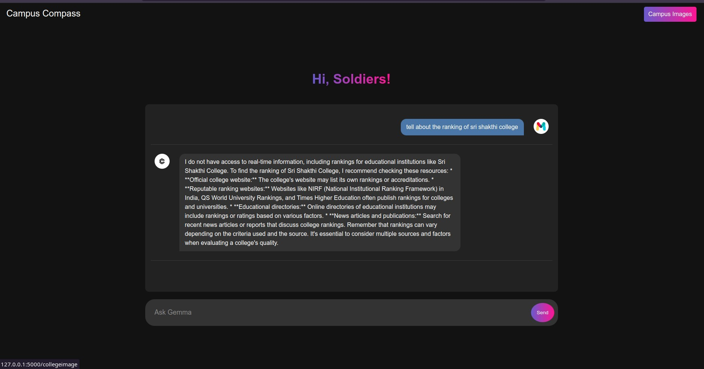

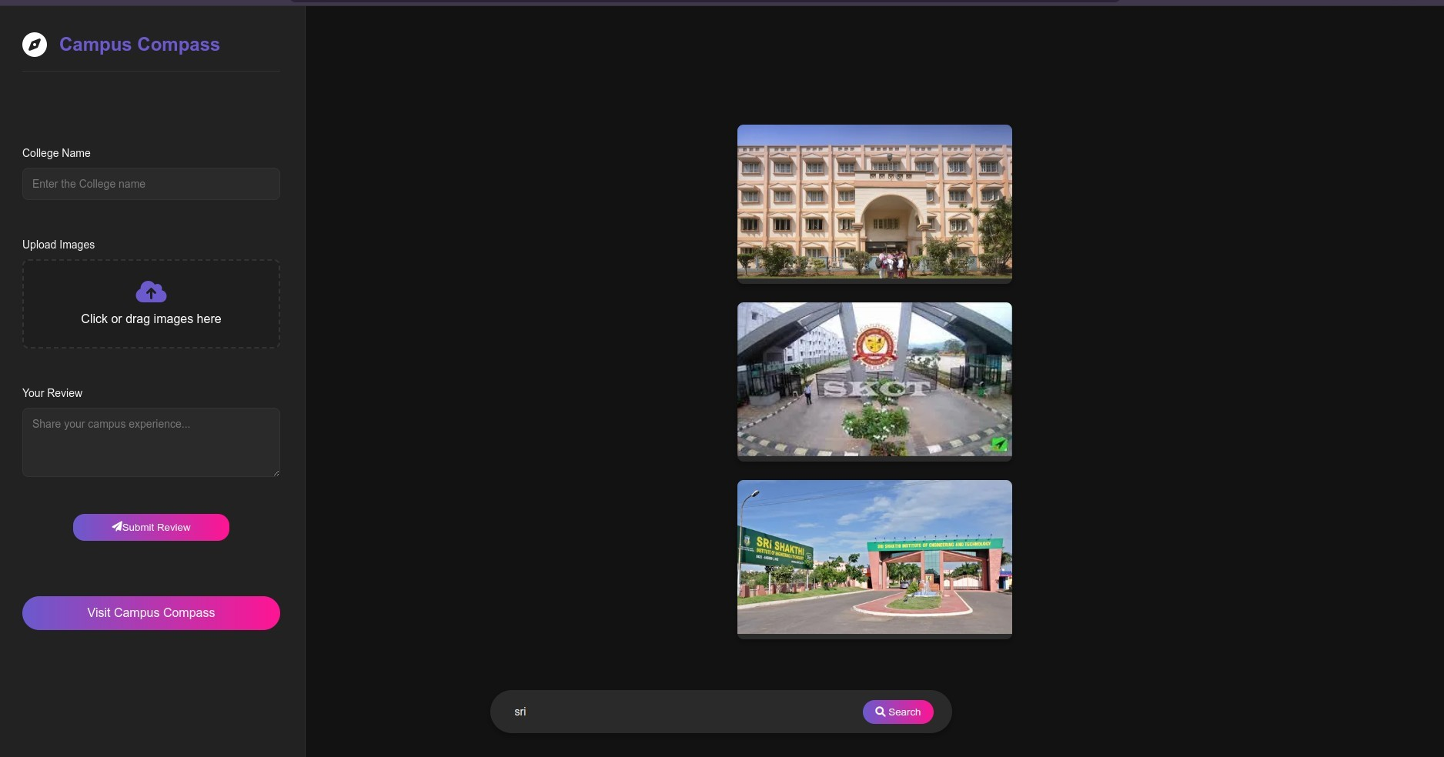

CONCLUSION

The given chatbot for students can resolve the complicated and usually frustrating process of choosing a higher education institution. The system would be able to offer students personalized, real-time assistance by making use of Python, Flask, MongoDB, the Gemma2:2b model, and a responsive frontend created with HTML, CSS, and JavaScript. It allows advanced usage of natural language processing in a wide range of queries to give responses that are accurate and to the context.

Scanning through for information on college options, admission requirements, and course details should be seamless and smooth for the student. The system is designed to be highly scalable, efficient, and user-friendly to provide a great user experience. MongoDB is flexible; hence, it can store and retrieve enormous unstructured data efficiently to dynamically recommend options by a chatbot and give personalized guidance.

While the project indeed did a great job, it also pointed out certain areas for further improvement, like handling more complicated queries and refining the accuracy of responses. Future iterations can be made by increasing the database of colleges, enhancing the natural language processing to handle a wide range of questions, and incorporating multimedia features for richer user interactions.

This chatbot platform, in the end, can revolutionize the way students explore higher education opportunities by offering them more informed decisions in a much quicker and easier way.

FUTURE SCOPE

While the college information chatbot is useful as it is, it can always be improved and enhanced. A number of key features can be built into the system in order to help improve its function, usability, and overall usefulness:
Real Time Data Integration: The current chatbot integrates data that gets updated from time to time. Integrating the real-time feed from official college websites, admission portals, and other authoritative sources will ensure the accuracy and freshness of information on everything. Real-time updates to include cutoff scores, available programs, application deadlines, and such other critical information can easily be availed by implementing APIs and web-scraping techniques.
Predictive Analytics and Forecasting: There should be a possibility, based on predictive analytics models integrated within the chatbot, for estimating what cutoff scores may look like in the future, taking trends over the years and volumes into consideration. It shall provide a good projection to students and allow them to plan appropriately. Various predictive models could be built with the help of machine learning algorithms which would be trained on this past trend.
NLP Understanding: While most of the results above indicated Gemma's performance was strong out-of-the-box, further improvements can and should be explored that allow the technology to better handle multi-step queries or questions with emotive language involved, along with rich context in the question posed. This also involves fine tuning for domain-specific, college admissions-oriented datasets to further develop improved NLP methodology in intent detection, recognition and extraction of both entities and sentiments.
So, the chatbot would propose personalized learning routes depending on the student profile, academic interests, and career goals. This could also involve recommending specific courses, extracurricular activities, or other resources that fit best with the aspiration of the student. Collaborative filtering and content-based filtering techniques are applicable to develop these personalized recommendations.
Integration of College Application Systems: The integration with college application systems will ensure a seamless process for the students to apply to the colleges. The integration could be in the form of populating application forms with information provided by the chatbot, giving direct links to application portals, and showing guidelines on requirement and deadlines for applications. It can be facilitated using APIs and webhooks.
Virtual Campus Tours and Interactive Maps: Inclusion of virtual campus tours and interactive maps would be much more engaging for students. This would include 360-degree virtual tours, interactive campus maps with points of interest, and virtual visits to classrooms, labs, and other facilities. This way, students can view campuses remotely for a better sense of the college environment.
Multilingual Support: This would make the chatbot support multiple languages, hence reaching more users. It would involve training the Gemma model on multilingual datasets and building multilingual UI. This would be a great stride in improving reach for the chatbot.
Accessibility Enhancement: Making it accessible with the inclusion of screen readers, keyboard navigation, and font size adjustment would enable this chatbot to be utilized by students with disabilities. It is very important for inclusivity and equal opportunity regarding access to information.
Gamification and Interactivity: Gamification could be applied with things like quizzes, challenges, and badges that make the research process of the college more fun and interactive. It may also be designed as an interactive tool in comparing colleges, calculating the probabilities of admission, and exploring careers.
Social Media and Student Community Integration: The integration of the chatbot with social media platforms and online student communities could provide real-time student sentiment, insights, and discussions. This may include listening to conversations on social media, aggregating student reviews from various platforms, and creating interactive forums where students can connect and share information.

gesting that while the model effectively ………...REFERENCE
- room for improvement in reducing f
- [1] Vaswani, A., Shazeer, N., Parmar, N., Uszkoreit, J., Jones, L., Gomez, A. N.,. & Polosukhin, I. (2017). Attention is all you need. Advances in neural information processing systems, 30. This is the seminal paper on Transformers, the architecture behind many modern LLMs
- Devlin, J., Chang, M. W., Lee, K., & Toutanova, K. (2018). Bert: Pre-training of deep bidirectional transformers for language understanding. arXiv preprint arXiv:1810.04805. (The BERT paper, an important innovation in LLMs)

- Radford, A., Narasimhan, K., Salimans, T., & Sutskever, I. (2018). Improving language understanding by generative pre-training.
- Brown, T. B., Mann, B., Ryder, N., Subbiah, M., Kaplan, J., Dhariwal, P.,. & Amodei, D. (2020). Language models are few-shot learners. Advances in neural information processing systems, 33, 1877-1901. Shows few-shot learning by LLMs.
- Jurafsky, D., & Martin, J. H. (2023). Speech and language processing. MIT press. (Extensive textbook about NLP)
- Flask...Documentation: https://flask.palletsprojects.com/en/2.3.x/
- MDN Web Docs (Mozilla Developer Network): https://developer.mozilla.org/en-US/docs/Web EXCELLENT RESOURCE FOR HTML, CSS AND JAVASCRIPT

