A Review on chloroquine is widely used as antimalarial agent

- Vaidya Sachin Shankar *
- Ushir Adinath Gorakh
- Bhalerao prashant Gajanan
- Prof. Shinde Divya. D

- Matoshri Institute of pharmacy,(Dhanore) Yeola{423401}

- ABSTRACT

- Chloroquine, a synthetic antimalarial drug, has been a cornerstone in the treatment and prevention of malaria for over 70 years. Its ability to interfere with the digestion of hemoglobin in Plasmodium parasites has made it highly effective against Plasmodium falciparum and Plasmodium vivax, the main causative agents of malaria. However, widespread resistance, particularly in Southeast Asia and parts of Africa, has reduced its effectiveness, prompting the use of alternative therapies, such as artemisinin-based combination therapies (ACTs). Despite the growing issue of resistance, chloroquine remains a valuable therapeutic option in areas where drug resistance is not yet widespread. This review explores the pharmacodynamics and pharmacokinetics of chloroquine, its clinical applications, including treatment and prophylaxis of malaria, the development of resistance, side effects, and its evolving role in malaria management. Furthermore, the paper discusses the future challenges of chloroquine use, including resistance mitigation strategies and the potential for combination therapies.

- KEYWORD:-
- Key term related to chloroquine
- Chloroquine, malaria, plasmodium falciparum, plasmodium vivax, Antimalarial therapy, Drug resistance,Artemisinin-based combination therapies(ACTs),Pharmacokinetics Pharmacodynamics,Malaria prophylaxis,Side effects,Retinal toxicity,Resistance mechanisms

- INTRODUCTION OF CHLOROQUINE:-

- Chloroquine is a medicine used to treat malaria, a disease caused by parasites. It works by increasing a substance in the blood called haeme, which is harmful to the malaria parasite. This kills the parasite and stops the disease from spreading.However, some types of malaria, including resistant and severe cases, may need different or additional medicines.Chloroquine is also sometimes used to treat certain conditions, like infections outside the intestines (amebiasis), rheumatoid arthritis, and lupus.It seems safe to use during pregnancy, though it hasn’t been fully studied.Early in the COVID-19 pandemic, chloroquine was tested as a treatment, but most studies stopped in mid-2020, and the NIH does not recommend it for COVID-19.This medicine is taken by mouth.

- Chloroquine can cause common side effects like muscle pain, loss of appetite, diarrhea, and skin rashes. Serious side effects include vision problems, muscle damage, seizures, and low levels of blood cells.It belongs to a group of medicines called 4-aminoquinolines. For malaria, it works by targeting the parasite inside red blood cells. However, it’s unclear how it helps with rheumatoid arthritis and lupus.Chloroquine was discovered in 1934 by Hans Andersag. It is included in the World Health Organization's List of Essential Medicines and is available as a generic drug.

- 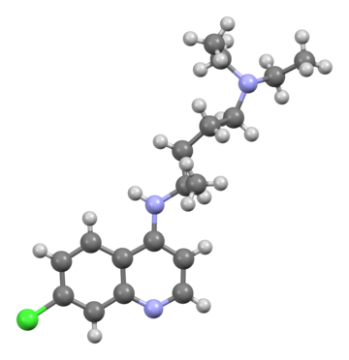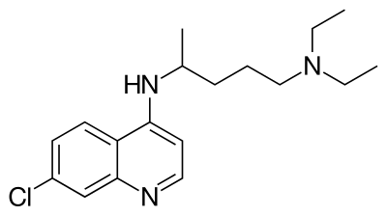
- Structure of chloroquine

- Medicinal Use :-

- 1. Treatment of Malaria: Effective against Plasmodium vivax, P. ovale, and P. malariae in non-resistant regions.
- 2. Prophylaxis of Malaria: Prevents malaria in areas with chloroquine-sensitive parasites.
- 3. Treatment of Rheumatoid Arthritis: Reduces inflammation and slows disease progression.
- 4. Management of Systemic Lupus Erythematosus (SLE): Alleviates symptoms like joint pain and skin rashes.
- 5. Treatment of Hepatic Amebiasis: Used as a secondary therapy for Entamoeba histolytica liver infections.
- 6. Management of Autoimmune Diseases: Useful in treating other immune-mediated conditions.
- 7. Antiviral Research: Investigated for potential antiviral properties against viruses like HIV and SARS-CoV-2.
- 8. Adjunct in Cancer Therapy: Studied for its role in inhibiting autophagy in cancer cells.
- 9. Anti-inflammatory Effects: Beneficial in managing chronic inflammatory conditions.
- 10. Porphyria Cutanea Tarda: Occasionally used to manage this rare metabolic disorder.

- 11. Dermatological Uses: Helps treat photosensitivity disorders and discoid lupus erythematosus.
- 12. Sarcoidosis Management: Sometimes used for cutaneous manifestations.
- 13. Polymyositis/Dermatomyositis: Investigated for its potential to reduce inflammation in these conditions.
- 14. Sjögren’s Syndrome: May help with symptoms like dry eyes and fatigue.
- 15. Experimental Use in Neurological Disorders: Studied for possible benefits in neurodegenerative diseases like Alzheimer’s.

- Side effects :-

- Side Effects of Chloroquine
- 1. Common Side Effects:-
- Blurred vision,Nausea, vomiting, and diarrhea,Stomach cramps,Skin rash, itching, and hair loss,Headache
- 2. Serious Side Effects:
- Swelling in legs or ankles,Shortness of breath,Pale skin, lips, or nails (anemia),Muscle weakness,Easy bruising or bleeding
- 3. Mental and Neurological Problems:
- Confusion or personality changes,Hallucinations (seeing or hearing things that aren't real),Twitching of the face or tongue,Uncontrolled movements (like dystonia or dyskinesia)
- 4. Hearing Issues:-Ringing in the ears (tinnitus),Hearing loss
- 5. Serious Infections:-High fever, severe chills, or persistent sore throat
- 6.Skin and Psoriasis:-Severe itching, especially in some people of African descent,Triggering psoriasis flare-ups
- 7. Taste Issues:- Unpleasant metallic taste
- 8. Eye Problems:- Permanent retinal damage (loss of vision)
- 9. Heart Problems:- Changes in heart rhythm or heart failure (rare but serious)
- 10.Blood Disorders:-Low red blood cells, white blood cells, or platelets (anemia, neutropenia)
- 11. Worsening of Porphyria:- Aggravates symptoms in people with porphyria (a rare genetic disorder)
- 12. Delayed Allergic Reactions:- Severe allergic response over time

- Pregnancy and Breastfeeding
- Generally safe at prescribed doses for malaria prevention during pregnancy.Small amounts pass into breast milk but are not harmful to babies.Pregnant women should avoid traveling to areas with malaria risk.
- Elderly Patients
- Limited data on safety for people over 65.
- Needs careful monitoring, especially for those with kidney issues

- 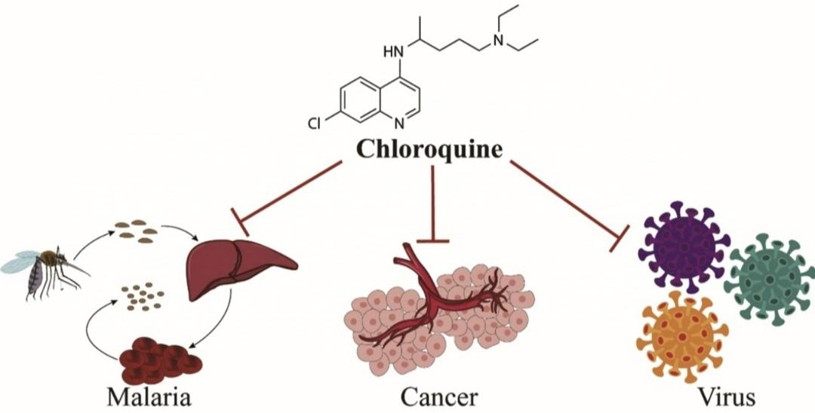
- Fig:- chloroquine used as various diseases

- Drug interactions:-
- Chloroquine has a number of drug–drug interactions that might be of clinical concern:[citation needed]
- Ampicillin – levels may be reduced by chloroquine.
- Antacids – may reduce absorption of chloroquine.
- Cimetidine – may inhibit metabolism of chloroquine; increasing levels of chloroquine in the body.
- Cyclosporine – levels may be increased by chloroquine.
- Mefloquine – may increase risk of convulsions.

- Overdose of chloroquine:-

- Chloroquine overdose can be fatal, with a 20% risk of death. It is absorbed quickly in the body, and symptoms usually begin within an hour. Overdose symptoms may include drowsiness, vision problems, seizures, breathing issues, and heart problems like irregular heartbeats and low blood pressure. It can also cause low potassium levels in the blood.The usual dose for treatment is 10 mg per kilogram of body weight, but poisoning begins at 20 mg per kilogram, and death may occur at 30 mg per kilogram. In children, even one pill can be deadly.

- Treatment includes:
- Mechanical ventilation for breathing support,Cardiac monitoring to check heart function,Activated charcoal to limit further absorption,Intravenous fluids and vasopressors like epinephrine to support blood pressure,Benzodiazepines to control seizures,Potassium chloride to correct low potassium levels (with caution due to the risk of high potassium later).Dialysis is not effective in treating chloroquine overdose. Prompt medical attention is crucial.

- 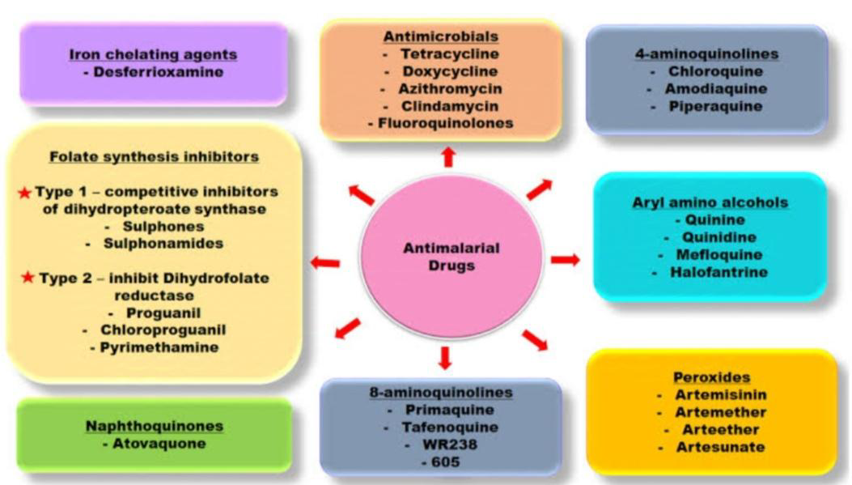
- Fig:- flowchart of classification of Antimalarial drugs

- Chloroquine as an antimalarial agent:-

- In the first half of the 19th century, quinine (QN) was successfully extracted from the bark of the Cinchona tree by French pharmacists, and it became the first effective treatment for malaria. Based on the structure of quinine, chloroquine (CQ) was synthesized by Bayer A.G. in Germany in 1934, and hydroxychloroquine (HCQ) was developed in 1944. When resistance to chloroquine emerged, other compounds were created, building on the quinine structure, to continue the fight against malaria.

- Malaria drug therapy:-

- Malaria is a serious infectious disease and a major health issue worldwide. According to the World Health Organization's 2018 report, around 219 million people were infected with malaria, especially children and pregnant women, and 435,000 people died from the disease. Malaria is caused by five types of parasites: Plasmodium falciparum, Plasmodium vivax, Plasmodium ovale, Plasmodium knowlesi, and Plasmodium malariae. Of these, P. vivax is the most common and causes the most widespread illness and death.

- Chloroquine (CQ) has been a widely used and effective treatment for malaria for many years. It is often given with primaquine to prevent the return of P. vivax. However, as drug-resistant strains of the malaria parasite have emerged, new treatments are urgently needed. Several new antimalarial drugs, based on quinoline derivatives, have been developed, showing effectiveness against malaria in single treatments. These include 4-aminoquinolines (like amodiaquine, pyronaridine, and piperaquine), aminoalcohols (like mefloquine and lumefantrine), and 8-aminoquinolines (like primaquine), all of which show promise in treating malaria.

- 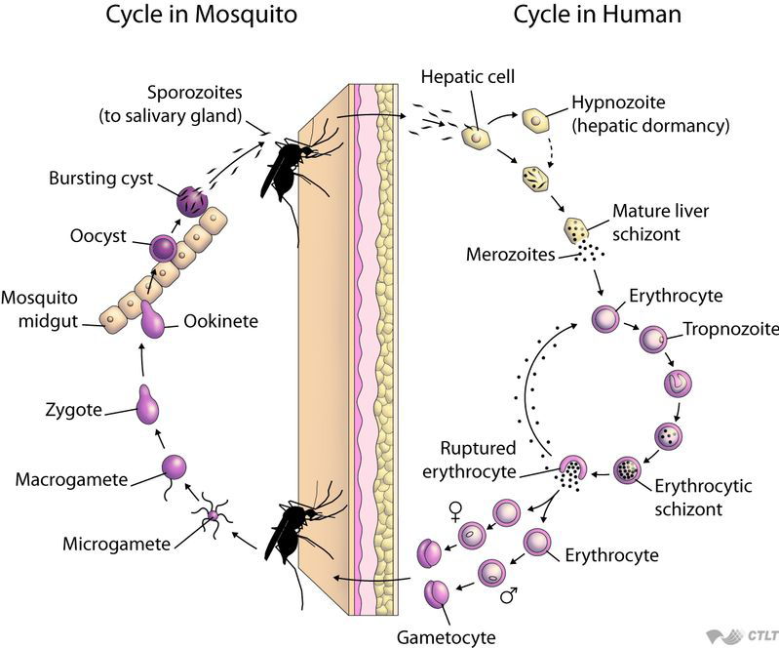
- Fig :- Malaria cycle

- Introduction of Antimalarial Drugs with the Quinoline Scaffold :-

- For many years, the bark of the Cinchona tree was used to treat fevers. Later, scientists discovered its active ingredient, quinine, which became the first effective medicine for malaria. Quinine works quickly and is very effective in killing malaria parasites in the blood, especially in severe cases. It also has a mild effect on certain parasite stages (P. vivax and P. malariae), but it has some side effects that made people look for better options.To improve safety and effectiveness, researchers created new drugs based on quinine's structure, such as chloroquine (CQ), amodiaquine (AQ), and mefloquine (MQ). These drugs were inspired by quinine's main chemical structure, the quinoline ring.Chloroquine, introduced in the 1940s, became the most widely used malaria drug because it was effective, safe, affordable, and worked against all malaria types in the blood. However, it does not work on liver stages or mature gametocytes (the parasite's sexual stages).

- 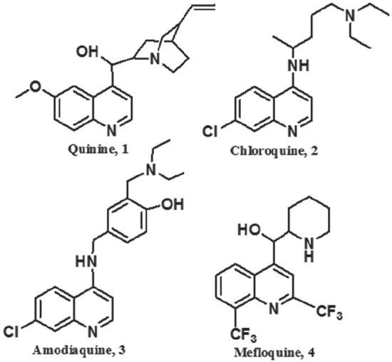
- Fig:- Chemical structure of antimalarial drugs containing the quinoline ring.

- The use of chloroquine (CQ) has become limited because malaria parasites in many regions have developed resistance to it, causing a major health concern in areas where malaria is common. To address this, researchers have worked to find new antimalarial drugs effective against CQ-resistant strains.One such drug, amodiaquine (AQ), is a modified version of CQ with a similar way of working. It is effective against CQ-resistant Plasmodium falciparum strains. However, AQ and CQ share some cross-resistance, meaning parasites resistant to CQ may also resist AQ. Additionally, AQ can cause serious side effects, such as damage to the liver (hepatotoxicity) and a drop in white blood cells (agranulocytosis), especially with long-term use. Because of this, AQ’s clinical use is limited.

- Mefloquine (MQ), another drug with a structure similar to quinine, is recommended for preventing and treating malaria in regions where CQ resistance is common. The Centers for Disease Control and Prevention (CDC) endorses its use. MQ is effective against blood-stage malaria parasites and lasts a long time in the body, but its toxicity has limited its widespread use. Today, MQ is often combined with artesunate to treat resistant malaria strains effectively.

- Chloroquine’s early success was due to its strong effectiveness, low toxicity, easy use, and affordable production. Unfortunately, widespread drug resistance, including to CQ and pyrimethamine/sulfadoxine, remains a major challenge for malaria treatment and control. This has led researchers to develop new drugs based on the quinoline structure, which could serve as alternatives to older antimalarial medications. In this context, new analogues of CQ and AQ with the 4-aminoquinoline structure are being studied as potential solutions.

- Mechanism of action on chloroquine against malaria

- The lysosomotropic character of chloroquine is believed to account for much of its antimalarial activity; the drug concentrates in the acidic food vacuole of the parasite and interferes with essential processes. Its lysosomotropic properties further allow for its use for in vitro experiments pertaining to intracellular lipid related diseases, autophagy, and apoptosis.

- Inside red blood cells, the malarial parasite, which is then in its asexual lifecycle stage, must degrade hemoglobin to acquire essential amino acids, which the parasite requires to construct its own protein and for energy metabolism. Digestion is carried out in a vacuole of the parasitic cell.[citation needed]

- Hemoglobin is composed of a protein unit (digested by the parasite) and a heme unit (not used by the parasite). During this process, the parasite releases the toxic and soluble molecule heme. The heme moiety consists of a porphyrin ring called Fe(II)-protoporphyrin IX (FP). To avoid destruction by this molecule, the parasite biocrystallizes heme to form hemozoin, a nontoxic molecule. Hemozoin collects in the digestive vacuole as insoluble crystals.[citation needed]

- Chloroquine enters the red blood cell by simple diffusion, inhibiting the parasite cell and digestive vacuole. Chloroquine (CQ) then becomes protonated (to CQ2+), as the digestive vacuole is known to be acidic (pH 4.7); chloroquine then cannot leave by diffusion. Chloroquine caps hemozoin molecules to prevent further biocrystallization of heme, thus leading to heme buildup. Chloroquine binds to heme (or FP) to form the FP-chloroquine complex; this complex is highly toxic to the cell and disrupts membrane function. Action of the toxic FP-chloroquine and FP results in cell lysis and ultimately parasite cell autodigestion. Parasites that do not form hemozoin are therefore resistant to chloroquine.
- 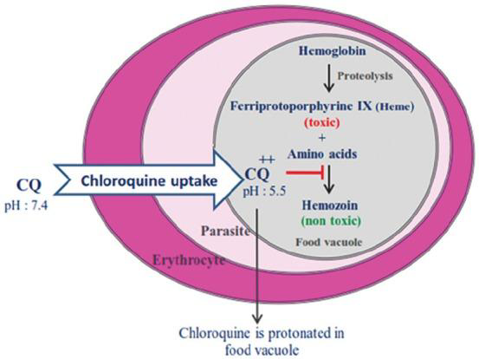
- Fig:-Mechanism of action on chloroquine against malaria

- The Mechanism of Chloroquine Resistance in Plasmodium Falciparum:-

- In 1957, the first parasite resistance to CQ was reported. Different factors were led to early resistance to the cheapest and safest antimalarial drug. These factors included frequent travels to malarious areas, uncontrolled treatment regimens with CQ, and finally the feeding of mosquitoes from different hosts.13 The weak accumulation of CQ into the FV of the parasite is the most important mechanism of resistance, accord with mutations in transporter proteins such as the P. falciparum CQ resistance transporter (PfCRT) and multi-drug resistant protein-1 (PfMDR1) which have located in the parasite’s FV membrane. Consequently, the decrease in drug accumulation is responsible for the loss of antiplasmodial activity. It has been reported that PfCRT mutation at amino acid 76 reduces the CQ uptake into the FV (figure 4).14,15 In other words, this mutation is resulted to CQ efflux out of the acidic FV,16,17 or the transporter (PfCRT) acts as a channel and allows the exit of CQ from the FV of the parasite.18,19 Furthermore, PfMDR1 transfer CQ into the vacuole.20 The mutation in PfMDR1 also reduces the transport capacity of the drug

- 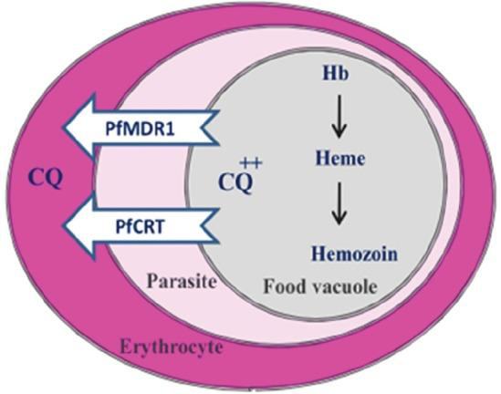
- Fig:- mechanism of chloroquine in plasmodium falciparum

- Drug resistance against antimalarial agents:-

- Antimalarial drugs are effective, but their use is challenged by drug resistance. Here's a simplified explanation of how resistance works:

- 1. Drug Resistance in Malaria Parasites:
- Over time, certain strains of Plasmodium (the malaria parasite) can evolve to resist treatment.This resistance is often linked to genetic changes in the parasite, especially in specific genes like Pfcrt and Pfmdr1.

- 2. Key Genes Involved in Resistance:
- The Pfcrt gene helps control how the parasite takes in and expels drugs like chloroquine.The Pfmdr1 gene codes for a protein that pumps drugs out of the parasite's cells.Mutations in these genes can make the parasite less responsive to drugs.

- 3. How Resistance Happens:
- Normally, drugs enter the parasite and accumulate in its cells, where they disrupt its processes.In resistant parasites, certain membrane transport proteins (like PfCRT and Pfmdr1) work together to pump the drug out before it can be effective.This leads to reduced drug accumulation, meaning the drug can't reach the levels needed to kill the parasite.

- 4. How Efflux and pH Affect Resistance:
- The balance between the PfCRT and Pfmdr1 proteins helps control the movement of drugs in and out of the parasite.An increase in energy-driven efflux (pumping drugs out) and a decrease in drug uptake are key factors in making the parasite resistant to treatment.Additionally, the pH of the parasite's food vacuole (where the drug needs to act) may be altered, further reducing the drug’s effectiveness.

- In short, drug resistance in malaria arises when the parasite evolves mechanisms that stop drugs from entering its cells or decrease the drugs' ability to act, often due to genetic mutations in key transport proteins.

- Importance of Chloroquine and Modifications in Its Structure:-
- The spread of chloroquine (CQ) resistance has been one of the most significant challenges in malaria treatment, impacting the drug's efficacy and leading to a shift in therapeutic strategies. Here's an overview of the key points from the text you provided:

- 1. History of CQ Resistance
- Initial Efficacy and Resistance Emergence: Chloroquine was the drug of choice for malaria treatment in many parts of the world since the 1950s. However, the development of resistance, particularly to Plasmodium falciparum, was reported in the 1960s, which diminished its effectiveness in certain geographical regions.

- Shift to Other Combinations: In response to CQ resistance, the combination of pyrimethamine and sulfadoxine (known as Fansidar) became the treatment of choice for a period of around 20 years. These combinations provided an alternative therapy that delayed the spread of resistance.

- 2. Reemergence of CQ Sensitivity
- Rescue of Sensitivity: Over time, studies showed that CQ sensitivity could be restored in certain areas. One example mentioned is the deletion of the PfCRT (Plasmodium falciparum chloroquine resistance transporter) mutation (T76) in Malawi, which occurred after CQ was discontinued in the region for 8 years. This indicates that the removal of CQ from circulation may help limit the spread of resistance, allowing for the recovery of drug sensitivity.Genetic Mutations and Resistance: The primary mutation associated with CQ resistance is located in the PfCRT gene, which encodes a transporter protein that affects the accumulation of CQ in the digestive vacuole (FV) of the parasite. The T76 mutation is one of the critical mutations that contribute to reduced drug accumulation and resistance.

- 3. Chemical Structure of CQ
- Key Structural Features: CQ contains a quinoline ring structure and a pentamidine side chain. The quinoline ring is essential for binding to heme within the parasite’s digestive vacuole, while the diethylamino group aids in the drug's accumulation in the FV.Quinoline Ring: The flat heteroaromatic ring in CQ is crucial for its interaction with heme, which results in the drug's antimalarial effect.Pentamidine Chain: The side chain facilitates the accumulation of CQ in the FV, contributing to the drug’s efficacy in killing the malaria parasite.
- 4. Design of New CQ Derivatives
- Research Focus on Quinoline Derivatives: Given the persistence of CQ resistance and the ongoing need for effective malaria treatment, researchers have focused on developing new quinoline-based antimalarial compounds. These new derivatives often retain the quinoline ring, as it is central to the drug’s action, but the pentamidine chain is frequently replaced with other substituents to enhance the drug’s activity or overcome resistance.
- Innovation in CQ Alternatives: The goal of these new compounds is to design antimalarials that maintain the therapeutic efficacy of CQ while circumventing the mechanisms of resistance that have reduced CQ's effectiveness in many regions

- .
- 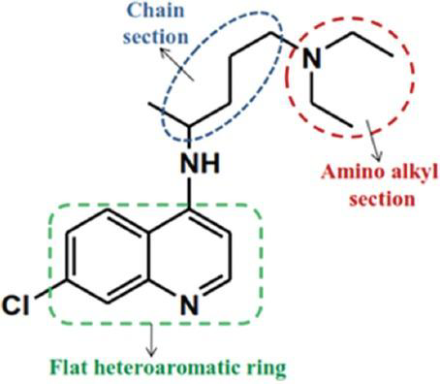
- Fig:- chemical structure of chloroquine

- PHARMACOKINETICS ACTION ON CHLOROQUINE

- 1] absorption
- Chloroquine oral solution has a bioavailability of 52-102% and oral tablets have a bioavailability of 67-114%.10 Intravenous chloroquine reaches a Cmax of 650-1300µg/L and oral chloroquine reaches a Cmax of 65-128µg/L with a Tmax of 0.5h.10

- 2] volume of distribution
- The volume of distribution of chloroquine is 200-800L/kg.10

- 3] protein binding
- Chloroquine is 46-74% bound to plasma proteins.9 (-)-chloroquine binds more strongly to alpha-1-acid glycoprotein and (+)-chloroquine binds more strongly to serum albumin.

- 4] metabolism
- Chloroquine is N-dealkylated primarily by CYP2C8 and CYP3A4 to N-desethyl chloroquine.5,6,7,10 It is N-dealkylated to a lesser extent by CYP3A5, CYP2D6, and to an ever lesser extent by CYP1A1.5,6,7,10 N-desethyl chloroquine can be further N-dealkylated to N-desethyl chloroquine, which is further N-dealkylated to 7-chloro-4-aminoquinoline.

- 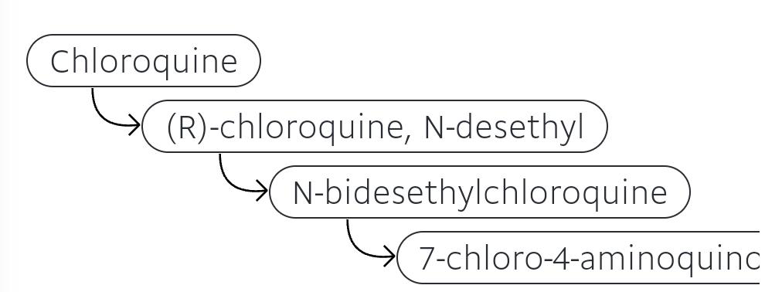
- 5] route of elimination
- Chloroquine is predominantly eliminated in the urine.10 50% of a dose is recovered in the urine as unchanged chloroquine, with 10% of the dose recovered in the urine as desethyl chloroquine.
- 6] half - life
- The half life of chloroquine is 20-60 days.
- 7]Clearance
- Chloroquine has a total plasma clearance of 0.35-1 L/h/kg.
- 8] toxicity
- Patients experiencing an overdose may present with headache, drowsiness, visual disturbances, nausea, vomiting, cardiovascular collapse, shock, convulsions, respiratory arrest, cardiac arrest, and hypokalemia.19 Overdose should be managed with symptomatic and supportive treatment which may include prompt emesis, gastric lavage, and activated charcoal.

- PHARMACOLOGICAL ACTION OF CHLOROQUINE:-

- Chloroquine has several pharmacological activities, particularly as an antimalarial and immunomodulatory drug. Below are the key pharmacological activities of chloroquine:

- 1. Antimalarial Activity

- Mechanism of Action: Chloroquine primarily exerts its antimalarial effects by interfering with the parasite's ability to digest hemoglobin in red blood cells. During this process, the malaria parasite releases heme, which is toxic. Chloroquine inhibits the parasite’s heme detoxification mechanism by blocking the action of the enzyme heme polymerase, leading to the accumulation of toxic free heme within the parasite, ultimately causing its death.

- Activity Against Plasmodium: Chloroquine is effective against the erythrocytic stages of Plasmodium parasites, including Plasmodium falciparum, Plasmodium vivax, Plasmodium malariae, and Plasmodium ovale. However, its effectiveness has decreased in regions where resistance has developed, especially against P. falciparum.

- 2. Immunomodulatory Effects

- Anti-inflammatory Activity: Chloroquine has potent anti-inflammatory effects, which is why it is used in autoimmune diseases like systemic lupus erythematosus (SLE) and rheumatoid arthritis. It interferes with the activation of immune cells by inhibiting the signaling pathways that promote inflammation.

- Inhibition of Cytokine Production: Chloroquine modulates the production of inflammatory cytokines by reducing the activation of transcription factors such as NF-kB (nuclear factor kappa-light-chain-enhancer of activated B cells) and decreasing the secretion of pro-inflammatory cytokines, such as TNF-alpha and interleukins.

- Endosomal Acidification: Chloroquine interferes with the acidification of endosomes and lysosomes in immune cells, impairing antigen processing and presentation, which in turn reduces the activation of T-cells and the overall immune response.

- 3. Antiviral Activity

- Interference with Viral Entry and Replication: Chloroquine has shown some antiviral activity against certain viruses. It can increase the pH of intracellular compartments like endosomes, which is essential for the fusion of certain viruses, such as coronaviruses and flaviviruses, with host cells. By inhibiting viral entry and replication, chloroquine was initially investigated as a potential treatment for diseases like COVID-19, although its efficacy in this area has been debated and largely disproven in clinical trials.

- Inhibition of Virus Spread: Chloroquine also inhibits the replication of some RNA viruses by interfering with viral RNA synthesis and protein translation, though its clinical efficacy remains controversial.

- 4. Anticancer Activity

- Autophagy Inhibition: Chloroquine inhibits autophagy, a process by which cells recycle damaged proteins and organelles. In cancer cells, autophagy often helps protect against cellular stress. By inhibiting this process, chloroquine can sensitize cancer cells to chemotherapy and promote cell death.

- Synergy with Chemotherapy: Chloroquine has been explored as an adjunct to chemotherapy, as it may improve the effectiveness of certain chemotherapeutic agents by preventing cancer cells from repairing damaged DNA or evading apoptosis (programmed cell death).

- 5. Neuropharmacological Effects

- CNS Penetration: Chloroquine can cross the blood-brain barrier, which is why it has been studied for neuroinflammatory conditions and as a potential treatment for diseases like Alzheimer's disease. Some studies suggest that chloroquine may affect amyloid-beta plaques, a hallmark of Alzheimer's, though more research is needed.

- Neuroprotective Effects: In some models, chloroquine has shown neuroprotective effects, possibly due to its ability to modulate oxidative stress and neuroinflammation.

- 6. Antiparasitic Activity

- Effect on Other Protozoa: Beyond malaria, chloroquine has been investigated for its effects on other protozoan parasites. It has shown activity against Entamoeba histolytica, the causative agent of amoebiasis, and Toxoplasma gondii, the causative agent of toxoplasmosis.

- 7. Other Pharmacological Effects

- Analgesic and Antipyretic Properties: Chloroquine exhibits mild analgesic and antipyretic effects, though these are less significant compared to its other pharmacological activities. This may be related to its anti-inflammatory properties.

- Muscle Relaxation and Cardiac Effects: Chloroquine has been shown to cause muscle weakness and cardiotoxicity, especially with long-term or high-dose usage. It can affect cardiac conduction, leading to arrhythmias, which is a significant concern when prescribing chloroquine for long durations.

- 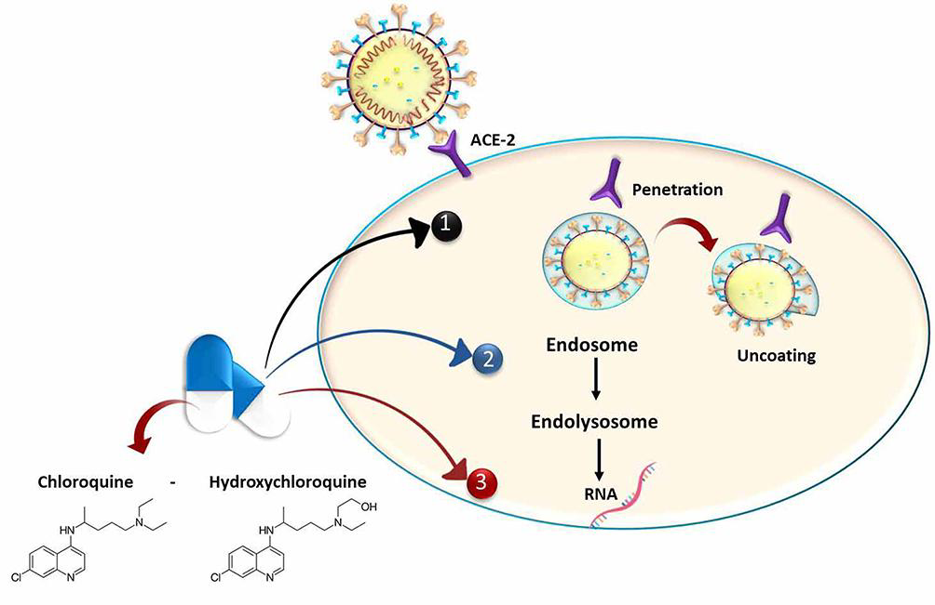
- Fig:- chloroquine and hydrochloroquine in covid-19

- CONCLUSION :-

- The spread of resistance to current antimalarial drugs has prompted significant efforts from both researchers and pharmaceutical companies to develop new and more effective treatments. Global organizations, such as the Bill and Melinda Gates Foundation (BMGF) and Medicines for Malaria Venture (MMV), continue to support malaria elimination programs worldwide, helping drive forward these efforts.In the face of growing resistance, particularly to drugs like chloroquine (CQ) and amodiaquine (AQ), many new compounds have been synthesized, drawing on the proven efficacy of the 4-aminoquinolone scaffold. This scaffold, present in CQ and AQ, serves as the backbone for developing new analogues designed to counteract resistance and improve the safety profile of these drugs.The newly synthesized CQ and AQ analogues have shown promising results in both in vitro and in vivo studies, demonstrating significant antimalarial activity, especially against CQ-resistant strains of Plasmodium falciparum. With the 7-chloro-4-aminoquinoline nucleus preserved in these analogues, several compounds have already entered preclinical and clinical development stages.Given the progress made with these new analogues, further research is essential to refine these compounds and enhance their efficacy, safety, and affordability. The goal is to produce a new generation of antimalarial drugs, based on the 4-aminoquinoline structure, that can effectively combat resistant strains of the parasite and become an integral part of global malaria elimination efforts. Continued innovation and development are crucial to addressing the ever-evolving challenge of malaria treatment and resistance.

- REFERENCE :-

- "Aralen Phosphate". The American Society of Health-System Pharmacists. Archived from the original on 8 December 2015. Retrieved 2 December 2015.
- "Chloroquine Use During Pregnancy". Drugs.com. Archived from the original on 16 April 2019. Retrieved 16 April 2019. There are no controlled data in human pregnancies.
- "Chloroquine or Hydroxychloroquine". COVID-19 Treatment Guidelines. National Institutes of Health. Archived from the original on 28 August 2020. Retrieved 14 February 2021.
- Mittra RA, Mieler WG (2013). "Chapter 89 – Drug Toxicity of the Posterior Segment". Retina (Fifth ed.). W.B. Saunders. pp. 1532–1554. doi:10.1016/B978-1-4557-0737-9.00089-8. ISBN 978-1-4557-0737-9. Retrieved 25 March 2020.
- Manson P, Cooke G, Zumla A, eds. (2009). Manson's tropical diseases (22nd ed.). [Edinburgh]: Saunders. p. 1240. ISBN 978-1-4160-4470-3. Archived from the original on 2 November 2018. Retrieved 9 September 2017.
- Bhattacharjee M (2016). Chemistry of Antibiotics and Related Drugs. Springer. p. 184. ISBN 978-3-319-40746-3. Archived from the original on 1 November 2018. Retrieved 9 September 2017.
- World Health Organization (2019). World Health Organization model list of essential medicines: 21st list 2019. Geneva: World Health Organization. hdl:10665/325771. WHO/MVP/EMP/IAU/2019.06.
- "Frequently Asked Questions (FAQs): If I get malaria, will I have it for the rest of my life?". US Centers for Disease Control and Prevention. 8 February 2010. Archived from the original on 13 May 2012. Retrieved 14 May 2012.
- Plowe CV (2005). "Antimalarial drug resistance in Africa: strategies for monitoring and deterrence". Malaria: Drugs, Disease and Post-genomic Biology. Current Topics in Microbiology and Immunology. Vol. 295. Springer. pp. 55–79. doi:10.1007/3-540-29088-5_3. ISBN 3-540-25363-7. PMID 16265887.
- Uhlemann AC, Krishna S (2005). "Antimalarial Multi-Drug Resistance in Asia: Mechanisms and Assessment". Malaria: Drugs, Disease and Post-genomic Biology. Current Topics in Microbiology and Immunology. Vol. 295. Springer. pp. 39–53. doi:10.1007/3-540-29088-5_2. ISBN 978-3-540-25363-1. PMID 16265886.
- "Chloroquine phosphate tablet – chloroquine phosphate tablet, coated". dailymed.nlm.nih.gov. Archived from the original on 8 December 2015. Retrieved 4 November 2015.
- CDC. Health information for international travel 2001–2002. Atlanta, Georgia: U.S. Department of Health and Human Services, Public Health Service, 2001.
- Amebic Hepatic Abscesses~treatment at eMedicine
- "Drugs & Medications". www.webmd.com. Retrieved 22 March 2020.
- "Chloroquine Side Effects: Common, Severe, Long Term". Drugs.com. Retrieved 22 March 2020.
- "Chloroquine phosphate tablet". DailyMed. 8 October 2018. Retrieved 7 April 2020.
- "Chloroquine: MedlinePlus Drug Information". medlineplus.gov. Retrieved 22 March 2020.
- Ajayi AA (September 2000). "Mechanisms of chloroquine-induced pruritus". Clinical Pharmacology and Therapeutics. 68 (3): 336. PMID 11014416.
- Vaziri A, Warburton B (1994). "Slow release of chloroquine phosphate from multiple taste-masked W/O/W multiple emulsions". Journal of Microencapsulation. 11 (6): 641–648. doi:10.3109/02652049409051114. PMID 7884629.
- Tönnesmann E, Kandolf R, Lewalter T (June 2013). "Chloroquine cardiomyopathy - a review of the literature". Immunopharmacology and Immunotoxicology. 35 (3): 434–442. doi:10.3109/08923973.2013.780078. PMID 23635029. S2CID 37926477.
- Kanny G, Renaudin JM, Lecompte T, Moneret-Vautrin DA (February 2002). "Chloroquine hypersensitivity syndrome". Eur J Intern Med. 13 (1): 75–76. doi:10.1016/s0953-6205(01)00195-9. PMID 11836088.
- "Malaria – Chapter 3 – 2016 Yellow Book". wwwnc.cdc.gov. Archived from the original on 14 January 2016. Retrieved 11 November 2015.
- Ullberg S, Lindquist NG, Sjòstrand SE (September 1970). "Accumulation of chorio-retinotoxic drugs in the foetal eye". Nature. 227 (5264): 1257–1258. Bibcode:1970Natur.227.1257U. doi:10.1038/2271257a0. PMID 5452818. S2CID 4191322.
- Ling Ngan Wong A, Tsz Fung Cheung I, Graham CA (February 2008). "Hydroxychloroquine overdose: case report and recommendations for management". European Journal of Emergency Medicine. 15 (1): 16–18. doi:10.1097/MEJ.0b013e3280adcb56. PMID 18180661. S2CID 41205035.
- Smith ER, Klein-Schwartz W (May 2005). "Are 1-2 dangerous? Chloroquine and hydroxychloroquine exposure in toddlers". The Journal of Emergency Medicine. 28 (4): 437–443. doi:10.1016/j.jemermed.2004.12.011. PMID 15837026.
- "Chloroquine". §6.1 Absorption by route of exposure. Retrieved 24 April 2020.
- Adelusi SA, Salako LA (November 1982). "Tissue and blood concentrations of chloroquine following chronic administration in the rat". The Journal of Pharmacy and Pharmacology. 34 (11): 733–735. doi:10.1111/j.2042-7158.1982.tb06211.x. PMID 6129306. S2CID 35269419.
- Walker O, Birkett DJ, Alván G, Gustafsson LL, Sjöqvist F (March 1983). "Characterization of chloroquine plasma protein binding in man". British Journal of Clinical Pharmacology. 15 (3): 375–377. doi:10.1111/j.1365-2125.1983.tb01513.x. PMC 1427768. PMID 6849768.
- Projean D, Baune B, Farinotti R, Flinois JP, Beaune P, Taburet AM, et al. (June 2003). "In vitro metabolism of chloroquine: identification of CYP2C8, CYP3A4, and CYP2D6 as the main isoforms catalyzing N-desethylchloroquine formation". Drug Metabolism and Disposition. 31 (6): 748–754. doi:10.1124/dmd.31.6.748. PMID 12756207. S2CID 2115928.
- Handzel DM, Romanou-Papadopoulou V, Briesen S (September 2021). "[Visual loss under chloroquine treatment-and not (only) due to bull's eye maculopathy!]" [Visual loss under chloroquine treatment-and not (only) due to bull's eye maculopathy!]. Der Ophthalmologe (in German). 118 (9): 953–955. doi:10.1007/s00347-020-01288-y. PMID 33300096. S2CID 228089310.
- Chen PM, Gombart ZJ, Chen JW (March 2011). "Chloroquine treatment of ARPE-19 cells leads to lysosome dilation and intracellular lipid accumulation: possible implications of lysosomal dysfunction in macular degeneration". Cell & Bioscience. 1 (1): 10. doi:10.1186/2045-3701-1-10. PMC 3125200. PMID 21711726.
- Kurup P, Zhang Y, Xu J, Venkitaramani DV, Haroutunian V, Greengard P, et al. (April 2010). "Abeta-mediated NMDA receptor endocytosis in Alzheimer's disease involves ubiquitination of the tyrosine phosphatase STEP61". The Journal of Neuroscience. 30 (17): 5948–5957. doi:10.1523/JNEUROSCI.0157-10.2010. PMC 2868326. PMID 20427654.
- Kim EL, Wüstenberg R, Rübsam A, Schmitz-Salue C, Warnecke G, Bücker EM, et al. (April 2010). "Chloroquine activates the p53 pathway and induces apoptosis in human glioma cells". Neuro-Oncology. 12 (4): 389–400. doi:10.1093/neuonc/nop046. PMC 2940600. PMID 20308316.
- Hempelmann E (March 2007). "Hemozoin biocrystallization in Plasmodium falciparum and the antimalarial activity of crystallization inhibitors". Parasitology Research. 100 (4): 671–676. doi:10.1007/s00436-006-0313-x. PMID 17111179. S2CID 30446678.
- Lin JW, Spaccapelo R, Schwarzer E, Sajid M, Annoura T, Deroost K, et al. (June 2015). "Replication of Plasmodium in reticulocytes can occur without hemozoin formation, resulting in chloroquine resistance" (PDF). The Journal of Experimental Medicine. 212 (6): 893–903. doi:10.1084/jem.20141731. PMC 4451122. PMID 25941254. Archived (PDF) from the original on 22 September 2017. Retrieved 4 November 2018.
- Martin RE, Marchetti RV, Cowan AI, Howitt SM, Bröer S, Kirk K (September 2009). "Chloroquine transport via the malaria parasite's chloroquine resistance transporter". Science. 325 (5948): 1680–1682. Bibcode:2009Sci...325.1680M. doi:10.1126/science.1175667. PMID 19779197. S2CID 206520905.
- Shafik SH, Cobbold SA, Barkat K, Richards SN, Lancaster NS, Llinás M, et al. (August 2020). "The natural function of the malaria parasite's chloroquine resistance transporter". Nature Communications. 11 (1): 3922. Bibcode:2020NatCo..11.3922S. doi:10.1038/s41467-020-17781-6. PMC 7413254. PMID 32764664.
- Tripathi KD (2003). Essentials of Medical Pharmacology (fifth ed.). Jaypee Brothers Medical Publisher Ltd. pp. 739–740.
- Alcantara LM, Kim J, Moraes CB, Franco CH, Franzoi KD, Lee S, et al. (June 2013). "Chemosensitization potential of P-glycoprotein inhibitors in malaria parasites". Experimental Parasitology. 134 (2): 235–243. doi:10.1016/j.exppara.2013.03.022. PMID 23541983.
- McDougald LR, Cervantes HM, Jenkins MC, Hess M, Beckstead R (22 November 2019). "Protozoal Infections". Diseases of Poultry (14 ed.). Wiley. ISBN 9781119371199.
- Munoz-Bellido JL, Munoz-Criado S, Garcìa-Rodrìguez JA (April 2000). "Antimicrobial activity of psychotropic drugs: selective serotonin reuptake inhibitors". International Journal of Antimicrobial Agents. 14 (3). International Society of Chemotherapy (Elsevier): 177–180. doi:10.1016/s0924-8579(99)00154-5. PMID 10773485.
- Savarino A, Boelaert JR, Cassone A, Majori G, Cauda R (November 2003). "Effects of chloroquine on viral infections: an old drug against today's diseases?". The Lancet. Infectious Diseases. 3 (11): 722–727. doi:10.1016/s1473-3099(03)00806-5. PMC 7128816. PMID 14592603.
- Al-Bari MA (February 2017). "Targeting endosomal acidification by chloroquine analogs as a promising strategy for the treatment of emerging viral diseases". Pharmacology Research & Perspectives. 5 (1): e00293. doi:10.1002/prp2.293. PMC 5461643. PMID 28596841.
- Fredericksen BL, Wei BL, Yao J, Luo T, Garcia JV (November 2002). "Inhibition of endosomal/lysosomal degradation increases the infectivity of human immunodeficiency virus". Journal of Virology. 76 (22): 11440–11446. doi:10.1128/JVI.76.22.11440-11446.2002. PMC 136743. PMID 12388705.
- Xue J, Moyer A, Peng B, Wu J, Hannafon BN, Ding WQ (1 October 2014). "Chloroquine is a zinc ionophore". PLOS ONE. 9 (10): e109180. Bibcode:2014PLoSO...9j9180X. doi:10.1371/journal.pone.0109180. PMC 4182877. PMID 25271834.
- te Velthuis AJ, van den Worm SH, Sims AC, Baric RS, Snijder EJ, van Hemert MJ (November 2010). "Zn(2+) inhibits coronavirus and arterivirus RNA polymerase activity in vitro and zinc ionophores block the replication of these viruses in cell culture". PLOS Pathogens. 6 (11): e1001176. doi:10.1371/journal.ppat.1001176. PMC 2973827. PMID 21079686.
- Huang Z, Srinivasan S, Zhang J, Chen K, Li Y, Li W, et al. (2012). "Discovering thiamine transporters as targets of chloroquine using a novel functional genomics strategy". PLOS Genetics. 8 (11): e1003083. doi:10.1371/journal.pgen.1003083. PMC 3510038. PMID 23209439.
- Fern K (2010–2020). "Cinchona officinalis – L." Plans for a Future. Archived from the original on 25 August 2017. Retrieved 2 February 2020.
- Institute of Medicine (US) Committee on the Economics of Antimalarial Drug (2004). Arrow KJ, Panosian C, Gelband H (eds.). Saving lives, buying time : economics of malaria drugs in an age of resistance. National Academies Press. doi:10.17226/11017. ISBN 9780309092180. PMID 25009879.
- Kouznetsov VV, Amado Torres DF (September 2008). "Antimalarials: construction of molecular hybrids based on chloroquine". Universitas Scientiarum. 13 (3): 306–320.
- Krafts K, Hempelmann E, Skórska-Stania A (July 2012). "From methylene blue to chloroquine: a brief review of the development of an antimalarial therapy". Parasitology Research. 111 (1): 1–6. doi:10.1007/s00436-012-2886-x. PMID 22411634. S2CID 54526057.
- Sneader W (2005). Drug Discovery. A History. Wiley. ISBN 0471899801.
- Pou S, Winter RW, Nilsen A, Kelly JX, Li Y, Doggett JS, et al. (July 2012). "Sontochin as a guide to the development of drugs against chloroquine-resistant malaria". Antimicrobial Agents and Chemotherapy. 56 (7): 3475–3480. doi:10.1128/AAC.00100-12. PMC 3393441. PMID 22508305. S2CID 32186437.
- "The History of Malaria, an Ancient Disease". Centers for Disease Control. 29 July 2019. Archived from the original on 28 August 2010.
- DE patent 683692, Andersag, Hans; Breitner, Stefan & Jung, Heinrich, "Process for the preparation of quinoline compounds containing amino groups with basic substituents in the 4-position", issued 1939-11-13, assigned to IG Farbenindustrie AG
- Kenyon RL, Wiesner JA, Kwartler CE (1 April 1949). "Chloroquine manufacture". Industrial & Engineering Chemistry. 41 (4): 654–662. doi:10.1021/ie50472a002.
- "Chloroquine". nih.gov. National Institutes of Health. Retrieved 24 March 2020.
- "Ipca Laboratories: Formulations – Branded". Archived from the original on 6 April 2019. Retrieved 14 March 2020.
- Hemdal J (20 February 2013). "Aquarium Fish: Chloroquine: A "New" Drug for Treating Fish Diseases". Advanced Aquarist. Archived from the original on 15 March 2013. Retrieved 26 March 2020.
- Francis-Floyd R, Floyd MR. "Amyloodinium ocellatum, an Important Parasite of Cultured Marine Fish" (PDF). agrilife.org. Archived from the original (PDF) on 1 June 2015. Retrieved 24 March 2020.
- Keyaerts E, Vijgen L, Maes P, Neyts J, Van Ranst M (October 2004). "In vitro inhibition of severe acute respiratory syndrome coronavirus by chloroquine". Biochemical and Biophysical Research Communications. 323 (1): 264–268. doi:10.1016/j.bbrc.2004.08.085. PMC 7092815. PMID 15351731.
- Devaux CA, Rolain JM, Colson P, Raoult D (May 2020). "New insights on the antiviral effects of chloroquine against coronavirus: what to expect for COVID-19?". International Journal of Antimicrobial Agents. 55 (5): 105938. doi:10.1016/j.ijantimicag.2020.105938. PMC 7118659. PMID 32171740.
- Vincent MJ, Bergeron E, Benjannet S, Erickson BR, Rollin PE, Ksiazek TG, et al. (August 2005). "Chloroquine is a potent inhibitor of SARS coronavirus infection and spread". Virology Journal. 2: 69. doi:10.1186/1743-422X-2-69. PMC 1232869. PMID 16115318.
- Savarino A, Boelaert JR, Cassone A, Majori G, Cauda R (November 2003). "Effects of chloroquine on viral infections: an old drug against today's diseases?". The Lancet. Infectious Diseases. 3 (11): 722–727. doi:10.1016/S1473-3099(03)00806-5. PMC 7128816. PMID 14592603.
- "Chloroquine or Hydroxychloroquine". COVID-19 Treatment Guidelines. National Institutes of Health. Archived from the original on 28 August 2020. Retrieved 14 February 2021.
- "Coronavirus (COVID-19) Update: Daily Roundup March 30, 2020". FDA. 30 March 2020. Archived from the original on 19 October 2020. Retrieved 28 February 2021.
- Smit M, Marinosci A, Agoritsas T, Calmy A (April 2021). "Prophylaxis for COVID-19: a systematic review". Clinical Microbiology and Infection (Systematic review). 27 (4): 532–537. doi:10.1016/j.cmi.2021.01.013. PMC 7813508. PMID 33476807.
- Meyerowitz EA, Vannier AG, Friesen MG, Schoenfeld S, Gelfand JA, Callahan MV, et al. (May 2020). "Rethinking the role of hydroxychloroquine in the treatment of COVID-19". FASEB Journal. 34 (5): 6027–6037. doi:10.1096/fj.202000919. PMC 7267640. PMID 32350928.
- Juurlink DN (April 2020). "Safety considerations with chloroquine, hydroxychloroquine and azithromycin in the management of SARS-CoV-2 infection". CMAJ. 192 (17): E450 – E453. doi:10.1503/cmaj.200528. PMC 7207200. PMID 32269021.
- "Assessment of Evidence for COVID-19-Related Treatments: Updated 4/3/2020". American Society of Health-System Pharmacists. Archived from the original on 14 April 2021. Retrieved 7 April 2020.
- Yazdany J, Kim AH (June 2020). "Use of Hydroxychloroquine and Chloroquine During the COVID-19 Pandemic: What Every Clinician Should Know". Annals of Internal Medicine. 172 (11): 754–755. doi:10.7326/M20-1334. PMC 7138336. PMID 32232419.
- Lovelace Jr B (15 June 2020). "FDA revokes emergency use of hydroxychloroquine". CNBC. Archived from the original on 11 October 2020. Retrieved 28 February 2021.

