**A REVIEW ON HERBAL DRUGS USED IN SKIN DISORDERS**

**Ch. Anuradha1, Dr. D. Rama Brahma Reddy2, V. Sreelakshmi3**

1 Assistant Professor & Department of Pharmaceutical Analysis, Nalanda Institute of Pharmaceutical Sciences, Sattenapalli(M), Guntur (Dist)-522438, AP-India

2 Principal & Professor, Department of Phytochemistry, Nalanda Institute of Pharmaceutical Sciences, Sattenapalli(M), Guntur (Dist)-522438, AP-India

3,4,5,6,7 Students, Pharmacy, Nalanda Institute of Pharmaceutical Sciences, Sattenapalli(M), Guntur

(Dist)-522438, AP-India

**ABSTRACT**

Skin diseases are many and a frequently occurring health problem affecting all ages from the neonates to the elderly and cause harm in number of ways. Maintaining healthy skin is important for a healthy body. Many people may develop skin diseases that affect the skin, including cancer, herpes and cellulitis. Some wild plants and their parts are frequently used to treat these diseases. The use of plants is as old as the mankind. Natural treatment is cheap and claimed to be safe. It is also suitable raw material for production of new synthetic agents. A review of some plants for the treatment of skin diseases is provided that summarizes the recent technical advancements that have taken place in this area during the past 17 years.

**Keyword:** Medicinal Plant, Skin Diseases, Ethno Medicine, Skin Disorder.

**INTRODUCTION:**

Herbal therapy for skin disorders has been used for thousands of years. Even our biologically close relatives, the great apes, use herbal self-medication. Specific herbs and their uses developed regionally, based on locally available plants and through trade in ethnobotanical remedies. Systems of herbal use developed regionally in Europe, Middle East, Africa, India, China, Japan, Australia, and therefore the Americas. two documented system still in use are the ayurvedic herbs in India and herb combinations developed as a part of traditional Chinese medicine in China. In Europe and the United States, use of herbs declined as purified extracts and synthetic chemical drug become available. Herbal medicines, particularly those for skin ailments, are becoming increasingly popular among patients and, to a lesser extent, with doctors.

Herbal remedies that have been utilized for generations in Asia, particularly China and India, are now being investigated scientifically. Herbal medicines and their indicated uses are overseen by the Germen regulatory authority Commission E. Currently, herbal items are only regulated as dietary supplements in the united State. Active substances, purity, and concentration are not standardized. There are also no Restrictions on which herbs can be sold for certain purposes. 1

**SKIN ANATOMY**:

The largest organ in the human body is the skin, which covers the body's outside. It serves as the initial line of defence as well. Numerous specialized cells and structures can be found in skin. The epidermis, dermis, and hypodermis are the three primary layers. Each layer contributes in a unique way to how the skin works as a whole. The epidermis, the top layer of skin, has varying thicknesses throughout the body. It is thickest on the palms and soles and thinnest (0.05 mm) on the eyelids (1.5 mm). Depending on where the skin is located the dermis' thickness also varies. The distance is 3.0 mm on the body's back and 0.3 mm on the eyelid. The hypodermis, or subcutaneous connective tissue, lies beneath the dermis. A layer of fat and connective tissue called the subcutaneous tissue contains larger blood arteries and nerves. This layer is crucial for controlling body temperature as well as the skin's own temperature. This layer's thickness varies across the body and from person to person. The primary skin accessories are hair follicles, sweat glands, and sebaceous glands.

The skin protects the internal organs, muscles, bones, and ligaments beneath it. The two main forms of skin are glabrous and hairy skin. However, the skin might also be sagging, dry, sensitive, pale, or worn out. People who lack vital nutrients including beta-carotene, the B complex vitamins, and vitamins C and E frequently experience dry skin.2

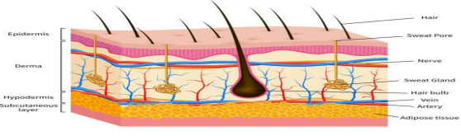

**Fig no 01: Anatomy of skin**

**Function of Skin**

The main functions of the skin include

1. Protection of the human body

2. Sensation i.e. transmitting to the brain information about the surroundings

3.Temperature regulation

4. Immunity i.e. the role of the skin for the immune system.

5. Enables movement and growth without injury

6. Excretion from the body of the certain types of waste material

7. Endocrine function e.g. re. Vitamin D.3

**Skin types**

While all human skin has basically the same structure, slight biological differences can make the big deal to the proper care and keeping of your skin. People can have more or less active sebaceous glands, more or less active sweat glands, and may store more or less water in their skin. Here are summaries of some common human skin types, and how to best care for them

**1.Oily skin:**

People with oily skin may have large pores, a shiny complexion, blackheads or pimples. This is because of the sebaceous glands in their dermis make a lot of oil, which can build up in pores, widening them and causing irritation.

The oil illness of skin can be increased by the factors including:

* Stress
* Hormones
* Heat and humidity

Paradoxically, washing often is not good for the oily skin. Many people are tempted and they try to wash the oil off – but this can result in the skin feeling dry, which will actually stimulate it to produce more oil. It’s recommended that the people with oily skin wash it no more than twice a day and avoid scrubbing when they wash. This will leave the skin’s natural oil intact so that there is less new oil that will be produced. Popping or picking at pimples and blackheads is also bad idea. This can cause injury to the skin, which can increase the inflammation of the blemish and cause it to take longer to heal! When picking out the cosmetic products, look for those with a label that says ”noncomedogenic”. That means it won’t clog pores.

**2.Combination skin:**

Combination skin is the skin that is oily in some areas, but may be dry in others. In people with combination skin, chin, nose, and forehead are the most commonly oily areas. Other areas such as the cheeks may be dry. People with combination skin may have large pores, blackheads, and shiny skin due to the production of a lot of oil by the glands in your dermis. This oil accumulates in pores and cause blackheads and blemishes. The same tips for caring for oily skin can be used on the oily areas of combination skin.

* **Acne**

Acne is the formation of papules, pustules, nodules, or cysts due to clogged and inflamed pilosebaceous units in hair follicles and the surrounding sebaceous glands. Acne can occur on any body, including the face, neck, chest, back, and shoulders. Acne is a skin condition that most commonly affects adolescents and manifests on the face and upper torso. Exams are the primary tool for making a diagnosis.4

**3.Normal Skin**:

Normal skin is skin that has a medium level of oil and water, leaving it protected from the elements, but not shiny or oily. This skin type usually has small pores and few blemishes, since the glands which produce oils are not highly active.

**4.Dry skin:**

People with dry skin may have a dull, rough complexion and may also show more wrinkles and lines than other skin types. Irritated red patches may appear, and pores may be completely invisible. This is because the dry skin has less active oil glands, leaving the skin without the sheen of protection from the environment.

Dry skin may be caused or may be made worse by

➢ Indoor heating.

➢ Certain medications.

➢ Hot baths and showers.

➢ Over washing, or washing with harsh soaps and cleansers.

➢ Exposure to weather such as sun, wind, cold, and dry heat.

**5. Sensitive Skin**

Sensitive skin may have show redness, itching, burning, and dryness. Sensitive skin may become irritated in response to certain skin care products. If you suspect you may have sensitive skin, it’s helpful to keep track of what products you have used recently. Discontinue use of any new products you have started using before irritation occurred, and try to determine if you can identify an ingredient in the new product that might have caused the irritation. With luck, you can avoid other products that use that ingredient**.3**

**Types of skin diseases:**

There are numerous types of skin diseases reported in the texts. However, they can be classified into six broad categories (Aitken, 1898).

**Inflammatory Skin Disorders:**

Inflammatory skin disorders include a range of rashes and lesions that cause irritation and inflammation in the skin. Many of the more well-known skin conditions, including acne, fall into this category. Other types of inflammatory skin conditions include dermatitis, eczema, diaper rash, psoriasis and sebaceous cysts.

**Viral Infections**

Most viral skin infections are temporary. But some of the viral infections can lead to scarring on skin if left untreated. Many of the skin rashes caused by childhood diseases are viral in nature. Chicken pox, herpes simplex virus (Type 1), herpes simplex virus (Type 2), measles and warts are some of the common viral skin infections.

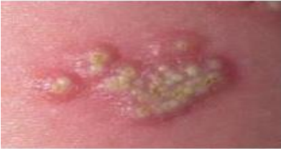

**Fig no 02: Viral infections**

**Bacterial Infections**

Bacterial skin problems are easier to treat than viral infections, because antibiotics usually provide an effective treatment. Examples of these disorders include folliculitis and impetigo.

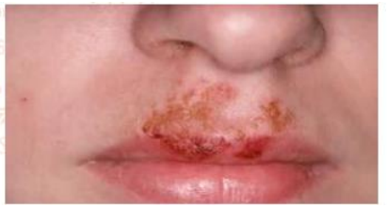

**Fig no 03: Bacterial infection**

**Fungal Infections**

Some microorganisms live on the skin and leave off dead skin cells. They can spread rapidly, leading to fungal infection. Candida and ringworm are the major microorganisms responsible for fungal infection.

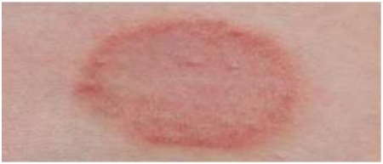

**Fig no 04: Fungal infection**

**Skin Cancer**

Three separate forms of skin cancer are recognized viz. basal cell cancer, squamous cell carcinoma and melanoma.

**Psoriasis:**

Psoriasis is characterized by flaky red patches of skin coated with silver scales that occur on the elbows, knees, and lower back, and can be uncomfortable or painful and sore. Psoriasis can be a small annoyance for some people, but it can be a severe problem for others. It has a negative impact on their quality of life. Psoriasis patients frequently experience periods of no or minor symptoms. Many herbs can help with psoriasis symptoms by reducing inflammation or slowing the proliferation of skin cells.

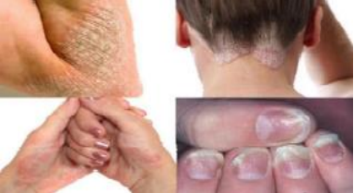

**Fig no 05: Skin cancer**

**Other Skin Disorder**

Other skin problems include moles and birthmarks. Neither of these are health problems in themselves, but moles should be watched for changes that may indicate skin cancer.6

**Herbal Drugs for Skin Disorders**

1. **Crocus sativus**

Common name: Saffron, Family: Iridaceae.

Crocus sativus.L is an herbaceous perennial-cormous plant which is believed to show many pharmacological actions. The plant contains important constituents like crocetin, picrocrocin, safranal (main component for characteristic aroma). Safranal is the aglycon of picrocrocin; those are responsible for many pharmacological act. Saffron is a naturally derived plant product that acts as an antispasmodic, diaphoretic, carminative, emmenagogic and sedative. The chemopreventive effect of aqueous saffron on chemically induced skin carcinogenesis using a histopathological approach was studied.7

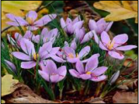

**Fig no 06: plant of crocus sativus**

**2.Avena sativa**

Common name: Oats, Family: Poaceae

It is native to the warm Mediterranean region. It is an annual plant. A. sativa is known in Saudi Arabia as 'Shofan'. Oat is cultivated in Europe, North America and Asia for its yield of grain. It has a distinctive inflorescence - a composite panicle, unlike wheat, rye and barley.

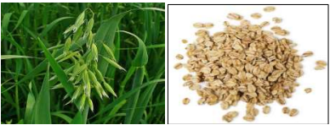

**Fig no 07: Plant of Avena sativa**

Different clinical studies have been undertaken to investigate the effect of oats on eczema and these have all showed a significant decrease in skin redness, dryness, scaliness, itching and erythema after application of oat extracts.

Oatmeal may also help itching at in colloidal form is a centuries-old topical treatment for different skin conditions, including skin rashes, erythema, burns, itch and eczema but few studies have examined the precise mechanism of action for the antiinflammatory activity of colloidal oatmeal.7-8

**3.Cassia fistula**

Common name: Golden shower, purging cassia, Indian laburnum, pudding-pipe tree. Cassia fistula, a semi-wild Indian Labernum (also known as the Golden Shower), is distributed in various countries including Asia, South Africa, Mexico, China, West Indies, East Africa and Brazil. It is an ornamental tree with beautiful bunches of yellow flowers.

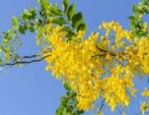

**Fig no:08 Cassia fistula plant with inflorescene**

This plant is widely used by tribal people to treat various ailments including ringworm and other fungal skin infections. Cassia fistula exhibited significant antimicrobial activity and showed properties that support folkloric use in the treatment of some diseases as broad-spectrum antimicrobial agents. The pulp of the ripe fruits has a mild, pleasant purgative action and is also used as an anti-fungal drug. The whole plant is used to treat diarrhea; seeds, flowers and fruits are used to treat skin diseases.6

4**.Clitoria ternatea**

Common name: Butterfly pea, Aparajeeta

Clitoria ternatea is a twining herbal medicinal plant mostly found in Asia. Various constituents are found in different parts of the plant. Butterfly pea or blue pea (Clitoria ternatea) from family of Fabaceae is a vine with vivid blue flowers 1 to 2 inches long.

It is a perennial climber widely used in the traditional ayurvedic system of Indian medicine for treating a wide variety of diseases. It is also used in the treatment of chronic bronchitis, dropsy, goiter, leprosy, mucous disorders, sight weakness, skin diseases, sore throat and tumors. Leaf

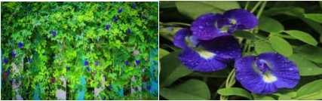

**Fig no:09 Plant and flowers of Clitoria ternatea**

juice is given orally twice a day for six days to cure scabies. The root powder is used as one of the ingredients in the preparation of the drug “SULAK” and its ointment to treat leprosy.

**5.Bauhinia variegata**

Common name: Kachanar, Orchid tree, Camel's Foot Tree, Mountain Ebony; Family: Caesalpiniaceae It is a well-known ornamental tree of tropical and sub-tropical climate with hot and dry summers and mild winters. Tree grows well in areas with full sun or partial shade and is fairly resistant to drought but susceptible to fire.

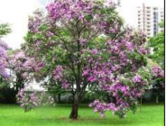

**Fig no:10 Orchid tree**

The bark is alterative, astringent and tonic and is useful in the treatment of skin diseases, scrofula and ulcers. The bark decoction is used for diarrhea control, as an astringent alternative and for treating scrofula, skin diseases and ulcers. It is also used to treat leprosy.

**6.Rosmarinus officinalis**

Common name: rosemary, Family: Lamiaceae

It is an aromatic plant with needle-like leaves belonging to the Lamiaceae family. Rosemary has therapeutic properties and has been used in the folk medicine, pharmaceutical, and cosmetics industries, mainly for its antioxidant and antiinflammatory properties, which are attributed to the presence of carnosol / carnosic and ursolic acids. Rosemary has potential applications in cosmetic formulations and in the treatment of pthological and non-pathological conditions, such as cellulite, alopecia, ultraviolet damage, and aging.

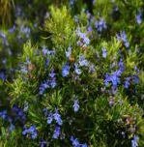

**Fig no:11 Plant of Rosmarinus officinalis**

Antioxidant activity is generally attributed to free radical scavenging, but secondary metabolites may play a biological role in the regulation of apoptosis, cell signal transduction, and xenobiotic metabolism in the liver.

**7. Curcuma longa**

Common name: turmeric, Family: Zingiberaceae

Turmeric is an ancient spice, a native of South East Asia, used from antiquity as dye and a condiment. It is a mild digestive, being aromatic, a stimulant and a carminative. Turmeric is one of nature's most powerful healers. The active ingredient in turmeric is curcumin. An ointment base on the spice is used as an antiseptic in India. Curcumin is a compound isolated from turmeric; a plant known for its medicinal use. In animal studies, daily applications of 1% curcumin gel reduced skin psoriasis-like inflammation artificially induced by imiquimod, Clinically, daily applications of a turmeric tonic significantly reduced the cutaneous symptoms and quality of life of patients affected by scalp psoriasis compared to the placebo.

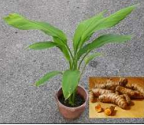

**Fig no:12 Plant and roots of curcuma longa**

So, it is also useful in treatment of eczema. It may be recommended for painful and inflamed rosacea symptoms.

**8.Azadirachta indica**

Common name: Neem, Family: Meliaceae

Neem (Azadirachta indica) is perhaps the most useful traditional medicinal plant in India. The former is popularly known as Indian neem (margosa tree) or Indian lilac, and the latter as the Persian lilac. Neem is an evergreen tree, cultivated in various parts of the Indian subcontinent. Every part of the tree has been used as traditional medicine for household remedy against various human ailments, from antiquity. Neem has been extensively used in ayurveda, unani and homoeopathic medicine and has become a cynosure of modern medicine.

Neem is used in Dermatitis Eczema, Acne, Bacterial, Fungal infections and other skin disorders. It has demonstrated its effectiveness as a powerful antibiotic. Neem also has shown antiviral, anti-fungal and anti-bacterial properties. It helps support a strong immune system and is used in cases of inflammatory skin conditions. Traditionally Neem has been used for skin and blood purifying conditions.

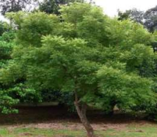

**Fig no:13 Neem tree.**

Since there has never been a report of the topical application of Neem causing an adverse side effect, this is a common procedure to cure skin ailments or allergic reactions. It is effective against a broad spectrum of skin diseases including eczema, psoriasis, dry skin, wrinkles, rashes and dandruff. The oil is used for skin diseases such as scrofula, indolent ulcers and ringworm. It is a common practice to apply neem all over the hair to kill head lice.7

**9.Achyranthes aspera**

Common name: Latjira, Chirchira, Aghedo, Prickly chaff flower, Family: Amaranthaceae

Achyranthes aspera (Amaranthaceae) is an important medicinal herb found as a weed throughout India. Though almost all of its parts are used in traditional systems of medicines, seeds, roots and shoots are the most important parts which are used medicinally.

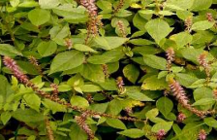

**Fig on:14 Achyranthus aspera plant.**

The plant is used in indigenous system of medicine as, antiarthritic, antifertility, laxative, anti-helminthic, aphrodisiac, antiviral, anti-plasmodic, antihypertensive, anticoagulant, diuretic and anti-tumor. It is pungent, antiphlegmatic, antiperiodic, diuretic, purgative and laxative, useful, boils and eruptions of skin etc. The plant is useful in liver complaints, scabies and other skin diseases It is also useful to treat cough, scrofula, skin rash, fungal infection, fever and snake bites. The juice of the plant is used in the treatment of boils, itches and skin eruptions.

**10. Lawsonia inermis**

Common name: Henna, mehndi, Family: Lythraceae

Lawsonia inermis is a small shrub frequently cultivated in India, Persia, and along the African coast of the Mediterranean Sea. It is much branched, deciduous, glabrous, sometime spinescent shrub or small tree with grayish brown bark, attaining a height of 2.4-5 m. It is cultivated as a hedge plant throughout India, and as a commercial crop in certain states of India for its dye.

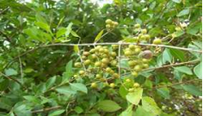

**Fig no:15 Plant of Withania somnifera.**

Powdered leaves of this plant, in the form of a paste, are used both as a cosmetic dye and as a remedy for boils, wounds, and some mycotic infections Mehndi also have effective antifungal activity against Candida albicans and other fungis, hence also be used in fungal infections of skin. The leaf paste is applied on cracked heels in rainy season due to mud infection. Henna also has antifungal properties and strongly absorbs UV light, thus its application is beyond cosmetic as it has proven useful against fungal diseases like athlete’s foot and as a sunscreen.6

**11.Matricaria chamomilla**

Common name: Chamomilla, Family: Asteraceae

It is a well-known and generally used medicinal herb. M. chamomilla, a member of the Asteraceae family, is one of the oldest medicinal plants It is used in herbal medicine for a sore stomach, irritable bowel syndrome, and as a gentle sleep aid. In addition, it is used as a mild laxative and is antiinflammatory and bactericidal.

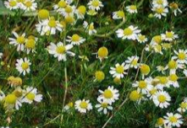

**Fig no:16 Plant of Withania somnifera**.

Allergies have been reported and those with daisy allergies may discover themselves allergic to chamomile. It has antibacterial, anti-fungal, anti-inflammatory and antiseptic properties. It is also believed to be hypoallergenic with the ability to neutralize skin irritants. treatment of patients with medium-degree atopic eczema, effectiveness of cream containing matricaria flower extract was superior to that of 0.5% hydrocortisone cream regarding the symptoms of pruritus, erythema and desquamation. Matricaria flower is externally applied for skin inflammations and irritations, bacterial skin diseases, nappy rash and cradle cap, eczema, wounds, abscesses, frostbite and insect bites.9

**12.Calendula officinalis**

Common name: Marigold, Family: Asteraceae

Calendula officinalis L. (marigold) is native to the Mediterranean countries. It has characteristic yellow-orange flower heads. Active ingredients of the calendula flower are triterpene saponins (oleanolic acid glycosides), triterpene alcohols (α-, β-amyrins, faradiol), and flavonoids (quercetin and isorhamnetin).

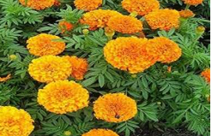

**Fig no: 17 Plant of Withania somnifera.**

Marigold, Calendula officinalis L. (Asteraceae) is well known for its medicinal properties and also its pharmaceutical and cosmetic uses.

Anti-inflammatory effects of Calendulae flos are related to the content of flavonoids and triterpene derivatives. Isorhamnetin 3-glycosides isolated from calendula flowers inhibited lipoxygenase. Oleanane-type triterpene glycosides exhibited a marked anti-inflammatory activity in the TPAinduced inflammation in the mouse ear. 8

**13.Withania somnifera**

Common name: Ashwagandha, winter cherry, Family: Solanaceae

The plant Withania somnifera, commonly known as “Ashwagandha”, is well known for its therapeutic uses in the Ayurveda system of traditional medicine. It grows as a short shrub (35–75 cm) with a central stem from which branches extend radially in a star pattern (stellate) and covered with a dense matte of wooly hairs. The chemistry of Withania has been extensively studied and over 35 chemical constituents have been identified, extracted, and isolated12. The biologically active chemical constituents are alkaloids (isopelletierine, anaferine), steroidal lactones (withanolides, withaferins), saponins containing an additional acyl group (sitoindoside VII and VIII), and withanolides with a glucose at carbon 27(sitoindoside IX and X). It is also rich in iron. Pharmacological investigations of W. somnifera have revealed its anti-inflammatory, antioxidant,

The plant Withania somnifera, commonly known as “Ashwagandha”, is well known for its therapeutic uses in the Ayurveda system of traditional medicine. It grows as a short shrub (35–75 cm) with a central stem from which branches extend radially in a star pattern (stellate) and covered with a dense matte of wooly hairs. The chemistry of Withania has been extensively studied and over 35 chemical constituents have been identified, extracted, and isolated12.

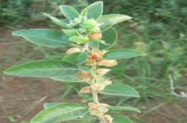

**Fig no18: Plant of Withania somnifera**

It is also rich in iron. Pharmacological investigations of W. somnifera have revealed its anti-inflammatory, antioxidant, immunomodulatory, and tumor cell proliferation inhibitory activities. A fomentation of the leaves is used for sore eyes, boils, and swollen hands and feet. Paste of the leaves is locally applied to kill lice infesting the body.

**14.Echinacea angustifolia**

Common name: Purple cone flower, Family: Asteraceae

Echinacea angustifolia is a perennial with one to several stems 1-6 dm tall, with stiff bristly hairs. Leaves are alternate, oblong to lance-shaped, 5-30 cm long, with three to five nerves running down the length of the blade.

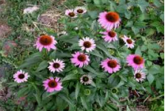

**Fig no 19: Plant of Echinacea angustifolia with flowers**

Root preparations of and Echinacea angustifolia have been used for the treatment of f wounds, bums and other cutaneous affections, and to treat disorders such as viral infections, cutaneous illnesses and acute and chronic disease due to a deficiency of immunological responses.10

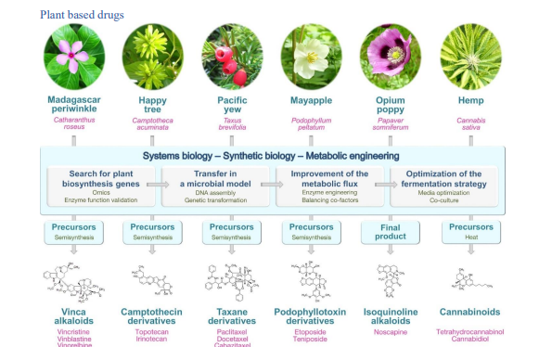

**Fig no 20: plant based drugs**

**CONCLUSION:**

Herbs offer a tremendous deal of potential to treat many skin conditions. In India, more than 80% of the population uses traditional medicine and various plantbased treatments to treat ailments of the skin. They are relatively inexpensive in comparison to traditional allopathic medicines and can be very helpful to the Indian population in general, and the impoverished in particular. Herbs are a great source of active compounds and can treat a variety of skin conditions, from rashes to deadly skin cancer, in a more efficient and safe manner. Since it appears that more than half of the plant species that can heal skin conditions are only found in forests, deforestation, habitat degradation, urbanisation, etc., may pose a severe threat to these species. The urgent need is to preserve these plants with the support of local involvement and conduct comprehensive study in this area to increase the potential for herbal medicines to treat skin conditions. 2

**REFERENCE:**

1.Sansare Anjali Sudhakar*1, Mali Shubhangi Ravsaheb, HERBAL DRUGS USE IN SKIN DISORDER, International Research Journal of Modernization in Engineering Technology and Science, Volume:05/Issue:03/March-2023.

2. Jitendra Kumar Pandey, Anushka Dixit, WORLD JOURNAL OF PHARMACEUTICAL AND MEDICAL RESEARCH, wjpmr, 2022, 8(11), 78-84.

3. Jagtap Vaishali. S, Ms. Ajgunde R.R., Herbal Drugs Used in Skin Disorder, International Journal of Research Publication and Reviews, Vol 4, no 12, pp 1142-1150 December 2023.

4. Ahuja, A., Gupta, J. and Gupta, R., 2021. Miracles of herbal phytomedicines in treatment of skin disorders: natural healthcare perspective. Infectious Disorders-Drug Targets (Formerly Current Drug Targets-Infectious Disorders), 21(3).

5. Prachi Ahirwar, Narendra Yadav, Piyush jain, REVIEW ON RECENT STATUS OF HERBAL MEDICINAL PLANTS AGAINST SKIN DISEASES, International Journal of Pharmaceutics & Drug Research, ISSN: 2347-6346, 22 May. 2022.

6. Patel Hemangi Hareshbhai, Review of herbal plants used in the treatment of skin diseases, Journal of Pharmacognosy and Phytochemistry 2021; 10(3).

7. Bhargava, V. Medicinal uses and pharmacological properties of Crocus sativus Linn (Saffron). Int. J. Pharm. Pharm. Sci 2011;3(3).

8. Grice EA, Kong HH, Conlan S, Deming CB, Davis J, Young AC, et al. Topographical and temporal diversity of the human skin microbiome. Science, 2009; 324: 1190–2.

9. Mann A, Banso A, Clifford LC. An antifungal property of crude plant extracts from Anogeissus leiocarpus and Terminalia avicennioides. Tanzania J. Health Res 2008; 10 (1).

10. Nasri H, Bahmani M, Shahinfard N, Nafchi AM, Saberianpour S, Kopaei MR. Medicinal plants for the treatment of acne vulgaris: a review of recent evidences. Jundishapur journal of microbiology 2015;8(11).

11. Proksch E, Brandner JM, Jensen JM. The skin: An indispensable barrier. Exp Dermatol, 2008; 17: 1063–72.