**An Review of A beneficial properties of Nyctanthes Arbor-tristis**

**Name :Miss.Sakshi S. Sonawane, Miss. Saloni S. Tambe, Mr.Akash H. Patil**

**Shri.swami samarth institute of pharmacy malwadi,**

**Bota,Tal.Sangamner dist. Ahilyanagar**

**E.mail :** [**sakshi28feb2003@gmail.com**](mailto:sakshi28feb2003@gmail.com)

**Abstract :**

Ayurveda, one of the oldest systems of medicine, emphasizes the use of plants and their derivatives in treating and managing various health issues. A notable example is Nyctanthes arbor-tristis Linn., commonly referred to as Parijat or Harsingar. This plant is highly esteemed in traditional Indian medicine for its extensive therapeutic benefits and is primarily found in the southern parts of India and Nepal. Recognized as a significant medicinal herb, Nyctanthes arbor-tristis is considered one of India’s most valuable traditional plants. For centuries, various herbal remedies have been utilized across the globe, and Night Jasmine, another name for Nyctanthes arbor-tristis, belongs to the Oleaceae family, thriving in tropical and subtropical regions around the world. The potential of Nyctanthes arbor-tristis to provide a safe and cost-effective alternative to standard pharmaceuticals makes it particularly noteworthy. Its importance in traditional medicine is deeply entrenched in Indian culture, where many people cultivate this plant in their gardens to ensure future generations can benefit from its medicinal properties.

**Keywords:** Nyctanthes Arbor-tristis, glycosides, oleanic acid, fever, Harsingar, Hair Loss, join pain.

**INTRODUCTION:**

Nyctanthes Arbor-tristis, commonly referred to as the “Tree of Sadness,” is a member of the Oleaceae family found in India and its neighboring regions. The name “Nyctanthes” is derived from two Greek terms: “Nykhta,” meaning night, and “anthos,” meaning flower. The seeds of this plant are round in shape. In Hindi, it is known as harsinghar, while in Sanskrit, it is called parijat, and in English, it is referred to as night jasmine .This plant is commonly known by several names, including Coral Jasmine, Harsinghar, Parijat, Queen of the Night, and Night Flowering Jasmine, and is frequently referred to as night jasmine. This species typically manifests as a small tree or shrub, characterized by its highly fragrant flowers. These blossoms, which bloom at night, create a striking display of red and white on the ground, only to wither away by dawn. During the daytime, the plant appears devoid of its vibrant colors. The flowering period extends from July to October lifespan of the plant ranges from 5 to 20 years.and it thrives best in a solitary, semi-shaded environment.

The flowers of this plant are notably soft and aromatic. Various phytochemicals such as flavonoids, glycosides, oleanic acid, essential oils, tannic acid, carotene, friedeline, lupeol, glucose, and benzoic acid have been identified, demonstrating significant properties including hair tonic effects, hepatoprotective benefits, and activities against , viruses, fungi, fever, histamines, malaria, bacteria, inflammation, and oxidative stress.

This underscores the importance of further investigation into the available data.The Its leaves, flowers, bark, fruits, and seeds possess various pharmacological properties and are utilized in alternative medicinal systems such as Ayurveda, Siddha, and Unani. The orange heart of the plant is used for dyeing silk and cotton, a practice that originated with Buddhist monks who dyed their robes using this flower. In Hindu mythology, the Parijata is considered one of the five wish-granting trees of Devaloka. This plant is commonly used in Indian medicine and is officially recognized in the Indian pharmacopoeia.This is a small native tree characterized by its rough, peeling bark, which can be grey or greenish in color. The shrub can attain a maximum height of ten meters. Its opposite leaves measure between 6 to 12 cm in length and 2 to 6.5 cm in width, featuring a smooth edge. Numerous plants have been investigated as potential sources of bioactive compounds for the treatment of various health conditions. Out of approximately 422,000 flowering plant species worldwide, over 50,000 are reported to possess medicinal and pharmacological properties. Nyctanthes arbortristis is a readily accessible plant, well recognized by the general populace, and does not require any special conditions for its harvesting and cultivation. This species thrives in hilly regions up to 1,500 feet above sea level, growing as a shrub that can reach heights of up to 3,000 feet.

The Unani system of medicine is an ancient traditional medical practice that originated in Greece, founded on the theoretical principles established by the Greek physician Hippocrates. This system has evolved through various stages, cultures, and regions, having been further developed by Roman and Arab physicians. Upon its introduction to India during the Mughal era, it was also enriched by Indian medical practitioners. N. arbor-tristis is a sub-Himalayan plant that grows naturally from Nepal to the Chenab River, extending through regions such as Burma, Assam, Central India, Bengal, Rajasthan, Madhya Pradesh, Chhotonagpur, and as far south as Godavari

T**axonomical Classification**

Kingdom: Plantae

Division: Magnoliophyta.

Class: Magnoliopsida

Order: Lamiales

Family: Oleaceae

Genus: Nyctanthes

Species: arbor-tristis

Binomial name: Nyctanthes arbor-tristis

**Vernacular names :**

English: Night jasmine, coral jasmine,

Hindi: Parja, Har, Siharu, Harsinghar.

Kannada: Parijata, Harsinghar

Odia: Shingadahar, harashingar, gangaseuli, jharasephali

Tamil: Pavilamalligai, manja-pu, pavazahamalligai

Telagu: Pagadammali, swetasarasa, paghada, karchia, karuchiya

Malayalam: Pavilamalli, parijatam, pavizhamalli, parijatakam

Marathi: Khurasli, Parijataka, Parijata

**Description :**

N. arbor-tristis Linn. (NAT) is a small tree or shrub that can reach heights of 15 to 20 feet, characterized by its grey, flaky bark. This species is widely appreciated as a flowering plant in warm, humid climates. The stems and shoots exhibit a somewhat square shape, with the stem bark being brown and rough, adorned with white spots. The leaves are four-sided, opposite, and short-petioled, presenting a quadrate or oblong shape. They are moderately thick, rough, pointed or coarsely serrate, and scabrous, displaying a dark green hue. The leaves are easily breakable, featuring abundant veins, with the lower surface being thicker than the upper. The plant produces terminal panicles composed of small umbellets, each containing six flowers. The calyx is campanulate and slightly notched, while the corolla tube is cylindrical and of similar length to the calyx, with segments numbering between five and seven. The involucel consists of four cordate, opposite, and sessile leaflets. The flowers are numerous, small, soft, and fragrant, featuring 6 to 8 white petals that resemble jasmine, arranged on a reddish tubular stalk. This plant typically blooms in the spring, producing such an abundance of flowers that it is rarely without blooms throughout its flowering cycle. It thrives best in bright, sunny locations and warm temperatures. The flowers open in the evening and close by morning, leaving a decorative carpet of fallen petals. The fruit is a dry, oblong, mucronate capsule, prominently veined, measuring approximately 1.25 cm in length and width. Initially green when unripe, the fruit turns brown upon ripening in the summer. It is compressed and contains two cells, each housing a yellowish-brown, thin, flat seed kernel that is elevated in the center. The seed itself is white, with a taste that is either bitter or tasteless and has astringent properties.

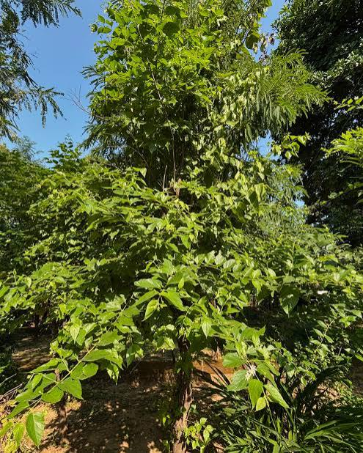

**Fig. 1 .** N.arbor tristis plant

**Traditional uses:**

**Parts used Leaves, Bark, Flower, Seeds**

**Leaves:** The Harsingar plant’s leaves have been utilized in the treatment of various ailments, including fevers, coughs, worm infestations, and arthritis.

The bitter juice extracted from the leaves serves as a tonic. The kadha, or decoction, is particularly effective for addressing worm infestations, constipation, and arthritis. Ayurvedic practitioners recommend the use of Parijat leaf decoction for the management of sciatica and arthritis. It is beneficial in alleviating several types of fevers, including those induced by malaria, dengue, and chikungunya. Recent research indicates that extracts from Parijat leaves and bark are notably effective in rapidly reducing fever and enhancing platelet counts in patients suffering from dengue and chikungunya.

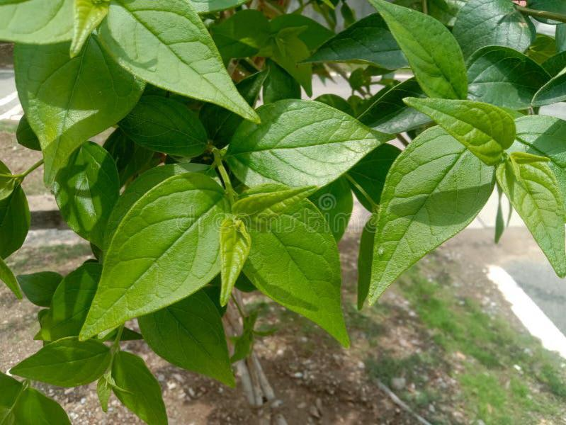

**Fig.2** N.arbor tristhis Leaves

**Flowers:** The flowers possess properties that make them useful for ophthalmic, stomachic, carminative, and trichogenous applications. They are beneficial in treating inflammations, ophthalmopathy, dyspepsia, splenomegaly, flatulence, colic, and greying of hair.

**Fig.3** N.arbor tristhis Flower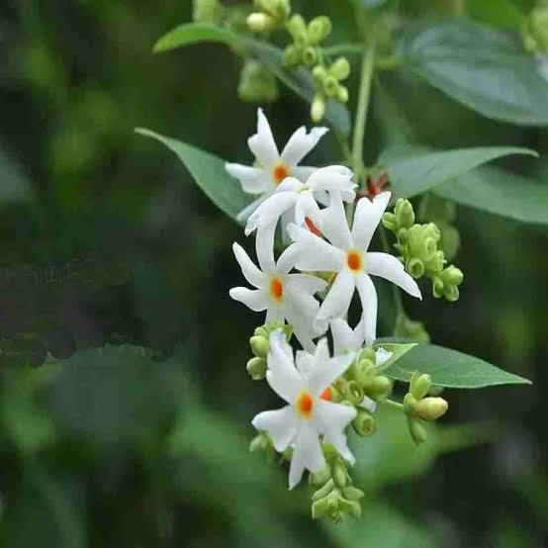

**Seeds:** The seeds are particularly effective in addressing baldness, scurvy, and scalp conditions.

**Fig. 4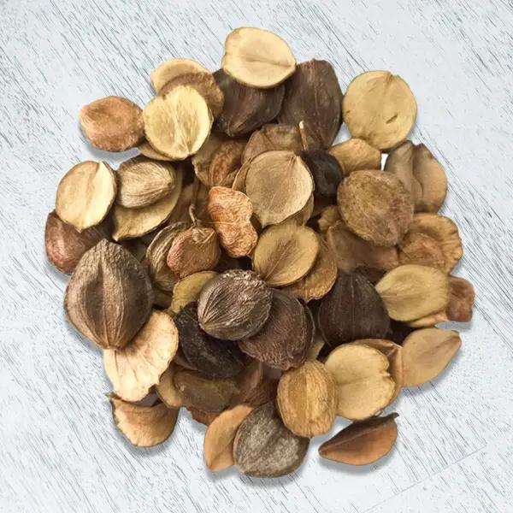 N.arbor tristhis seeds**

**Bark:** The bark is utilized as an expectorant.

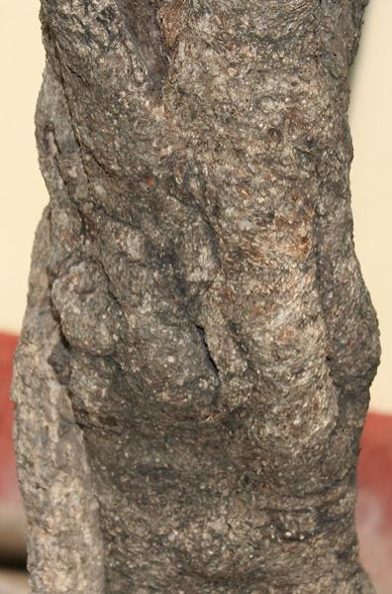

**Fig .5.**  **N.arbor tristhis bark**

**Chemical constituents :**

The leaves of Nyctanthes arbor-tristis are rich in various active chemical compounds. Some of the prominent phytochemicals identified in these leaves include flavanol glycosides, D-mannitol, β-sitosterol, astragaline, nicotiflorin, oleanolic acid, nyctanthic acid, ascorbic acid, and tannic acid, among others, which have been extensively documented.

**Benefits of Nyctanthes arbortristis :**

**1.Arthritis:**

The leaves of Parijat, also known as Harsingar, serve as potent herbal treatments for alleviating painful ailments such as osteoarthritis. In Ayurvedic terminology, osteoarthritis is referred to as Sandhivata, which arises from an imbalance of the Vata dosha. This condition is characterized by pain, swelling, and restricted joint movement. The consumption of powdered Parijat leaves aids in restoring balance to the elevated Vata, thereby mitigating the symptoms associated with arthritis due to its Vata-balancing attributes.

**2.Ringworm :**

Ringworm, also known as Dadru, is characterized by itching and a burning sensation, resulting from an imbalance between the Kapha and Pitta dosha. The juice extracted from Parijat leaves is effective in managing fungal infections and alleviating the itching associated with ringworm. This efficacy is attributed to its properties that combat skin diseases and pacify Kapha

**3.Sciatica**

Sciatica, known in Ayurveda as Gridhrasi, is primarily caused by an imbalance in the Vata dosha. In some cases, an increase in both Vata and Kapha doshas can also play a role in the condition. The herb Parijat, with its heating properties, helps to calm the aggravated Vata. Furthermore, it is effective in restoring balance between the Kapha and Vata doshas, providing relief from the symptoms linked to sciatica.

**4.Joint Pain:**

Parijat oil is effective in alleviating discomfort associated with bone and joint pain. In the context of Ayurveda, bones and joints are identified as areas influenced by Vata within the body. Joint pain primarily arises from an imbalance in Vata. The application of Parijat oil aids in mitigating joint pain due to its properties that restore Vata balance.

**5.Hair Loss:**

Parijat possesses Keshya properties, functioning as a hair tonic that aids in reducing hair loss and fostering hair growth. The application of Parijat flower juice or a paste made from its seeds directly onto the scalp can yield rapid results and enhance hair growth.

**6.Fever:**

Parijat, also known as Harsingar, may be effective in managing fever. According to Ayurvedic principles, the buildup of Ama which refers to toxic residues resulting from poor digestion, can occasionally lead to fever. Consuming the juice of Parijat leaves mixed with honey can alleviate fever symptoms by diminishing Ama, owing to its Ushna (heating) characteristics.

**7.Indigestion:** ,

In Ayurveda, indigestion is referred to as Agnimandya, which arises from an imbalance in the Pitta dosha. This condition occurs when food remains undigested due to Mand Agni, or low digestive fire, leading to the production of Ama, which are toxic byproducts resulting from improper digestion. The herb Parijat is known to enhance Agni, thereby promoting better digestion through its Deepan (appetizer) and Pachan (digestive) qualities.

**8.Diabetes:**

Diabetes, or Madhumeha in Ayurvedic terms, is caused by an exacerbation of the Vata-Kapha dosha along with compromised digestion. This impaired digestive process results in the buildup of Ama within the pancreatic cells, adversely affecting insulin function. Parijat is beneficial in managing diabetes due to its properties that balance Vata and Kapha, as well as its Tikta (bitter) characteristics. It aids in preventing the accumulation of Ama and enhances insulin function, thus helping to regulate blood sugar levels and alleviate the symptoms associated with diabetes.

**Treatment of Piles, Gout, Dry Cough:**

The seeds of N. arbortristis are employed in the management of piles. A decoction made from the flowers of N. arbortristis is used for the treatment of gout. The leaves serve as a remedy for dry cough. An aqueous paste derived from the leaves is applied externally to address skin issues, particularly ringworm. Additionally, the young leaves are recognized for their benefits as a female tonic. N. arbortristis also exhibits hypoglycaemic properties, enhancing the effects of exogenous insulin in a streptozotocin-induced diabetic rat model

**Side Effects of Nyctanthes Arbortristis:**

Caution and moderation are advised when using Parijat. The following side effects may occur:

• The leaves of Parijat possess a bitter and pungent flavor, which may induce vomiting in first-time users. Prolonged consumption of Parijat leaves may lead to gastric lesions due to the presence of salicylate.

• Additionally, the leaves contain phenol, which may result in stomach irritation, nausea, and vomiting in some individuals.

• Consuming large quantities of Parijat leaves can lead to nausea, stomach irritation, and diarrhea, attributed to the glycoside content within the leaves.

**Toxicity of Nyctanthes arbor-tristis:**

The ethanolic extract of Nyctanthes arbor-tristis has demonstrated irritant properties, as evidenced by its dose-dependent laxative effect, which resulted in the production of unformed, semi-liquid, collagenous pale stools in albino mice. Additionally, when introduced into the eyes of rabbits, it caused conjunctival obstruction accompanied by edema.A subject who handled the dried leaves developed vesicular lesions on both hands. The toxic effects of the ethanolic extract of the leaves have also been observed in rats, where administration of varying doses (1, 2, and 4 gm/kg/day) over six consecutive days led to the formation of gastric ulcers.Furthermore, the antifungal efficacy of the leaves has been confirmed against Alternaria alternata. A study assessing the antitrypanosomal activity of a fifty percent ethanol extract of the leaves revealed significant effects. The leaves of Nyctanthes arbor-tristis are widely utilized in Ayurvedic medicine for treating various ailments, including intestinal worm infestations and as a laxative.Other parts of the plant are also beneficial in medicinal applications, particularly in Ayurveda. The powdered seeds are employed to treat scalp conditions and hemorrhoids, as well as skin disorders. Traditionally, the powdered stem bark is used for rheumatic pain and internal injuries, while the bark itself serves as an expectorant when combined with other agents. The flowers possess bitter, astringent, carminative, and stomachic properties and are utilized for various ophthalmic applications. Additionally, the juice extracted from the flowers is used to prevent hair greying and baldness.

**Conclusion:**

Night Jasmine has been utilized for numerous medicinal and domestic purposes for over a century, owing to its extensive applications in health management. Chemical and phytochemical analyses reveal that the plant comprises various active compounds and distinct bio-markers. Its wide-ranging use in health management is documented in nearly all ancient texts. This review concludes that Night Jasmine serves as an effective remedy for numerous ailments; however, further validation through comprehensive clinical research is necessary to fully ascertain its benefits for humanity.

**Reference:**

**1.**Wealth of India, A Dictionary of Indian Raw Materials and Industrial Products, VII, (National Institute of Science Communication, CSIR, New Delhi) 1997; 69-70.

**2.**Shirazi MMH. Makhzan al-Advia, Matba Ahmadi, Delhi. 1278, pp. 638

639.

**3.**Ghani MN. Khazain al-Advia, Vol. 6, CCRUM, New Delhi. 2010, pp.510-11.

**4.**Khan MS. Taleef Sharifi, Akmal al-Mat'aba, Delhi.1880, pp. 214-215.

**5.**Medicinal plants used in Ayurveda, Phytomedicine,Supplement-II, 2000; 23.

**6.**Gadgoli, C., Shelke, S. 2010. Crocetin from the tubular calyx of Nyctanthes arbortristis. Nat. Prod. Res., 24(17): 1610 5.

**7.** Thokala M. A Literary Review of Nyctanthes Arbortristislinn (Parijatha) Linn in Ayurvedic Classics. World J Pharm Res. Volume 7, Issue 04, 410-419.

**8.** Sopi RB and Khan MFH. Bronchodilatory effect of ethanolic extract of the leaves of Nyctanthes arbortristis. Pharmacognosy Res. 2013 Jul-Sep; 5(3): 169–172.

**9.** Talakal TS, Dwivedi SK and Sharma SR. Invitro-Invivo antitrypanosomal potential of Nyctanthes arbor-tristis Leaves, Pharmaceutical Bio, 2000 38(5) 326-329.

**10.** Rahman JMF, Shahriar M, Chakraborty P, Sattar M and Choudhary MS. A cutanic tabular and chronic Toxicity study of Nyctanthes arbor- tristis L. Hamdard Med. 2000 43 (2): 19-23.

**11.** Saxena RS, Gupta B, Saxena KK, Singh RC and prasad DN. Analgesic, Antipyretics and ulcerogenic activities of Nyctanthes of Nyctanthes arbor-tristis fex tract Jethnopharma. 1987: 19:193-200.

**12.** B N Bhawmic and B K Chaudhari , Antiallergic activities of some Traditional Indian medicinal plant,Indian BOT Rept 1(2) 164-165 (1982).

**13.** Naredhirakannan RT, Smeera T, In Vitro antioxidant studies on ethanolic extract of leaves and stem of Nyctanthes arbor tristis L. (Night Flowering Jasmine) International Journal of Biology and Medical research 2010 1- 188-192.

**14.** Tuniwachwattika P, Rayanil K, Taylor WC. Chemical Constituent from the flower of Nyctanthes arbor-tristis Sciences Asia 2003, 29, 21-30.

**15.** Chopra, R.N., Nayar, S.L., Chopra, I.C. Glossary of Indian medicinal plants. New Delhi,CSIR., 1956.

**16.** Chopra, R.N., Chopra, I.C., Handa, K.L., Kapur, L.D. Indigenous drugs of India. Academic Publishers, Calcutta, India, 1958: 51-595.

**17.** Kirtikar, K.R., Basu, B.D. Nyctanthes arbor-tristis in medicinal plants, edited by Blatter, E., Cains, J.F., Mhaskar, K.S. LM Basu Publishers, Allahabad, India, 1935: 536.

**18.** Chatterjee, A., Pakrashi, S.C. The Treatise on Indian medicinal plants. Publications & Information Directorate, New Delhi, India, 1994; 3: 76

**19.**Satyal P, Paudel P, Poudel A, Setzer W N. Chemical composition And biological activities of essential oil from leaf and bark of Nyctanthes arbor-tristis L from Nepal. Journal of Medicinal and Aromatic Plants.2012;3(1): 1-4.

**20.**Suresh V, Arunachalam G, Senthil Kumar N, In vitro Anthelminthic activity of Nyctanthes arbor-tristis Linn. Bark, Journal of Pharmacy Research,2011:4(1):283-284.

**21.**K. Priya, Deepak Ganjewala. Antibacterial activities and Phytochemical analysis of different plant parts Of Nyctanthes arbortristis (Linn.), Research Journal of Phytochemistry. 2007:1:61-67.

**22.**  Laxmi Verma, Vaibhav Tamrakar, Narul Haque, Anil Kumar. Antifungal activity of Different parts of Nyctanthes arbor-tristis Linn. (Parijat) against clinical pathogens, Shodh Darpan (Special Issue), 2016: 1 (4) .ISSN No. 2454-1516