**“LANTANA CAMARA”: THE THERAPEUTIC POTENTIAL OF MEDICINAL PLANT”**

Name : Miss.Saloni S. Tambe, Miss.Sakshi S. Sonawane, Mr. Akash H. Patil

Shri. Swami samarth institute of pharmacy malwadi,

Bota, Tal. Sangamner Dist. Ahilyanagar

# **ABSTRACT**

Lantana camera, a plant native to the Americas, has been used in traditional medicine for centuries. This review aims to summarize the current knowledge on the pharmacological properties and therapeutic potential of lantana camera India has a rich tradition of a plant-based knowledge in health care. Among the large number of herbal drugs existing in India, very few have studied systematically so far. Lantana camara is an evergreen plant found everywhere in India it is well known to cure several diseases and used in various folk medicinal preparations. Lantana camara belonging to family of verbanaceae. .The plant has been reported to possess anti-inflammatory, antimicrobial,antioxidant activity making it a potential candidate for the treatment of various diseaseDifferent parts of the plants are used in the treatment of cold, headache, chickenpox, eye injuries, cuts, cancer, leprosy, skin itches, asthma and arterial hypertension . Studies conducted in India have found that lantana leaves can display antimicrobial, Fungicidal and insecticidal properties. Traditionally it has been used treating various ailments and they were supported by scientific data’s. Systemic analysis of this plant provides a variety of bioactive molecules for development of newer pharmaceutical product. The knowledge of medicine and medicinal plants and their study of scientific chemical principles may lead to the discovery of newer and cheaper drugs. Plants due to lack of technology as using plants as remedies were proven to be useful.This article reviews the Pharmacological activities and information of lantana camera

Key Words: Medicinal plants, Lantana camara linn, Phytoconstituents, Therapeutic potential, Biodiversity , pharmacological properties

# **INTRODUCTION**

Lantana camara, commonly referred to as Lantana, is a notable plant species originating from the Americas. It belongs to the Verbenaceae family and is characterized by its shrub-like growth. This versatile species has been widely naturalized in tropical and subtropical areas around the globe. Historically, various parts of Lantana camara, including its leaves, flowers, and roots, have been utilized in traditional medicine to address a wide array of health issues.

In addition to its ornamental appeal, Lantana camara is recognized for being a rich source of bioactive compounds such as flavonoids, terpenoids, and phenolic acids, all of which contribute to its therapeutic properties. Scientific research has highlighted its potential as an anti-inflammatory, antimicrobial, antioxidant, and anticancer agent, sparking interest in its applications within pharmaceutical and biomedical fields.

Lantana camara is a flowering ornamental shrub that falls under the Verbenaceae family. In India, it was likely introduced before the 19th century and is now found widely across the country, particularly in regions with moderate to high summer rainfall and well-drained slopes. This plant can grow individually, in clusters, or form dense thickets that may outcompete more desired plant species.

In recent decades, numerous traditional plants, including Lantana camara, have been subjected to extensive scientific investigation, revealing a host of medicinal properties such as anticancer, anti-inflammatory, anti-diabetic, antibacterial, and antifungal effects. Notably, pharmacological studies have demonstrated that extracts from Lantana camara possess significant antioxidant properties.

The objective of this project is to document the medicinal attributes of Lantana camara and explore future avenues for scientific research aimed at developing effective therapeutic compounds.

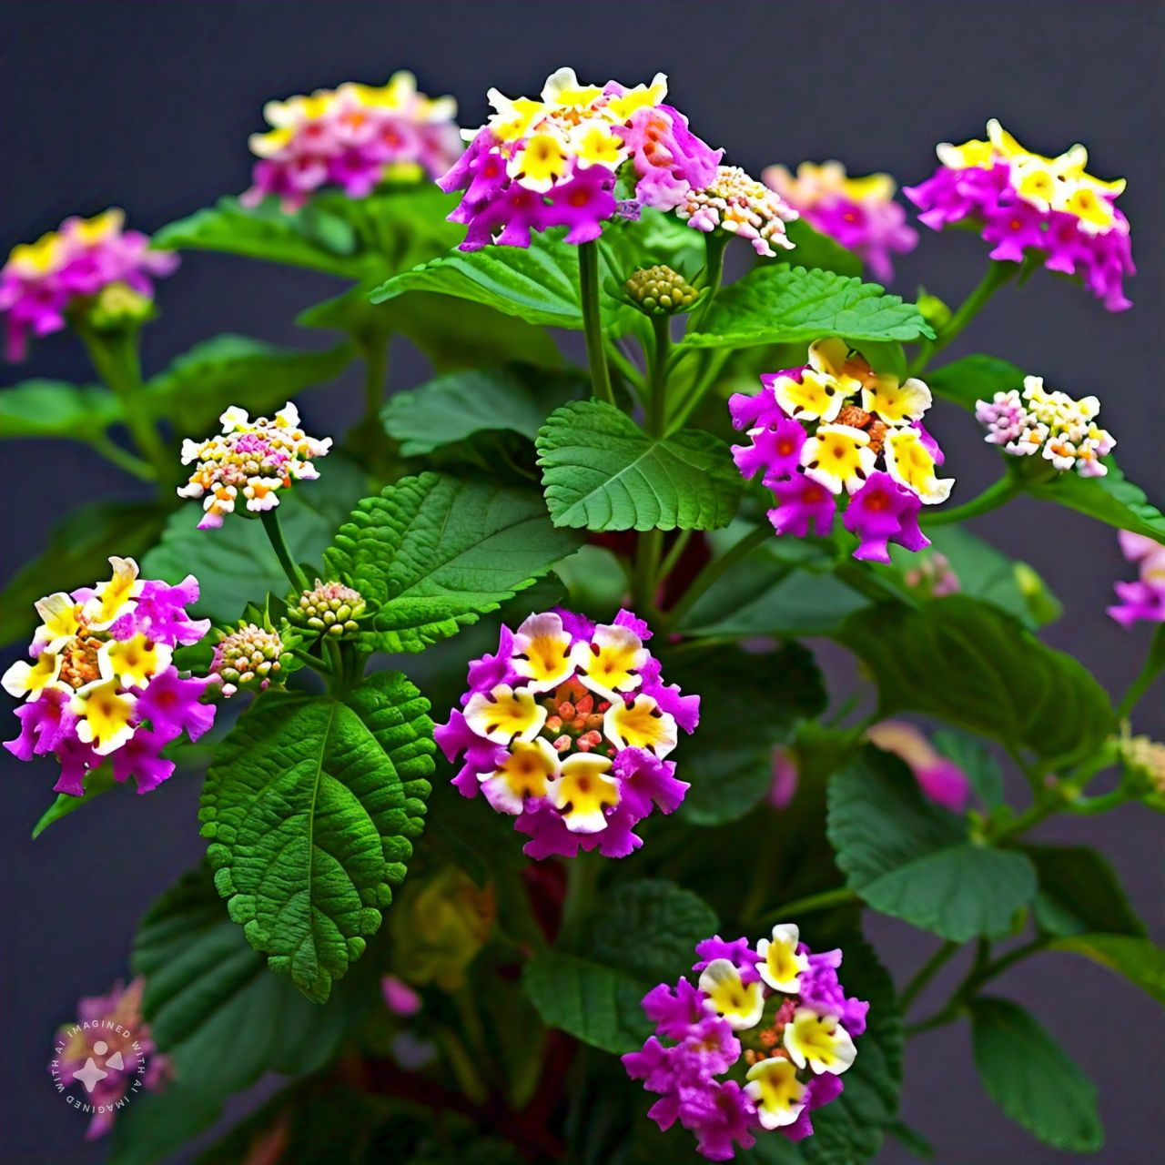**LANTANA CAMARA**

Fig.1 Lantana Plant

About Lantana

Botanical Name: Lantana Camara Linn.

Common Names:

English: Lantana Weed

Hindi: Raimuniya

Marathi: Ghaneri, Tantani

Family: Verbenaceae

Plant Form: Shrub

Ayurveda Description:

Sanskrit Name: Chaturangi, Vanacchedi

Properties: Rasa: Kashaya, Tikta; Guna; Guru; Virya: Sita

Therapeutic Uses: Plant pacifies vitiated condition of vata And kapha

# **MORPHOLOGY**

Lantana camara is a robust shrub that typically grows between 1.2 and 2.4 meters tall, although it can exceed that height. It features sturdy, recurved thorns and has a distinctive scent reminiscent of black currants. The plant has a strong root system and often develops multiple branches, forming dense clumps, thickets, or climbing vines.

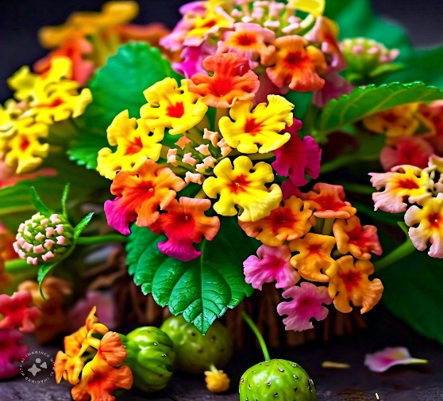 Fig. Flower & Fruit of Lantana Camara

**Stem:**

The plant exhibits a robust and branched structure, which can be either square or round in cross-section, typically showing a green or brown hue. It has the potential to reach heights of 2 to 4 meters.

**Leaves:**

Leaves are arranged either in opposite pairs or in whorls and are characterized by their simple, ovate, or elliptical shape, measuring between 2 and 10 cm in length and 1 to 5 cm in width. The leaf edges can be either smooth or serrated, with surfaces that may be rough, hairy, or glandular.

**Flowers:**

The flowers are small, tubular, and emit a pleasant fragrance, available in shades of yellow, pink, orange, or purple. They cluster in groups, known as umbels, located at the branch tips, with each umbel containing 20 to 40 individual flowers.

**Fruits:**

The plant produces small, round, and fleshy berries ranging from 2 to 6 mm in diameter, which can be green when unripe and turn purple once mature. Each berry typically contains two seeds.

**Roots:**

The roots consist of a primary taproot that branches extensively and have a combination of fibrous and woody qualities.

**Other Features:**

The leaves and flowers possess a distinct aroma, and both the leaves and stems can have a hairy or glandular appearance. Depending on growth conditions, this plant can develop into either a shrub or a small tree.

# History

Lantana camara, commonly known as Lantana, is a flowering shrub that originates from the tropical areas of Central and South America. Its history traces back to the 17th century, marked by several key developments:

- **1680s**: Spanish missionaries introduced Lantana to Europe, bringing it from their colonies in the Americas.

- **18th Century**: The plant gained popularity in European gardens, especially in England, due to its fragrant blooms and its appeal to butterflies and other pollinators.

- **19th Century**: British colonizers spread Lantana to Asia and Africa, where it quickly adapted and established itself in the local environments.

- **Early 20th Century**: It was introduced to Australia and the United States, where it was cultivated for ornamental purposes and to help control erosion.

- **Mid-20th Century**: Lantana began to exhibit invasive characteristics in various regions, notably in Australia, South Africa, and the southern United States, where it outcompeted native species and led to ecological and economic challenges.

Currently, Lantana camara is recognized as a significant invasive species in many areas, prompting various efforts to manage its expansion and minimize its effects on local ecosystems. Despite these issues, it continues to be a favored ornamental plant in numerous locations, appreciated for its bright flowers and low maintenance needs. Notably, Lantana camara is native to Mexico and was first brought to India from Srilanka in 1809.

Distribution:

A worldwide plant is lantana camara. More than 60 nations have received it, including those in Africa, America, Australia, Chaina, Hong Kong, Malaysia, India, Sri Lanka, the United States, and New Zealand.

Habitat:

It commonly occurs in agricultural lands, coastal regions, natural forests, planted woodlands, grasslands, riverbanks, shrublands, urban areas, wetlands, and various wastelands.

Life Cycle:

The life cycle of Lantana camara, a flowering shrub, includes several distinct stages:

1. **Seed Germination** (1-3 weeks): Seeds sprout in warm conditions (above 60°F/15°C) and damp soil.

2. **Seedling Stage** (1-3 months): Once germinated, seedlings emerge and develop their initial leaves and root systems.

3. **Sapling Stage** (3-6 months): The seedlings progress into saplings, with increased growth in leaves, stems, and roots.

4. **Maturation Stage** (6-12 months): As the plant matures, it begins to produce clusters of small, fragrant flowers.

5. **Flowering Stage** (year-round): Lantana continuously produces flowers in a variety of colors, including pink, yellow, orange, and purple, attracting pollinators.

6. **Fruiting Stage** (year-round): The flowers eventually turn into small, berry-like fruits that contain seeds.

7. **Seed Dispersal** (year-round): Birds and other animals consume the fruits, aiding in the dispersal of seeds to new locations.

8. **Dormancy** (optional): In cooler regions, Lantana may enter a dormant state during the winter, resuming growth in the spring.

9. **Regeneration**: The plant can regenerate from cuttings, roots, or leftover seeds, enabling it to rapidly colonize new areas.

Types of Lantana Species:

Lantana plants are popular in gardens due to their vibrant flowers and ability to attract local pollinators. However, before starting a lantana garden, it’s important to check whether any species are considered invasive in your area. Typically, these plants thrive in hot and humid conditions, which are prevalent in the southern United States. When the climate suits them, lantana species require minimal upkeep and can enhance the beauty of your garden significantly.

# 1.Common Lantana (Lantana camara):

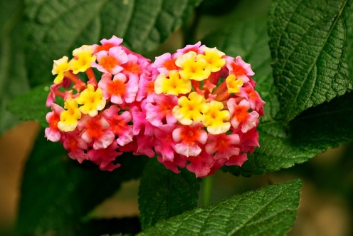

Certainly! Here’s a rephrased version of the information you provided about the plant:

**Physical Characteristics:**

- Exhibits a shrub-like form, reaching heights of up to 6 feet (1.8 meters) and widths of 8 feet (2.4 meters).

- Features grayish-green leaves with a rough texture and a notable scent.

- Produces clusters of small, fragrant flowers in various colors, including pink, yellow, orange, and purple.

- Bears berry-like fruits that contain seeds.

**Growth Habit:**

- Known for its rapid growth and tendencies to become invasive in numerous areas.

- Can create dense thickets that overshadow native plant species.

- Adaptable to different soil types and moisture conditions.

- Thrives in environments ranging from full sun to partial shade.

**Uses:**

- Commonly utilized as an ornamental plant for gardens and landscaping.

- Effective for erosion control and enhancing soil stability.

- Attracts butterflies and other pollinators, making it beneficial for wildlife.

- Used in traditional medicine practices in various cultures.

# 2.Trailing Lantana (Lantana montevidens):

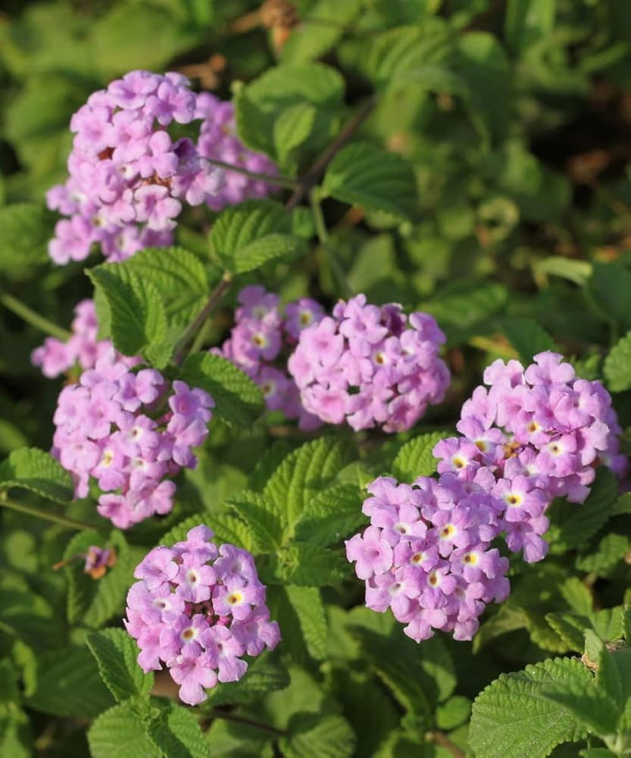

Trailing Lantana (Lantana montevidensis) is a notable variant within the Lantana genus, recognized for its distinctive growth pattern and features. Here are some important aspects of Trailing Lantana:

**Physical Features:**

- Exhibits a spreading, trailing, or cascading growth style, reaching lengths of up to 6 feet (1.8 meters).

- Possesses grayish-green leaves that are rough to the touch and have a unique scent.

- Produces clusters of small, aromatic flowers in a variety of colors, including pink, yellow, orange, and purple.

- Develops berry-like fruits that contain seeds.

**Growth Behavior:**

- Known for its rapid spread, often considered invasive in several areas.

- Capable of forming thick mats that can overshadow native plant species.

- Adapts well to different soil types and varying moisture levels.

- Thrives in conditions ranging from full sunlight to partial shade.

**Applications:**

- Commonly used as an ornamental plant in hanging baskets, containers, or as ground cover.

- Valuable for erosion control and stabilizing soil on slopes and embankments.

- Attracts butterflies and other pollinators, contributing to local biodiversity.

- Its cascading growth creates appealing displays, especially when spilling over walls or containers.

**Native Range:**

This species is originally found in the tropical regions of South America, with its name referencing its discovery in Montevideo, Uruguay.

# 3. Buttonsage (Lantana involucrata):

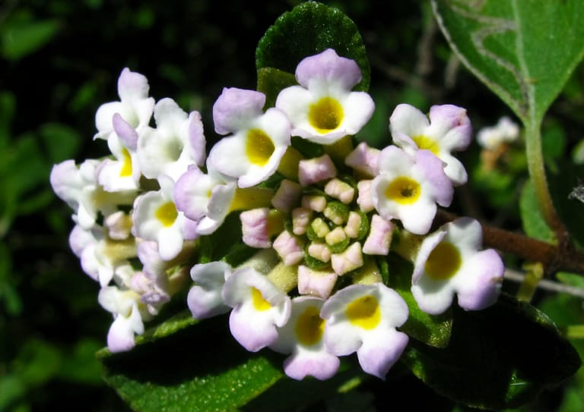

Button Sage Lantana (Lantana involucrata) is a unique variant of the Lantana species, recognized for its characteristic button-shaped flower clusters and sage-like leaves. Here are some essential points regarding Button Sage Lantana:

**Physical Characteristics:**

- This shrub can grow up to 6 feet (1.8 meters) tall and 4 feet (1.2 meters) wide.

- Its leaves are grayish-green, rough in texture, and emit a sage-like fragrance.

- It features button-like clusters of small, fragrant flowers that come in yellow, pink, and purple hues.

- The plant produces berry-like fruits that contain seeds.

**Growth Habit:**

- The growth rate is slow to moderate.

- It can develop into dense shrubs or hedges.

- The plant is adaptable to various soil types and moisture conditions.

- It thrives in full sun to partial shade environments.

**Uses:**

- Button Sage Lantana serves as an attractive ornamental plant for gardens and landscapes.

- It can be utilized as a hedge or screening plant.

- The plant is beneficial for attracting butterflies and other pollinators.

- Its foliage and flowers are noted for their fragrance.

4. Popcorn Lantana (Lantana trifolia):

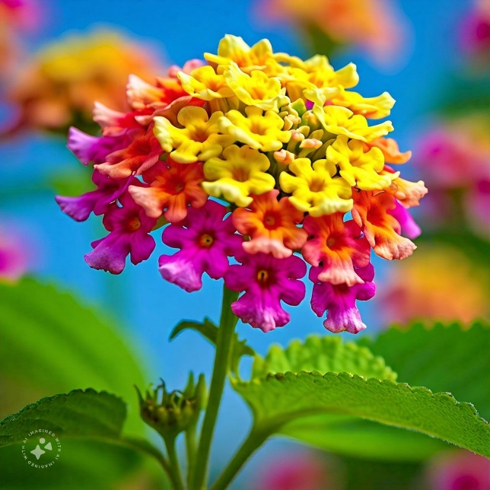

Popcorn Lantana (Lantana depressa) is a distinctive variant within the Lantana genus, recognized for its unique flower clusters that resemble popcorn.

_Physical Traits:_

- A low-growing shrub that can reach a height of up to 3 feet (90 cm) and spread about 6 feet (1.8 meters) wide.

- Features grayish-green, rough-textured leaves that emit a notable fragrance.

- Boasts clusters of small, fragrant flowers that come in a range of colors, including yellow, pink, and purple.

- Produces small, berry-like fruits that contain seeds.

_Growth Characteristics:_

- Exhibits rapid growth, creating dense, spreading mats.

- Adaptable to various soil types and moisture conditions.

- Thrives in full sunlight to partial shade.

- Drought-resistant but benefits from consistent watering for optimal growth.

_Applications:_

- Used ornamentally in landscaping and gardens.

- Serves as effective ground cover and helps prevent erosion.

- Attracts butterflies and other pollinators.

- Noted for its fragrant leaves and blossoms.

**Medicinal properties of lantana camara**

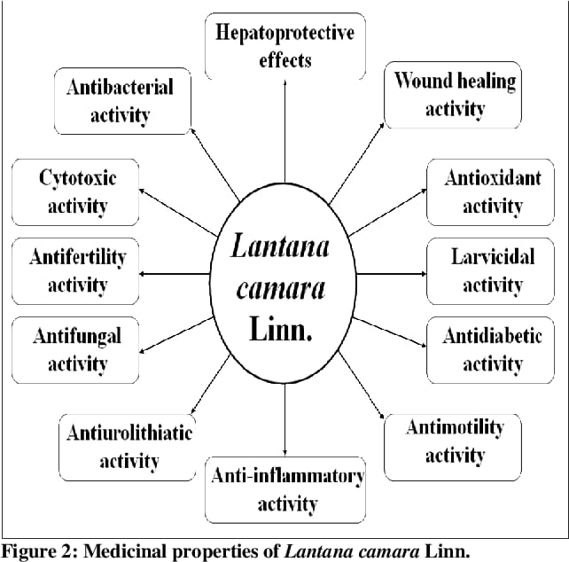

Lantana camara, a flowering shrub, is noted for its various medicinal properties, particularly in traditional healing practices. Here are some of the benefits associated with Lantana:

1. **Wound Healing and Antiseptic**: Both extracts and oils from Lantana have shown promise in promoting the healing of wounds and serving as an antiseptic against bacterial and fungal infections.

2. **Anti-inflammatory Properties**: The plant is recognized for its potential to mitigate inflammation, which could be beneficial for conditions like arthritis, gout, and other inflammatory diseases.

3. **Antimalarial Potential**: Studies suggest that extracts of Lantana may be effective against Plasmodium falciparum, the parasite responsible for malaria.

4. **Antimicrobial Effects**: Lantana exhibits significant antibacterial and antifungal activities, making it useful for preventing various infections.

5. **Relief for Pain and Fever**: Traditionally, Lantana is utilized for pain relief and to reduce fever, making it a remedy for rheumatic pain due to its analgesic and antipyretic properties.

6. **Skin Condition Treatment**: The antiseptic and anti-inflammatory characteristics of Lantana make it a common solution for various skin issues, including eczema, acne, and dermatitis.

7. **Natural Insect Repellent**: The oil derived from Lantana is recognized for its effectiveness in repelling mosquitoes and other insects, providing a natural alternative to chemical repellents.

8. **Antioxidant Benefits**: This plant is rich in antioxidants, which can help protect the body from the damaging effects of free radicals and oxidative stress.

9. **Support for Digestive Wellness**: Traditionally, Lantana has been used to treat digestive issues such as diarrhea, dysentery, and stomach ulcers, attributed to its antiseptic and anti-inflammatory effects.

10. **Respiratory Support**: The shrub has been employed to help alleviate respiratory conditions like bronchitis, asthma, and coughs, thanks to its expectorant and anti-inflammatory properties.

# **HERBAL MEDICINES**

The presence of hazardous substances in various Lantana species underscores the importance of investigating their phytochemical properties. P. G. J. Louw was the first to carry out a detailed study on the chemical constituents of *Lantana camara* in 1943.

In 1948, he separated Lantadene B, with the chemical structure C33H48O5, from all parts of the Lantana plant. He also identified and named its main active component, which he referred to as Lantadene A, with the molecular formula C32H44O5 (Louw, 1948).

The biological activities attributed to Lantana are primarily linked to the Lantadene compounds, which exhibit a wide range of properties, such as antipyretic, antimicrobial, antimutagenic, fungicidal, insecticidal, and nematicidal effects.

In addition to Lantadenes, some of these biological activities could also derive from Lantana’s secondary metabolites, which encompass alkaloids, terpenoids, phenolics, iridoid glycosides, furanonaphthoquinones, flavonoids, phenyl ethanoid glycosides, and other relevant compounds.

Early studies on Lantana species primarily focused on their essential oils, achieving a maximum yield of 0.2% from the leaves and 0.6% from the flowers through hydro distillation.

Analysis of the dry biomass of Lantana revealed a composition of 16.2% lignin, 26% cellulose, 21% hemicellulose, and 31% soluble fiber when heated in water.

Extensive research has documented the antibacterial properties of *Lantana camara* globally. In traditional Indian medicine, it is utilized for its intestinal antiseptic qualities and for treating conditions such as tetanus, rheumatism, and malaria. Leaf extracts showcase antibacterial, fungicidal, insecticidal, and nematicidal activities, and the plant is also used to address tumors, pustules, and fistulas. A decoction of the plant can be prescribed for ailments like tetanus, rheumatism, malaria, and abdominal discomfort.

Pounded leaves can be applied to cuts, ulcers, and swollen areas for relief, while a decoction made from the plant and its fruits can serve as a wound lotion.

For external treatments, it is commonly utilized as a lotion or hot compress to alleviate symptoms associated with eczema and rheumatism.

LANTANA OIL:

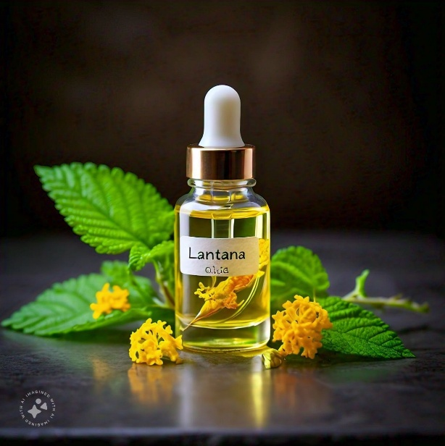

**Uses of Lantana Oil:**

1. **Aromatherapy**: This oil is known for its calming effects, making it ideal for reducing feelings of stress and anxiety during aromatherapy sessions.

2. **Skincare**: Thanks to its antiseptic and anti-inflammatory qualities, lantana oil can be effective in treating acne, healing wounds, and soothing various skin irritations.

3. **Haircare**: Lantana oil supports healthy hair growth, alleviates dandruff, and provides relief to irritated scalps.

4. **Insect Repellent**: The oil’s natural properties make it a favored ingredient in products intended to repel insects.

5. **Perfumery**: Its sweet, floral scent lends itself well to use in fragrances, cosmetics, and perfumes.

6. **Traditional Medicine**: Historically, lantana oil has been utilized in treating an array of health conditions, including fever, rheumatism, and digestive issues.

7. **Wound Healing**: With its antiseptic and anti-inflammatory effects, it aids in the healing of wounds and the repair of tissues.

8. **Pain Relief**: The oil is recognized for its analgesic and anti-inflammatory benefits, assisting in pain management and the reduction of inflammation.

9. **Antibacterial and Antifungal**: Lantana oil demonstrates antimicrobial properties, making it useful for combating bacterial and fungal infections.

10. **Natural Remedy**: It serves as a home remedy for various ailments, such as respiratory conditions like bronchitis and asthma.

**Lantana Leaves as a Natural Home Remedy:**

- **Cough**: Lantana leaves possess a natural cooling effect, which can help ease a cough when inhaled.

- **Flu (Influenza)**: The cooling properties of these leaves may assist in reducing fever associated with the flu.

- **Headache**: Drinking tea made from lantana leaves is a traditional approach to relieve headaches.

- **Indigestion**: Lantana leaf tea can help alleviate symptoms related to indigestion.

- **Joint Pain**: The medicinal benefits of lantana leaves include their use as a natural treatment for rheumatic joint pain.

CONCLUSION

There is a growing interest in natural medicine, making it crucial to conduct research on medicinal plants for the development of herbal treatments that can benefit individuals. One significant plant in this context is Lantana camara, which is widely recognized for its use in traditional medicine worldwide. Studies, both scientific and ethnomedical, have highlighted the therapeutic potential of Lantana camara, indicating that it may serve as an important candidate for drug development. Moreover, it has been noted that this plant can be applied externally to address conditions like scabies and leprosy, as well as function as an antiseptic for minor wounds and provide relief for itchy skin.

REFERENCES

* 1. Ganesh T, Saikatsen, Thilagam G, Loganatham T, Raja Chakraborty;Pharmacognostic and anti hyperglycemic Evaluation of lantana camara (L) var. Aculeate Leaves in alloxaninducedhyperglycemicrats,Int J Res Pharm., 2010; 1(3): 247-252.
  2. Barre JT, Bowden BF, Coll JC, De Jesus J, De La Fuente VE, Janairo GC, Ragasa CY; A bioactive triterpene from Lantana camara. Phytochemistry, 1997; 45 (2):321-324.
  3. Bashir, S.; Jabeen, K.; Iqbal, S.; Javed, S.; Naeem, A. Lantana camara: Phytochemical Analysis and Antifungal Prospective. Planta Daninha 2019, 37, <https://doi.org/10.1590/s0100-83582019370100137>.
  4. Bhuvaneswari, E.; Giri, R.S. Physicochemical and phytochemical screening in Lantanacamara leaves. Journal of Pharmacognosy and Phytochemistry 2018, 7, 1962–1966.
  5. Verma, R.K.; Verma, S.K. Phytochemical and termiticidal study of Lantana camara var. Aculeata leaves. Fitoterapia 2006, 77, 466–468, <https://doi.org/10.1016/j.fitote.2006.05.014>
  6. Badakhshan MP, Sasidharan S, Rameshwar NJ, Ramanathan S; A comparative study: antimicrobial activity of methanol extracts ofLantanacamara various parts. Pharmacognosy Research, 2009; 1 (6):348-351.
  7. Acharya, C.L. & P.D. Sharma.1994. Tillage and mulch effects on soil physical environment, root growth, nutrient uptake and yield of maize and wheat on an Alfisol in north-west India. Soil and Tillage Research 32: 291-302.
  8. CSIR. 1962. The Wealth of India (Raw Material) Vol. 6. Pp. 31-35. Council of Scientific and Industrial Research, New Delhi.
  9. Sabu MC and Kuttan R. Anti-diabetic activity of medicinal plants and its relationship with their antioxidant property. Journal of Ethnopharmacology. 81 (2); 2002:155-160.
  10. Day, M., C.J. Wiley, J. Playford& M.P. Zalucki. 2003. Lantana: current management status and future prospects. ACIAR Monograph 102: 28
  11. Nayak BS, Raju SS, Ramsubhag A. Investigation of wound healing activity of Lantana camara in Sprague Dawley Rats using a burn wound model. Int J Appl Res Nat Pro 2008;1(1):15-19.
  12. Jitendra P, GS Kumar, Shahimqureshi MD, Bharatkumar D, Ashokumar K. Phytochemicals and pharmacological activities of Lantana camara Linn. Research Journal of Pharmacognosy and Pharmacodynamics 2010;2(6):418-422.
  13. Deepak G, Silviya S, Kishwar HK. Biochemical composition and antibacterial activities of Lantana camara plant with yellow, lavender, red, white flowers. EurAsia J BioSciences 2009;3:69-77.
  14. Claude K, Paul Waako, Moses Joloba, Otwaoydek. The antimycobacterial activity of Lantana camara plant traditionally used in south-western Uganda. Afr Health Sci 2010; 4(1):40-45.
  15. Mary Kensa V. Studies on phytochemical screening and anti-bacterial activities of Lantana camara Linn. Plant Sciences feed 2011;1(5):74-79.
  16. Plantsnap.com was first indexed by Google

2013https://www.plantsnap.com/plantblog/types-of-lantana/ in May

* 1. Zizira.com was first indexed by Google more than 10 years agohttps://www.zizira.com/blogs/plants/lantana-camara
  2. Sagar L, Sehgal R, Ojha S; Evaluation of Antimotility effect of Lantana camara L. Var.Acuelata constituents on neostigmine induced Gastrointestinal transit in mice. BMC Complementaryand Alternative Medicine, 2005; 5: 18.
  3. Ito K, Ito M (2011) Sedative effects of vapor inhalation of the essential oil of Microtoenapatchoulii and its related compounds. J Nat Med 65:336–343. <https://doi.org/10.1007/s11418-010-0502-x>
  4. <https://en.m.wikipedia.org/wiki/Lantana_camara#cite_ref-Day_7-2>
  5. A review of Lantana camara studies in India N. Priyanka, P. Joshi Published 2013 Environmental Science
  6. Jitendra P, GS Kumar, Deviprasad SP, Shamimqureshi MD. Phytochemical andanthelmintic evaluation of Lantana camara(L) var aculeate leaves against pheretima posthuma. Journal of Global Trends in Pharmaceutical Sciences 2011;2(1):11-20.
  7. Shahid P, Rajinder R, PK Verma, Pankaj NK. Medicinal plants and their role in wound healing. Vetscan 2008;3(1).
  8. Deepak G, Silviya S, Kishwar HK. Biochemical composition and antibacterial activities of Lantana camara plant with yellow, lavender, red, white flowers. EurAsia J BioSciences 2009;3:69-77.
  9. Rajesh D, Amita G, Mandal TG, Deshdeepak S, Vivek B,Gaurav AM. Lavekar GS. Antimicrobial activity of some Indian medicinal plants. Afr.J.Trad.Cam 2007;4(3):313-318
  10. Mayee R, Thosar A. Evaluation of Lantana camara Linn. (verbanaceae) forAntiurolithiatic and Antioxidant activities in rats. Int. J Pharm clin. Res. 2011;3(1):10-14. Ogendo JO, Walker DJ, Belmain SR, Deng AL. Comparision of toxic and repellant effects of Lantana camara with tephysosia vogeii hook and a synthetic pesticide against sito philus zeamais motschulsky in stored maize grain. Insect Sci. Applic. 2003;23(2):127-135.
  11. Emmanuel NA, Akakpo JA, Moudachirou M, Leclercq JQ. Treatment of bovine dermatophilosis with senna alata, Lantana camara and mitracarpus scaber leaf extracts. Journal of Ethanopharmacology 2003;86:167-171.
  12. Ooyedapo O, Akinpelu BA, Akinwanmi KF, Adeyinka MO, Sipeolu FO. Red blood cell membrane stabilizing potentials of exracts of Lantana camara and its fractions. Adv. In Nat. Appl. Sci. 2010;2(4):46-51.
  13. Herbal Medicine and Biotechnology for the Benefit of Human Health Priyanka Srivastava, Rakhi Chaturvedi, in Animal Biotechnology, 2014
  14. Alves TM, Silva AF, Brandão M, Grandi TS, Smânia E, Smânia Júnior A, et al. Biological screening of Brazilian medicinal plants. Mem Inst Oswaldo Cruz 2000;95:367-73.
  15. Tripathi AK, Shukla BN. Antifungal activity of some plant extracts Against Fusarium oxysporum sp. Causing wilt of linseed. J Mycol Plant Pathol 2002;32:266-7.
  16. Patel SJ, Venugopalan N, Pradeep S. Screening for antimicrobial Activity of weeds. Internet J Microbiol 2007;4(1).