**A SUMMARY OF DIVERSE CHROMATOGRAPHIC APPROACHES**

**Ms. Rani P. Gomase\***

**Lecturer, Amrutvahini Institute of Pharmacy, Sangamner.**

**Corresponding Address:**

Ms. Rani P. Gomase

ranigomase@gmail.com

**Abstract:**

Chromatography is a technique employed to separate the individual components of a mixture. In this process, the mixture's components are distributed within a liquid solution referred to as the mobile phase, which transports them through a medium containing another material called the stationary phase. Effective separation of components relies on their differing affinities for the mobile and stationary phases. The primary objective of chromatography is to analyze the qualitative and quantitative chemical composition of a sample, with its main function being the purification and extraction of one or more components from that sample.

This paper will explore the historical background and fundamental concepts of chromatography, along with the key principles governing its operation. In this review, we will provide a concise overview of the principles, various types, schematic representations, and applications associated with each chromatographic method.

**Key Words:** Mobile Phase, Separation, Adsorption, Partition, Industrial

**Introduction:**

The word “chromatography” is derived from the Greek words “Chroma,” meaning “color,” and “graphien,” which translates to “to write.” The method was first developed by Russian botanist M. S. Tswett in 1903. Chromatography is an analytical technique utilized to separate, identify, and purify the components of a mixture. It is based on the principle of differential interaction between solutes in two distinct phases: the stationary phase and the mobile phase. To improve analysis time and accommodate the diverse range of substances that can be identified, numerous modifications were made to chromatography techniques. Pumps were introduced to increase pressure and reduce the duration of runs. Additionally, detection methods were enhanced by incorporating tools such as spectroscopy and electrochemical techniques.1

**Definition**- Chromatography is a technique utilized in laboratories for the separation of mixtures. The mixture is dissolved in a liquid referred to as the mobile phase, which carries it through a system containing a different substance called the stationary phase. The constituents of the mixture are separated due to their varying velocities. This separation occurs as a result of differential partitioning between the mobile and stationary phases.2 Variations in retention on the stationary phase influenced by slight differences in a compound’s partition coefficient affect the separation process. The components intended for separation are distributed between two phases: one is the stationary phase, and the other is the mobile phase, which moves in a designated direction.3

**Principle of Chromatography**

The core concept of chromatography revolves around the principle that mixtures of molecules applied to surfaces or solid and fluid stationary phases (stable phases) will separate from each other as they move with the aid of a mobile phase. The characteristics of molecules associated with adsorption (liquid-solid), partition (liquid-solid), and differences in their molecular weights are significant factors influencing this separation process. These differences cause certain components of the mixture to reside longer in the stationary phase and move more slowly through the chromatographic system, while others quickly transition into the mobile phase and exit the system at a faster rate.

Three components thus form the basis of the chromatography technique.

**Stationary phase:** This phase is always composed of a “solid” phase or “a layer of a liquid adsorbed on the surface a solid support”.

**Mobile phase:** This phase is always composed of “liquid” or a “gaseous component”. Separated molecules: The type of interaction between the stationary phase, mobile phase and substances contained in the mixture is the basic component effective4, 5

The aim of chromatography, which is also utilized for quantitative analysis, is to attain adequate separation in a timely manner. To achieve this objective, various chromatographic methods have been developed. Some of these include column chromatography, affinity chromatography, gas chromatography, thin-layer chromatography (TLC), paper chromatography, ion exchange chromatography, gel permeation chromatography, and high-pressure liquid chromatography.6

**Types of Chromatography**

Following are the types of chromatography

* Column Chromatography
* Ion-Exchange Chromatography
* Paper Chromatography
* Thin-Layer Chromatography
* Gas Chromatography
* High-Pressure Liquid Chromatography (HPLC) 7

1. **Column Chromatography**:

Because proteins differ in size, shape, net charge, stationary phase used, and binding capacity, each of these distinctive components can be separated using chromatographic techniques, the most common application of these techniques being column chromatography.

**Principle**:

The movement of the colour impurity corridor moves in colour animals, when the mobile phase and the mixture, which are to be divided, are captured from the top columns. Compared to factors with less adsorption. Basics this movement is excluded first, but the basics are excluded. This movement will be severely excluded at the end.8

**Types of Column Chromatography**

**1. Adsorption Column Chromatography:** Adsorption is the underlying principle of this method. When a mixture of materials (adsorbate) dispersed in the mobile phase (eluent) passes through a column of stationary material (adsorbent), they move in accordance with their respective affinities towards stationary material. The chemical that has a stronger attraction for stationary phase’s moves more slowly and the compound with a weaker affinity phases travel more quickly. The compounds are divided in this manner.

**2. Partition Column Chromatography**: This technique uses partition as its underlying premise. A combination of solutes will be distributed according to their partition coefficient when there are two immiscible liquids present. The component that is more soluble in the stationary phase travels slower and the component that is more soluble in the mobile phase travels faster when a mixture of compounds that have been dissolved in the mobile phase is transported through a column of liquid stationary phase. Liquids are not permitted to be the stationary phase. In order to create a thin film or coating of a liquid that serves as a stationary phase, a solid support is employed. Simple solvent extraction techniques requiring only a few (one to three) extractions can completely separate substances with significant differences in their partition coefficients.9

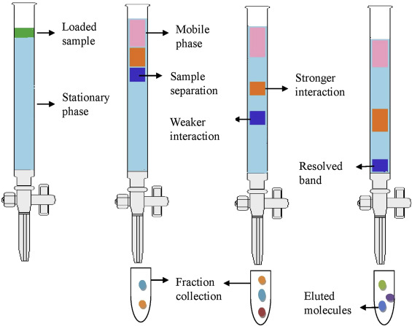

**Fig 1: Column Chromatography**

**Applications of column chromatography**

The most effective way to separate active substances. Analysis of plant constituents is by column chromatography.

* To remove contaminants from the vital components.
* Separates metabolites from the main component.
* Used to measure the presence of phytomenadione in the body.
* Concentration of flucinolone, acetonide and betamethasone in the formulation.
* It is used to separate inorganic ions like copper, cobalt and nickel ions.
* Calculating the w/w ratio of strychnine in iron phosphate syrup with quinine and strychnine.
* Quinine concentration in ethanolic solution determination.
* Helpful for separating carbs from their derivatives.10

1. **Ion-Exchange Chromatography:**

The electrostatic interactions between charged protein groups and solid support material are the foundation of ionexchange chromatography (matrix). Ionic ties are used to bind the protein to the column since the matrix has an ion load that is the opposite of that of the protein to be separated. By altering the buffer solution’s pH, ion salt concentration, or ionic strength, proteins can be removed from the column. Anion-exchange matrices are positively charged ionexchange materials that bind negatively charged proteins. Cation-exchange matrices, on the other hand, bind to negatively charged groups and adsorb positively charged proteins.11

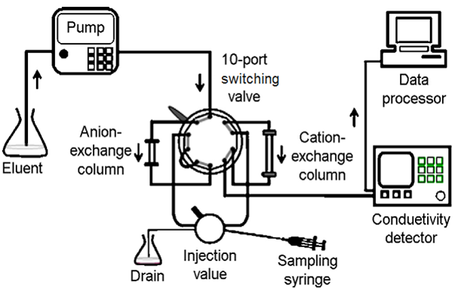

**Fig. 2: Ion Exchange Chromatography**

**Principle:**

Based on the charged groups that each molecule has, ion-exchange chromatography separates the molecules. Ion-exchange chromatography uses coulombic (ionic) interactions to keep analyte molecules on the column. Ions with opposite charges make up the matrix used in ion exchange chromatography. Essentially, on the stationary phase matrix, molecules engage in electrostatic interactions with opposite charges. The immobile matrix that comprises charged, ionizable functional groups or ligands makes up the stationary phase. Ionic functional groups (R-X) that interact with analyte ions of the opposite charge can be seen on the stationary phase surface.

**Application:**

* **Protein purification**: Ion exchange chromatography is commonly used to purify proteins from complex mixtures. By selecting the appropriate stationary phase and elution conditions, specific proteins can be separated and purified with high purity and yield.
* **Pharmaceutical industry**: In drug development, ion exchange chromatography is employed to separate and purify active pharmaceutical ingredients, ensuring high quality and safety of medications.
* **Environmental analysis**: This technique plays a crucial role in water and soil analysis by separating and quantifying ions, heavy metals, and other pollutants, aiding in environmental monitoring and regulatory compliance.
* **Nucleic acid separation**: Ion exchange chromatography is utilized for separating DNA and RNA fragments based on their charge characteristics. This is essential in molecular biology research and genetic analysis.
* **Biotechnology**: Ion exchange chromatography is often a part of downstream processing in biotechnology, helping to isolate and purify biomolecules like enzymes, antibodies, and hormones.

1. **Paper Chromatography**:

Paper Chromatography In analytical chemistry, paper chromatography is a technique used to separate dissolved chemical compounds by taking advantage of their differing rates of migration through paper sheets. It is a cheap yet effective analytical tool that only needs very little raw material. The procedure entails applying the test substance or sample as a spot close to a filter paper sheet’s corner. To establish a stationary liquid phase, a suitable solvent is first used to permeate the paper.

The components of the combination are soluble to variable degrees in another solvent, which is subsequently applied to a paper edge near the test location. Through capillary action, the solvent permeates the paper and, as it passes over the sample spot, carries the various components of the sample with it. Depending on how soluble each component is in the stationary and moving solvents, the components move with the flowing solvent at different speeds.

For the separation of complicated combinations of amino acids, peptides, carbohydrates, steroids, purines, and a lengthy list of simple chemical compounds, paper chromatography has evolved into a common procedure. On paper, inorganic ions can also be easily separated. Thin layer chromatography is compared.13

**Principle of Paper Chromatography:**

Partition, in which the constituent components are spread or partitioned between liquid phases, is the fundamental idea behind paper chromatography. Aqueous solvent is used, acting as the stationary phase and being kept in the pores of filter paper, while the mobile phase moves over the paper. The compounds in the mixture are separated through capillary action of the paper’s pores because of variations in their affinity toward water (in stationary phase solvents) and mobile phase solvents. The components can also be separated using the principle of adsorption between solid and liquid phases, where the stationary phase is a liquid solvent and the mobile phase is the solid surface of the paper. Despite partitioning being the basic operating concept of paper chromatography, it is used in numerous therapeutic applications. 14

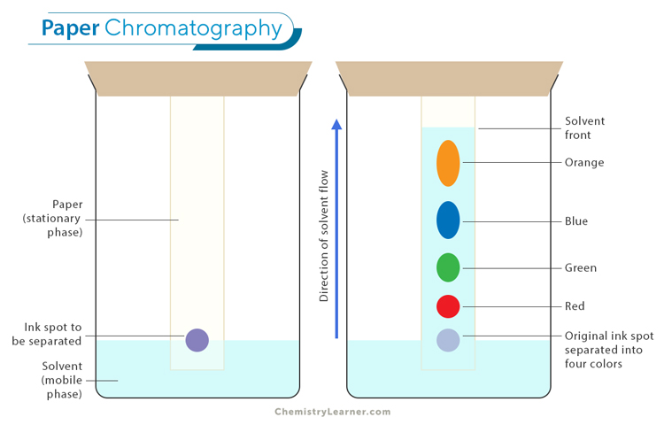

**Fig.3: Paper Chromatography**

**Types of Paper Chromatography**

1. **Descending**: By letting the solvent to go down the paper, the chromatogram is developed. Mobile phase is put in the solvent holder at the top of this picture. The solvent pours down the paper from above, keeping the spot at the top.

2. **Ascending**: The chromatographic paper is raised by the solvent in this area. For the separation of organic and inorganic compounds, paper chromatography in both ascending and descending directions is employed. Both the sample and the solvent rise.

3. **Ascending-Descending**: This is a combination of the two methods mentioned above. To allow the paper to become descending after passing the rod, the upper portion of ascending chromatography can be folded over the rod.

4. **Chromatography**: The sample is placed in the center of a circular filter paper that has been taken. After the spot has dried, the filter paper is connected horizontally to a Petri dish filled with solvent, allowing the paper’s wick to be submerged in the solvent. The components are divided into concentric rings when the solvent rises through the wick.

5. **Two-Dimensional**: Paper that is square or rectangular is utilised for this technique. In this instance, the sample is put to one of the corners, and development is carried out perpendicular to the first run’s direction

**Applications of Paper Chromatography:**

Paper chromatography has a wide range of uses. The following is a discussion of some of the applications for paper chromatography in several fields:

* Diversification of drug brews
* Separation of proteins, vitamins, antibiotics and carbs
* Drug identification • Determining impurities
* Analysis of drug metabolites in blood and urine
* To research the ripening and fermentation processes
* To verify the medications purity
* To examine cosmetics
* To identify adulterants
* To identify food and drink pollutants
* For the purpose of inspecting the reaction mixtures in biochemical labs
* To identify narcotics and dopes in both people and animals.

1. **Thin Layer Chromatography (TLC)**

Non-volatile mixtures can be separated using the chromatography technique known as thin layer chromatography (TLC). A sheet of an inert substrate, such as glass, plastic, or aluminium foil, is used for thinlayer chromatography. This substrate is coated with a thin layer of an adsorbent material, typically silica gel, aluminium oxide (alumina), or cellulose. The stationary phase refers to this adsorbent layer. A solvent or solvent combination (referred to as the mobile phase) is dragged up the plate by capillary action after the sample has been placed on the plate. Separation is accomplished because various analytes ascend the TLC plate at various speeds15

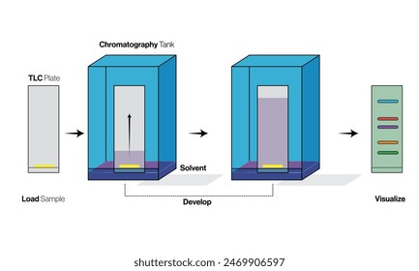

**Fig.4: Thin Layer Chromatography**

**Principle of Thin Layer Chromatography:**

Thin-layer chromatography (TLC), like other chromatographic methods, is based on the separation principle. The relative affinity of chemicals for the two phases is what drives the separation. The substances in the mobile phase pass over the stationary phase’s surface. The compounds that have a stronger attraction for the stationary phase move slowly whereas the other compounds move quickly during the movement. As a result, the mixture is successfully separated. After the separation procedure is complete, the mixture’s constituent components show up as spots at the appropriate levels on the plates. Suitable detecting techniques are used to determine their nature and character.16

**Applications of Thin Layer Chromatography**

* TLC does qualitative testing on a variety of drugs, including sedatives, local anaesthetics, anticonvulsant tranquillizers, analgesics, antihistamines, steroids, and hypnotics.
* In biochemical analysis, such as the separation or isolation of biochemical metabolites from blood plasma, urine, bodily fluids, serum, etc., TLC is incredibly helpful.
* It is possible to detect natural compounds using thin layer chromatography, such as volatile or essential oils, fixed or fixed oils, glycosides, waxes, alkaloids, etc.
* It is frequently employed to separate complex medicinal compositions.
* It is employed to clean samples, and a direct comparison between the sample and the original sample is made. To distinguish and identify colours, sweeteners, and preservatives in the food sector. It is employed in the cosmetics sector.
* It is used to study if a reaction is complete.17

1. **Gas Chromatography**

A popular method of chromatography used in analytical chemistry for separating and studying substances that may be evaporated without decomposing is gas chromatography (GC). GC is frequently used to determine a substance’s purity or to separate the various ingredients in a mixture. By injecting a gaseous or liquid sample into a mobile phase, which is frequently referred to as the carrier gas and passing the gas through a stationary phase, gas chromatography is a method for separating chemicals in mixtures. An inert gas or an unreactive gas, such as helium, argon, nitrogen, or hydrogen, typically makes up the mobile phase.

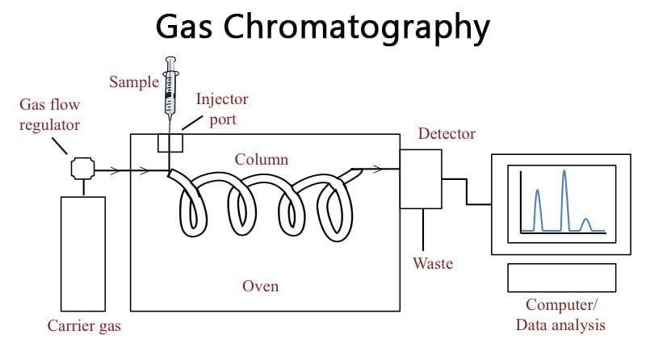

**Fig.4: Gas Chromatography**

**Principle of Gas Chromatography:**

“Partition” is the separation tenet in general counsel. The mixture of the separated components is heated to vapour and then combined with the gaseous mobile phase. The more soluble components in the stationary phase move more slowly and elute later. First to elute out is the component that is less soluble in stationary phase. No two components have the same conditions for the partition coefficient. As a result, the components are divided based on their partition coefficient. The definition of a partition coefficient is the ratio of a substance’s solubility in two immiscible liquids at a fixed temperature.

**Applications of Gas Chromatography**

* **Qualitative Analysis**: By comparing the sample’s retention time or volume to the standard, or by gathering the various elements as they leave the chromatograph and identifying these substances using additional techniques like UV, IR, or NMR.
* **Quantitative Analysis**: The quantity of the detected component and the detectors’ response factor are inversely correlated with the area under a single component elution peak.
* **Pharmaceutical Applications**: Drug goods such as antibiotics (penicillin), antivirals (amantidine), general anaesthetics (chloroform, ether), sedatives/hypnotics (barbiturates), etc. are subject to quality control and analysis.

1. **High-Performance Liquid Chromatography (HPLC)**

The analytical chemistry method of high-performance liquid chromatography (HPLC), formerly known as high-pressure liquid chromatography is used to separate, recognise and quantify each component in a mixture. It uses pumps to move a column of solid adsorbent material through a pressured liquid solvent containing the sample combination. The adsorbent material and each component in the sample interact slightly differently, resulting in various flow rates for the various components and their separation as they exit the column.

HPLC has been used for manufacturing (such as during the production of pharmaceutical and biological products), legal (such as detecting performance enhancing drugs in urine), research (such as separating the components of a complex biological sample, or of similar synthetic chemicals from each other), and medical (such as determining the levels of vitamin D in blood serum) purposes.18

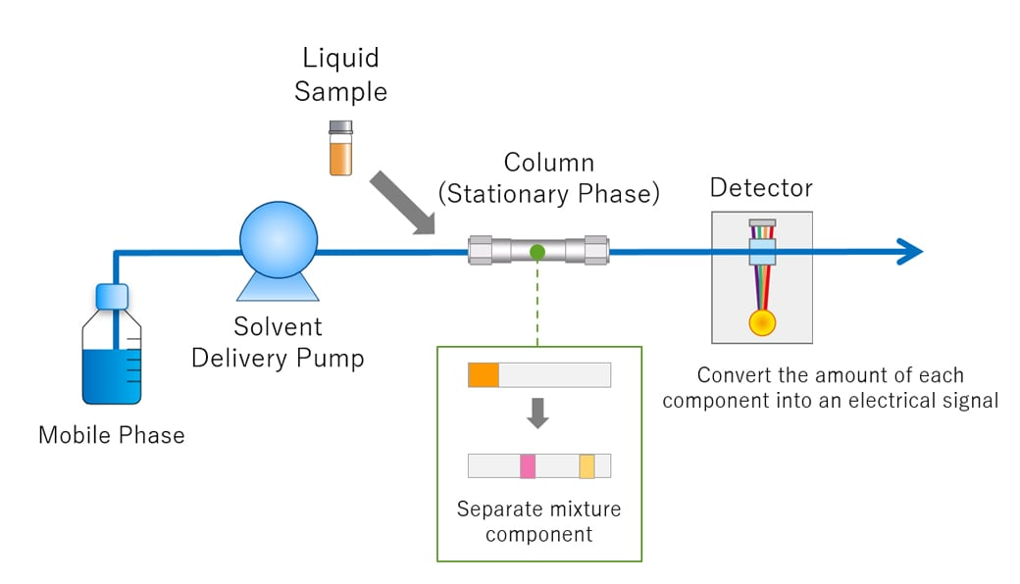

**Fig. 6: High-Performance Liquid Chromatography**

**Principle of High-Performance**:

Liquid Chromatography High performance chromatography has replaced the previous word for liquid chromatography, High Pressure Liquid Chromatography, which is preferable since it more accurately characterizes the chromatography’s features and dispels the idea that high pressure is required to conduct analysis. Column chromatography, which is used in use all over the world, relies on gravity or operates at low pressure. As a result, band broadening via diffusion events takes longer to complete.

The disadvantage in this situation is that a quicker flow rate cannot be used because of the back pressure build up that occurs at higher flow rates. This damage to the stationary phases’ matrices impairs their ability to resolve their constituents. Massive advancements in column chromatographic methods over the past ten years have made a variety of stationary phases and pumping systems that can sustain these pressures available. These advancements produced a variety of separation techniques that allowed for quicker analysis using HPLC, leading to its emergence as the most widely used, potent, and adaptable form.

**Applications of High-Performance Liquid Chromatography:**

The HPLC technique has advanced to the point where it can now be used in practically every field of chemistry, biochemistry, and pharmacy.

* Examination of medications
* Examination of artificial polymers
* Pollutant analysis in environmental analytics
* Drug detection in biological matrices
* Isolation of priceless goods
* Controlling the purity and quality of delicate chemicals and industrial items
* Biopolymer separation and purification, such as those of enzymes or nucleic acids
* Purifying of water
* Trace component pre-concentration
* Exchange of ligands in chromatography
* Protein ion-exchange chromatography
* Chromatography of oligosaccharides and carbohydrates at high pH.19

**Conclusion**:

The analytical purpose of chromatography is to determine qualitative and quantitative chemical composition of the sample and its primary objective is to clean up and extract one or more of the sample components. This article will discuss the history and basics of what is meant by chromatography, as well as the fundamental analytical purpose of chromatography is to determine qualitative and quantitative chemical composition of the sample and its primary objective is to clean up and extract one or more of the sample components.

In this review, we have briefly mentioned and concentrated. In principle, types, schematic diagram and applications for each chromatographic type such that Column chromatography, Ion-exchange chromatography, Paper Chromatography, Thin-layer chromatography, Gas chromatography and High pressure liquid chromatography.

**References**:

1. Ravali R, Phaneendra M, Bhanu JK, Ramya SL, Sushma K (2011) Recent Trends in Analytical Techniques for the Development of Pharmaceutical Drugs. J Bioanal Biomed.
2. Murry J (2011) Organic Chemistry with Biological Applications 2nd (Edn.), Brooks/Cole Cengage Learning Belmont Calif.
3. Alan DM, Andrew W (1997) Compendium of Chemical Terminology 2nd (Edn.), Blackwell Scientific Publications, Oxford.
4. Engel RG, George S, Gary ML, Pavia DL (2010) Introduction to Organic Laboratory Techniques: A Smallscale Approach 2nd (Edn.), Chemicke Listy pp: 950-953.
5. Gerberding SJ, Byers CH (1998) Preparative IonExchange Chromatography of Proteins from Dairy whey. J Chromatogr A 808(1-2): 141-151.
6. Harwood LM, Moody CJ, Cranwell PB (2017) Experimental Organic Chemistry. Blackwell Scientific.
7. Engel RG, George S, Gary ML, Pavia DL (2010) Introduction to Organic Laboratory Techniques: A Smallscale Approach 2nd (Edn.), Chemicke Listy pp: 950-953.
8. Column-Chromatography (2020) Chemistry, byjus.
9. Shawn A (2013) an Introduction to Ion Exchange Chromatography, Bio-Rad.
10. Gel chromatography (2017) chemistry Encyclopedia Britannica
11. Uppsala (1991) Ion Exchange chromatohgraphy: Principles and methods, Amercham Pharmacia Biotech SE-751.
12. Jungbauer A, Hahn R (2009) Ion-Exchange Chromatography. Methods in Enzymology 463: 349-371
13. Thompson NE, Foley KM, Stalder E, Burgess RR (2009) Identification, Production, and Use of Polyolresponsive Monoclonal Antibodies for Immuno affinity Chromatography. Methods Enzymol 463: 475-494.
14. Eigsti NW (1967) Paper Chromatography for Student Research. The American Biology Teacher 29(2): 123- 134.
15. Tatchell AR, Furnis BS, Hannaford AJ, Smith PWG (1989) Practical Organic Chemistry 5th (Edn.), John Wiley & Sons
16. Fair JD, Kormos CM (2008) A Flash Column Chromatograms Estimated from Thin-layer Chromatography Data. Journal of Chromatography 1211(1-2): 49-54.
17. Berlin (1987) Reports of the German Botanical Society. Biodiversity Heritage Library 24(1906).
18. Karger BL, Berry LV (1971) Rapid Liquid chromatographic Separation of Steroids on Columns Heavily Loaded with Stationary Phase. Clin Chem 17(8): 757-764.
19. Sagar A (2023) High-performance Liquid Chromatography or Commonly known as HPLC, is an Analytical Technique used to Separate, Identify or Quantify each Component in a Mixture. Microbe Notes.